Extended Data Fig. 1 - 9
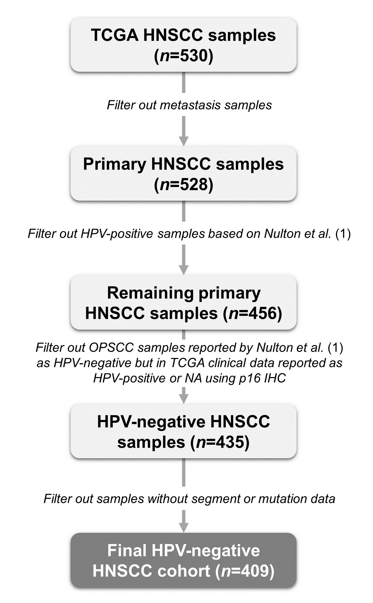
Extended Data Fig. 1 | Filtering of the human papilloma virus-negative head and neck squamous cell carcinoma TCGA. Clinical data of 530 head and neck squamous cell carcinoma (HNSCC) samples from TCGA dataset were downloaded; 528 primary HNSCC samples were left after filtering out two metastasis samples. Human papillomavirus (HPV)-positive samples were filtered out based on detection of viral transcripts, as reported by Nulton et al. (1). In addition, oropharynx squamous cell carcinoma (OPSCC) samples reported by Nulton et al. (1) as HPV-negative but described as HPV-positive or NA in TCGA dataset using p16 immunohistochemistry (IHC) were filtered as well. From the 435 HPV-negative HNSCC samples, segment and mutation data was unavailable for 26 samples, leaving us with a cohort of 409 HPV-negative HNSCC for further analysis.

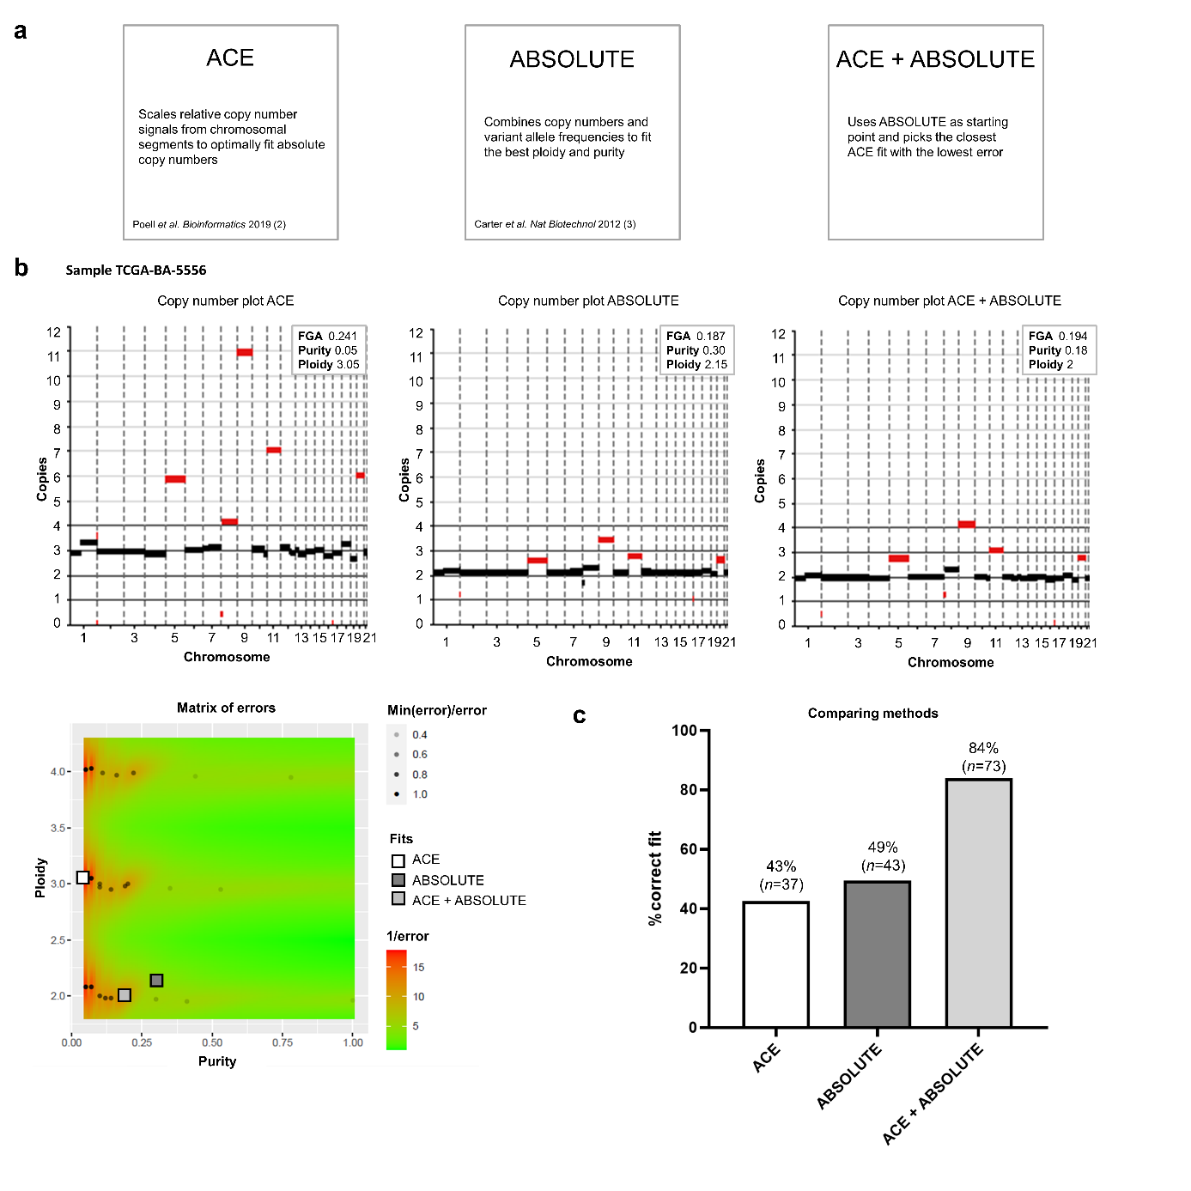
Extended Data Fig. 2 | Evaluating R packages ACE, ABSOLUTE and the combination to infer the purity, ploidy, copy numbers and purity from TCGA human papilloma virus-negative head and neck squamous cell carcinoma cohort. a, R package ACE (Poell et al. (2)) scales relative copy number signals from chromosomal segments to optimally fit absolute copy numbers, ABSOLUTE (Carter et al. (3)) combines copy numbers and variant allele frequencies to fit the best ploidy and purity, ACE + ABSOLUTE uses ABSOLUTE as starting point and picks the closest ACE fit with the lowest error. b, Representative sample of TCGA with copy number plots using ACE (left), ABSOLUTE (middle) and ACE + ABSOLUTE (right) and accompanying matrix of errors. c, Result of scoring all TCGA human papilloma virus (HPV)-negative head and neck squamous cell carcinoma (HNSCC) samples with provided FGA < 0.10 (n=87) using ACE, ABSOLUTE and ACE + ABSOLUTE. When fits were equally performing they were both scored as correct.
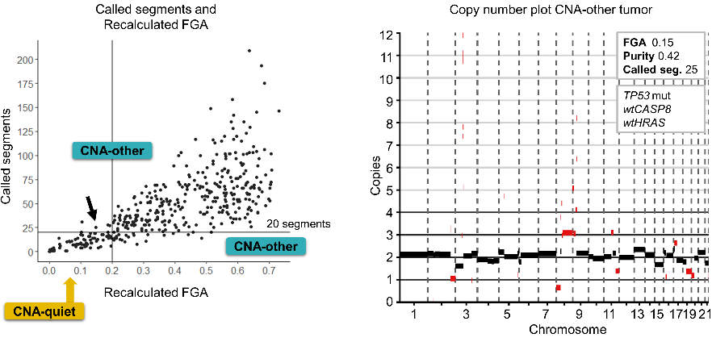
Extended Data Fig. 3 | Copy number plot of copy number alteration-other TCGA tumor. Called segments and recalculated fraction genome altered (FGA) in left panel, as in Fig. 1g. Arrow indicates representative sample with FGA < 0.20 but ≥ 20 called segments.
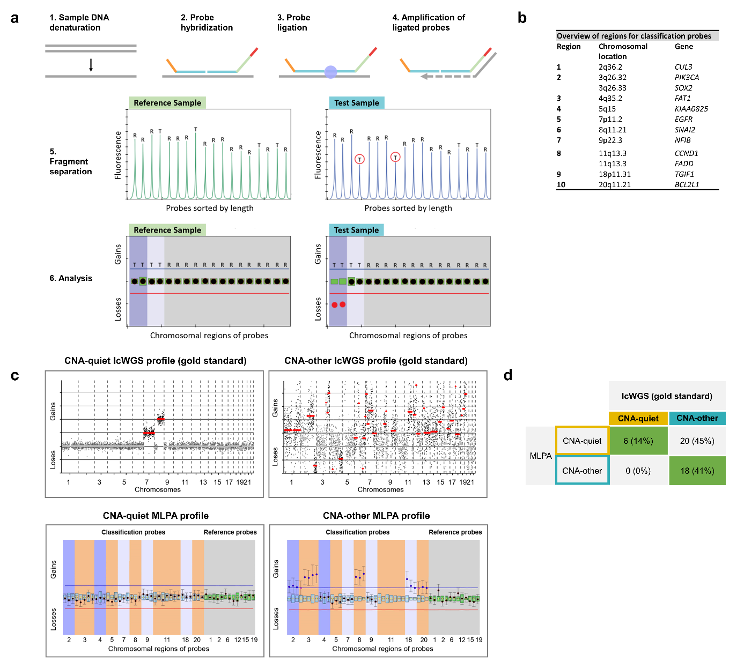
Extended Data Fig. 4 | Pre-screening method multiplex ligation-dependent probe amplification. a, Schematic representation of workflow of multiplex ligation-dependent probe amplification (MLPA) with 1. DNA denaturation, 2. probe hybridization, 3. probe ligation, 4. amplification of ligated probes, 5. fragment separation and 6. data analysis. b, Overview of ten most frequently gained and lost regions in human papilloma virus-negative head and neck cancer tumors used for the selection of classification probes. c, Representative example of a copy number alteration (CNA)-quiet and CNA-other copy number profile using the gold standard low coverage whole genome sequencing (lcWGS) as well as CNA-quiet and -other MLPA profiles. d, Results of a pilot evaluating MLPA as pre-screening method using 44 head and neck squamous cell carcinoma samples with lcWGS as gold standard.
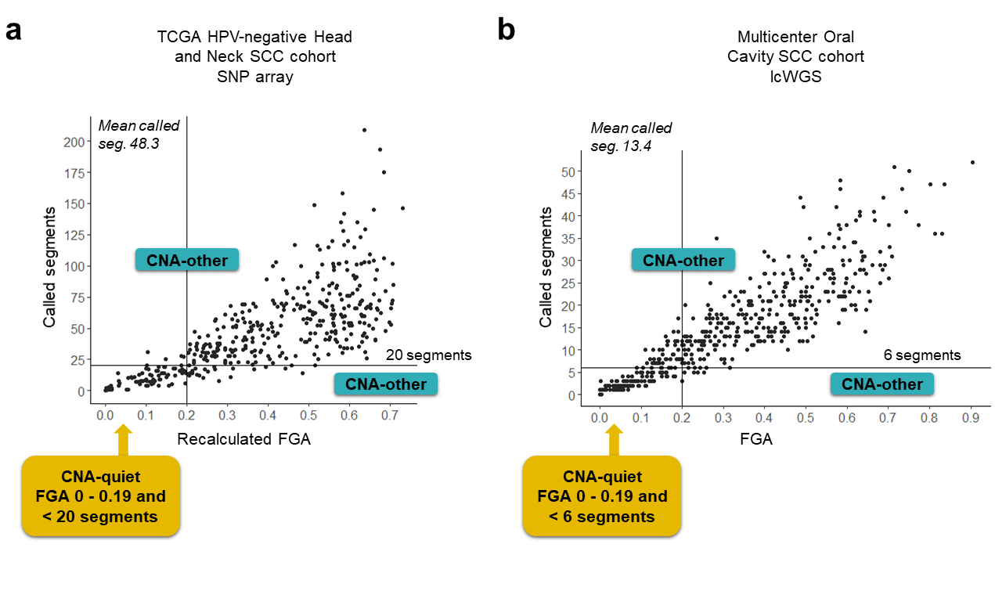
Extended Data Fig. 5 | Cut-off for copy number alteration (CNA)-quiet tumors in TCGA human papillomavirus (HPV)-negative head and neck squamous cell carcinoma (SCC) cohort and multicenter oral cavity SCC cohort. Called segments (y-axis) and fraction genome altered (FGA, x-axis) were used to classify CNA-quiet tumors in the a, TCGA cohort and b, Multicenter cohort. To translate cut-off for CNA-quiet tumors from TCGA cohort, where data was obtained by single nucleotide polymorphisms (SNP) array, to the multicenter cohort, where data was obtained by low coverage whole genome sequencing (lcWGS), average called segments were calculated and the ratio was used to calculate the segment cut-off for the multicenter oral cavity SCC cohort.
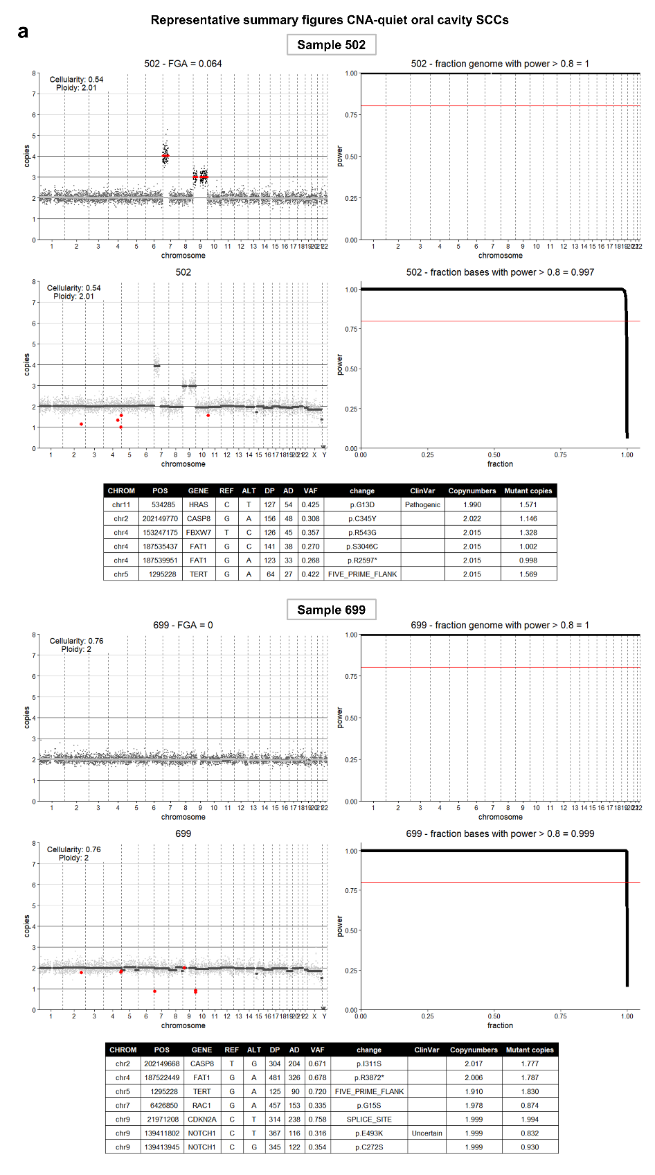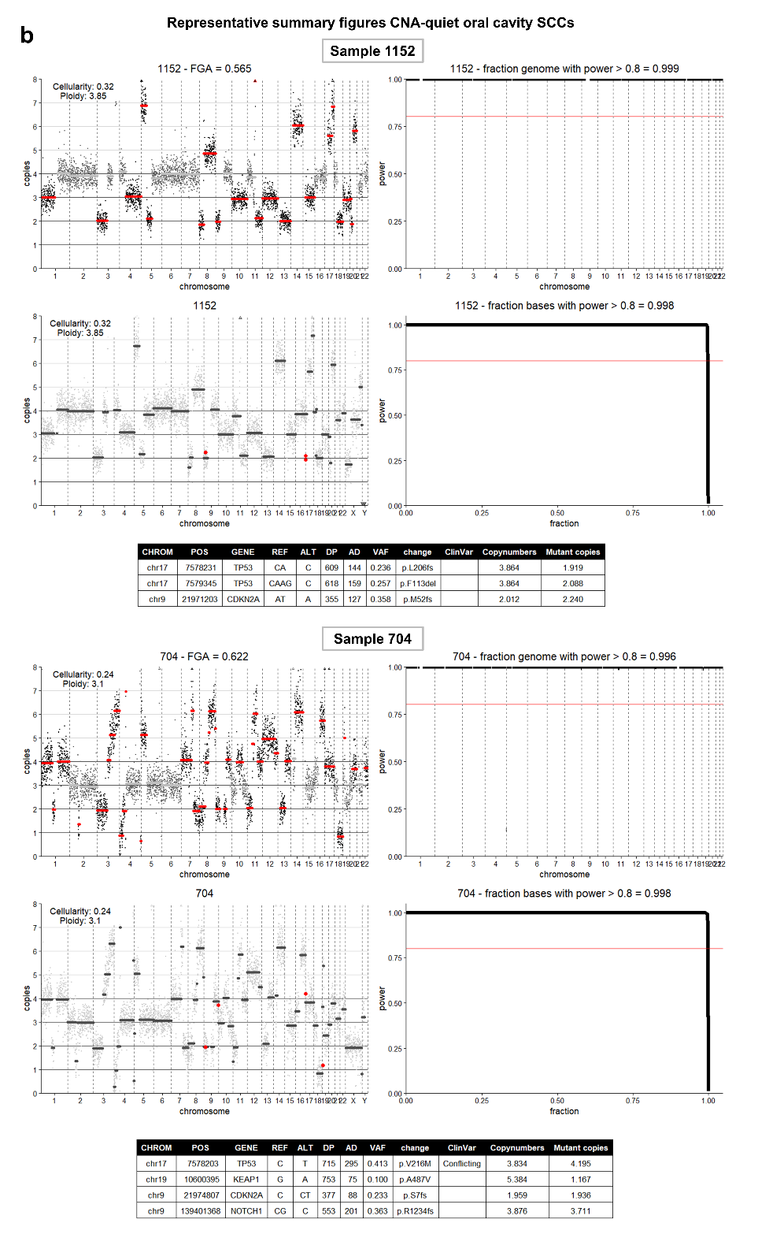
Extended Data Fig. 6 | Summary figures of somatic variants and called segments. a-b, Representative summary figures of a, copy number alteration (CNA)-quiet and b, CNA-other oral cavity squamous cell carcinomas (OCSCCs). Called segments in upper left panel in red, as output from low coverage whole genome sequencing (lcWGS). In the lower left panel the somatic variant copies (in red) are plotted on the copy numbers. The table shows details on the variants. In the two right panels are the power to call segments (upper panel) and variants (lower panel). Samples were required to have > 80% power over at least 80% of the genome.

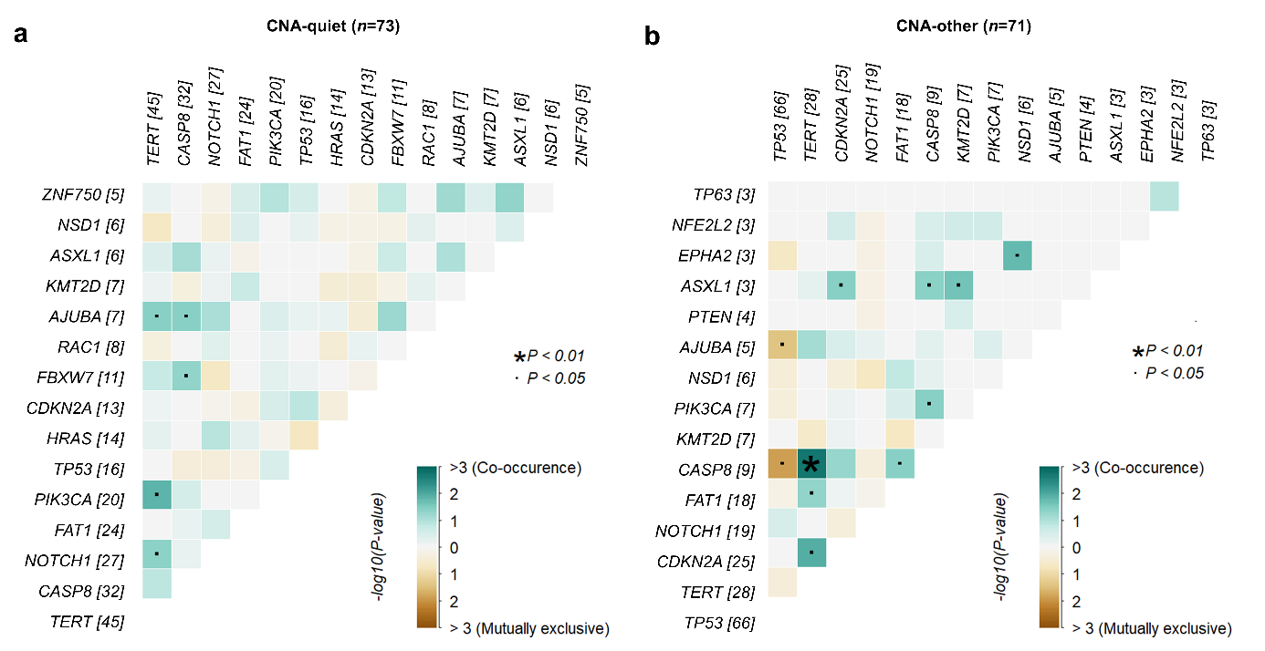
Extended Data Fig. 7 | Mutually exclusive and co-occurrence analysis. Pair-wise Fisher’s Exact test to detect co-occurrence or mutually exclusive events with * p < .01 and • p < .05. in a, copy number alteration (CNA)-quiet (n=73) and b, CNA-other OCSCC (n=71). 15 most prevalent genes are displayed with mutation count between square brackets.

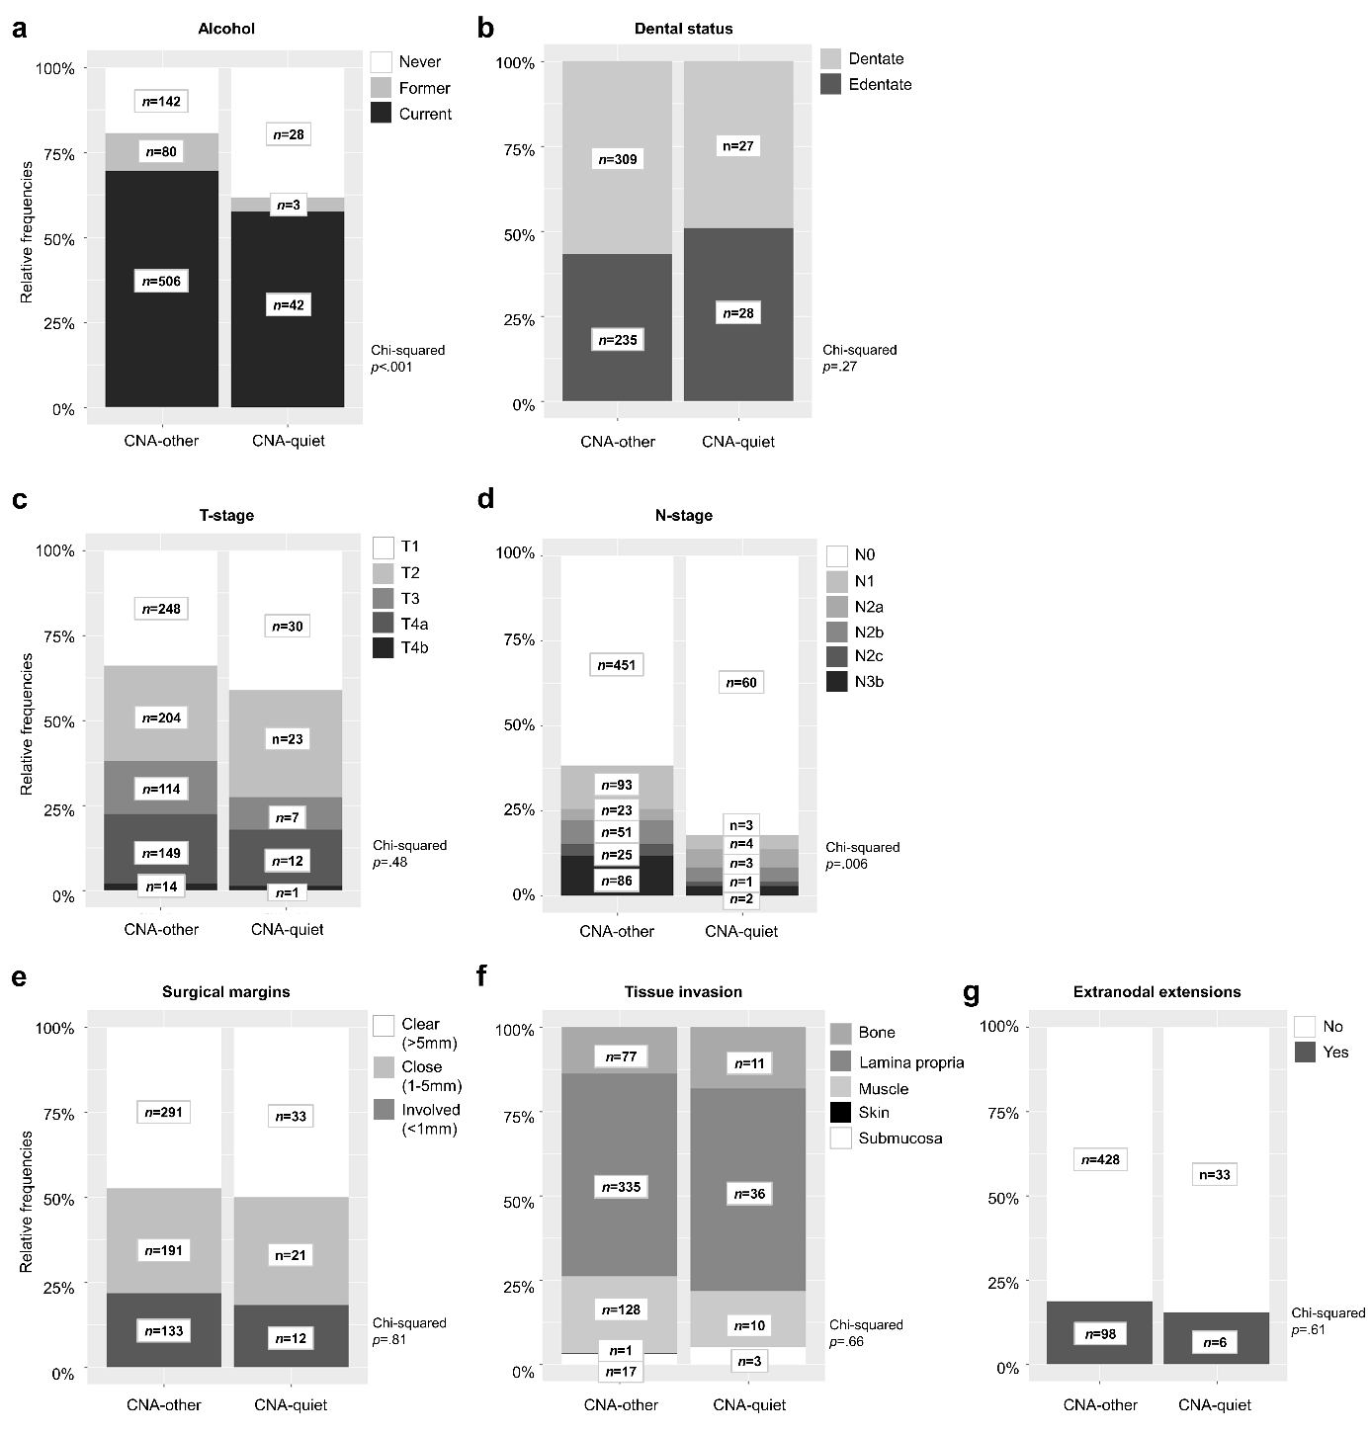
Extended Data Fig. 8 | Comparison between copy number alteration (CNA)-quiet and -other oral cavity SCC. a-g, Relative frequencies and number of patients per category of a, alcohol use b, dental care c, T-stage, d, N-stage, e, surgical margins, f, tissue invasion and g, presence of extranodal extensions in CNA-quiet and -other groups. T-, and N-stage according to TNM classification 8th edition, 2017. Pathological stage was used when available; when the patient was not treated with surgery, clinical stage was used. p-values were obtained using a Chi-squared test. Unknowns were excluded from the analysis.

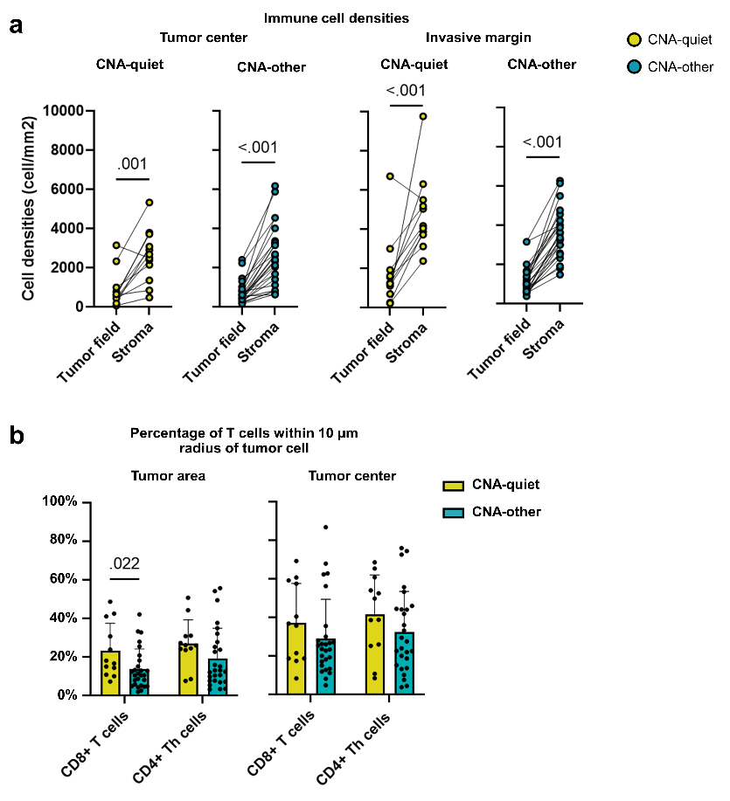
Extended Data Fig. 9 | Multiplex immunohistochemistry to characterize the tumor immune microenvironment of copy number alteration (CNA)-quiet (n=12) and -other (n=27) oral cavity squamous cell carcinomas. a, Total immune cell (T cells, B cells and M2-like macrophages together) densities (in cells/mm2) in tumor field and stromal compartments within tumor center and invasive margin of CNA-quiet (yellow) and -other (blue) OCSCC. p-values were obtained by a two-tailed paired nonparametric Wilcoxon rank-sum test. b, Percentage of CD8+ T cells and CD4+ Th cells within 10 µm radius of a tumor cell in the tumor area (left) and tumor center (right) of CNA-quiet and –other OCSCC. p-values were obtained by multiple unpaired non-parametric Mann-Whitney tests.

References
1. Nulton TJ, Olex AL, Dozmorov M, Morgan IM, Windle B. Analysis of The Cancer Genome Atlas sequencing data reveals novel properties of the human papillomavirus 16 genome in head and neck squamous cell carcinoma. Oncotarget. 2017;8(11):17684-99.
2. Poell JB, Mendeville M, Sie D, Brink A, Brakenhoff RH, Ylstra B. ACE: absolute copy number estimation from low-coverage whole-genome sequencing data. Bioinformatics. 2019;35(16):2847-9.
3. Carter SL, Cibulskis K, Helman E, McKenna A, Shen H, Zack T, et al. Absolute quantification of somatic DNA alterations in human cancer. Nat Biotechnol. 2012;30(5):413-21.

