Supplementary Material 2

Identification of Diagnostic Biomarkers for Diabetes Nephropathy by Multi-Chip Integrated Bioinformatics combining Machine-Learning Strategies and Mendelian Randomization
Jiaming Su, Yan Guo, Jiyuan Hu
* Correspondence: Hongfang Liu, E-mail: a2954@bucm.edu.cn.

Supplementary Figure
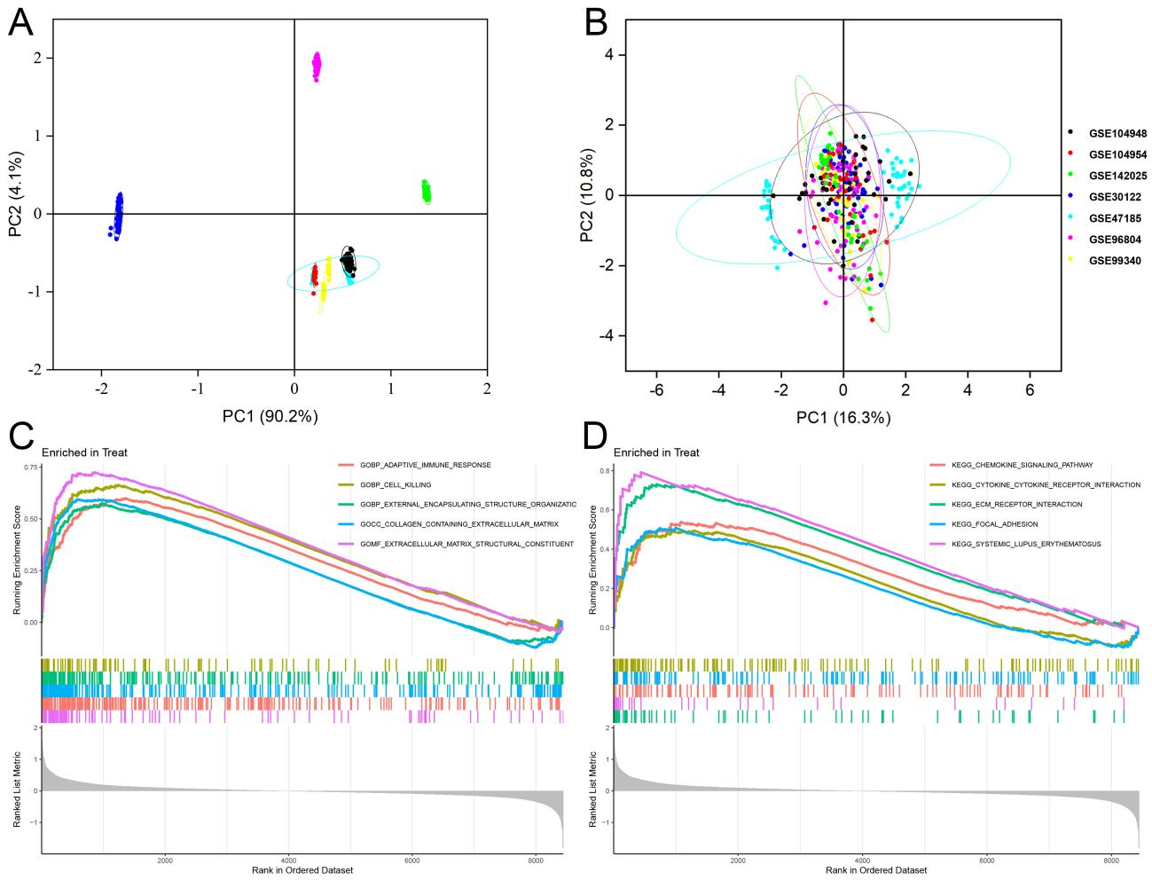
Fig. S1 Identification and functional enrichment analysis of DEGs in DN patients. A Gene expression profiles without the removal of the batch effect. B Gene expression profiles with removal of batch effect. C Active GO functional enrichment of gene expression matrix in DN. D Active KEGG pathway of gene expression matrix in DN.

