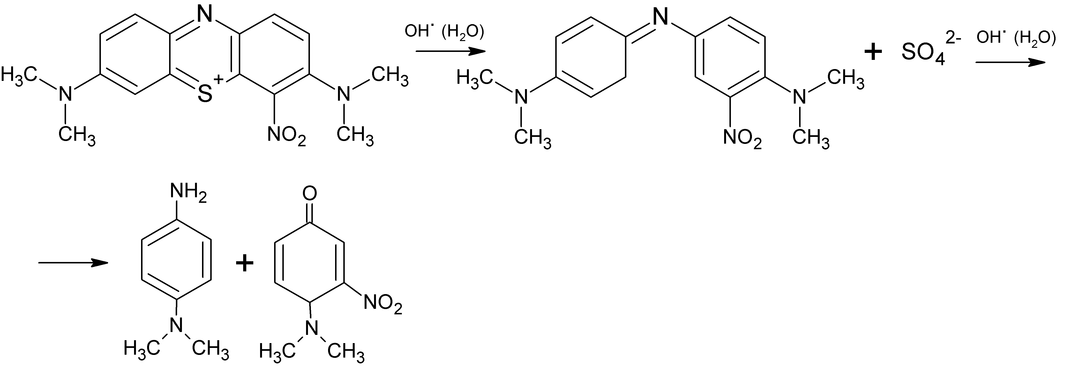
Scheme 1 The pathway of methylene green destruction by plasma action

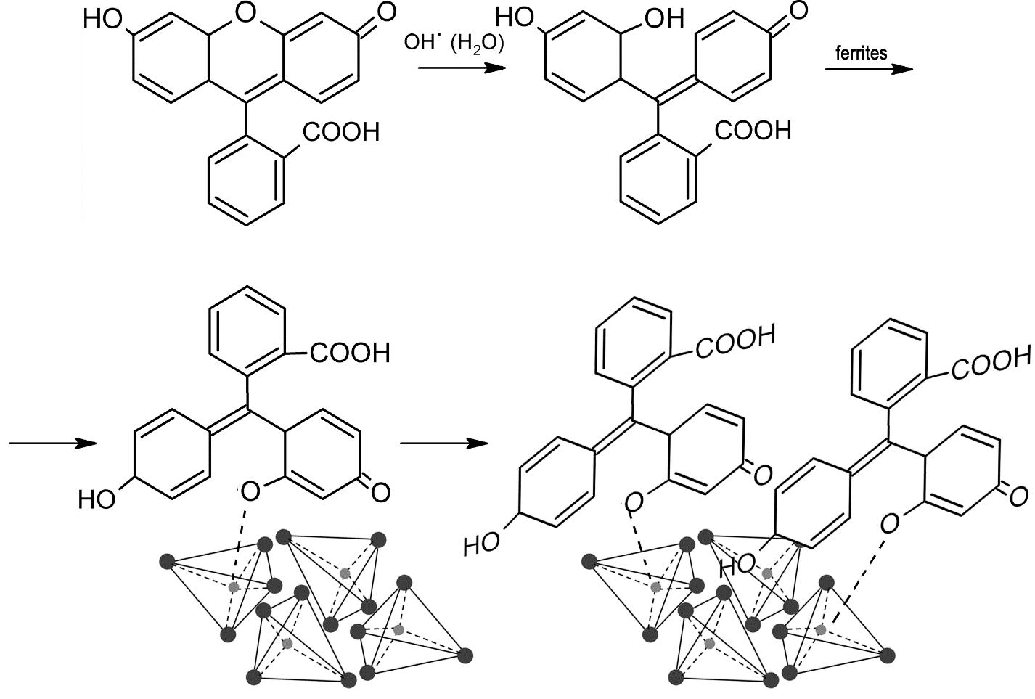
Scheme 2 Possible transformations of the fluorescein dye under the joint action of plasma and synthesized structures

