Supplementary Material of
Forecasting strong subsequent events in the Italian territory: a National and Regional application for NESTOREv1.0
P. Brondi^{a*}, S. Gentili^{b} and R. Di Giovambattista^{c}
^{a*} National Institute of Oceanography and Applied Geophysics - OGS, Via Treviso 55, 33100, Cussignacco, Udine, Italy, corresponding author, pbrondi@ogs.it
^{b} National Institute of Oceanography and Applied Geophysics - OGS, Udine, Italy,
^{c} Istituto Nazionale di Geofisica e Vulcanologia, Rome, Italy

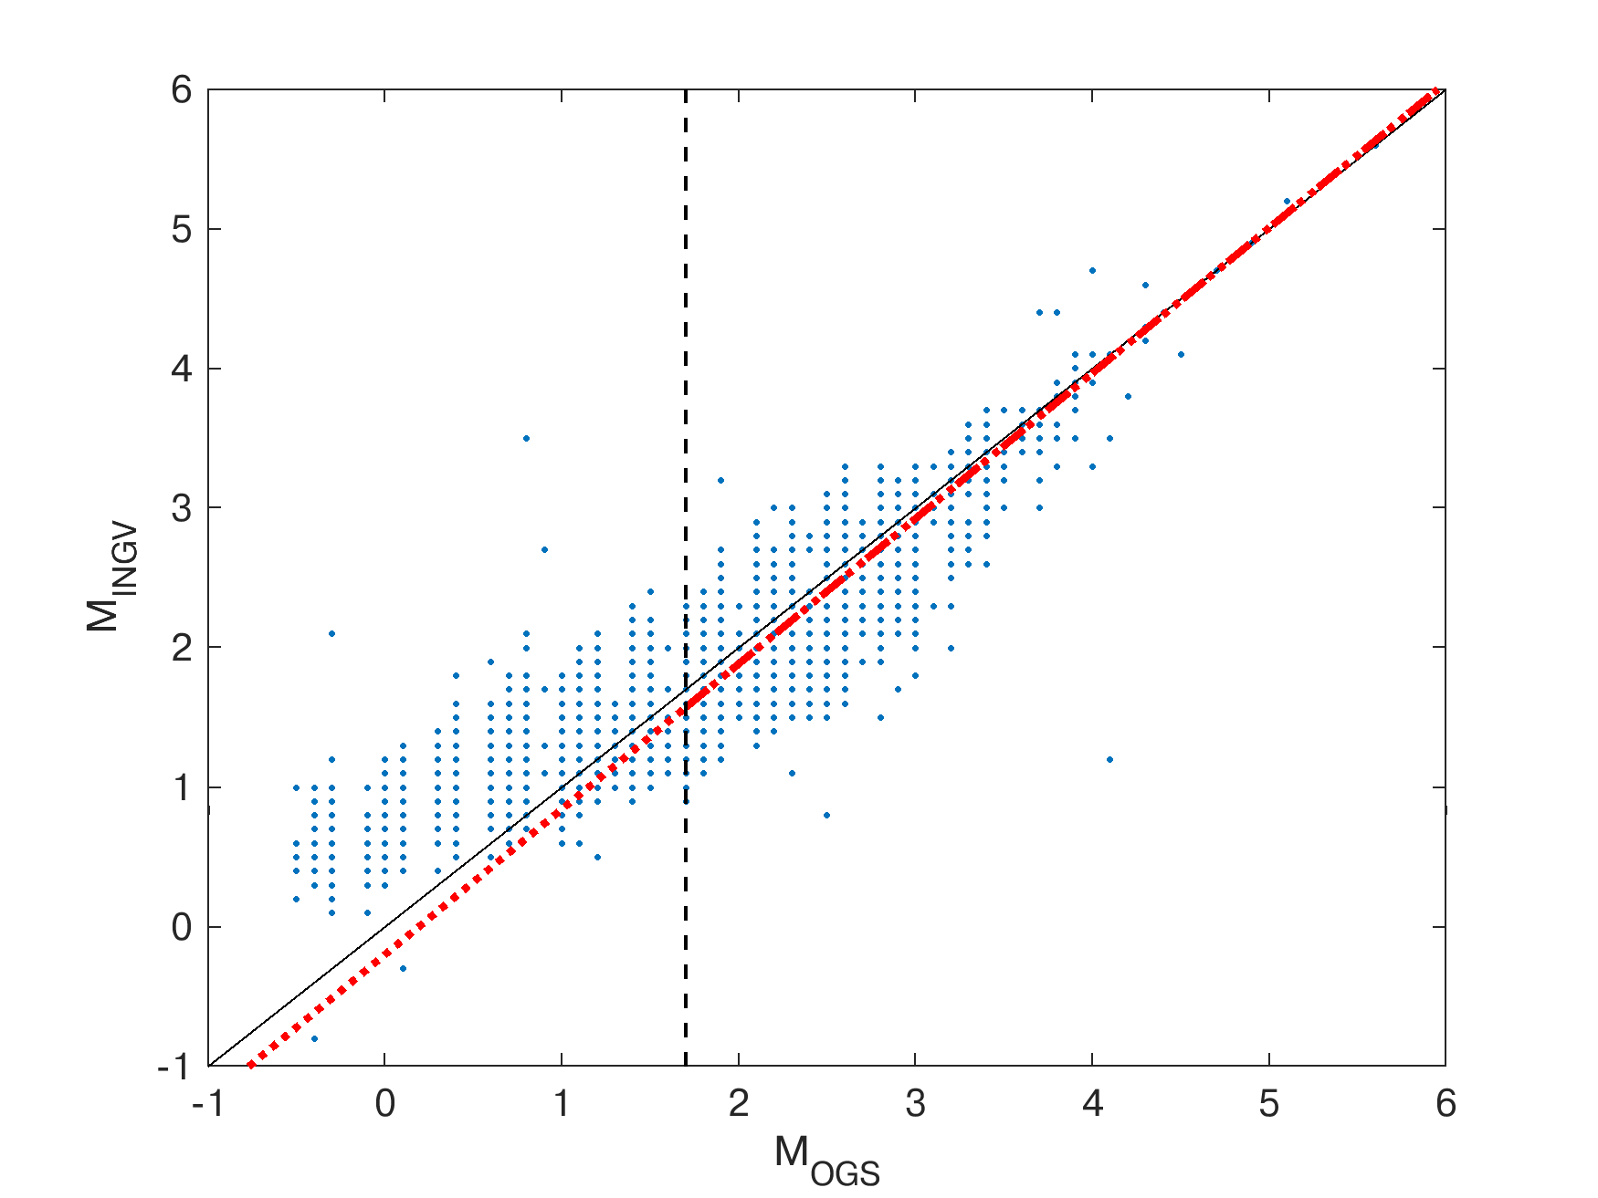
Fig. S1 Comparison of OGS converted local magnitude and INGV local magnitude for the common events in the 1980-2020 period in the NEI region and orthogonal fit of the data. Black continuous line is 1:1 line; red dot-dashed line represents orthogonal fit for M_{OGS} and M_{INGV} ≥ 1.7; vertical dashed line: M_{OGS}=1.7

S1. Modules of NESTOREv1.0
The NESTOREv1.0 machine learning algorithm is freely available on GitHub (https://github.com/
StefaniaGentili/NESTORE) and consists of four modules: cluster identification, training, testing and near-real-time classification (Gentili et al. 2023).

S1.1 Cluster Identification Module
Given a seismic catalogue for a given area, the first module detects clusters using a user-selected window-based method. After setting a minimum threshold M_{th} for the magnitude of the first strong event M_{FSE}, all events with M_{FSE}≥M_{th} are considered as main operational earthquakes. We refer to these events as First Strong Events (FSEs). Then, for each FSE, all events located at a distance R from its epicentre and occurring in a time window ΔT after its origin time are collected in the corresponding cluster. R and ΔT are estimated as function of M_{FSE} by using a region-specific equations. Several equations have been proposed for different regions in the last 40 years (Gardner and Knopoff 1974; Uhrhammer 1986; Kagan 2002; Lolli and Gasperini 2003; Gentili and Bressan 2008; Gentili and Di Giovambattista 2020), and those used in this work are described in the following Section 2. After the clustering procedure, the module labels the resulting clusters as type A if the magnitude difference between the strongest aftershock and the FSE (DM) is less than or equal to one, and as type B otherwise. Information about the M_{c} of the cluster, its aftershocks and foreshocks is also provided by NESTOREv1.0.

S1.2 Training Module
The training module of NESTOREv1.0 calculates nine seismicity features using aftershocks whose minimum magnitude is equal to M_{FSE}-2 and that occur at least one minute after the FSE (Table 1); this delay was added to ensure that the increase in completeness magnitude due to waveform superposition after the FSE does not affect the results. To be considered for analysis, a cluster must have a M_{c}≤M_{FSE}-2. For more details, see Gentili and Di Giovambattista (2022). The features refer to the number of events, their spatial distribution, the fault area, the magnitude and the energy trend over time (Table S1) and are calculated with increasing time interval T_{i} after the occurrence of the FSE.

# | Feature Name | Definition | Type
1 | Number of Events  (N₂) | $$N_{2}\left(i\right)=\sum_{i}{n_{i}} if m_{i}≥M_{FSE}-2$$  where m_{i} = magnitude of the i^{th} event,  M_{FSE} = magnitude of the First Strong Event | Space-Time distribution of events
2 | Linear Concentration of Events  (Z) | $$Z\left(i\right)=\frac{mean({10}^{0.69m_{i}-3.22})}{mean(r_{ij})}$$  where r_{ij} = distance between the generic i^{th} and j^{th} event | Space-Time distribution of events
3 | Normalized event Source area  (S) | $$S\left(i\right)=\sum_{i}{{10}^{(m_{i}-M_{FSE})}}$$  where m_{i} = magnitude of the i^{th} event,  M_{FSE} = magnitude of the First Strong Event | Source area and Magnitude trend along time
4 | Cumulative deviation of S from the long-term trend on increasing length windows  (SLCum) | $$SLCum\left(i\right)=\sum_{i}{abs[S\left(t_{i}\right)-S(t_{i-1})\frac{i∙dt}{(i-1)∙dt}}$$  Where S is calculated on [s₁, t_{i}], ${ t}_{i}=s_{1}+i∙dt$, dt = 6 hours | Source area and Magnitude trend along time
5 | Cumulative deviation of S from the long-term trend on sliding windows  (SLCum2) | $SLCum2\left(i\right)=\sum_{i}{abs[S(\left[s_{1}+\left(i-1\right)∙dt, s_{1}+i∙dt\right])-S(\left[s_{1}+\left(i-1\right)∙dt,s_{1}+\left(i-1\right)∙dt+dτ\right])\frac{dt}{dτ}}$]  Where S is calculated over the generic time interval [a, b] | Source area and Magnitude trend along time
6 | Cumulative variation of magnitude from event to event  (V_{m}) | $$V_{m}\left(i\right)=\sum_{i}{|m_{i}-m_{i-1}|}$$  where m_{i} = magnitude of the i^{th} event,  m_{i-1} = magnitude of previous one | Source area and Magnitude trend along time
7 | Normalized radiated Energy  (Q) | $$Q\left(i\right)=\frac{\sum_{i}{E_{i}}}{E_{m}}$$  where E_{m} = energy of the First Strong Event,  E_{i} = energy of the i^{th} event | Energy trend along time
8 | Cumulative deviation of Q from the long-term trend on increasing length windows  (QLcum) | $$QLCum\left(i\right)=\sum_{i}{abs[Q\left(t_{i}\right)-Q(t_{i-1})\frac{i∙dt}{(i-1)∙dt}}$$  Where Q calculated on [s₁, t_{i}], ${ t}_{i}=s_{1}+i∙dt$, dt = 6 hours | Energy trend along time
9 | Cumulative deviation of Q from the long-term trend on sliding windows  (QLCum2) | $QLCum2\left(i\right)=\sum_{i}{abs[Q(\left[s_{1}+\left(i-1\right)∙dt, s_{1}+i∙dt\right])-Q(\left[s_{1}+\left(i-1\right)∙dt,s_{1}+\left(i-1\right)∙dt+dτ\right])\frac{dt}{dτ}}$]  Where Q calculated over the generic time interval [a, b] | Energy trend along time

Table S1 features used by NESTOREv1.0 in this work
Specifically, the training module of NESTOREv1.0 finds suitable threshold values for the features in order to separate clusters of type A and B. For each feature and each time interval T_{i}, an independent one-node decision tree is used to define a threshold such that most type A clusters are above this threshold, while most type B clusters are beyond it. This approach assumes that type A clusters have a higher feature value than B type clusters. The time intervals T_{i} range from 6 hours to 7 days after the occurrence of FSE, with a time step of 6 hours on the first day and 24 hours on the following days. Note that the number of analyzed clusters change depending on the time interval, because as soon as an aftershock of magnitude ≥M_{FSE}-1 occurs in a cluster of type A, the cluster typology is already defined and the cluster is not analyzed any more. The algorithm ensures good reliability of the thresholds by applying the Leave One Out (LOO) method, which determines a feature-dependent interval range (hereafter "good interval range ΔT_{G}") in which the thresholds are stable and have the best performance in discriminating the cluster typology (Gentili and Di Giovambattista 2020, 2022; Gentili et al. 2023). This performance is estimated using four evaluators: Accuracy, Informedness, Precision and Recall (Powers 2011; Gentili and Di Giovambattista 2017; Gentili et al. 2023).
​Accuracy is defined as the ratio between the number of correctly classified clusters and the number of clusters.
Informedness is the difference between the True Positive Rate (TPR) and the False Positive Rate (FPR), defined as:

$$TPR= \frac{number of type A clusters correctly classified}{Number of type A clusters}$$
$$FPR= \frac{number of type B clusters uncorrectly classified}{Number of type B clusters}$$

Precision is the ratio between the number of correctly classified A-type clusters and the number of clusters classified as A-type. Recall has the same definition as TPR.
ΔT_{G} is defined as the set of intervals T_{i} in which:
- Accuracy, Precision, and Recall are > 0.5.
- Accuracy of the feature ≥ Accuracy of a tree classifying every cluster as B-type.
- Informedness > 0.
- T_{i} is smaller or coinciding to the time in which Informedness is maximum (s₂).
For T_{i} larger than the final time of ΔT_{G} (s₂), both the features and the thresholds are inherited from the last shorter period and their performance is checked again with a second application of the LOO method to avoid poor classifications due to selection effects on A-type clusters (for more details see Gentili and Di Giovambattista 2022). Due to the lower percentage of A-type cases compared to B-type cases, which decreases with increasing time interval T_{i}, NESTOREv1.0 estimates the thresholds only in the periods where there are at least two A-type clusters. To avoid possible errors in classification due to the magnitude uncertainty, NESTOREv1.0, like Gentili and Di Giovambattista (2022), excludes clusters with a DM between 0.8 and 1.2 from the analysis by default in both the training and testing procedures. The output of the training module is for each feature, ΔT_{G}, the values of the thresholds for the time interval within ΔT_{G}, the probability of being a cluster of type A if the feature is above or below the threshold (estimated on the training set after the choice of thresholds). In addition, the training module provides the number of A-type and B-type clusters for each time interval to be used during the testing procedure.

S1.3 Testing Module
We applied the test module to the second part of the cluster catalogue to retrospectively test the ability to forecast type A clusters. NESTOREv1.0 estimates the same set of features for each cluster of the test database for the intervals T_{i} used for the training module and, using the probability of being an A-type provided by each classifier, applies a Bayes theorem-based approach to estimate the final probability of being an A-type:

$$P_{i}\left({A | F}_{1}…F_{N}\right)=\frac{{\left[{N\left(B\right)}_{i}\right]}^{N-1}\prod_{n=1}^{N}{p_{n,i}}}{{\left[{N\left(B\right)}_{i}\right]}^{N-1}\prod_{n=1}^{N}{p_{n,i}}{+\left[{N\left(A\right)}_{i}\right]}^{N-1}\prod_{n=1}^{N}{(1-p_{n,i})}} (1)$$

Where N is the number of features, N(A)_{i} and N(B)_{i} is the number of A-type and B-type clusters in the training database for the ith time interval, p_{n,i} is the probability that it is an A-type cluster if the nth feature estimated for the cluster is above or below the corresponding threshold for the ith time interval (Gentili et al. 2023). NESTOREv1.0 provides this Bayesian probability along with a probability obtained simply by the sum of the binary voting of the feature classifiers (Gentili et al., 2023).
S1.4 Near real-time classification module
Finally, we used the near-real-time classification module of NESTOREv1.0 to estimate the cluster type in near-real-time mode by using a catalog independent of the training and testing module. This module identifies the cluster from the catalog of an occurring sequence and determines the Bayesian probability that it is type A using the thresholds and probabilities previously derived by the training module (Equation 1, Figure 3). In addition, depending on the current probability of being type A for the cluster at the last T_{i}, an Aftershock-based Traffic Light System (ATLS) is displayed (Figure 14). In particular, it is red if an SSE event is expected, green if an SSE event is not expected and the forecasting of the SSE event is uncertain (Gentili et al. 2023).

S2. Cluster Identification Laws
In both the national and regional approaches, we identified clusters using a window-based approach. In the case of the national study, we used Uhrhammer (1986) and Lolli and Gasperini (2003) laws for the spatial and temporal selection of aftershocks, respectively:

$$R=e^{-1.024+0.804M_{FSE} } (2)$$

$$∆T=60+60 ∙\left(M_{FSE}-4\right) (3)$$

where M_{FSE} is the magnitude of the FSE, R is the radius of the circular area in km around the epicenter and ΔT is the time window in days starting from the FSE origin time.
In the case of the regional study, we applied the same method and used the following relationships from Gentili and Di Giovambattista (2020) for spatial and temporal clustering:

$$R={10}^{0.41M_{FSE}-1 }+2 (4)$$

$$∆T={10}^{0.33M_{FSE}+0.42 } (5)$$

The equations are derived by the ones of Gentili and Bressan (2008) with the addition 2 km in space in order to take into account the inaccuracies in localization in the first years of the catalogue. Similar to equations 2 and 3, R is the radius value in km and ΔT is the time window in days.

S3. Training Thresholds
ΔT (day) | 0.25 | 0.50 | 0.75 | 1
S | 0.034 | 0.034 | 0.034 | 0.034
Z | 0.003 | 0.003 | 0.003 | 0.003
SLCum | - | 0.034 | 0.034 | 0.050
QLCum | - | 1.028 | 1.028 | 1.028
SLCum2 | - | - | 0.034 | 0.034
QLCum2 | - | - | 0.352 | 0.352
Q | 0.007 | 0.007 | 0.007 | 0.007
V_{m} | 0.050 | 0.050 | 0.050 | 0.050
N₂ | 1.50 | 1.50 | 1.50 | 1.50

Table S2 Values of features’ thresholds found for ITA using C_ITA_{train}. Boldface numbers correspond to the periods characterized by the maximum Informedness after which the thresholds are inherited.

ΔT (day) | 0.25 | 0.50 | 0.75
S | 0.014 | 0.061 | 0.061
Z | 0.009 | 0.009 | 0.009
SLCum | - | 0.061 | 0.061
QLCum | - | 0.910 | 0.910
SLCum2 | - | - | 0.060
QLCum2 | - | - | 0.905
Q | 0.002 | 0.013 | 0.013
V_{m} | 0.65 | 0.65 | 0.65
N₂ | 0.50 | 2.00 | 2.00

Table S3 Values of features’ thresholds found for NEI using C_NEI_{train} catalog. Boldface numbers correspond to the period characterized by the maximum Informedness after which the thresholds are inherited.

S4. Testing Performances

a)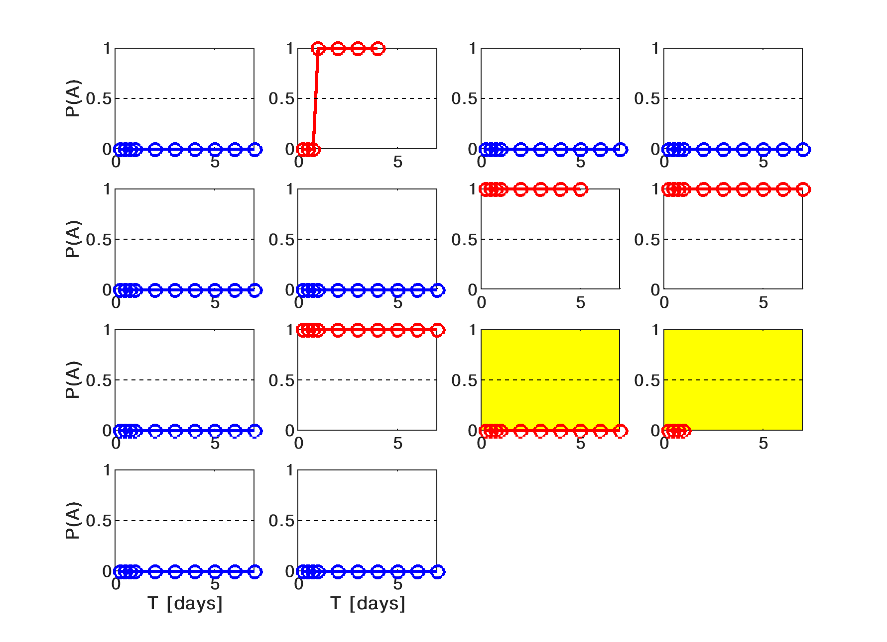
b)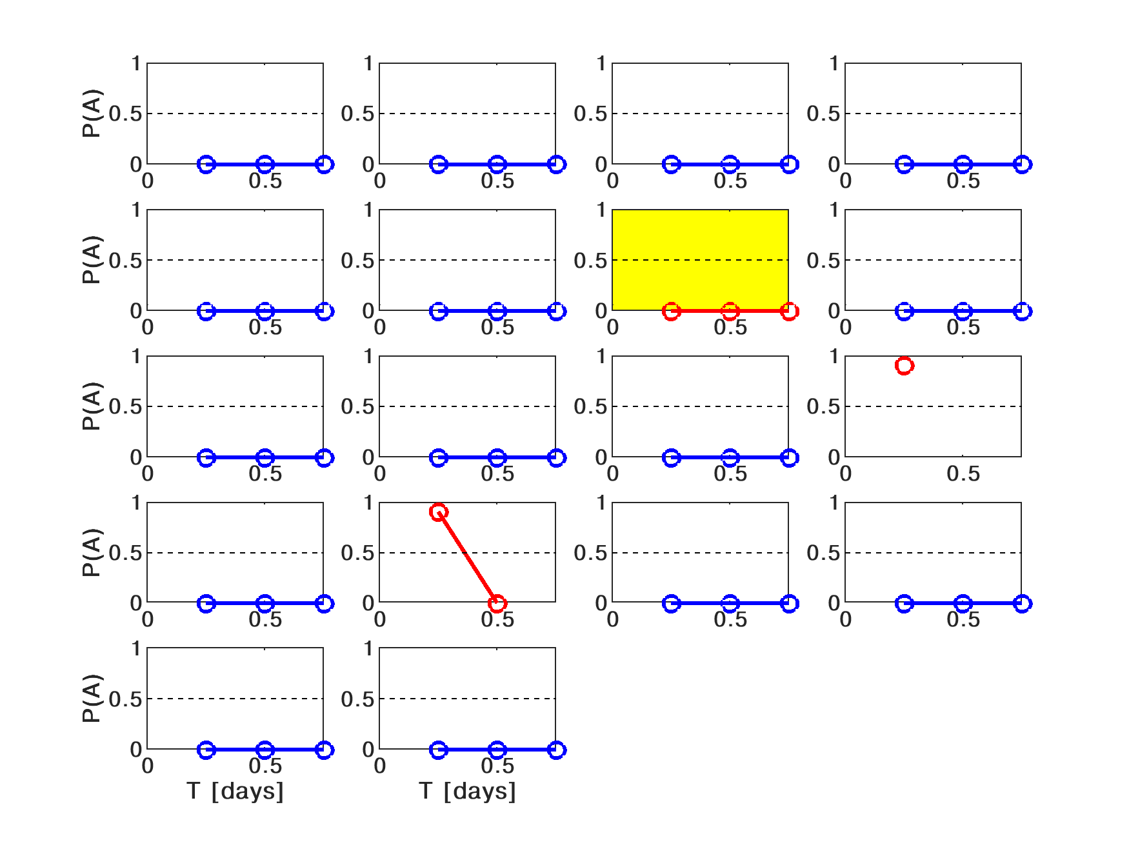
Fig. S2 a) Probability of being an A-type cluster for C_ITA_{test} and b) C_NEI_{test} for increasing time intervals from the FSE. The yellow boxes indicate misclassifications of clusters found for the entire range of periods

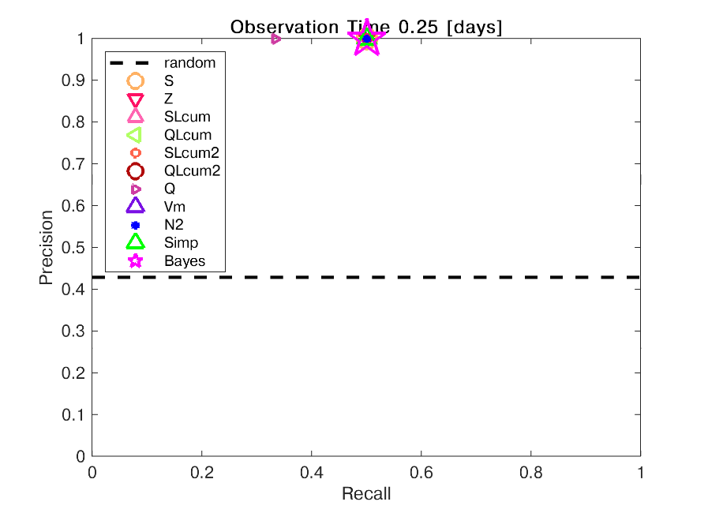
Fig. S3 Performance of C_ITA_{train} thresholds on the C_ITA_{test} at 6 hours after the FSE in terms of Precision-Recall

S5. Thresholds Characterization for Italian Territory
S5.1 Thresholds variability along time
It is well known that the density of the national accelerometer network in Italy has increased in the last 40 years, with advantages in the location of seismic events, the calculation of the magnitude and the value of the completeness magnitude. In the period 1981-1984 there was a first significant development phase of the network, with both the transition to data acquisition in digital format (Boschi et al. 1990; Barba et al. 1995; Marchetti et al. 2004) and a significant increase in the number of seismic stations in the national area (Barba et al. 1995; Marchetti et al. 2004). Assuming that in the period 1980-1984 the still suboptimal situation of the network could have influenced the definition of the clusters and their seismicity, we analyzed the weight of the data from this period on the NESTOREv1.0 feature thresholds of the C_ITA catalog. In particular, starting from the C_ITA catalog covering the period 1980-2020, we compared the thresholds obtained 6 hours after the FSE from the training with those from the 1984-2020 and 1990-2020 training periods. Figures S4a and S4b show the values of features S and Z obtained at 6 hours as a function of the three training databases, while Figures S5a and S5b show the normalized values of these features for the clusters together with the thresholds of the three different trainings. The analysis is performed for a time period of 6 hours because for longer time most of the features’ thresholds are inherited. In particular, it can be seen that the threshold value for S with respect to the period 1980-2020, remains the same in the period 1984-2020, while it decreases by 30% in the period 1990-2020. For Z, the value increases almost threefold in the period 1984-2020 compared to the period 1980-2020 and is in line with the value for the period 1990-2020. Figure S4a shows that in the period 1980-1984, the two clusters (1 A and 1 B) are found to be well separated by the threshold, so that their elimination has no effect on the threshold for S. In contrast, in the period 1984-1990, there is a cluster B (July 23, 1986) that has the highest value for S compared to all other B type clusters. Then the exclusion of this cluster in the 1990-2020 training explains the observed decrease in the threshold. On the other hand, the increase in threshold for Z in the 1984-2020 training is related to the presence of the February 28, 1980 cluster A, whose Z value is slightly higher than the threshold in the 1980-2020 training (Figure S5b). We hypothesize that this value, which is among the lowest compared to the average of the other A-type clusters, may have to do with the overestimation of the distances between aftershocks caused by the low station density in the national network in 1980. The exclusion of this cluster in the 1984-2020 training results in NESTOREv1.0 setting the Z threshold to the highest observed value.
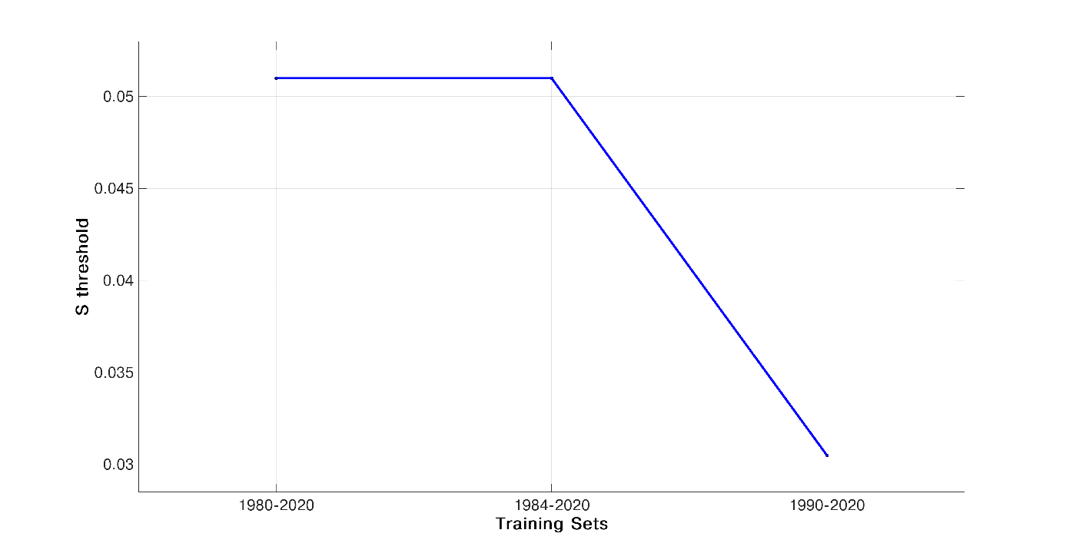
a)
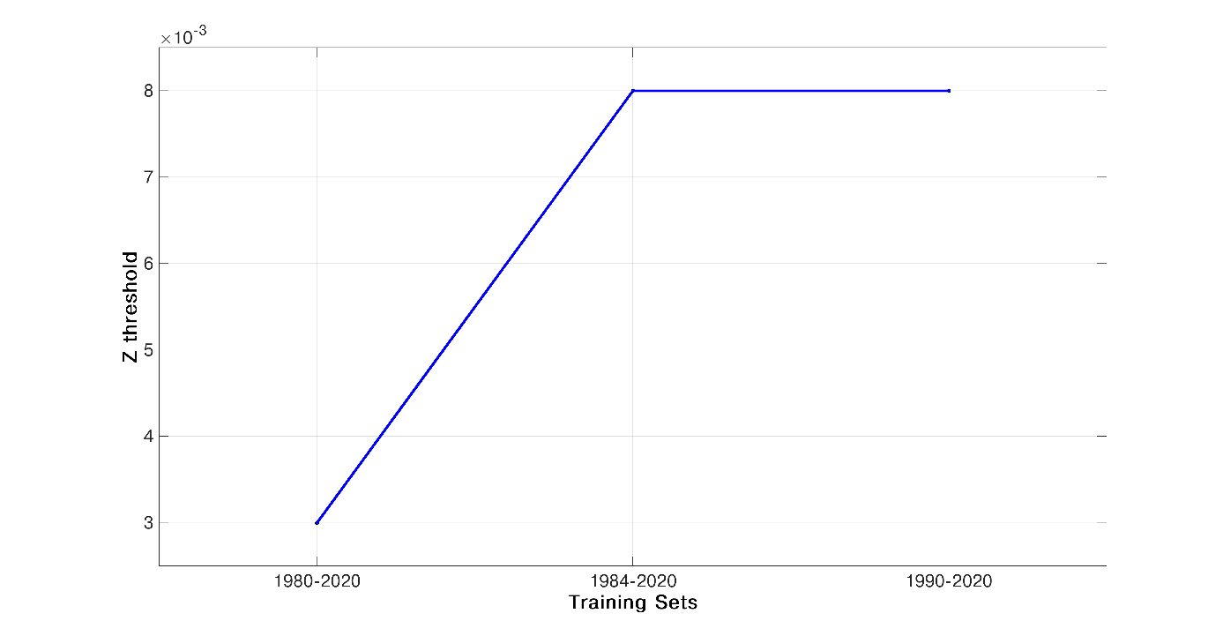
b)
Fig. S4 a) S and b) Z threshold values found for ITA in correspondence of the training periods 1980-2020, 1984-2020 and 1990-2020
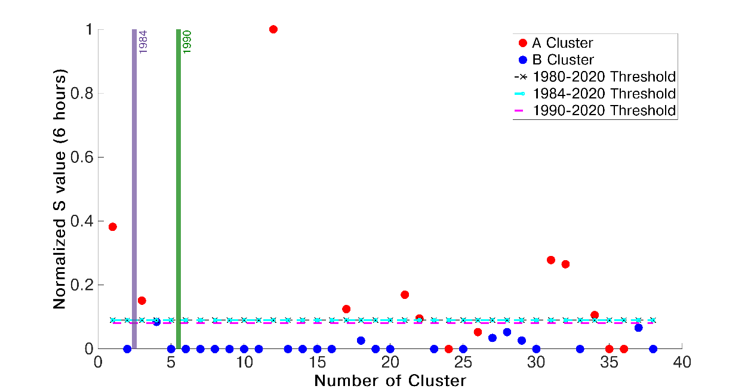
a)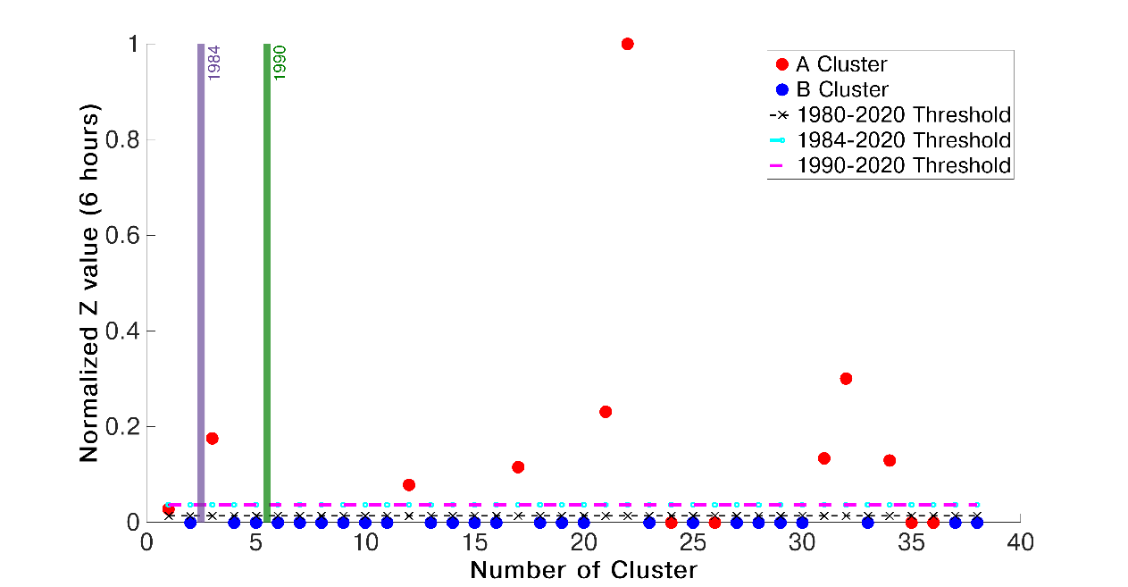
b)
Fig. S5 a) S and b) Z values obtained at 6 hours from the FSE for C_ITA. Red and blue points represent A and B-type clusters, while black, cyan and magenta vertical lines indicate the threshold values found by NESTOREv1.0 in correspondence of the training periods 1980-2020, 1984-2020 and 1990-2020, respectively

For V_{m} and N₂, on the other hand, the same threshold values are observed for all three training databases considered. With the exception of 4 outliers of type A, which have almost zero values, the two cluster populations A and B in the three databases are well separated from each other by the same threshold value. A similar behavior is seen for Q, although the threshold is not available for the period 1984-2020. In this case, the already mentioned cluster B from July 23, 1986 has an important influence on the non-convergence of the training for this period. However, the threshold found in the 1980-2020 period turns out to be the same one that can well distinguish most A's from B's in the 1984-2020 period. This analysis not only shows the stability of the 6-hour thresholds for the N₂, V_{m} and Q features over time, but also allows us to conclude that the clusters that occurred in the period characterized by a worse performance of the Italian national network do not have a significant impact on the thresholds of the NESTOREv1.0 features. Therefore, we considered it reasonable not to exclude clusters from the 1980s period from the C_ITA catalog.

S5.2 Thresholds Refinement for National and Regional approaches and their comparison

Sections 5 and 6 of the paper examined the retrospective ability of NESTOREv1.0 to forecast type A clusters on a test database, using both a national and regional approach. This analysis was performed by splitting the C_ITA and C_NEI cluster catalogues into two parts, each of which was used to train the algorithm and evaluate its forecasting performance. In this section, we describe the calculation of feature thresholds for ITA and NEI areas performed by the NESTOREv1.0 training procedure for the entire duration of the C_ITA and C_NEI catalogues (1980-2020), with the aim of characterising the two classes and enabling near-real-time applications (Gentili et al. 2023) for clusters after 2020. First, we performed the training in the period 1980-2020 and we decided to delete from the C_ITA and C_NEI catalogues the clusters that were not correctly classified by the NESTOREv1.0 testing module in at least one period T_{i} . This allowed us to consider a training database that was cleaned of all outliers corresponding to the NESTOREv1.0 model. Therefore, four clusters (all of type A) and two clusters (one of type A and one of type B) were excluded by C_ITA and C_NEI, respectively. We refer to the resulting refined catalogues as C_ITA_{R} and C_NEI_{R}. Tables S4 and S5 show the thresholds values of the features found for C_ITA_{R} and C_NEI_{R}. The numbers in bold correspond to the T_{i} associated with the maximum value of Informedness. For longer periods T_{i}, the threshold is inherited from the interval s₂. Even if the larger training set allowed to increase ΔT_{G} for two features (up to 5 days for ITA in the case of feature S and up to 1 day for feature N₂), we decided to show the thresholds for the time intervals of sections 5 and 6 to ensure more stable results supported by an independent testing. Interestingly, in the case of the ITA area, the thresholds for Z, Q, V_{m} and N₂ obtained at 6 hours are valid for each subsequent time period. A comparison of the two tables shows that in the first 12 hours after the FSE, the NEI thresholds for almost all features are 2 or 3 times smaller than the ITA thresholds. After 18 hours, the NEI values increase and become 4 or 5 times larger for S, SLCum, QLCum, Q and N₂. From this period onwards, the NEI values exceed the ITA values, with the difference being even more pronounced for N₂, V_{m} and Z. This observation underlines the different cluster characteristics between NEI and ITA areas. The seismic activity in the NEI areas seems to be characterized by a lower seismic productivity in the first hours after the FSE than the seismicity at the national level, which behaves differently in the following periods. Examining the number of aftershocks between M_{FSE} and M_{FSE}-2 (N₂) for the A-type clusters of the two areas, we found that the average after 6 hours is 4 for ITA and 2 for NEI. In the correspondence of 1 day after the FSE, for 44% of the ITA A-type clusters, mainly located in the Umbria region, N₂ increases by 50%, while in the remaining cases, the increase is below 20%. In the same period, for the 50% of NEI A-type clusters characterized by low productivity, the SSE has already occurred. In the remaining 50% of the NEI A-type clusters, the increase in seismicity is on average the same or slightly higher than in the Umbria region. It is worth to point out that a comparison of ITA and NEI thresholds is significant only 6 hours after FSE, as the performance of C_NEI_{train} thresholds in C_NEI_{test} proves to be poor after this period.
We also found that the thresholds found for the ITA area are not adequate to distinguish the cluster typology in the NEI region. Thus, we found that using the ITA thresholds found for S, Q and N₂ 6 hours after the FSE would mean that 33%, 100% and 50% of NEI clusters of type A would be misclassified, respectively. Similarly, the national thresholds obtained for SLCum and S at 12 hours would lead to misclassification of 33% and 30% of A-type cases in NEI, respectively. As expected, these results confirm that the use of a regional approach for NESTOREv1.0 is more suitable for the forecasting of strong aftershocks on a regional scale than the nationwide application. Comparing the thresholds obtained for C_ITA_{train} (Table S2) with those of C_ITA_{R} (Table S4), we find that they are unchanged over time for most of the features of ITA. In contrast, comparing Table S3 and Table S5 the thresholds for NEI for time intervals longer than 0.25 days (6 hours) are more unstable over time. This is probably due to the lower number of A clusters in the training set and thus the lower coverage of the feature space. A planned continuous monitoring of the cluster in the area in the following years will make it possible to estimate the thresholds in a larger data set and to check their stability.

ΔT [day] | 0.25 | 0.50 | 0.75 | 1
S | 0.034 | 0.034 | 0.034 | 0.034
Z | 0.003 | 0.003 | 0.003 | 0.003
SLCum | - | 0.034 | 0.034 | 0.034
QLCum | - | 1.028 | 1.028 | 1.028
SLCum2 | - | - | 0.034 | 0.034
QLCum2 | - | - | 0.940 | 1.217
Q | 0.005 | 0.005 | 0.005 | 0.005
V_{m} | 0.050 | 0.050 | 0.050 | 0.050
N₂ | 1.50 | 1.50 | 1.50 | 1.50

Table S4 Values of features’ thresholds found for ITA using C_ITA_{R}. Boldface numbers correspond to the periods characterized by the maximum Informedness after which the thresholds are inherited.

ΔT [day] | 0.25 | 0.50 | 0.75
S | 0.015 | 0.015 | 0.065
Z | - | 0.009 | 0.010
SLCum | - | 0.015 | 0.051
QLCum | - | 0.150 | 0.732
SLCum2 | - | - | 0.051
QLCum2 | - | - | 0.732
Q | 0.002 | 0.002 | 0.012
V_{m} | - | 0.65 | 0.70
N₂ | 0.50 | 0.50 | 3.00

Table S5 Values of features’ thresholds found for NEI using C_NEI_{R}. Boldface numbers correspond to the periods characterized by the maximum Informedness after which the thresholds are inherited.

S6. Detailed results for Near-Real-Time analysis
Figures S6 and S7 show a detail on the near-real-time analysis of the 2023 Gambettola and Montagano sequences.

a)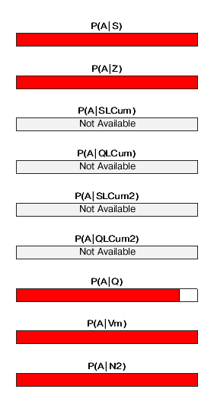b)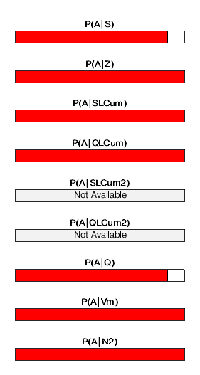 c)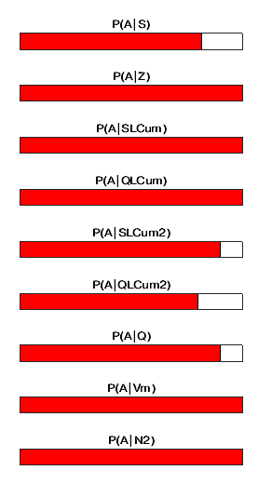 d)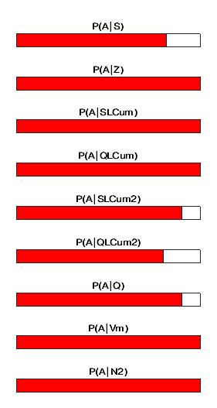

Fig. S6 Near-real-time probability to be an A-type given by each feature for 2023 Gambettola A-type cluster at a) 6 hours, b) 12 hours, c) 18 hours, d) 1 day after the FSE. Red bar indicates a P(A) > 0.5, blue bars indicates 0.5≤P(A)≤ 0.1 is equal or smaller than 0.5, white bars indicates P(A)=0, gray bars indicates that, according to the 1980-2020 used training, the feature voting is not available

a)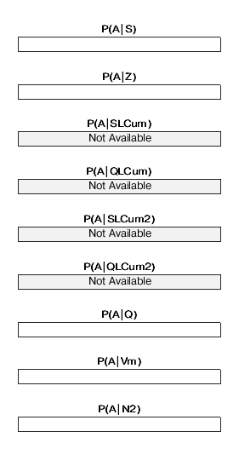 b)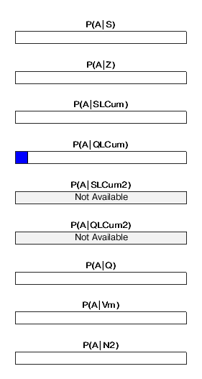c)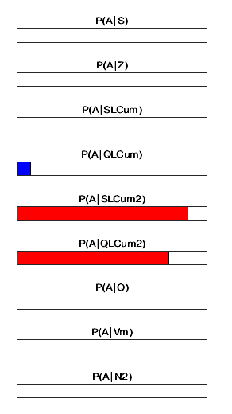d)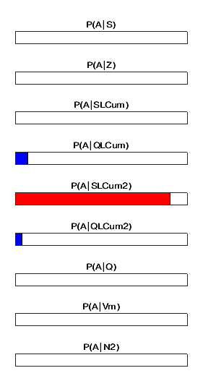
Fig. S7 Near-real-time probability to be an A-type given by each feature for 2023 Montagano B-type cluster at a) 6 hours, b) 12 hours, c) 18 hours, d) 1 day after the FSE. Red bar indicates a P(A) > 0.5, blue bars indicates 0.5≤P(A)≤ 0.1 is equal or smaller than 0.5, white bars indicates P(A)=0, gray bars indicates that, according to the 1980-2020 used training, the feature voting is not available

References
Barba S, Di Giovambattista R, Smiriglio G (1995). Italian seismic databank allows on line access, Eos, 76 (1995), p. 89
Boschi E, Pantosti D, Valensise G (1990). Paradoxes of Italian seismicity EOS Transactions A.G.U., 1990 Fall Meeting, 71, 1787-1788.
Gardner JK, Knopoff L (1974). Is the sequence of earthquakes in Southern California, with aftershocks removed, Possionian? Bull. Seismol. Soc. Am. 64 (5), 1363–1367.
Gentili S, Bressan G (2008). The partitioning of radiated energy and the largest aftershock of seismic sequences occurred in the northeastern Italy and western Slovenia. J. Seismol. 12, 343–354.
Gentili,S, Di Giovambattista R (2017). Pattern recognition approach to the subsequent event of damaging earthquakes in Italy. Phys. Earth Planet. Inter., 266, pp. 1-17
Gentili S, Di Giovambattista R, Peresan A (2017). Seismic quiescence preceding the 2016 central Italy earthquakes. Phys. Earth Planet. Inter. 272, 27–33.
Gentili S, Di Giovambattista R (2020). Forecasting strong aftershocks in earthquake clusters from northeastern Italy and western Slovenia. Phys. Earth Planet. Inter. 303, 106483. https://doi.org/10.1016/j.pepi.2020.106483
Gentili S, Di Giovambattista R (2022) Forecasting strong subsequent earthquakes in California clusters by machine learning. Phys. Earth Planet. Inter. 327, 106879. https://doi.org/10.1016/j.pepi.2022.106879
Gentili S, Brondi P, Di Giovambattista R (2023). NESTOREv1.0: A MATLAB Package for Strong Forthcoming Earthquake Forecasting. Seismol. Res. Lett. And https://doi.org/10.1785/0220220327 .
Lolli B, Gasperini P (2003). Aftershocks hazard in Italy Part I: estimation of time magnitude distribution model parameters and computation of probabilities of occurrence. J. Seismol. 7, 235–257.
Marchetti A, Barba S, Cucci L, Pirro M (2004). Performances of the Italian seismic network, 1985–2002: the hidden thing. arXiv:physics/0405032
Powers DMW (2011). Evaluation: From precision, recall and F-measure to ROC, informedness, markedness and correlation, J. Machine Learn. Technol. 2, no. 1, 37–63.
Uhrhammer R (1986). Characteristics of northern and central California seismicity, Earthq. Notes 57, no. 1, 21.

