Vitamin C induced DNA cleavage using curcumin loaded Fe₃O₄-silane magnetic nanoparticles
Natarajan Prabakaranª*, Paulpandian Muthu Mareeswaran^{b}*, Poovan Shanmugavelan^{c}
ªDepartment of Chemistry, NPR College of Engineering and Technology, NPR Nagar, Natham, Dindigul – 624 401, Tamil Nadu, India.
^{b}Department of Chemistry, College of Engineering, Anna University, Chennai – 600 025, Tamil Nadu, India.
^{c}Department of Chemistry, School of Sciences, Tamil Nadu Open University, Chennai – 600 015, Tamil Nadu, India.

Supporting Information
Materials
Ferric chloride (FeCl₃; Merck), ferrous sulphate (FeSO₄.2H₂O; Merck), curcumin (Merck), hydrochloric acid (Merck), sodium hydroxide (Merck), cetyl trimethylammonium bromide (CTAB; Sisco Research Laboratory-India), tetraethylorthosilane (TEOS; Sigma-Aldrich), methanol and herring sperm DNA (Sisco Research Laboratory-India), CT-DNA and pUC18 DNA (GeNei-Bangalore) were used as received.
Synthesis of Fe₃O₄ magnetic nanoparticles
The procedure reported by Kang et al¹ was slightly modified for the preparation of Fe₃O₄ nanoparticles. Accordingly, 160 mg of CTAB were dissolved in 25 ml of deoxygenated water (nitrogen gas purged) and 5 ml of 1N HCl was added drop by drop. 1.2 g of FeCl₃ and 0.6 g of FeSO₄. 2H₂O were successively dissolved in the deoxygenated solution with vigorous stirring. The resulting solution was added drop wise into 100 mL of 1.5 M NaOH solution under stirring. A black precipitate was separated as the pH reached 10 and the precipitate was allowed to settle using the external magnetic field and the supernatant solution was decanted. Purified deoxygenated water was added to the black mass with stirring and centrifuged at 8000 rpm. After repeating the last step more than 3 times the pH was adjusted to neutral by adding 0.01 M HCl. Finally the black magnetic nanoparticles (MNPs) were washed in acetone and separated using magnet and then dried.

pUC18 DNA Cleavage
pUC18 DNA (5 µL, 20 ng) were placed in 0.5 mL polymerized chain reaction (PCR) tube and 5 to 60 µL (54 µM) of CSFMNPs were added and the mixtures were allowed to stand at 37 ºC for 90 min, after which 5 µL of a loading buffer solution (0.25% Bromophenol blue, 0.25% Xylene cyanole, and 30% glycerol) was added. The solution underwent electrophoresis on a 0.8% agrose gel in 0.5X TAE buffer [10 mL of 0.5 M EDTA (18.63 g EDTA dissolved in 80 mL of distilled water and the pH was adjusted to 8.0 using 1N NaOH and the final volume was made up to 100 mL), and 2.42 g Tris base in 50 mL of distilled water were added with 5.71 mL of glacial acetic acid mixed well and made up to 100 mL with distilled water] containing 15 µL/100 mL of EB solution at 60 mV applied voltage for about 90 min. Electrophoresis experiments were carried out using a LARK-DYY-6C power supply unit with GeNei UV-illuminator. The gel was photographed using a BIORAD system.

Table S1. UV-CD specific elipticity and angle of rotation measured in the absence of Vitamin-C

S.No | Compounds | Specific elipticity |  | Specific Rotation (α) |  | Angle of Rotation (β)
S.No | Compounds | Positive (mdeg) | Negative (mdeg) | Positive (mdeg) | Negative (mdeg) | Positive | Negative
1 | DNA | 10670.1  (273 nm) | -9486.8  (248 nm) | 6109.9  (292 nm) | -11073.6  (261 nm) | 1° 7’ | -3° 2’
2 | DNA+50 µl sample | 10882.5  (275 nm) | -8698.5  (247 nm) | 6275.3  (294 nm) | -10152.5  (259 nm) | 1° 8’ | -2° 9’
3 | DNA+100 µl sample | 11159.2  (273 nm) | -9430.5  (247 nm) | 6633.1  (292 nm) | -10894.3  (261 nm) | 1° 9’ | -3° 1’
4 | DNA+200 µl sample | 11485.7  (272 nm) | -8893.8  (247 nm) | 6359.1  (291 nm) | -11610.5  (258 nm) | 1° 8’ | -3° 3’

Table S2. UV-CD specific elipticity and angle of rotation measured in the presence of Vitamin-C

S.No | Compounds | Specific elipticity |  | Specific Rotation (α) |  | Angle of Rotation (β)
S.No | Compounds | Positive (mdeg) | Negative (mdeg) | Positive (mdeg) | Negative (mdeg) | Positive | Negative
1 | DNA | 7889.4 (277 nm) | -9330.7  (244 nm) | 4656.1 (291 nm) | -10442.8  (261 nm) | 1° 3’ | -3° 1’
2 | DNA+10 µl vitamin C | 9632.3 (273 nm) | -2427.9  (246 nm) | 6394.6 (290 nm) | -7573.3  (256 nm) | 1° 8’ | -2° 2’
3 | DNA+20 µl vitamin C | 15551.7 (269 nm) | -6284.5  (242 nm) | 9762.8 (291 nm) | -4320.3  (253 nm) | 2° 8’ | -1° 2’
4 | DNA+200 µl sample | 8353.4 (272 nm) | -8692.8  (247 nm) | 4279.1 (290 nm) | -9808.5  (259 nm) | 1° 2’ | -2° 8’
5 | DNA+200 µl sample+20 µl vitamin C | 19586.1 (262 nm) | -10701  (207 nm) | 12753.1 (282 nm) | -16055.1  (216 nm) | 3° 6’ | -4° 6’

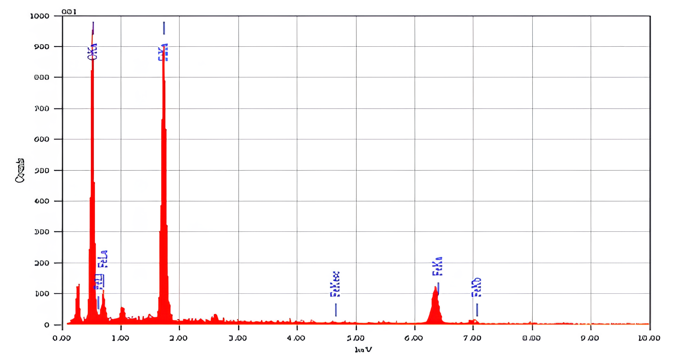
Figure S1. EDAX spectrum of CLFS.

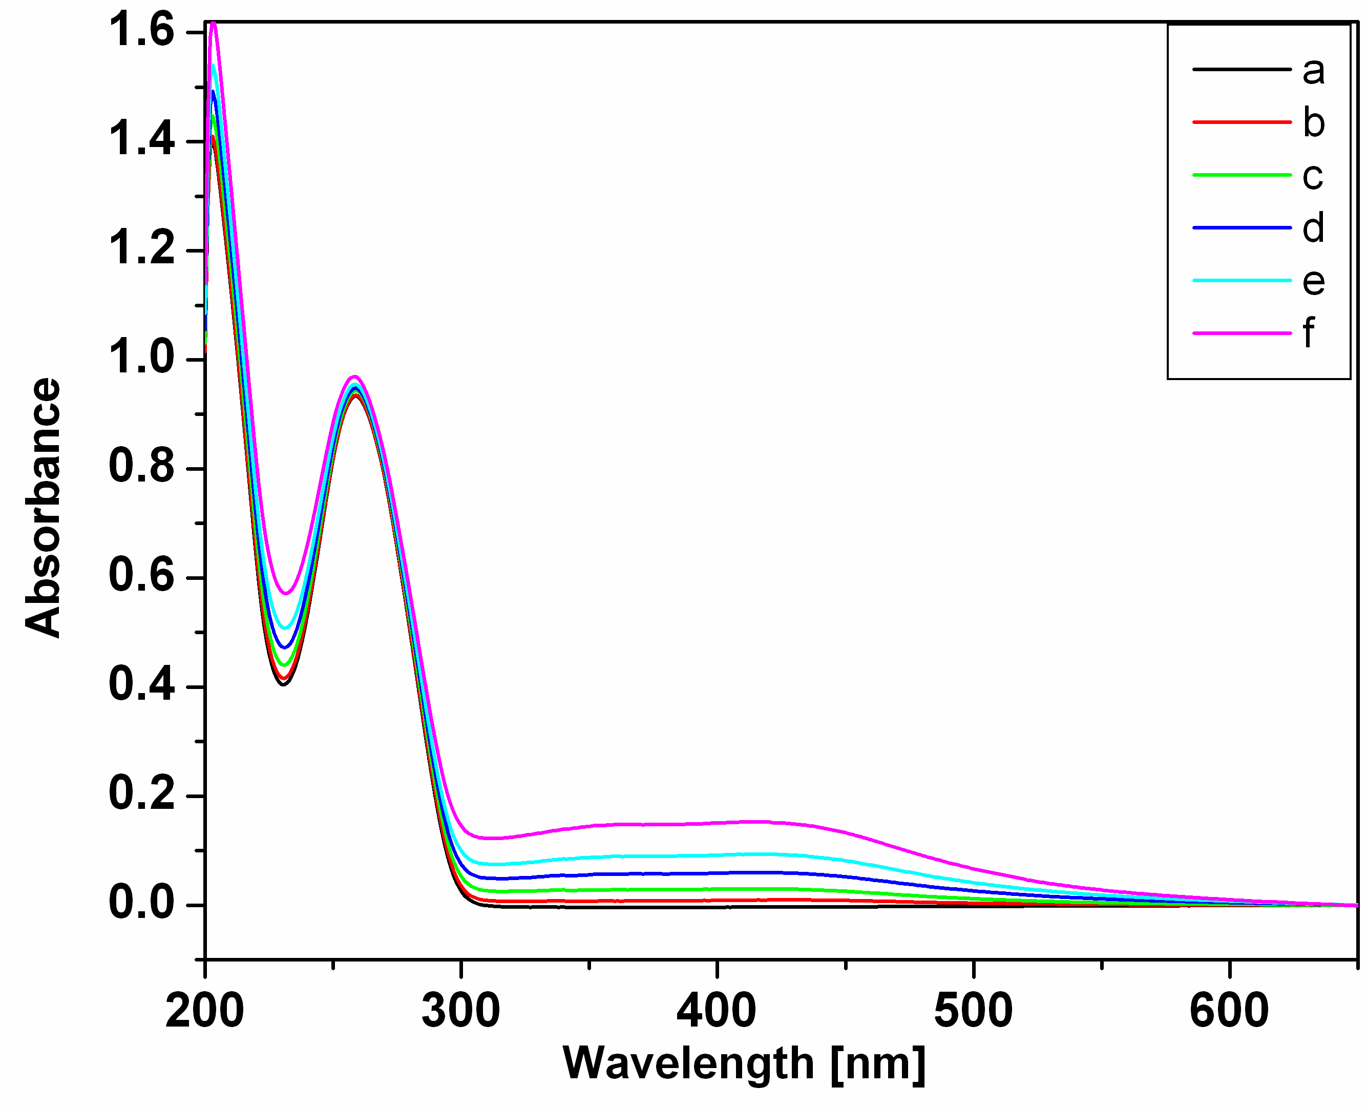

Figure S2. UV-vis spectra of DNA with increasing concentrations of CLFS (b to f in the order of 20, 40, 80, 100 and 200 µL of 54 µM).

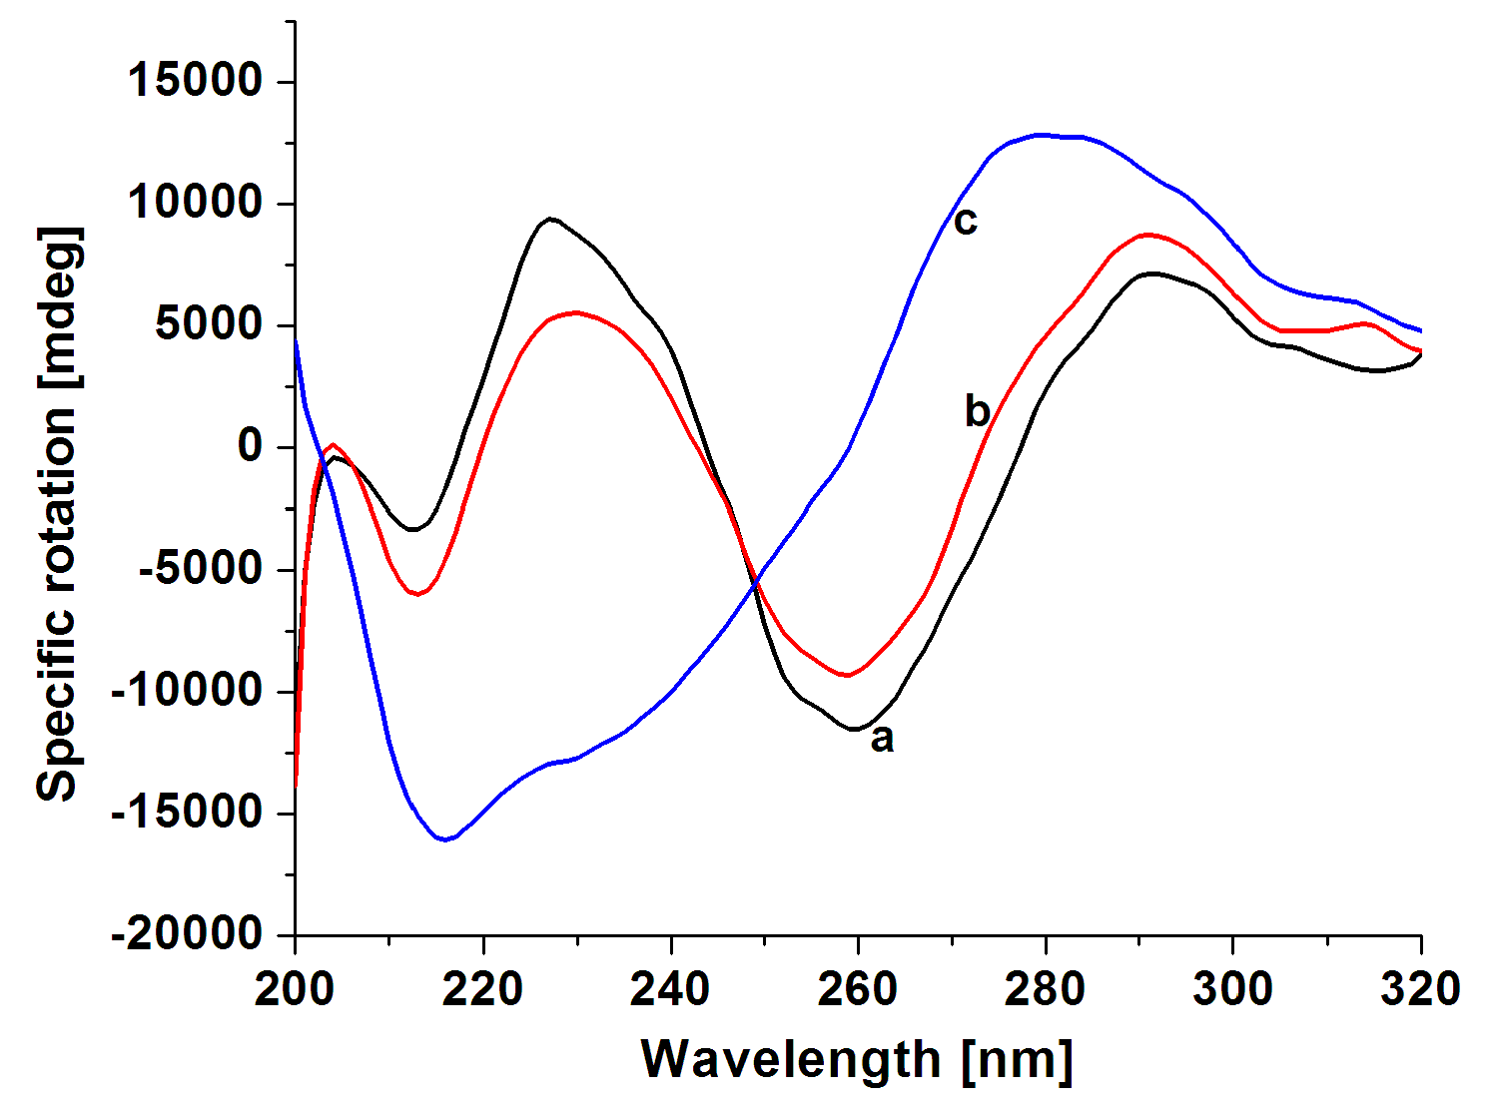

Figure S3. UV-CD specific rotation spectra of (a) Free CT-DNA, (b) a + 200 µL of CLFS and (c) b + 20 µL of vitamin C.

