Supplementary Materials

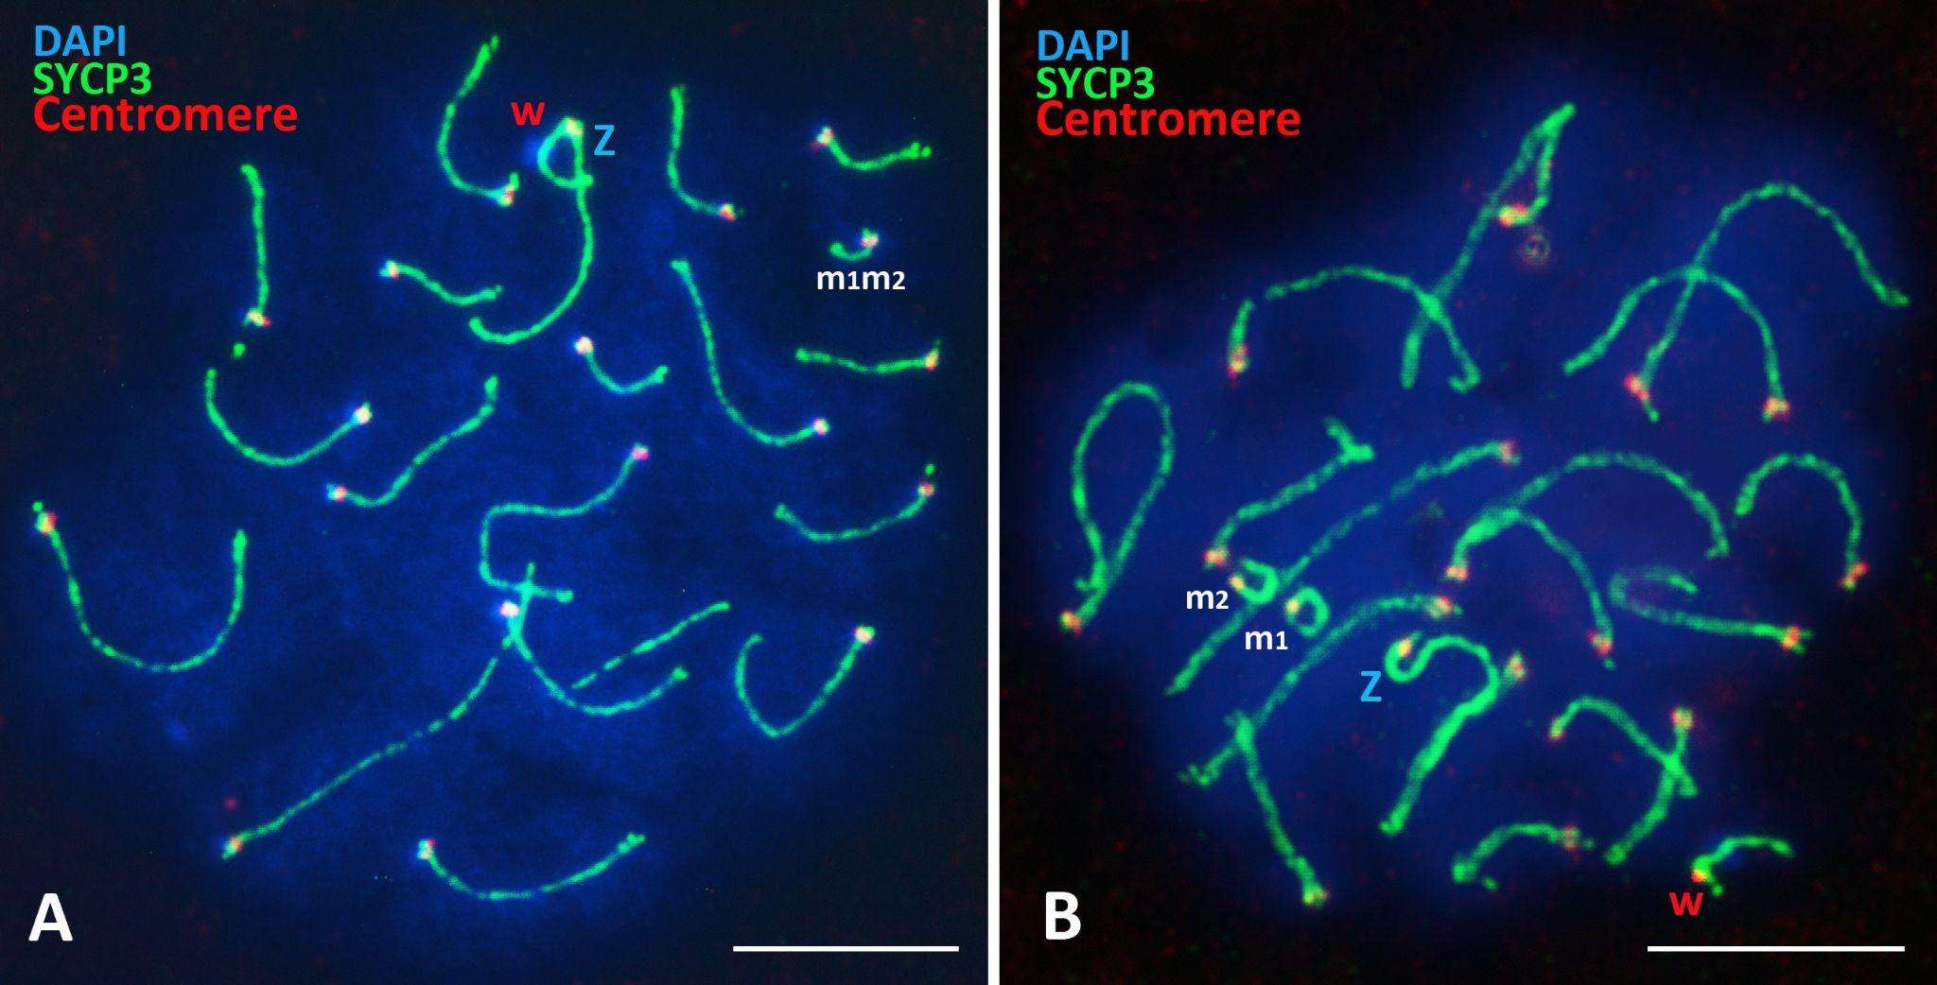
Figure SM1. early diplotene nucleus of normal ploidy with 18 autosomal homeologous bivalents and sex ZW-bivalent. The Z and W univalents contact in their centromeric regions. Heterochromatic region on the W chromosome is clearly visible. Axial elements are immunostained with anti‐SYCP3 antibodies (green), сentromeres with ACA‐antibodies (red), chromatin stained with DAPI, 4′,6‐diamidino‐2‐phenylindole (blue). Bars: 10 μm.

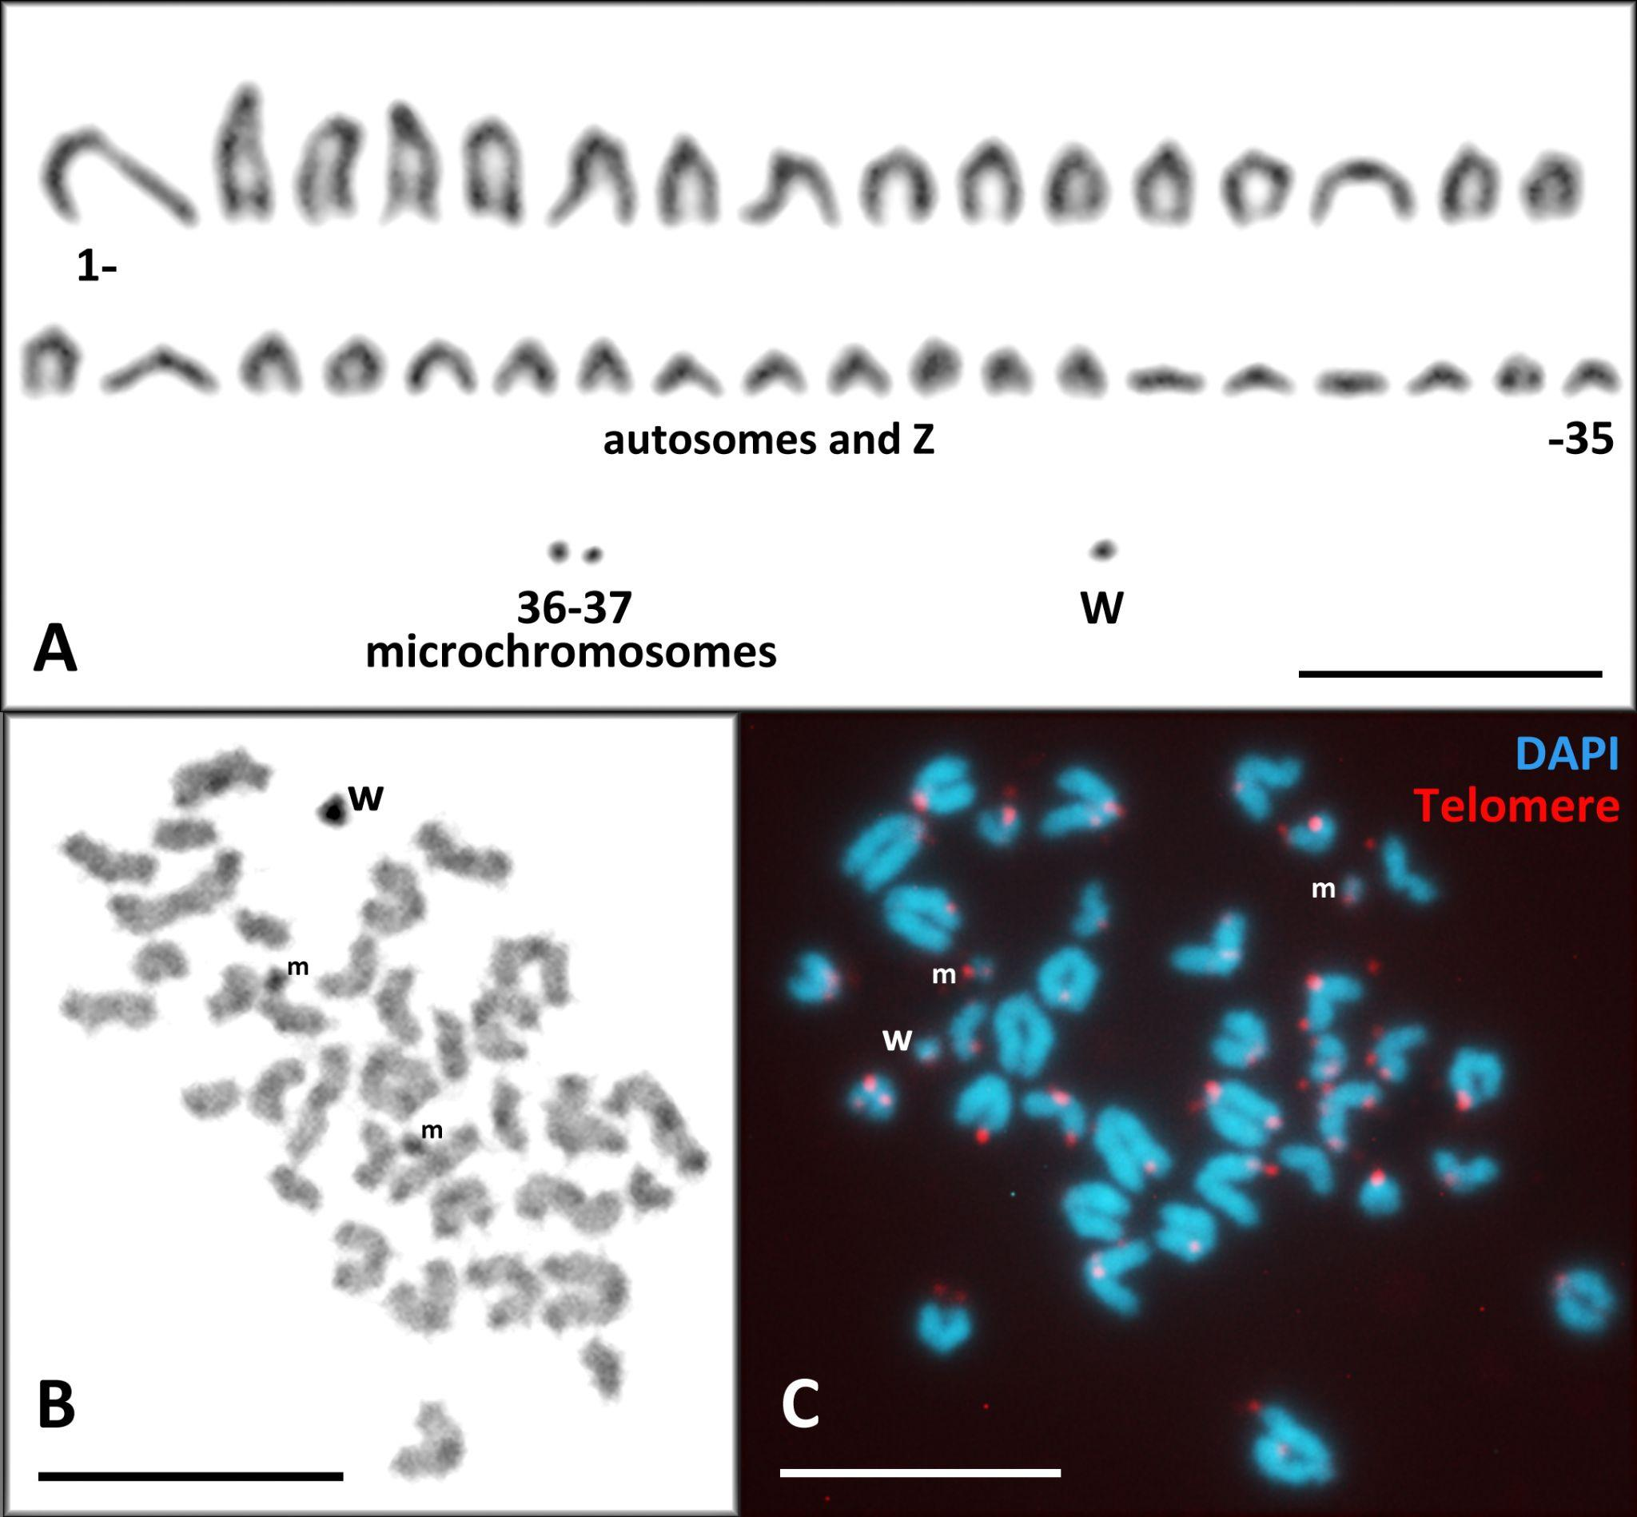

Figure SM2. Mitotic karyotypes of D. armeniaca after conventional Giemsa staining (A), C-banding (B), and FISH with DNA probe to telomere repeats (C) . Karyotype has 34 autosomal acrocentric chromosomes, 2 microchromosomes, Z chromosome (that is indistinguishable from autosomes) and W chromosome that has strong heterochromatin block detectable by C-banding and no extra accumulation of telomere repeats. Bars: 10 μm.
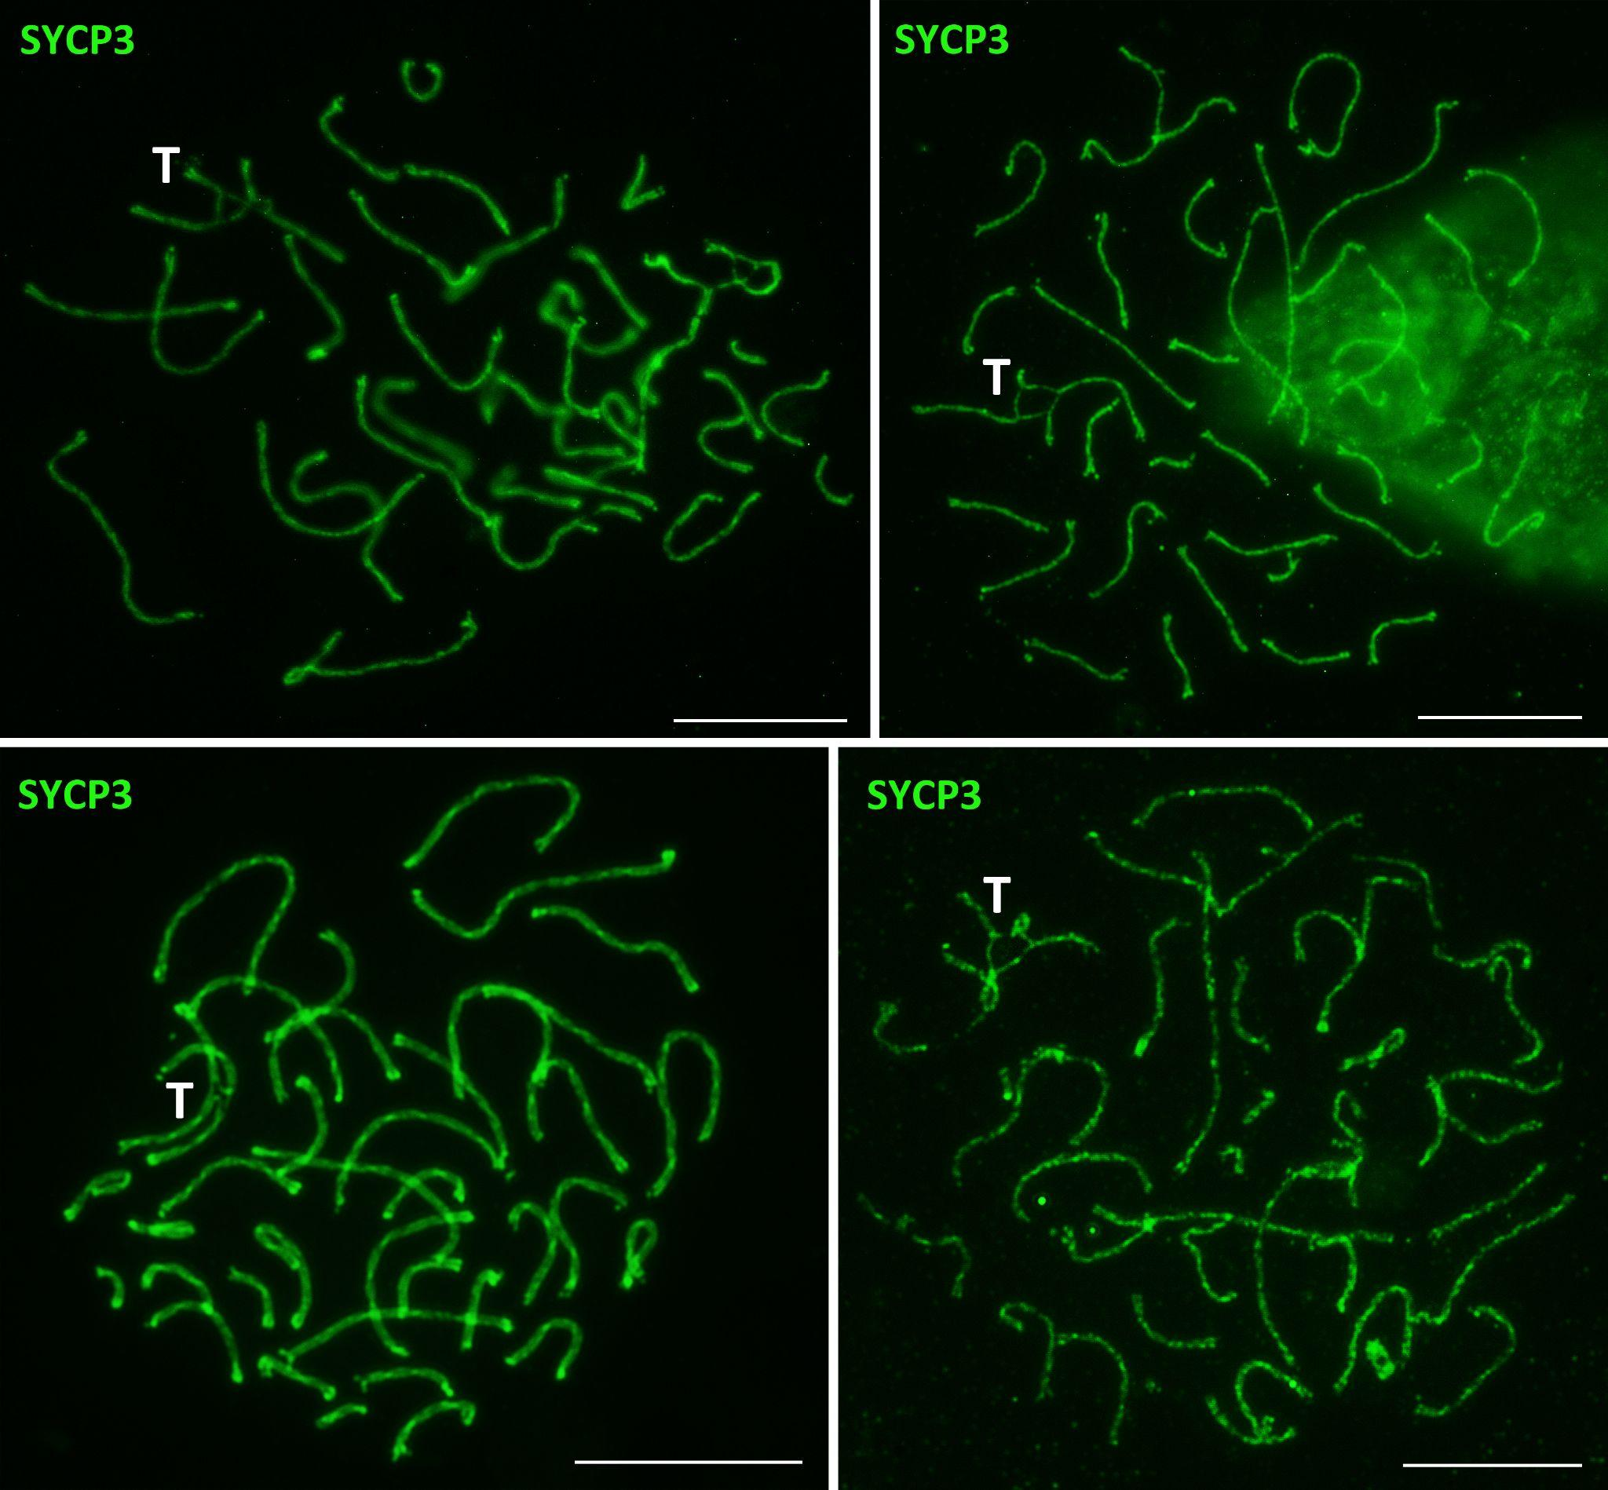

Figure SM3. Oocytes I nuclei of D. armeniaca after genome endoduplication. Ectopic synapsis of sister/homeologous chromosomes leading to formation of tetravalents indicated “T”. Bars: 10 μm.

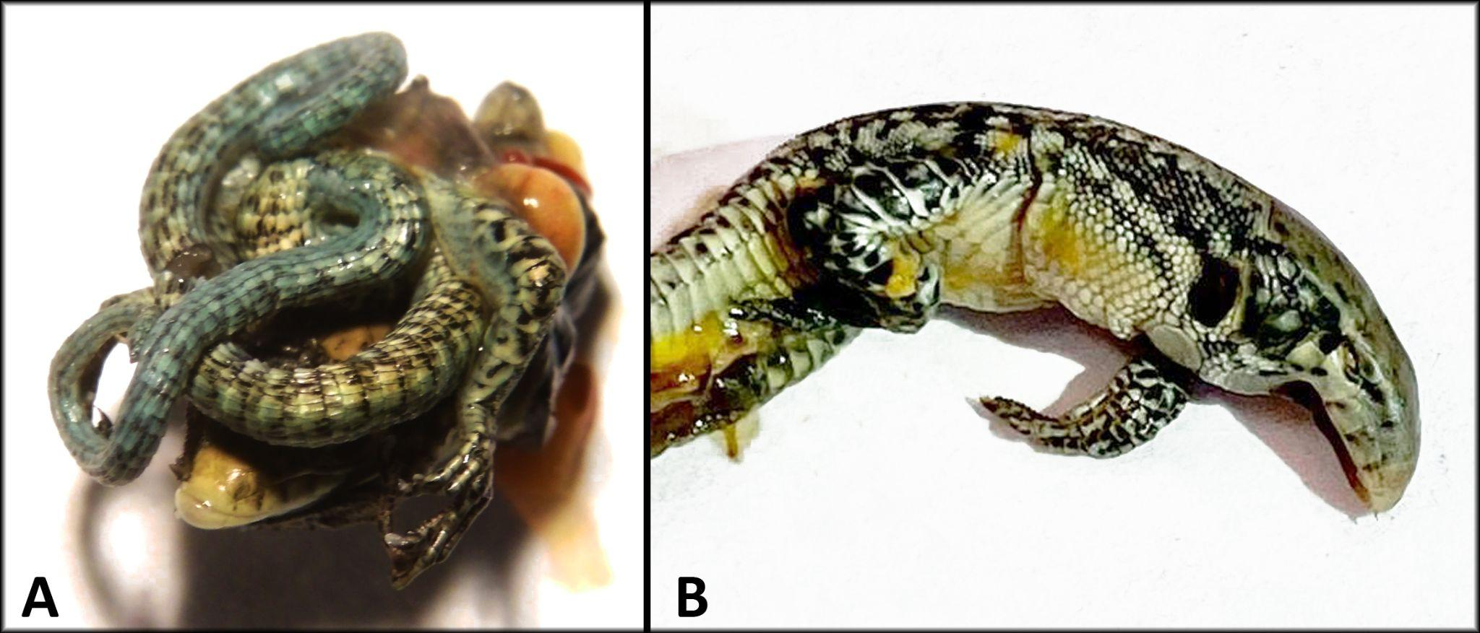

Figure SM4. Detected by us embryonic developmental anomalies during incubation of eggs of parthenogenetic species D. armeniaca. A - unclosed body cavities; B - complete absence of the lower jaw, the deviations known from previous publications (Darevsky 1960; Danielyan 1970).

