Supplementary Table 1 Baseline demographic characteristics

Characteristics
Gender, n (%)
Male | 3 (8.33%)
Female | 33 (91.67%)
Age (years), median (IQR) | 58.5 (53,65)
Skin type, n (%)
Type I | 0
Type II | 2 (5.56%)
Type III | 9 (25.00%)
Type IV | 21 (58.33%)
Type V | 4 (11.11%)
Type VI | 0
Baseline melanin index, mean (SD)
Group A | 266.34 (±65.8)
Group B | 283.40 (±63.4)
Group C | 278.64 (±64.7)
Control | 278.52 (±72.5)

Supplementary table 2 Mean duration of wound healing process

Healing process | Group A (n) | Group B (n) | Group C (n) | Control (n) | P-value
Pain, median (IQR) | 1 | 1 | 1 | 1 | >0.999
Crusting, mean (SD) | 18.93 (1.76) | 18.79 (1.75) | 18.49 (1.83) | 18.86 (1.94) | 0.478
Edema, median (IQR) | 1 | 1 | 1 | 1 | >0.999
Erythema, median (IQR) | 4 (3-7) | 4 (3-7) | 4.5 (3-7) | 4.5 (3-7) | 0.708
n = number of lesions; p-value = comparison of data between all groups; Significant differences at p < 0.05.

Supplementary Figures

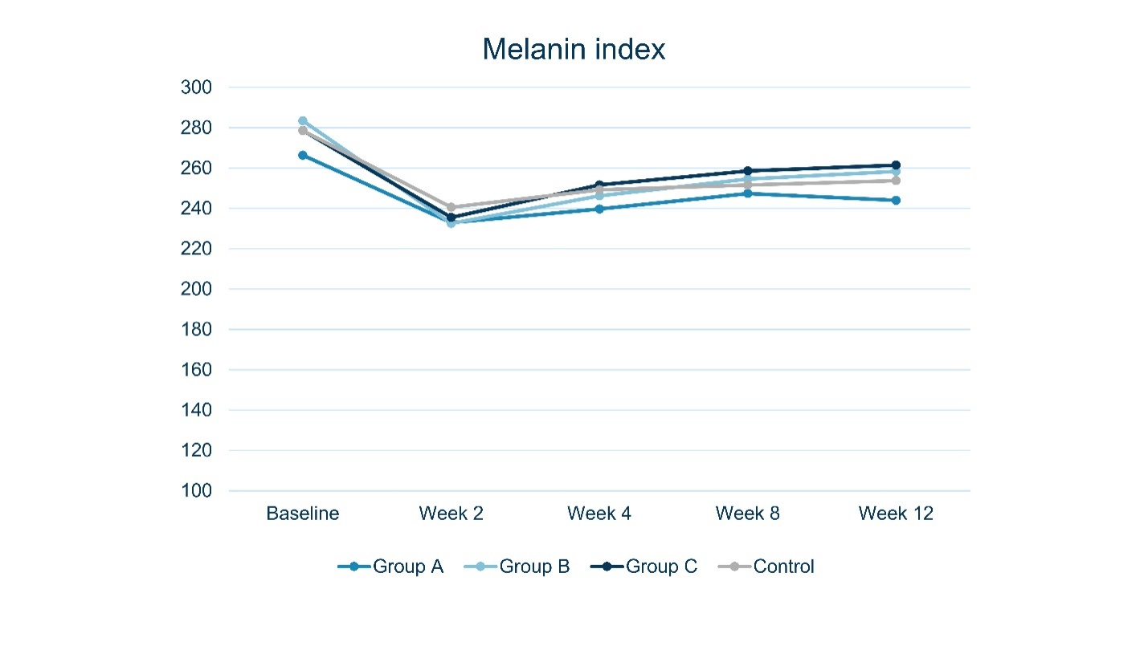
Supplementary Figure 1 Mean melanin index at baseline, week 2, 4, 8, and 12 after treatment
p-value between Groups A, B, and C compared to control group
- Topical clobetasol vs Control: p=0.368
- Topical clobetasol under occlusion vs Control: p=0.941
- Topical brimonidine vs Control: p=0.801

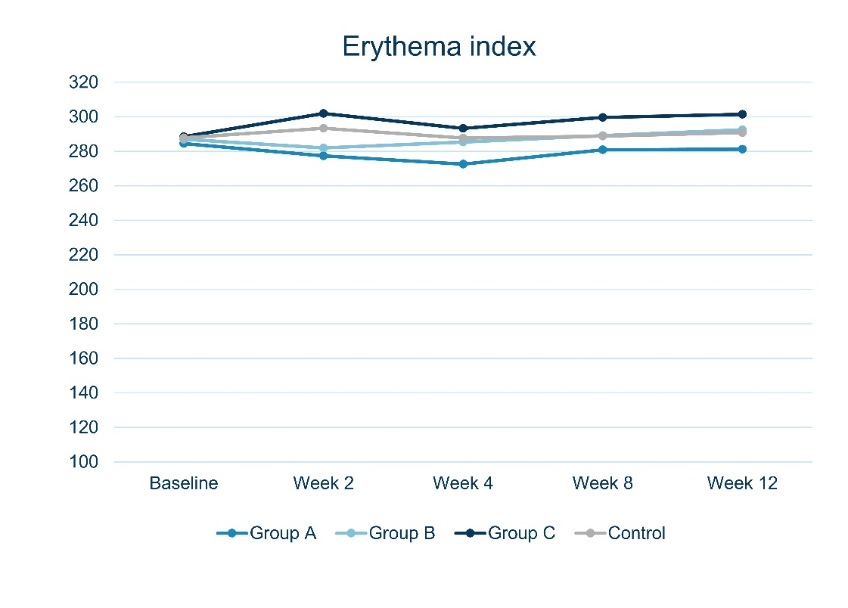

Supplementary Figure 2 Mean erythema index at baseline, week 2, 4, 8, and 12 after treatment

p-value between Groups A, B, and C compared to control group
- Topical clobetasol vs Control: p=0.311
- Topical clobetasol under occlusion vs Control: p=0.784
- Topical brimonidine vs Control: p=0.444

