Supplementary Figures and Tables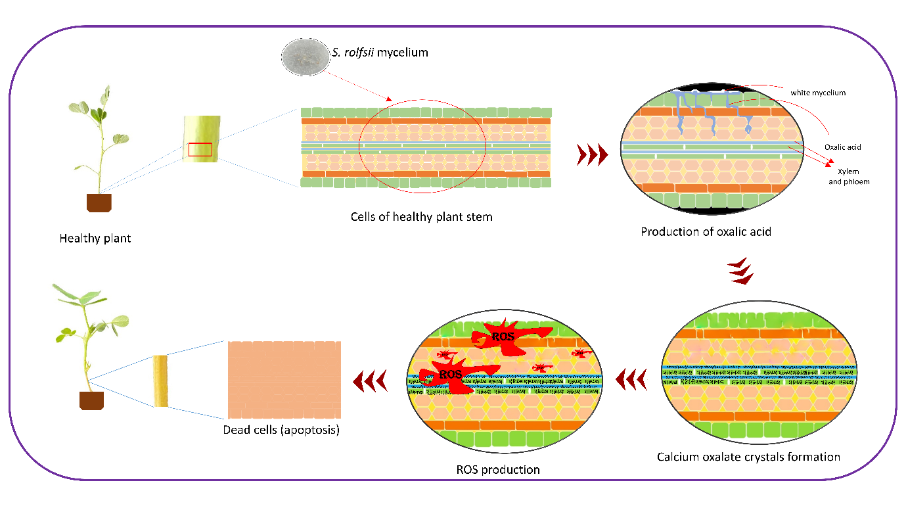
Supplementary fig 1: Mechanism of Sclerotium rolfsii infection, events like growth of mycelium, production of oxalic acid into the cells, blockage vascular bundle due to formation of oxalate crystals, finally ROS production and leading apoptosis of infected cells.

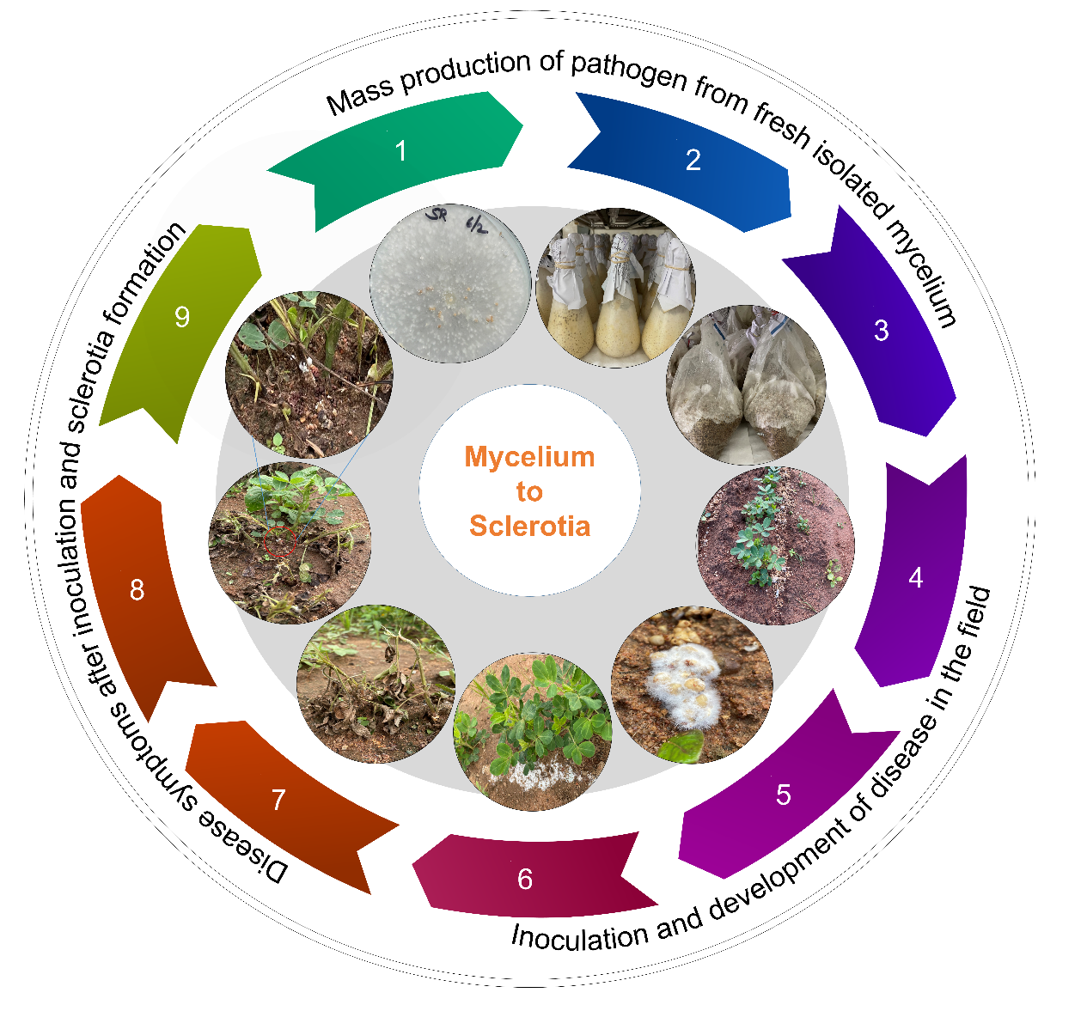

Supplementary fig 2: Protocol followed for sick-field screening of minicore accessions for stem rot. Events like isolation, mass multiplication of S. rolfsii, artificial inoculation in field, development of disease in plants, disease symptoms development have been clearly defined.

Supplementary table 1: Different Variability statistics for component traits of stem rot (PDI, PM) from field screening from three different seasons
Statistics | PDI | PM
Maximum | 100 | 100
Minimum | 0 | 0
Grand Mean | 48.4437 | 33.623
Standard Error of Mean (SEm) | 17.1942 | 17.982
Critical Difference (CD) 5% | 47.7232 | 49.91
Critical Difference (CD) 1% | 62.7677 | 65.644
Environmental Variance | 591.2788 | 400.72
Genotypic Variance | 1024.5689 | 511.09
Phenotypic Variance | 1615.8477 | 911.8
Environmental Coefficient of Variance | 50.1948 | 59.537
Genotypic Coefficient of Variance | 66.0744 | 67.238
Phenotypic Coefficient of Variance | 82.978 | 89.809
Heritability (Broad Sense) | 0.6341 | 0.5605
Genetic Advance | 52.5059 | 34.867

PDI: Percent disease incidence, PM: Percent mortality

Supplementary table 2: Genotypic and phenotypic correlation coefficients of two component traits of stem rot across the seasons (years)
 | Traits | 2016 PDI | 2017 PDI | 2022 PDI | 2016 PM | 2017 PM | 2022 PM
Genotypic Correlation | 2016 PDI | 1** | 0.3539** | 0.3524** | 0.7735** | 0.3549** | 0.3195**
 | 2017 PDI |  | 1** | 0.7045** | 0.3907** | 0.9028** | 0.737**
 | 2022 PDI |  |  | 1** | 0.4202** | 0.7176** | 0.9945**
 | 2016 PM |  |  |  | 1** | 0.4581** | 0.3916**
 | 2017 PM |  |  |  |  | 1** | 0.7343**
 | 2022 PM |  |  |  |  |  | 1**
Phenotypic correlation | 2016 PDI | 1** | 0.2873** | 0.2928** | 0.6474** | 0.2857** | 0.2522**
 | 2017 PDI |  | 1** | 0.5503** | 0.3267** | 0.8503** | 0.5303**
 | 2022 PDI |  |  | 1** | 0.3333** | 0.5685** | 0.9361**
 | 2016 PM |  |  |  | 1** | 0.3807** | 0.2942**
 | 2017 PM |  |  |  |  | 1** | 0.5396**
 | 2022 PM |  |  |  |  |  | 1**

2016, 2017, 2022 are the years when the screening of stem rot was done
PDI: Percent disease incidence, PM: Percent mortality
Significance codes: 0.001 ‘**’, 0.01, ‘*’, 0.05 ‘.’

Supplementary table 3: Different Variability statistics for component traits of stem rot (DS, LL) from Oxalic acid assay
Statistics | Disease score | Lesion length
Maximum | 6 | 31
Minimum | 1 | 0.5
Grand Mean | 4.0889 | 8.9622
Standard Error of Mean (SEm) | 0.9036 | 2.3792
Critical Difference (CD) 5% | 2.5054 | 6.601
Critical Difference (CD) 1% | 3.2931 | 8.68
Environmental Variance | 2.4497 | 16.9824
Genotypic Variance | 10.4781 | 21.3516
Phenotypic Variance | 12.9278 | 38.334
Environmental Coefficient of Variance | 38.2781 | 45.982
Genotypic Coefficient of Variance | 79.1647 | 51.5588
Phenotypic Coefficient of Variance | 87.9332 | 69.0844
Heritability (Broad Sense) | 0.8105 | 0.557
Genetic Advance | 6.0033 | 7.104

Supplementary table 4: Depicting the comparison between the field screening and oxalic acid assay into classes (Resistant, Moderately resistant, Susceptible)
Genotype |  | Field screening |  |  |  |  | OAA
 |  | 2016 PM (90DAS) | 2017 PM (90DAS) | 2022 PM (90DAS) | Remarks |  | 20mM (36hours) | Remarks
ICG10036 |  | 32.58 | 44.32 | 89.90 | S |  | 6 | S
ICG10092 |  | 42.19 | 52.38 | 58.19 | S |  | 6 | S
ICG10185 |  | 31.37 | 34.39 | 5.56 | MR |  | 6 | S
ICG10384 |  | 55.53 | 45.76 | 63.21 | S |  | 5 | S
ICG10474 |  | 52.67 | 59.34 | 85.61 | S |  | 2 | R
ICG10479 |  | 16.89 | 18.68 | 31.43 | R |  | 2 | R
ICG10554 |  | 14.05 | 50.00 | 60.92 | S |  | 6 | S
ICG10566 |  | 53.57 | 45.11 | 85.71 | S |  | 6 | S
ICG10890 |  | 16.25 | 60.66 | 72.92 | S |  | 6 | S
ICG11088 |  | 54.55 | 24.52 | 71.67 | S |  | 2 | R
ICG111 |  | 25.00 | 25.00 | 26.29 | R |  | 3 | R
ICG11109 |  | 34.06 | 24.70 | 47.02 | MR |  | 3 | MR
ICG11144 |  | 40.38 | 51.87 | 84.86 | S |  | 6 | S
ICG11219 |  | 45.00 | 40.62 | 50.96 | S |  | 5 | S
ICG1137 |  | 53.51 | 66.67 | 84.21 | S |  | 4 | S
ICG1142 |  | 24.87 | 75.96 | 72.92 | S |  | 4 | S
ICG11426 |  | 22.36 | 25.06 | 35.22 | MR |  | 6 | S
ICG11457 |  | 14.96 | 20.53 | 39.86 | R |  | 1 | R
ICG115 |  | 33.56 | 78.04 | 40.35 | S |  | 4 | S
ICG11515 |  | 16.25 | 24.04 | 84.24 | S |  | 6 | S
ICG11651 |  | 32.26 | 68.10 | 74.18 | S |  | 4 | S
ICG11862 |  | 15.23 | 20.78 | 14.29 | R |  | 5 | S
ICG12189 |  | 55.00 | 53.66 | 79.83 | S |  | 1 | R
ICG12276 |  | 35.88 | 51.40 | 32.58 | MR |  | 3 | MR
ICG12625 |  | 37.50 | 11.68 | 52.82 | S |  | 6 | S
ICG12672 |  | 28.75 | 36.22 | 24.14 | S |  | 5 | S
ICG12879 |  | 54.56 | 45.43 | 79.46 | S |  | 6 | S
ICG12921 |  | 16.87 | 52.78 | 68.30 | S |  | 5 | S
ICG12988 |  | 22.13 | 73.99 | 82.07 | S |  | 6 | S
ICG13099 |  | 12.19 | 29.86 | 46.15 | S |  | 5 | S
ICG13491 |  | 57.78 | 73.04 | 65.71 | S |  | 6 | S
ICG13603 |  | 21.03 | 52.26 | 77.38 | S |  | 3 | S
ICG13787 |  | 12.84 | 13.06 | 24.76 | S |  | 6 | S
ICG13856 |  | 24.77 | 51.65 | 70.55 | S |  | 3 | S
ICG13858 |  | 15.48 | 59.92 | 84.16 | S |  | 6 | S
ICG1399 |  | 25.71 | 57.50 | 59.52 | S |  | 3 | S
ICG14106 |  | 36.88 | 68.09 | 88.64 | S |  | 6 | S
ICG14118 |  | 46.15 | 36.65 | 15.38 | S |  | 5 | S
ICG1415 |  | 16.94 | 26.29 | 84.51 | S |  | 6 | S
ICG14466 |  | 16.31 | 23.31 | 43.18 | MR |  | 5 | MR
ICG14475 |  | 19.09 | 25.88 | 55.74 | MR |  | 4 | MR
ICG14523 |  | 19.40 | 14.50 | 9.38 | R |  | 6 | S
ICG14630 |  | 62.82 | 53.24 | 60.92 | S |  | 3 | S
ICG14705 |  | 15.46 | 21.43 | 23.21 | R |  | 4 | MR
ICG14710 |  | 69.05 | 43.00 | 44.28 | S |  | 6 | S
ICG14985 |  | 19.36 | 50.00 | 86.67 | S |  | 1 | R
ICG1519 |  | 27.96 | 75.60 | 87.81 | S |  | 3 | S
ICG15287 |  | 26.15 | 55.74 | 80.99 | S |  | 3 | S
ICG15309 |  | 14.73 | 67.66 | 83.48 | S |  | 6 | S
ICG15419 |  | 7.29 | 17.57 | 95.00 | S |  | 4 | S
ICG163 |  | 11.67 | 19.05 | 18.68 | R |  | 1 | R
ICG1668 |  | 19.44 | 8.57 | 20.54 | R |  | 6 | S
ICG1711 |  | 44.88 | 64.09 | 77.10 | MR |  | 2 | MR
ICG188 |  | 38.75 | 61.25 | 46.88 | S |  | 6 | S
ICG1973 |  | 56.82 | 58.81 | 58.97 | S |  | 1 | R
ICG2106 |  | 41.87 | 53.96 | 69.03 | S |  | 6 | S
ICG2381 |  | 29.63 | 54.29 | 25.00 | S |  | 4 | S
ICG2511 |  | 30.30 | 29.29 | 12.50 | S |  | 6 | S
ICG2773 |  | 14.04 | 15.95 | 17.85 | R |  | 4 | S
ICG2777 |  | 21.03 | 14.64 | 2.63 | R |  | 6 | S
ICG2857 |  | 21.90 | 38.56 | 16.67 | R |  | 1 | R
ICG2925 |  | 29.04 | 16.59 | 55.00 | S |  | 5 | S
ICG3027 |  | 36.44 | 34.20 | 48.36 | S |  | 5 | S
ICG3053 |  | 44.75 | 37.86 | 8.00 | S |  | 6 | S
ICG3102 |  | 17.95 | 57.14 | 77.83 | S |  | 6 | S
ICG332 |  | 28.13 | 79.09 | 66.07 | S |  | 6 | S
ICG334 |  | 28.22 | 57.89 | 87.50 | S |  | 6 | S
ICG3343 |  | 57.78 | 39.23 | 64.61 | S |  | 6 | S
ICG3673 |  | 60.71 | 72.98 | 89.59 | S |  | 4 | S
ICG3681 |  | 51.93 | 88.10 | 82.56 | S |  | 3 | S
ICG3746 |  | 39.86 | 62.43 | 72.50 | S |  | 1 | R
ICG3775 |  | 69.97 | 21.98 | 83.92 | S |  | 6 | S
ICG397 |  | 56.90 | 57.11 | 91.88 | S |  | 6 | S
ICG4156 |  | 18.25 | 41.43 | 19.95 | MR |  | 3 | MR
ICG434 |  | 21.03 | 54.09 | 93.45 | S |  | 6 | S
ICG4343 |  | 39.37 | 41.43 | 27.63 | S |  | 6 | S
ICG4389 |  | 23.11 | 7.94 | 24.56 | R |  | 5 | S
ICG4412 |  | 27.50 | 9.64 | 10.00 | R |  | 6 | S
ICG442 |  | 42.31 | 46.25 | 80.39 | S |  | 4 | S
ICG4527 |  | 17.69 | 18.59 | 38.83 | S |  | 5 | S
ICG4538 |  | 21.01 | 18.33 | 31.88 | S |  | 5 | S
ICG4543 |  | 70.90 | 66.13 | 75.37 | S |  | 5 | S
ICG4598 |  | 15.19 | 31.78 | 48.64 | S |  | 5 | S
ICG4670 |  | 28.97 | 58.33 | 61.71 | S |  | 6 | S
ICG4729 |  | 25.76 | 59.06 | 91.11 | S |  | 2 | R
ICG4911 |  | 31.88 | 66.25 | 80.56 | S |  | 1 | R
ICG4955 |  | 57.14 | 48.68 | 79.70 | S |  | 6 | S
ICG4998 |  | 50.00 | 37.18 | 12.50 | S |  | 6 | S
ICG513 |  | 9.76 | 34.57 | 20.94 | MR |  | 6 | S
ICG5195 |  | 53.00 | 88.10 | 83.33 | S |  | 6 | S
ICG5221 |  | 54.72 | 49.87 | 79.13 | S |  | 6 | S
ICG5236 |  | 56.25 | 69.05 | 57.14 | S |  | 5 | S
ICG5286 |  | 16.94 | 4.82 | 30.56 | S |  | 6 | S
ICG5327 |  | 14.93 | 16.76 | 41.67 | S |  | 5 | S
ICG5475 |  | 41.44 | 45.13 | 61.67 | S |  | 4 | S
ICG5494 |  | 56.56 | 64.85 | 78.00 | S |  | 4 | S
ICG5609 |  | 59.85 | 53.57 | 87.50 | S |  | 6 | S
ICG5662 |  | 17.92 | 21.43 | 26.74 | R |  | 5 | S
ICG5663 |  | 8.19 | 47.62 | 5.88 | S |  | 5 | S
ICG5745 |  | 37.07 | 14.64 | 0.00 | S |  | 6 | S
ICG5779 |  | 24.82 | 74.68 | 76.47 | S |  | 6 | S
ICG5827 |  | 27.72 | 28.81 | 62.91 | S |  | 5 | S
ICG5891 |  | 7.39 | 23.31 | 24.21 | MR |  | 4 | MR
ICG6057 |  | 15.77 | 35.90 | 15.00 | MR |  | 6 | S
ICG6201 |  | 60.66 | 64.68 | 81.87 | S |  | 5 | S
ICG6375 |  | 74.17 | 40.83 | 69.05 | S |  | 4 | S
ICG6407 |  | 65.95 | 45.75 | 54.41 | S |  | 6 | S
ICG6654 |  | 45.74 | 80.74 | 80.98 | S |  | 1 | R
ICG6703 |  | 35.42 | 46.62 | 68.77 | S |  | 1 | R
ICG6766 |  | 32.38 | 42.98 | 35.58 | S |  | 5 | S
ICG6813 |  | 11.38 | 37.50 | 25.00 | S |  | 6 | S
ICG6888 |  | 39.23 | 49.67 | 81.77 | S |  | 2 | S
ICG7153 |  | 18.38 | 35.30 | 25.15 | MR |  | 4 | MR
ICG7190 |  | 53.38 | 55.46 | 63.94 | S |  | 4 | S
ICG721 |  | 15.50 | 34.52 | 14.02 | R |  | 2 | R
ICG7243 |  | 47.60 | 18.15 | 24.09 | S |  | 6 | S
ICG76 |  | 59.92 | 77.18 | 16.61 | S |  | 6 | S
ICG7906 |  | 22.07 | 50.18 | 50.91 | S |  | 5 | S
ICG7963 |  | 38.99 | 55.46 | 58.92 | S |  | 5 | S
ICG7969 |  | 51.07 | 88.05 | 74.89 | S |  | 4 | S
ICG8083 |  | 55.93 | 76.84 | 68.06 | S |  | 4 | S
ICG81 |  | 39.06 | 67.54 | 81.67 | S |  | 3 | S
ICG8285 |  | 18.78 | 13.75 | 22.92 | S |  | 5 | S
ICG8490 |  | 9.88 | 16.67 | 17.00 | R |  | 6 | S
ICG8517 |  | 64.35 | 33.67 | 52.01 | S |  | 4 | S
ICG8567 |  | 68.33 | 74.69 | 75.33 | S |  | 6 | S
ICG862 |  | 41.67 | 45.79 | 35.91 | S |  | 6 | S
ICG875 |  | 13.39 | 24.13 | 34.52 | R |  | 1 | R
ICG8760 |  | 20.39 | 31.14 | 32.13 | MR |  | 5 | MR
ICG9037 |  | 21.62 | 23.27 | 10.34 | R |  | 6 | S
ICG9249 |  | 70.29 | 51.58 | 61.82 | S |  | 4 | S
ICG9315 |  | 43.65 | 76.97 | 68.89 | S |  | 3 | S
ICG9418 |  | 50.00 | 71.43 | 72.50 | S |  | 5 | S
ICG9507 |  | 12.95 | 58.41 | 78.42 | S |  | 6 | S
ICG9666 |  | 22.47 | 21.66 | 43.00 | MR |  | 4 | MR
ICG9777 |  | 24.05 | 34.44 | 24.55 | MR |  | 6 | S
ICG9809 |  | 18.37 | 51.19 | 81.39 | S |  | 1 | R
ICG9905 |  | 24.40 | 27.53 | 16.67 | R |  | 4 | S
ICG9961 |  | 24.93 | 19.64 | 19.79 | R |  | 6 | S
PM: percent mortality, S: susceptible, R: resistant, MR: moderately resistant
OAA: oxalic acid assay, 20Mm: 20 millimolar oxalic acid

