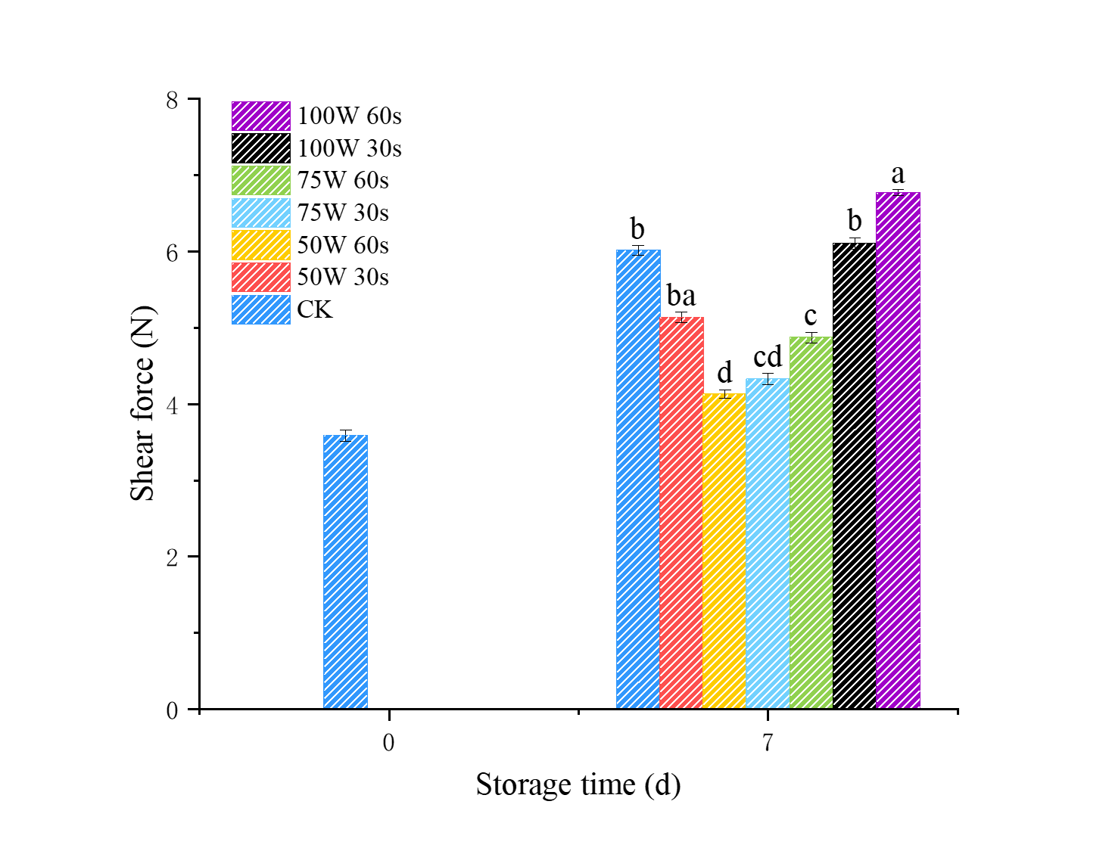
Fig. S1. Effect of MT on shear force of Dr fruiting bodies during storage. Here, the vertical bars indicate the standard error calculated from the results of three experimental runs. Where shown, different letters represent significant differences across groups at the same storage time (P < 0.05).

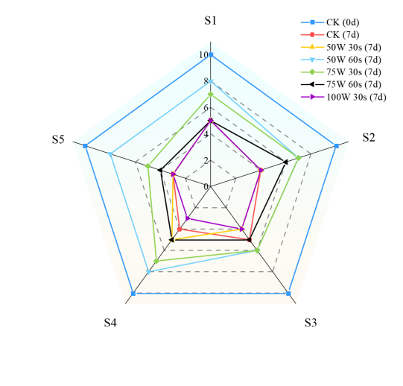
Fig. S2 Effect of MT on sensory evaluation of Dr fruiting bodies during storage.

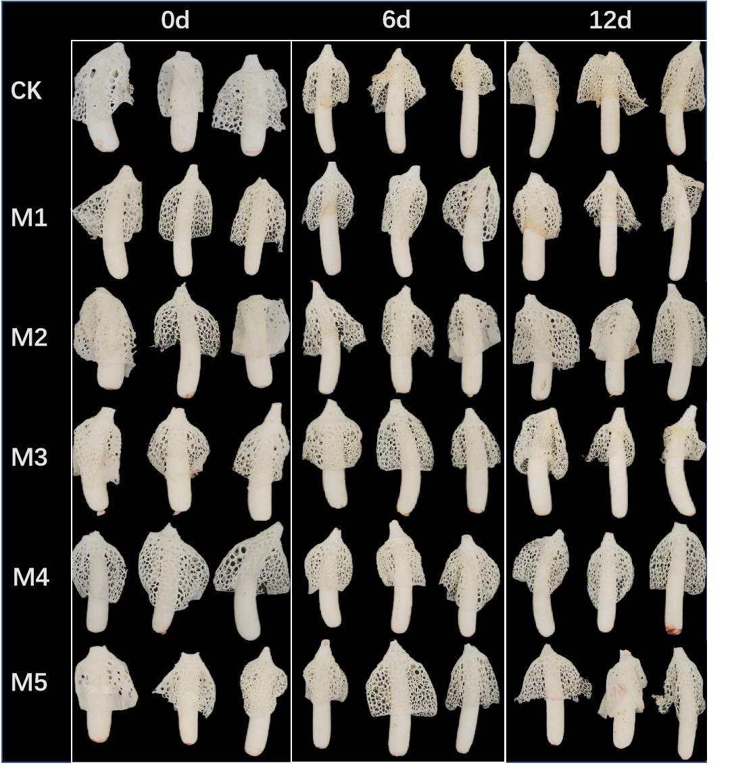
Fig. S3 Effect of MT on appearance of Dr fruiting bodies during storage.

Tab. S1 Dictyophora rubrovolvata sensory evaluation standard
Score | Colour | Autolysis degree | Off-odour | Texture stretchy | Consumer acceptance
10-8 | White | No | No | Brittle | Pleasure
7-4 | Slight browning | Slight autolysis | Slightly | Slight softening | Ordinarily enjoy
3-0 | Severe browning | Severe autolysis | Obvious | Loss brittleness and severe softening | Nonacceptance

Tab. S2 Effect of MT on the content of free amino acids
Component  (g kg−1) | 0d | 6d |  |  |  |  |  | 12d
Component  (g kg−1) | At harvest | CK | M1 | M2 | M3 | M4 | M5 | CK | M1 | M2 | M3 | M4 | M5
Asp | 0.09±0.01 | 0.11±0.01^{d} | 0.20±0.02^{b} | 0.14±0.01^{c} | 0.33±0.02ª | 0.15±0.01^{c} | 0.12±0.01^{d} | 0.16±0.01ª | 0.18±0.01ª | 0.20±0.02ª | 0.18±0.01ª | 0.17±0.01ª | 0.13±0.01^{b}
Glu | 1.29±0.13 | 3.99±0.14ª | 2.07±0.21^{c} | 2.69±0.27^{b} | 1.54±0.15^{d} | 2.20±0.22^{c} | 2.65±0.27^{b} | 0.52±0.05^{d} | 1.57±0.16^{b} | 1.94±0.19ª | 0.89±0.09^{c} | 1.61±0.16^{b} | 1.71±0.17^{b}
Ser | 1.60±0.16 | 1.15±0.11^{c} | 1.11±0.11^{c} | 1.32±0.13^{b} | 1.31±0.13^{b} | 1.83±0.18ª | 1.75±0.18ª | 0.12±0.01e | 0.32±0.03^{d} | 1.31±0.13ª | 1.13±0.11^{b} | 1.38±0.14ª | 0.75±0.08^{c}
His | 1.19±0.12 | 2.15±0.21ª | 1.20±0.12^{b} | 1.28±0.13^{b} | 1.19±0.12^{b} | 1.19±0.12^{b} | 1.37±0.14^{b} | 0.31±0.03^{c} | 0.94±0.09ª | 0.96±0.07ª | 0.54±0.05^{b} | 0.98±0.04ª | 0.18±0.02^{d}
Gly | 0.88±0.09 | 3.28±0.33ª | 3.30±0.23ª | 1.98±0.12^{c} | 2.33±0.23^{b} | 2.09±0.21^{c} | 2.17±0.22^{b} | 0.20±0.02^{d} | 0.87±0.09^{b} | 0.57±0.06^{c} | 0.92±0.09^{b} | 2.0±0.17ª | 0.27±0.03^{d}
Thr | 1.42±0.14 | 3.57±0.36ª | 1.91±0.19^{c} | 1.78±0.18^{c} | 2.71±0.27^{b} | 1.53±0.15^{d} | 1.45±0.14^{d} | 0.23±0.02^{c} | 0.76±0.08ª | 0.76±0.08ª | 0.66±0.07^{b} | 0.84±0.08ª | 0.59±0.06^{b}
Arg | 1.32±0.13 | 1.39±0.14ª | 1.43±0.14ª | 1.26±0.13^{ab} | 1.29±0.13^{ab} | 1.20±0.12^{b} | 1.36±0.14ª | 0.53±0.05ª | 0.31±0.03^{b} | 0.58±0.06ª | 0.27±0.03^{c} | 0.37±0.04^{b} | 0.26±0.03^{c}
Ala | 5.73±0.57 | 8.86±0.89ª | 8.08±0.81ª | 6.89±0.69^{b} | 6.67±0.67^{b} | 5.94±0.59^{c} | 7.39±0.74ª | 1.62±0.16^{c} | 2.26±0.23^{b} | 3.76±0.38ª | 2.88±0.29^{b} | 4.29±0.43ª | 3.08±0.31ª
Tyr | 0.58±0.06 | 0.67±0.07ª | 0.72±0.07ª | 0.64±0.06ª | 0.60±0.06ª | 0.39±0.04^{b} | 0.42±0.04^{b} | 0.91±0.09ª | 0.77±0.08^{b} | 0.77±0.08^{b} | 0.7±0.07^{b} | 0.82±0.08ª | 0.74±0.07^{b}
Val | 0.18±0.02 | 0.56±0.06^{b} | 0.35±0.03^{c} | 0.62±0.06ª | 0.41±0.04^{c} | 0.32±0.03^{c} | 0.34±0.03^{c} | 0.36±0.04^{d} | 0.60±0.06^{c} | 0.93±0.09ª | 0.53±0.05^{c} | 0.79±0.08^{b} | 0.48±0.05^{c}
Met | 1.3±0.11 | 2.25±0.23ª | 2.34±0.23ª | 1.76±0.18^{b} | 1.51±0.15^{c} | 1.48±0.15^{c} | 1.62±0.16^{b} | 2.51±0.25ª | 1.40±0.14^{c} | 1.42±0.14^{c} | 1.09±0.11^{d} | 1.1±0.11^{d} | 1.95±0.02^{b}
Trp | 0.07±0.01 | 0.02±0.01^{b} | 0.03±0.01^{b} | 0.04±0.01^{b} | 0.04±0.01^{b} | 0.11±0.01ª | 0.03±0.01^{b} | 0.05±0.01ª | 0.04±0.01ª | 0.03±0.01ª | 0.03±0.01ª | 0.04±0.01ª | 0.03±0.01ª
Phe | 1.33±0.08 | 1.44±0.14^{c} | 1.49±0.15^{b} | 1.50±0.15^{b} | 1.55±0.16ª | 1.37±0.14^{c} | 1.65±0.17ª | 0.33±0.03^{c} | 0.56±0.06^{b} | 0.59±0.06^{b} | 0.55±0.06^{b} | 0.76±0.08ª | 0.47±0.05^{b}
Ile | 0.15±0.01 | 0.27±0.03^{c} | 0.33±0.03^{b} | 0.34±0.03^{b} | 0.40±0.04ª | 0.30±0.03^{b} | 0.25±0.03^{c} | 0.12±0.01^{c} | 0.43±0.04ª | 0.47±0.05ª | 0.39±0.04^{b} | 0.48±0.05ª | 0.33±0.03^{b}
Leu | 1.29±0.13 | 1.38±0.14^{b} | 1.45±0.14ª | 0.54±0.05^{d} | 1.51±0.15ª | 1.04±0.14^{c} | 1.54±0.15ª | 0.31±0.03^{c} | 0.56±0.06^{b} | 0.63±0.0ª6 | 0.52±0.05^{b} | 0.64±0.06ª | 0.62±0.06ª
Lys | 0.09±0.01 | 0.14±0.01^{c} | 0.25±0.03ª | 0.19±0.02^{b} | 0.31±0.03ª | 0.16±0.02^{b} | 0.14±0.01^{c} | 0.26±0.03ª | 0.20±0.02^{b} | 0.31±0.03ª | 0.21±0.02^{b} | 0.23±0.02^{b} | 0.14±0.01^{c}
Pro | 0.68±0.07 | 0.73±0.07^{b} | 1.15±0.11ª | 0.06±0.06e | 0.24±0.02^{c} | 0.12±0.01^{d} | 0.10±0.01^{d} | 0.20±0.02^{b} | 0.17±0.02^{c} | 0.15±0.01^{c} | 0.13±0.01^{d} | 0.26±0.03ª | 0.13±0.01^{d}
Sweet* | 9.63±0.26 | 16.85±1.69ª | 14.39±1.44^{b} | 11.97±0.20^{d} | 13.01±1.3^{bc} | 11.38±1.14^{d} | 12.77±1.28^{c} | 2.17±0.22e | 4.22±0.42^{d} | 6.39±0.64^{b} | 5.58±0.56^{c} | 8.51±0.75ª | 4.69±0.47^{c}
Bitter* | 7.51±0.15 | 10.19±1.02ª | 9.76±0.98ª | 7.94±0.79^{b} | 8.13±0.81^{b} | 7.49±0.75^{c} | 8.25±0.83^{b} | 4.70±0.47^{c} | 5.00±0.15^{b} | 5.76±0.58ª | 4.05±0.41^{d} | 5.42±0.54ª | 4.44±0.44^{c}
Umami* | 2.05±0.17 | 4.91±0.49ª | 3.22±0.32^{c} | 3.65±0.36^{b} | 2.78±0.28^{d} | 2.90±0.29^{d} | 3.33±0.13^{c} | 1.85±0.19^{c} | 2.72±0.27^{b} | 3.22±0.32ª | 1.98±0.09^{c} | 2.82±0.28^{b} | 2.72±0.27^{b}
Total amino acids | 19.19±0.92 | 31.95±0.22ª | 27.37±0.74^{b} | 23.56±0.36^{c} | 23.92±0.39^{c} | 21.77±0.18^{d} | 24.35±0.44^{c} | 8.72±0.87^{c} | 11.93±0.49^{b} | 15.37±0.54ª | 11.61±0.16^{b} | 16.75±0.68ª | 11.85±0.19^{b}
*Sweet: Ala + Gly + Ser + Thr; *Bitter: Arg + His + Ile +Leu + Met + Phe + Val; *Umami: Lys + Tyr

