Supplementary Material
Protocol for a Prospective, Multicenter Observational Cohort Study to Evaluate the Efficacy and Safety of Dazhuhongjingtian Injection in the Treatment of Hospitalized Patients with Stable and Unstable Angina
Tian Song¹†, Qianzi Che¹†, Ning Liang¹†, Jing Guo¹, Xiaoyu Liu¹, Lu Yang¹, Yin Jiang¹, Nannan Shi¹*, Yanping Wang¹*
* Correspondence: Nannan Shi, 13811839164@vip.126.com; Yanping Wang, wangyanping4816@163.com

Supplementary Material: detailed information of DZHJT injection

Overview
The injections of DZHJT utilized in this study are products manufactured by Tonghua Yusheng Pharmaceutical Company, Limited, following the standard YBZ11852006-2018Z. The Food and Drug Administration of China has granted approval for these injections to be used in the treatment of stable angina and coronary heart disease [1].
DZHJT, scientifically known as Rhodiola Kirilowii (Regel) Regel, is a member of the family Crassulaceae and the genus Rhodiola [2]. Roughly 90% of Rhodiola species, inclusive of DZHJT, are predominantly found in the northwest, southwest, and northeast regions of China. These species thrive in environments like slopes and rocks, flourishing at altitudes that range from 1600 to 3900 meters [2].
Salidroside and tyrosol are identified as two of the most potent constituents present in the DZHJT injection, and their molecular formula are shown in Figure 2 and Figure 3 respectively. Every milliliter of this product contains no less than 3.5mg of salidroside (C₁₄H₂₀O₇) and no less than 0.30mg of tyrosol (C₈H₁₀O₂) per 1ml [3].

Procedure
Take 1670g of DZHJT, add water and decoct three times, each time with 6 times the amount of water, each time for 2 hours, combine the decoction, filter it, concentrate the filtrate to a clear paste with a relative density of 1.15-1.20 (50℃), add ethanol to make the alcohol content reach 70%, stir evenly, refrigerate for 24 hours (5-10℃), filter, wash the precipitate with a small amount of 70% ethanol (5-10℃) once, filter, combine the filtrate, recover the ethanol and concentrate to a clear paste with a relative density of 1.15-1.20 (50℃), add more ethanol to make the alcohol content reach 85%, stir evenly, refrigerate for 24 hours (5-10℃), filter, wash the precipitate with a small amount of 85% ethanol (5-10℃) once, filter, combine the filtrate, adjust the pH to 8.0, refrigerate for 12 hours (5-10℃), filter, recover the ethanol from the filtrate and concentrate to a clear paste with a relative density of 1.20-1.30 (50℃), add 1000ml of injection water, refrigerate for 12 hours (5-10℃), filter, adjust the pH of the filtrate to 7.0, add activated carbon, heat and boil for 30 minutes, refrigerate for 72 hours (5-10℃), remove the carbon and filter, ultrafilter the filtrate with a column capable of retaining molecules with a molecular weight of 10000, concentrate the ultrafiltrate, freeze-dry, add injection water to the freeze-dried substance to make 1000ml, filter through a microporous filter membrane, seal, sterilize, and obtain the product. The drug to solvent ratio is approximately 1:6 and resulting drug to extract ratio is 1.67.

Characteristics
This product is a clear liquid from light yellow to brown yellow.

Identification
Take 10ml of this product, place it in a separatory funnel, shake it with water-saturated n-butanol for extraction 3 times, each time 10ml. Combine the n-butanol liquid, recover the solvent until dry, and the residue is dissolved in 10ml of methanol, which is used as the test solution. Take salidroside and tyrosol references and add methanol to make a mixed solution containing 1mg per 1ml, which is used as the reference solution. According to the Thin Layer Chromatography, take 2-3μl of the above-mentioned reference solution, and 2-10μl of the test solution, and spot them on the same silica gel G thin-layer plate, using trichloromethane-methanol (6:1) as the developing agent. Develop, take out, dry, spray with a mixed solution of 1% potassium ferricyanide-1% ferric chloride (1:1). In the chromatogram of the test product, at the position corresponding to the reference chromatogram, a spot of the same color appears.

Fingerprint Chromatogram

Determination by High Performance Liquid Chromatography [3]
The establishment of chromatographic conditions and system suitability testing constitutes a critical component in the analysis process. The selection of the medium, in this case, Octadecyl silane-bonded silica gel (Agilent XDB C₁₈ chromatographic column, 150mmx4.6mm, 5μm), directly influences the effectiveness of the study. Acetonitrile serves as mobile phase A, while 0.07% phosphoric acid solution serves as mobile phase B. A gradient elution program is applied according to the provided table, with the column temperature set at 30°C and a flow rate of 0.8ml per minute. The detection takes place at a wavelength of 278nm. According to the peak of salidroside, the theoretical plate number must be no less than 30000, demonstrating system suitability.
Time (min) | Mobile Phase A (%) | Mobile Phase B (%)
0~10 | 0 | 100
10~30 | 0→3 | 100→97
30~38 | 3→5 | 97→95
38~45 | 5→7 | 95→93
45~50 | 7→13 | 93→87
50~60 | 13→22 | 87→78
60~70 | 22 | 78
The creation of the reference solution involves utilizing the salidroside reference substance. An appropriate amount is accurately weighed and a solution containing 0.05mg per 1ml is prepared using water, ensuring precision and reproducibility.
In the development of the test solution, precision is equally essential. A measure of 0.5ml of the product is taken accurately and transferred to a 10ml volumetric flask. The flask is then diluted to the marking with water, shaken thoroughly, filtered, and the filtrate is obtained.
The measurement method involves the accurate drawing of 20μl each from the reference solution and the test solution. These samples are then introduced into the liquid chromatograph, and measurements are conducted. The chromatographic peaks are recorded within 60 minutes, as depicted in Figure 4. The fingerprint chromatogram of this product should exhibit a chromatographic peak with the same retention time as the reference chromatographic peak. In alignment with the similarity evaluation system of Chinese medicine chromatographic fingerprint, the similarity between the complete chromatogram of the test product fingerprint and the reference fingerprint chromatogram should be no less than 0.90, thereby confirming the authenticity and quality of the test product.

Determination by Ultra-high performance liquid chromatography [4]
The methodology for this experiment relies heavily on the use of specialized equipment, including an Ultra-high performance liquid chromatograph (Waters Acquity UPLC) and Acquity UPLC BEH Shield RP18 (2.1× 100 mm, 1.7 µm) chromatographic column, both of which are manufactured by Waters Corporation, USA. Another instrumental asset is the BT125D balance with a precision of one hundred thousandths, procured from Sartorius Scientific Instruments Co., Ltd., Germany.
A variety of chemical reagents are employed for this analysis. This includes DZHJT injection (from Tonghua Yusheng Pharmaceutical Co., Ltd.), salidroside reference substance (from National Institute for Food and Drug Control, with a content calculated as 99.8 %), chromatographically pure methanol (Sigma, USA), chromatographically pure formic acid (from Tianjin Kemiou Chemical Reagent Co., Ltd.), and ultrapure water.
The chromatographic analysis involves setting specific parameters. The chromatographic column is an Acquity UPLC BEH Shield RP18 (2.1× 100 mm, 1.7 µm). The mobile phase consists of 0.1% formic acid water (A) and methanol (B). The sample temperature is maintained at 25° C, while the column temperature is set at 40° C. The flow rate is kept at 0.2mL/min with an injection volume of 3μL. Detection occurs at a wavelength of 275 nm, and the elution program runs from 0 to 13 minutes, shifting from 5% B to 18% B.
For the preparation of the reference solution, an accurate amount of salidroside reference substance is weighed and placed in a 25 mL brown volumetric flask. This is then diluted to the mark with distilled water, creating a reference reserve solution. Similarly, the test solution is prepared by accurately measuring 1mL of DZHJT injection into a 25 mL brown volumetric flask. Distilled water is added to the mark, after which the solution is shaken well and left to stand at room temperature. Post filtration through a 0.22μm microporous membrane, the solution is then sampled for UPLC chromatographic analysis under the predetermined chromatographic conditions. The resultant chromatogram, depicted in the Figure 5, shows a successful separation of salidroside.

Determination by High Performance Liquid Chromatography [5]
The experimental setup involves an assortment of instruments and chemicals. The equipment includes the Waters 2695 High Performance Liquid Chromatograph, supplemented by a 2487 dual-channel ultraviolet-visible detector (Waters, USA), an AB204-S model balance with a precision of one ten-thousandth (Mettler Toledo, Switzerland), a GWF-8JD particle analyzer (Tianjin Tianhe Analytical Instrument Co., Ltd.), an FE20 Laboratory pH meter (Mettler Toledo Instruments Co., Ltd.), and a 102CR Electric blast drying oven (Shandong Weifang Jingying Medical Equipment Company).
Chemicals used for this experiment are chromatographic grade methanol, supplied by Thermo Fisher Scientific (China) Co., Ltd., analytically pure phosphoric acid (Shijiazhuang Yellow Phosphorus Factory), and purified water (Hangzhou Wahaha Group Co., Ltd.). Reference substances include salidroside (Batch number: HJTG2016012001) and tyrosol (Batch number: LC2015121601), procured from Nanjing Spring and Autumn Bioengineering Co., Ltd., each with a purity exceeding 98%, and 5% Glucose injection from China Resources Double-Crane Pharmaceutical Co., Ltd.
The procedure commences with the preparation of the combined solution. According to the DZHJT injection instructions and common clinical dosages, 10 mL (2 vials) of DZHJT injection is diluted with 250 mL of 5% glucose injection. The resulting solution is divided into three groups, each group consisting of three samples. These samples are subjected to varying conditions like room temperature, light exposure, and a constant temperature of 40 ℃. Measurements of insoluble particles, pH value, and the content of active components (salidroside and tyrosol) are taken at different time intervals, namely 0, 2, 4, 8, 12, and 24 hours.
For the reference solution, an appropriate amount of salidroside and tyrosol reference substances are weighed and dissolved in a sufficient quantity of methanol to create a reference reserve solution. The concentrations of salidroside and tyrosol are 1.800 and 1.360 mg·mL⁻¹ respectively. Then, the salidroside and tyrosol reserve solution is diluted with methanol to prepare a mixed reference solution with concentrations of 270.0 and 136.0μg·mL⁻¹ respectively. The solution is vortexed for 2 minutes and then set aside.
The test solution is prepared by filtering the DZHJT injection through a 0.22 µm pore filter. The resulting filtrate serves as the test solution. The chromatographic conditions are set using a Symmetry® C₁₈ chromatographic column (4.6 mm×250 mm, 5μm) and a mobile phase consisting of methanol and a 0.4% phosphoric acid aqueous solution (25:75). The flow rate is set at 1.0 mL·min⁻¹, the detection wavelength is 275 nm, the column temperature is maintained at 30 ℃, and the injection volume is set at 10μL. The resulting chromatograms of the blank solution, reference solution, and test solution are illustrated in the Figure 6.

Usage and Dosage
Intravenous drip. 10ml at a time, added to 250ml of 5% glucose injection solution, once a day. A course of treatment lasts 10 days or follow the doctor's advice.

Supplementary Material: Questionnaires

Canadian Cardiovascular Society grading of angina pectoris [6]
Grade | Description
Grade I | Ordinary physical activity does not cause angina, such as walking and climbing stairs. Angina occurs with strenuous, rapid, or prolonged exertion at work or recreation.
Grade II | Slight limitation of ordinary activity. Angina occurs during walking or climbing stairs rapidly, walking uphill, walking or stair climbing after meals, or in cold or windy conditions, under emotional stress, or only during the first few hours after awakening. Angina occurs when walking more than two blocks on level ground and climbing more than one flight of ordinary stairs at a normal pace and in normal conditions.
Grade III | Marked limitation of ordinary physical activity. Angina occurs when walking one or two blocks on level ground and climbing one flight of stairs in normal conditions and at a normal pace.
Grade IV | Inability to carry on any physical activity without discomfort; anginal syndrome may be present at rest.

Seattle Angina questionnaire [7]
The following is a list of activities that people often do during the week. Although for some people with several medical problems, it is difficult to determine what it is that limits them, please go over the activities listed below and indicate how much limitation you have. This should reflect any limitations you've had due to chest pain, chest tightness, or angina over the past 4 weeks.
Place an 'x' in one box on each line.

Activity | Severely Limited | Moderately Limited |  | Somewhat Limited |  | A Little Limited |  | Not Limited |  | Limited or did not do for other reasons
Dressing yourself
Walking indoors on level ground
Showering
Climbing a hill or a flight of stairs without stopping
Gardening, vacuuming, or carrying groceries
Walking more than a block at a brisk pace
Running or jogging
Lifting or moving heavy objects (e.g., furniture, children)
Participating in strenuous sports (e.g., swimming, tennis)
2. Compared with 4 weeks ago, how often do you have chest pain, chest tightness, or angina when doing your most strenuous level of activity? I have had chest pain, chest tightness, or angina... |  |  | Much more often |  | Slightly more often |  | About the same |  | Slightly less often |  | Much less often.
3. Over the past 4 weeks, on average, how many times have you had chest pain, chest tightness, or angina? I get chest pain, chest tightness, or angina... |  |  | 4 or more times per day |  | 1-3 times per day |  | 3 or more times per week but not every day |  | 1-2 times per week |  | Less than once a week | None over the past 4 weeks
4. Over the past 4 weeks, on average, how many times have you had to take nitros (nitroglycerin tablets) for your chest pain, chest tightness, or angina? |  |  | 4 or more times per day |  | 1-3 times per day |  | 3 or more times per week but not every day |  | 1-2 times per week |  | Less than once a week | None over the past 4 weeks
5. How bothersome is it for you to take your pills for chest pain, chest tightness, or angina as prescribed? |  |  | Very bothersome |  | Moderately bothersome |  | Somewhat bothersome |  | A little bothersome |  | Not bothersome at all | My doctor has not prescribed pills
6. How satisfied are you that everything possible is being done to treat your chest pain, chest tightness, or angina? |  |  | Not satisfied at all |  | Mostly dissatisfied |  | Somewhat satisfied |  | Mostly satisfied |  | Highly satisfied
7. How satisfied are you with the explanations your doctor has given you about your chest pain, chest tightness, or angina? |  |  | Not satisfied at all |  | Mostly dissatisfied |  | Somewhat satisfied |  | Mostly satisfied |  | Highly satisfied
8. Overall, how satisfied are you with the current treatment of your chest pain, chest tightness, or angina? |  |  | Not satisfied at all |  | Mostly dissatisfied |  | Somewhat satisfied |  | Mostly satisfied |  | Highly satisfied
9. Over the past 4 weeks, how much has your chest pain, chest tightness, or angina interfered with your enjoyment of life? |  |  | It has severely limited my enjoyment of life |  | It has moderately limited my enjoyment of life |  | It has slightly limited my enjoyment of life |  | It has barely limited my enjoyment of life |  | It has not limited my enjoyment of life
10. If you had to spend the rest of your life with your chest pain, chest tightness, or angina the way it is right now, how would you feel about this? |  |  | Not satisfied at all |  | Mostly dissatisfied |  | Somewhat satisfied |  | Mostly satisfied |  | Highly satisfied
11. How often do you worry that you may have a heart attack or die suddenly? |  |  | I can't stop worrying about it |  | I often think or worry about it |  | I occasionally worry about it |  | I rarely think or worry about it |  | I never think or worry about it

Evaluation of Qi Stagnation and Blood Stasis Syndrome [8]
Question | Responses
1. Chest Pain (fixed location) | None, Mild: occasional pain, not severe, can relieve itself, Moderate: daily occurrence, severe pain, requires medication for relief, Severe: multiple occurrences daily, affecting daily activities
2. Chest Distress | None, Mild: slight chest distress, Moderate: obvious chest distress, sometimes with sigh-like breath, Severe: chest distress like suffocation, incessant sighing
3. Palpitations | None, Mild: occasional, slight discomfort, Moderate: happens sometimes, lasts long, obvious discomfort, Severe: happens frequently, hard to calm down, severely affecting life
4. Dark Red Lips and Gums | None, Yes
5. Rough Skin | None, Yes
6. Dark Purple Tongue | None, Mild: dark red tongue, Severe: dark purple tongue
7. Tongue with Purpura | None, Yes
8. Varicose Veins under the Tongue | None, Mild: varicose veins at the base of the tongue, Severe: varicose veins at the base of the tongue exceeding half of the tongue veins
9. Stringy Pulse | None, Yes
10. Coronary Lesions | Mild (50% ≤ coronary stenosis < 70%), Moderate (70% ≤ coronary stenosis < 90%), Severe (coronary stenosis≥90% or left main stenosis≥50%)
11.Low-Density Lipoprotein | Normal, Elevated, Lowered
Total Score

Supplementary Figures
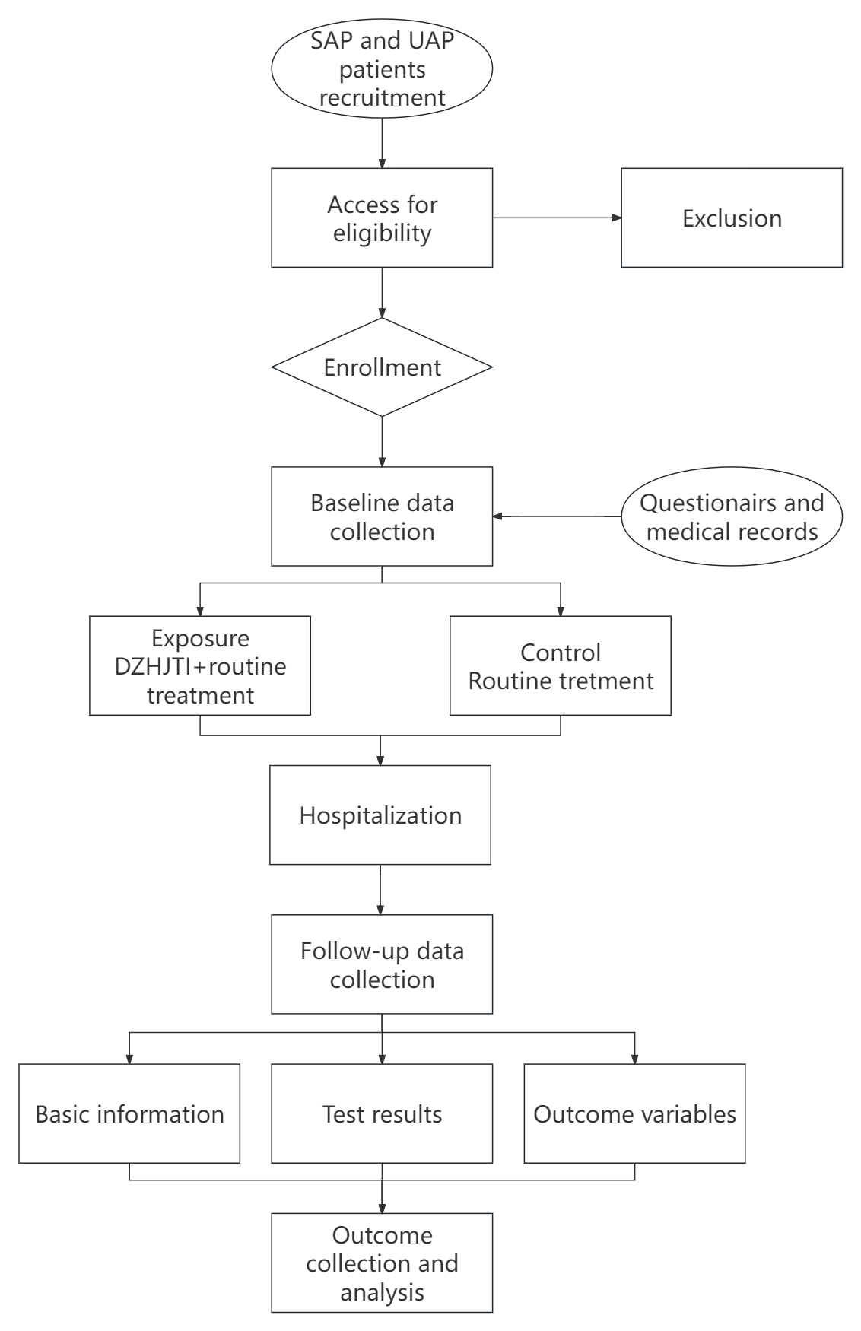
Figure 1 flow chart of study
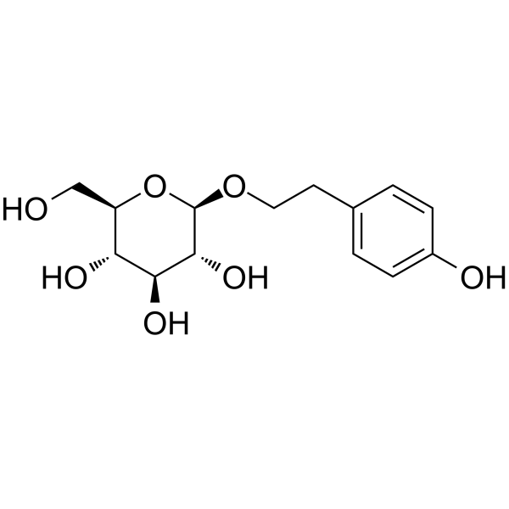
Figure 2 Salidroside molecular formula, C₁₄H₂₀O₇ [9]

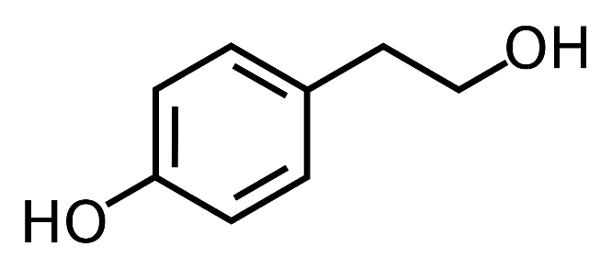

Figure 3 Tyrosol molecular formula, C₈H₁₀O₂ [10]

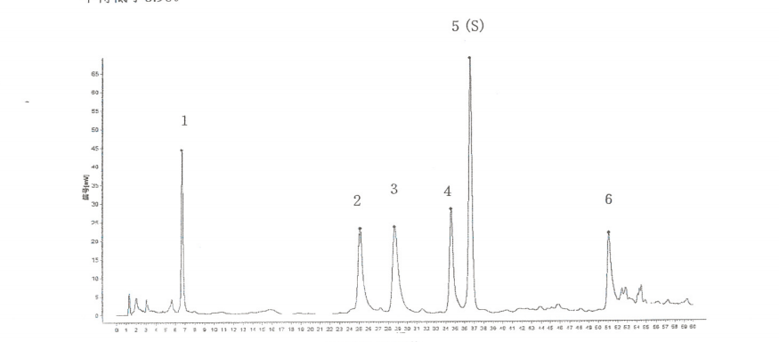
Figure 4 Fingerprint diagram for the extraction of Dazhuhongjingtian. Peak 1: Gallic acid; Peak 2: p-Hydroxybenzoic acid; Peak 3: Tyrosol; Peak 5(S): salidroside; Peak 6: p-Coumaric acid [3]
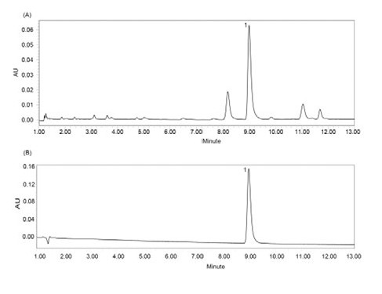
Figure 5 UPLC Chromatogram (275 nm) (A) DZHJT Injection Sample; (B) Reference Substance (1- Salidroside) [4]
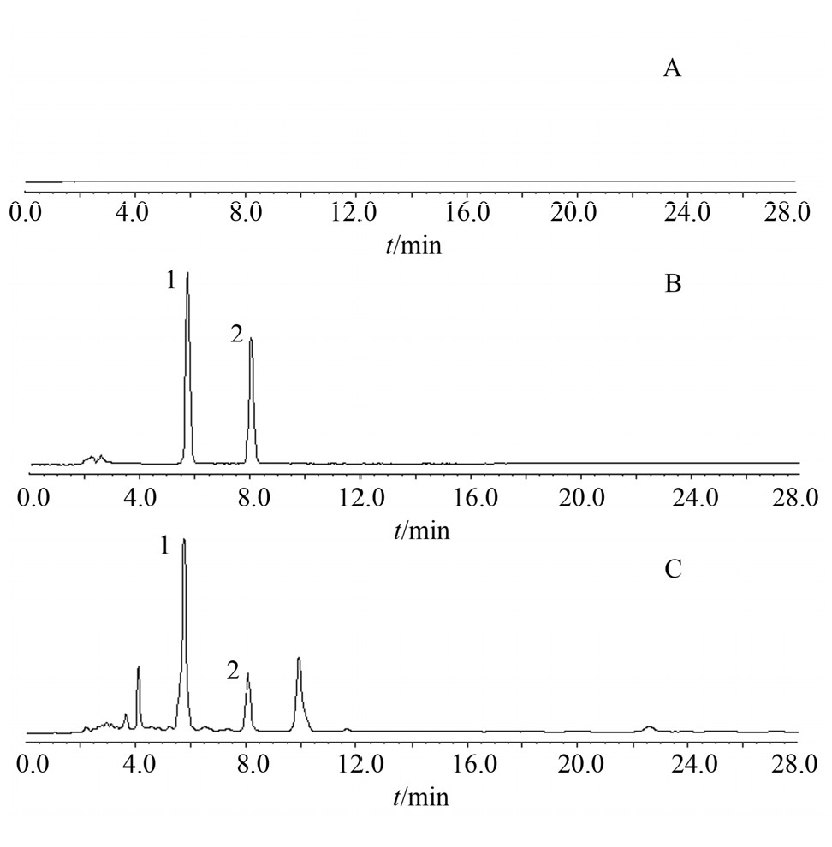
Figure 6 High-performance liquid chromatogram; A: blank control; B: reference standard; C: sample; 1: salidroside; 2: tyrosol [5]

References:
1 Ran N, Pang Z, Guan X, et al. Therapeutic Effect and Mechanism Study of Rhodiola wallichiana var. cholaensis Injection to Acute Blood Stasis Using Metabolomics Based on UPLC-Q/TOF-MS. Evidence-based Complementary and Alternative Medicine 2019;2019. doi:10.1155/2019/1514845
2 Zhuang W, Yue L, Dang X, et al. Rosenroot (Rhodiola): Potential Applications in Aging-related Diseases. Aging Dis 2019;10:134. doi:10.14336/AD.2018.0511
3 National Medical Products Administration. Dazhu Hongjingtian injection [YBZ11852006]. https://www.nmpa.gov.cn/zwfw/sdxx/ypbzbbjfb/index.html. 2022.
4 Du ranran, Li Yue, Liu Liping. [UPLC method to determine the content of salidroside in large plant Rhodiola rosea injection]. Inner Mongolia Traditional Chinese Medicine 2017;36:1.
5 Zhi Xuran, Liu Hongtao, Bai Wanjun, et al. [Study on the Compatibility Stability of Sofren Injection]. Modern Applied Pharmacy in China 2019;36:4.
6 Campeau L. Letter: Grading of angina pectoris. Circulation 1976;54:522–3. doi:10.1161/CIRC.54.3.947585
7 Spertus JA, Winder JA, Dewhurst TA, et al. Development and evaluation of the Seattle Angina questionnaire: A new functional status measure for coronary artery disease. J Am Coll Cardiol 1995;25:333–41. doi:10.1016/0735-1097(94)00397-9
8 He H, Chen G, Gao J, et al. Xue-Fu-Zhu-Yu capsule in the treatment of qi stagnation and blood stasis syndrome: a study protocol for a randomised controlled pilot and feasibility trial. Trials 2018;19:1–8. doi:10.1186/S13063-018-2908-9/FIGURES/1
9 Yu P, Hu C, Meehan EJ, et al. X-ray cyrstal structure and antioxidant activity of salidroside, a phenylethanoid glycoside. Chem Biodivers 2007;4:508–13. doi:10.1002/CBDV.200790043
10 Dionisio KL, Phillips K, Price PS, et al. Data Descriptor: The Chemical and Products Database, a resource for exposure-relevant data on chemicals in consumer products. Sci Data 2018;5. doi:10.1038/SDATA.2018.125

