Supplementary Information
Transparent and High-porosity Aluminum Alkoxide Network-forming Glasses
Zihui Zhang¹, Yingbo Zhao^{1,2,*}
¹School of Physical Science and Technology, ShanghaiTech University, Shanghai, 201210, P. R. China.
²Shanghai Key Laboratory of High-Resolution Electron Microscopy, ShanghaiTech University, Shanghai 201210, China.
*Corresponding authors: zhaoyb2@shanghaitech.edu.cn

Table of Contents
Section S1 Experimental Section S2
Section S2 General Characterization of aluminum alkoxide glasses S5
Section S3 Characterization of Al-BHET S7
Section S4 Characterization of Al-MTBT S11
Section S5 Characterization of Al-BHET-TPTO S14
Section S6 Characterization of Al-BHET-TPTO-2 S18
Section S7 Simulation for Pair-distribution Functions S23
References S25

Section S1 Experimental Section
Equipment and Conditions Used
Powder X-ray diffraction is measured with Rigaku MiniFlex600-C X-ray diffractometer with Cu target. Differential scanning calorimetry is measured with TA DSC250 instrument under nitrogen atmosphere. Nuclear magnetic resonance (NMR) is measured by a Bruker AVANCE III HD500 spectrometer. A solvent mixture of DMSO-D⁶ and D₂O with the addition of KOH was used to digest the aluminum alkoxide glasses. Elemental analysis for oxygen content was carried out on a Perkinelmer SERIES ll 2400 (Clarus 580) elemental analyzer, and the routine C,H,N measurement was carried out with Elementar Vario EL CUBE fully automatic elemental analyzer. The Al element content was determined using Thermo ICP-OES Icap7400 Plasma Emission Spectroscopy. Pair-distribution function is measured with a Rigaku Smartlab Studio II instrument with silver targets, where the scanning range is 3-157 ° and the scanning speed is 0.1 °/min. X-ray absorption spectra was measured at BL02B of Shanghai Light Source with alumina as calibration standard. The scanning electron microscopy images of the samples were captured using JSM-7800F Prime scanning electron microscope.
The sample activation was carried out with Tousimis Samdri-795 critical point dryer and Quantachrome Instruments' Anton Paar brand FloVac degassing station. A MicrotracBEL Belsorp-MAXII high-throughput specific surface area analyzer was used to perform gas and vapor adsorption measurement. N₂ uptake at 77K was measured using a Quantachrome Instruments Autosorb-iQ-MP-AG BET gas adsorption specific surface analyzer. The instrument software VersaWin was used to calculate the BET specific surface area and DFT pore size distribution for all adsorption isotherms. The Anton Paar Ultrapyc 5000 was used to determine the sample's skeleton density.
The Agilent Cary 5000 UV visible near-infrared spectrophotometer was used to measure diffuse reflectance and absorption, while the PerkinElmer TGA 8000 infrared spectrometer was used to obtain the infrared spectra. The fluorescence of Al-MTBT glass was acquired using HORIBA Fluorolog-3 photoluminescence spectrometer with 320 nm excitation.

Materials
Bis(2-hydroxyethyl) terephthalate (BHET) were bought from Sinopharm Wokai. (Methanetetrayltetrakis(benzene-4,1-diyl))tetramethanol (MTBT), 1,1,1-triphenyl-2,5,8,11-tetraoxatridecan-13-ol (TPTO) were bought from Yanshen Technology. Ethanol absolute (EtOH), 1-butanol (n-BuOH), glacial acetic acid (HOAc), tetrahydrofuran (THF), ethylene glycol methyl ether (EGME), acetone, methanol anhydrous (MeOH) were bought from Sinopharm Shanghai Trial. Aluminum sec-butoxide (Al-(OsBu)₃)were bought from Bidepharm. All reagents purchased were used directly without further purification.

Synthesis Procedure for Aluminum Alkoxide Glasses and Composites
Synthesis of Al-BHET
310 mg of BHET (1.22 mmol) is dissolved in 2 mL 1-butanol, 500 μL glacial acetic acid, and 4 mL ethanol in a glass vial placed on a hot plate heated to 120 °C. Then 300 mg Al-(OsBu)₃, (1.22 mmol) is added to this solution, which is stirred overnight on the 120 °C hotplate to get a clear, colorless solution. To ensure the absence of small crystallites and impurities, the solution can be filtered with a 0.45 µm nylon (NY) syringe filter before evaporation in a petri dish pre-heated on a 125 °C hotplate to give the Al-BHET glass.
Synthesis of Al-BHET-TPTO
To 495 mg (1.95 mmol) of BHET and 195 mg (0.45 mmol) of TPTO, 8 mL ethanol, 4 mL 1-butanol, and 1 mL glacial acetic acid are added to give a clear and colorless solution, which is then added to 495 mg (2.01 mmol) Al-(OsBu)₃ and stir overnight at 120 °C hotplate. The Al-BHET-TPTO glass is obtained by evaporating the solution in a petri dish on a hotplate set at 128 °C.
Synthesis of Al-BHET-TPTO-2
Following the steps of Al-BHET-TPTO mentioned above, the mass of BHET was changed to 207.2 mg (0.815 mmol), and the mass of TPTO was changed to 355.8 mg (0.815 mmol).
Table S1. Name, quantity, and feeding percentage of the ready sample
Number | Name | Feed ratio of Al to hydroxyl groups
No 1. | Al-BHET | 1:2
No 2. | Al-BHET-TPTO | 1:2 (n_{OH}BHET:n_{OH}TPTO= 9:1)
No 3. | Al-BHET-TPTO-2 | 1:2 (n_{OH}BHET:n_{OH}TPTO= 2:1)
Synthesis of Al-MTBT
4 mL tetrahydrofuran, 4 mL ethylene glycol methyl ether, 2 mL ethanol and 100 μL glacial acetic acid is added to 120 mg (0.27 mmol) of MTBT to give a clear solution. The solution was then added to 276 mg (1.12 mmol) Al-(OsBu)₃ and stirred overnight at 110 ℃ to give a light-yellow transparent solution. The solution is then evaporated in a petri dish on a hotplate at 135 ℃.
Al/BHET/TPTO series for DSC measurement
To maintain consistency, 30 mg of Al-(OsBu)₃ and 31 mg of BHET (0.122 mmol) are added to a solvent mixture of 400 μL EtOH, 200 μL n-BuOH, and 50 μL HOAc. Different amounts of TPTO is then added to this mixture to give the desirable molar ratio, ranging from 1.065 g (2.44 mmol) to 0.0266 g (0.061 mmol). The solution is then evaporated to give the sample for DSC measurement, with heating rate of 20 ℃/min.
Synthesis of UiO-66@Al-BHET
UiO-66 is synthesized according to literature reports ^{S1}. The UiO-66 is added to the above-mentioned Al-BHET synthesis (200 μL Al-BHET solution per 8 mg UiO-66) and the evaporation vitrification is carried out same as Al-BHET.
Activation
All aluminum alkoxide glasses samples were activated by solvent exchange followed by super-critical CO₂ drying. Al-BHET and Al-MTBT were exchanged three times with tetrahydrofuran, followed by three times with acetone. The Al-BHET-TPTO samples were exchanged with a 1:1 mixture of tetrahydrofuran and ethanol for 4 days, followed by 3 exchanges with acetone. The composite material is directly vacuum dried after three exchanges of tetrahydrofuran. All samples were degassed at 80 ℃ for 2 hours using a degassing station before gas adsorption testing.

Section S2 General Characterization of aluminum alkoxide glasses
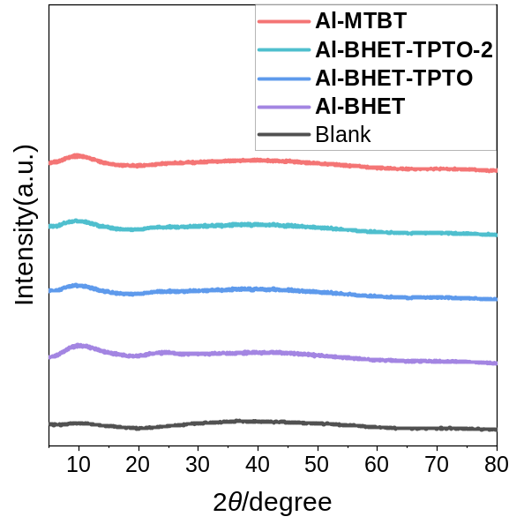
Figure S1. X-ray diffraction pattern of synthesized Al-MOF glass
Table S2. Skeleton density test
Sample Name | Sample weight | Skeleton  density | Average volume | Relative average. deviation.
Al-BHET | 0.1232 g | 1.4108 g/cm³ | 0.0873 cm³ | 0.1878 %
Al-BHET-TPTO | 0.1204 g | 1.4646 g/cm³ | 0.0822 cm³ | 0.2636 %
Al-MTBT | 0.1066 g | 1.3337 g/cm³ | 0.0799 cm³ | 0.2205 %
Table S3. Gas adsorption analysis
Sample Name | Surface Area  (77K N₂) | Pore volume  (195 K CO₂) | Porosity  (195 K CO₂)
Al-BHET | / | 0.1067 cc/g | 13.08 cm³/cm³
Al-BHET-TPTO | 496.904 m²/g | 0.2949 cc/g | 30.16 cm³/cm³
Al-BHET-TPTO-2 | 106.165 m²/g | 0.2443 cc/g | /
Al-MTBT | 362.544 m²/g | 0.2200 cc/g | 22.69 cm³/cm³

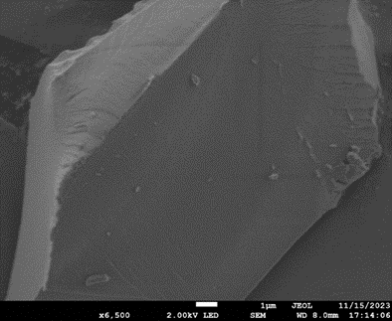
(a) (b)

(c) (d)

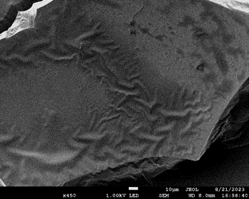
(e) (f)
Figure S2. Scanning electron microscopy image of Al-MOF glass (a is ground Al-BHET, b is Al-MTBT, c and d are Al-BHET-TPTO, e and f are Al-BHET-TPTO-2).

Section S3 Characterization of Al-BHET
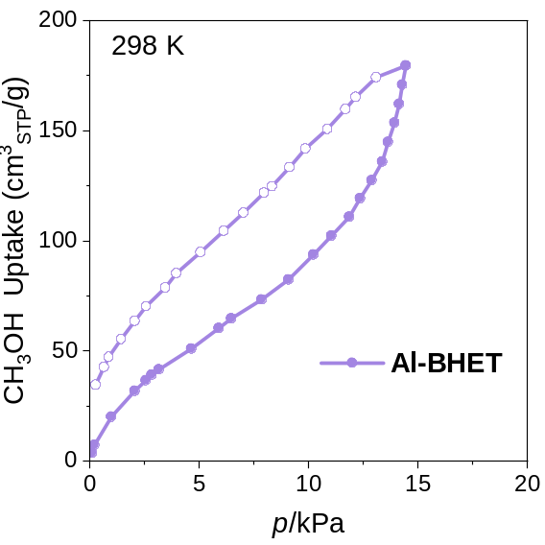
Figure S3. 298 K methanol vapour adsorption on Al-BHET

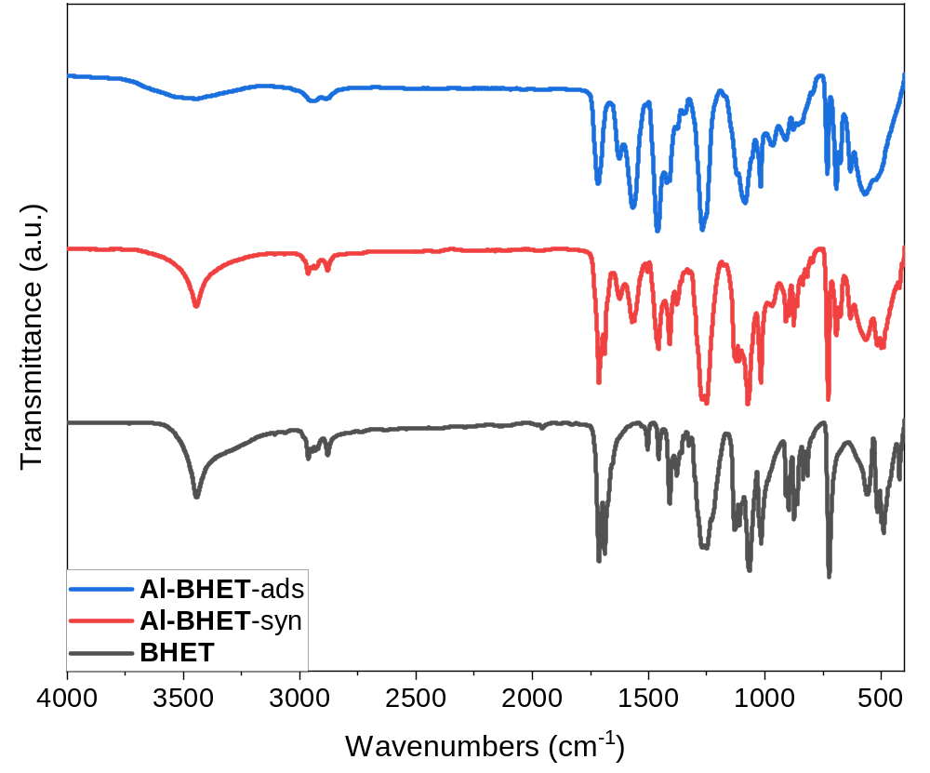
Figure S4. Infrared spectrum of Al-BHET

Figure S5. Al-BHET digestion nuclear magnetic resonance comparison diagram (using a mixed solvent of DMSO-D₆ and D₂O, with the addition of KOH). According to the integration of peak area, the molar ratio of ligand HOAc and BHET in the Al-BHET is HOAc: BHET= 2.25.

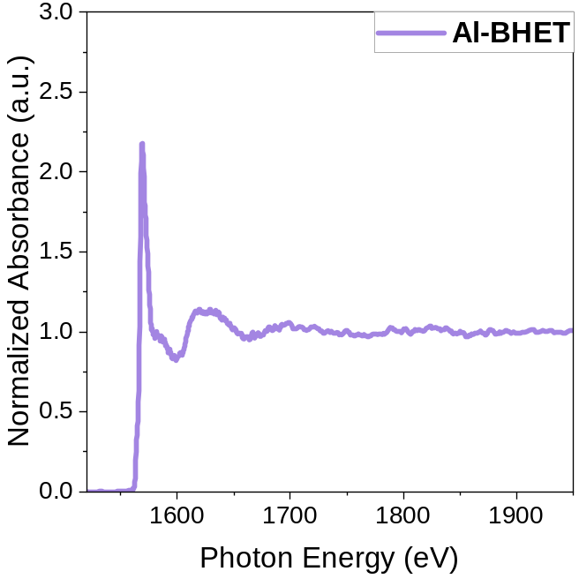
Figure S6. X-ray absorption spectra of Al-BHET glass

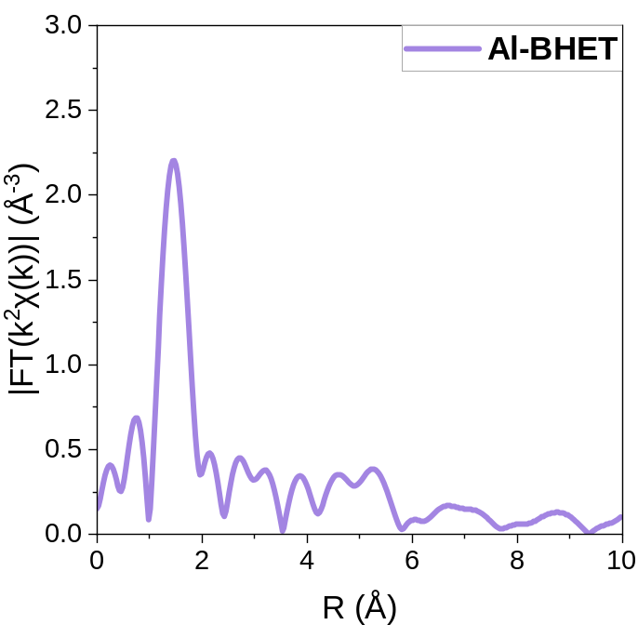
Figure S7. EXAFS spectra of Al-BHET glass

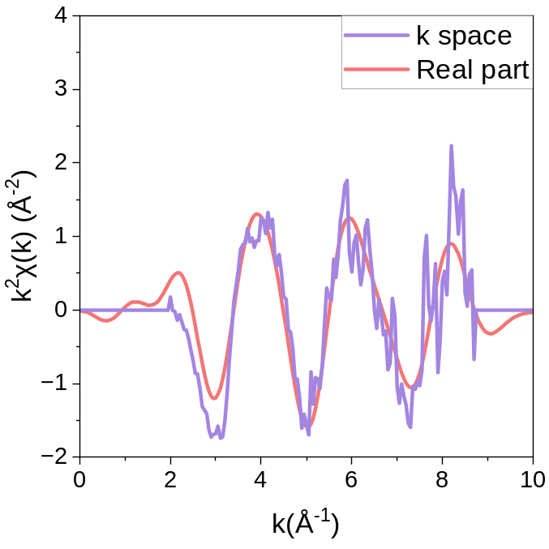
Figure S8. Al-BHET in k and q space

Section S4 Characterization of Al-MTBT
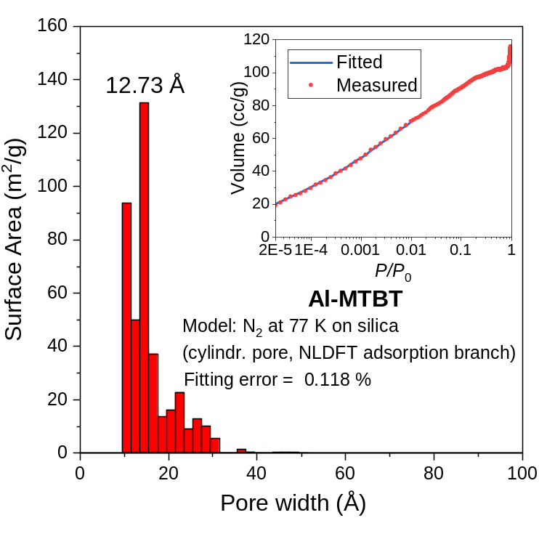
Figure S9. Pore size distribution of Al-MTBT under 77 K nitrogen gas
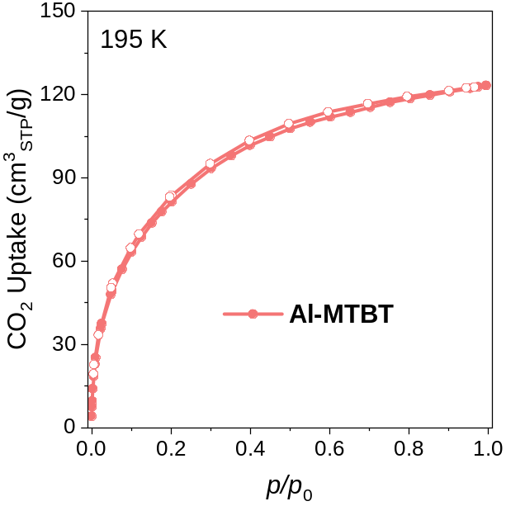
Figure S10. 195 K CO₂ adsorption of Al-MTBT

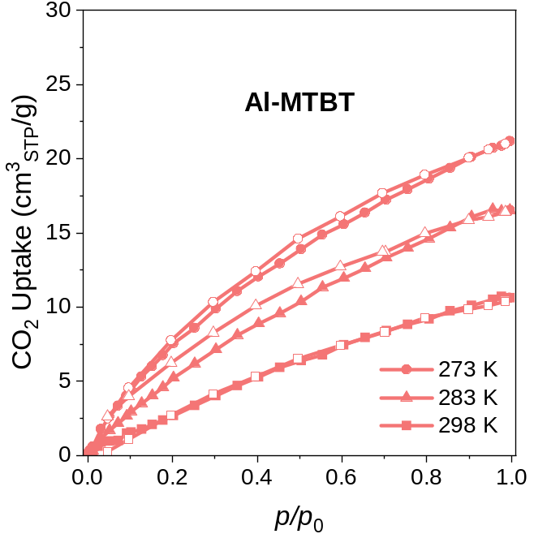
Figure S11. CO₂ adsorption at different temperatures in Al-MTBT

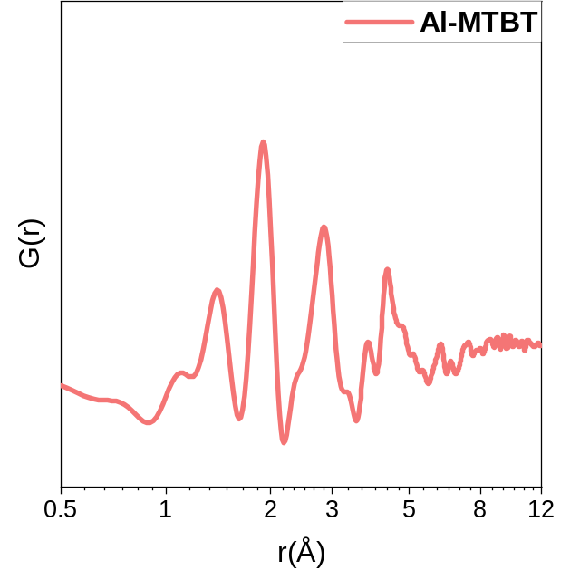
Figure S12. PDF graph of Al-MTBT

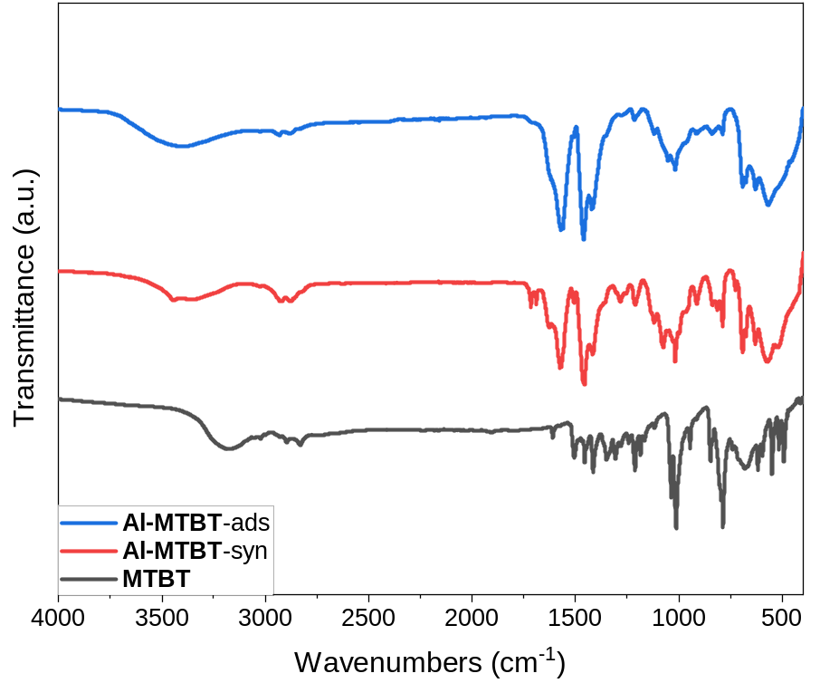
Figure S13. Infrared spectrum of Al-MTBT

Section S5 Characterization of Al-BHET-TPTO
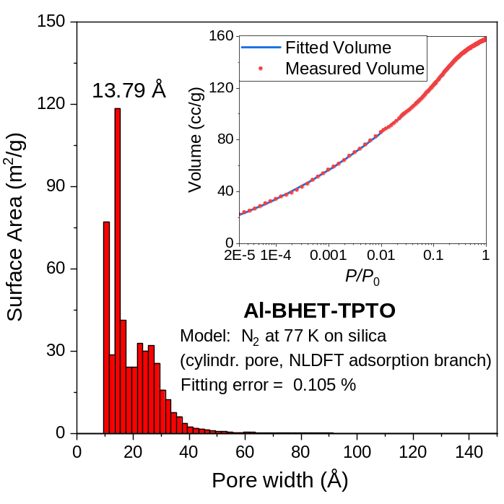
Figure S14. Pore size distribution of Al-BHET-TPTO under 77 K nitrogen gas

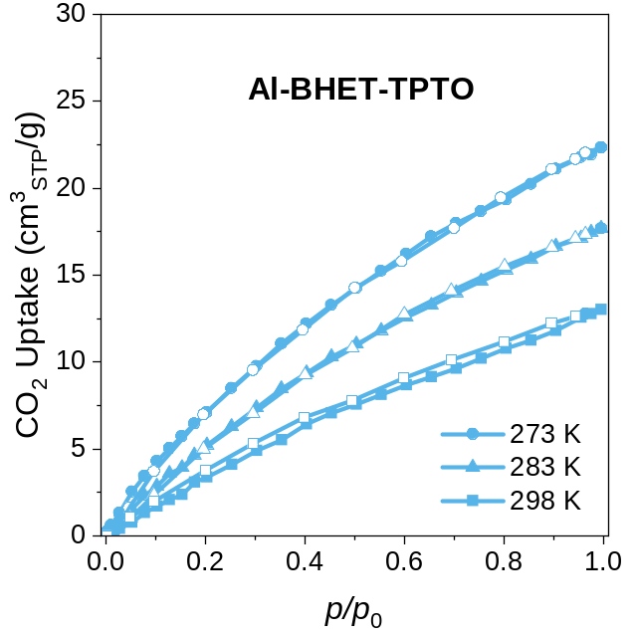
Figure S15. CO₂ adsorption at different temperatures in Al-BHET-TPTO

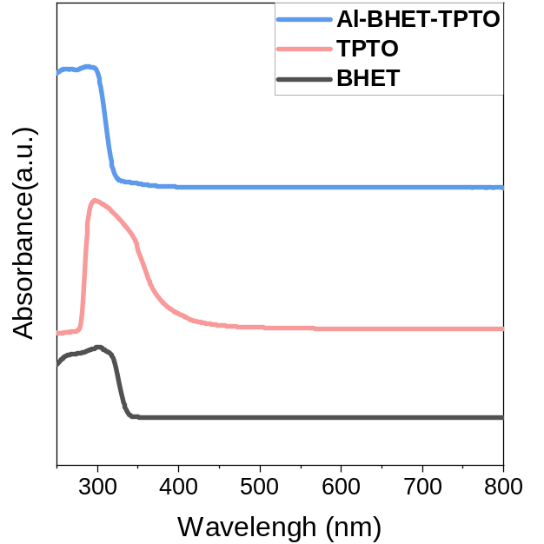
Figure S16. Absorption spectrum of Al-BHET-TPTO

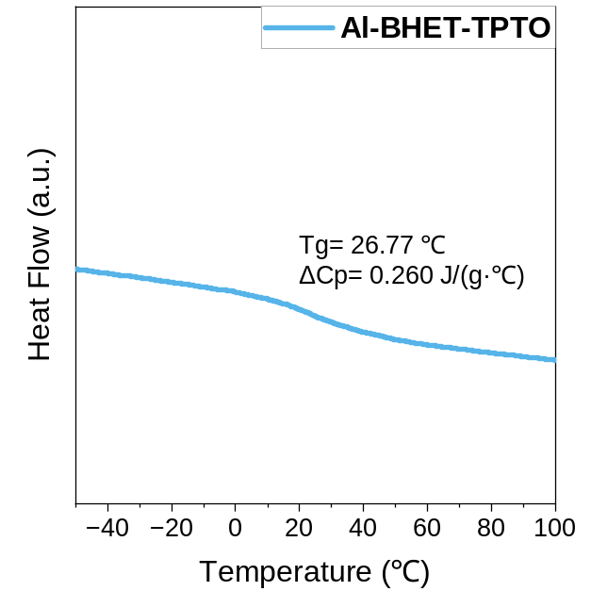
Figure S17. DSC curve and glass transition temperature of Al-BHET-TPTO

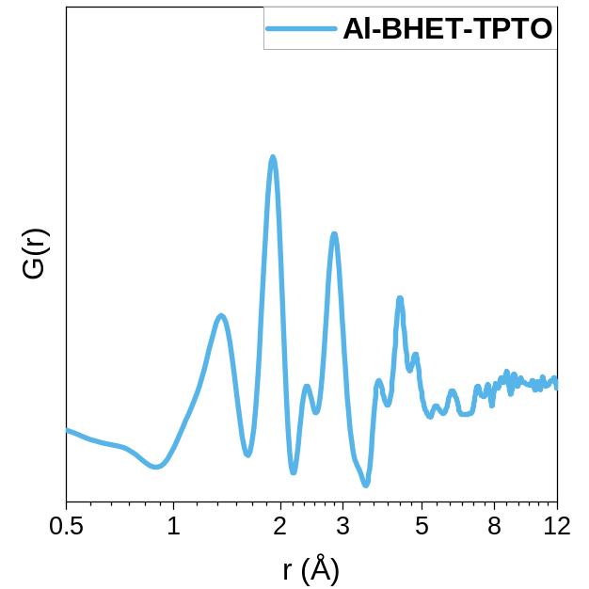
Figure S18. PDF graph of Al-BHET-TPTO
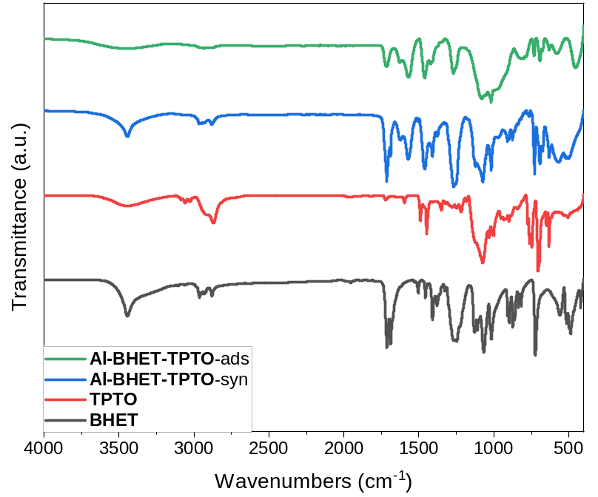
Figure S19. Infrared spectrum of Al-BHET-TPTO
Figure S20. Digestion nuclear magnetic resonance of Al-BHET-TPTO, showing BHET:TPTO=11.72

Section S6 Characterization of Al-BHET-TPTO-2
Figure S21. 77 K N₂ and 195 K CO₂ adsorption of Al-BHET-TPTO-2

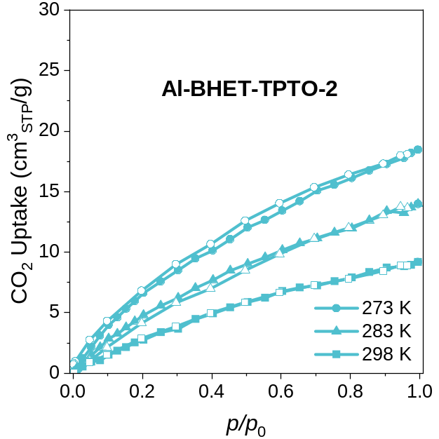
Figure S22. CO₂ adsorption at different temperatures in Al-BHET-TPTO-2

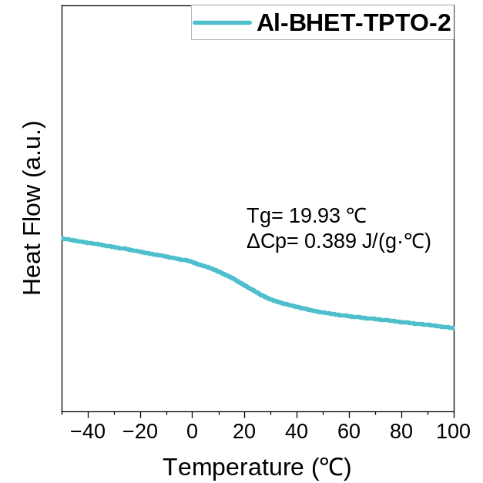
Figure S23. DSC curve and glass transition temperature of Al-BHET-TPTO-2

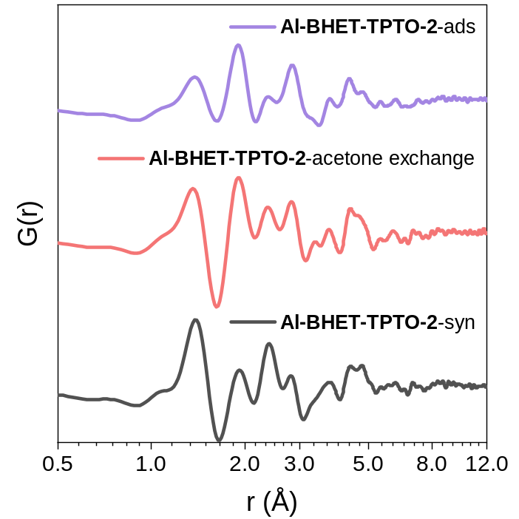
Figure S24. Pair distribution function diagram of Al-BHET-TPTO-2 (Among them, “syn” represents the newly synthesized sample, “acetone exchange” represents the sample after three exchanges with acetone, and “ads” represents the sample after exchange with a 1:1 mixture of tetrahydrofuran: ethanol solution. Unless otherwise specified in the text, it refers to “ads” samples.)
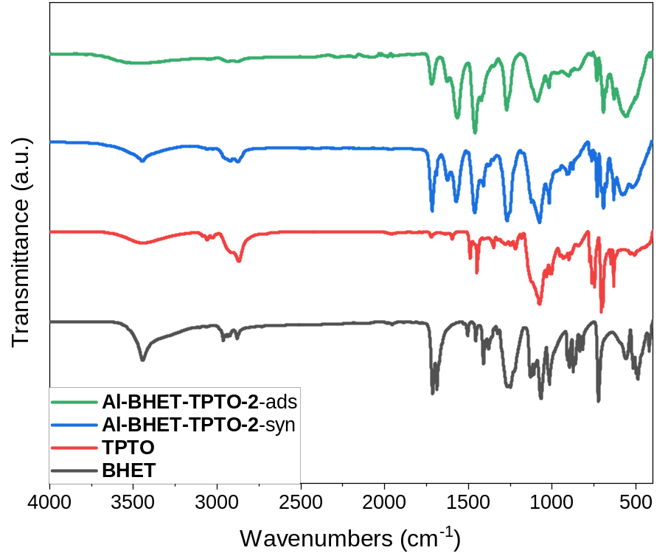
Figure S25. Infrared spectrum of Al-BHET-TPTO-2

Figure S26. Digestion nuclear magnetic resonance of Al-BHET-TPTO-2-acetone exchange, which shows BHET:TPTO=2.63

Figure S27. Digestion nuclear magnetic resonance of Al-BHET-TPTO-2, which shows after acetone exchange, alcohol/acetone mixture exchange and supercritical CO₂ drying, BHET:TPTO=3.1

Section S7 Simulation for Pair-distribution Functions
The PDF simulation for short- and medium range ordering is carried out using I.S.A.A.C.S program ^{S2}. The structure model has its inorganic core adopted from AlOC-41 ¹⁷, which is then attached to BHET as peripheral ligand. Periodic boundary condition was applied in the simulation for simplicity.

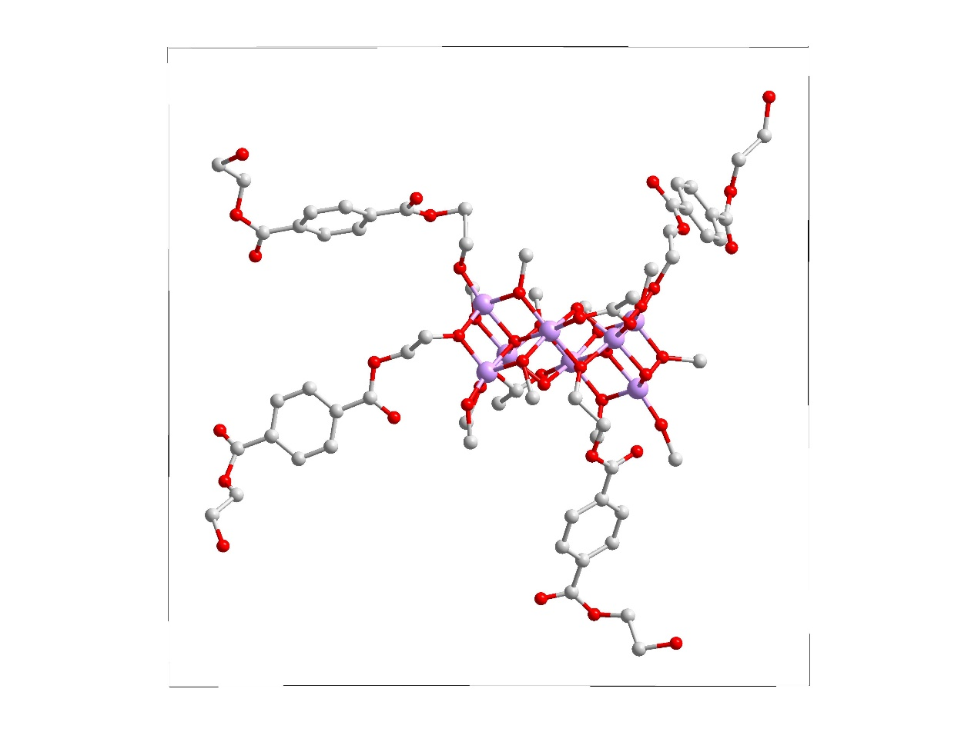
Figure S28. BHET attached to the core of AlOC-41 used for simulating the PDF of Al-BHET that reflects its short- and medium-range order

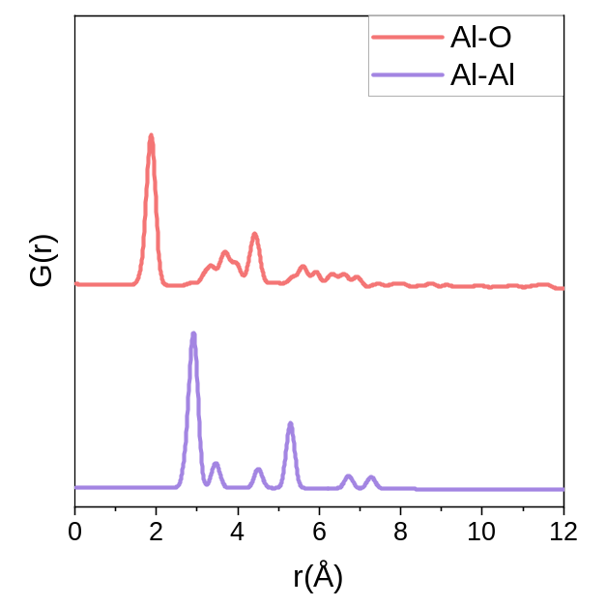
Figure S29. Simulated G(r) in for Al-Al and Al-O pair for the model in fig. S28

References
S1 Lu, G., Cui, C., Zhang, W., Liu, Y. & Huo, F. Synthesis and Self-Assembly of Monodispersed Metal-Organic Framework Microcrystals. Chem. Asian J. 8, 69-72 (2013).
S2 Le Roux, S. & Petkov, V. ISAACS - interactive structure analysis of amorphous and crystalline systems. J. Appl. Crystallogr. 43, 181-185 (2010).

