Author Biographies
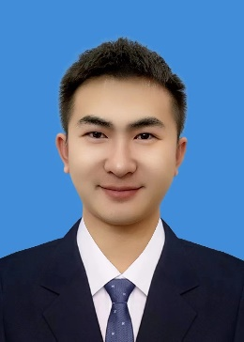
Shen Yifan is currently an associate professor at Liaoning Technical University. He obtained his doctoral degree from Liaoning Technical University in 2022. He obtained a master's degree from Liaoning Technical University in 2019. His main research interest is GNSS-R sea surface altimetry.
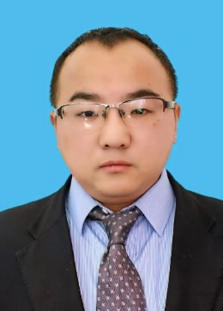
Huizhong Zhu is currently a professor at the Liaoning Technical University. He obtained his Ph.D. degrees from GNSS Research Center of Wuhan University in 2012. His main research interests include GNSS data processing of large-scale networks, GNSS orbit determination, and clock estimation research.
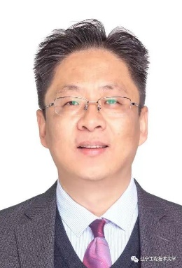
Wei Zheng received the Ph.D. degree from the College of Physics, Huazhong University of Science and Technology, in 2007. From 2007 to2015, he worked as an Associate Research Fellow with the Institute of Geodesy and Geophysics Chinese Academy of Sciences. From 2015 to 2022, he has worked with the Qian Xuesen Laboratory of Space Technology, China Academy of Space Technology, as a research fellow. Since 2022, he has been working with the China Academy of Aerospace Science and Innovation, as a research fellow. His research interests include satellite gravity, underwater integrated navigation, satellite sea surface altimetry, and satellite navigation.
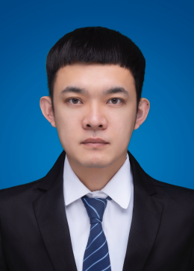
Wang Qiang is a lecturer at Liaoning Technical University. He received his doctoral degree from Liaoning Technical University in 2023. He obtained a master's degree from Liaoning Technical University in 2019. His main research interest is GNSS-R ocean altimetry.

Liang Chen received his master's degree in 2012 and a doctorate in 2020 from Wuhan University and worked as a postdoctoral fellow at Beihang University. He visited the German Research Centre for Geosciences (GFZ) as an academic scholar in 2016. Now he is a professor of Liaoning Technical University. His current research focuses primarily on multi-GNSS PPP, realtime precise clock estimation, precise orbit determination and GNSS wide-area augmentation.
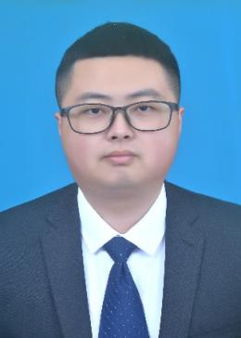
Yuqiang Gui is currently a master’s student at Liaoning Technical University, mainly focuses on GNSS-IR sea surface altimetry ionospheric error correction. His current research foucuses on building oceanic gravity field and data convergence.
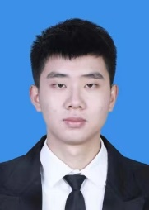
Jianyu Wen is currently a master's student at Liaoning Technical University, mainly focuses on GNSS-IR sea surface altimetry tropospheric error correction and iGNSS-R sea surface altimetry.

