Table 1: Demographics, antenatal history and delivery data.

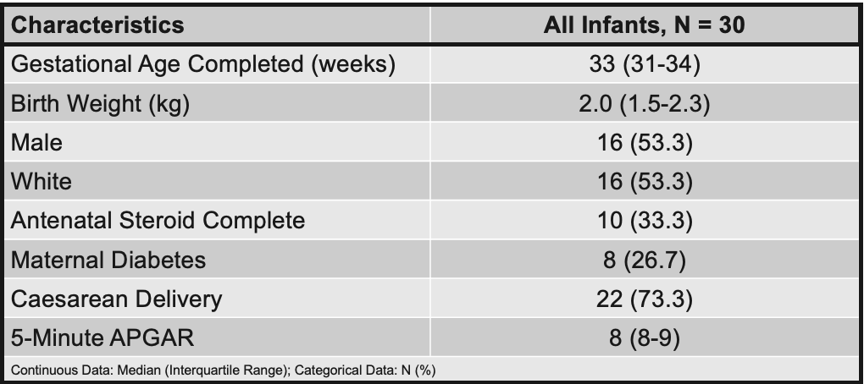

Table 2: Clinical data of enrolled infants.

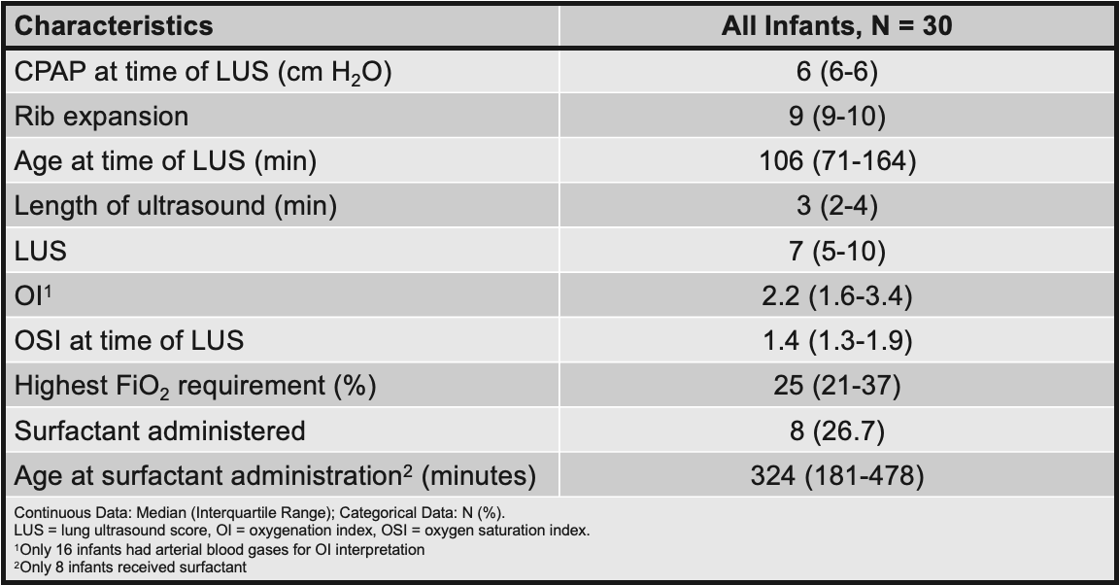

Table 3: Diagnostic accuracy of using a lung ultrasound score >9 for prediction of surfactant administration and FiO2 > 0.3.

