Supporting information –Tables and Figures

TABLE CAPTIONS

Table S1. Foliar Phosphorus (P) and Sulfur (S) composition of various species of Grevillea genus, determined by ICP-MS.
Table S2. Pearson correlation coefficients between physiological elements among the main nutrients for the different organs of Grevillea meisneri (ue: upper epidermis; le: lower epidermis; c: cortex; pe-en: pericycle and endodermis layers; p: phloem). Correlation P-value are all ≤ 0.0001, except when indicated. Values of Pearson correlation coefficient higher than 0.5 are indicated in bold.

FIGURE CAPTIONS

Figure S1. Micro-XRF maps of Cl, Mg, P and S for a frozen hydrated leaf margin cross section of Grevillea. meisneri. The pixel size is 3 μm. The intensity scales are different between elements. c, cuticle; le, lower epidermis; pm, palisade mesophyll; sm, spongy mesophyll, ue, upper mesophyll.
Figure S2. Micro-XRF maps of Mn, Ca, Cl, K, Mg, P and S for a frozen hydrated leaf mid-rib cross section of Grevillea meisneri. The pixel size is 3 μm. The intensity scales are different between elements. le, lower epidermis; pm, palisade mesophyll; sm, spongy mesophyll; ue, upper epidermis; vb, vascular bundles.
S
Figure S3. Micro-XRF maps of Cl, Mg, P and S for a frozen hydrated stem cross section of Grevillea meisneri. The pixel size is 3 μm. The intensity scales are different between elements. c, cortex; mr, medullary ray; p, phloem; pi, pith; pd, periderm; x, xylem.
Figure S4. Micro-XRF maps of Cl, Mg, P and S for a frozen hydrated primary root cross section of Grevillea meisneri. The pixel size is 3 μm. The intensity scales are different between elements. c, cortex; mr, medullary ray; p, phloem; pd, periderm; x, xylem.
Figure S5. Micro-XRF maps of Mn, Ca, Cl, K, Mg, P and S for a frozen hydrated young root cross section of Grevillea meisneri. The pixel size is 3 μm. The intensity scales are different between elements. c, cortex; e, epidermis; p, phloem; pe-en, pericycle-endodermis; x, xylem.
Figure S6. Micro-XRF maps of Mn, K, Cl, Mg, P, S and Cr for a frozen hydrated cluster root cross section of G. meisneri. The pixel size is 3 μm. The intensity scales are different between elements. Pixel intensities on Mn and K maps were over-increased to observed cluster rootlets. c, cortex; cr, cluster rootlet; p, phloem; pe-en, pericycle-endodermis; x, xylem. Asterisks indicate soil particles.
Figure S7. PCA analysis for element localization (normalized XRF signal) on cross-section of lower epidermis of a Grevillea meisneri leaf.

Table S1. Foliar Phosphorus (P) and Sulfur (S) composition of various species of Grevillea genus, determined by ICP-MS.
 | Composition (ppm (%RSD))
 | P | S
Grevillea meisneri leaves | 228.79 (2.15) | 1294.50 (6.48)
Grevillea gillivrayi leaves | 240.56 (2.35) | 1816.94 (11.23)
Grevillea exul ssp. exul leaves | 282.99 (1.26) | 2561.52 (15.03)
Grevillea ‘rosa jenkinsii’ leaves | 1183.58 (0.83) | 2232.81 (8.00)

Table S2. Pearson correlation coefficients between physiological elements among the main nutrients for the different organs of Grevillea meisneri (ue: upper epidermis; le: lower epidermis; c: cortex; pe-en: pericycle and endodermis layers; p: phloem). Correlation P-value are all ≤ 0.0001, except when indicated. Values of Pearson correlation coefficient higher than 0.5 are indicated in bold.
 | Leaf margin |  | Leaf mid-rib |  | Stem | Primary root | Cluster parent root
 | ue | le | ue | le | c | c | pe-en | p
Ca/Cl | 0.72 | 0.59 | 0.36 | 0.49 | 0.29 | 0.45 | 0.44 | 0.83
Ca/K | 0.48 | 0.63 | 0.51 | 0.53 | 0.42 | 0.41 | 0.59 | 0.83
Ca/Mg | 0.68 | 0.36 | 0.76 | 0.45 | 0.53 | 0.35 | 0.61 | 0.36
Ca/P | 0.69 | 0.48 | 0.40 | 0.42 | 0.42 | 0.32 | 0.62 | 0.06#
Ca/S | 0.69 | 0.54 | 0.49 | 0.53 | 0.65 | 0.47 | 0.57 | 0.22
Cl/K | 0.68 | 0.69 | 0.90 | 0.90 | 0.77 | 0.81 | 0.70 | 0.90
Cl/Mg | 0.56 | 0.46 | 0.38 | 0.41 | 0.24 | 0.34 | 0.47 | 0.55
Cl/P | 0.70 | 0.70 | 0.47 | 0.59 | 0.28 | 0.42 | 0.44 | 0.38
Cl/S | 0.85 | 0.79 | 0.68 | 0.75 | 0.33 | 0.20 | 0.55 | 0.52
K/Mg | 0.42 | 0.29 | 0.49 | 0.43 | 0.39 | 0.34 | 0.49 | 0.54
K/P | 0.28 | 0.44 | 0.54 | 0.62 | 0.41 | 0.50 | 0.68 | 0.45
K/S | 0.64 | 0.60 | 0.58 | 0.78 | 0.46 | 0.20 | 0.78 | 0.55
Mg/P | 0.50 | 0.52 | 0.37 | 0.34 | 0.40 | 0.26 | 0.64 | 0.47
Mg/S | 0.55 | 0.52 | 0.46 | 0.45 | 0.44 | 0.21 | 0.63 | 0.48
P/S | 0.67 | 0.78 | 0.40 | 0.59 | 0.39 | 0.20 | 0.75 | 0.80
# P-value: 0.07

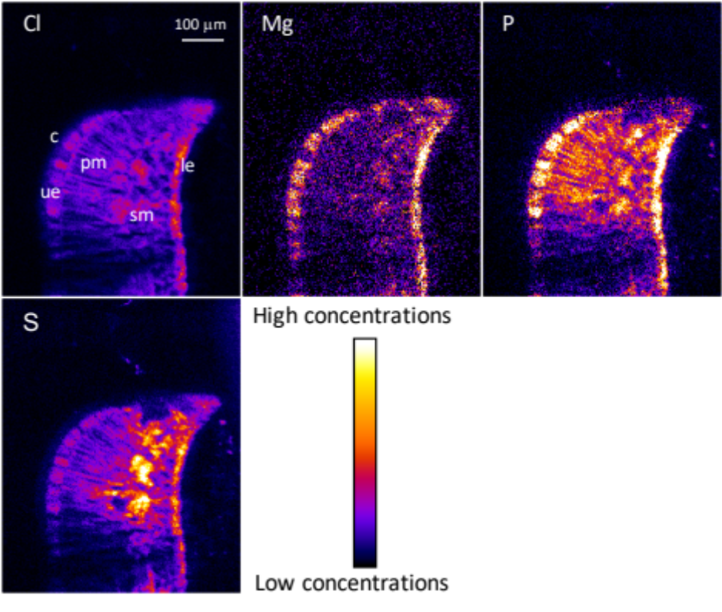
Figure S1.Micro-XRF maps of Cl, Mg, P and S for a frozen hydrated leaf margin cross section of Grevillea. meisneri. The pixel size is 3 μm. The intensity scales are different between elements. c, cuticle; le, lower epidermis; pm, palisade mesophyll; sm, spongy mesophyll, ue, upper mesophyll.

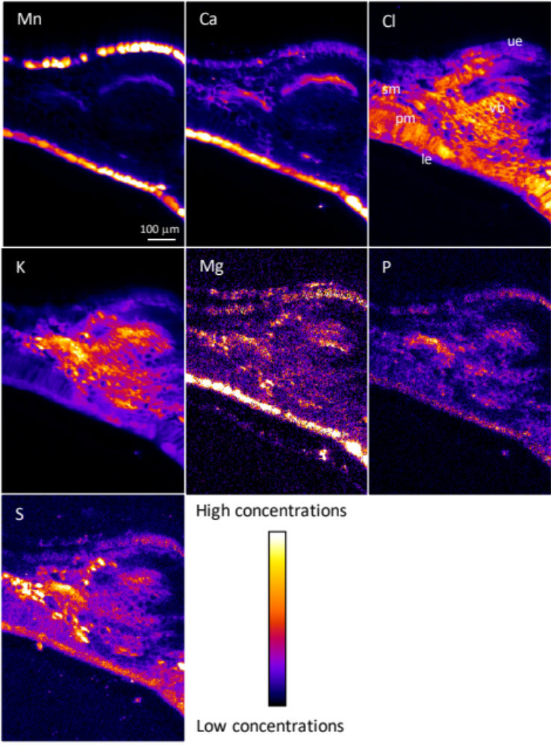
Figure S2. Micro-XRF maps of Mn, Ca, Cl, K, Mg, P and S for a frozen hydrated leaf mid-rib cross section of Grevillea meisneri. The pixel size is 3 μm. The intensity scales are different between elements. le, lower epidermis; pm, palisade mesophyll; sm, spongy mesophyll; ue, upper epidermis; vb, vascular bundles.
S

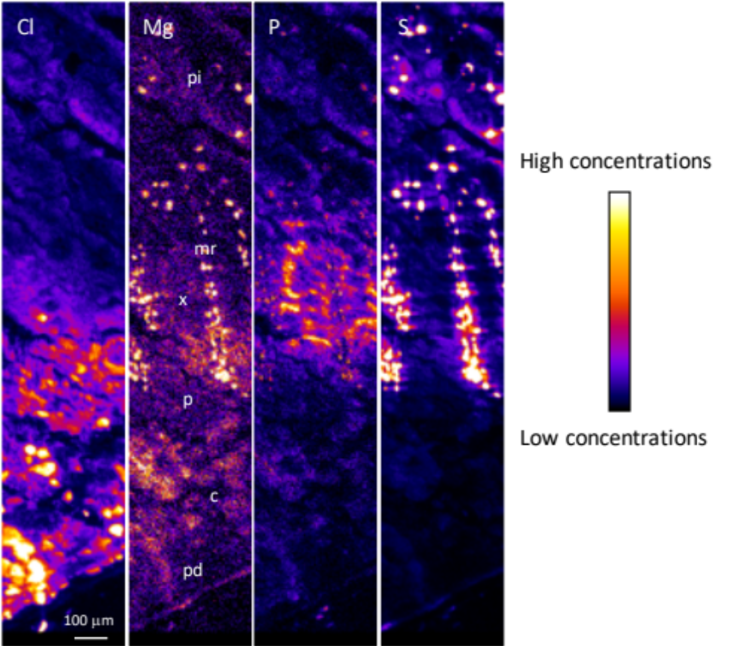
Figure S3. Micro-XRF maps of Cl, Mg, P and S for a frozen hydrated stem cross section of Grevillea meisneri. The pixel size is 3 μm. The intensity scales are different between elements. c, cortex; mr, medullary ray; p, phloem; pi, pith; pd, periderm; x, xylem.

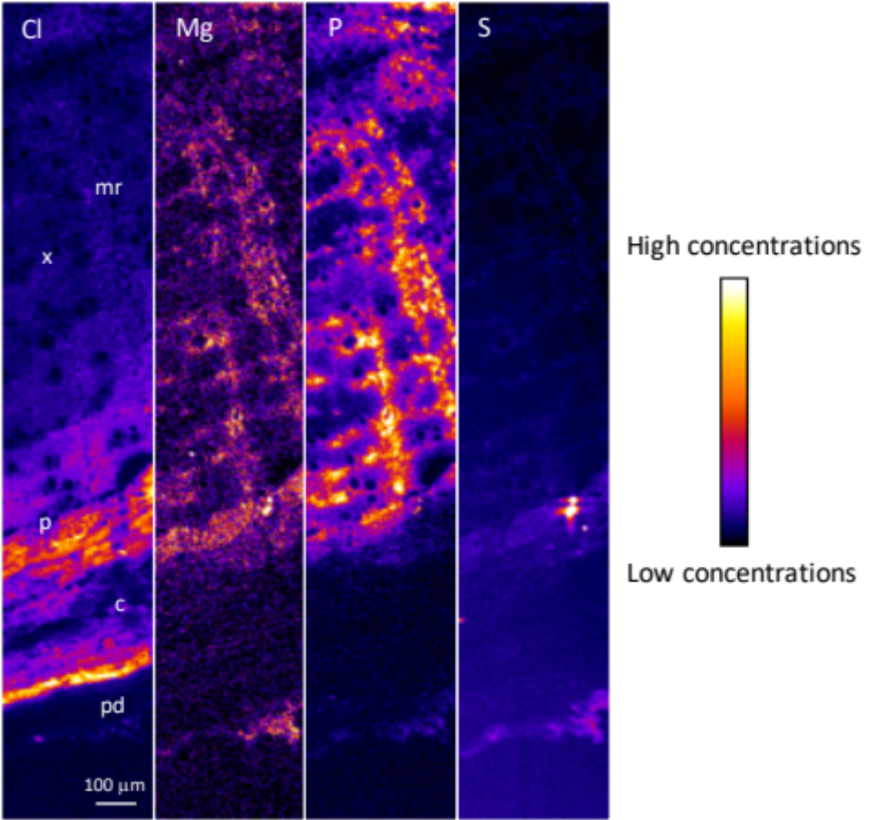
Figure S4. Micro-XRF maps of Cl, Mg, P and S for a frozen hydrated primary root cross section of Grevillea meisneri. The pixel size is 3 μm. The intensity scales are different between elements. c, cortex; mr, medullary ray; p, phloem; pd, periderm; x, xylem.

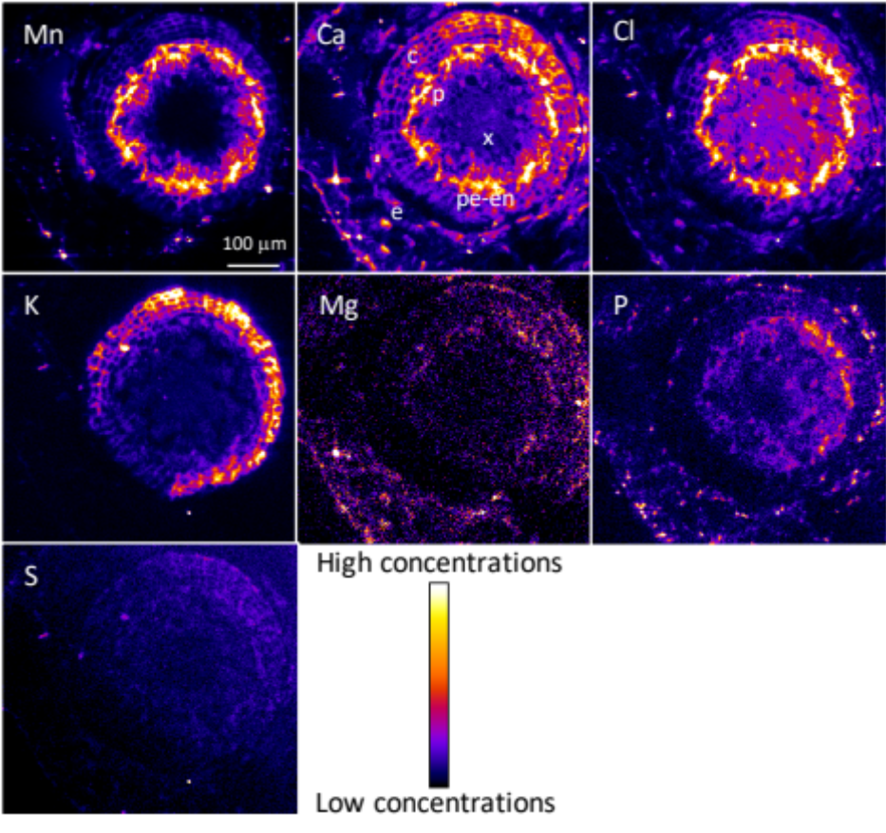
Figure S5. Micro-XRF maps of Mn, Ca, Cl, K, Mg, P and S for a frozen hydrated young root cross section of Grevillea meisneri. The pixel size is 3 μm. The intensity scales are different between elements. c, cortex; e, epidermis; p, phloem; pe-en, pericycle-endodermis; x, xylem.

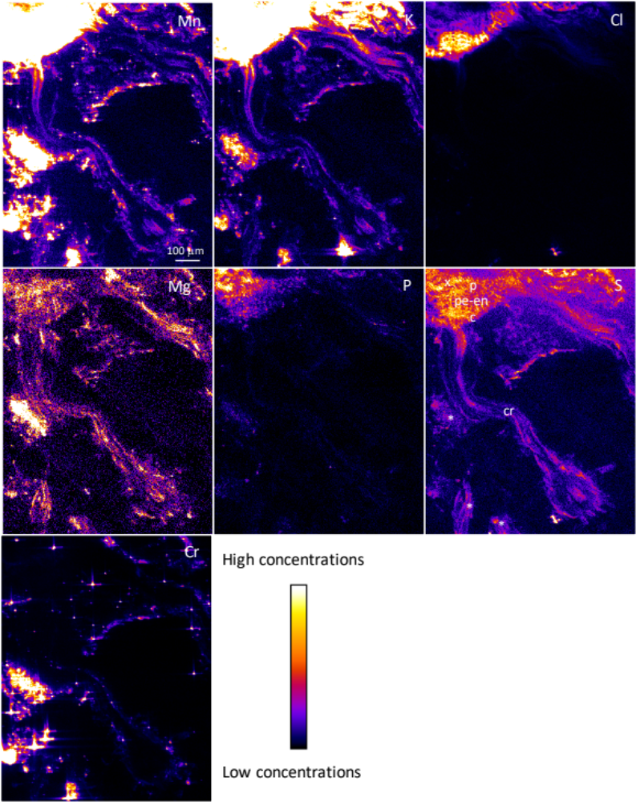
Figure S6. Micro-XRF maps of Mn, K, Cl, Mg, P, S and Cr for a frozen hydrated cluster root cross section of G. meisneri. The pixel size is 3 μm. The intensity scales are different between elements. Pixel intensities on Mn and K maps were over-increased to observed cluster rootlets. c, cortex; cr, cluster rootlet; p, phloem; pe-en, pericycle-endodermis; x, xylem. Asterisks indicate soil particles.

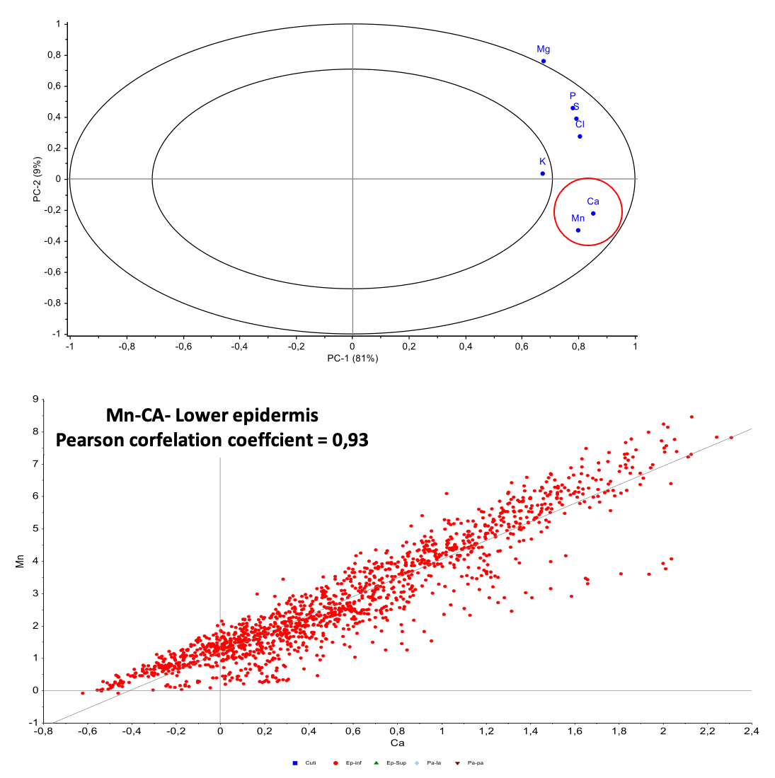

Figure S7. PCA analysis for element localization (normalized XRF signal) on cross-section of lower epidermis of a Grevillea meisneri leaf.

