Supplementary Fig 1. CRISPR/Cas9-mediated TP53KO-eHEPOs.
A The flow cytometry results represent GFP positive cells percentage 24h later of the gRNA transfection (top). Cell viability was assessed by counting DAPI-negative cells (bottom). B The schematic representation of sanger sequence results for the other growing clones, B2, B5, B6, B8, D2. The arrow indicates Adenine nucleotide insertion followed by PAM sequence. C IHC staining of H&E, Ki67 and P53 in the other clones, B2, B5, B6, D2.

Supplementary Fig. 2. Transcriptome of eHEPOs
A Light microscope images of eHEPOs prior to RNAseq. B-C The dot plot of selected WT or TP53KO-eHEPO enriched signal pathways. The figure represents the minus multiplication value of the NES score. D The heatmap of Yamashita’s EpCAM upregulated liver cancer subclass (log (matrix values), default (logFC), p ≤ 0.05). E-F The dot plot of selected Cell Cycle & Apoptosis and Metabolism related enriched signal pathways. The figure represents the minus multiplication value of the NES score.

Supplementary Fig. 3. pc-ME production and validation.
A The schematic showing of the production of activated LX-2 stellate cell secretome (left), LX-2 cells before and after induction TGFB (10uM, 24h) (middle), and confirmation with qPCR markers specific for activated LX-2 stellar cells (right). B The schematic showing the production M2 polarized macrophage cell secretome (top), THP1, MO and M2 cells before and after induction (bottom-left), and confirmation with qPCR markers specific for M2 macrophages (bottom-right). C The IF staining of TP53KO-eHEPOs at passage 3-5 and 8. (Scale: 50 um) D Masson’s trichrome staining of other two TP53KO-eHEPO clones, B2, B8

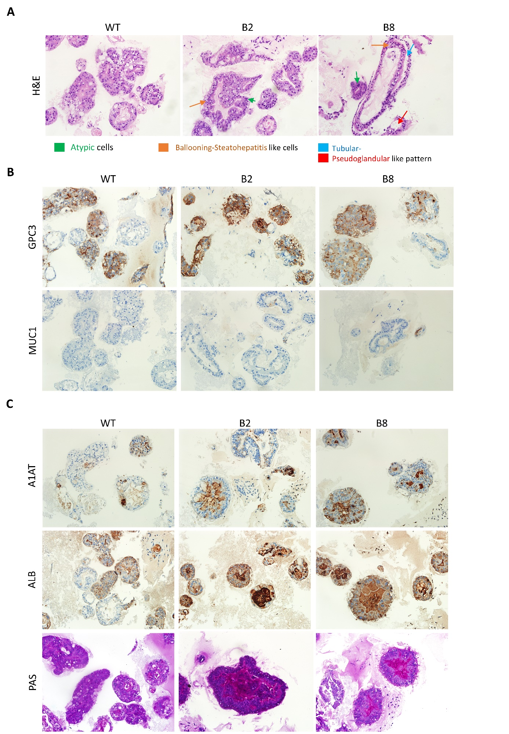

Supplementary Fig. 4. IHC staining of the other two TP53KO-eHEPO clones B2 and B8
A Images represent H&E staining in WT and p53KO clones. B Liver cancer initiation markers GPC3 and MUC1 C Differentiation related PAS, ALB and A1AT IHC staining in TP53KO-eHEPO clones B2 and B8. All figures represent similar scale size with the main figure and 10x zoom.

Supplementary Fig. 5. Stem cell and DNA damage in TP53KO-eHEPOs
A The flow cytometry of the CD44, CD133, CD24 and CD90 surface markers at EM and day 12 for DM and iDM medium. Plots prepared in Flowjo software (n = 3). B The IF staining of DNA damage, H2AX-ser139 and cell death, cleaved-caspase3, markers in WT and TP53KO-eHEPOs (Scales: 50 um).

Supplementary Fig. 6. Kaplan Meier Plots of TP53KO-eHEPOs
The overall survival (OS) Kaplan meier plots of the selected genes related with A Fibrosis B Inflammation C ECM modification and D Tumorigenesis gene set enriched in the TP53KO-eHEPOs. All plots employing median and auto-select best cutoff parameters [1]. Blue frame around COL1A1 represents a non-significant P value.

Reference:
1. Menyhart O, Nagy A, Gyorffy B. Determining consistent prognostic biomarkers of overall survival and vascular invasion in hepatocellular carcinoma. R Soc Open Sci., 2018 Dec 5;5(122):181006. doi: 10.1098/rsos.181006.

