Supplemental Table 1A. Pearson correlation among epigenetic clocks and chronological age
Epigenetic clocks | Age | HorvathAge | HannumAge | PhenoAge | GrimAge
Age | 1.00
HorvathAge | 0.73 | 1.00
HannumAge | 0.81 | 0.77 | 1.00
PhenoAge | 0.73 | 0.66 | 0.75 | 1.00
GrimAge | 0.83 | 0.64 | 0.76 | 0.74 | 1.00
All correlations had P < 0.05

Supplemental Table 1B. Pearson correlation among epigenetic age acceleration measures and chronological age
Epigenetic age acceleration | Age | HorvathAA | HannumAA | PhenoAA | GrimAA | DunedinPACE
Age | 1.00
HorvathAA | -0.006 | 1.00
HannumAA | -0.003 | 0.43 | 1.00
PhenoAA | 0.006 | 0.28 | 0.42 | 1.00
GrimAA | -0.001 | 0.10 | 0.26 | 0.35 | 1.00
DunedinPACE | 0.104 | -0.03 | 0.21 | 0.38 | 0.60 | 1.00
All correlations had P < 0.05, except for HorvathAA and DunedinPACE (P=0.084).

Supplemental Table 2. Associations between demographic factors and blood lipids
Blood lipids | TC |  |  | ln(HDL-C) |  |  | LDL-C |  |  | ln(TG)
 | βª | SE | P | βª | SE | P | βª | SE | P | βª | SE | P
Age | -0.742 | 0.070 | 1.09×10⁻¹³ | -0.001 | 0.001 | 0.109 | -0.498 | 0.067 | 2.59×10⁻⁹ | -0.003 | 0.001 | 0.014
Female Sex | 17.874 | 1.247 | 3.42×10⁻¹⁸ | 0.224 | 0.011 | 8.84×10⁻²⁴ | 6.600 | 1.138 | 6.66×10⁻⁷ | -0.022 | 0.017 | 0.191
Educational attainment (ref=less than high school degree)
High school degree or equivalent | -0.982 | 2.411 | 0.696 | 0.061 | 0.017 | 0.001 | -2.526 | 2.154 | 0.247 | -0.057 | 0.034 | 0.101
College degree and above | -0.318 | 3.103 | 0.919 | 0.116 | 0.021 | 1.38×10⁻⁶ | -2.061 | 2.967 | 0.491 | -0.135 | 0.038 | 0.001
TC, total cholesterol; HDL-C, high-density lipoprotein; LDL-C, low-density lipoprotein; TG, triglycerides
Model: blood lipid level ~ age at methylation measurement + sex + race/ethnicity + fasting status + lipid-lowering medication use + body mass index + smoking status + educational attainment (less than high school, high school degree or equivalent, college degree and above)
ªβ corresponds to the change in blood lipid level associated with a 1-year increase in age, being a female compared with male, having a high school degree or equivalent compared with having less than high school degree, or having a college degree and above compared with having less than high school degree, respectively.
P-value < 0.05 in bold

Supplemental Table 3. Associations between epigenetic age acceleration and blood lipids in the full sample and stratified by racial/ethnic group
 | Overall (n=3,813) |  |  | Non-Hispanic White (n=2,563) |  |  | Non-Hispanic Black (n=622) |  |  | Hispanic (n=509)
 | βª | SE | P | βª | SE | P | βª | SE | P | βª | SE | P
TC
HorvathAA | 0.181 | 0.110 | 0.107 | 0.141 | 0.127 | 0.275 | -0.157 | 0.243 | 0.521 | 0.094 | 0.299 | 0.757
HannumAA | -0.261 | 0.112 | 0.024 | -0.363 | 0.135 | 0.010 | -0.117 | 0.357 | 0.745 | 0.188 | 0.509 | 0.716
PhenoAA | -0.195 | 0.103 | 0.065 | -0.240 | 0.131 | 0.073 | -0.248 | 0.268 | 0.360 | -0.033 | 0.330 | 0.921
GrimAA | -0.656 | 0.191 | 0.001 | -0.615 | 0.210 | 0.005 | -1.025 | 0.470 | 0.037 | -0.648 | 0.693 | 0.362
DunedinPACE | -38.74 | 4.417 | 3.95×10⁻¹¹ | -35.338 | 4.878 | 4.43×10⁻⁹ | -29.27 | 11.69 | 0.017 | -55.64 | 18.39 | 0.007
ln(HDL-C)
HorvathAA | 0.001 | 0.001 | 0.533 | 0.001 | 0.001 | 0.256 | -0.001 | 0.002 | 0.439 | -0.001 | 0.002 | 0.450
HannumAA | -0.002 | 0.001 | 0.050 | -0.002 | 0.001 | 0.185 | -0.004 | 0.003 | 0.169 | -0.004 | 0.002 | 0.088
PhenoAA | -0.002 | 0.001 | 0.017 | -0.002 | 0.001 | 0.059 | -0.003 | 0.002 | 0.117 | 4.40×10⁻⁴ | 0.003 | 0.863
GrimAA | -0.009 | 0.002 | 2.44×10⁻⁵ | -0.008 | 0.002 | 0.001 | -0.010 | 0.004 | 0.031 | -0.006 | 0.004 | 0.177
DunedinPACE | -0.447 | 0.044 | 4.08×10⁻¹³ | -0.444 | 0.048 | 6.61×10⁻¹² | -0.546 | 0.135 | 3.04×10⁻⁴ | -0.200 | 0.103 | 0.069
LDL-C
HorvathAA | 0.084 | 0.089 | 0.352 | 0.024 | 0.096 | 0.805 | 0.047 | 0.225 | 0.835 | -0.072 | 0.285 | 0.804
HannumAA | -0.202 | 0.106 | 0.064 | -0.312 | 0.131 | 0.021 | 0.011 | 0.282 | 0.969 | 0.230 | 0.456 | 0.620
PhenoAA | -0.220 | 0.090 | 0.018 | -0.221 | 0.110 | 0.050 | -0.350 | 0.250 | 0.170 | -0.237 | 0.280 | 0.409
GrimAA | -0.619 | 0.166 | 0.001 | -0.568 | 0.188 | 0.004 | -1.062 | 0.312 | 0.002 | -0.716 | 0.579 | 0.232
DunedinPACE | -27.87 | 4.882 | 9.69×10⁻⁷ | -24.200 | 5.060 | 1.89×10⁻⁵ | -19.49 | 9.151 | 0.041 | -58.68 | 17.36 | 0.003
ln(TG)
HorvathAA | 0.001 | 0.002 | 0.378 | 0.001 | 0.002 | 0.580 | -0.005 | 0.003 | 0.054 | 0.005 | 0.004 | 0.155
HannumAA | 0.002 | 0.002 | 0.241 | 0.001 | 0.002 | 0.596 | 0.005 | 0.003 | 0.145 | 0.010 | 0.004 | 0.020
PhenoAA | 0.004 | 0.002 | 0.012 | 0.003 | 0.002 | 0.127 | 0.007 | 0.002 | 0.003 | 0.005 | 0.004 | 0.281
GrimAA | 0.012 | 0.003 | 3.89×10⁻⁵ | 0.010 | 0.003 | 0.006 | 0.018 | 0.006 | 0.004 | 0.009 | 0.007 | 0.249
DunedinPACE | 0.409 | 0.073 | 1.35×10⁻⁶ | 0.379 | 0.083 | 4.11×10⁻⁵ | 0.789 | 0.131 | 9.45×10⁻⁷ | 0.139 | 0.210 | 0.515
TC, total cholesterol; HDL-C, high-density lipoprotein; LDL-C, low-density lipoprotein; TG, triglycerides
Model: blood lipid level ~ age at methylation measurement + sex + race/ethnicity + fasting status + lipid-lowering medication use + body mass index + smoking status + educational attainment (less than high school, high school degree or equivalent, college degree and above)
ªβ corresponds to the change in blood lipid level associated with a 1-unit increase in age, being a female compared with male, having a high school degree or equivalent compared with having less than high school degree, or having a college degree and above compared with having less than high school degree, respectively.
P-value < 0.05 in bold

Supplemental Table 4. Associations between epigenetic age acceleration and total cholesterol or LDL-C levels in participants by fasting status at the time of cholesterol measurement
 | Fastingª |  | Non-fasting^{b}
 | β^{c} | P | β^{c} | P
TC
HorvathAA | 0.318 | 0.025 | -0.138 | 0.402
HannumAA | -0.213 | 0.113 | -0.391 | 0.154
PhenoAA | -0.228 | 0.077 | -0.140 | 0.401
GrimAA | -0.699 | 0.004 | -0.602 | 0.025
DunedinPACE | -0.728 | 3.34×10⁻¹² | -0.273 | 0.019
ln(HDL-C)
HorvathAA | 0.002 | 0.134 | -0.002 | 0.240
HannumAA | -0.001 | 0.298 | -0.004 | 0.044
PhenoAA | -0.002 | 0.018 | -0.002 | 0.264
GrimAA | -0.007 | 0.004 | -0.011 | 3.51×10⁻⁴
DunedinPACE | -0.006 | 1.71×10⁻⁹ | -0.007 | 5.59×10⁻⁹
LDL-C
HorvathAA | 0.165 | 0.121 | -0.100 | 0.521
HannumAA | -0.197 | 0.120 | -0.209 | 0.378
PhenoAA | -0.246 | 0.028 | -0.174 | 0.238
GrimAA | -0.738 | 0.001 | -0.393 | 0.133
DunedinPACE | -0.559 | 2.68×10⁻⁹ | -0.095 | 0.378
ln(TG)
HorvathAA | 0.001 | 0.418 | 0.001 | 0.787
HannumAA | 0.002 | 0.478 | 0.003 | 0.361
PhenoAA | 0.004 | 0.050 | 0.005 | 0.025
GrimAA | 0.013 | 5.86×10⁻⁵ | 0.010 | 0.016
DunedinPACE | 0.005 | 1.60×10⁻⁵ | 0.006 | 4.42×10⁻⁴
TC, total cholesterol; HDL-C, high-density lipoprotein; LDL-C, low-density lipoprotein; TG, triglycerides; HorvathAA, HorvathAge acceleration; HannumAA, HannumAge acceleration; PhenoAA, PhenoAge acceleration; GrimAA, GrimAge acceleration
Model: blood lipid level = epigenetic age acceleration + age at methylation measurement + sex + race/ethnicity + lipid-lowering medication status + body mass index + smoking status + educational attainment (less than high school degree, high school degree or equivalent, college degree and above)
ªSample size for TC, HDL-C, LDL-C, and TG: 2529, 2489, 2531, and 2527.
^{b}Sample size for TC, HDL-C, LDL-C, and TG: 1282, 1242, 1282, and 1279.
^{c}β corresponds to the change in blood lipid level associated with a 1-unit increase in epigenetic age acceleration.
P-value < 0.05 in bold

Supplemental Table 5. Associations between epigenetic age acceleration and total cholesterol or LDL-C levels in participants by lipid-lowering medication use at the time of cholesterol measurement
 | Using lipid-lowering medicationª |  | Not using lipid-lowering medication^{b}
 | β^{c} | P | β^{c} | P
TC
HorvathAA | 0.108 | 0.532 | 0.224 | 0.151
HannumAA | -0.226 | 0.238 | -0.304 | 0.072
PhenoAA | -0.153 | 0.402 | -0.262 | 0.088
GrimAA | -0.418 | 0.144 | -0.916 | 0.001
DunedinPACE | -0.456 | 5.95×10⁻⁵ | -0.684 | 1.08×10⁻⁹
ln(HDL-C)
HorvathAA | 8.28×10⁻⁵ | 0.952 | 0.001 | 0.395
HannumAA | -0.004 | 0.013 | -4.46×10⁻⁴ | 0.800
PhenoAA | -0.002 | 0.119 | -0.002 | 0.076
GrimAA | -0.006 | 0.010 | -0.011 | 1.63×10⁻⁴
DunedinPACE | -0.005 | 2.70×10⁻⁷ | -0.007 | 8.55×10⁻¹¹
LDL-C
HorvathAA | 0.029 | 0.841 | 0.108 | 0.381
HannumAA | -0.050 | 0.767 | -0.349 | 0.018
PhenoAA | -0.143 | 0.307 | -0.315 | 0.025
GrimAA | -0.395 | 0.079 | -0.860 | 2.67×10⁻⁴
DunedinPACE | -0.343 | 6.67×10⁻⁴ | -0.465 | 5.24×10⁻⁶
ln(TG)
HorvathAA | 0.001 | 0.479 | 0.002 | 0.545
HannumAA | 0.002 | 0.396 | 0.002 | 0.439
PhenoAA | 0.004 | 0.044 | 0.004 | 0.081
GrimAA | 0.007 | 0.019 | 0.016 | 3.70×10⁻⁴
DunedinPACE | 0.005 | 7.10×10⁻⁴ | 0.006 | 3.45×10⁻⁵
TC, total cholesterol; HDL-C, high-density lipoprotein; LDL-C, low-density lipoprotein; TG, triglycerides; HorvathAA, HorvathAge acceleration; HannumAA, HannumAge acceleration; PhenoAA, PhenoAge acceleration; GrimAA, GrimAge acceleration
Model: blood lipid level = epigenetic age acceleration + age at methylation measurement + sex + race/ethnicity + fasting status + body mass index + smoking status + educational attainment (less than high school degree, high school degree or equivalent, college degree and above)
ªSample size for TC, HDL-C, LDL-C, and TG: 1868, 1821, 1869, and 1867.
^{b}Sample size for TC, HDL-C, LDL-C, and TG: 1943, 1910, 1944, and 1939.
^{c}β corresponds to the change in blood lipid level associated with a 1-unit increase in epigenetic age acceleration.
P-value < 0.05 in bold

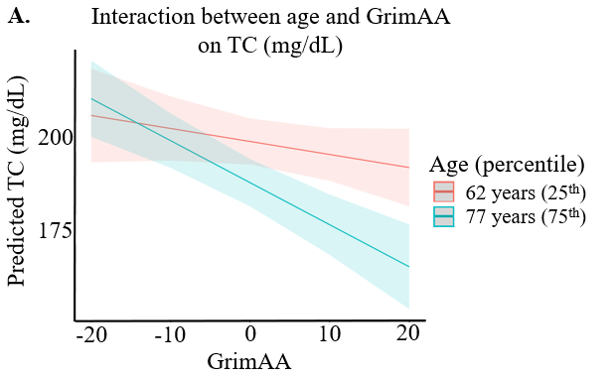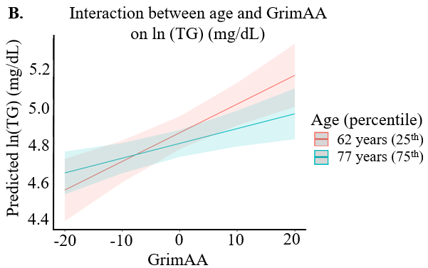
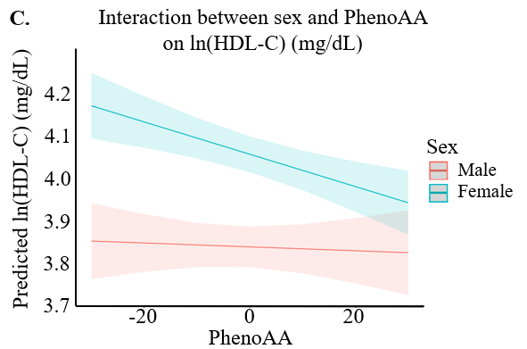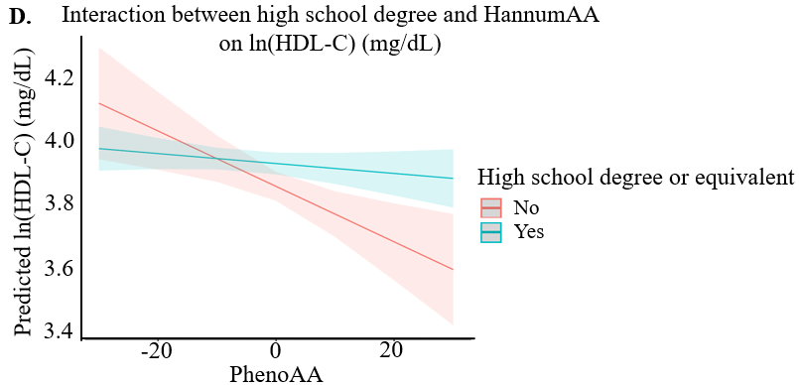
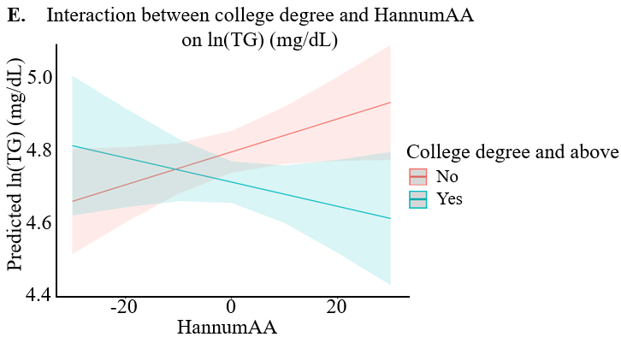

Supplemental Figure 1. Plots of predicted blood lipid levels by by GrimAA, PhenoAA, or HannumAA across demographic levels in the full sample (P_{interaction} < 0.05). A: predicted TC by GrimAA at the 25th (62 years) and 75th percentile (77 years) of age. B: predicted TG by GrimAA at the 25th (62 years) and 75th percentile (77 years) of age. C: predicted ln(HDL-C) by PhenoAA for males and females. D: Predicted ln(HDL-C) by HannumAA for participants with less than high school degree and participants with high school degree and above. E: Predicted ln(TG) by HannumAA for participants with less than college degree and participants with college degree and above.
TC, total cholesterol; HDL-C, high-density lipoprotein; TG, triglycerides; GrimAA, GrimAge acceleration; PhenoAA, PhenoAge acceleration; HannumAA, HannumAge acceleration
Interaction model: blood lipid level ~ epigenetic age acceleration + age at methylation measurement + sex + race/ethnicity + fasting status + lipid-lowering medication use + body mass index + smoking status + high school degree or equivalent + college degree and above + epigenetic age acceleration × demographic factor
Only interactions with GrimAA, PhenoAA, or HannumAA and demographic factors with P_{interaction} < 0.05 in the interaction model are shown.
Age was centered for the interaction analysis.
The line and corresponding confidence intervals represent the predicted blood lipid levels at the corresponding value of epigenetic age acceleration.

