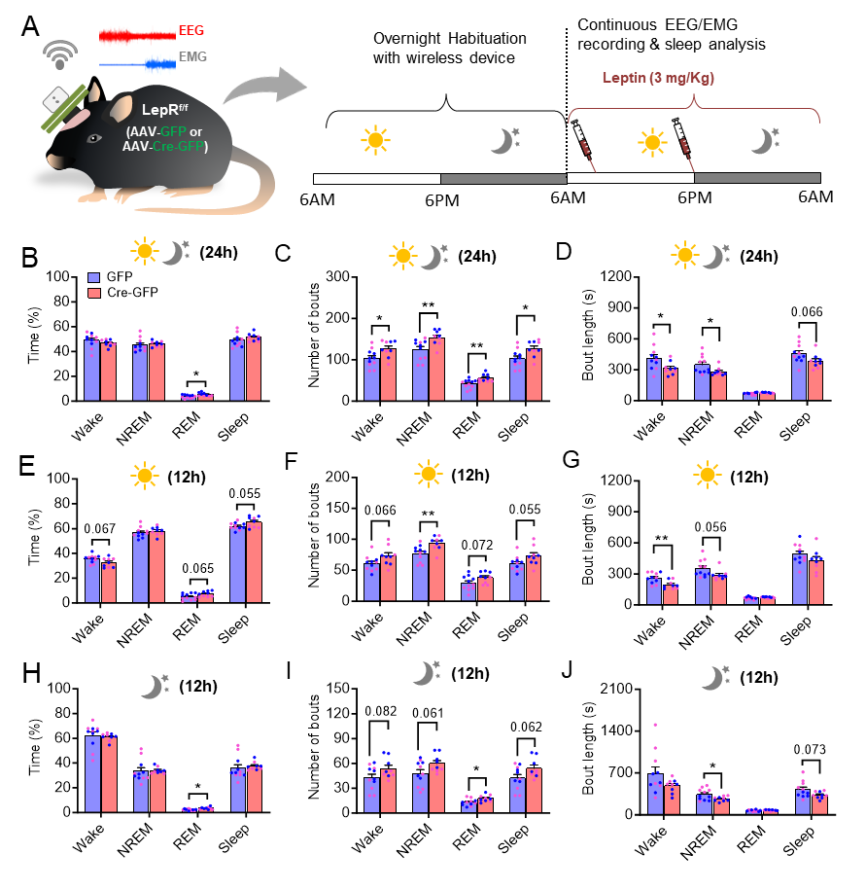
Supplemental figure 1.
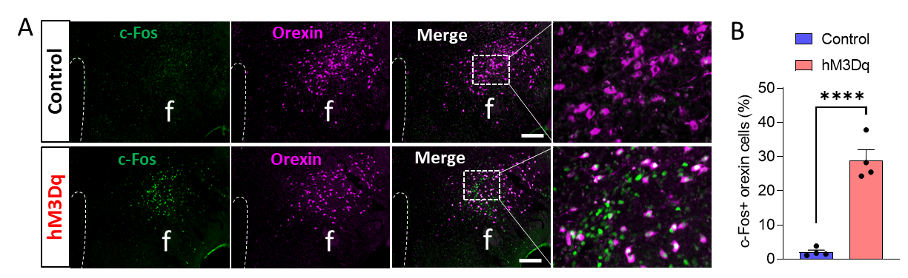
Supplemental figure 2.
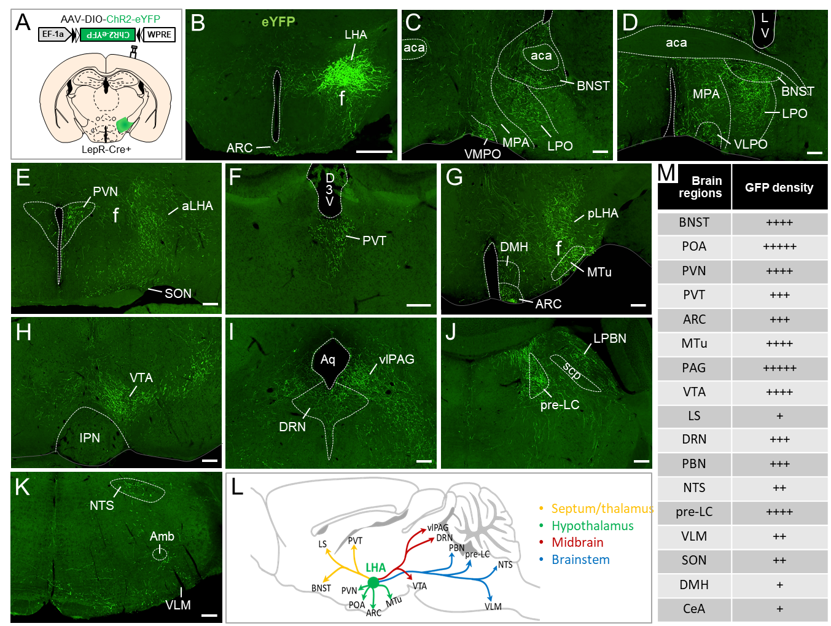
Supplemental figure 3.
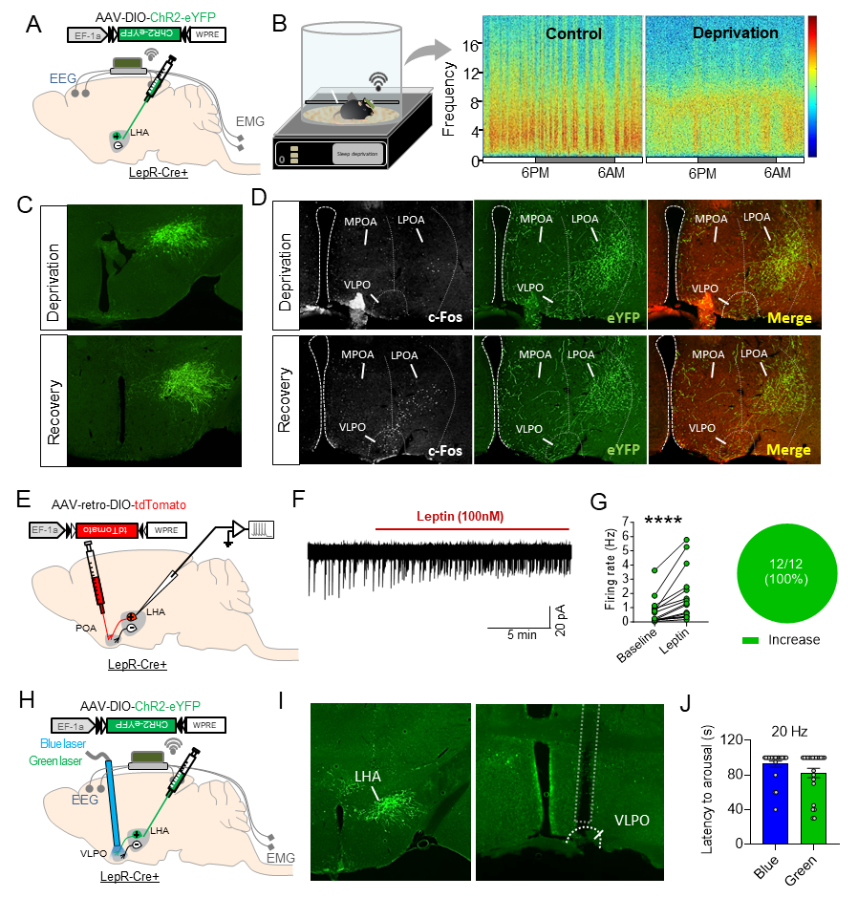
Supplemental figure 4.
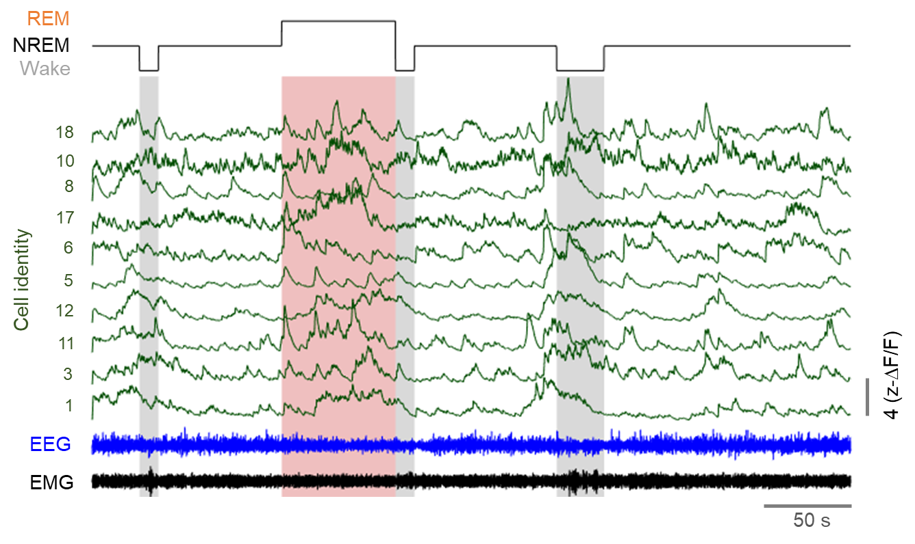
Supplemental figure 5.
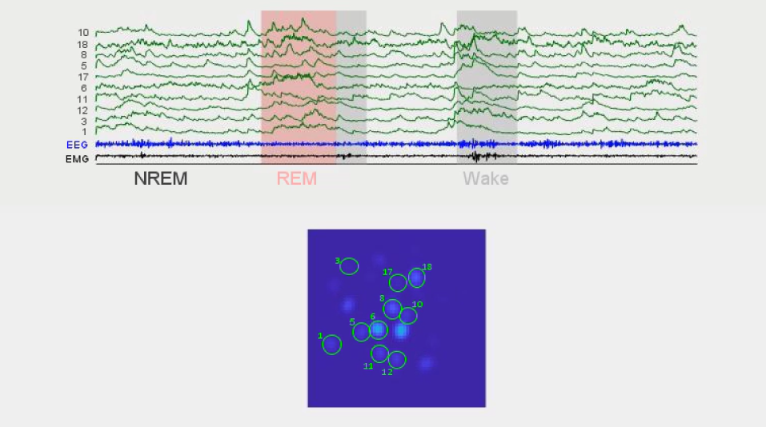
Supplemental video 1.
Supplemental figure 1: Altered sleep-wake patterns in LHA^{LepR-KO} mice after leptin treatment. (A) Schematic showing the experimental design for sleep recording with systemic leptin treatment. (B-J) Sleep architecture analysis showing the total sleep time, number of sleep bouts, and bout length of male (blue dots) and female (pink dots) mice during 24-hour (B-D), 12-hour light cycle (E-G) and 12-hour dark cycle (H-J). Data are presented as mean ± SEM. *p<0.05, **p<0.01 by unpaired student’s t-test.
Supplemental figure 2: Chemogentic activation of LHA^{LepR+} neurons increases the activity of orexin neurons. (A) Representative FIHC images showing robust c-Fos induction in LHA orexin neurons 90-min after CNO treatment in hM3Dq-DREADD but control mouse. (B) Quantification of c-Fos+ orexin neurons in control and hM3Dq-DREADD mice (N=4 mice). Data are presented as mean ± SEM. ****p<0.0001 by student’s t-test.
Supplemental figure 3: Whole-brain mapping of efferent projections of LHA^{LepR+} neurons. (A) Schematic showing unilateral viral injection into the LHA of LepR-Cre+ mouse for anterograde tract-tracing. (B) Representative image showing the precise targeting of LHA and unilateral eYFP expression in the LHA^{LepR+} neurons (N=3 mice). (C-K) Representative FIHC images showing the major brain regions where eYFP+ fibers are moderate to heavily innervated. (L) Summary diagram depicting the brain regions receiving inputs from LHA^{LepR+} neurons. (M) A summary table listing the relative eYFP+ fiber density observed in different brain regions. Relative fiber density: sparse (+), moderate (++), dense (+++), heavy (++++), compact (+++++). Abbreviations: lateral hypothalamic area (LHA), anterior commissure (aca), fornix (f), bed nucleus of the stria terminalis (BNST), lateral preoptic area (LPO), medial preoptic area (MPO), ventromedial preoptic area (VMPO), ventrolateral preoptic area (VLPO), lateral ventricle (LV), paraventricular nucleus of hypothalamus (PVN), anterior lateral hypothalamic area (aLHA), posterior lateral hypothalamus (pLHA), supraoptic nucleus (SON), paraventricular nucleus of the thalamus (PVT), dorsal 3rd ventricle (D3V), dorsomedial hypothalamic nucleus (DMH), arcuate nucleus of hypothalamus (ARC), medial tuberal nucleus (MTu), ventral tegmental area (VTA), aqueduct (Aq), ventrolateral periaqueductal grey (vlPAG), dorsal raphe nucleus (DRN), pre-locus coeruleus (pre-LC), superior cerebellar peduncle (scp), lateral parabrachial nucleus (PBN), nucleus of solitary tract (NTS), ambiguus nucleus (Amb), ventrolateral medulla (VLM). Scale bar: 500 µm for B and 200 µm for C-K.
Supplemental figure 4: Optogenetic activation of leptin-excitatory LHA^{LepR+}VLPO circuit does not promote arousal. (A) Schematic of viral injection for anterograde tract-tracing of LHA^{LepR+} neurons. (B) Diagram of concurrent sleep deprivation (SD) and wireless polysomnographic recording and representative heatmap spectrograms showing effective SD. (C) Representative FIHC images showing the precise targeting of LHA by AAV-DIO-ChR2-eYFP in both SD and SD-recovery mice. (D) Representative double FIHC images showing the innervation of LHA^{LepR+} neurons to the VLPO and LPO where sleep-active (cFos⁺) neurons reside. (E) Schematic showing the viral strategy to label POA-projecting LHA^{LepR+} neurons for electrophysiological recording. (F) Representative loose seal recording trace showing the increased firing rate of POA-projecting LHA^{LepR+} neurons in response to leptin treatment. (G) Quantification of increased firing rate by leptin treatment and a summary pie chart showing the complete leptin-excitatory nature of POA-projecting LHA^{LepR+} neurons (from N=3 mice). (H) Schematic showing viral injection and simultaneous wireless EEG/EMG recording and optogenetic stimulation of LHA^{LepR+}VLPO circuit. (I) Representative images showing the precise targeting of AAV and optic canula to the LHA and the VLPO, respectively. (J) Quantitative analysis of latency to arousal in response to blue or green light stimulation of LHA^{LepR+}VLPO circuit. Data are presented as mean ± SEM. ****p<0.0001 by paired student’s t-test.
Supplemental figure 5: GCaMP traces of ten representative LHALepR+ neurons across different sleep-wake states.
Supplemental Video 1: A short movie demonstrating changes in GCaMP activity of ten randomly selected LHA^{LepR+} neurons expressing GCaMP6m (green traces at the top and green circles in the fully processed GCaMP recording video shown at the bottom) across different sleep-wake states determined by time-synced EEG/EMG recording (blue and black traces). The video is played at 100 fps.

