SUPPLEMENTARY INFORMATION (SI)
Assessment of uranium and thorium co-contaminant exposure from incidental concrete dust ingestion

Nur Shahidah Abdul Rashidª, Wooyong Um^{a,b,c,*}, Albert L. Juhasz^{d}, Ibrahim Ijang^{e}, Khoo Kok Siong^{f}, Bhupendra Kumar Singh^{a,c}, Nurul Syiffa Mahzanª, and Siti Khadijah Maliki^{g}

ªDivision of Advanced Nuclear Engineering (DANE), Pohang University of Science and Technology (POSTECH), Pohang, Gyeongbuk 790-784, Republic of Korea
^{b}Division of Environmental Science and Engineering (DESE), Pohang University of Science and Technology (POSTECH), Pohang, Gyeongbuk 790-784, Republic of Korea
^{c}Nuclear Environmental Technology Institute (NETI), Pohang University of Science and Technology (POSTECH), Pohang, Gyeongbuk 790-784, Republic of Korea
^{d}Future Industries Institute, University of South Australia, Mawson Lakes, South Australia, 5095, Australia
^{e}Malaysian Nuclear Agency (MNA), Bangi, Selangor, 43000, Malaysia
^{f}Department of Applied Physics, Faculty of Science and Technology, The National University of Malaysia (UKM), Bangi, Selangor, 43600, Malaysia
^{g}Pohang Accelerator Laboratory (PAL), Pohang University of Science and Technology (POSTECH), Pohang, Gyeongbuk 790-784, Republic of Korea

*Corresponding author: Wooyong Um
E-mail address: wooyongum@postech.ac.kr; Tel: +82-54-279-9563; Fax: +82-54-279-955
Seven pages, two figures, and three tables.
Physicochemical and morphological characterization of unspiked- (UC) and spiked-concretes (SC)
The total concentrations of ²³⁸U and ²³²Th were measured using instrumental neutron activation analysis (INAA). Before irradiation, 0.20 ± 0.05 g of concrete samples were placed in a high-purity polyethylene irradiation vial (∅ 1 cm × 3 cm H) and sealed. Samples were irradiated with thermal neutron flux at the PUSPATI TRIGA Mark II reactor, Malaysian Nuclear Agency, for 5 hours (h) at the rotatory rack with an average of 4.10 × 10¹² n⋅cm⁻² s⁻¹ at a maximum thermal power of 750 kW and evaluated using a calibrated high-resolution coaxial Ortec Hyper-Pure Germanium detector with 1.9 keV energy resolution, 25.4% relative efficiency, and 1,332 keV ⁶⁰Co gamma (γ)-ray. The Gamma Vision software (EG&G ORTEC, USA) was used to assess peak areas, and each count was measured for 1 h. The concrete pH, moisture content, and organic content were determined using the standards of the American Public Health Association 4500-H⁺B, American Society for Testing and Materials D2216-19, and the International Standard Organization protocols, respectively [1-5].
The mineral phase was determined using X-ray diffraction (XRD) (Miniflex 600, Rigaku, Japan). The XRD pattern was measured between 10° and 90° with a scan step size of 0.02° using Cu Kα (×2) radiation to distinguish distinct mineral varieties based on their crystal structures. Meanwhile, the concrete microstructure and surface element composition were investigated using field emission scanning electron microscopy with electron dispersive X-ray (FESEM-EDX) (Carl Zeiss Gemini SEM 500) at high-resolution and low charging settings. Samples were dried at 60 ~ 70 °C and coated with a 100 Å thin layer of platinum for 38 seconds (s) using a sputter coater (Quorum Q150RS) under a vacuum of 2 × 10^{–3} mbar. The Torr vacuum was used during imaging to avoid charging effects. The sample was subjected to a low vacuum at a 20 kV accelerating voltage, 60 to 90 mA current range, and 8.2 mm working distance.
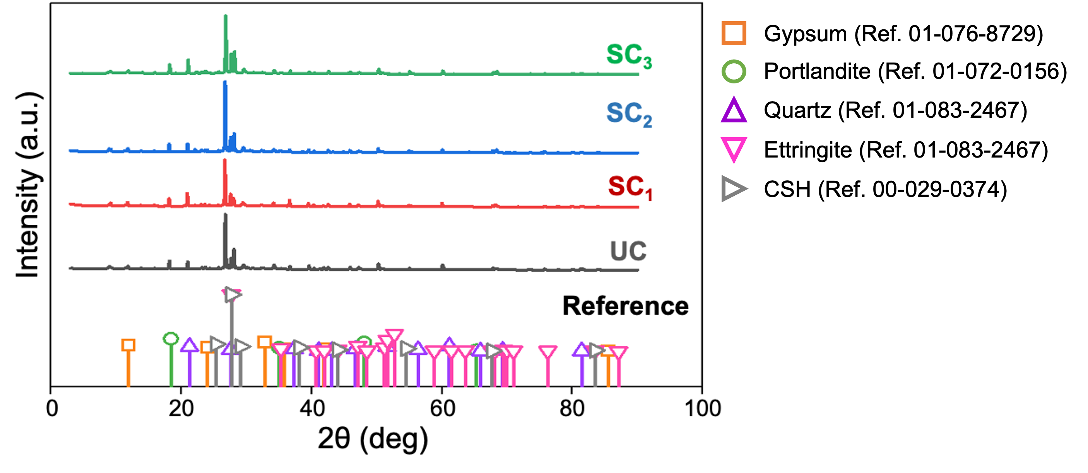
Fig. S1. X-ray diffraction (XRD) patterns of unspiked- (UC) and spiked-concrete dust (SC).
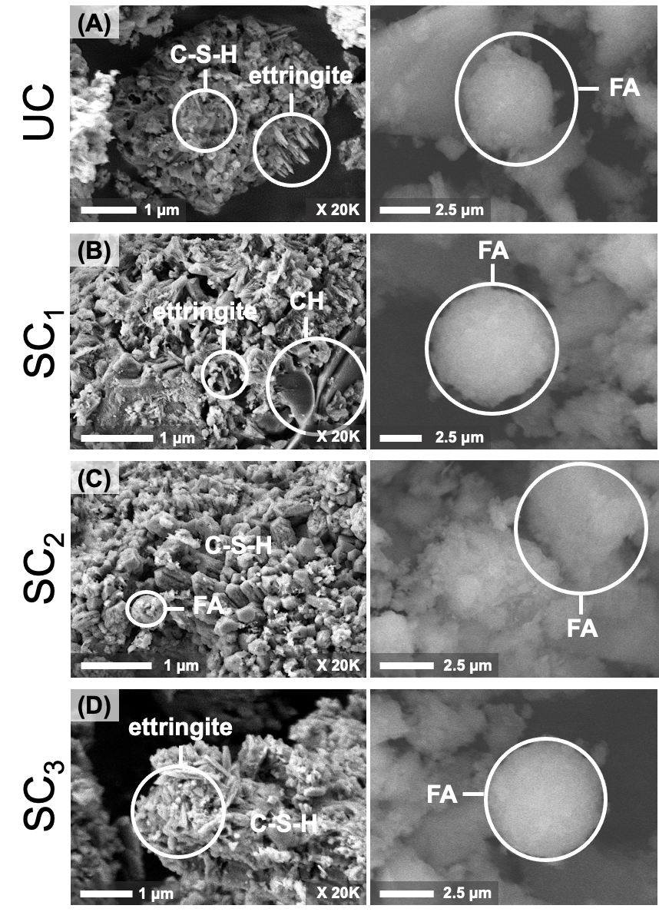
Fig. S2. Field emission scanning electron microscopy (FESEM) results of unspiked concrete (UC) and spiked concrete dust (SC). No significant differences in morphology and composition between UC and SC were observed (Table S1 corresponding to the EDX analysis). The FESEM-EDX and XRD (Fig. S1) results were consistent with Han et al. [6] and Yilmaz and Ozmen [7] in which calcite (CaCO₃), quartz (SiO₂), gypsum (CaSO₄), portlandite (Ca(OH)₂), ettringite (Ca₆Al₂(SO₄)₃(OH)₁₂⋅26H₂O), and calcium silicate hydrate (C-S-H) were the key mineral phases in concrete samples.

Table S1. EDX elemental analysis of UC and SC dust.
Materials | Element (wt. % ± σ %)
Materials | O | C | Ca | Si | Al | Fe
UC | 42.7 ± 0.3 | 36.3 ± 0.4 | 9.4 ± 0.1 | 5.4 ± 0.1 | 3.0 ± 0.1 | 1.6 ± 0.1
SC₁ | 42.6 ± 0.2 | 34.3± 0.3 | 9.0 ± 0.1 | 9.2 ± 0.1 | 3.2 ± 0.2 | 1.1 ± 0.1
SC₂ | 41.6 ± 0.3 | 33.8 ± 0.3 | 10.1 ± 0.1 | 7.2 ± 0.1 | 2.8 ± 0.1 | 1.3 ± 0.1
SC₃ | 41.0 ± 0.3 | 36.9 ± 0.5 | 9.5 ± 0.1 | 8.6 ± 0.1 | 3.1 ± 0.1 | 1.6 ± 0.1

Table S2. EDX elemental analysis of control and treated SD rat erythrocytes post UC-, SC-, and R-amended diet exposure.
Treatments | Element (wt. % ± σ %)
Treatments | U | Th
Control + diet | n.d. | n.d.
UC + diet | n.d. | n.d.
SC₁ + diet | n.d. | n.d.
SC₂ + diet | n.d. | n.d.
SC₃ + diet | 0.6 ± 0.3 | 0.2 ± 0.1
R₁ + diet | 0.8 ± 0.1 | 0.2 ± 0.1
R₂ + diet | 1.2 ± 0.4 | 0.3 ± 0.1
R₃ + diet | 1.4 ± 0.2 | 0.4 ± 0.1
n.d. means not detected

Table S3. Hematological control and treated SD rat's blood with UC-, SC-, and R-amended diet exposure.
Treatments | Time | RBC | Hb | PCV | MCV | MCHC | WBC | Neutrophils | Monocytes | Lymphocyte | PLT
Treatments | (h) | (×10¹²/L) | (g/L) | (L/L) | (fL) | (gL) | (×10⁹/L) | (×10⁹/L) | (×10⁹/L) | (×10⁹/L) | (×10⁹/L)
Control + diet |  | 8.31 ± 0.3 | 153 ± 0.5 | 0.45 ± 0.02 | 51.7 ± 0.5 | 336 ± 2.9 | 7.60 ± 0.80 | 0.53 ± 0.05 | 0.36 ± 0.05 | 3.57 ± 0.50 | 1051 ± 7.7
UC + diet | 6 | 8.47 ± 0.2 | 155 ± 0.3 | 0.45 ± 0.04 | 51.7 ± 0.5 | 340 ± 5.3 | 7.80 ± 0.90 | 0.72 ± 0.01 | 0.37 ± 0.05 | 3.71 ± 0.20 | 1050 ± 5.0
UC + diet | 12 | 8.56 ± 0.2 | 156 ± 0.2 | 0.45 ± 0.03 | 51.8 ± 0.1 | 342 ± 6.0 | 7.80 ± 0.10 | 0.75 ± 0.02 | 0.37 ± 0.06 | 3.65 ± 0.10 | 1050 ± 6.2
UC + diet | 24 | 8.41 ± 0.3 | 156 ± 0.1 | 0.45 ± 0.04 | 51.9 ± 0.7 | 342 ± 5.4 | 7.80 ± 0.50 | 0.75 ± 0.09 | 0.37 ± 0.09 | 3.71 ± 0.30 | 1048 ± 2.7
UC + diet | 48 | 8.55 ± 0.1 | 157 ± 0.6 | 0.46 ± 0.08 | 52.5 ± 0.6 | 342 ± 4.3 | 7.80 ± 0.80 | 0.74 ± 0.05 | 0.37 ± 0.07 | 3.64 ± 0.20 | 1056 ± 2.8
SC₁ + diet | 6 | 8.56 ± 0.2 | 156 ± 0.2 | 0.45 ± 0.05 | 52.5 ± 0.2 | 348 ± 1.3 | 7.80 ± 0.60 | 0.80 ± 0.09 | 0.37 ± 0.08 | 4.67 ± 0.50 | 1057 ± 1.4
SC₁ + diet | 12 | 8.62 ± 0.2 | 160 ± 0.7 | 0.45 ± 0.01 | 52.8 ± 0.7 | 354 ± 5.8 | 9.30 ± 0.90 | 1.05 ± 0.01 | 0.37 ± 0.08 | 5.32 ± 0.20 | 1062 ± 8.6
SC₁ + diet | 24 | 9.11 ± 0.2 | 170 ± 0.9 | 0.46 ± 0.02 | 53.3 ± 0.8 | 365 ± 1.5 | 12.0 ± 0.10 | 1.13 ± 0.09 | 0.38 ± 0.03 | 6.89 ± 0.50 | 1079 ± 4.3
SC₁ + diet | 48 | 9.52 ± 0.1 | 173 ± 0.9 | 0.46 ± 0.01 | 53.9 ± 0.2 | 371 ± 4.2 | 12.3 ± 0.40 | 1.15 ± 0.04 | 0.39 ± 0.03 | 7.74 ± 0.10 | 1096 ± 8.6
SC₂ + diet | 6 | 9.52 ± 0.3 | 174 ± 0.5 | 0.45 ± 0.01 | 53.7 ± 0.3 | 371 ± 0.5 | 12.4 ± 0.40 | 1.12 ± 0.02 | 0.39 ± 0.01 | 7.65 ± 0.20 | 1091 ± 7.0
SC₂ + diet | 12 | 9.54 ± 0.3 | 174 ± 0.3 | 0.45 ± 0.01 | 53.8 ± 0.2 | 371 ± 0.6 | 12.5 ± 0.30 | 1.15 ± 0.05 | 0.40 ± 0.02 | 7.80 ± 0.20 | 1093 ± 11.2
SC₂ + diet | 24 | 9.69 ± 0.1 | 176 ± 0.9 | 0.46 ± 0.05 | 53.9 ± 0.2 | 373 ± 0.4 | 12.5 ± 0.30 | 1.17 ± 0.07 | 0.42 ± 0.01 | 8.08 ± 0.30 | 1124 ± 11.7
SC₂ + diet | 48 | 9.73 ± 0.1 | 179 ± 0.1 | 0.47 ± 0.01 | 54.1 ± 0.1 | 376 ± 0.1 | 12.5 ± 0.10 | 1.19 ± 0.05 | 0.43 ± 0.01 | 8.47 ± 0.10 | 1137 ± 10.2
SC₃ + diet | 6 | 9.70 ± 0.1 | 177 ± 0.2 | 0.47 ± 0.02 | 54.2 ± 0.8 | 377 ± 8.7 | 12.5 ± 0.40 | 1.23 ± 0.03 | 0.43 ± 0.01 | 8.63 ± 0.80 | 1181 ± 16.6
SC₃ + diet | 12 | 9.71 ± 0.1 | 178 ± 0.4 | 0.47 ± 0.03 | 54.4 ± 0.5 | 378 ± 6.6 | 12.6 ± 0.10 | 1.30 ± 0.04 | 0.45 ± 0.02 | 8.71 ± 0.80 | 1197 ± 14.4
SC₃ + diet | 24 | 9.71 ± 0.1 | 182 ± 0.1 | 0.49 ± 0.01 | 54.7 ± 0.6 | 380 ± 8.5 | 12.7 ± 0.20 | 1.57 ± 0.09 | 0.53 ± 0.01 | 9.66 ± 0.80 | 1237 ± 7.90
SC₃ + diet | 48 | 9.73 ± 0.1 | 183 ± 0.1 | 0.49 ± 0.01 | 54.9 ± 0.9 | 382 ± 6.9 | 12.8 ± 0.10 | 1.72 ± 0.06 | 0.56 ± 0.03 | 10.1 ± 0.70 | 1253 ± 7.5
R₁ + diet | 6 | 8.86 ± 0.1 | 169 ± 1.2 | 0.45 ± 0.03 | 52.3 ± 0.3 | 361 ± 0.7 | 10.6 ± 0.71 | 0.98 ± 0.01 | 0.57 ± 0.04 | 4.78 ± 0.22 | 1109 ± 14.1
R₁ + diet | 12 | 9.32 ± 0.1 | 186 ± 0.4 | 0.47 ± 0.03 | 55.0 ± 0.2 | 399 ± 0.9 | 47.2 ± 0.99 | 4.05 ± 0.04 | 2.02 ± 0.08 | 8.17 ± 0.16 | 2039 ± 8.0
R₁ + diet | 24 | 9.16 ± 0.1 | 174 ± 0.6 | 0.46 ± 0.02 | 53.3 ± 0.2 | 363 ± 1.0 | 13.0 ± 0.73 | 1.74 ± 0.02 | 0.58 ± 0.03 | 5.15 ± 0.09 | 1130 ± 12.8
R₁ + diet | 48 | 8.91 ± 0.1 | 171 ± 0.7 | 0.45 ± 0.04 | 53.3 ± 0.2 | 361 ± 0.7 | 12.2 ± 0.77 | 1.68 ± 0.04 | 0.51 ± 0.04 | 4.90 ± 0.09 | 1059 ± 15.2
R₂ + diet | 6 | 8.92 ± 0.8 | 171 ± 0.3 | 0.47 ± 0.02 | 53.7 ± 0.4 | 372 ± 0.9 | 12.2 ± 0.43 | 1.51 ± 0.09 | 0.68 ± 0.04 | 5.28 ± 0.36 | 1125 ± 1.0
R₂ + diet | 12 | 9.57 ± 0.9 | 192 ± 0.3 | 0.49 ± 0.01 | 56.5 ± 0.7 | 402 ± 1.8 | 54.0 ± 0.97 | 5.08 ± 0.04 | 3.6 ± 0.14 | 9.10 ± 0.57 | 2145 ± 0.6
R₂ + diet | 24 | 9.27 ± 0.6 | 174 ± 0.3 | 0.47 ± 0.02 | 54.5 ± 0.4 | 374 ± 1.3 | 15.7 ± 0.48 | 1.84 ± 0.07 | 0.75 ± 0.05 | 5.44 ± 0.37 | 1185 ± 0.9
R₂ + diet | 48 | 9.26 ± 0.4 | 173± 0.2 | 0.47 ± 0.03 | 53.5 ± 0.7 | 373 ± 1.2 | 15.5 ± 0.46 | 1.69 ± 0.08 | 0.71 ± 0.08 | 5.33 ± 0.38 | 1182 ± 1.1
R₃ + diet | 6 | 9.24 ± 0.3 | 172 ± 0.7 | 0.47 ± 0.01 | 54.0 ± 0.3 | 376 ± 2.3 | 20.8 ± 0.59 | 2.09 ± 0.02 | 1.49 ± 0.02 | 6.26 ± 0.28 | 1215 ± 0.3
R₃ + diet | 12 | 9.77 ± 0.2 | 198 ± 0.8 | 0.50 ± 0.01 | 57.6 ± 0.1 | 420 ± 3.5 | 65.5 ± 0.16 | 6.53 ± 0.04 | 4.27 ± 0.06 | 9.57 ± 0.16 | 2228 ± 0.7
R₃ + diet | 24 | 9.37 ± 0.3 | 177 ± 0.7 | 0.48 ± 0.02 | 55.5 ± 0.2 | 383 ± 2.5 | 24.8 ± 0.74 | 2.65 ± 0.03 | 1.68 ± 0.02 | 7.32 ± 0.24 | 1336 ± 0.4
R₃ + diet | 48 | 9.32 ± 0.3 | 174 ± 0.8 | 0.47 ± 0.02 | 54.5 ± 0.2 | 380 ± 2.4 | 22.8 ± 0.20 | 2.53 ± 0.04 | 1.49 ± 0.01 | 7.31 ± 0.25 | 1215 ± 0.3
RBC, red blood cell; Hb, hemoglobin; PCV, packed cell volume; MCV, mean corpuscular volume; MCHC, mean corpuscular hemoglobin concentration; WBC, white blood cell; PLT, platelets.

REFERENCES
- APHA, American Public Health Association. Standard Methods for the Examination of Water and Wastewater; 4500-H+ pH Value (1912).
- ASTM, American Society for Testing and Materials. Standard Test Methods for Laboratory Determination of Water (Moisture) Content of Soil and Rock by Mass; ASTM D2216−19 (2019).
- ISO, International Organization for Standardization, Fertilizers and soil conditioners: Mineral soil amendments, Determination of total calcium and magnesium content. ISO 22145:2021 (2021).
- ISO, International Organization for Standardization. Fertilizers and soil conditioners: Determination of water-soluble potassium content, Potassium tetraphenylborate gravimetric method. ISO 17319 (2015).
- ISO, International Organization for Standardization. Soil quality: Determination of total nitrogen, Modified Kjeldahl method. ISO 11261 (1995).
- S. Han, S. Hong, S. Nam, W. S. Kim and W. Um, Ann. Nucl. Energy, 149, 107795 (2020).
- S. Yilmaz and H. B. Ozmen, High performance concrete technology and applications, London, UK: IntechOpen (2016).

