Supplementary information for

Atomic-scale insights into topotactic transformations in extra-large pore silicate zeolites using time-resolved 3D electron diffraction
Yi Luo^{1,4,5*}, Hao Xu^{2,3,5*}, Yue Han^{2,5}, Wen Tong², Meichen Jiao², Naihong Wang², Jingang Jiang², Xiaodong Zou^{1*}, Peng Wu^{2,3*}
¹Department of Materials and Environmental Chemistry, Stockholm University, Stockholm, Sweden.
²Shanghai Key Laboratory of Green Chemistry and Chemical Processes, State Key Laboratory of Petroleum Molecular & Process Engineering, School of Chemistry and Molecular Engineering, East China Normal University, Shanghai, China.
³Institute of Eco-Chongming, Shanghai, China.
⁴State Key Laboratory of Green Chemical Engineering and Industrial Catalysis, Sinopec Shanghai Research Institute of Petrochemical Technology, Shanghai, China.
⁵These authors contributed equally.
*Corresponding authors: Peng Wu (pwu@chem.ecnu.edu.cn), Xiaodong Zou (xzou@mmk.su.se), Hao Xu (hxu@chem.ecnu.edu.cn) and Yi Luo (luoy755.sshy@sinopec.com).

This supplementary file includes:

Materials and Methods
Supplementary Figures 1-15
Supplementary Tables 1-4
Supplementary References

Materials and Methods
Chemicals. N,N,N',N'-tetramethyl-1,6-hexanediamine (99.0 wt%, Shanghai Sinopharm Chemical Reagent). Isopropanol (≥ 99.7 wt%, Shanghai Sinopharm Chemical Reagent),1,4-dibromobutane (>99.0 wt%, Shanghai Sinopharm Chemical Reagent), Hydroxide resin (DIAION), Colloidal silica (29 ~ 31 wt%, Macklin), Sodium hydroxide (NaOH, ≥ 96 wt%, Shanghai Sinopharm Chemical Reagent), Hydrochloric acid (HCl, 36.0 ~ 38.0 wt%, Shanghai Sinopharm Chemical Reagent), Ethanol (EtOH, ≥ 99.8 wt%, Shanghai Sinopharm Chemical Reagent), tert-Butyl hydroperoxide (65 wt% in water, TCI; ~ 5.5 M in decane, Aldrich).
Synthesis of the OSDA. 1,1,6,6-Tetramethyl-1,6-diazacyclododecane-1,6-diium hydroxide (TDDH) was previously used to synthesize a zeolite RZM-3, which has the same framework structure as EMM-23 (1). The preparation of TDDH involved the following steps: firstly, 17.23 g of N,N,N',N'-tetramethyl-1,6-hexanediamine was dissolved into 240 mL of isopropanol, and then 21.59 g of 1,4-dibromobutane was added to the mixture under stirring. The obtained mixture was refluxed at 355 K for 8 h. Secondary, the mixture was cooled to room temperature, leading to the formation of white solid 1,1,6,6-tetramethyl-1,6-diazacyclododecane-1,6-diium bromide salt (TDDB). The solid TDDB product was further recovered by filtration, washed with ethyl acetate thoroughly, and dried at 353 K for 12 h. In the end, TDDB was converted into its hydroxide form by anion-exchange with hydroxide resin, resulting in an aqueous solution TDDH with a concentration of ~25 wt%.
Synthesis of ECNU-45. ECNU-45 zeolite was synthesized using TDDH as the OSDA with the assistance of ECNU-45 zeolite seed. In a typical synthesis, 0.12 g NaOH was first dissolved in 5.895 g TDDH aqueous solution, and then 7.5 g colloidal silica was added dropwise into the solution under stirring. 0.1125 g ECNU-45 seed (5 wt% of SiO₂ in the silica source) was added to the mixture. Excess 6.2962 g H₂O was removed by heating at 80 °C to form a gel with a molar composition of 1.0 SiO₂ : 0.15 TDDH : 0.08 NaOH : 5 H₂O. The gel was then heated at 150 °C for 5 days in an autoclave under a rotatory condition (10 r.p.m.) for crystallization. The obtained solid powder of ECNU-45 was recovered by filtration, washed with deionized water, and dried at 80 °C for 12 h. The ECNU-45 seed used in the synthesis was prepared by following a similar procedure but without adding the seed. Typically, 0.04 g NaOH, 2.62 g TDDH aqueous solution, and 2.5 g colloidal silica were mixed together to prepare a gel with a molar composition of 1.0 SiO₂ : 0.2 TDDH : 0.08 NaOH : 5 H₂O (Excess 2.59 g H₂O was removed at 80 °C). The gel was then crystallized at 150 °C for 5 days under rotatory conditions (10 r.p.m.). The seed was recovered using the same procedures as those of the as-made ECNU-45.
Topotactic reaction and transformation of as-made ECNU-45. The topotactic reactions and phase transformations of as-made ECNU-45 were performed in the HCl/EtOH/H₂O solution. In a typical run, 3 g HCl (containing 1.905 g H₂O) was mixed with an appropriate amount of EtOH to make the whole solution volume achieve 30 mL, resulting in 1M HCl/EtOH/H₂O solution. Then, 1.0 g as-made ECNU-45 was mixed with 30 mL 1M HCl/EtOH/H₂O solution. The reactions of the ECNU-45 samples were performed in Teflon-lined stainless-steel autoclaves at 190 °C under static conditions for different times of 1, 2, 4, 6, 8, 10, and 24 h.
3D ED data collection and structure determination.
3D ED data were collected using the cRED (continuous rotation electron diffraction) method implemented in the software Instamatic (2), on a JEOL JEM2100 (LaB6 filament) transmission electron microscope operated at 200 kV (λ = 0.0251 Å), equipped with a Timepix hybrid pixel detector (Amsterdam Scientific Instruments). For the sample preparation, each sample was first crushed in an agate mortar, suspended in ethanol (99.5 wt%), and then dispersed by ultrasonication. A drop of each suspension was transferred to a TEM grid for the 3D ED data collection. All the 3D ED data were collected at room temperature using a high-tilt side-entry holder (JEOL). A tilt step of 0.23 degree and an explore time of 0.5 s (per frame) were applied for the 3D ED data collection. The 3D ED data were processed using XDS (3). The structures were solved using direct methods in SHELXT and refined (kinematically) using SHELXL and Shelxle (4, 6). Atomic scattering factors for electrons were used for the structure refinement (7). The partially occupied Si and O atoms were located from the difference Fourier maps. Restraints were mainly applied to the partially occupied atoms and the atomic displacement parameters (ADPs).
Other general characterizations. Powder X-ray diffraction (PXRD) patterns were collected on a Rigaku Ultima IV X-ray diffractometer using the CuKα radiation (λ = 1.541 Å) in 2θ range of 5° to 35°. SEM images were recorded on a Hitachi S-4800 microscope. The N₂ sorption isotherms were obtained on the BELSORP-MAX instrument at 77 K. Before the measurement, the samples were activated at 573 K under vacuum for at least 10 h. The surface areas were calculated by the Brunauer−Emmett−Teller (BET) method, while the microporous pore volumes were determined using the t-plot method. The CHN chemical analysis was carried out on an Elementar Vario Ⅲ instrument. The organic contents of zeolite products were determined by TGA on a METTLER TOLEDO TGA/SDTA 851 apparatus from 303 K to 1073 K at a heating rate of 10 K min⁻¹ in air. The liquid ¹³C NMR spectrum was recorded on a BRUKER AV 500 instrument. The solid-state ²⁹Si and ¹³C MAS NMR were obtained on a VARIAN VNMRS-400WB NMR spectrometer. The amount of silica species in the liquid phase was determined by inductively coupled plasma optical emission spectroscopy (ICP-OES) analysis (Agilent 5110).

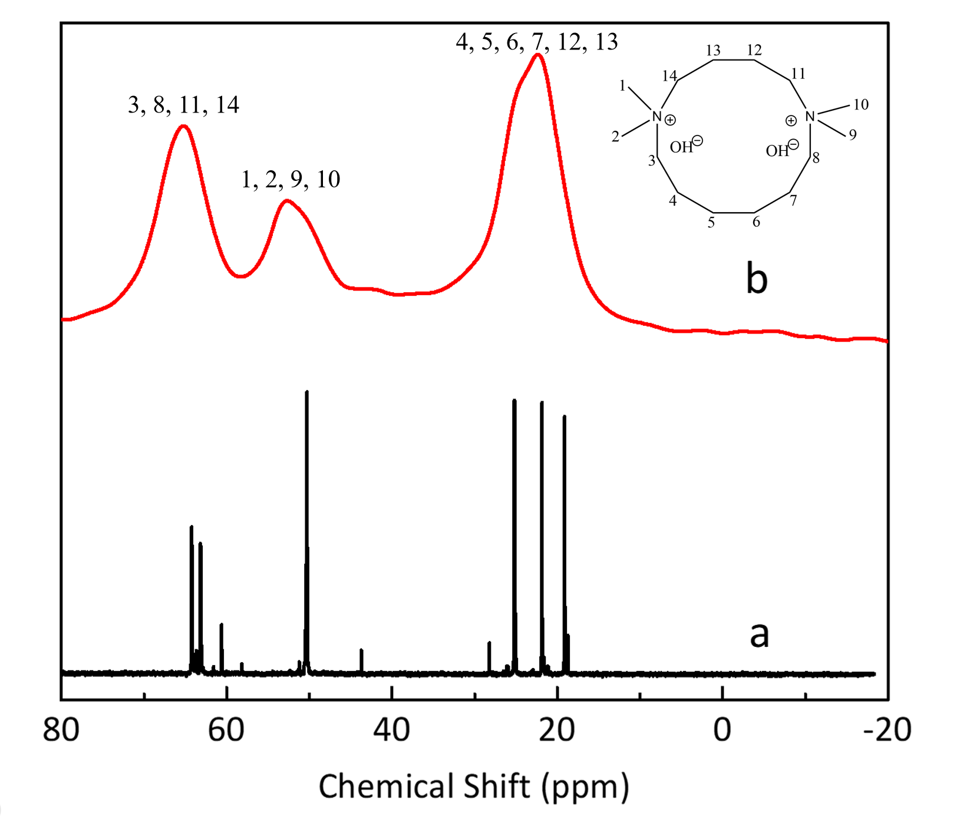
Supplementary Fig. 1 The liquid-state ¹³C NMR spectrum of TDDH (a) and the solid-state ¹³C NMR spectrum of as-made ECNU-45 (b).

The solid-state ¹³C NMR spectrum of as-made ECNU-45 matches the liquid-state ¹³C NMR spectrum of TDDH, indicating the TDDH molecules were intact in the framework structure of ECNU-45. The C/N molar ratio determined by elemental analysis was 7.13, which is consistent with the theoretical value of TDDH molecules (C/N = 7). This also confirmed that the OSDA molecules were well preserved in the hydrothermal synthesis.

Supplementary Fig. 2 PXRD patterns (CuKα) of ECNU-45 and ECNU-46 before and after calcination (550℃ for 6 h in air). Topotactic transformation-derived ECNU-46 is a thermally stable zeolite composed of 24-ring extra-large pores. As reported previously, EMM-23 is stable after calcination (540℃ in air) (8).

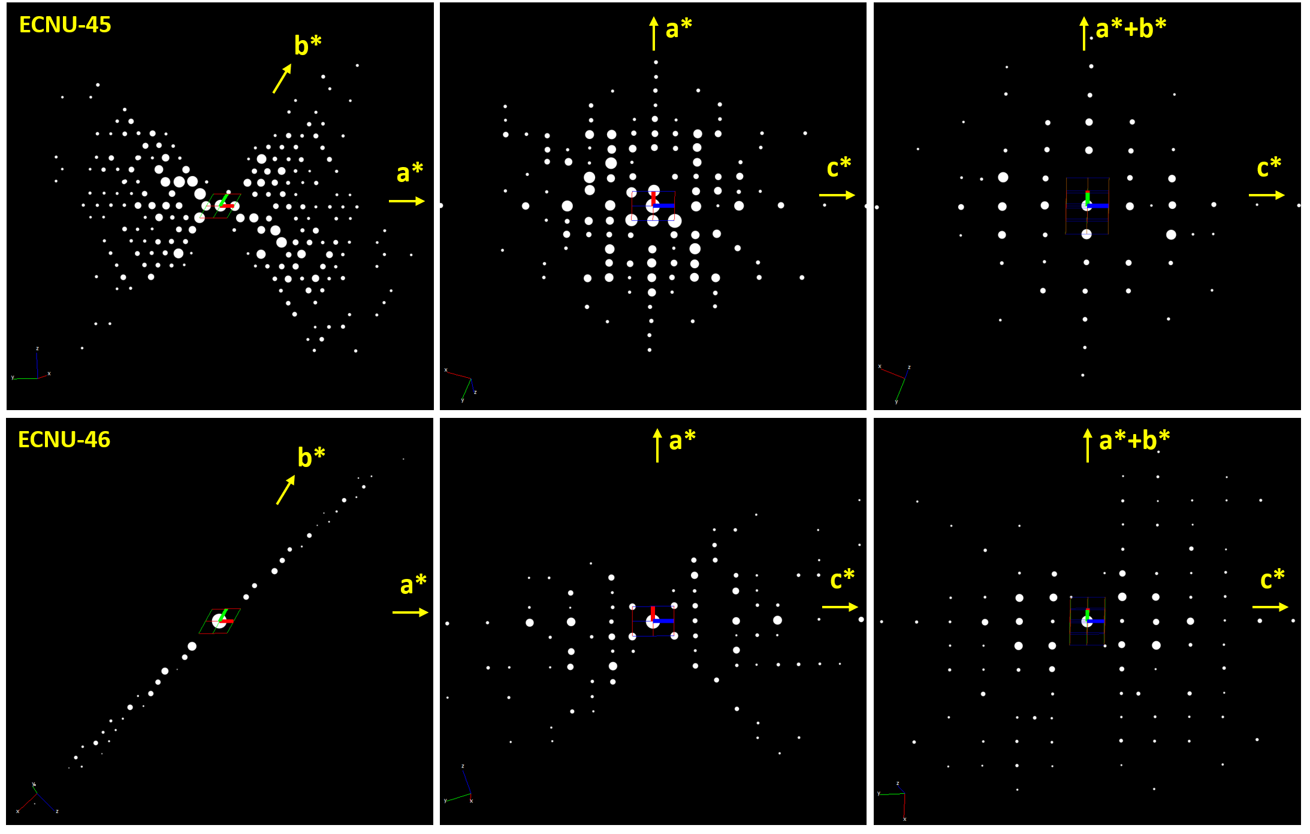
Supplementary Fig. 3 2D slices of the reconstructed 3D reciprocal lattices of ECNU-45 (top row) and ECNU-46 (bottom row) obtained from the cRED data. The observed reflection conditions of ECNU-45 and ECNU-46 are the same as hhl: l = 2n and 00l: l = 2n. The deduced possible space groups are P-62c and P31c.

b
a
Supplementary Fig. 4 Pawley fit profiles of the PXRD patterns (CuKα) of ECNU-45 (a) and ECNU-46 (b). Observed (blue line), calculated (red line), and difference (grey line) profiles are presented. The black tick marks under the patterns are the positions of the Bragg reflections. The refined unit cell parameters are a=19.9616 and c=13.8771 Å for ECNU-45, and a=19.7848 and c=14.1435 Å for ECNU-46. Both structures have the same space group P-62c.

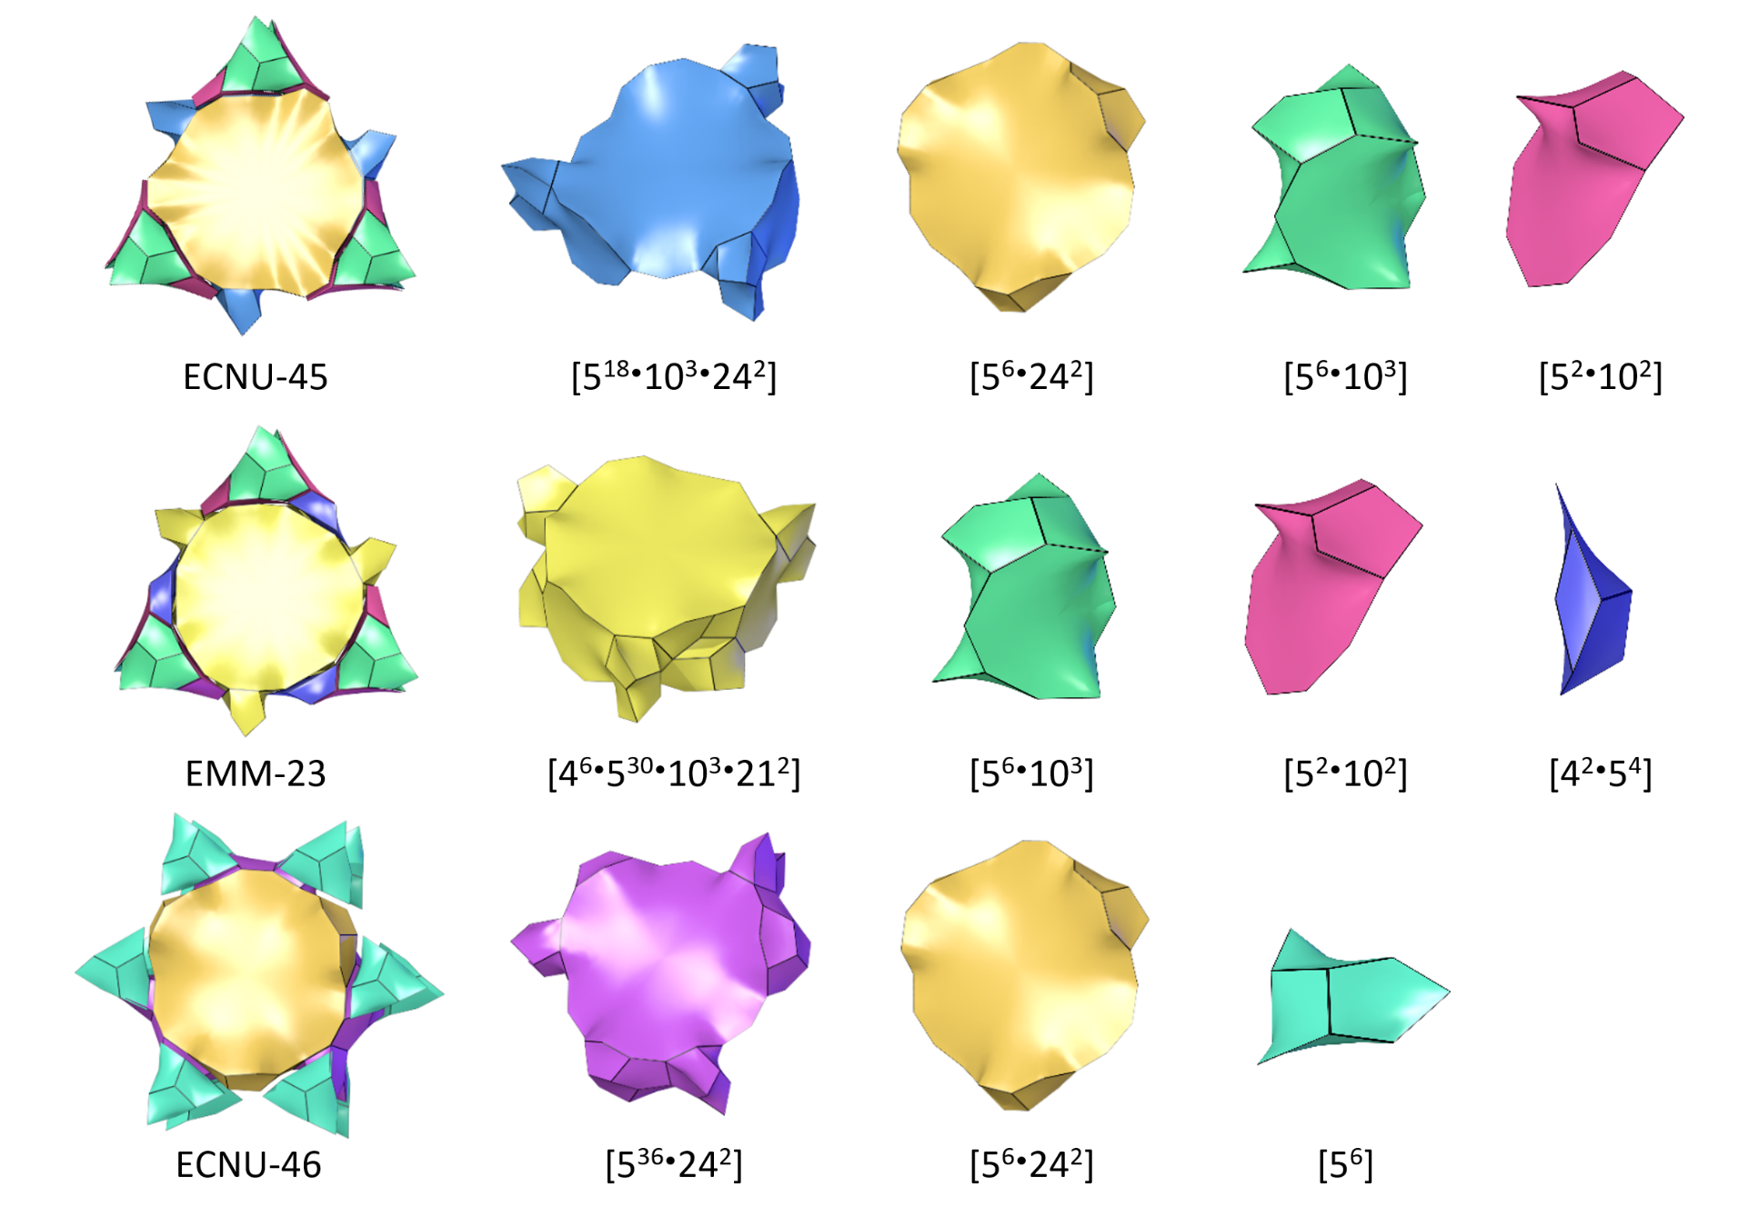
Supplementary Fig. 5 Topological analysis of isocellular zeolites ECNU-45, EMM-23 and ECNU-46. The natural tiling compositions of ECNU-45, EMM-23 and ECNU-46. The natural tiling compositions of ECNU-45 were determined from its framework structure without including the T8. The natural tiling compositions of EMM-23 were determined from its framework structure with the fully occupied T8 and T9. The topological analysis was performed using the crystallographic programs Topos and 3dt (9).

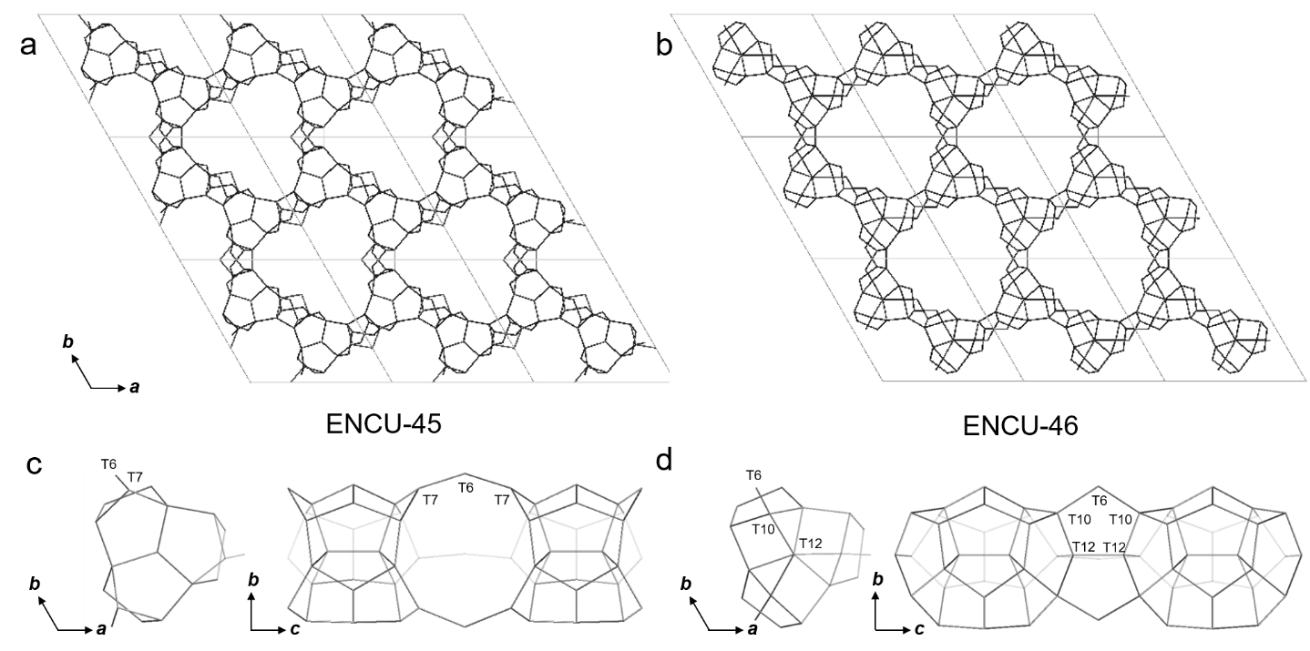

Supplementary Fig. 6 The framework structure of (a) ECNU-45 and (b) ECNU-46 viewed along the c-axis. The columnar building unit of (c) ECNU-45 and (d) ECNU-46 viewed along the c-axis and a-axis. Each 24-ring channel is constructed by six such columns. The labelled T-sites are associated to the major changes in the topotactic transformation. Only the T…T connections are shown for clarity. Comparing the structures between ECNU-45 and ECNU-46, five out of eight T sites (T1-T5) remained at the same positions, T6 and T7 in (c) moved by 0.40 Å and 1.42 Å respectively towards the center of the column, marked T6 and T10 in (d). The T8 connected to T7 in ECNU-45 (not shown due to the low occupancy 27%) is removed. A new bond is formed between T10 and the new T-site T12; see (c) and (d).

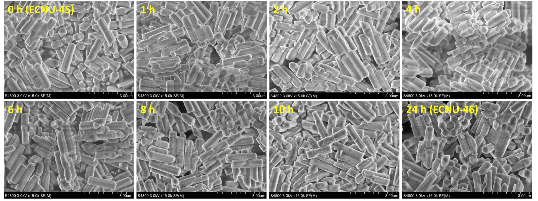

Supplementary Fig. 7 SEM images of ECNU-45 after being reacted in HCl/EtOH/H₂O solution for 0, 1, 2, 4, 6, 8, 10, and 24 h, respectively. No noticeable morphology changes were observed. Some crystals may partially dissolve in the acidic solution to leach the Si(OH)₄ species.

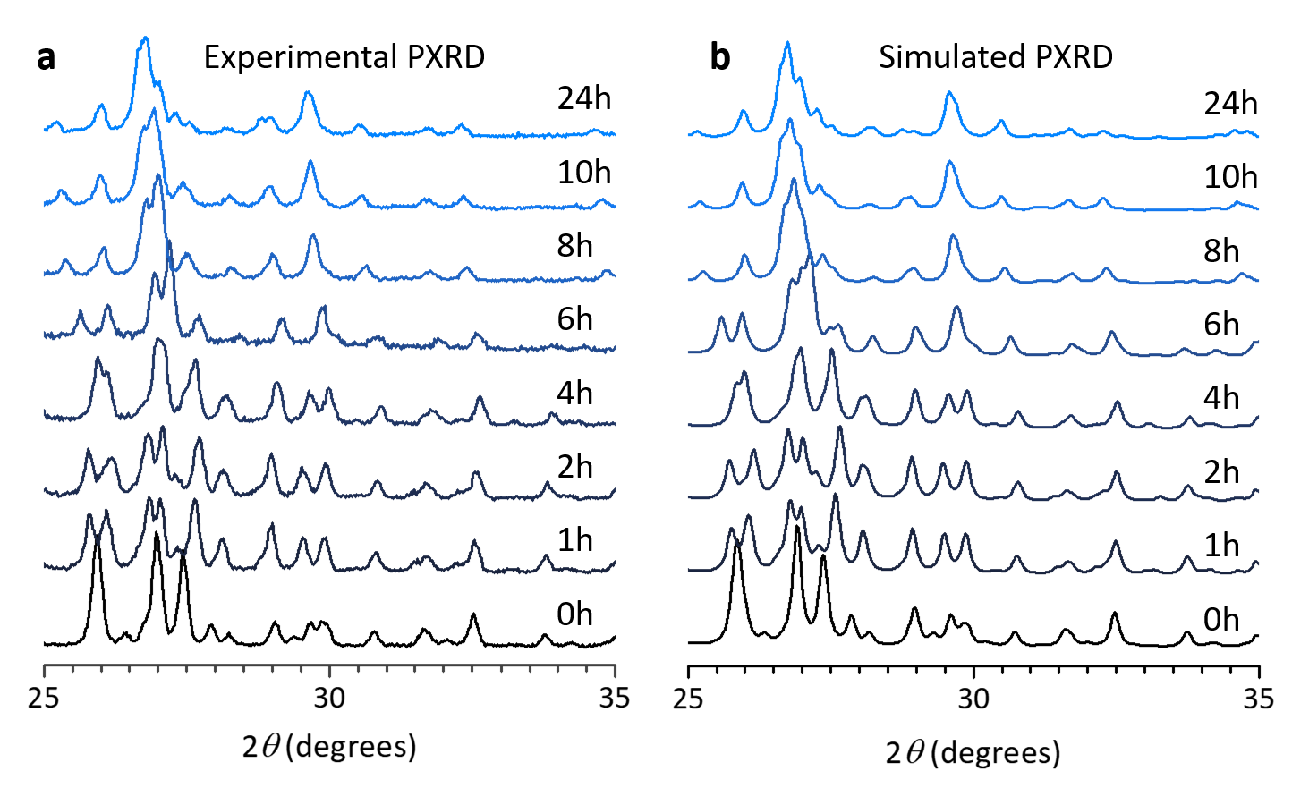
Supplementary Fig. 8 Enlarged experimental and simulated PXRD patterns (CuKα) in the 2θ of 25-35°. a, Experimental PXRD patterns of intermediates obtained at reaction times of 0, 1, 2, 4, 6, 8, 10 and 24 h. b, Simulated PXRD patterns of the intermediate structures determined using the 3D ED data. The slight differences between the experimental and simulated PXRD patterns could be attributed to the preferred orientations of crystals.

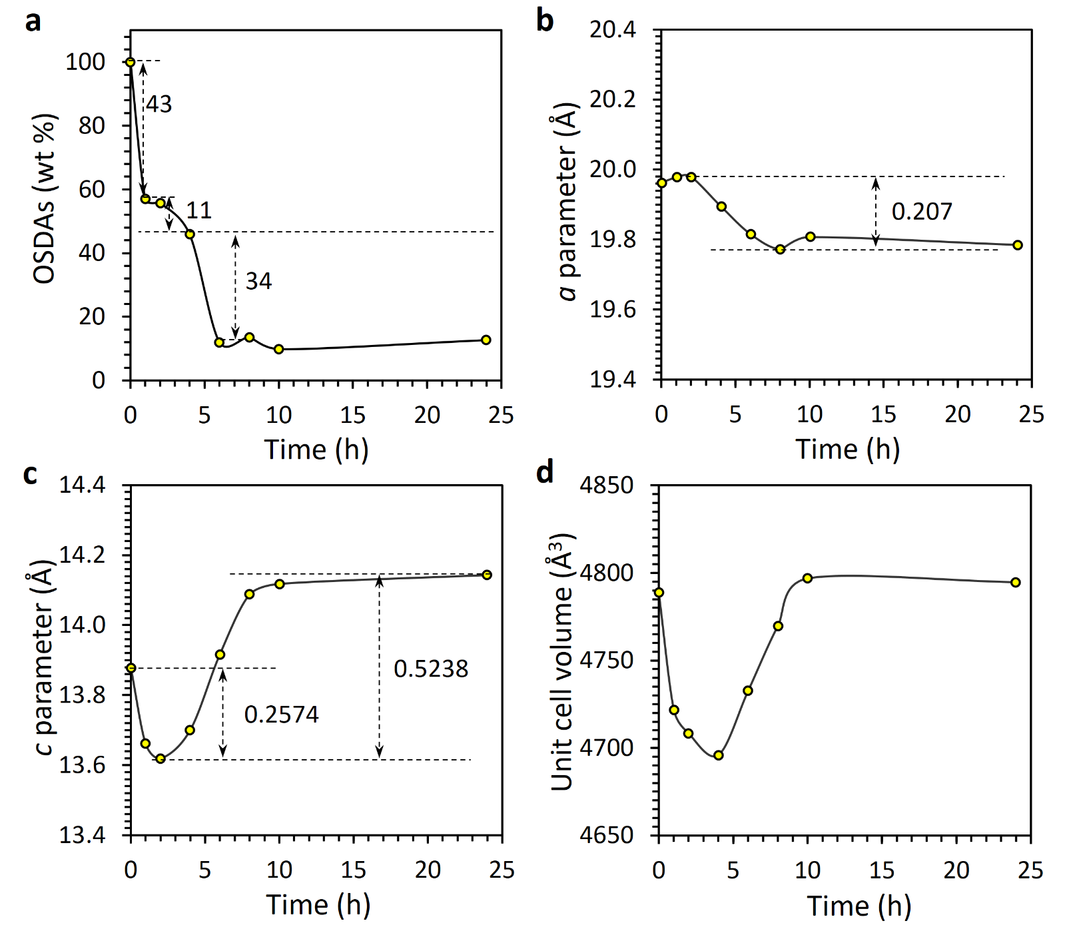
Supplementary Fig. 9 Variations of OSDAs contains and unit cell parameters during the topotactic reactions. a, Remained OSDAs in the intermediates determined by TGA. It shows that most OSDAs are removed after 6 h of the topotactic reactions. At each stage, the OSDAs exhibit a rapid removal followed by a slow one. b-d, Change of unit cell parameters and volumes determined by Pawley fitting of the PXRD data. A contraction of the a-parameter is observed during the first and second stages of topotactic reactions (0 – 8 h). Meanwhile, the c-parameter is first contracted (0 – 4 h) and then expanded (4 – 8 h). No significant change in the unit cell was observed in the third stage. The contraction of a- and c-parameters could be associated to the removal of OSDAs.

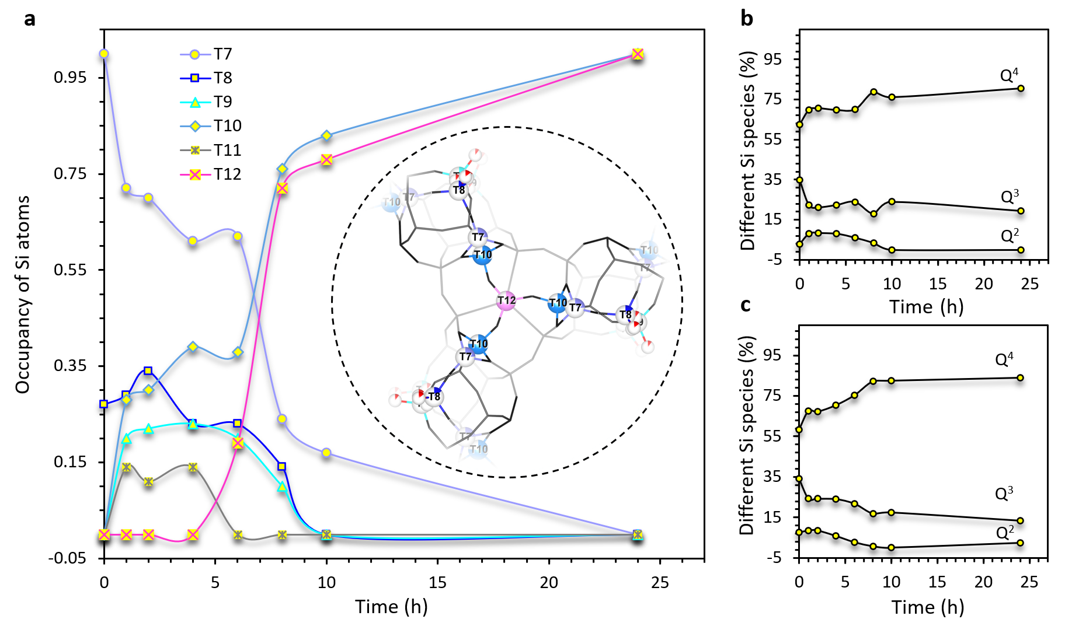

Supplementary Fig. 10 a, The plot of the occupancies of Si species at T7, T8, T9, T10, T11 and T12 as a function of time. b and c, The compositions of Q², Q³ and Q⁴ species of intermediates determined using 3D ED and ²⁹Si solid-state NMR (Supplementary Fig. 11 and Supplementary Table 4), respectively.

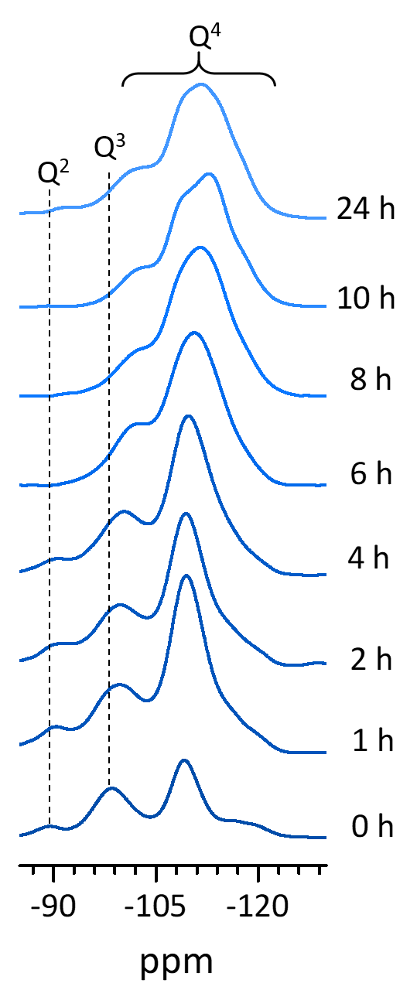

Supplementary Fig. 11 Solid-state ²⁹Si MAS NMR spectra of the intermediates. The compositions of Q², Q³ and Q⁴ species determined by the spectra are plotted in Supplementary Fig. 10c and listed in Supplementary Table 4.

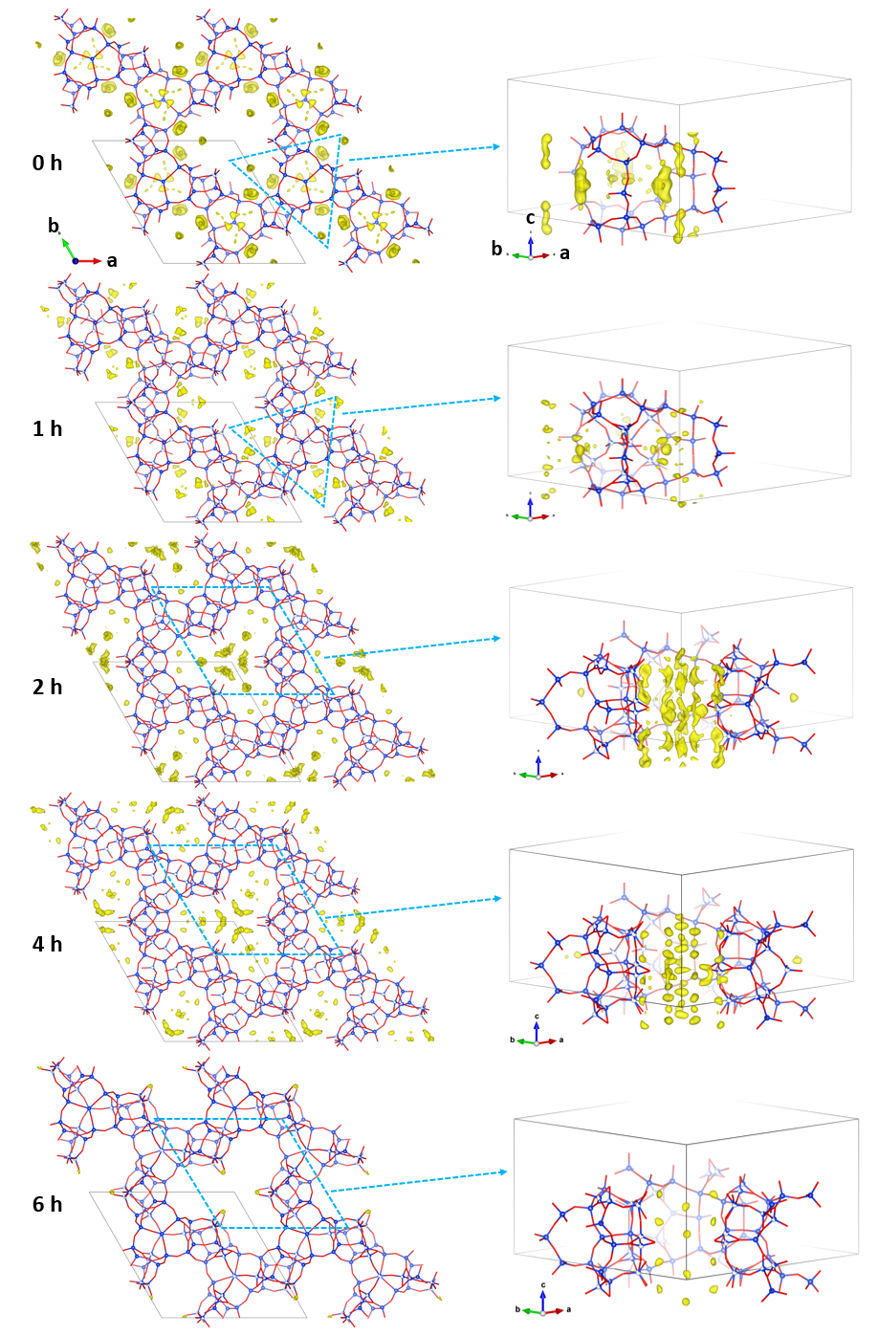
Supplementary Fig. 12 Difference Fourier maps of intermediate structures obtained from the 3D ED data. The maps indicate the major locations of the OSDAs at different time points (highlighted by blue circles) (10,11). It is worth noting that the OSDAs might adapt different configurations and arrangements, in particularly here where the pore symmetry is higher than the symmetry of the OSDA. The difference Fourier maps present only averaged distributions of the OSDAs, and it is therefore difficult to locate individual atoms in the OSDA.

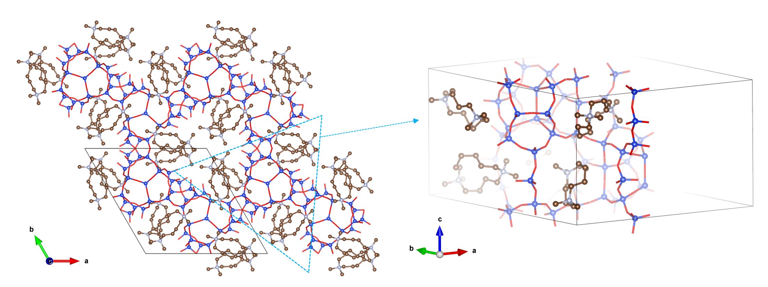
Supplementary Fig. 13 Modelling of the OSDA positions in ECNU-45. The modelling was conducted in P1 symmetry, incorporating six OSDA molecules per unit cell. The predicted OSDA locations align closely with the difference Fourier maps derived from the 3D ED data.

Supplementary Fig. 14 TGA curves of ECNU-45 and ECNU-46. The much smaller weight loss of ECNU-46 between 200 and 400 ℃ compared to that of ECNU-45 indicates that nearly all the OSDAs occluded inside the pores of ECNU-45 were extracted by heat treatment at 463 K in the HCl/EtOH/H₂O solution.

Supplementary Fig. 15 N₂ adsorption/desorption isotherm of ECNU-46 at 77 K. It gives a BET surface area of 545 m²⸱g⁻¹ and a micropore volume of 0.19 cm³⸱g⁻¹.

Supplementary Table 1 Experimental parameters of the 3D ED data and the structure refinement and crystallographic details of ECNU-45.
Reaction time | 0h | 1h | 2h | 4h | 6h | 8h | 10h | 24h
Crystal data
Formula | [Si_{59.6}O_{131.2}] | [Si_{63.1}O_{138.1}] | [Si_{63.4}O_{138.7}] | [Si_{63.2}O_{138.3}] | [Si_{62.6}O_{136.4}] | [Si_{62.9}O_{133.6}] | [Si_{61.1}O_{129.6}] | [Si_{62.0}O_{130.0}]
Crystal System | Hexagonal
Space group | $$P-62c$$
a (Å)* | 19.9616 | 19.9773 | 19.9794 | 19.8949 | 19.8160 | 19.7724 | 19.8072 | 19.7848
b (Å)* | 19. 9616 | 19.9773 | 19.9794 | 19.8949 | 19.8160 | 19.7724 | 19.8072 | 19.7848
c (Å)* | 13.8771 | 13.6617 | 13.6197 | 13.6992 | 13.9169 | 14.0878 | 14.1180 | 14.1435
V (Å³) | 4788.7 | 4721.8 | 4708.29 | 4695.8 | 4732.7 | 4769.7 | 4796.8 | 4794.58
ρ (g/cm³) | 1.308 | 1.400 | 1.410 | 1.410 | 1.389 | 1.359 | 1.312 | 1.323
Data collection
Tilt range (°) | 120.77 | 112.66 | 103.06 | 95.98 | 90.28 | 83.45 | 103.31 | 102.55
No. of frames | 470 | 437 | 403 | 375 | 351 | 325 | 405 | 396
Total time (min) | 4.45 | 4.14 | 3.81 | 3.55 | 3.32 | 3.08 | 3.85 | 3.75
Data details
Resolution (Å) | 0.90 | 0.90 | 0.95 | 0.95 | 0.90 | 0.95 | 0.95 | 0.90
I/σ(I) | 5.31 | 5.78 | 4.62 | 5.69 | 5.55 | 5.40 | 4.18 | 4.58
Completeness (%) | 98.5 | 96.6 | 98.6 | 95.0 | 99.0 | 98.5 | 98.8 | 89.5
CC_{1/2} | 97.9 | 99.5 | 98.3 | 98.5 | 99.4 | 99.4 | 96.2 | 98.6
R_{meas} (%) | 21.6 | 18.0 | 21.4 | 18.2 | 14.6 | 13.3 | 29.4 | 29.7
Total reflections | 12203 | 9238 | 7102 | 7075 | 6902 | 5015 | 8264 | 10641
Refinement
d_{min} (Å) | 1.0 | 0.95 | 1.0 | 1.00 | 1.00 | 0.95 | 1.00 | 0.95
Rint | 0.1786 | 0.1537 | 0.1791 | 0.1516 | 0.1200 | 0.1054 | 0.2476 | 0.2591
Observed data | 1354 | 1257 | 1018 | 1099 | 1216 | 1027 | 1002 | 1230
N_{reflections}, | 1760 | 1972 | 1716 | 1665 | 1729 | 1860 | 1750 | 1808
N_{parameters}, | 169 | 235 | 232 | 232 | 219 | 222 | 178 | 159
N_{restraints} | 65 | 186 | 213 | 134 | 159 | 159 | 74 | 7
R1, wR2  [$F^{2}>2.0σ(F^{2})$] | 0.1494,  0.3344 | 0.1400,  0.3347 | 0.1516,  0.3405 | 0.1591,  0.3414 | 0.1723,  0.3602 | 0.1454,  0.3294 | 0.1378,  0.3146 | 0.1226,  0.2887
R1, wR2  (all data) | 0.1630,  0.3493 | 0.1655,  0.3562 | 0.1810,  0.3624 | 0.1805,  0.3606 | 0.1888,  0.3743 | 0.1877,  0.3579 | 0.1671,  0.3367 | 0.1479,  0.3143
Bond lengths and angles
dSi-O_{min} (Å) | 1.56 | 1.56 | 1.55 | 1.56 | 1.55 | 1.56 | 1.56 | 1.56
dSi-O_{max} (Å) | 1.64 | 1.64 | 1.65 | 1.64 | 1.66 | 1.66 | 1.62 | 1.63
dSi-O_{mean} (Å) | 1.60 | 1.60 | 1.59 | 1.60 | 1.60 | 1.60 | 1.59 | 1.58
∠O-Si-O_{min} (°) | 105 | 103.6 | 104.6 | 102.7 | 103.5 | 104.3 | 103.3 | 104.2
∠O-Si-O_{max} (°) | 114 | 117 | 114 | 117 | 116.6 | 117 | 116 | 114
∠O-Si-O_{mean} (°) | 109.4 | 109.6 | 109.4 | 109.4 | 109.4 | 109.4 | 109.4 | 109.5
∠Si-O-Si_{min} (°) | 133 | 139 | 141.9 | 138 | 135.5 | 137.9 | 136.8 | 138.9
∠Si-O-Si_{max} (°) | 180 | 180 | 180 | 180 | 180 | 180 | 180 | 180
∠Si-O-Si_{mean} (°) | 153.5 | 152.4 | 153.0 | 151.6 | 154.4 | 156.4 | 157.9 | 159.3
*The unit cell parameters identified from PXRD data were applied in the refinement.

The 3D ED data used for structure determination and refinement in this study are of high quality, with the data resolution ranging from 1.00 to 0.95 Å (average: 0.98 Å) and the data completeness ranges from 89.5 to 99.0 % (average: 96.8 %). These high-quality data allowed us to reliably determine the intermediate structures, enabling atomic scale visualization of detailed structural changes during topotactic reactions and transformations. The coordinates of all T sites, including both fully and partially occupied ones, were directly and exclusively determined using the 3D ED data. During the refinement, the occupancies of partially occupied T sites were refined without restraints. Restraints were mainly imposed on the bond lengths and angles, and anisotropic atomic displacement parameters of atoms of low occupancies, as these atoms only give smaller contributions to electrostatic potential maps and may be more flexible. The R1 values of the structural refinements vary from 0.1226 to 0.1723 (on average: 0.1473; $F^{2}>2.0σ(F^{2})$). The refined structures exhibited reasonable Si-O bond lengths (1.55 to 1.66 Å; average: 1.59 Å) and O-Si-O angles (102.7° to 117.0°, average: 109.5°). Occupancies were also reasonable and consistent with zeolite chemistry principles. For example, T8 and T12 need to be bonded by T7 and T10 through O atoms, respectively. Therefore, T8 disappeared earlier than T7 during the reactions, and its occupancy was consistently lower than that of T7 (Fig. 3). Similarly, T12 appeared after T10 and its occupancy was consistently lower than and increased highly in line with that of T10.

Supplementary Table 2 The content of Si species in the acidic solution and the remaining OSDA in the solid product along with the increase of reaction time.
Treatment time  (h) | Si species content ª  (μg) | OSDA amount ^{b} (wt.%) | OSDA remained (%)
0 | / | 17.73 | 100
1 | 514.8 | 10.13 | 57.1
2 | 546.0 | 9.87 | 55.6
4 | 549.6 | 8.14 | 45.9
6 | 747.6 | 2.13 | 12.0
8 | 1203.6 | 2.41 | 13.6
10 | 1278.0 | 1.74 | 9.8
24 | 3346.8 | 2.24 | 12.6
ª The Si leaching amount for 0.5 g of ECNU-45 zeolite as determined by ICP analysis.
^{b} Determined by TGA, the weight loss in the 200 to 400 ℃ range was assigned to the removal of OSDAs.

During the topotactic reactions, Si leaching was observed, and the detected Si amount increased with prolonged reaction time, which supplies Si(OH)₄ species for the topotactic reaction and transformation of ECNU-45 into ECNU-46. As there are remaining Si(OH)₄ species in the acidic solution, some crystals of ECNU-45 are dissolved and not transformed into ECNU-46. For OSDAs, they are mostly removed during the first and second stages of the topotactic reactions. In each stage, the OSDAs experienced a fast removal followed by a slow one (Supplementary Fig. 9a). In the first stage, 42.9 % were removed in the first 1 h and 11% were removed in the later 3 h. In the second stage, 33.9 % were removed in the first 2 h and almost none was removed later.

Supplementary Table 3 Determination of gest organic SDA molecules in the as-made Na-ECNU-27 zeolite
Elemental analysis (wt.%) |  |  |  | TG analysis (wt. %) |  |  | Guest species^{b}
C | H | N | C/N ratioª | H₂O | SDA | Framework | H₂O/a.u. | SDA/a.u.
13.39 | 3.63 | 2.19 | 7.13 | 6.65 | 21.73 | 71.62 | 19.5 | 5.0
ª C/N mass ratio
^{b} Determined by the results of elemental and TG analysis

The amount of OSDA molecules occluded in the as-made ECNU-45 was evaluated by both elemental and TG analysis. The C/N mass ratio determined by elemental analysis was 7.13, which was consistent with the theoretical value of TDDH molecules (C/N=7). This also confirmed that the OSDA molecules were well preserved in the high-temperature crystallization process. Combing with the TG analysis, the amount of H₂O and OSDA molecules were determined to be 19.5 and 5.0, respectively, for each unit cell. The calculated chemical composition is |(C₁₄H₃₂N₂)_{5.0} (H₂O)_{19.5}|[Si_{59.6}O_{131.2}].

Supplementary Table 4 ²⁹Si NMR chemical shifts and peak area of products reacted for different time.
Time (h) | Q² (ppm) | Q³ (ppm) | Q⁴ (ppm) |  |  | Total Q⁴ (%)
0 | -89.66(7.5)ª | -98.61(34.2) | -108.93(47.9) | -117.53(10.4) |  | 58.3
1 | -90.77(8.4) | -99.56(24.2) | -109.54(57.2) | -117.01(10.3) |  | 67.5
2 | -91.35(8.6) | -99.75(24.2) | -109.44(56.0) | -116.67(11.2) |  | 67.2
4 | -91.36(5.8) | -100.11(24.0) | -109.84(58.0) | -116.41(12.3) |  | 70.3
6 | -96.5(2.8) | -101.9(21.8) | -110.1(55.6) | -115.4(19.8) |  | 75.4
8 | -93.9(0.8) | -102.1(16.9) | -110.5(59.1) | -115.6(23.2) |  | 82.3
10 | -97.9(1.1) | -102.4(13.9) | -109.1(34.8) | -113.5(13.1) | -118.1(37.1) | 85.0
24 | -92.18(3.3) | -101.54(18.4) | -110.08(48.1) | -115.34(30.2) |  | 78.3
ªThe numbers in parentheses indicate the percentage of each configuration.

Supplementary References

1. Y. Wang et al., The synthesis of RZM-3 zeolite with EWT topology structure using 1,1,6,6-tetramethyl-1,6-diazacyclododecane-1,6-diium dihydroxide as structure-directing agent. Micropor. Mesopor. Mater. 275, 87–94 (2019).
2. M. O. Cichocka, J. Ångström, B. Wang, X. Zou, S. Smeets, High-throughput continuous rotation electron diffraction data acquisition via software automation. J. Appl. Crystallogr. 51, 1652–1661 (2018).
3. W. Kabsch, XDS. Acta Crystallogr. D66, 125–132 (2010).
4. G. M. Sheldrick, SHELXT – Integrated space-group and crystal-structure determination. Acta Crystallogr. A71, 3–8 (2015).
5. G. M. Sheldrick, Crystal structure refinement with SHELXL. Acta Crystallogr. C71, 3–8 (2015).
6. C. B. Hübschle, G. M. Sheldrick, B. Dittrich, ShelXle: a Qt graphical user interface for SHELXL. J. Appl. Crystallogr. 44, 1281–1284 (2011).
7. P. A. Doyle, P. S. Turner, Relativistic Hartree–Fock X-ray and electron scattering factors. Acta Crystallogr. A24, 390–397 (1968).
8. T. Willhammar et al., EMM-23: A Stable High-Silica Multidimensional Zeolite with Extra-Large Trilobe-Shaped Channels. J. Am. Chem. Soc. 136, 13570–13573 (2014).
9. V. A. Blatov, A. P. Shevchenko, D. M. Proserpio, Applied Topological Analysis of Crystal Structures with the Program Package ToposPro. Cryst. Grow. Des. 14, 3576–3586 (2014).
10. J. T. C. Wennmacher et al., Electron Diffraction Enables the Mapping of Coke in ZSM-5 Micropores Formed during Methanol-to-Hydrocarbons Conversion. Angew. Chem. Int. Ed. 61, e202205413 (2022).
11. Y. Luo, M. T. B. Clabbers, J. Qiao, Z. Yuan, W. Yang, X. Zou, Visualizing the Entire Range of Noncovalent Interactions in Nanocrystalline Hybrid Materials Using 3D Electron Diffraction. J. Am. Chem. Soc. 144, 10817–10824 (2022).

