Supporting informations

Docking calculations with SeeSAR software

Cancers proteins 3F66, 4XVE, 1XF0 and 5Y8Y

Molecule M1

LogS = 2,965 (Intrinsic aqueous solubility)
LogP = 2,81
BBB (Blood-Brain-Barrier) log ([brain]:[blood]) = 0,085
TPSA (Topological Polar Surface Area) = 27,1 Å² (> 140 Å² : bad, < 90 Å² : good)
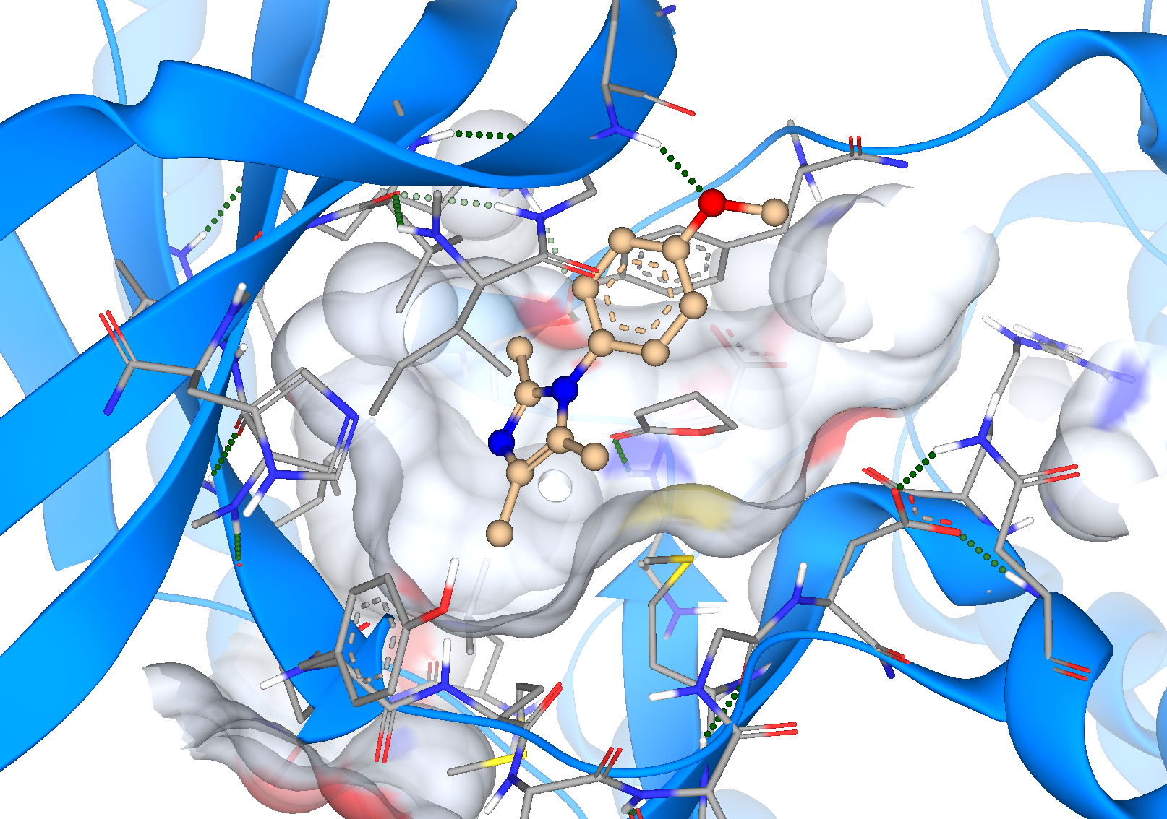
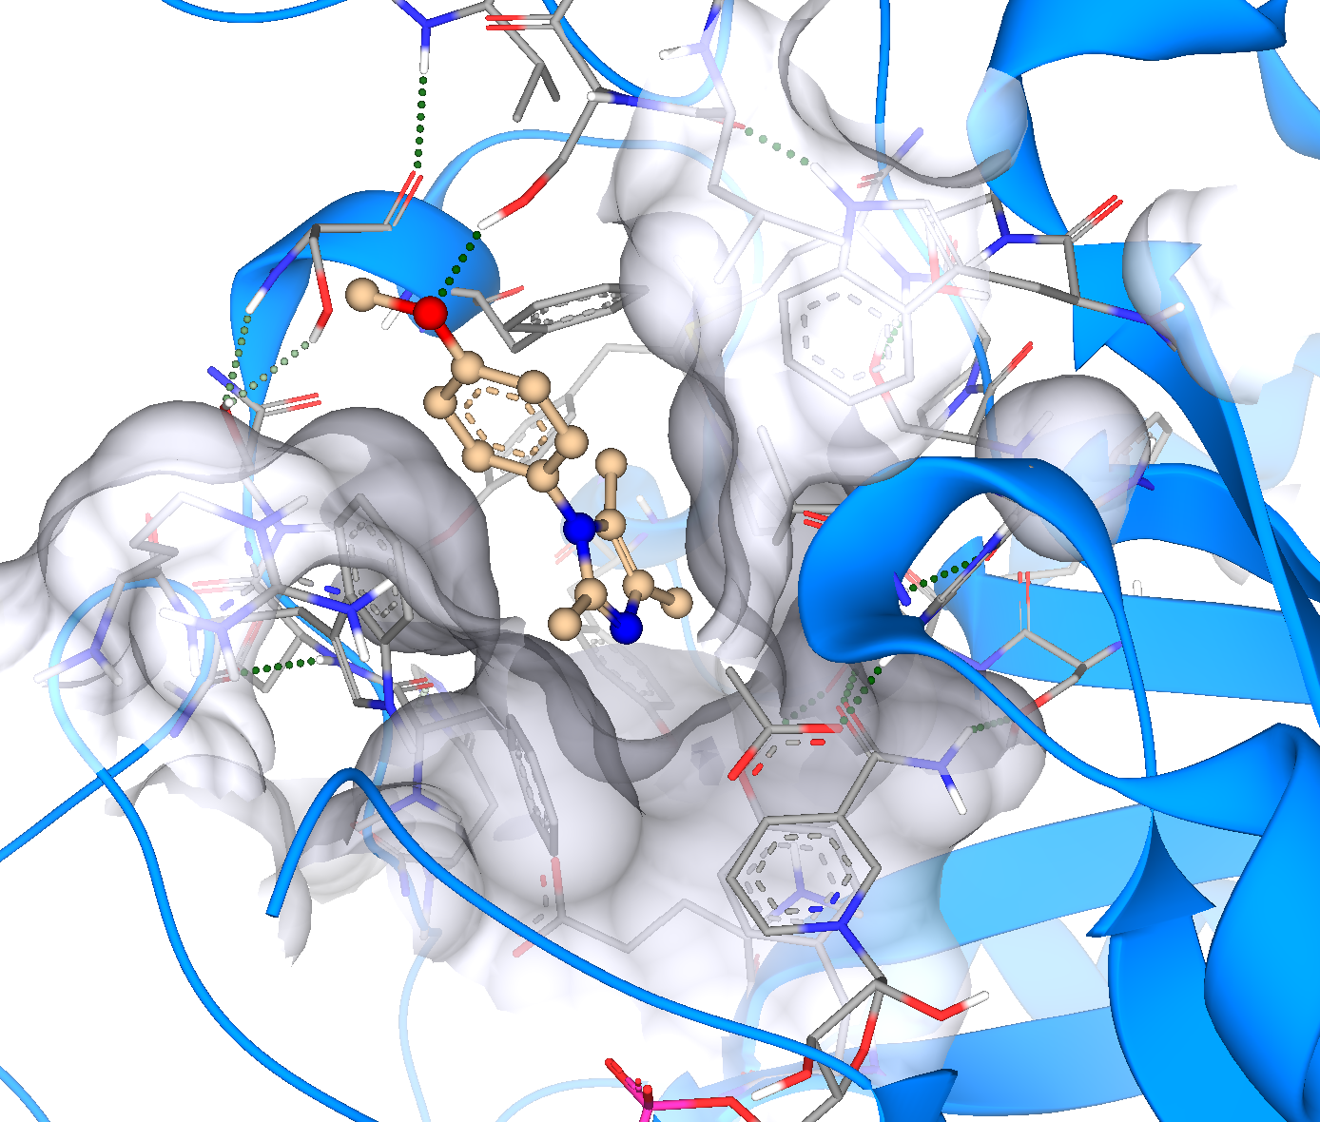

M1 in 1XF0 M1 in 3F66

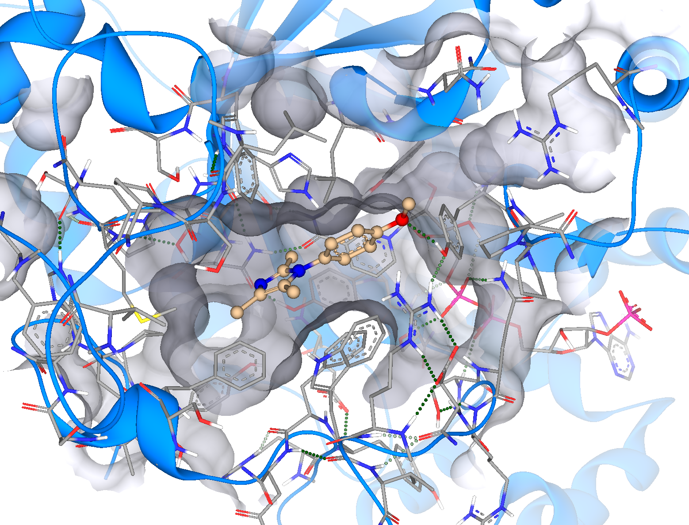
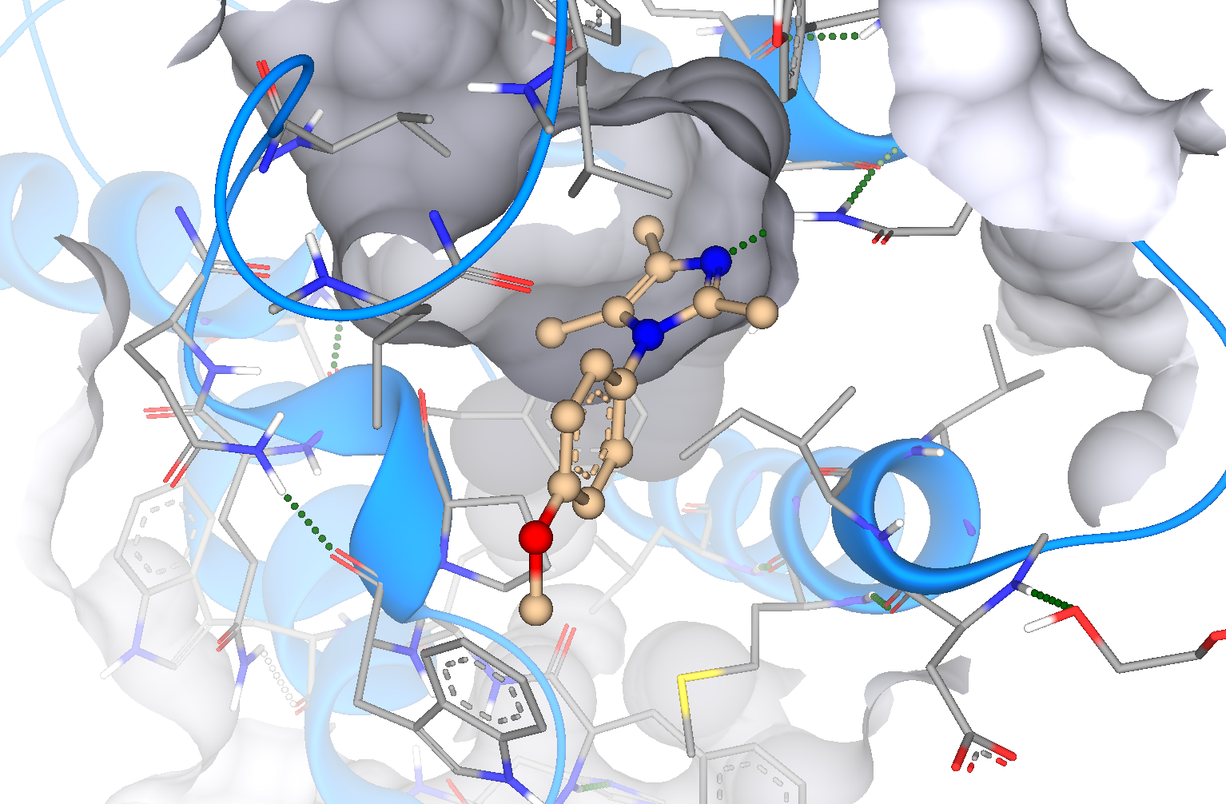

M1 in 4XVE M1 in 5Y8Y

Molecule M2

LogS = 4,485 (Intrinsic aqueous solubility)
LogP = 2,35
BBB (Blood-Brain-Barrier) log ([brain]:[blood]) = 0,593
TPSA (Topological Polar Surface Area) = 75 Å² (> 140 Å² : bad, < 90 Å² : good)

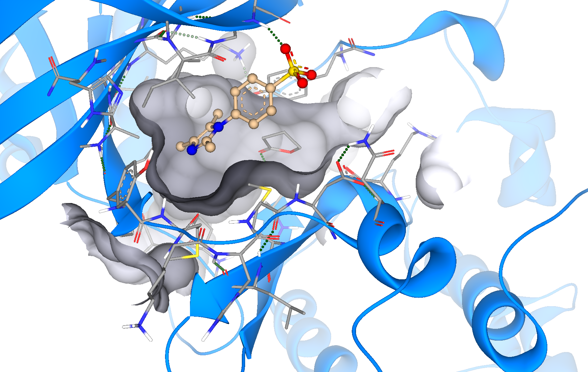
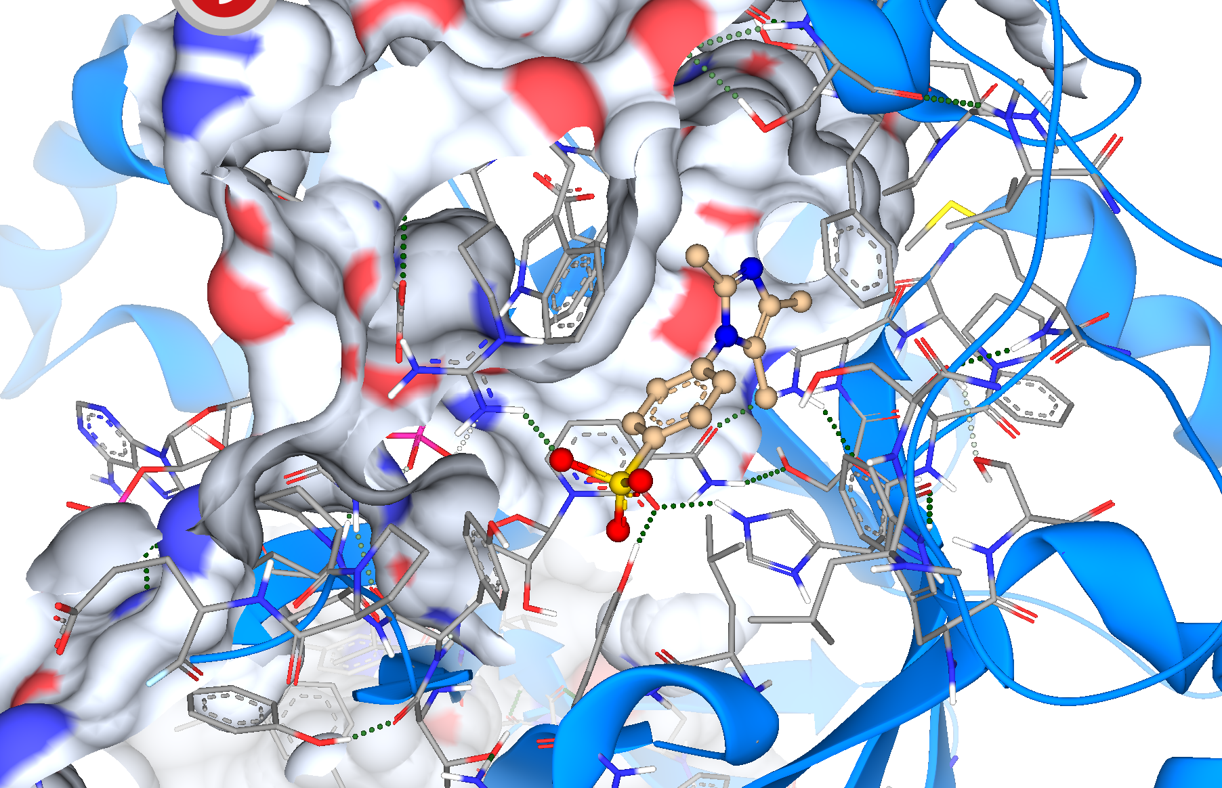

M2 in 1XF0 M2 in 3F66

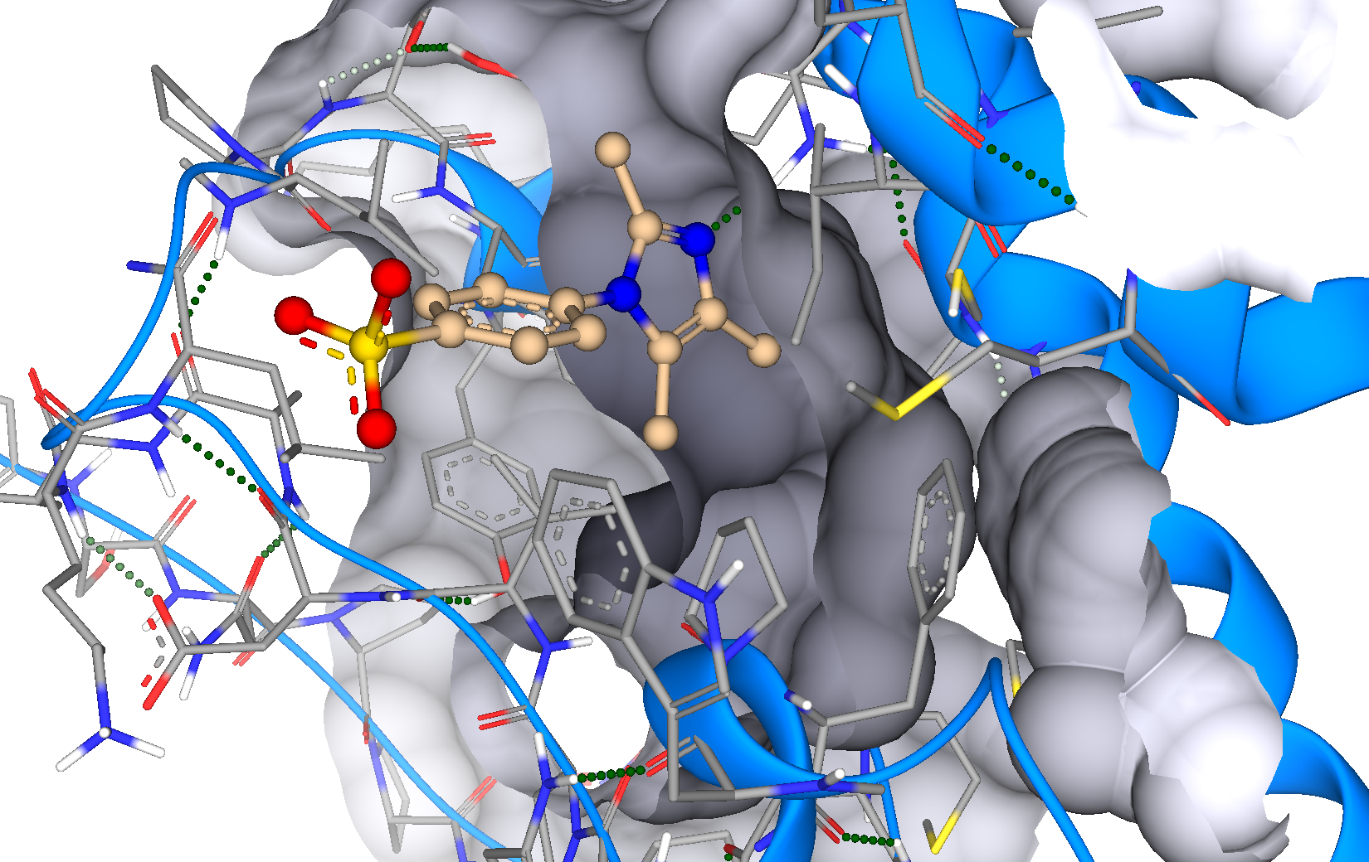
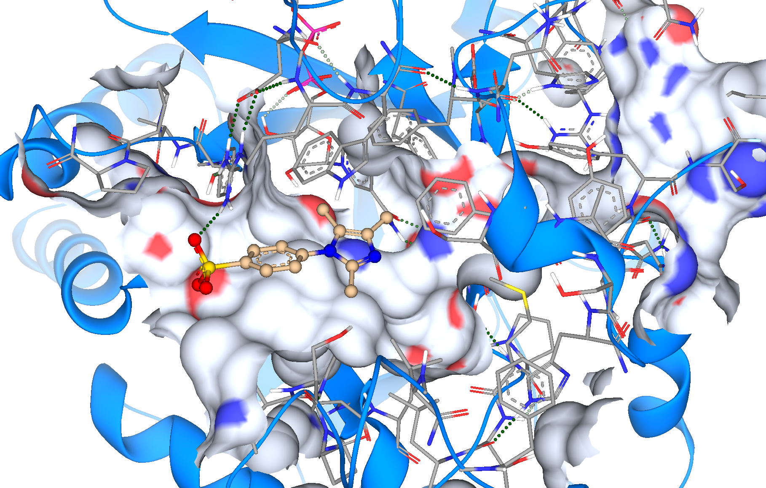

M2 in 4XVE M2 in 5Y8Y

Molecule M3

LogS = 2,871 (Intrinsic aqueous solubility)
LogP = 2,38
BBB (Blood-Brain-Barrier) log ([brain]:[blood]) = -0,786
TPSA (Topological Polar Surface Area) = 61,5 Å² (> 140 Å² : bad, < 90 Å² : good)

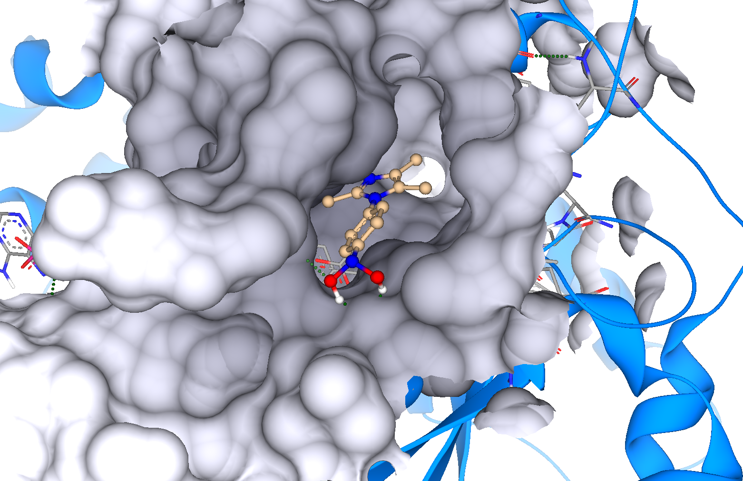
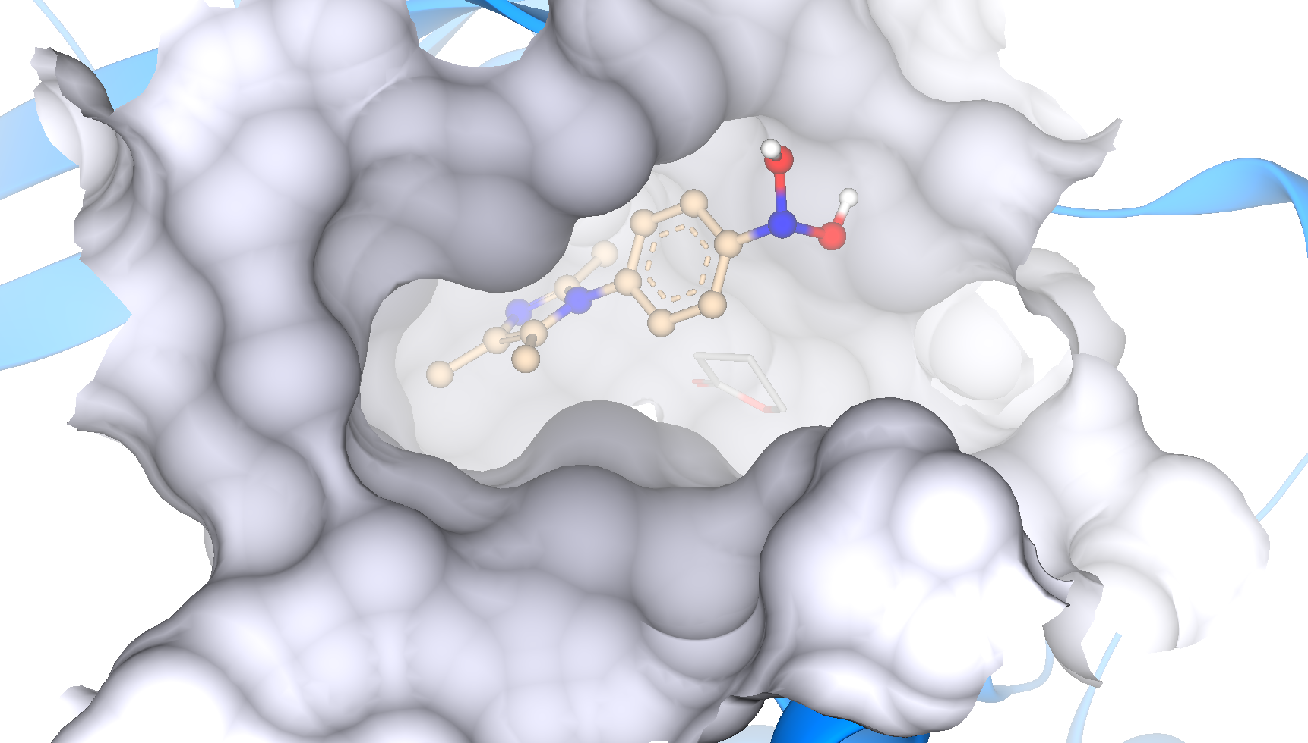

M3 in 1XF0 M3 in 3F66

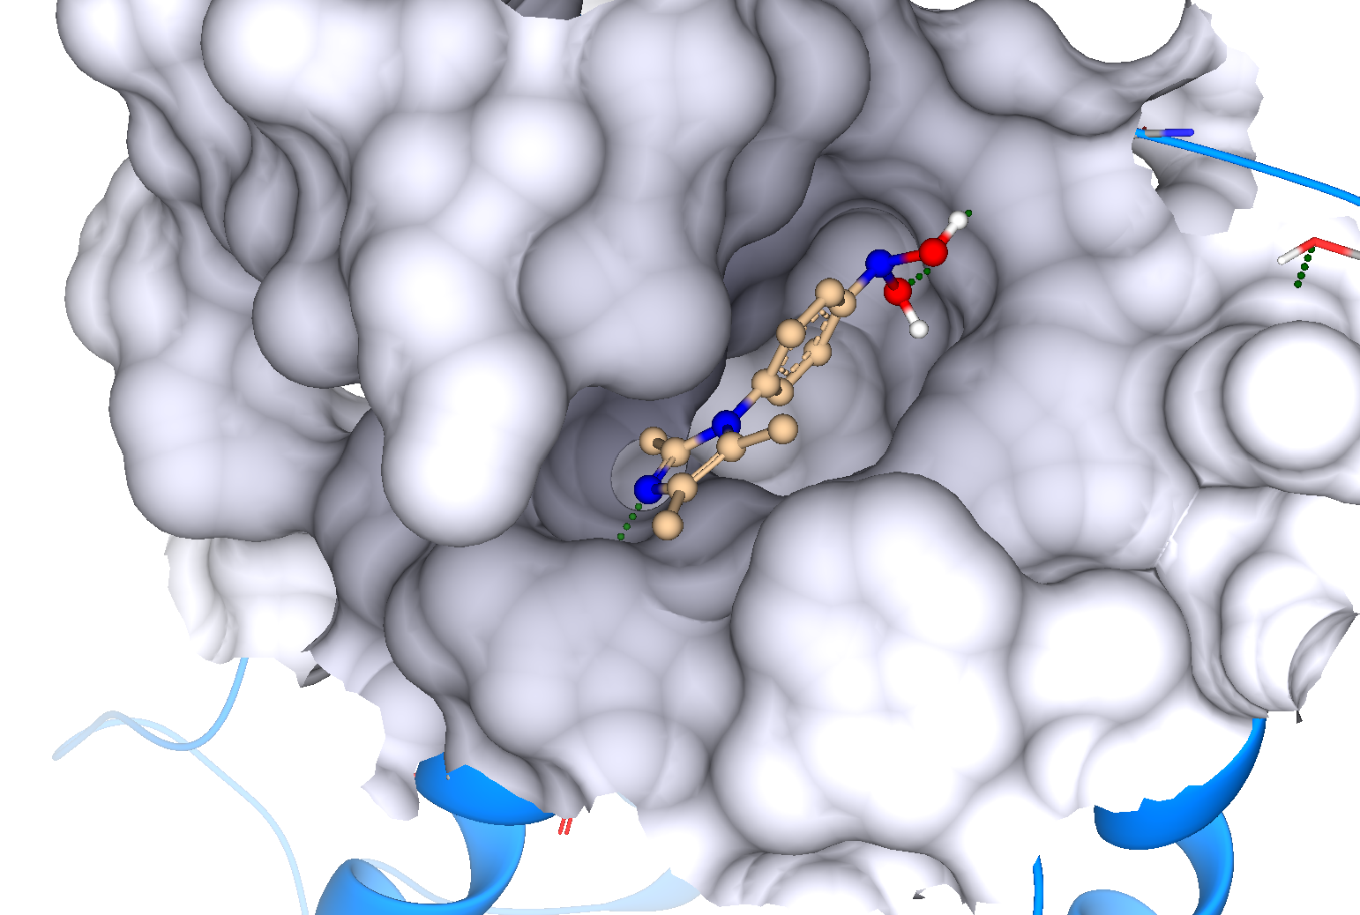
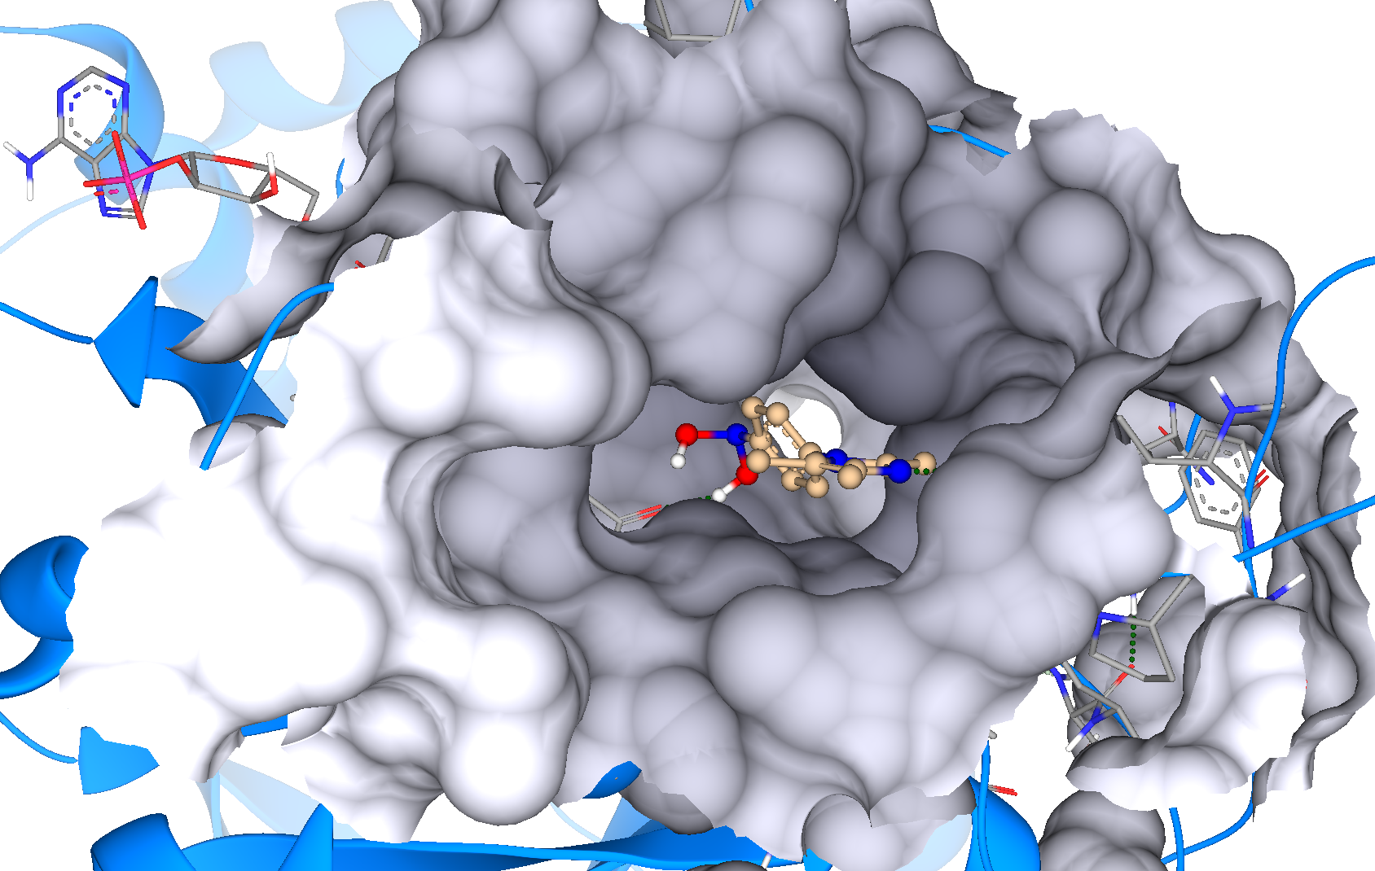

M3 in 4XVE M3 in 5Y8Y

Molecule M4

LogS = 4,931 (Intrinsic aqueous solubility)
LogP = 1,33
BBB (Blood-Brain-Barrier) log ([brain]:[blood]) = -0,145
TPSA (Topological Polar Surface Area) = 28,7,5 Å² (> 140 Å² : bad, < 90 Å² : good)

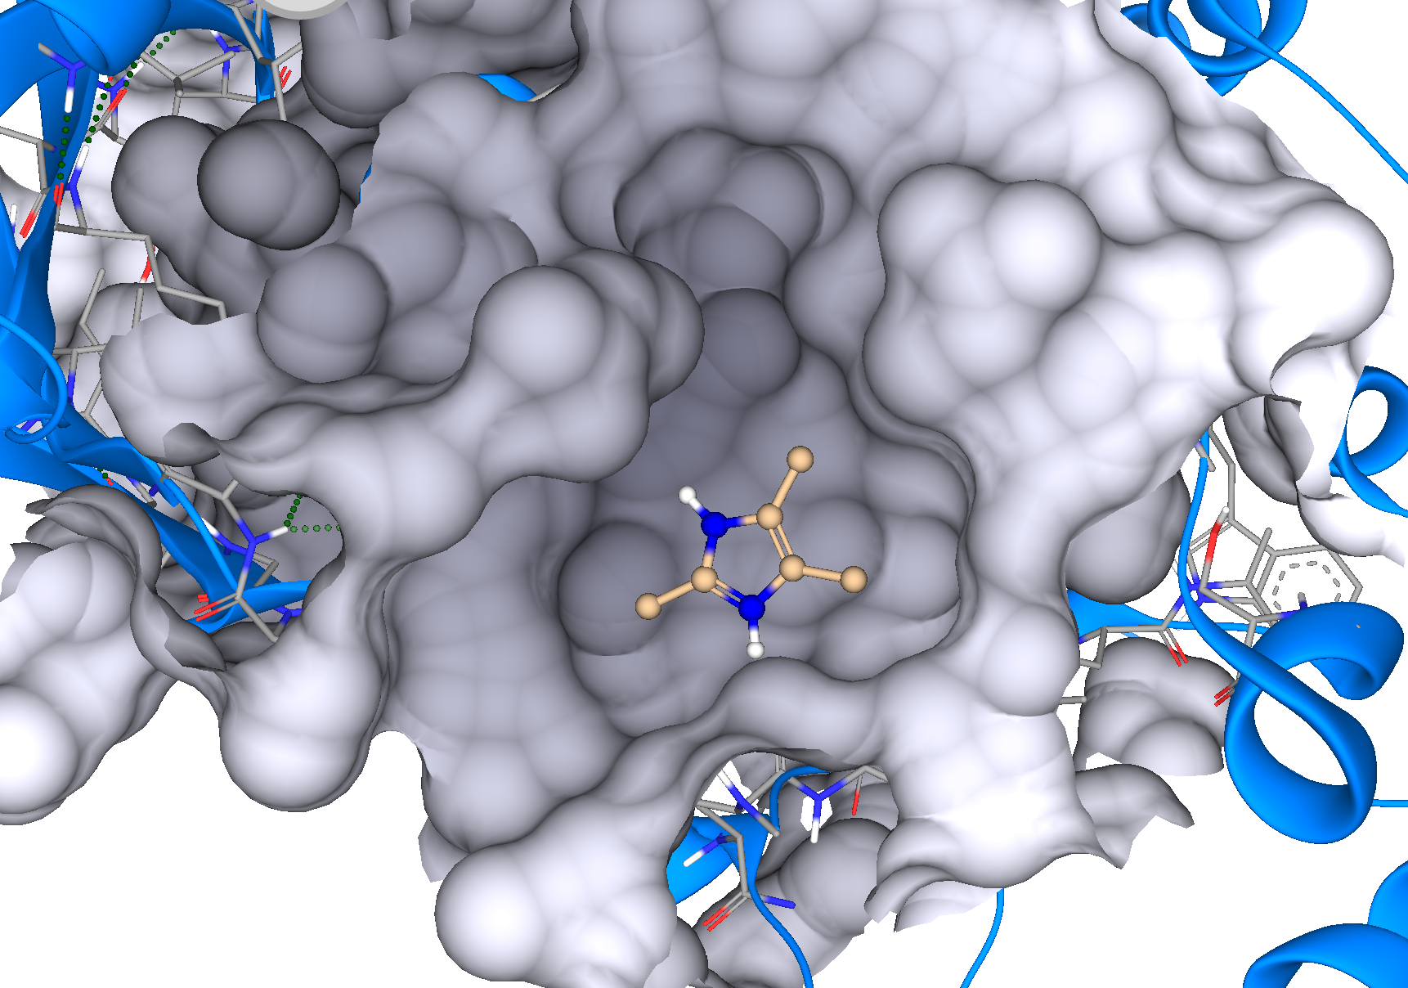
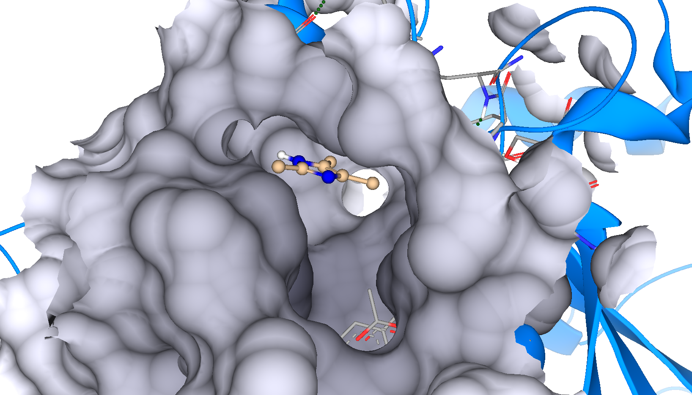

M4 in 1XF0 M4 in 3F66

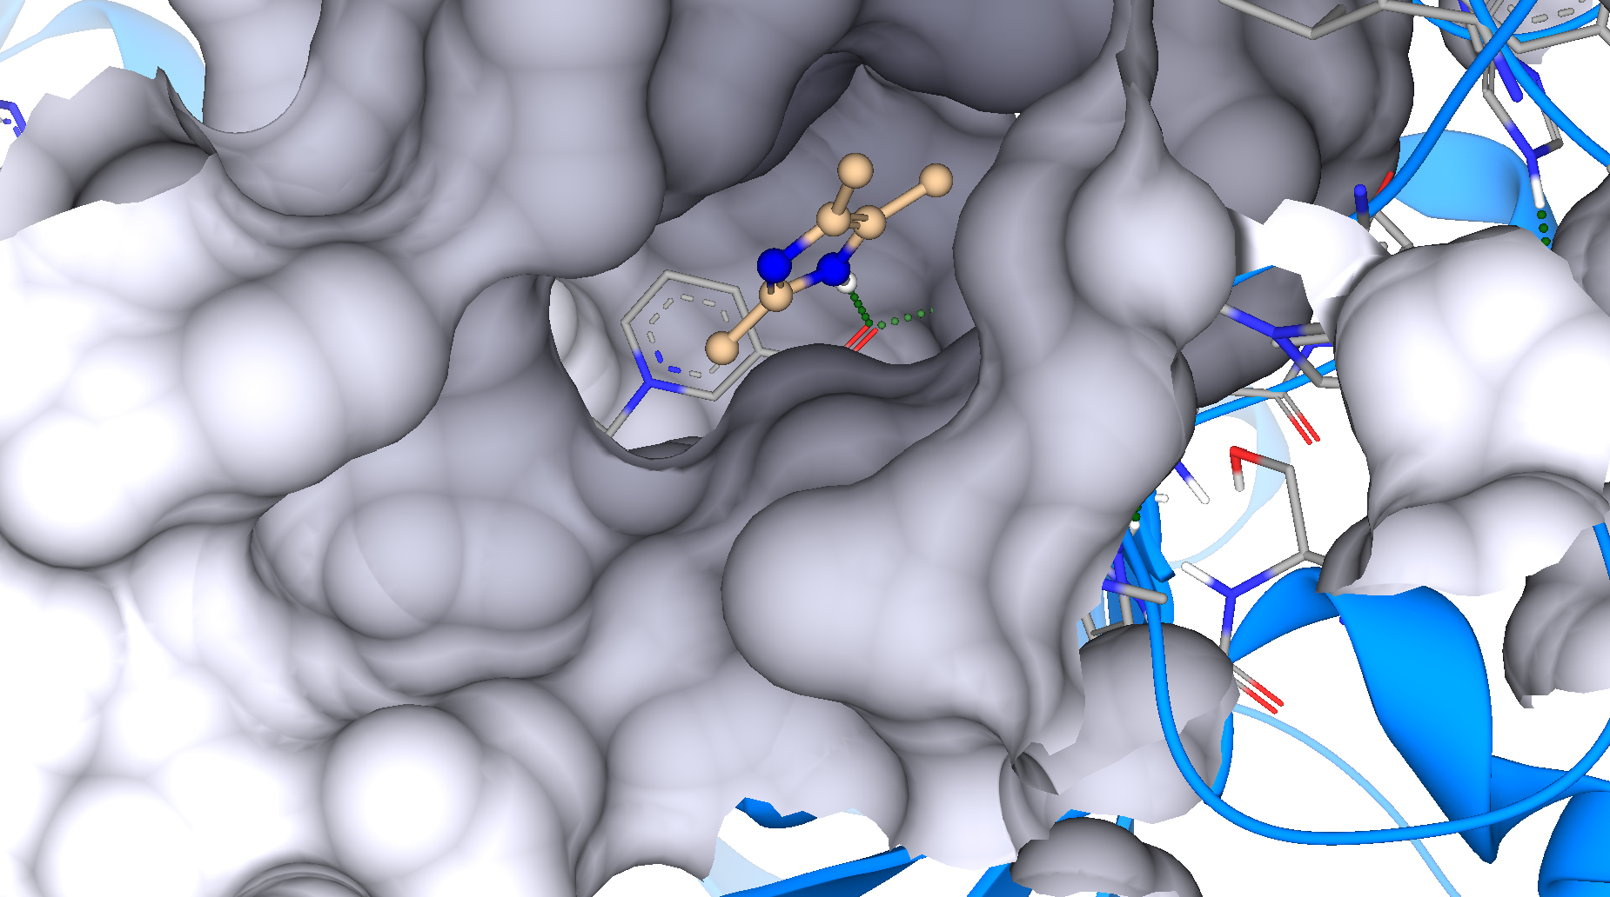
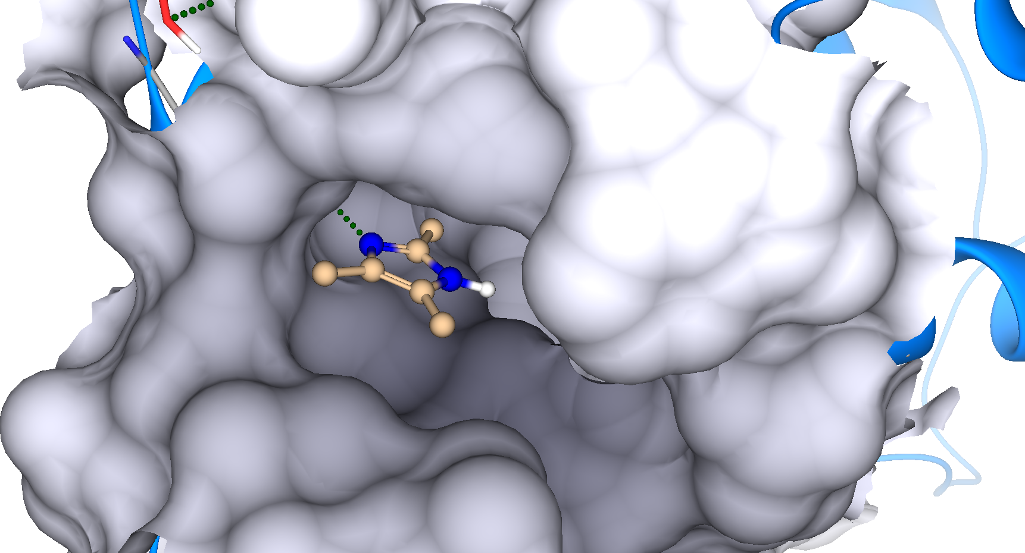

M4 in 4XVE M4 in 5Y8Y

