Supplemental Information

An unusually prolonged Pacific-North American pattern promoted the quad-state tornado outbreak on 10-11 December 2021

Dongmin Kim^{1,2}, Sang-Ki Lee², Hosmay Lopez², Jong-Hoon Jeong^{3,4} and Jin-Sil Hong^{5,2}

¹Cooperative Institute for Marine and Atmospheric Studies, University of Miami, Miami, FL, USA
²Atlantic Oceanographic and Meteorological Laboratory, NOAA, Miami, FL, USA
³Joint Institute for Regional Earth System Science and Engineering, University of California, Los Angeles, CA, USA
⁴Jet Propulsion Laboratory, California Institute of Technology, Pasadena, CA, USA
⁵Northern Gulf Institute, Mississippi State University, MS, USA

Included materials:
Supplementary Tables S1, and S2
Supplementary Figures S1, S2, S3, S4, S5, and S6

Table S1. The numbers of positive/negative PNA, and warm/cold Gulf of Mexico (GoM) days used in the study. Positive/negative PNA is identified based on the criterion that the PNA index during November-January (NDJ) is greater/less than half the standard deviation (82.18 gpm). The same criteria are applied for warm/cold GoM based on the area-averaged SSTAs over the Gulf of Mexico region (0.27K; 100°W-80°W, 18°N-31°N). The thresholds of definitions for all indices derived from a 400 model-year in the CESM-LENS are the same as the observation (numbers in the brackets). The thresholds of PNA, and GoM in CESM-LENS are 67.28 gpm, and 0.18K, respectively. Note that the total numbers of days in the observation and CESM-LENS are 3680 days, and 36800 days, respectively. The numbers in the parentheses are the percentage of each case.
Total n=3680 [n=36800] | PNA | GoM
Positive phase | 1329 (49.4%) [14304 (53.5%)] | 802 (36.1%) [12260 (48.7%)]
Negative phase | 1361 (50.6 %) [12401 (46.5%)] | 1421 (63.9%) [12903 (51.3%)]

Table S2. The numbers of long-lived/short-lived PNA days used in the study. The long-lived negative PNA days are defined as the negative PNA less than the half standard deviation that persists for equal to or longer than six days. On the other hand, the short-lived negative PNA days are defined as the negative PNA less than the half standard deviation that persists for less than six days. Note that the numbers in the bracket are derived from CESM-LENS. The numbers in the parentheses are the percentage of each case.
Total n=1361 [n=12401] | Long-lived (-) PNA | Short-lived (-) PNA
Number of days | 948 (69.6%) [9597 (77.3%)] | 413 (30.4%) [2804 (22.7%)]
Number of events | 82 (48.8%) [701 (54.1%)] | 86 (51.2%) [597 (45.9%)]
The mean length of event days | 11.5 days [13.6 days] | 4.8 days [4.6 days]

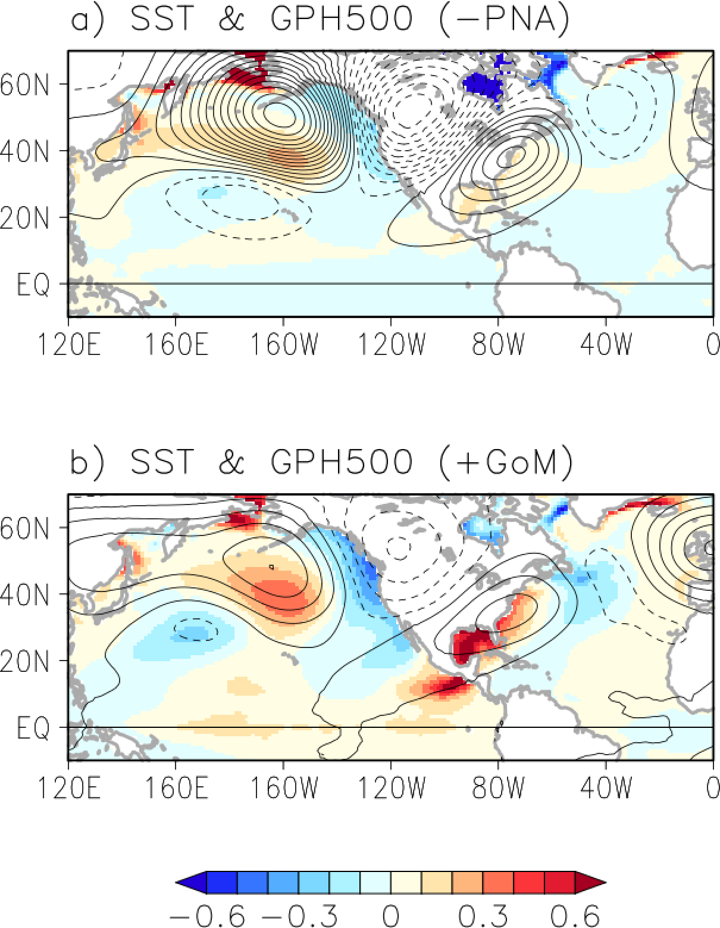
Fig. S1. Composite analysis of the large-scale environment during negative PNA and the warm Gulf of Mexico in the CESM-LENS. Composite of SSTAs (shaded, K), geopotential height at 500 hPa (contour, the intervals are 10 gpm in negative PNA case and 5 gpm in warm GoM case, solid/dashed lines indicate positive and negative values, respectively) derived from CEMS-LENS during (a) negative PNA and (b) positive GoM, respectively.

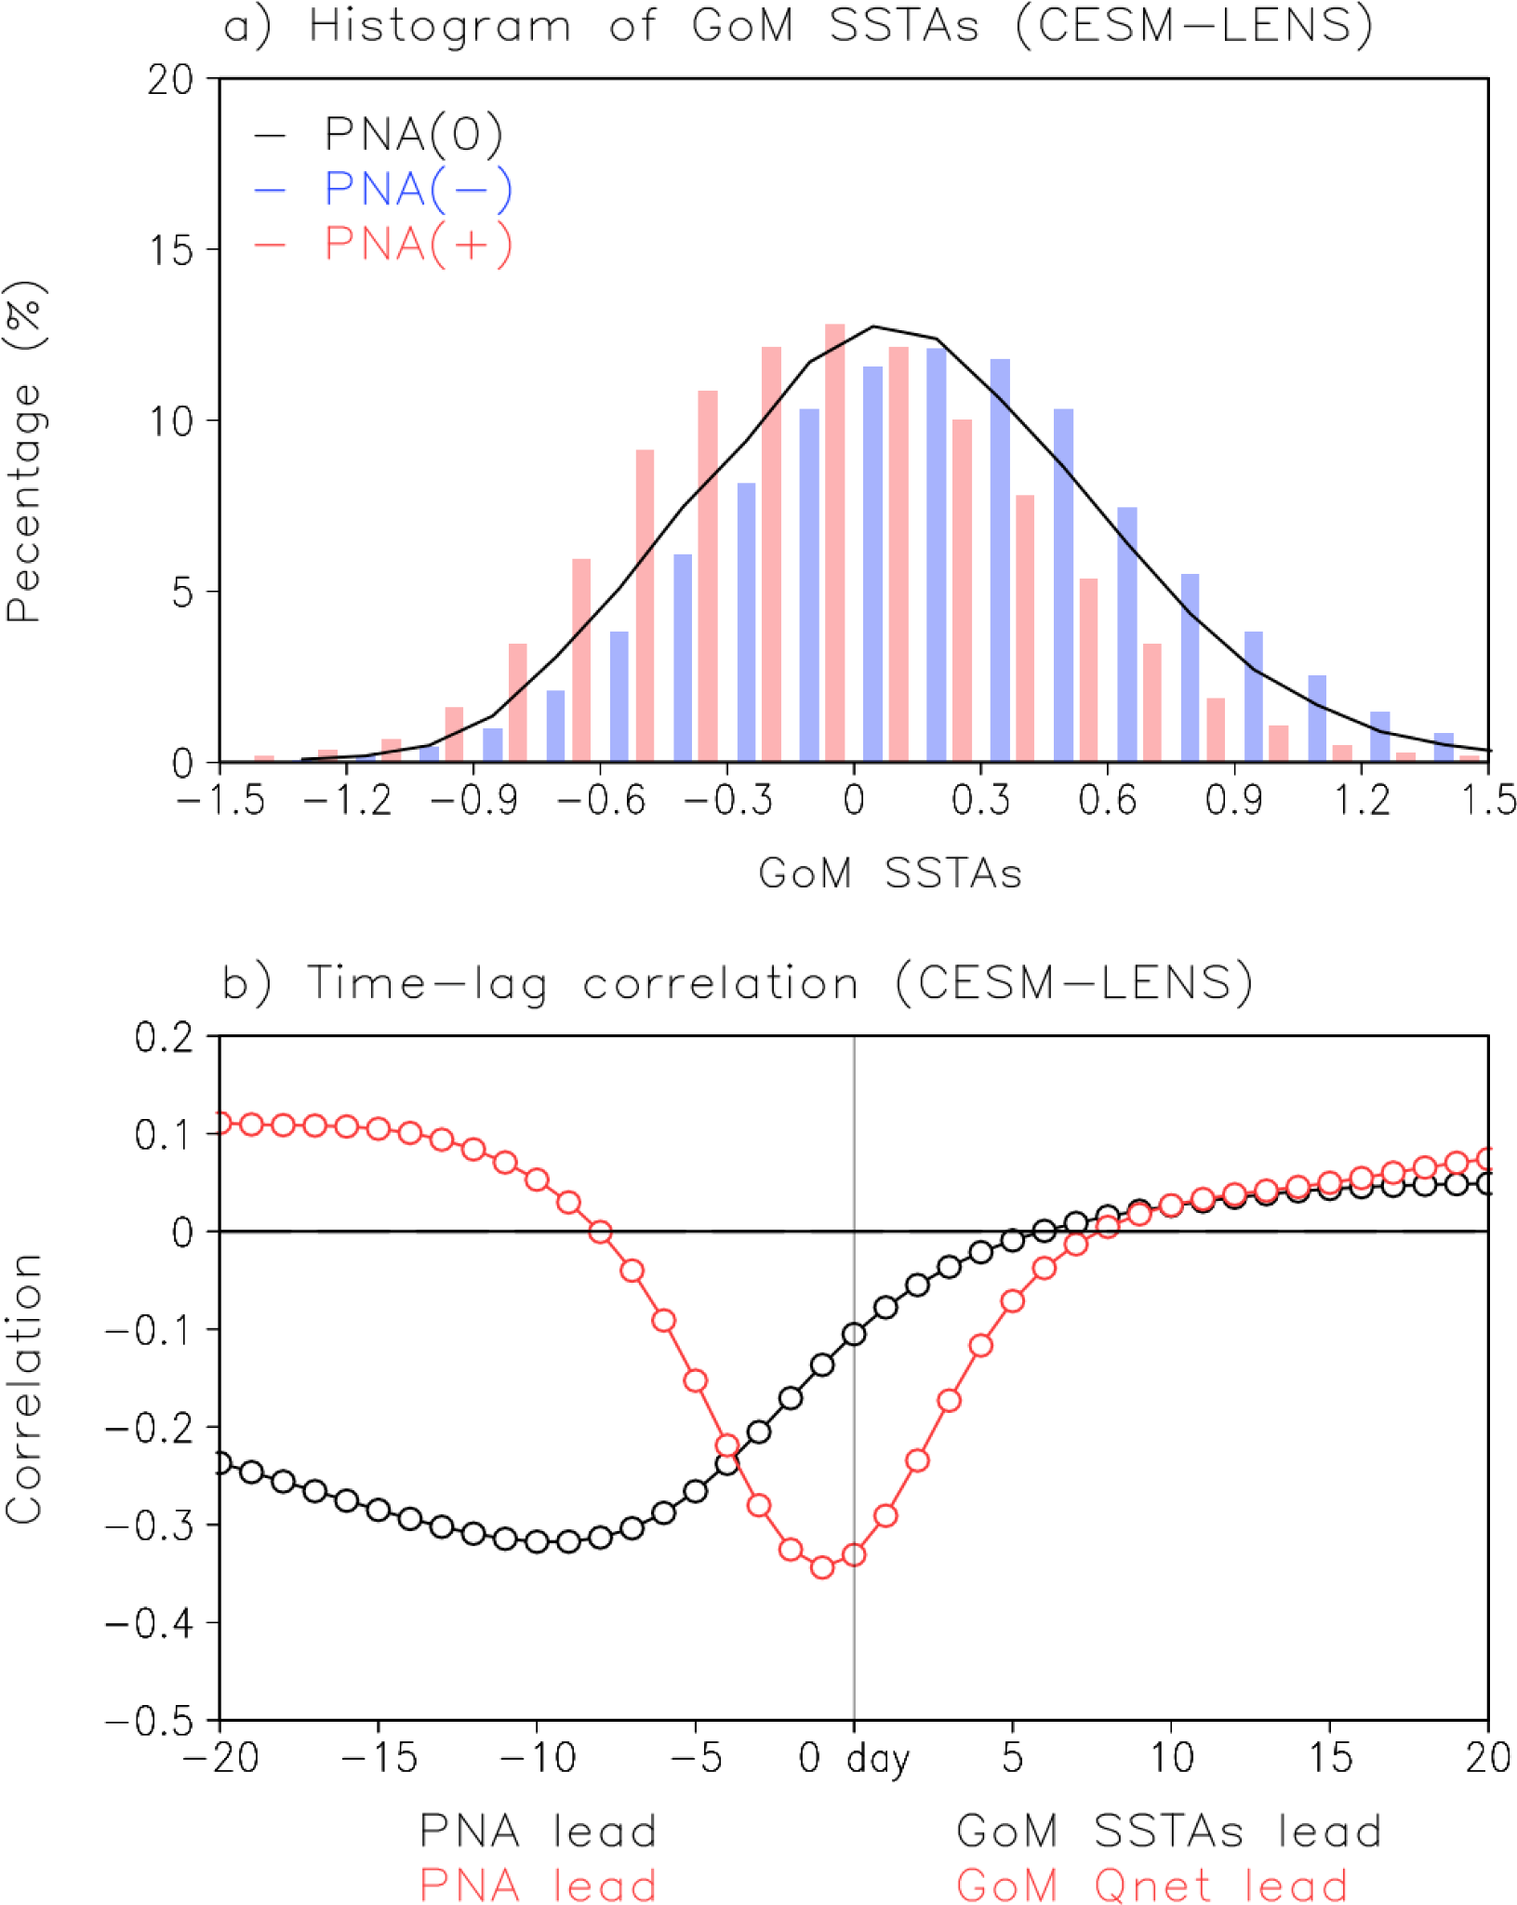
Fig. S2. Physical links between negative PNA and warm Gulf of Mexico sea surface temperatures in the CESM-LENS. (a) Histogram of the GoM SSTAs during positive PNA (red bars), negative PNA (blue bars), and neutral case (black line). (b) Lead-lag correlation (days) between the PNA index and the GoM SSTAs (black), and between the PNA index and the spatially averaged net surface heat flux (red, positive downward) over the GoM (100°W-80°W, 18°N-31°N). Results in this figure are derived from CESM-LENS.

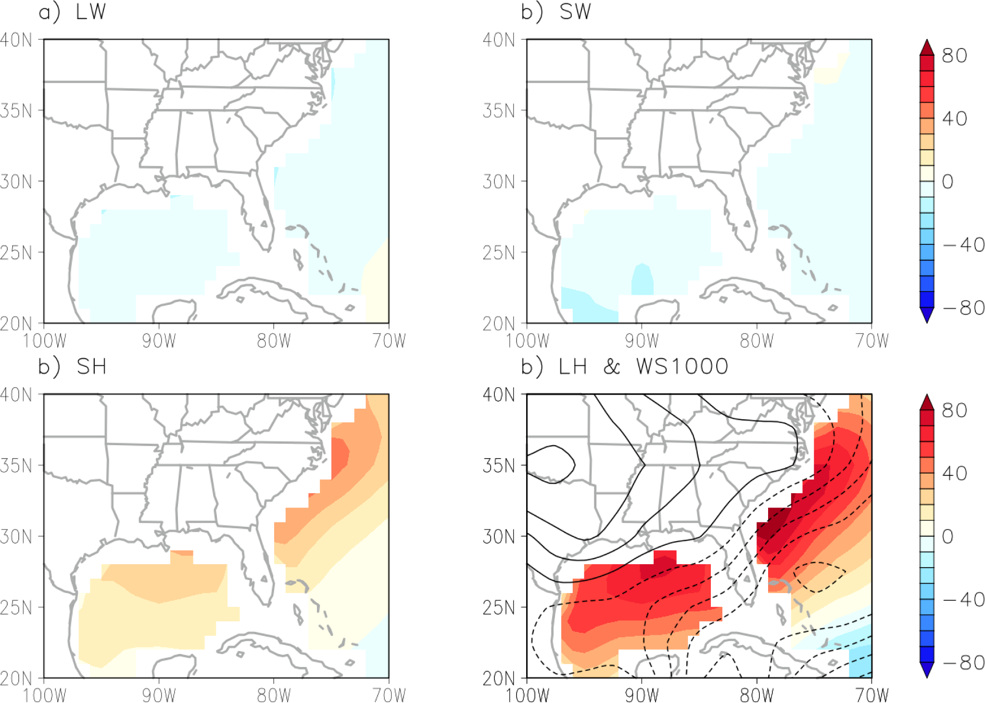
Fig. S3. Composite analysis of the surface heat components over the Gulf of Mexico and eastern US seaboard during negative PNA. Composite of (a) longwave radiation flux (W m⁻²), (b) shortwave radiation flux (W m⁻²), (c) sensible heat (W m⁻²) and (d) latent heat (shaded, W m⁻²) and wind speed anomalies at 925 hPa (contour, interval is 0.1 m s⁻¹, solid/dashed lines indicate positive and negative values, respectively) during negative PNA. The positive value of surface flux is downward. Note that the land area is masked out.

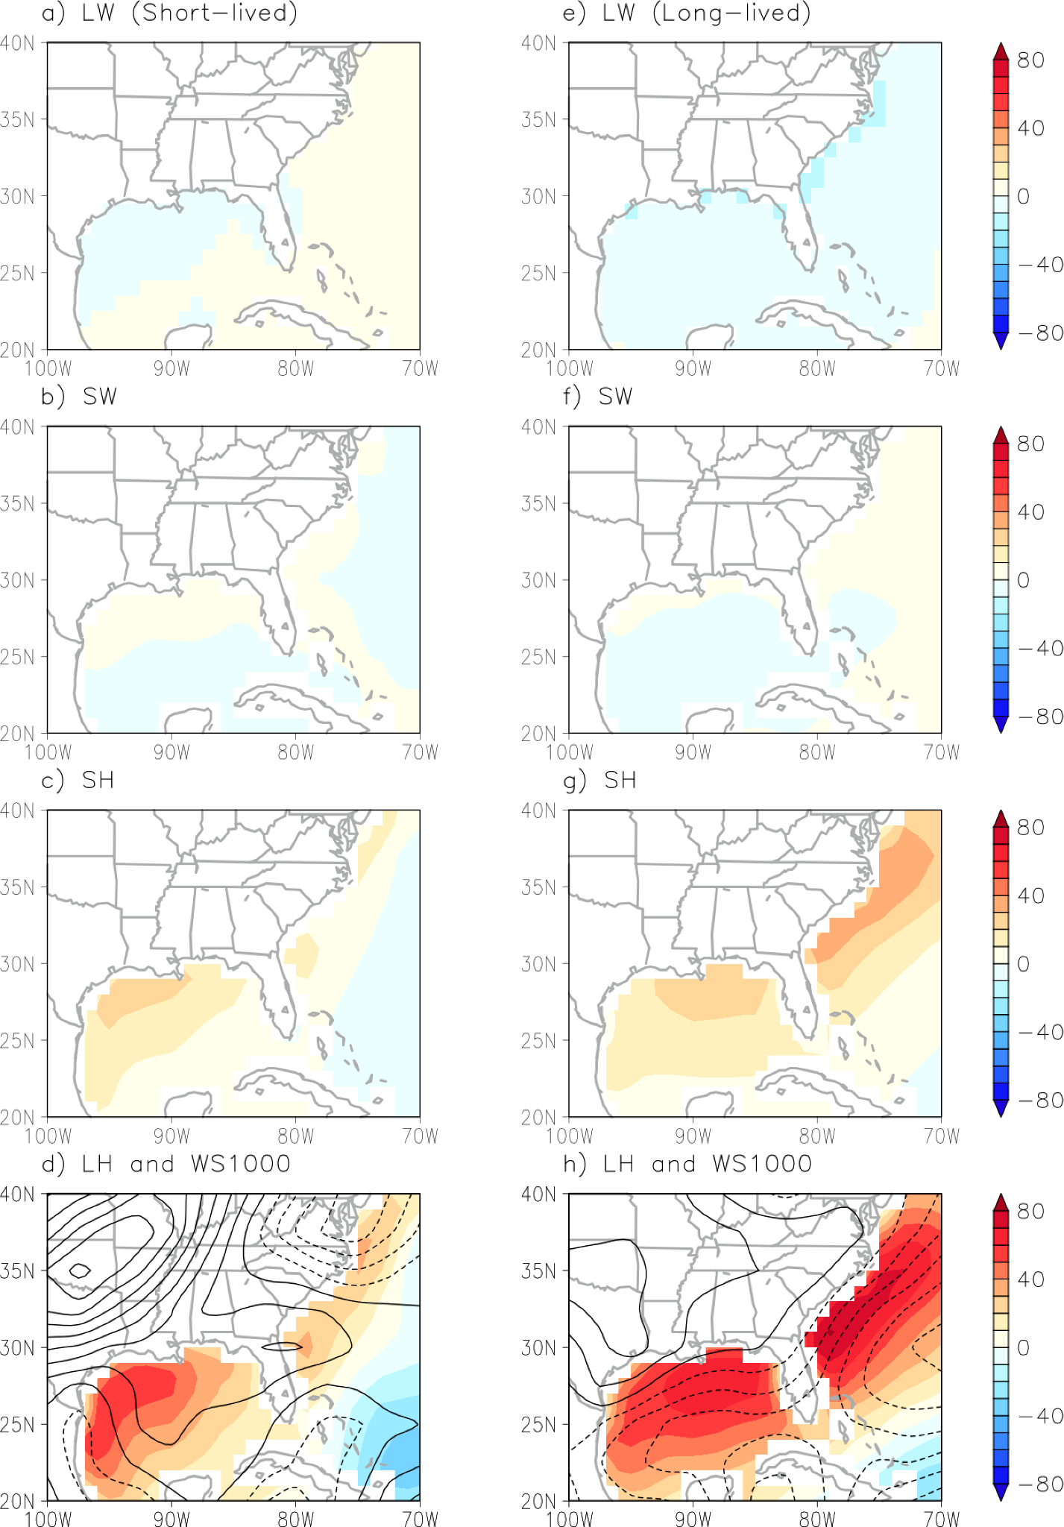
Fig. S4. Composite analysis of the surface heat components over the Gulf of Mexico and eastern US seaboard during the short-lived negative PNA and the long-lived negative PNA. Composite of (a) longwave radiation flux (W m⁻²), (b) shortwave radiation flux (W m⁻²), (c) sensible heat (W m⁻²) and (d) latent heat (shaded, W m⁻²) and wind speed anomalous at 925 hPa (contour, interval is 0.1 m s⁻¹, solid/dashed lines indicate positive and negative values, respectively) during the short-lived negative PNA. (e)-(h) are the same as (a)-(d) but for during the long-lived negative PNA. The positive value of surface flux is downward. Note that the land area is masked out.

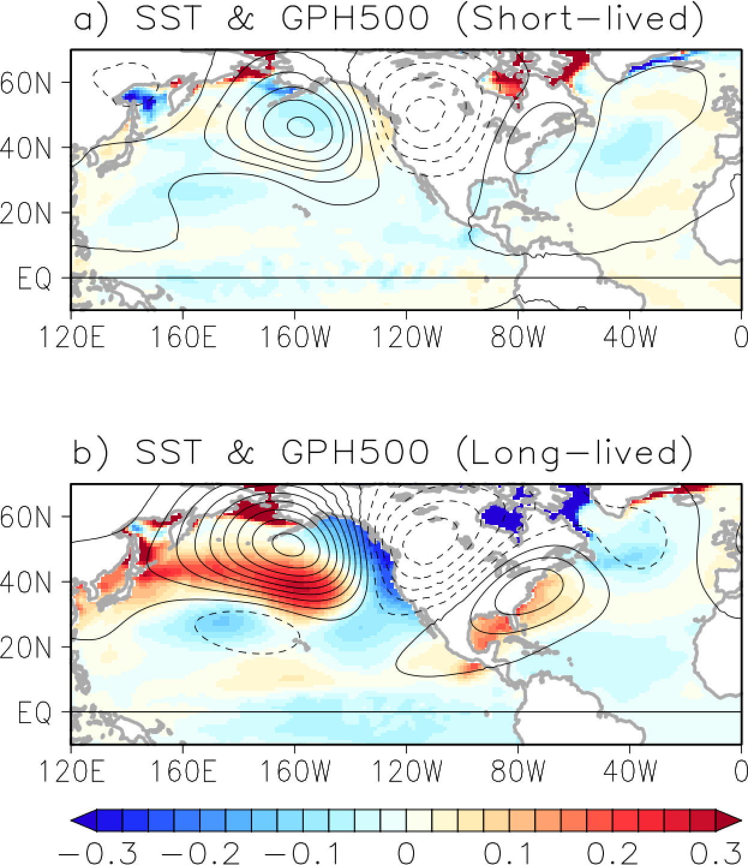

Fig. S5. Composite analysis of the large-scale environment during the short-lived negative PNA and the long-lived negative PNA in the CESM-LENS. Composite of (a) SSTAs (shaded, K), geopotential height at 500 hPa (contour, the interval is 10 gpm, solid/dashed lines indicate positive and negative values, respectively) during the short-lived negative PNA. (b) is the same as (a) but for during the long-lived negative PNA. Results in this figure are derived from CESM-LENS.

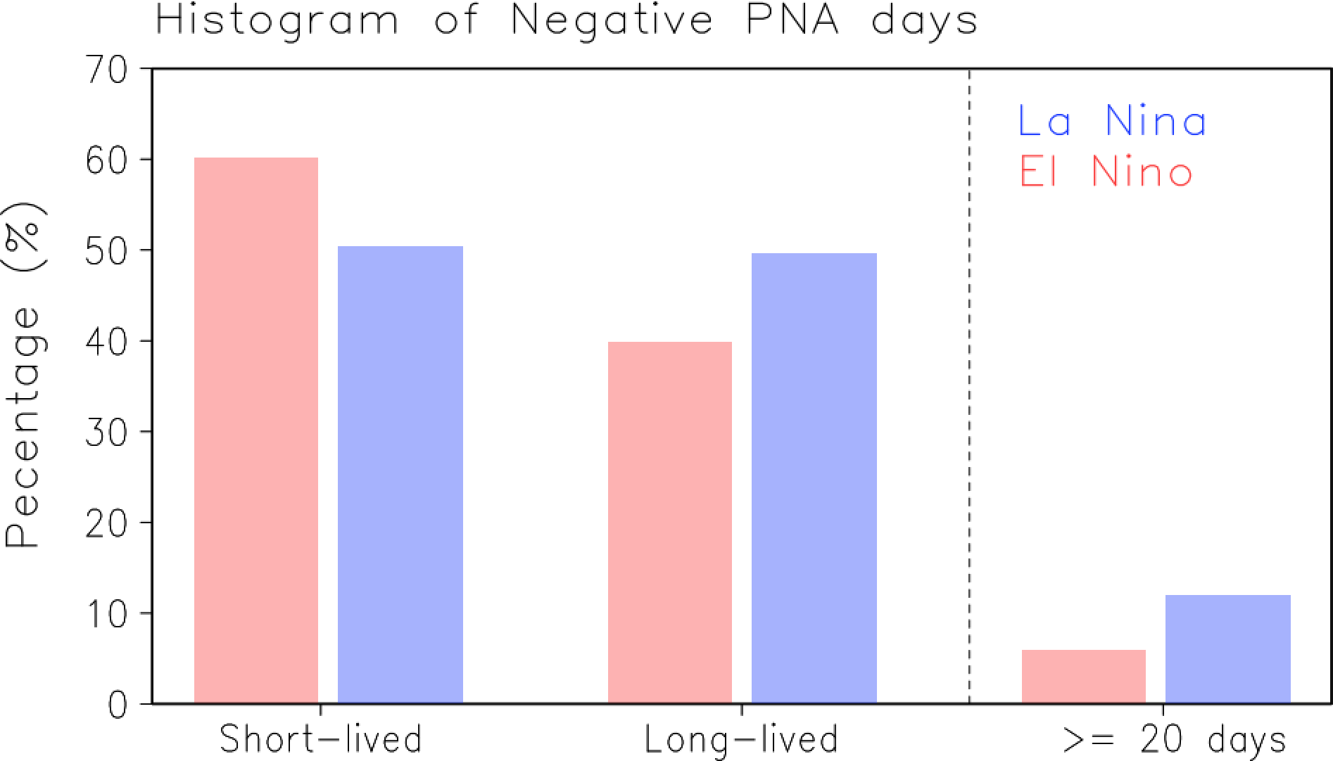
Fig. S6. Impact of El Niño - Southern Oscillation on the short- and long-lived negative PNA in the CESM-LENS. Histogram of short- and long-lived negative PNA during El Nino (red bars) and La Nina years (blue bars), respectively. The bars at the left side of the dotted line are histograms of extreme long-lived (≥ 20 days) negative PNA during El Nino (red bar) and La Nina years, respectively. Results in this figure are derived from CESM-LENS.

