Spatially Fractionated GRID radiation potentiates immune-mediated tumor control.
Rebecca A. Bekker^{1,4}, Nina Obertopp^{2,4}, Gage Redler³, José Penagaricano³, Jimmy J. Caudell³, Kosj Yamoah³, Shari Pilon-Thomas², Eduardo G. Moros³, Heiko Enderling^{5,6,*}

¹Department of Integrated Mathematical Oncology, H. Lee Moffitt Cancer Center & Research Institute, Tampa, FL, 33612, USA
²Department of Immunology, H. Lee Moffitt Cancer Center & Research Institute, Tampa, FL, 33612, USA
³Department of Radiation Oncology, H. Lee Moffitt Cancer Center & Research Institute, Tampa, FL, 33612, USA
⁴Cancer Biology Ph.D. Program, University of South Florida, Tampa, FL, 33612, USA
⁵ Department of Radiation Oncology, The University of Texas MD Anderson Cancer Center, Houston, TX, 77030, USA
⁶Institute for Data Science In Oncology, The University of Texas MD Anderson Cancer Center, Houston, Texas, 77030, USA
* Correspondence: henderling@mdanderson.org

SUPPLEMENTARY FIGURES AND TABLES

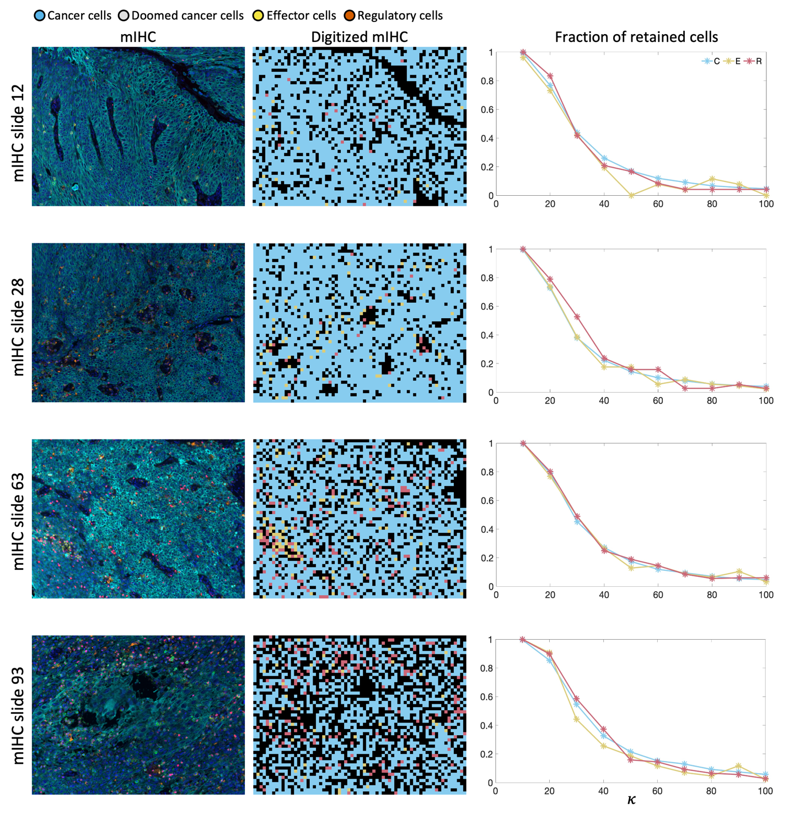
Fig. S1 Multiplex immunohistochemistry slides (left), associated digitized mIHC /in silico tumors (center), and the fraction of retained cells of each subpopulation for the in silico tumors, for conversion factors $κ ∈\left[10,100\right]$.

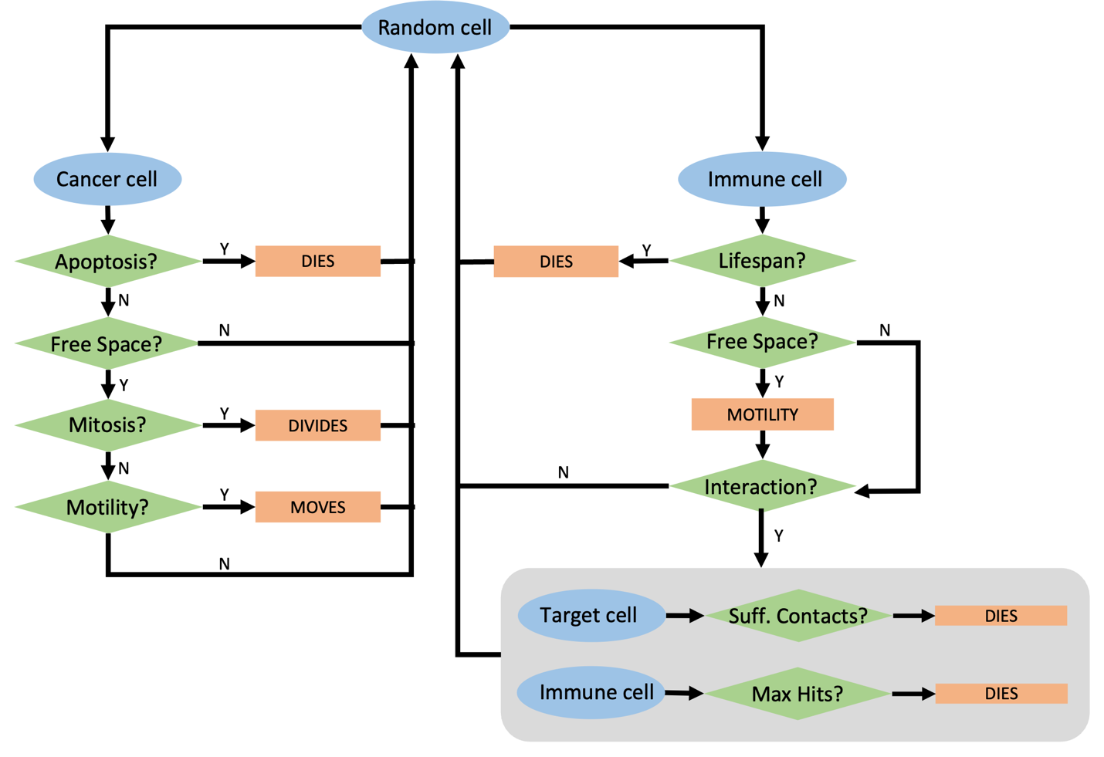

Fig. S2 In silico rules governing cancer cell and immune cell behavior.

Name | Value | Units | References
Cell cycle duration | $$x\sim N\left(24,2\right),$$  $$x ϵ[18,30]$$ | $$hr$$
Random death probability | 0.003 | $$hr^{-1}$$ | (1)
Migration speed | 6 | $$bodylengths /hr$$ | (2, 3)
Effector cell contacts needed for death | 3 |  | (4)
Repair time of contact from effector cell | 1 | $$hr$$ | (5)
$$SF_{C}(2Gy)$$ | 0.48

Table S1. Cancer cell parameters.

Name | Value | Units | Reference
Lifespan | 10 | $$days$$ | (6)
Maximum number of cytotoxic contacts with cancer cells | 10
Regulatory cell contacts needed for death | 3
Migration speed | $$15$$ | $$bodylengths /hr$$ | (7-9)
Recruitment due to cancer cell random death | $$ζ_{Apoptosis}$$ | $$cells / event$$ | LHS
Recruitment due to effector induced cancer cell death | $$ζ_{effector }$$ | $$cells / event$$ | LHS
Recruitment due to radiation induced cancer cell death | $$ζ_{Tx}$$ | $$cells / event$$ | LHS
Placement of immune cells | $$μ$$ |  | LHS
$$SF_{E}(2Gy)$$ | $$≈0.60$$ |  | (10)

Table S2. Effector cell parameters. LHS: Latin hypercube sampling.
Table S2. Effector cell parameters. LHS: Latin hypercube sampling.

Name | Value | Unit | Reference
Life span | 10 | $$days$$
Max contacts with prey | 10
Migration speed | 15 | $${bodylengths}/{hr}$$
Recruitment due to cancer cell birth | $$ζ_{regulatory}$$ | $${cells}/{event}$$ | LHS
$$SF_{E}(2Gy)$$ | $$≈0.77$$ |  | (10)

Table S3. Regulatory cell parameters. LHS: Latin hypercube sampling.

Parameter | Meaning | Range | Units
$$ζ_{apoptosis}$$ | Recruitment rate of effector cells due to apoptosis of cancer cells | [0.05, 0.2] | cells per cancer cell death
$$ζ_{immune}$$ | Recruitment rate of effector cells due to effector cell-induced death of cancer cells | [0.05, 0.2] | cells per cancer cell death
$$μ$$ | Probability of placing effector cells that are recruited due to effector cell induced cancer cell death near those locations | [0.2, 0.6] | -
$$ζ_{regulatory}$$ | Recruitment rate of regulatory cells due to proliferation of cancer cells | [0.001, 0.2] | cells per cancer cell birth

Table S4. Ranges used to generate parameter sets 1-15.

Parameter set | $$ζ_{apoptosis}$$ | $$ζ_{effector}$$ | $$ζ_{regulatory}$$ | $$μ$$
1 | 0.145 | 0.065 | 0.15357 | 0.24
2 | 0.085 | 0.085 | 0.11377 | 0.45333
3 | 0.175 | 0.185 | 0.19337 | 0.34667
4 | 0.115 | 0.095 | 0.1005 | 0.26667
5 | 0.095 | 0.165 | 0.0076333 | 0.37333
6 | 0.135 | 0.155 | 0.034167 | 0.29333
7 | 0.165 | 0.105 | 0.1801 | 0.32
8 | 0.185 | 0.075 | 0.073967 | 0.21333
9 | 0.055 | 0.135 | 0.16683 | 0.56
10 | 0.155 | 0.055 | 0.047433 | 0.4
11 | 0.105 | 0.115 | 0.087233 | 0.53333
12 | 0.195 | 0.125 | 0.1403 | 0.58667
13 | 0.075 | 0.145 | 0.0209 | 0.48
14 | 0.065 | 0.175 | 0.12703 | 0.50667
15 | 0.125 | 0.195 | 0.0607 | 0.42667

Table S5. Parameter values of parameter sets 1-15. Parameter sets highlighted in green led to tumor clearance without treatment, and parameter sets highlighted in yellow are the ones used within the manuscript.

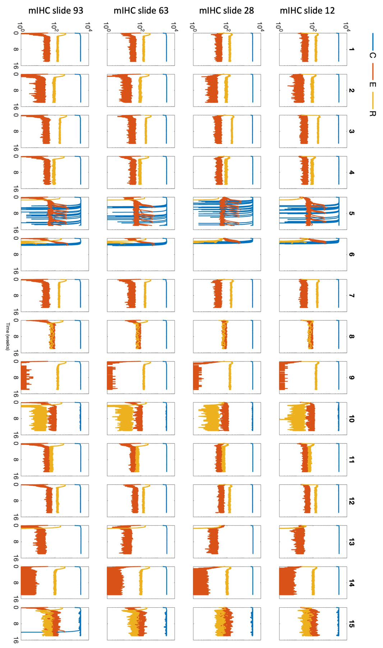
Fig. S3. Simulations of mIHC slides 12, 28, 63 and 93 using parameter sets 1-15, without treatment. Parameter sets 5 and 6 consistently lead to tumor eradication. (Blue – cancer cells, red – effector cells, yellow – regulatory cells).

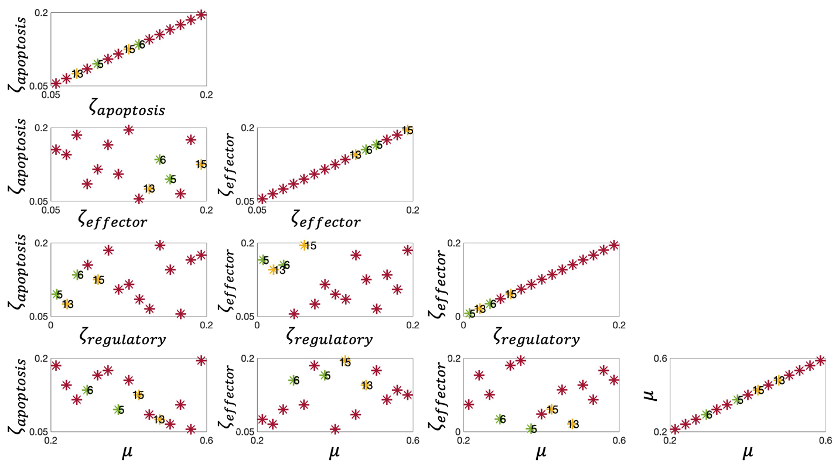
Fig. S4 Distribution of the generated parameter sets in the explored parameter spaces: (i) $ζ_{apoptosis}$ recruitment of effector-immune cells due to cancer cell apoptosis,
(ii) $ζ_{effector}$ recruitment of effector-immune cells due to effector-cell induced cancer cell death, (iii) $ζ_{regulatory}$ recruitment of regulatory cells due to the increasing cancer cell population, (iv) 𝜇 the probability of placing an effector cell (recruited in (ii)) near the location of cancer cell death, (Green stars indicating tumor eradication without treatment: parameter sets 5 and 6, yellow stars indicating the parameter sets used in this study: parameter sets 13 and 15, red stars: other parameter sets).

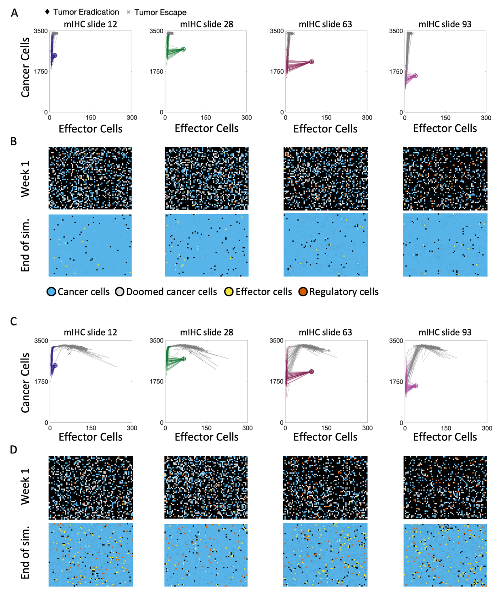
Fig. S5 WTRT does not leads to clearance when immunogenicity of Tx is low. Parameter set 13: A. Cancer-effector plane dynamics of mIHC slides 12, 28, 63, 93 treated with 2Gy x 35 WTRT, using parameter set 13. B. Snapshots of mIHC slides 12, 28, 63, 93 at the end of the first week of treatment (top row) and at the end of simulation. Parameter set 15: C. Cancer-effector plane dynamics of mIHC slides 12, 28, 63, 93 treated with 2Gy x 35 WTRT, using parameter set 13. D. Snapshots of mIHC slides 12, 28, 63, 93 at the end of the first week of treatment (top row) and at the end of simulation (bottom row). (Legend: A,C: non-grey line segments – on treatment, grey line segments – post-treatment, diamonds – tumor eradication, crosses – tumor escape. B,D: cyan - cancer cells, grey – doomed cancer cells, with irreparable RT-induced damage, yellow - effector immune cells, red - regulatory immune cells).
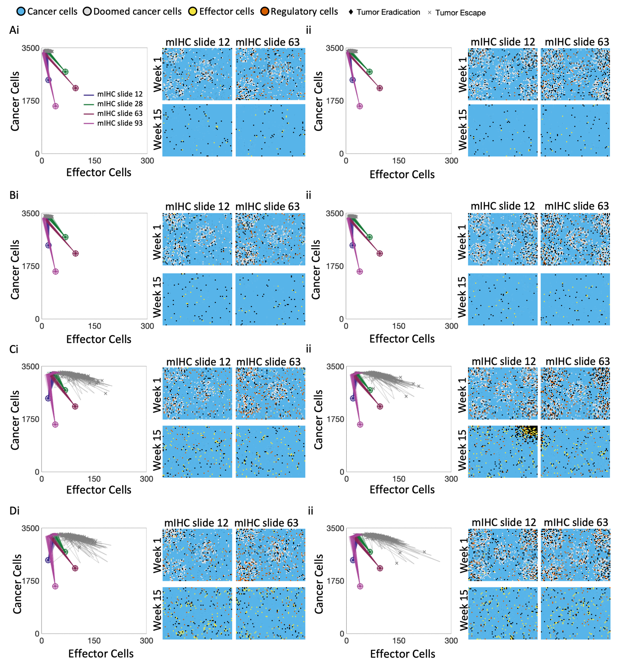
Fig. S6 SFRT-GRID does not lead to clearance when treatment isn’t sufficiently immunogenic. Phase plane dynamics of cancer cells and effector cells.
- Parameter set 13, treatment is not immunogenic, i. grid (30:70); ii grid (50:50)
- Parameter set 13, treatment has low immunogenicity, i. grid (30:70); ii grid (50:50)
- Parameter set 15, treatment is not immunogenic , i. grid (30:70); ii grid (50:50)
- Parameter set 15, treatment has low immunogenicity , i. grid (30:70); ii grid (50:50)

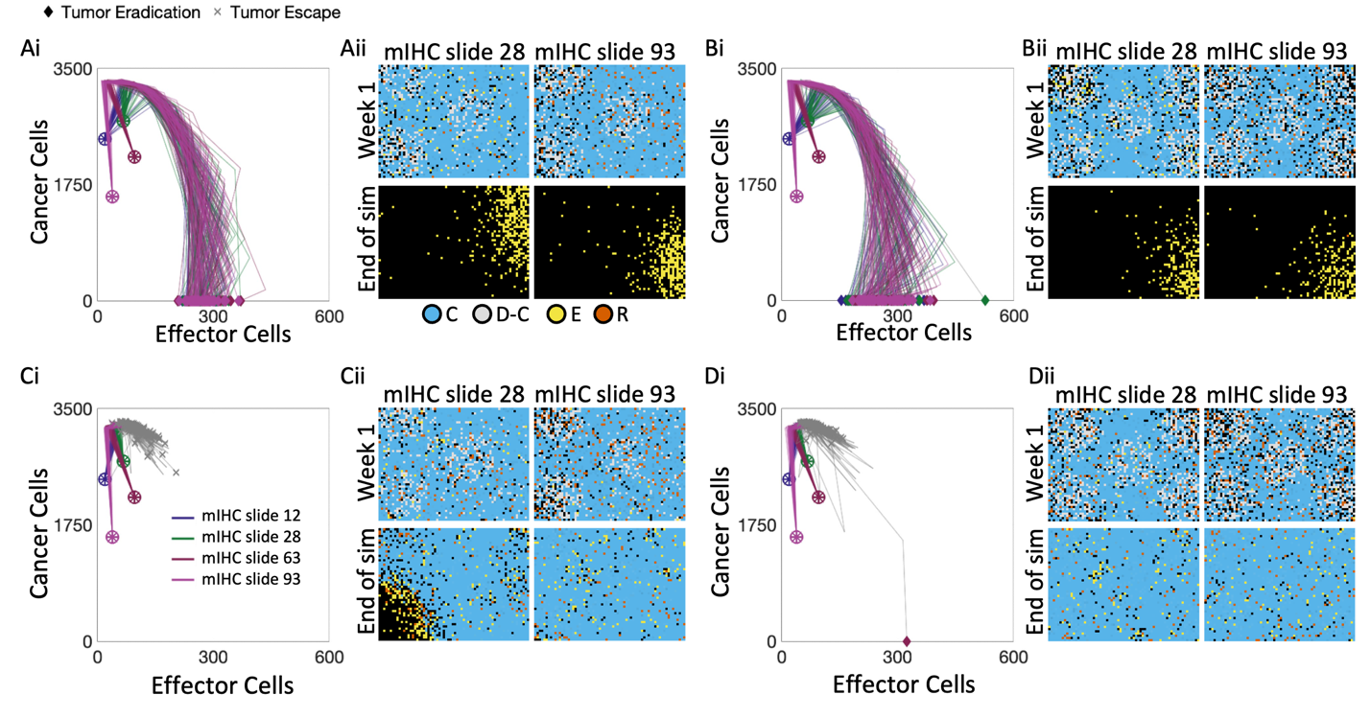
Fig. S7 SFRT-GRID leads to clearance when Tx is sufficiently immunogenic. Parameter set 13: A.i. Cancer-effector plane dynamics and snapshots of mIHC slide 28 and 93 treated with 2Gy x 35 SFRT-GRID (30:70). A.ii. Snapshots of representative simulations of mIHC slides 28 and 93 at the end of week 1 (top row), and tumor clearance (bottom row). B.i. Cancer-effector plane dynamics and snapshots of mIHC slide 28 and 93 treated with 2Gy x 35 SFRT-GRID (50:50). B.ii. Snapshots of representative simulations of mIHC slides 28 and 93 at the end of week 1 (top row), and tumor clearance (bottom row). Parameter set 15: C.i. Cancer-effector plane dynamics and snapshots of mIHC slide 28 and 93 treated with 2Gy x 35 SFRT-GRID (30:70). C.ii. Snapshots of representative simulations of mIHC slides 28 and 93 at the end of week 1 (top row), and week 15 (bottom row). D.i. Cancer-effector plane dynamics and snapshots of mIHC slide 28 and 93 treated with 2Gy x 35 SFRT-GRID (50:50). D.ii. Snapshots of representative simulations of mIHC slides 28 and 93 at the end of week 1 (top row), and week 15 (bottom row). (Legend: Cancer-Effector planes: non-grey line segments – on treatment, grey line segments – post-treatment, diamonds – tumor eradication, crosses – tumor escape. ABM snapshots: cyan - cancer cells, grey – doomed cancer cells, with irreparable RT-induced damage, yellow - effector immune cells, red - regulatory immune cells).

 | 7 days prior (p-value) | 1 day prior (p-value)
Effector vs Tx | 3.85525E-06 | 1.62323E-07
Effector vs Apoptosis | 1.52024E-07 | 3.46094E-08
Tx vs Apoptosis | 3.60809E-08 | 0.242124283

Table S6. P-values of the two-sided Wilcoxon rank sum test, comparing the contribution of effector-mediated cancer cell death, treatment, and apoptosis in the 7 day or 1 day leading up to and including clearance of mIHC slide 12, parameter set 15 treated with 2Gy x 35 WTRT (see Fig. 7 A-D).

 | 7 days prior (p-value) | 1 day prior (p-value)
Effector vs Tx | 7.0597E-18 | 5.43451E-18
Effector vs Apoptosis | 7.05333E-18 | 6.79694E-18
Tx vs Apoptosis | 0.404178298 | 0.005359835

Table S7. P-values of the two-sided Wilcoxon rank sum test, comparing the contribution of effector-mediated cancer cell death, treatment, and apoptosis in the 7 day or 1 day leading up to and including clearance of mIHC slide 63, parameter set 13 treated with 2Gy x 35 SFRT-GRID (30:70) (see Fig. 7E-H).

 | 7 days prior (p-value) | 1 day prior (p-value)
Effector vs Tx | 3.85525E-06 | 1.62323E-07
Effector vs Apoptosis | 1.52024E-07 | 3.46094E-08
Tx vs Apoptosis | 3.60809E-08 | 0.242124283

Table S8. P-values of the two-sided Wilcoxon rank sum test, comparing the contribution of effector-mediated cancer cell death, treatment, and apoptosis in the 7 day or 1 day leading up to and including clearance of mIHC slide 63, parameter set 13 treated with 2Gy x 35 SFRT-GRID (50:50) (see Fig. 7E-F, I-J).

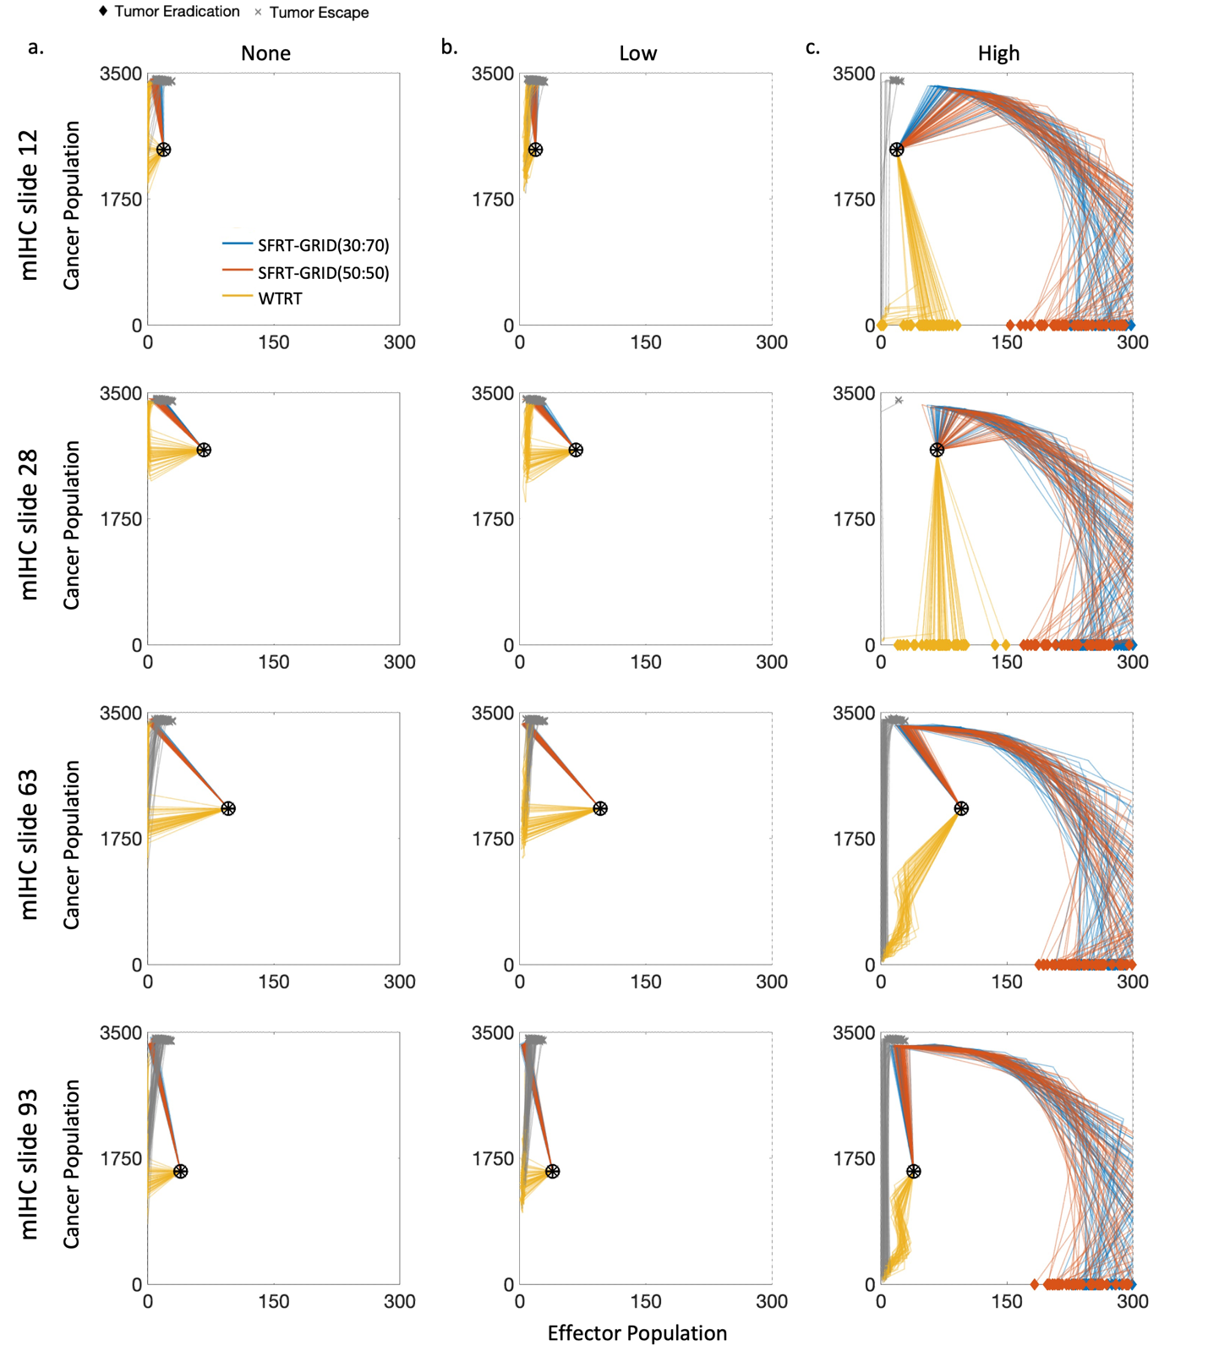
Fig. S8 Cancer-Effector Planes of each mIHC slides during treatment with 2Gy x 35, for parameters set 13.
- Treatment is not immunogenic ${(ζ}_{Tx}=0)$.
- Treatment has low immunogenicity ${(ζ}_{Tx}=0.01)$.
- Treatment is highly immunogenic ${(ζ}_{Tx}=0.1)$.

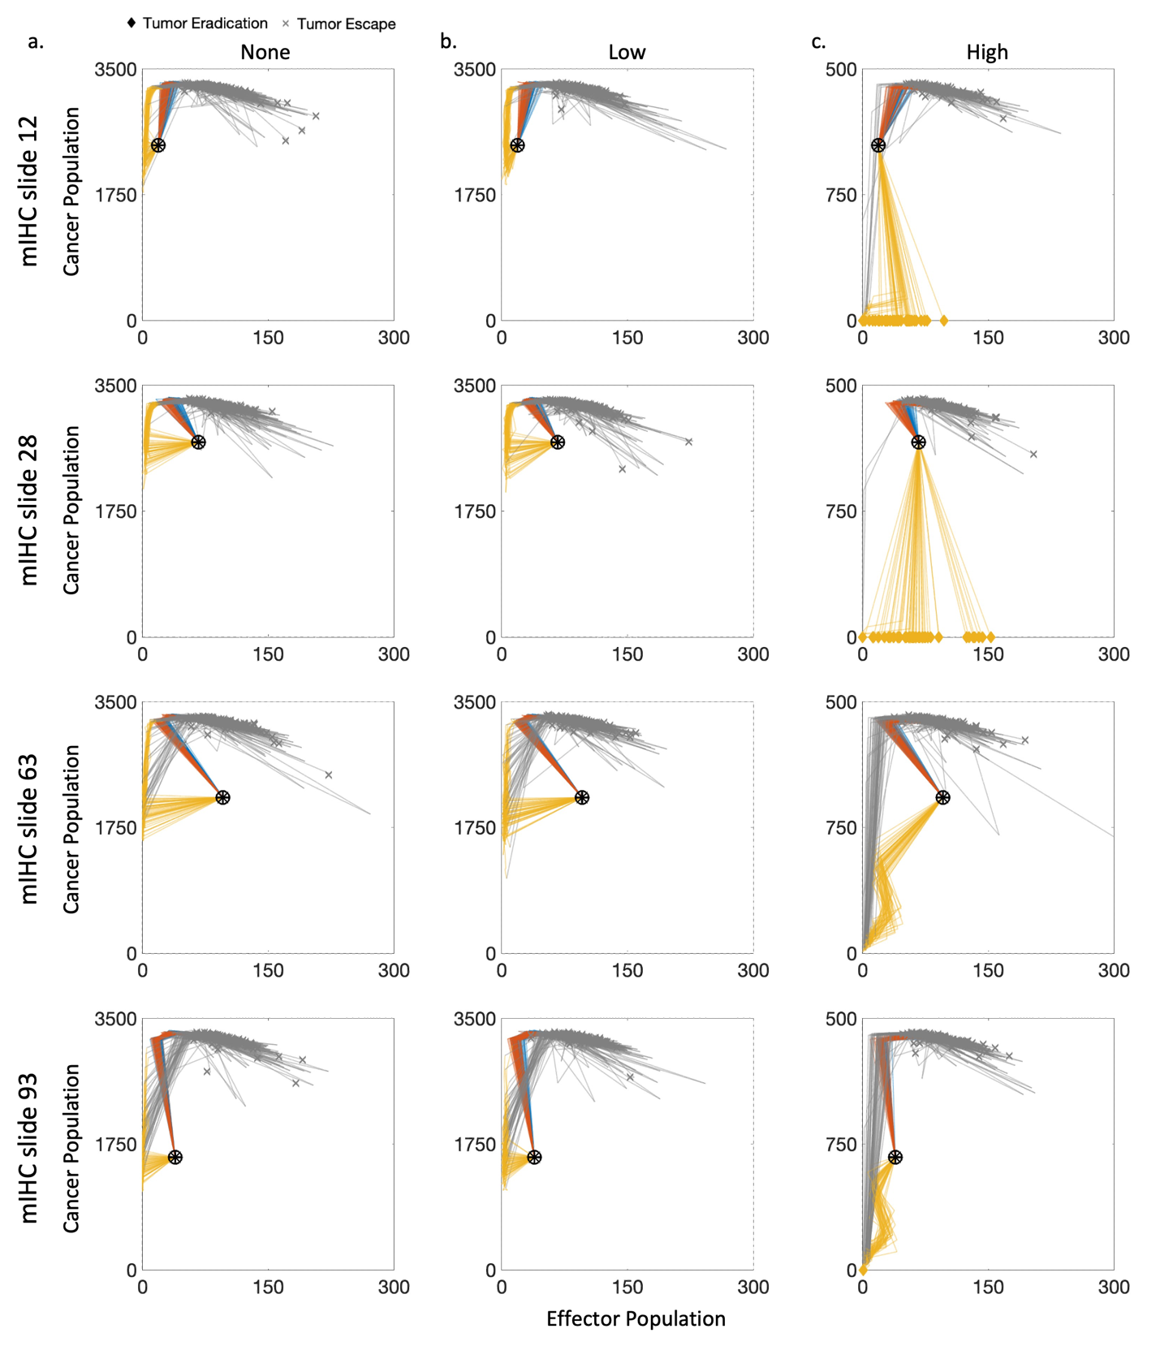
Fig. S9 Cancer-Effector Planes of each mIHC slides during treatment with 2Gy x 35, for parameters set 15.
- Treatment is not immunogenic ${(ζ}_{Tx}=0)$.
- Treatment has low immunogenicity ${(ζ}_{Tx}=0.01)$.
- Treatment is highly immunogenic ${(ζ}_{Tx}=0.1)$.

References:

1. Chaplain MAJ, Graziano L, Preziosi L. Mathematical modelling of the loss of tissue compression responsiveness and its role in solid tumour development. Mathematical Medicine and Biology: A Journal of the IMA. 2006;23(3):197-229.
2. Enderling H, Anderson Ar Fau - Chaplain MAJ, Chaplain Ma Fau - Beheshti A, Beheshti A Fau - Hlatky L, Hlatky L Fau - Hahnfeldt P, Hahnfeldt P. Paradoxical dependencies of tumor dormancy and progression on basic cell kinetics. 2009(1538-7445 (Electronic)).
3. Enderling H, Hlatky L Fau - Hahnfeldt P, Hahnfeldt P. Migration rules: tumours are conglomerates of self-metastases. 2009(1532-1827 (Electronic)).
4. Weigelin B, den Boer AT, Wagena E, Broen K, Dolstra H, de Boer RJ, et al. Cytotoxic T cells are able to efficiently eliminate cancer cells by additive cytotoxicity. Nature Communications. 2021;12(1):5217.
5. Beck RJ, Bijker DI, Beltman JB. Heterogeneous, delayed-onset killing by multiple-hitting T cells: Stochastic simulations to assess methods for analysis of imaging data. PLoS Comput Biol. 2020;16(7):e1007972.
6. Singh K, Stempora L, Harvey RD, Kirk AD, Larsen CP, Blazar BR, et al. Superiority of rapamycin over tacrolimus in preserving nonhuman primate Treg half-life and phenotype after adoptive transfer. Am J Transplant. 2014;14(12):2691-703.
7. Miller MJ, Wei SH, Parker I, Cahalan MD. Two-Photon Imaging of Lymphocyte Motility and Antigen Response in Intact Lymph Node. Science. 2002;296(5574):1869-73.
8. Mueller SN. Effector T-cell responses in non-lymphoid tissues: insights from in vivo imaging. Immunology & Cell Biology. 2013;91(4):290-6.
9. Bougherara H, Mansuet-Lupo A, Alifano M, Ngô C, Damotte D, Le Frère-Belda M-A, et al. Real-Time Imaging of Resident T Cells in Human Lung and Ovarian Carcinomas Reveals How Different Tumor Microenvironments Control T Lymphocyte Migration. Frontiers in Immunology. 2015;6.
10. Alfonso JCL, Grass GD, Welsh E, Ahmed KA, Teer JK, Pilon-Thomas S, et al. Tumor-immune ecosystem dynamics define an individual Radiation Immune Score to predict pan-cancer radiocurability. Neoplasia (New York, NY). 2021;23(11):1110-22.

