Supplementary Information
Table S1 Environmental impact of MCB production, showing the contribution of the input parameters.
Inputs | kgCO₂-eq. | kgSO₂-eq. | kgNOx-eq. | kgPO₄-eq. | m³H₂O-eq. | Single Score Damage  (Pt)
Electricity consumption | 1149.890 | 0.794 | 1.223 | 0.206 | 71.899 | 24.0
Water consumption | 4.408 | 0.019 | 0.012 | 0.009 | 182.585 | 0.49
Transport | 7.415 | 0.032 | 0.039 | 0.008 | 0.568 | 0.33
Nutrient biomass | -62.579 | 0.317 | 0.608 | 0.153 | 187.181 | 1.79
Substrate biomass | 0.177 | 0.001 | 0.001 | 0.00 | 0.010 | 0.01
Acrylic varnish | 0.080 | 0.001 | 0.00 | 0.00 | 0.052 | 0.04x10⁻¹
PP grow bags | 0.251 | 0.001 | 0.001 | 0.00 | 0.103 | 0.01
Disposable gloves | 1.346 | 0.004 | 0.002 | 0.00 | 0.711 | 0.04
Isopropanol | 2.082 | 0.008 | 0.005 | 0.002 | 0.556 | 0.08
Waste biomass | 22.796 | 0.002 | 0.00 | 0.111 | 0 | 0.47
Wastewater | 3.174 | 0.019 | 0.021 | 0.057 | -162.530 | 0.05
Waste PP grow bags | 0.012 | 0.00 | 0.00 | 0.001 | 0.001 | 0.01x10⁻¹
Waste disposable gloves | 0.029 | 0.00 | 0.00 | 0.001 | 0.003 | 0.01
Total | 1,129.080 | 1.197 | 1.911 | 0.549 | 281.140 | 27.29

Table S2 Environmental impact (equivalent emissions, midpoint damage, and single score endpoint damage) of the MCB production process. (HH = human health; TE = terrestrial ecosystems; FE = freshwater ecosystems; AE = aquatic ecosystems; DALY = Disability Adjusted Life Years; USD2013 = United States Dollars in the year 2013)
Impact Category | Unit | Material Prep. | Sterilisation | Incubation | Post-Process | Waste
Global Warming Potential | kgCO₂-eq | -53.57 | 85.38 | 441.69 | 629.67 | 26.01
Acidification Potential | kgSO₂-eq. | 0.35 | 0.08 | 0.31 | 0.44 | 0.02
Photochemical Ozone Creation Potential | kgNOx-eq. | 0.65 | 0.10 | 0.47 | 0.67 | 0.02
Eutrophication Potential | kgPO₄-eq. | 0.16 | 0.02 | 0.08 | 0.11 | 0.17
Water Deprivation Potential | m³-eq. | 197.19 | 178.82 | 28.06 | 39.42 | -162.53
Midpoint Damage
Global Warming (HH) | DALY | 4.26x10⁻⁵ | 8.00x10⁻⁵ | 4.14x10⁻⁴ | 5.90 x10⁻⁴ | 2.34 x10⁻⁵
Global Warming (TE) | species.yr | 1.29 x10⁻⁷ | 2.42 x10⁻⁷ | 1.25 x10⁻⁶ | 1.78 x10⁻⁶ | 7.06 x10⁻⁸
Global Warming (FE) | species.yr | 3.51 x10⁻¹² | 6.60 x10⁻¹² | 3.41 x10⁻¹¹ | 4.87 x10⁻¹¹ | 1.93 x10⁻¹²
Stratospheric Ozone Depl. | DALY | 2.38 x10⁻⁷ | 2.13 x10⁻⁸ | 1.05 x10⁻⁷ | 1.50 x10⁻⁷ | 3.23 x10⁻⁹
Ionizing Radiation | DALY | 7.86 x10⁻⁹ | 5.66 x10⁻⁹ | 6.35 x10⁻⁹ | 8.77 x10⁻⁹ | 8.61 x10⁻¹⁰
POCP (HH) | DALY | 1.62 x10⁻⁷ | 7.61 x10⁻⁸ | 3.68 x10⁻⁷ | 5.20 x10⁻⁷ | 8.04 x10⁻⁹
Fine Particulates | DALY | 5.77 x10⁻⁵ | 1.65 x10⁻⁵ | 5.86 x10⁻⁵ | 8.10 x10⁻⁵ | 4.56 x10⁻⁶
POCP (TE) | species.yr | 2.34 x10⁻⁸ | 1.10 x10⁻⁸ | 5.34 x10⁻⁸ | 7.53 x10⁻⁸ | 1.16 x10⁻⁹
Terrestrial Acidification | species.yr | 7.38 x10⁻⁸ | 1.22 x10⁻⁸ | 5.11 x10⁻⁸ | 7.05 x10⁻⁸ | 3.88 x10⁻⁹
Freshwater Eutrophication | species.yr | 1.26 x10⁻⁸ | 3.12 x10⁻⁹ | 7.67 x10⁻⁹ | 9.99 x10⁻⁹ | 8.21 x10⁻⁸
Marine Eutrophication | species.yr | 6.50 x10⁻¹¹ | 6.06 x10⁻¹³ | 1.33 x10⁻¹² | 1.78 x10⁻¹² | 1.01 x10⁻¹⁰
Terrestrial Ecotoxicity | species.yr | 2.26 x10⁻⁹ | 8.44 x10⁻¹⁰ | 3.86 x10⁻⁹ | 5.38 x10⁻⁹ | 1.54 x10⁻¹⁰
Freshwater Ecotoxicity | species.yr | 1.45 x10⁻⁹ | 1.12 x10⁻⁹ | 5.37 x10⁻⁹ | 7.63 x10⁻⁹ | 5.07 x10⁻¹⁰
Marine Ecotoxicity | species.yr | 2.52 x10⁻¹⁰ | 2.14 x10⁻¹⁰ | 1.02 x10⁻⁹ | 1.45 x10⁻⁹ | 1.05 x10⁻¹⁰
Human Carcinogenic Tox. | DALY | 7.81 x10⁻⁶ | 1.03 x10⁻⁵ | 1.84 x10⁻⁵ | 2.59 x10⁻⁵ | 2.80 x10⁻⁶
Human Non-Carcinogenic Tox. | DALY | 9.83 x10⁻⁶ | 3.46 x10⁻⁶ | 1.35 x10⁻⁵ | 1.88 x10⁻⁵ | 7.82 x10⁻⁶
Land Use | species.yr | 2.01 x10⁻⁷ | 6.25 x10⁻⁹ | 2.96 x10⁻⁸ | 4.23 x10⁻⁸ | 1.82 x10⁻⁹
Mineral Resource Scarcity | USD2013 | 0.05 | 0.02 | 0.08 | 0.11 | 0.01
Fossil Resource Scarcity | USD2013 | 3.49 | 12.42 | 66.20 | 94.08 | 0.14
Water consumption (HH) | DALY | 3.32x10⁻⁶ | 8.71 x10⁻⁶ | -1.14 x10⁻⁶ | -1.73 x10⁻⁶ | -8.41 x10⁻⁶
Water consumption (TE) | species.yr | 2.04 x10⁻⁸ | 5.76 x10⁻⁸ | 1.77 x10⁻⁸ | 2.48 x10⁻⁸ | -5.11 x10⁻⁸
Water consumption (AE) | species.yr | 1.76 x10⁻¹¹ | 3.08 x10⁻¹² | 3.34 x10⁻¹² | 4.76 x10⁻¹² | -2.27 x10⁻¹²
Endpoint Damage
Single Score (Total) | Pt | 2.19 | 2.17 | 9.26 | 13.14 | 0.53
Table S3 Sensitivity of equivalent emissions from MCB production to electricity, water, and organic biomass.
Sensitivity Parameter | Impact | Low | Baseline | High | % Variation
Electricity | kgCO₂-eq. | -20.819 | 1129.08 | 2278.97 | ±101.8%
 | kgSO₂-eq. | 0.424 | 1.232 | 2.04 | ±65.6%
 | kgNOx-eq. | 0.688 | 1.911 | 3.134 | ±64.0%
 | kgPO₄-eq. | 0.343 | 0.549 | 0.755 | ±37.5%
 | m³-eq. | 209.241 | 281.140 | 353.039 | ±25.6%
Water | kgCO₂-eq. | 1121.498 | 1129.08 | 1136.663 | ±0.7%
 | kgSO₂-eq. | 1.192 | 1.232 | 1.271 | ±3.2%
 | kgNOx-eq. | 1.878 | 1.911 | 1.945 | ±1.8%
 | kgPO₄-eq. | 0.483 | 0.549 | 0.615 | ±12.0%
 | m³-eq. | 261.085 | 281.140 | 301.194 | ±7.1%
Biomass | kgCO2-eq. | 1168.686 | 1129.08 | 1089.474 | ±3.5%
 | kgSO2-eq. | 0.895 | 1.232 | 1.569 | ±27.4%
 | kgNOx-eq. | 1.304 | 1.911 | 2.519 | ±31.8%
 | kgPO₄-eq. | 0.285 | 0.549 | 0.813 | ±48.1%
 | m³-eq. | 93.948 | 281.140 | 468.332 | ±66.6%
Table S4 Sensitivity of equivalent emissions from MCB production to travel distance. (KSI = Kumasi; SUN = Sunyani; ACC = Accra; WA = Wa).
Travel Distance | kgCO₂-eq. | kgSO₂-eq. | kgNOx-eq. | kgPO₄-eq. | m³H₂O-eq. | Single Score Damage  (Pt)
Baseline (3.5 km) | 1,129.08 | 1.232 | 1.911 | 0.549 | 281.14 | 27.29
KSI – SUN (125 km) | 1,386.2 | 2.380 | 3.264 | 0.833 | 300.843 | 38.89
KSI – ACC (250 km) | 1,650.74 | 3.562 | 4.656 | 1.125 | 321.114 | 50.82
KSI – WA (500 km) | 2,179.82 | 5.926 | 7.439 | 1.710 | 361.656 | 74.70
WA – ACC (800 km) | 2,814.71 | 8.762 | 10.779 | 2.412 | 410.306 | 103.34
Emission/km (Slope) | 2.1163 | 0.0095 | 0.0111 | 0.0023 | 0.1622 | 0.0955
Table S5 Sensitivity of equivalent emissions from MCB production to energy mix.
Country | kgCO₂-eq. | kgSO₂-eq. | kgNOx-eq | kgPO4 eq. | m³H₂O-eq. | Single Score Damage  (Pt)
Ghana | 1129.08 | 1.23 | 1.91 | 0.55 | 281.14 | 27.29
Ethiopia | 22.61 | 0.60 | 0.80 | 0.40 | 218.58 | 5.83
DR Congo | 32.61 | 0.69 | 0.85 | 0.40 | 218.02 | 6.12
Zambia | 543.52 | 5.43 | 2.93 | 1.42 | 247.76 | 32.18
Kenya | 704.37 | 6.06 | 3.51 | 0.80 | 249.93 | 34.08
Mozambique | 1679.19 | 18.23 | 9.04 | 4.58 | 410.22 | 90.99
South Africa | 3564.36 | 43.64 | 20.50 | 10.59 | 514.05 | 204.68
Table S6 Sensitivity of equivalent emissions from MCB production to fuel source, compared to concrete brick production. (E = electricity; L = liquified petroleum gas; F = firewood; C = charcoal).
Process | kgCO₂-eq. | kgSO₂-eq. | kgNOx-eq. | kgPO₄-eq. | m³H₂O-eq. | Single Score Damage  (Pt)
MCB-E | 1129.08 | 1.23 | 1.91 | 0.55 | 281.14 | 27.29
MCB-L | 294.87 | 3.22 | 1.93 | 0.65 | 223.1 | 19.34
MCB-F | -732.35 | 0.57 | 0.89 | 0.38 | 215.96 | 5.92
MCB-C | 47.08 | 0.59 | 0.87 | 0.39 | 290.52 | 8.08
Concrete | 346.48 | 0.85 | 1.04 | 0.25 | 72.64 | 9.94
Table S7 Environmental impact of MCBs compared to concrete bricks over 20- and 100-year timeframes. (E = electricity; L = liquified petroleum gas; F = firewood; C = charcoal).
Brick Type | kgCO₂-eq. | kgSO₂-eq. | kgNOx-eq. | kgPO₄-eq. | m³H²O-eq. | Single Score Damage  (Pt)
20 years
MCB-E | 1934.81 | 1.37 | 2.14 | 0.71 | 287.08 | 41.98
MCB-F | 73.38 | 0.70 | 1.11 | 0.55 | 221.90 | 20.61
Concrete | 1881.87 | 1.44 | 1.31 | 5.10 | 95.32 | 104.48
100 years
MCB-E | 9674.06 | 6.85 | 10.68 | 3.55 | 1435.40 | 209.88
MCB-F | 366.90 | 3.52 | 5.56 | 2.73 | 1109.52 | 103.07
Concrete | 1881.87 | 1.44 | 1.31 | 5.10 | 95.32 | 104.48

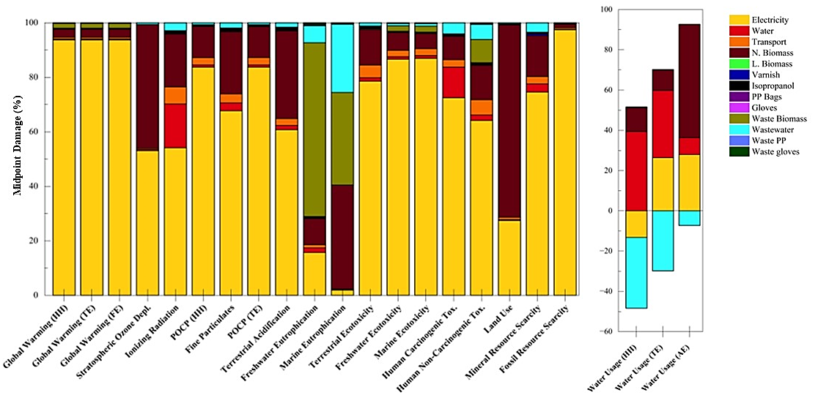
Figure S1 Environmental impact of MCB production (midpoint damage) showing the contribution of the input parameters.
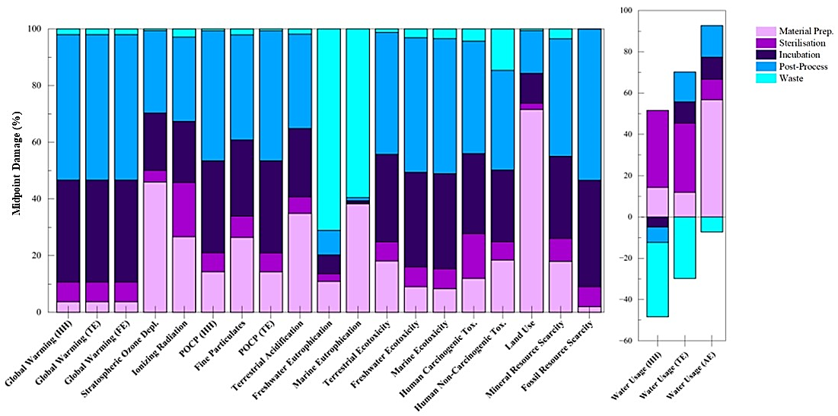
Figure S2 Environmental impact (midpoint damage) of MCB production showing the impact contribution of the process stages.

(b)
(a)

Figure S3 Environmental impact (endpoint damage) of MCB production showing the (a) impact contribution of the process stages and (b) environmental hotspots.

