Appendix file
Manuscript name: Comparison of Markov Model and Dynamic Model in Economic Evaluations for Infectious Diseases: A case of Bictegravir/emtricitabine/tenofovir Treatment-native adults of HIV-1 in China
Wenjuan Wang^{1#,} Dachuang Zhou^{1#}, Kejia Zhou¹, Di Zhang¹, Hao Li¹, Hongliu Zhang¹, Xin Jiang¹, Ruihua Wang¹,Xi Wang², Wenxi Tang^{1*}
¹Center for Pharmacoeconomics and Outcomes Research, China Pharmaceutical University, Nanjing 211198, Jiangsu Province, China.
²Infection Center, Beijing You'an Hospital, Capital Medical University, Beijing 100069, China.
#These authors contributed equally to this work.
*Corresponding Author: Wenxi Tang, Email: tokammy@cpu.edu.cn.

content
1 Supplementary Details of Model Design 2
1.1 Markov Model 2
1.2 Dynamic Model 3
1.2.1 Algorithm for Infection Probability 3
1.2.2 Model Verification 4
2 Derivation and Details of Model Parameters 5
2.1 Derivation of Transition Probabilities between Health States 5
2.3 Costs and Utilities 6
3 Supplementary Data on Results 8
Reference 9

Table S1 transition probabilities 5
Table S2 Cost and Utility of ADEs[1-3] 6
Table S3 Cost and Utility of AEs[3-9] 7

Fig. S1 The decision tree of the Markov model 2
Fig. S2 The number of infections in each of the five subgroups (2015-2019) 4
Fig. S3 The number of new HIV cases in each of the five subgroups (2015-2045) 8

Supplementary Details of Model Design

Markov Model
In Section 2.2.1 of the main manuscript, assumptions regarding alternative regimens were mentioned, and the specific decision tree was illustrated as follows:
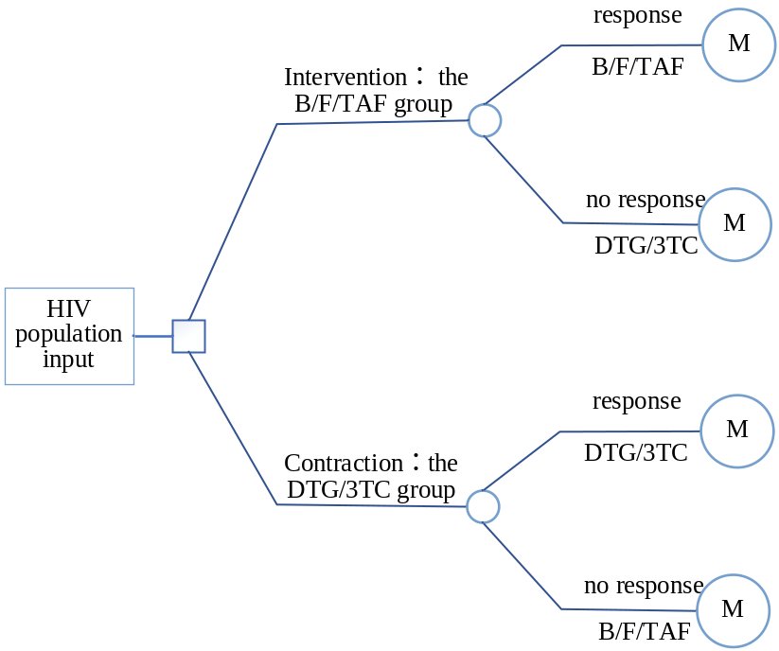
Fig. S1 The decision tree of the Markov model

Dynamic Model

Algorithm for Infection Probability
In Section 2.3.1, the differential risks of HIV infection among five subtypes are introduced, and the detailed counting formulas for the infection probabilities of these five subtypes are as follows:
S, I, and T represented the populations of susceptible individuals, infected individuals, and those undergoing treatment, respectively. The indices 1 to 5 corresponded to five subgroups: general males, general females, MSM (Men who have Sex with Men), MIDU (People who use drugs via injection), and FIDU (People who use drugs via non-injection). "i" denoted the infection probability, with i4_s and i4_b distinguishing the probabilities of transmission through sexual contact and blood transmission, respectively. β represented the infection coefficient, and "t" signified the number of cycles.
- Normal male: i1(t+1)=β_1*[I2(t)+T2(t)*(1-w)]/(I2(t)+T2(t)+S2(t));
- Normal female: i2(t+1)=β_2*[I1(t)+T1(t)*(1-w)]/(I1(t)+T1(t)+S1(t))
- MSM: i3(t+1)=β_3*[I3(t)+T3(t)*(1-w)]/(I3(t)+T3(t)+S3(t));
- MIDU:
i4_s(t+1)=β_4s*[I5(t)+T5(t)*(1-w)]/(I5(t)+T5(t)+S5(t)),
i4_b(t+1)=β_4b*[ I4(t)+T4(t)*(1-w)I4(t)+T4(t)*(1-w)]/( I4(t)+T4(t)+S5(t)+I5(t)+T5(t)+S5(t));
- FIDU:
i5_s(t+1)=β_5s*[I4(t)+T4(t)*(1-w)]/(I4(t)+T4(t)+S4(t)),
i5_b(t+1)=β_5b*[ I4(t)+T4(t)*(1-w)I4(t)+T4(t)*(1-w)]/( I4(t)+T4(t)+S5(t)+I5(t)+T5(t)+S5(t));

Model Verification
This was a supplementary section on the validation of the dynamic model. The figure displayed the model's predicted data alongside actual HIV epidemiological data and their fitting results.
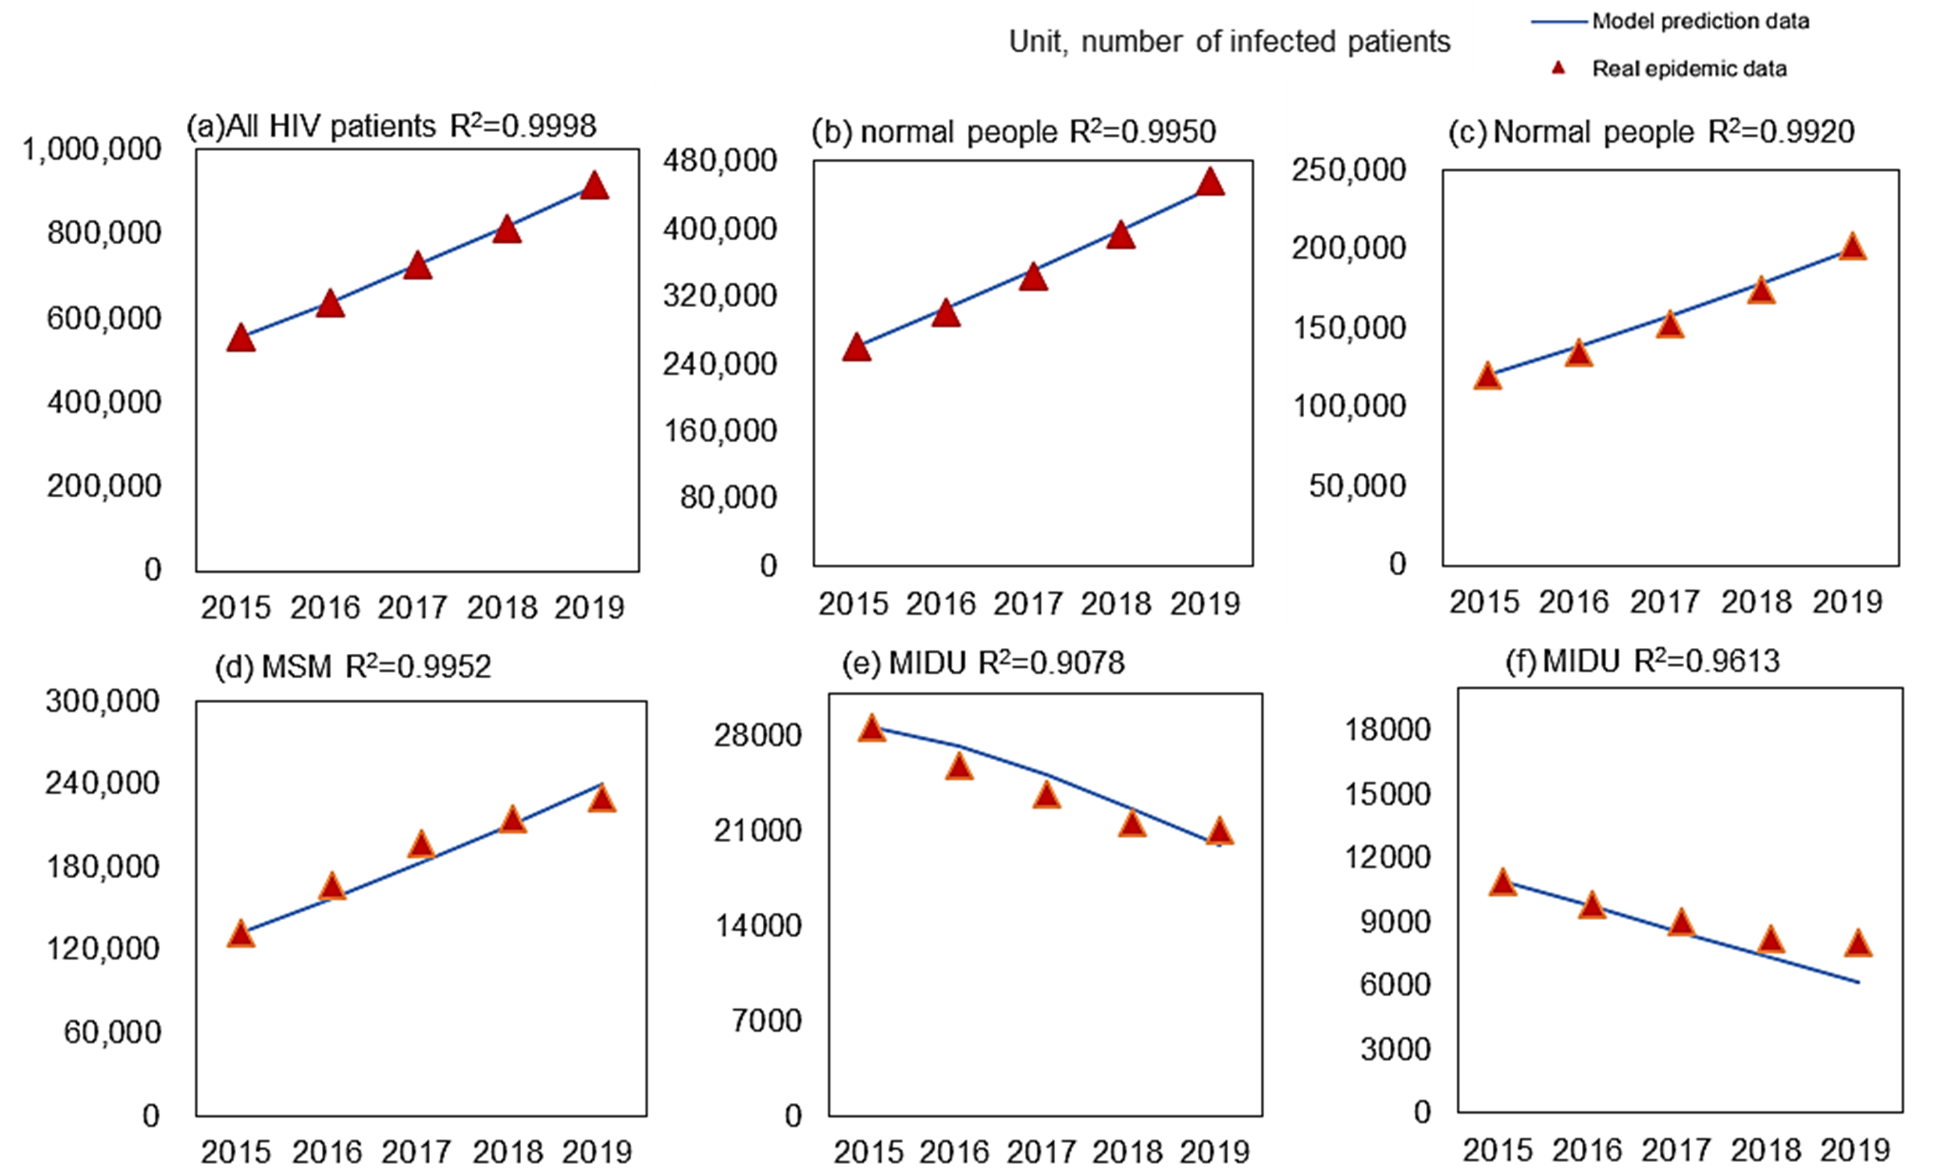
Fig. S2 The number of infections in each of the five subgroups (2015-2019)

Derivation and Details of Model Parameters

Derivation of Transition Probabilities between Health States
The classification of the five health states was based on the count of CD4 cells. Consequently, the transition probabilities between adjacent states were calculated based on the ratio of changes in CD4 cell counts due to ART drug intervention and the distance between the two states. For instance, during the initial 48 weeks of receiving B/F/TAF treatment, patients experienced a monthly increase of 19.42 CD4 cells. Therefore, the probability of transitioning from the state of less than 100 to the range of 100 to 200 was calculated as 19.42/100=0.19. Below are all the transition probabilities between adjacent states derived from the changes in CD4 cells due to ART drug intervention:
Table S1 transition probabilities
Parameters |  | Transition Probabilities (monthly)
 |  | CD4:  <100~>100 | CD4:  >100~>200 | CD4:  >200~>350 | CD5:  >350~>500
B/F/TAF | Week 0-48 | 0.19 | 0.19 | 0.13 | 0.13
DTG/3TC | Week 0-48 | 0.19 | 0.19 | 0.12 | 0.12
Second line | Week 0-96 | 0.09 | 0.09 | 0.06 | 0.06
Third line | Week 0-96 | 0.08 | 0.08 | 0.06 | 0.06
B/F/TAF | Week 48-96 | 0.05 | 0.05 | 0.03 | 0.03
DTG/3TC | Week 48-96 | 0.04 | 0.04 | 0.02 | 0.02
any ART regime | Week after 96 | 0 | 0 | 0 | 0
no response | all periods | 0.04 | 0.04 | 0.03 | 0.03

Costs and Utilities
Costs and utilities associated with the treatment of ADEs and AEs were meticulously calculated based on the likelihood of clinical manifestations. Various types of ADEs and AEs, along with the calculation process, are outlined as follows:
Table S2 Cost and Utility of ADEs[1-3]
Types of ADEs | Proportion, % | Cost, $/month | Disutility | Duration (months)
Acute AIDS-related events
Cervical cancer | 0.30% | 178.08 | 0.15 | 3
Cryptosporidiosis | 1.30% | 556.57 | 0.15 | 3
Coccidiosis | 0.10% | 556.57 | 0.15 | 3
Oral esophageal candidiasis | 9.00% | 611.51 | 0.15 | 3
Histoplasmosis | 0.30% | 4114.45 | 0.15 | 3
PCP | 10.10% | 590.91 | 0.15 | 1
Pneumonia | 13.00% | 1309.41 | 0.15 | 1
Salmonella sepsis | 0.10% | 841.35 | 0.15 | 4
Tuberculosis | 4.90% | 5147.03 | 0.15 | 4
Chronic AIDS-related events
AIDS dementia | 3.10% | 4743.11 | 0.39 | Lifelong
CMV retinitis | 4.50% | 14977.0 | 0.15 | Lifelong
CMV colitis/other | 0.90% | 1051.53 | 0.15 | Lifelong
Cryptococcal meningitis | 1.10% | 1611.58 | 0.15 | Lifelong
Kaposi’s sarcoma cutaneous | 3.80% | 1398.71 | 0.15 | Lifelong
Kaposi’s sarcoma visceral | 0.90% | 9995.78 | 0.15 | Lifelong
Lymphoma, central nervous system | 1.40% | 15897.8 | 0.39 | Lifelong
Lymphoma, other | 0.60% | 3988.81 | 0.15 | Lifelong
MAC | 5.80% | 17009.31 | 0.39 | Lifelong
PML | 1.40% | 9391.34 | 0.39 | Lifelong
Toxoplasmas’ encephalitis | 1.90% | 3499.17 | 0.15 | Lifelong
Wasting syndrome | 13.10% | 18168.15 | 0.39 | Lifelong
Total | 100.00% | 7171.01 | 0.1609
Abbreviation: ADEs: AIDS-defining events.
Table S3 Cost and Utility of AEs[3-9]
Types of AEs | Classification of cost, $/month |  |  | Total cost, $/month | Proportion of events, %
Types of AEs | Medicine | Other medical service | Test | Total cost, $/month | B/F/TAF | DTG/3TC | Second line | Third line
Rash | 51.98406 | 31.96411 | 6.339484 | 91.18767 | / | / | 9.3% | 11.8%
Hepatotoxicity | 103.977 | 43.11165 | 15.11089 | 161.3006 | / | / | 0 | /
Blood lipid | 18.66163 | 0 | 0 | 18.66163 | / | / | 41% | /
Diarrhea | 45.64309 | 15.35793 | 7.606191 | 78.60711 | 13% | 9% | 36% | 16.5%
Anemias | 54.51597 | 41.11466 | 11.55187 | 118.1915 | / | / | / | /
Headache | 31.96411 | 11.41375 | 1.163734 | 45.64161 | 17% | 10% | / | /
Cost ($,month） |  |  |  |  | 17.98 | 11.64 | 44.44 | 14.66
Disutility of any AEs |  |  |  |  | 0.011
Abbreviation: AEs: adverse reactions.

Supplementary Data on Results
The dynamic model predicted the number of new HIV cases from 2015 to 2045. The results indicated that the annual incidence in the B/F/TAF group was consistently lower than that in the DTG/3TC group.
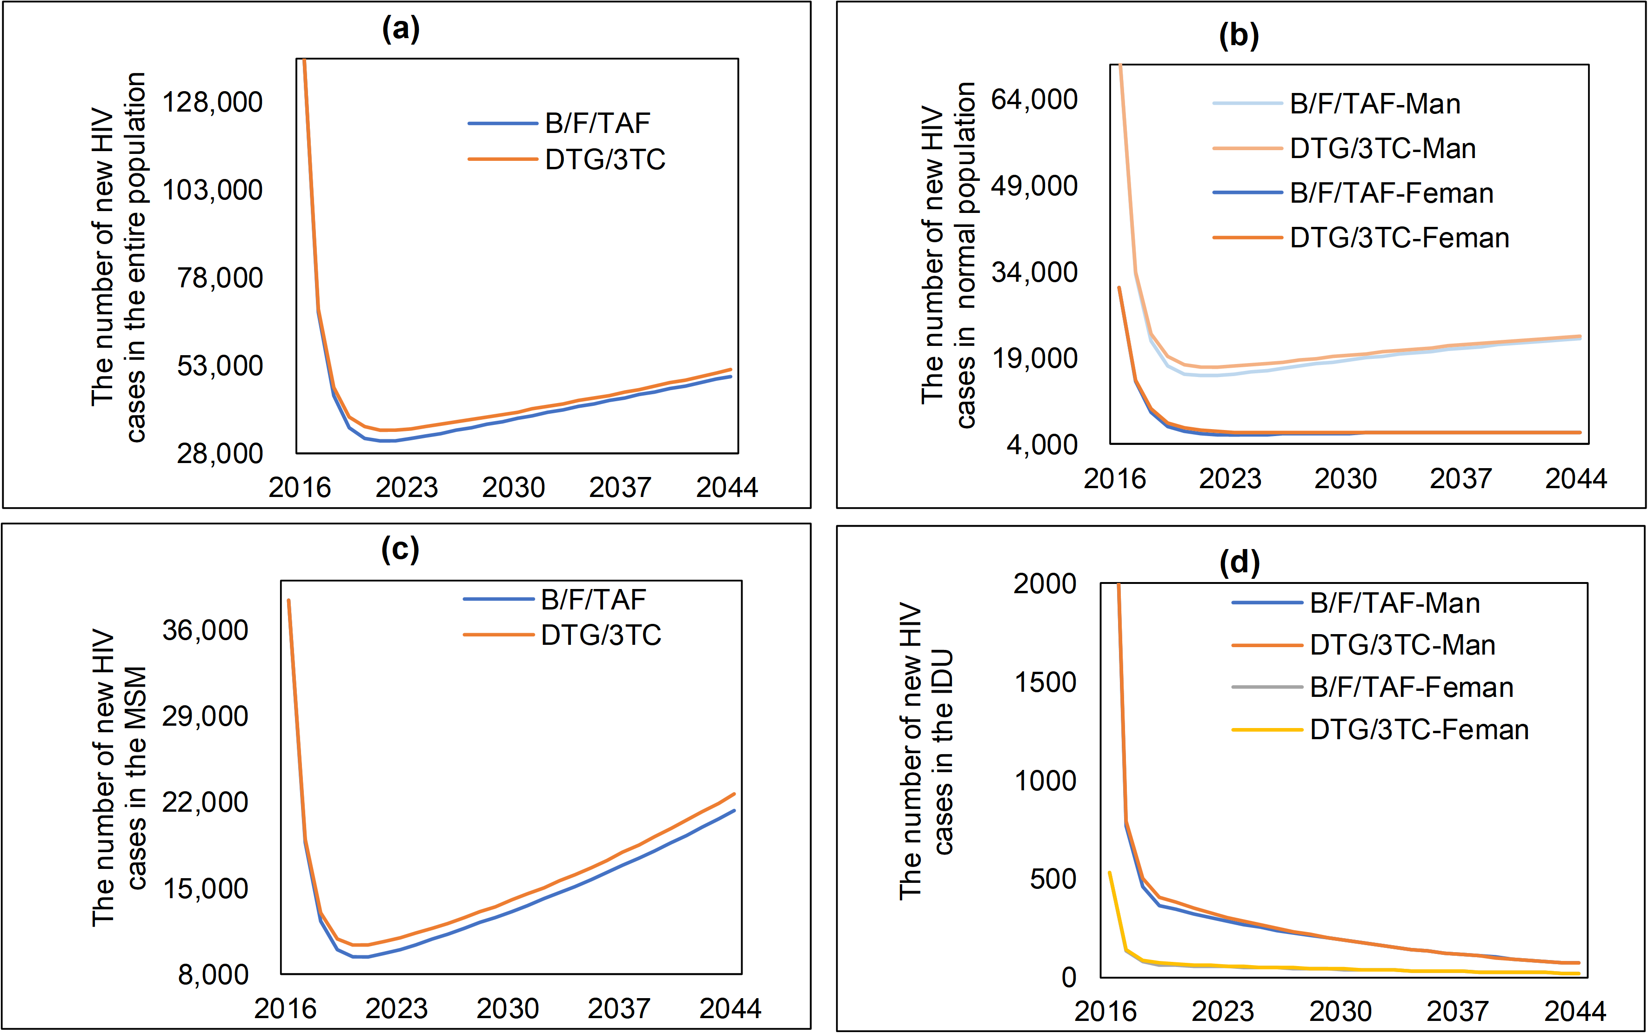
Fig. S3 The number of new HIV cases in each of the five subgroups (2015-2045)

Reference
1. Peng S, Tafazzoli A, Dorman E, Rosenblatt L, Villasis-Keever A, Sorensen S. Cost-effectiveness of DTG + ABC/3TC versus EFV/TDF/FTC for first-line treatment of HIV-1 in the United States. J MED ECON. 2015 2015/1/20;18(10):763-76. 10.3111/13696998.2015.1046878
2. world development indicators. 2023. https://databank.worldbank.org/reports.aspx?dsid=2&series=PA.NUS.PPP. Accessed 01 Oct 2023
3. Simpson KN, Pei PP, Möller J, Baran RW, Dietz B, Woodward W, et al. Lopinavir/ritonavir versus darunavir plus ritonavir for HIV infection: A cost-effectiveness analysis for the United States. PHARMACOECONOMICS. 2013 2013/1/1;31(5):427-44. 10.1007/s40273-013-0048-3
4. Gallant J, Lazzarin A, Mills A, Orkin C, Podzamczer D, Tebas P, et al. Bictegravir, emtricitabine, and tenofovir alafenamide versus dolutegravir, abacavir, and lamivudine for initial treatment of HIV-1 infection (GS-US-380-1489): a double-blind, multicentre, phase 3, randomised controlled non-inferiority trial. LANCET. 2017 2017/11/4;390(10107):2063-72. 10.1016/S0140-6736(17)32299-7
5. Cahn P, Madero JS, Arribas JR, Antinori A, Ortiz R, Clarke AE, et al. Dolutegravir plus lamivudine versus dolutegravir plus tenofovir disoproxil fumarate and emtricitabine in antiretroviral-naive adults with HIV-1 infection (GEMINI-1 and GEMINI-2): week 48 results from two multicentre, double-blind, randomised, non-inferiority, phase 3 trials. LANCET. 2019 2019/1/12;393(10167):143-55. 10.1016/S0140-6736(18)32462-0
6. An L, Jianwei L, Leaf P, Ying S, Liang H, Hongli M, et al. Clinical observation of efficacy and safety of second-line antiviral therapy of HIV/AIDS. Chinese Journal of AIDS & STD. 2015;21(06):450-2. 10.13419/j.cnki.aids.2015.06.02
7. Dai L, Su B, Liu A, Zhang H, Wu H, Zhang T, et al. Adverse events in Chinese human immunodeficiency virus (HIV) patients receiving first line antiretroviral therapy. BMC INFECT DIS. 2020 2020/2/19;20(1):158. 10.1186/s12879-020-4878-2
8. Society EAC. EACS Guidelines（Version10.1）. 2022. https：//www.eacsociety.org/files/guidelines-10.1_30032021_1.pdf. Accessed 01 Oct 2023
9. Spinner CD, Kümmerle T, Schneider J, Cordes C, Heiken H, Stellbrink HJ, et al. Efficacy and Safety of Switching to Dolutegravir With Boosted Darunavir in Virologically Suppressed Adults With HIV-1: A Randomized, Open-Label, Multicenter, Phase 3, Noninferiority Trial: The DUALIS Study. OPEN FORUM INFECT DI. 2020 2020/9/1;7(9):ofaa356. 10.1093/ofid/ofaa356

