Supporting informtation
Combinations of meso-(4-carboxyphenyl) and meso-(4-hydroxyphenyl) porphyrins as anti-HIV-1 agents
Debdulal Sharma, ^{#a} Aradhana Singh,^{#b} Sanaullah Safi,^{b} Ritu Gaur^{*b} and Devashish Sengupta*ª
ªDepartment of Chemistry, Assam University, Silchar-788011, Assam, India
^{b}Faculty of Life Sciences and Biotechnology, South Asian University, New Delhi-110068, India.

Corresponding Author
*Devashish Sengupta, E-mail: devashish.sengupta@uni.sydney.edu.au.
*Ritu Gaur. E-Mail: rgaur@sau.ac.in.

1 Synthesis:
1.1 Synthesis of 5,10,15-tri-(4-methoxycarbonylphenyl)-20-(4-hydroxyphenyl) porphyrin (PBe₃OH):
A 500 mL amber-coloured round bottom (RB) flask fitted with a water-cooled reflux condenser attached to a drying tube was charged with propionic acid (180 mL). The contents of the flask were set to reflux for 30 minutes. After that, the system’s temperature was brought down to 70 °C followed by the addition of methyl-4-formylbenzoate (7.57 g, 46 mmol, 3.2 eq) and 4-hydroxybenzaldehyde (3.17 g, 26 mmol, 1.8 eq). Pyrrole (4 mL, 57 mmol, 4 eq) was then added drop by drop over a period of twenty minutes. The reaction set-up was set to reflux for a period of 90 minutes. On completion of the reaction, excess of propionic acid was removed by distillation. The crude product remaining in the reaction vessel was neutralised using 0.5 M ammonia and washed with deionised water, followed by warm diethyl ether. The product mixture so obtained was kept overnight and then loaded onto a silica gel column for separation. The column was initially run with 20% hexane in DCM, followed by plain DCM. The desired compound was eluted out with DCM. The product-laden fraction collected was concentrated, and a second column was run for further purification with DCM as eluent. The pure fraction collected was concentrated on a rotary evaporator, and the concentrate was resuspended in DCM. The gradual addition of hexane precipitated out the desired compound. Colour: Purple, Yield: 0.950 g, 8%.
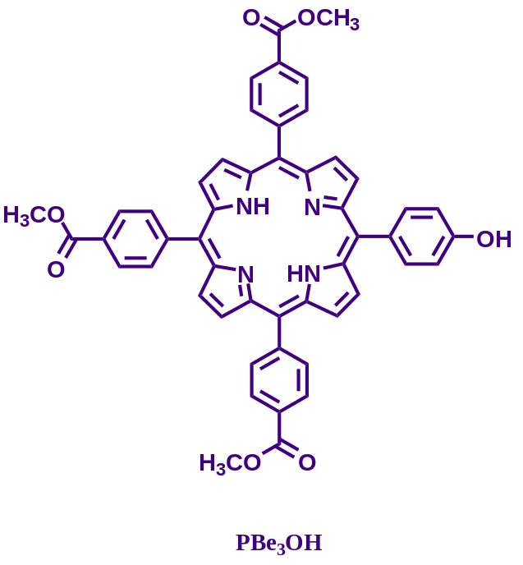
PBe₃OH: UV-Vis (DMF, 1 μM solution): 649 nm, (λ_{max}; Q-band), 592 nm (λ_{max}; Q-band), 551 nm (λ_{max}; Q-band), 515 nm (λ_{max}; Q-band), 420 nm (λ_{max}; Soret band). Emission (DMF, 1 μM solution), λ_{ex}= 420 nm (S-band): 645 nm, 668 nm Q(0,0), 721 nm Q(0,1) with Stokes shift 301 nm Q(0,1)-B(0,0); ¹H-NMR (500 MHz, CDCl₃, 298.05 K), δ: 8.94 (d, 2H, J = 4.8 Hz, β-Pyrrole), 8.85 (s, 4H, β-Pyrrole), 8.81 (d, 2H, J = 4.8 Hz, β-Pyrrole), 8.46 (d, 6H, J = 8 Hz), 8.31 (d, 6H, J = 8 Hz,), 8.07 (d, 2H, J = 8.3 Hz), 7.24 (d, 2H, J = 8.3 Hz), 4.14 (s, 9H, O-CH₃), -2.76 (s, 2H, NH-pyrrole); ¹³C (400 MHz, CDCl₃) δ: 167.35, 155.79, 146.84, 135.75, 134.55, 130.00, 129.89, 128.64, 127.97, 120.88, 119.71, 119.14, 113.85, 52.49. MALDI-TOF Calculated for C₅₀H₃₆N₄O₇ [M+H]⁺ m/z 805.2662, found 805.038.
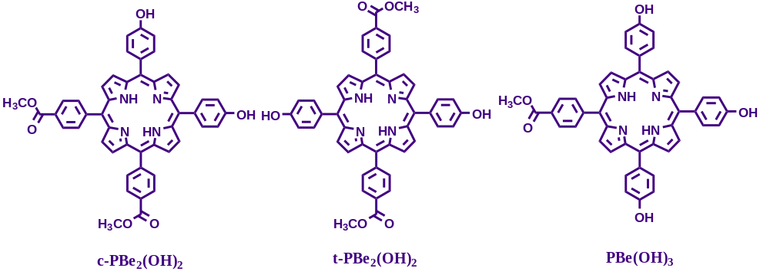
The one-pot synthesis also led to the formation of 5,10-di-(4-methoxycarbonylphenyl)-15,20-di-
-(4-hydroxyphenyl) porphyrin (c-PBe₂(OH)₂), 5,15-di-(4-methoxycarbonylphenyl)-10,20-di-(4-hydroxyphenyl) porphyrin (t-PBe₂(OH)₂) and 5-tri-(4-methoxycarbonylphenyl)-10,15,20-tri-(4-hydroxyphenyl) porphyrin (PBe(OH)₃), all of which were isolated, purified and characterised.
c-PBe₂(OH)₂: UV-Vis (DMF, 10 μM solution): 650 nm, (λ_{max}; Q-band), 594 nm (λ_{max}; Q-band), 554 nm (λ_{max}; Q-band), 517 nm (λ_{max}; Q-band), 422 nm (λ_{max}; Soret band). Emission (DMF, 10 μM solution), λ_{ex}= 422 nm (S-band): 658 nm Q(0,0), 722 nm Q(0,1) with Stokes shift 236 nm Q(0,0)-B(0,0); ¹H-NMR (500 MHz, CDCl₃, 298.05 K), δ: 8.94 (d, 2H, J = 4.8 Hz, β-Pyrrole), 8.85 (s, 4H, β-Pyrrole), 8.81 (d, 2H, J = 4.8 Hz, β-Pyrrole), 8.46 (d, 4H, J = 8 Hz), 8.31 (d, 4H, J = 8 Hz,), 8.07 (d, 4H, J = 8.3 Hz), 7.24 (d, 4H, J = 8.3 Hz), 4.14 (s, 9H, O-CH₃), -2.76 (s, 2H, NH-pyrrole); δ: MALDI-TOF Calculated for C₄₈H₃₄N₄O₇ [M] m/z 762.2478, found 762.291.
t-PBe₂(OH)₂: UV-Vis (DMF, 10 μM solution): 649 nm, (λ_{max}; Q-band), 594 nm (λ_{max}; Q-band), 552 nm (λ_{max}; Q-band), 515 nm (λ_{max}; Q-band), 422 nm (λ_{max}; Soret band). Emission (DMF, 10 μM solution), λ_{ex}= 422 nm (S-band): 660 nm Q(0,0), 722 nm Q(0,1) with Stokes shift 238 nm Q(0,0)-B(0,0); ¹H-NMR (400 MHz, CDCl₃, 298.05 K), δ: 8.90 (d, 4H, J = 4.6 Hz, β-Pyrrole), 8.78 (d, 4H, J = 4.6 Hz, β-Pyrrole), 8.44 (d, 4H, J = 7.8 Hz), 8.30 (d, 4H, J = 7.8 Hz), 8.06 (d, 4H, J = 8.1 Hz,), 7.23 (d, 4H, J = 8.1 Hz), 4.12 (s, 6H), 3.89 (s, br, 2H, -OH), -2.77 (s, 2H, NH-pyrrole); δ: MALDI-TOF Calculated for C₄₈H₃₄N₄O₇ [M] m/z 762.2478, found 762.874
PBe(OH)₃: UV-Vis (DMF, 10 μM solution): 649 nm, (λ_{max}; Q-band), 602 nm (λ_{max}; Q-band), 560 nm (λ_{max}; Q-band), 519 nm (λ_{max}; Q-band), 428 nm (λ_{max}; Soret band). Emission (DMF, 10 μM solution), λ_{ex}= 428 nm (S-band): 616, 660 nm Q(0,0), 721 nm Q(0,1) with Stokes shift 232 nm Q(0,0)-B(0,0); ¹H-NMR (400 MHz, CDCl₃, 298.05 K), δ: 8.91 (d, 2H, J = 4.9 Hz, β-Pyrrole), 8.90 (s, 4H, β-Pyrrole), 8.79 (d, 2H, J = 4.9 Hz, β-Pyrrole), 8.46 (d, 2H, J = 8.1 Hz), 8.32 (d, 2H, J = 8.1 Hz), 8.09 (d, 6H, J = 8.3 Hz), 7.24 (d, 6H, J = 8.3 Hz), 4.14 (s, 3H, O-CH₃), -2.74 (s, 2H, NH-pyrrole); δ: MALDI-TOF Calculated for C₄₆H₃₂N₄O₅ [M+H]⁺ m/z 721.7928, found 721.346.
1.2 Synthesis of 5,10,15-tri-(carboxyphenyl)-20-(4-hydroxyphenyl) porphyrin (PB₃OH):
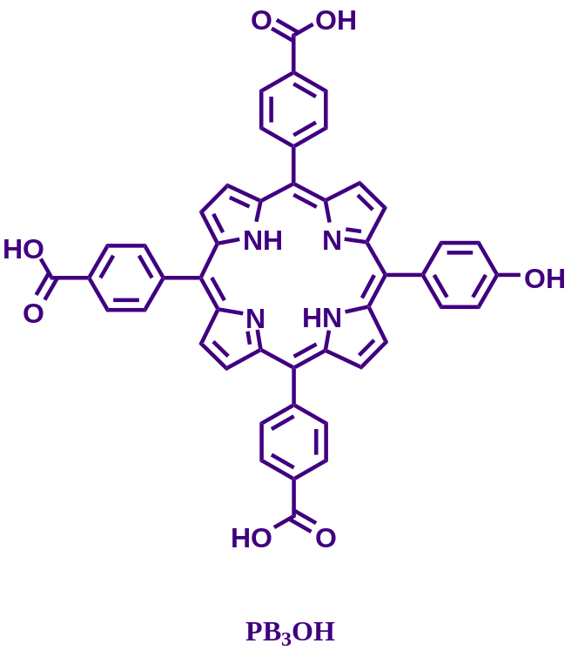
Compound PBe₃OH (0.084 g, 0.104 mmol, 1 eq) was dissolved in DMF (21.8 mL) in a 150 mL single neck round bottom flask. The flask was then charged with crushed NaOH (0.87 g, 21.75 mmol, 209 eq) and the contents were subjected to stirring for 30 min. Thereafter deionized water (80 mL) was added and stirring continued for 30 more minutes. The pH of the reaction mixture was then brought down to 4.5, using 6 N HCl, when the product finally precipitated out. The precipitate was recovered through centrifugation, washed repeatedly with MeOH, water and dried. Yield: 0.068 g,. 85%.
PB₃OH: UV-Vis (Water, 10 μM solution): 653 nm (λ_{max}; Q-band), 598 nm (λ_{max}; Q-band), 559 nm (λ_{max}; Q-band), 523 nm (λ_{max}; Q-band), 421 nm (λ_{max}; Soret band). Emission (Water, 10 μM solution), λ_{ex}= 421 nm (S-band): 614 nm, 662 nm Q(0,0) with Stokes shift 241 nm ($Δλ= λ_{em}^{max}- λ_{abs}^{max}$); ¹H-NMR (300 MHz, DMSO-d6, 300 K), δ: 8.92 (d, 2H, J = 5 Hz, β-Pyrrole), 8.82 (s, 4H, β-Pyrrole), 8.77 (d, 2H, J = 5 Hz, β-Pyrrole) 8.36 (d, 6H, J = 8.3 Hz), 8.28 (d, 6H, J = 8.3 Hz) 8.00 (d, 2H, J = 8.5 Hz), 7.22 (d, 2H, J = 8.5 Hz), -2.90 (s, 2H, NH-pyrrole); MALDI-TOF Calculated for C₄₇H₃₀N₄O₇ [M+2H]⁺ m/z 764.227, found 764.089.
A similar procedure was employed to obtain 5,10-di-(4-carboxyphenyl)-15,20-di-(4-hydroxyphenyl) porphyrin (c-PB₂(OH)₂), 5,15-di-(4-carboxyphenyl)-10,20-di-(4-hydroxyphenyl) porphyrin (t-PB₂(OH)₂), 5,10,15-di-(4-carboxyphenyl)-20-(4-hydroxyphenyl) porphyrin PB(OH)₃, the hydrolysis product of the free-base esters c-PBe₂(OH)₂, t-PBe₂(OH)₂, PBe(OH)₃.
c-PB₂(OH)₂: UV-Vis (Water, 10 μM solution): 690, (λ_{max}; Q-band), 600, (λ_{max}; Q-band), 562 (λ_{max}; Q-band), 524 (λ_{max}; Q-band), 419 (λ_{max}; Soret band). Emission (Water, 10 μM solution), λ_{ex}= 419 nm (S-band): 612, 654 (0,0), 710 (0,1) with Stokes shift 235 nm Q(0,0)-B(0,0); ¹H-NMR (400 MHz, DMSO-d6, 298.05 K), δ: 8.83-8.92 (m, 8H) 8.38 (d, 4H, J = 7.3 Hz), 8.31 (d, 4H, J = 7.3 Hz) 8.02 (d, 4H, J = 7.1 Hz), 7.23 (d, 4H, J = 7.1 Hz), -2.87 (s, 2H, NH-pyrrole); Calculated for C₄₆H₃₀N₄O₆ [M+H]⁺ m/z 734.2165, found 734.855
t-PB₂(OH)₂: UV-Vis (DMF, 10 μM solution): 662, (λ_{max}; Q-band), 601, (λ_{max}; Q-band), 560 (λ_{max}; Q-band), 522 (λ_{max}; Q-band), 426 (λ_{max}; Soret band). Emission (DMF, 10 μM solution), λ_{ex}= 426 nm (S-band): 612, 653 (0,0), 708 (0,1) with Stokes shift 228 nm Q(0,0)-B(0,0); ¹H-NMR (400 MHz, DMSO-d6, 298.05 K), δ: 8.83-8.92 (m, 8H) 8.38 (d, 4H, J = 7.3 Hz), 8.31 (d, 4H, J = 7.3 Hz) 8.02 (d, 4H, J = 7.1 Hz), 7.23 (d, 4H, J = 7.1 Hz), -2.87 (s, 2H, NH-pyrrole); Calculated for C₄₆H₃₀N₄O₆ [M+H]⁺ m/z 734.2165, found 734.554
PB(OH)₃: UV-Vis (Water, 10 μM solution): 684, (λ_{max}; Q-band), 602, (λ_{max}; Q-band), 567 (λ_{max}; Q-band), 525 (λ_{max}; Q-band), 420 (λ_{max}; Soret band). Emission (Water, 10 μM solution), λ_{ex}= 420 nm (S-band): 614, 657 (0,0), 710 (0,1) with Stokes shift 237 nm Q(0,0)-B(0,0); ¹H-NMR (400 MHz, DMSO-d6, 298.05 K), δ: 9.95 (d, 2H, J = 6.1 Hz), 8.82 (s, 4H), 8.79 (d, 2H, J = 2.4 Hz), 8.38 (d, 6H, J = 7.6 Hz), 8.33 (d, 6H, J = 7.6 Hz), 8.00 (d, 2H, J = 7.3 Hz), 7.20 (d, 2H, J = 7.3 Hz), -2.88 (s, 2H, NH-pyrrole). MALDI-TOF: Calculated for C₄₆H₃₀N₄O₆ [M+H]⁺ m/z 706.7580, found 706.863
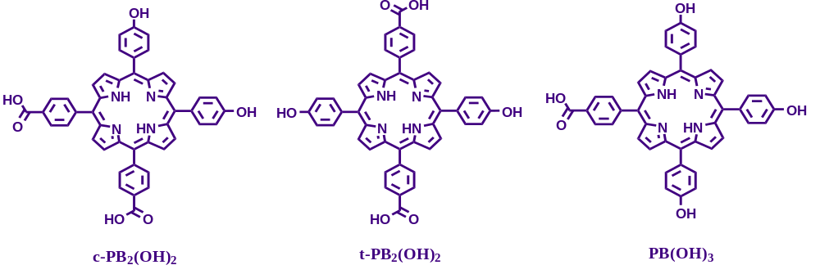
Methods:
Cell lines and plasmids: HEK-293T and TZM-bl cells were cultured at 37 °C with 5% CO2 in Dulbecco's modified Eagle's media supplemented with 10% FBS and 1% penicillin, streptomycin antibiotic solution. The TZM-bl cell line is a derivative of the HeLa cell line, and it is modified to express CD4, CCR5, and CXCR4. This cell line is very susceptible to infection by most HIV, SIV, and SHIV strains. It has separate copies of the luciferase and -galactosidase genes controlled by the HIV-1 long terminal repeat promoter. HIV infection may be precisely measured as a function of luciferase or β-galactosidase activity.^{1,2} The TZM-bl cell lines, HIV-1 subtype B molecular clones NL4-3, and NL4-3 env- generously provided by Dr. Eric O. Freed (National Cancer Institute, NIH, USA). The HIV-1 subtype C clone, K3016, was a generous gift from Dr. Christina Ochsenbauer, University of Alabama, USA; Gene Bank accession: KC156129).
Preparation of test compounds: All the compounds were prepared in 5% DMSO in water (-) solution. T20 (Enfuvirtide) stock solution was prepared by using only DMSO. The antiviral activity of the compounds was investigated in dark non-photodynamic (non-PDT) and photodynamic (PDT ) conditions under specific conditions.
Cytotoxicity Assay: To analyze the effect of these compounds on cell viability, the cytotoxicity of the compounds was tested against TZM-Bl cells and HEK293T cells. The cytotoxicity test was carried out according to the manufacturer's instructions using the Cell Titre-Blue Cell Viability Assay kit (Promega, USA). 7000 cells/well were cultured on an opaque white 96-well plate with serial dilutions of compounds for 48 h in the dark before being treated with 20 µl/well Cell Titre-Blue reagent for 4 hours at 37 °C. The concentrations employed for toxicity tests on HEK293T and TZM-bl cells varied from 0.1µM to 50µM. A Bio Tek microplate reader was used to record the fluorescent signals at 530/25 excitation and 590/35 emission. For testing the effect of compounds on the cell viability under photodynamic (PDT) conditions, HEK-293T and TZM-bl cells were incubated with compounds at concentrations ranging from 0.1µM to 50µM, followed by 45 minutes of light irradiation at a distance of 6 inches inside an experimentally designed light chamber. After 48 hours of incubation at 37°C, the viability of the treated cells was compared to that of the untreated cells.
Viral gene expression studies: HEK-293T cells were cultured to about 50%-60% confluency in a 6-well culture plate, then transfected with 3 μg of HIV-1 NL4-3 or K3016 DNA and generated in the presence or absence of 500nM to 5 μM compounds. The viral supernatant was collected 24 hours after transfection, centrifuged, and filtered to remove residual cell debris. The cells that had been transfected were washed and collected in 1X phosphate-buffered saline (PBS). After centrifugation at 845 g for 5 minutes, the cell pellets were lyzed in 1X RIPA (radioimmunoprecipitation assay) buffer. 50mM Tris-HCl pH 8.0, 150mM sodium chloride, 1.0% NP-40, 0.5% sodium deoxycholate, 0.1% SDS, and 1X protease inhibitor cocktail (Roche, Germany) are used to make 1X RIPA buffer.
Virus infectivity assay: A TZM-bl cell-based single-cycle infectivity assay was used to assess the infectivity of the viruses produced in the presence or absence of porphyrins.^{62,63}.TZM-bl cells were infected with 10ng of HIV-1 subtype B NL4-3 or subtype C K3016 p24 equivalent virus for 2 h. After infection, the cells were washed and incubated for 48 h without test compounds at 37 °C. Relative luminescence was measured 48 h post-infection and compared to the control. The infectivity of HIV-1 subtype B NL4-3 virus or HIV-1 subtype C K3016 virus produced in the presence of 5% DMSO in water (-), in the absence of the carboxyphenyl porphyrins, served as the treatment control.
Entry inhibition assay in TZM-bl cells under non-PDT conditions: NL4-3/K3016 viral stocks were generated in HEK293T cells. After 24 hours, the viral supernatant was collected, centrifuged, and filtered to remove any remaining cell debris. The HIV-1 p24 Antigen Capture Kit was used to quantify the virus. The p24 normalized virus was utilized to infect TZM-bl cells in the presence of 20 µg DEAE-dextran per ml (7X10⁴/well). The concentration of the compounds was used in the range of 100nM to 5µM. Three distinct conditions were used for the infection: A) Compounds were added to the cells during virus infection. B) The compounds were introduced to the cells after virus infection and incubated for 48 hours.T-20, an HIV-1 fusion inhibitor, was utilized as a positive control. C). TZM-bl cells were pre-treated with 5 µM of carboxyphenyl porphyrins for 2 h before virus infection.
The luciferase activity in cell lysates was evaluated 48 hours after infection using the Steady-Glo luciferase assay kit (Promega, USA) according to the manufacturer's instructions. The percentage relative entry was obtained by normalizing the luciferase units compared to the 5% DMSO in water (-) control.
Entry inhibition assay in T cells under non-PDT conditions:
Human T-cell line- HuTR5 cells were infected with the HIV-1 NL4-3 or K3016 virus. The infected cells were washed and cultured for 4 days for NL4-3 and 7 days for K3016 at 37° C in the presence or absence of compounds. The virus was then quantified using p24ELISA.
Temperature arrest assay under non-PDT conditions:
TZM-bl cells were maintained with the compounds for 2 hours at 4 °C during virus infection using spinoculation infection. The cells were subsequently washed and separated into two sets: one set was incubated with the compounds, and the other was incubated without the compounds for 48 hours at 37 °C. Following the manufacturer's instructions, the relative luciferase activity was determined using the Steady-Glo luciferase assay kit (Promega, USA).
Time of addition assay:
TZM-bl cells were infected with 10ng of HIV1NL4-3 p24 equivalent virus. To assess the antiviral activity of the compounds upon virus entry, compounds were introduced at -0mins, 30mins, 1h, and 2h following virus addition to the cells and maintained through the course of infection. After 2 h, cells were washed and incubated for 48 hours. The luciferase activity in cell lysates was evaluated 48 hours after infection using the Steady-Glo luciferase assay kit (Promega, USA) according to the manufacturer's instructions. The percentage relative entry was obtained by normalizing the luciferase units compared to the 5% DMSO in water (-) control.
Entry inhibition assay in TZM-bl cells under PDT conditions:
50ng of HIV-1 p24 equivalent HIV-1 NL4-3 or K3016 virus was pre-treated with 10 nM to 500 nM compounds and exposed to a specific light source at a distance of 6 inches inside an experimentally designed light chamber for 45 minutes. After being pre-treated, the virus infected TZM-bl cells for 2 hours at 37°C. After infection, cells were washed and maintained for 48 hours without compounds. HIV-1 fusion inhibitor T-20 was used as a positive control. The relative luminescence corresponding to HIV infection was measured. For checking the effect of porphyrins on virus production, TZM-bl cells were infected with 50ng of HIV-1 p24 equivalent HIV-1 NL4-3 or K3016 virus for 2 h at 37°C. Following infection, cells were treated with the compounds and irradiated for 45 minutes from a distance of 6 inches inside the light chamber by a specific light source. After 48 hours of incubation at 37°C, the relative luminescence corresponding to HIV production inside the cells was measured.

Figure S1: Synthetic methodology involved in the synthesis of the hydrophilic free base carboxyphenyl porphyrin derivatives TCPP, PB₃OH, c-PB₂(OH)₂, t-PB₂(OH)₂ and PB(OH)₃
Table S1: ¹H Chemical shift data (δ, ppm) for PBe₃OH, c-PBe₂(OH)₂, t-PBe₂(OH)₂ and PBe(OH)₃ in CDCl₃. Multiplicity, integration and coupling constants in parentheses.
Code | H-β-pyrrolic | ArH | -OCH3 | -NH pyrrole
PBe₃OH | 8.94 (d, 2H, J = 4.8 Hz), 8.85 (s, 4H), 8.81 (d, 2H, J = 4.8 Hz), | 8.46 (d, 6H, J = 8 Hz), 8.31 (d, 6H, J = 8 Hz,), 8.07 (d, 2H, J = 8.3 Hz), 7.24 (d, 2H, J = 8.3 Hz), | 4.14 (s, 9H) | –2.76 (s, 2H)
c-PBe₂(OH)₂ | 8.94 (d, 2H, J = 4.8 Hz), 8.85 (s, 4H), 8.81 (d, 2H, J = 4.8 Hz) | 8.46 (d, 4H, J = 8 Hz), 8.31 (d, 4H, J = 8 Hz,), 8.07 (d, 4H, J = 8.3 Hz), 7.24 (d, 4H, J = 8.3 Hz) | 4.14 (s, 6H) | –2.76 (s, 2H)
t-PBe₂(OH)₂ | 8.90 (d, 4H, J = 4.6 Hz), 8.78 (d, 4H, J = 4.6 Hz) | 8.44 (d, 4H, J = 7.8 Hz), 8.30 (d, 4H, J = 7.8 Hz), 8.06 (d, 4H, J = 8.1 Hz,), 7.23 (d, 4H, J = 8.1 Hz) | 4.12 (s, 6H) | –2.76 (s, 2H)
PBe(OH)₃ | 8.91 (d, 2H, J = 4.9 Hz), 8.90 (s, 4H, β-Pyrrole), 8.79 (d, 2H, J = 4.9 Hz) | 8.46 (d, 2H, J = 8.1 Hz), 8.32 (d, 2H, J = 8.1 Hz), 8.09 (d, 6H, J = 8.3 Hz), 7.24 (d, 6H, J = 8.3 Hz) | 4.14 (s, 3H) | –2.74 (s, 2H)
Table S2: UV-Vis and Emission data of PBe₃OH, c-PBe₂(OH)₂, t-PBe₂(OH)₂ and PBe(OH)₃.
Code | Solvent/  Concentration | Absorption (nm) | Emission
Code | Solvent/  Concentration | λ_{abs}/nm (ε/10³ M⁻¹ cm⁻¹) | λ_{em/}  nm | Stokes shift
PBe₃OH | DMF/1 μM | 420 (394.3), 515 (17.3), 551 (9.6), 592 (5.4), 649 (6.2) | 645, 668, 721 | 301
c-PBe₂(OH)₂ | DMF/10 μM | 422 (316.8), 517 (23.7), 554 (16.9), 594 (8.6), 650 () | 658, 722 | 236
t-PBe₂(OH)₂ | DMF/10 μM | 422 (10.7), 515 (1.4), 552 (1.1), 594 (0.8), 649 (0.7) | 660, 722 | 238
PBe(OH)₃ | DMF/10 μM | 428 (315.7), 519 (7.9), 560 (21.5), 602 (13.2), 649 (2.4). | 616, 660, 721 | 232

Figure S2: UV-Vis and emission spectral plot of PBe₄, PBe₃OH, c-PBe₂(OH)₂, t-PBe₂(OH)₂ and PBe(OH)₃ recorded in DMF at a concentration of 10 μM.
Table S3: ¹H Chemical shift data (δ, ppm) for PB₃OH, PB₃C₆₀ in DMSO-d6. Multiplicity, integration and coupling constants in parentheses.
Code | -COOH | H-β-pyrrolic | ArH | -OH | -NH
PB₃OH |  | 8.92 (d, 2H, J = 5 Hz), 8.82 (s, 4H), 8.77 (d, 2H, J = 5 Hz,) | 8.36 (d, 6H, J = 8.3 Hz), 8.28 (d, 6H, J = 8.3 Hz) 8.00 (d, 2H, J = 8.5 Hz), 7.22 (d, 2H, J = 8.5 Hz) |  | –2.90 (s, 2H, NH-pyrrole)
c-PB₂(OH)₂ | - | 8.83-8.92 (m, 8H) | 8.38 (d, 4H, J = 7.3 Hz), 8.31 (d, 4H, J = 7.3 Hz) 8.02 (d, 4H, J = 7.1 Hz), 7.23 (d, 4H, J = 7.1 Hz) | - | –2.87 (s, 2H, NH-pyrrole)
t-PB₂(OH)₂ | 12.81 | 8.91 (d, 4H, J = 5.1 Hz), 8.81 (d, 4H, J = 5.6 Hz). | 8.38 (d, 4H, J = 8 Hz), 8.33 (d, 4H, J = 8 Hz), 7.21 (d, 4H, J = 7.6 Hz), 6.90 (d, 4H, J = 8 Hz). | 3.58  (s, br, 2H) | –2.91 (s, 2H, NH-pyrrole)
PB(OH)₃ | - | 9.95 (d, 2H, J = 6.1 Hz), 8.82 (s, 4H), 8.79 (d, 2H, J = 2.4 Hz,) | 8.38 (d, 6H, J = 7.6 Hz), 8.33 (d, 6H, J = 7.6 Hz) 8.00 (d, 2H, J = 7.3 Hz), 7.20 (d, 2H, J = 7.3 Hz) | - | –2.88 (s, 2H, NH-pyrrole)
A
B

Figure S3: UV-Vis and emission spectral plot of c-PB₂(OH)₂, t-PB₂(OH)₂, PB(OH)₃, PB₃OH and TCPP recorded in water at a concentration of 10 μM.
Table S4: UV and emission spectral data c-PB₂(OH)₂, t-PB₂(OH)₂, PB(OH)₃, PB₃OH and TCPP recorded in water at a concentration of 10 μM.
A
B
Code | Solvent/  Concentration | Absorption (nm) | Emission
Code | Solvent/  Concentration | λ_{abs}/nm (ε/10³ M⁻¹ cm⁻¹)  B(0,0), Qy(1,0), Qy(0,0), Qx(1,0), Qx(0,0) | λ_{em}/nm  -, Q(0,0), Q(0,1) | Stokes shift*  (nm)
PB₃OH | Water/10 μM | 421 (112.6), 523 (9.1), 559 (10.8), 598 (7.9), 653 (5.4) | 614, 662, -, | 241
c-PB₂(OH))₂ | Water/10 μM | 419 (65.0), 524 (3.7), 562 (3.7), 600 (3.2), 690 (7.2) | 612, 654, 710 | 235
t-PB₂(OH))₂ | Water/10 μM | 426 (20.0), 522 (3.2), 560 (2.6), 601 (1.9), 662 (1.9). | 612, 654, 708 | 228
PB(OH)₃ | Water/10 μM | 420 (48.7), 525 (2.8), 567 (2.9), 602 (2.7), 684 (4.9) | 614, 657, 710 | 237
TCPP | Water/10 μM | 418 (195.7), 520 (12.5), 557 (11.4), 594 (7.3), 649 (4.4). | 611, 660, 706 | 288
*Stokes shifts were calculated as $Δλ= λ_{em}^{max}- λ_{abs}^{max}$^{3,4}

2 Characterization:
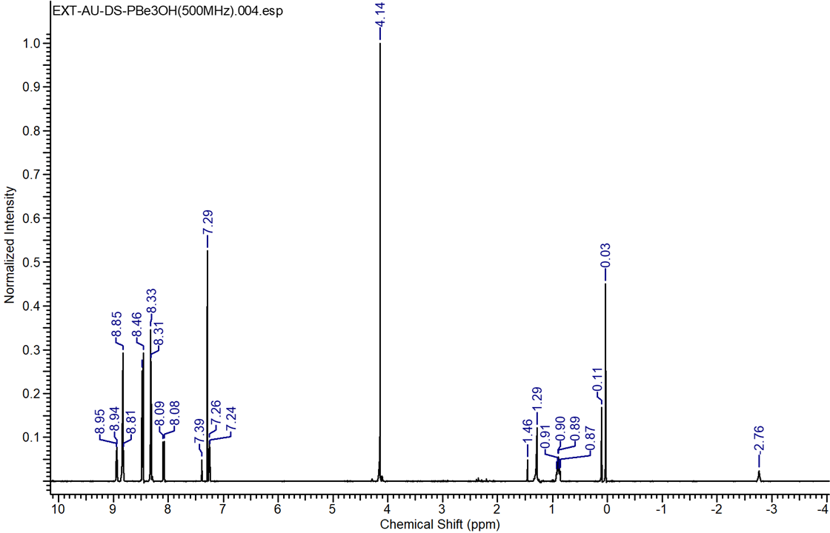
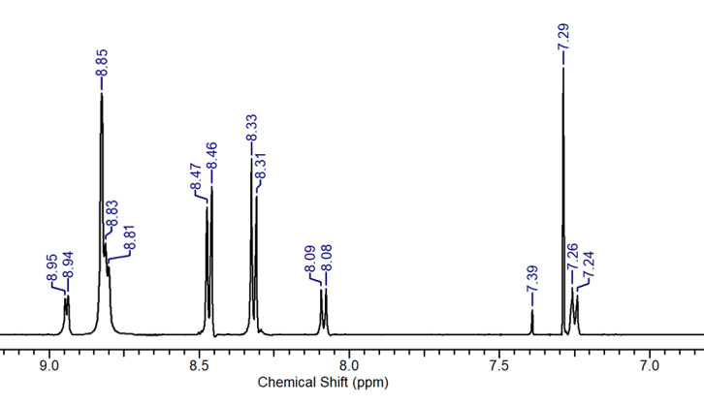
2.1 ¹H-NMR Spectra:
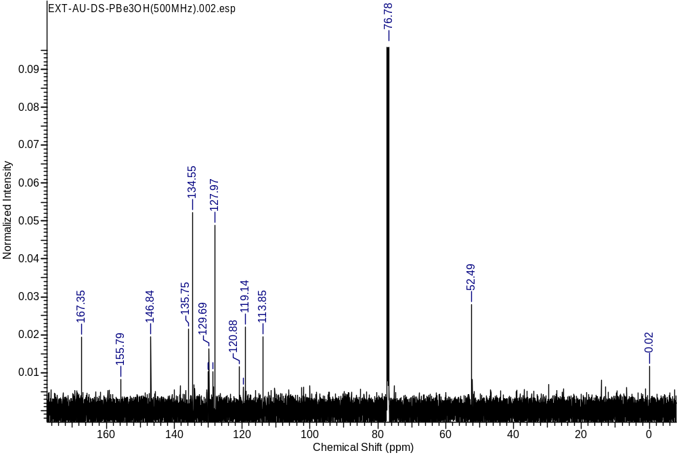Figure S4: ¹H-NMR Spectra: 5,10,15-tri-(4-methoxycarbonylphenyl)-20-(4-hydroxyphenyl) porphyrin (PBe₃OH)
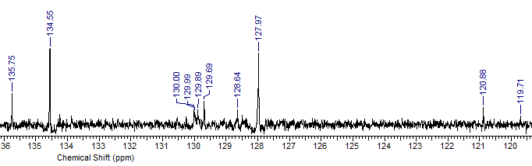
Figure S5: ¹³C-NMR Spectra: 5,10,15-tri-(4-methoxycarbonylphenyl)-20-(4-hydroxyphenyl) porphyrin (PBe₃OH)
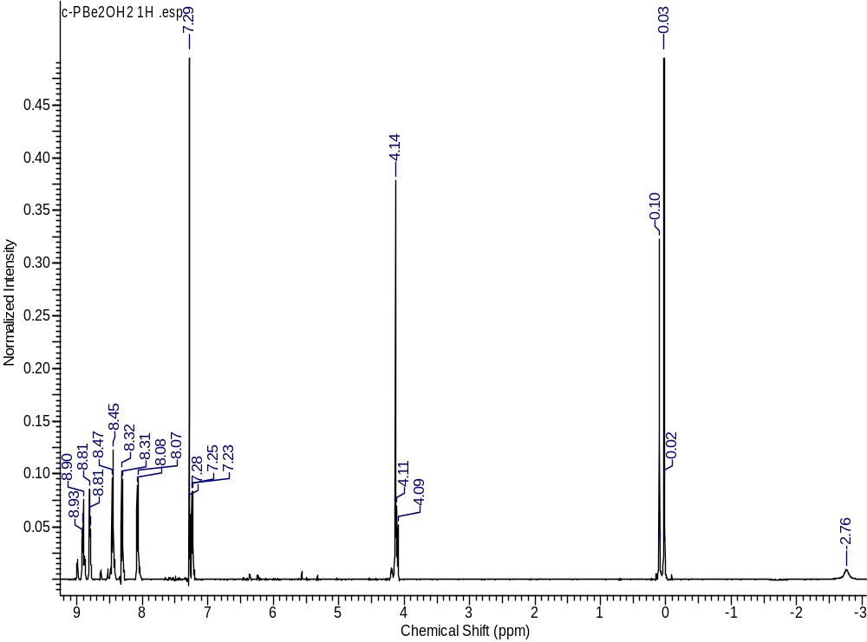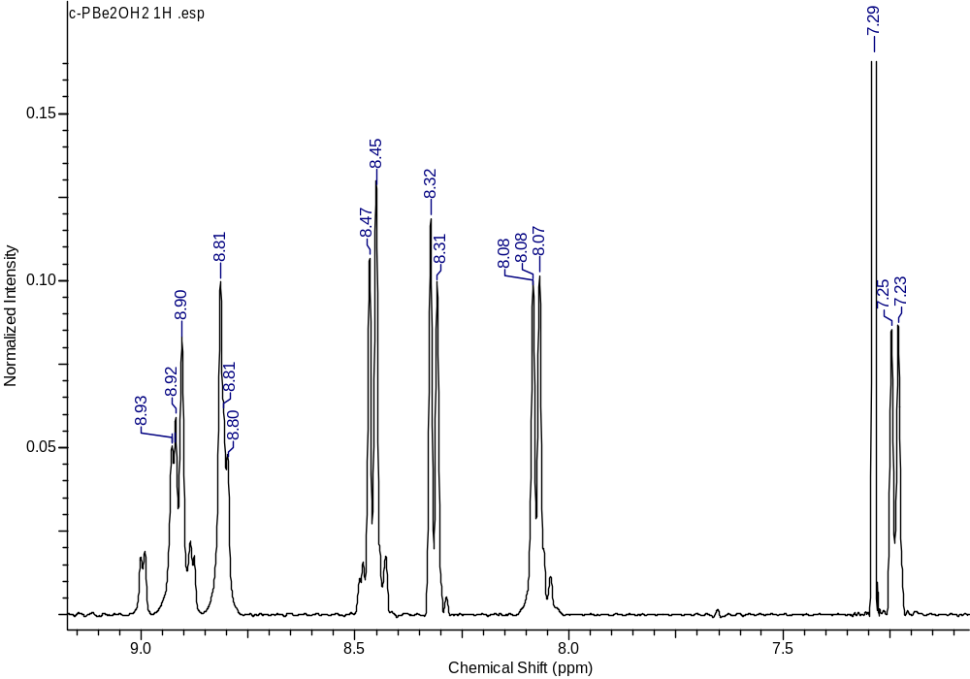
Figure S6: ¹H-NMR Spectra: 5,10-tri-(4-methoxycarbonylphenyl)-15,20-(4-hydroxyphenyl) porphyrin (c-PBe₂(OH)₂)
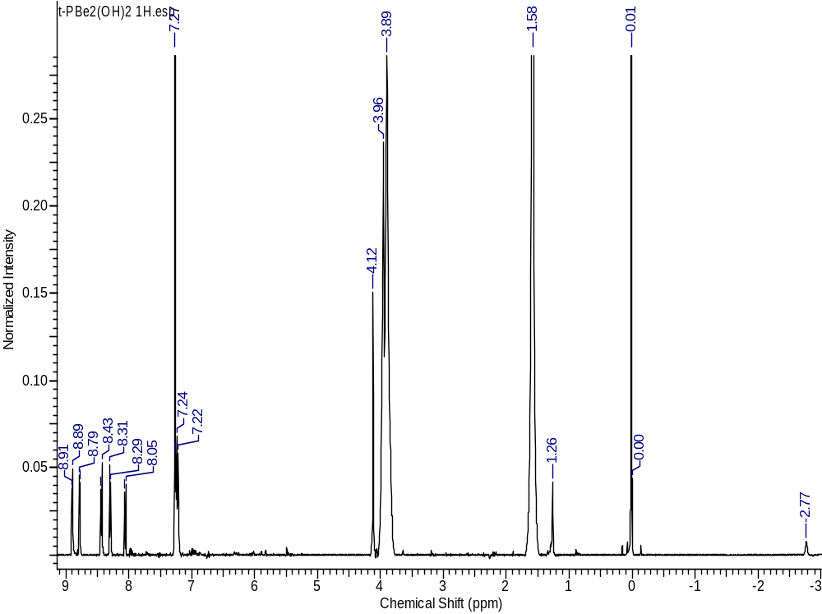
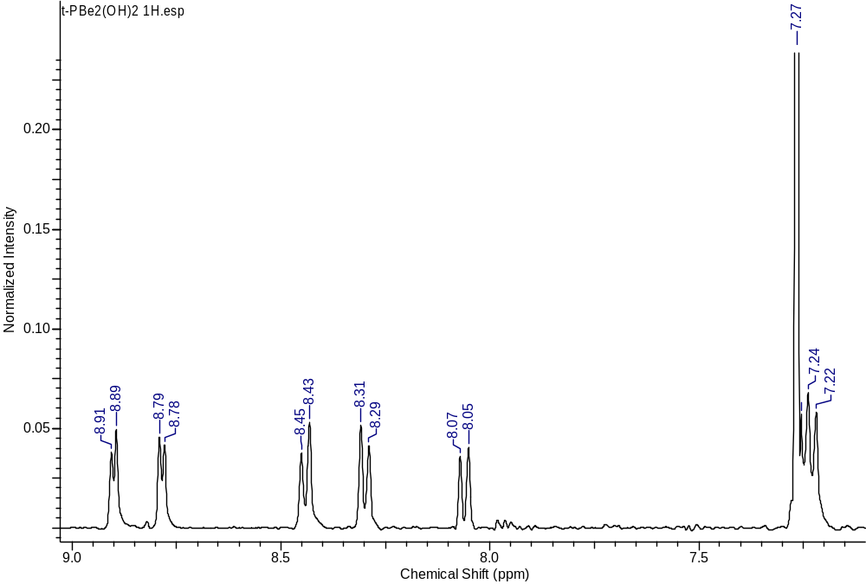
Figure S7: ¹H-NMR Spectra: 5,15-tri-(4-methoxycarbonylphenyl)-10,20-(4-hydroxyphenyl) porphyrin (t-PBe₂(OH)₂)
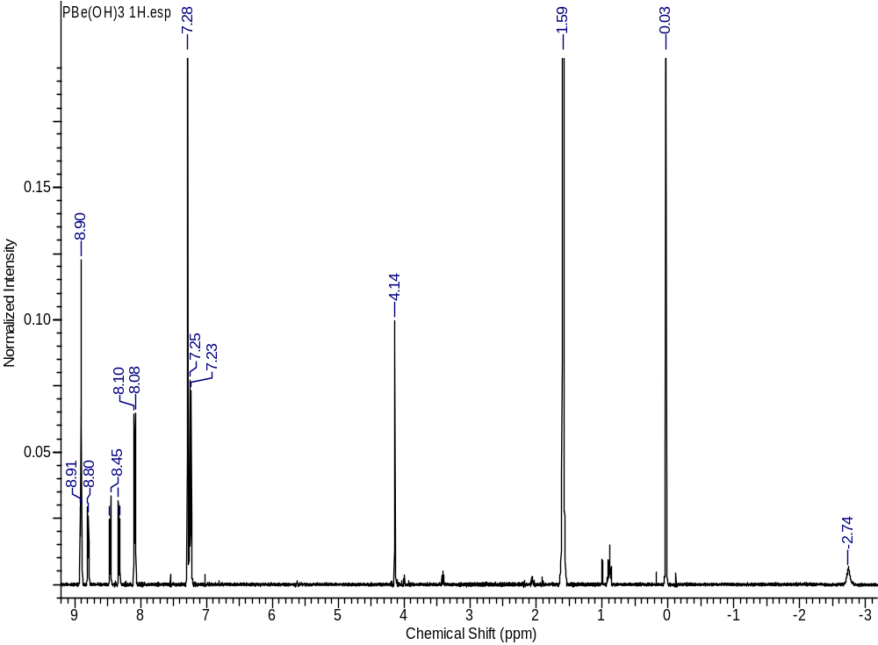
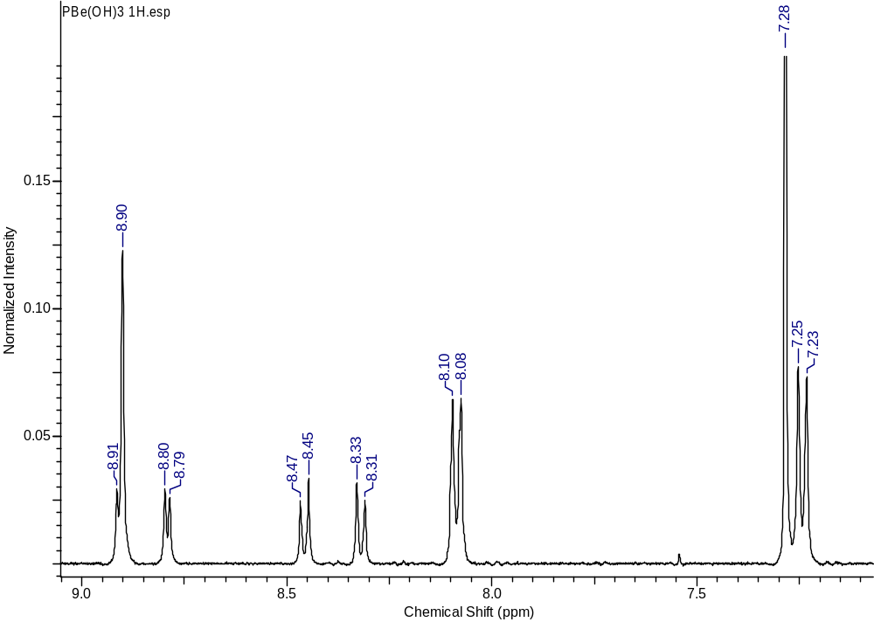
Figure S8: ¹H-NMR Spectra: 5-(4-methoxycarbonylphenyl)-10,15,20-(4-hydroxyphenyl) porphyrin (PBe(OH)₃)
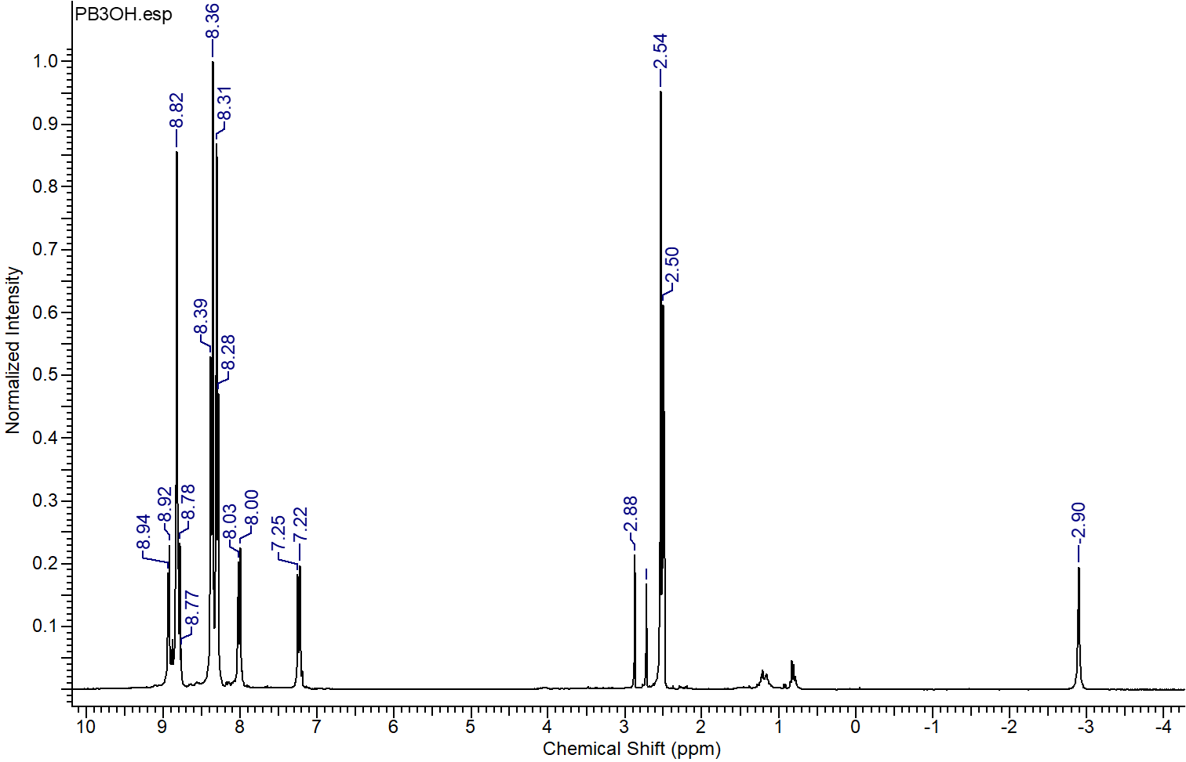
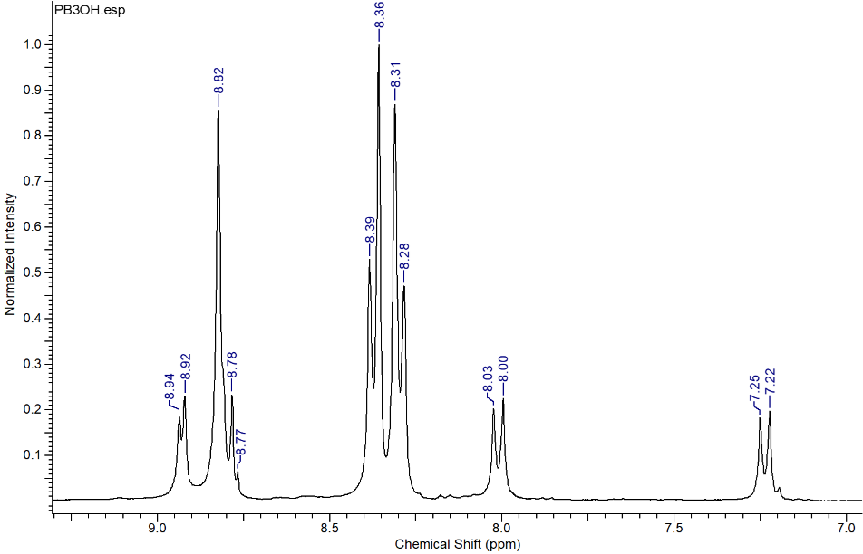
Figure S9: ¹H-NMR Spectra: 5,10,15-tri-(4-carboxyphenyl)-20-(4-hydroxyphenyl) porphyrin (PB₃OH)
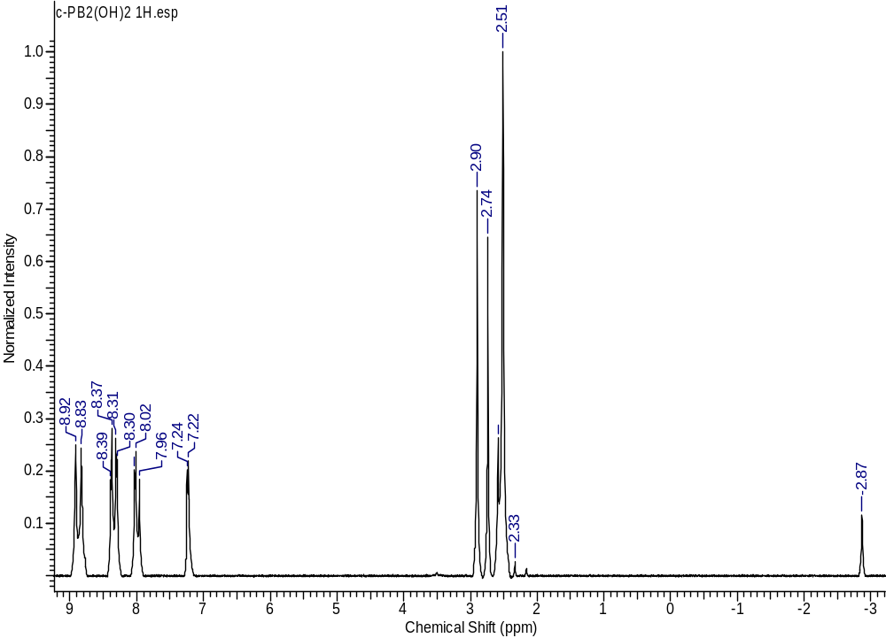
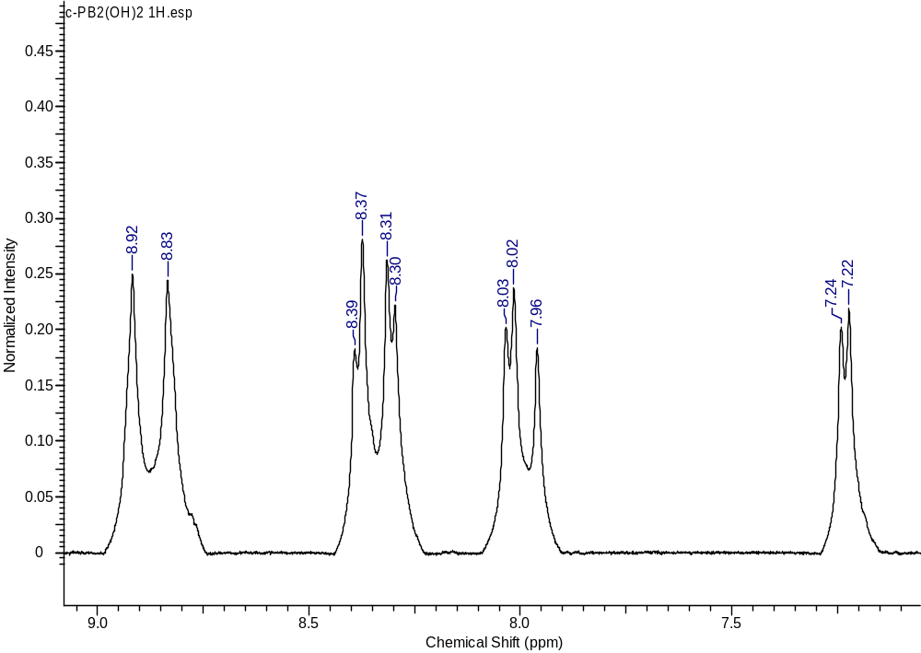
Figure S10: ¹H-NMR Spectra: 5,10-di-(4-carboxyphenyl)-15,20-di-(4-hydroxyphenyl) porphyrin (c-PB₂(OH)₂)
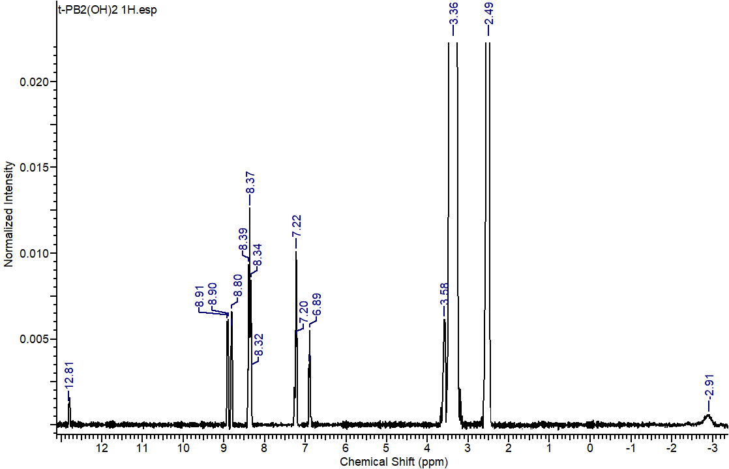
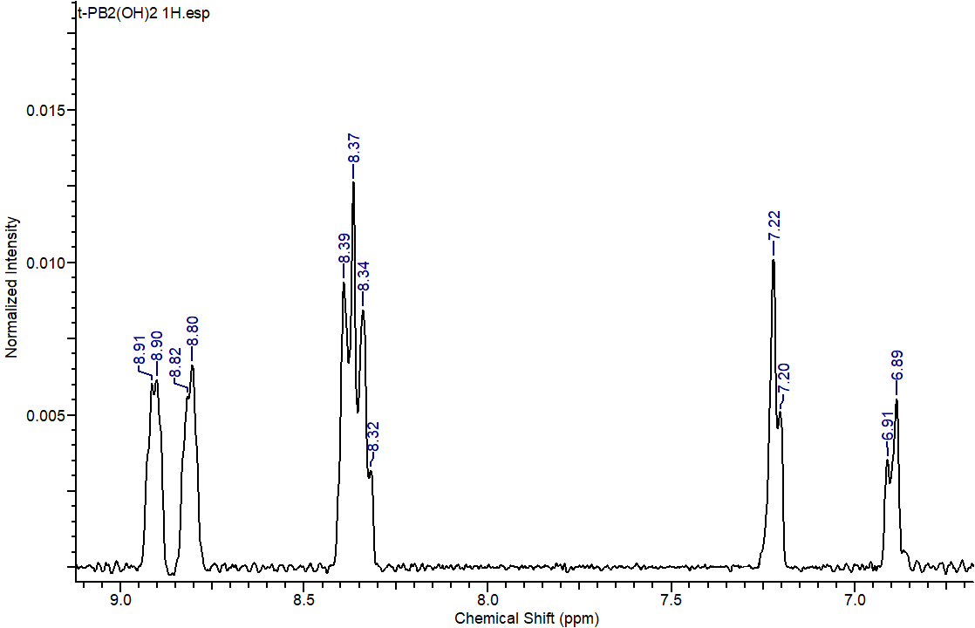
Figure S11: ¹H-NMR Spectra: 5,15-di-(4-carboxyphenyl)-10,20-di-(4-hydroxyphenyl) porphyrin (t-PB₂(OH)₂)
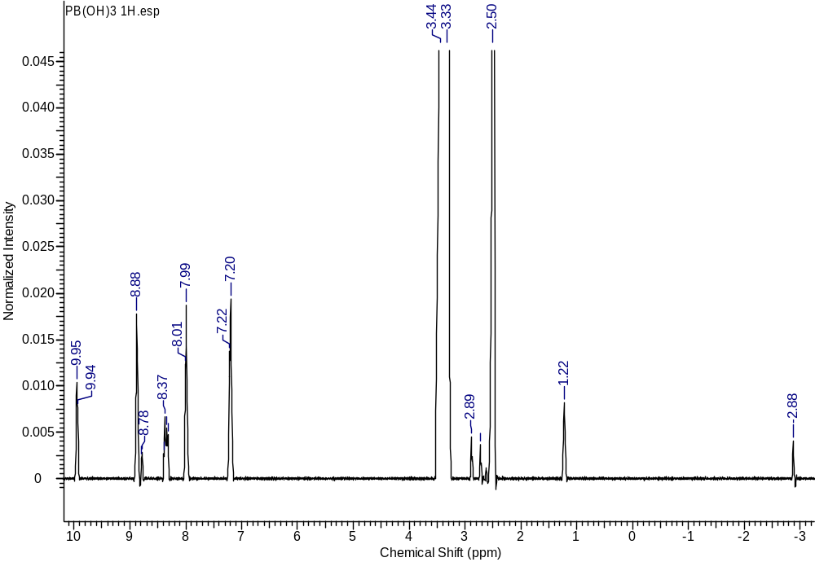
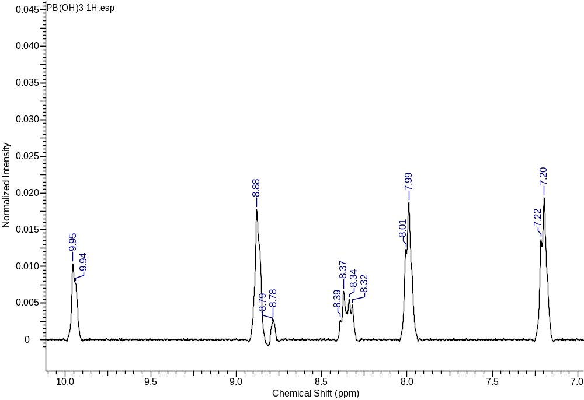
Figure S12: ¹H-NMR Spectra: 5-(4-carboxyphenyl)-10,15,20-tri-(4-hydroxyphenyl) porphyrin (PB(OH)₃)
2.2 Mass Spectra:
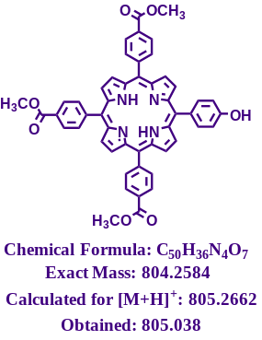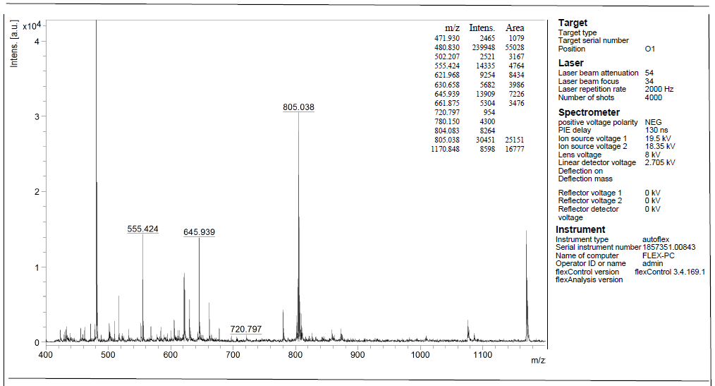
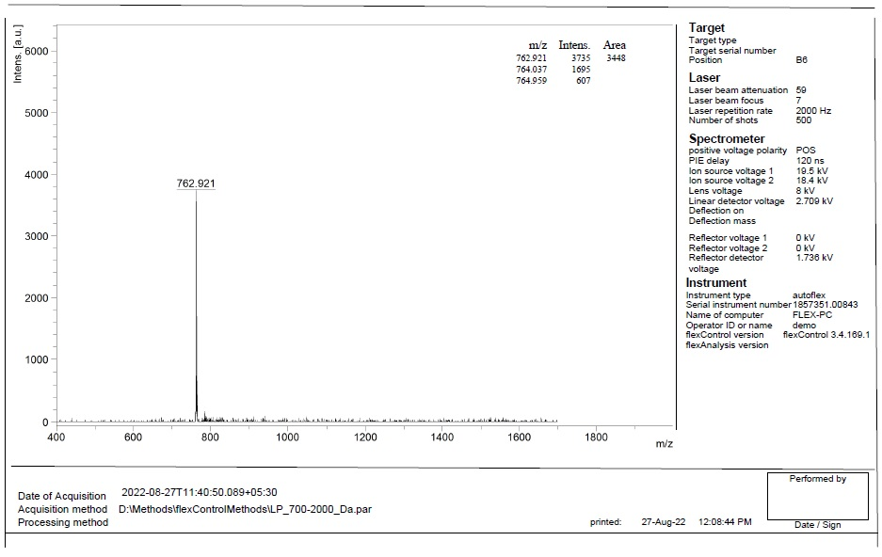
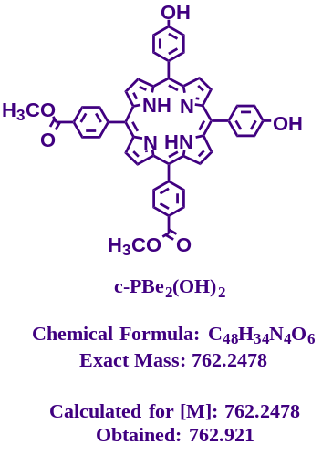Figure S13: MALDI-TOF Spectra: 5,10,15-tri-(4-methoxycarbonylphenyl)-20-(4-hydroxyphenyl) porphyrin (PBe₃OH)
Figure S14: MALDI-TOF Spectra: 5,10-di-(4-methoxycarbonylphenyl)-15,20-di-(4-hydroxyphenyl) porphyrin (c-PBe₂(OH)₂)
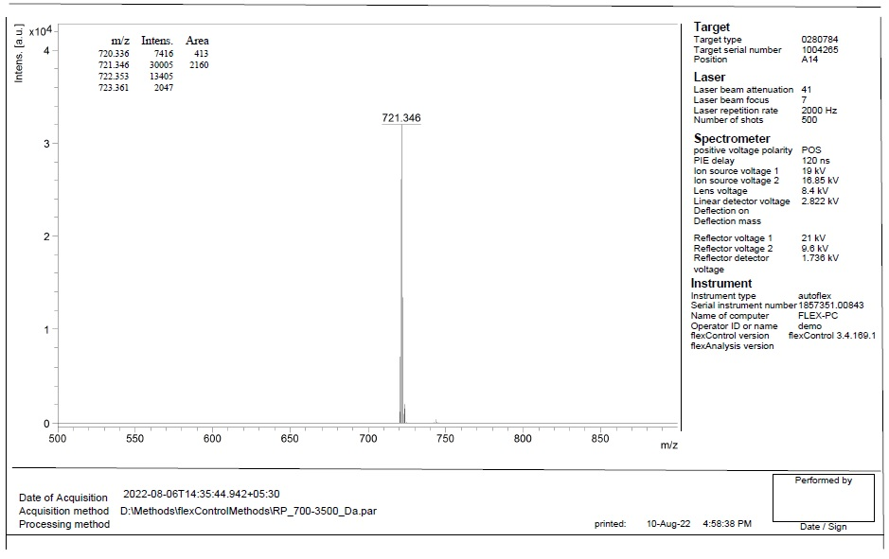
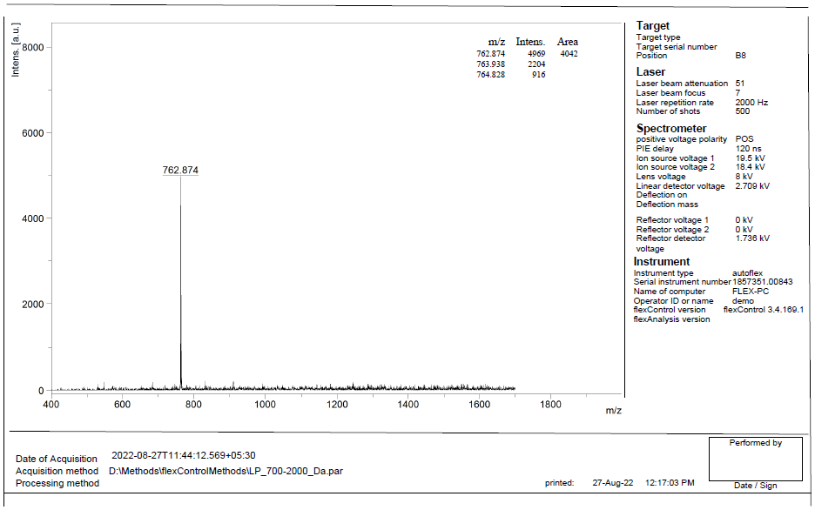
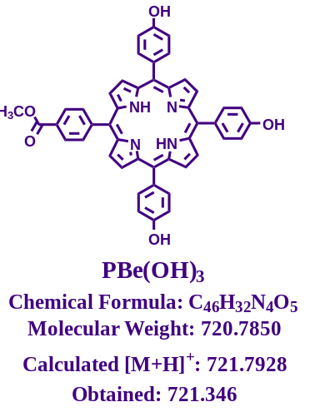Figure S15: MALDI-TOF Spectra: 5,15-di-(4-methoxycarbonylphenyl)-10,20-(4-hydroxyphenyl) porphyrin (t-PBe₂(OH)₂)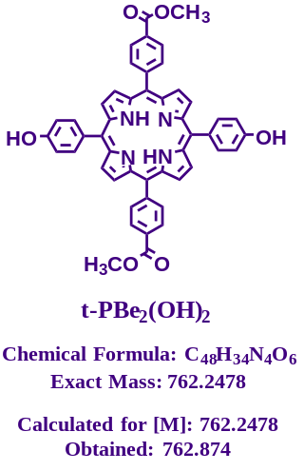
Figure S16: MALDI-TOF Spectra: 5-(4-methoxycarbonylphenyl)-10,15,20-tri-(4-hydroxyphenyl) porphyrin (PBe(OH)₃)
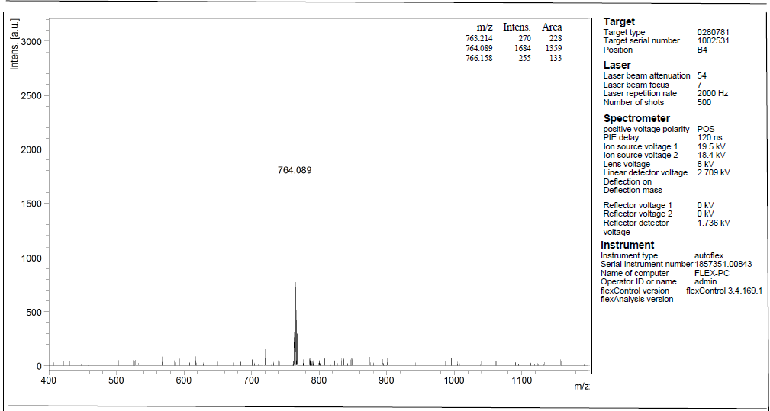
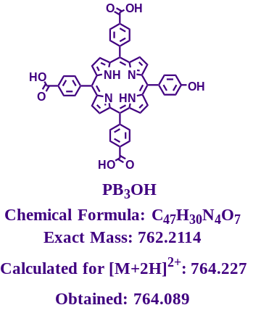Figure S17: MALDI-TOF Spectra: 5,10,5-tri-(4-carboxyphenyl)-20-(4-hydroxyphenyl) porphyrin (PB₃(OH))
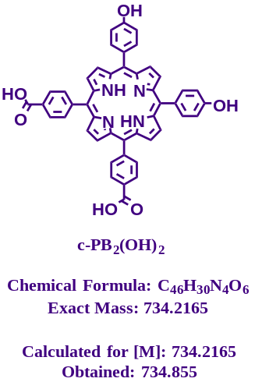
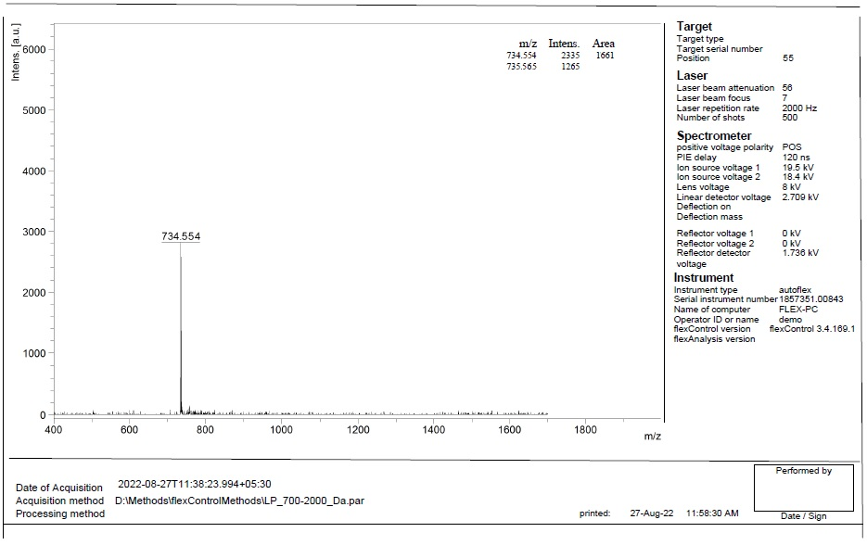
Figure S18: MALDI-TOF Spectra: 5,10-di-(4-carboxyphenyl)-15,20-di-(4-hydroxyphenyl) porphyrin (c-PB₂(OH)₂)
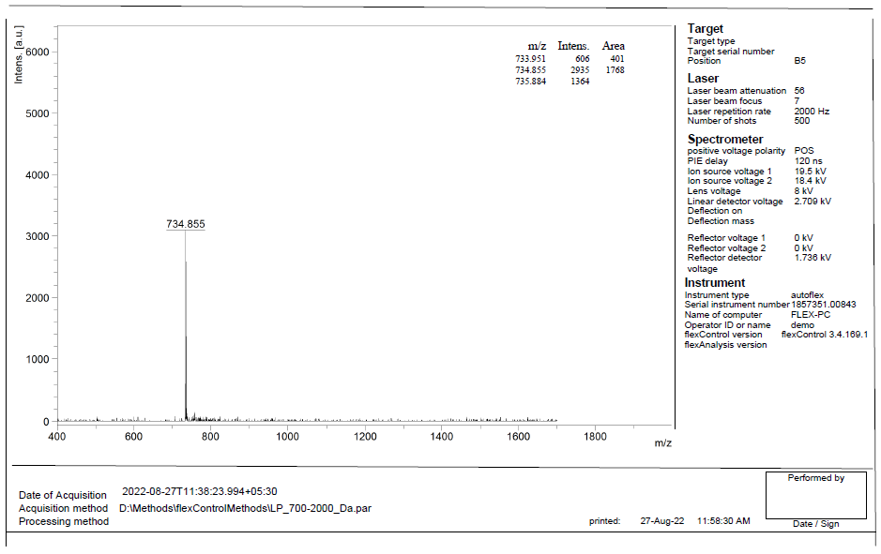
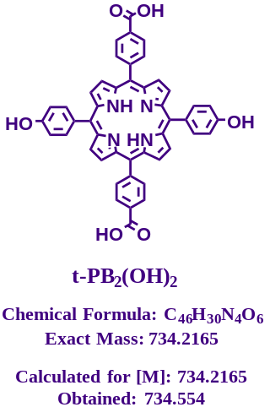Figure S19: MALDI-TOF Spectra: 5,15-di-(4-carboxyphenyl)-10,20-di-(4-hydroxyphenyl) porphyrin (t-PB₂(OH)₂)
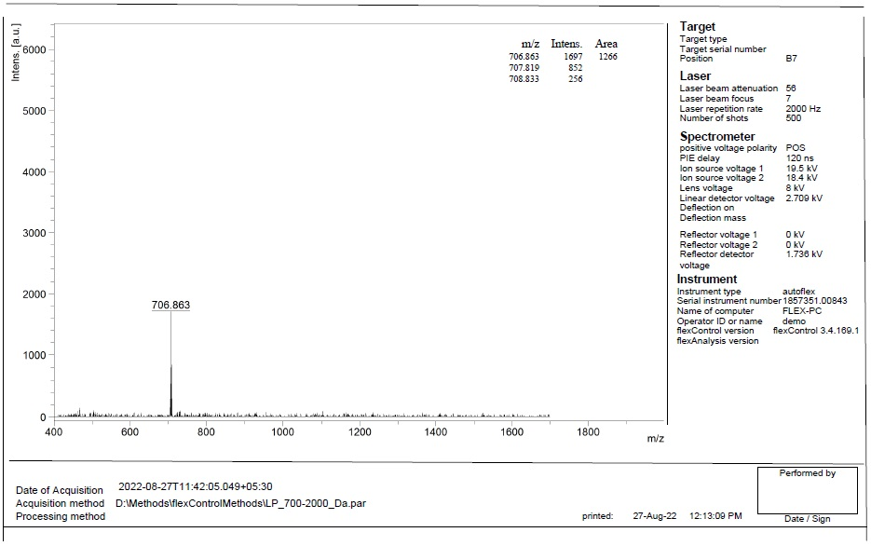
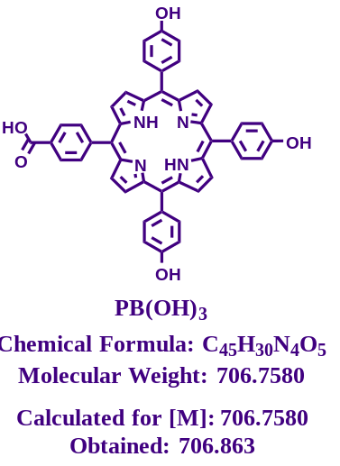
Figure S20: MALDI-TOF Spectra: 5-(4-carboxyphenyl)-10,15,20-tri-(4-hydroxyphenyl) porphyrin (PB(OH)₃)
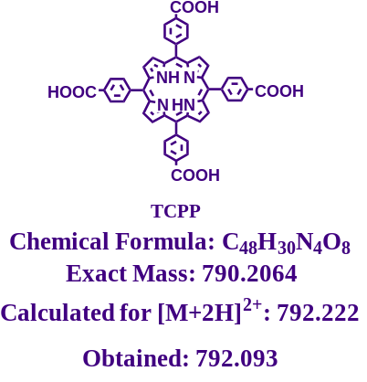
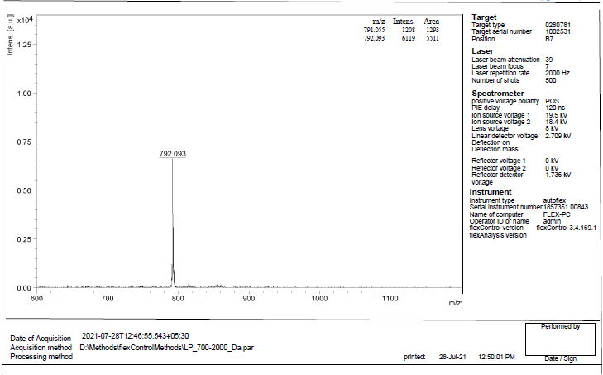
Figure S21: MALDI-TOF Spectra TCPP

Table S5. Cytotoxicity assay for selected cell lines in the presence of carboxyphenyl porphyrins under both non-PDT and PDT conditions. The CC₅₀ value represents the mean ± standard deviations from three independent experiments.
Sl No. | Compounds | CC₅₀ (under non-PDT conditions) |  | CC₅₀ (under PDT conditions)
Sl No. | Compounds | HEK293T cells (µM) | TZM-bl cells (µM) | TZM-bl cells (µM)
1. | TCPP | 52.152 | 50.867 | 2.712
2. | THPP | 50.534 | 54.915 | 3.139
3. | PB₃OH | 54.820 | 56.658 | 4.899
4. | c-PB₂(OH)₂ | 45.583 | 48.625 | 33.554
5. | t-PB₂(OH)₂ | 47.585 | 49.790 | 35.250
6. | PB(OH)₃ | 51.642 | 56.367 | 32.841

Figure S22: Carboxyphenyl porphyrins did not affect HIV-1 NL4-3 or K3016 virus gene expression or release under non-PDT conditions. Immunoblot analysis of virion and cell-associated (a). HIV-1 NL4-3 Gag and (b). HIV-1 K3016 Gag expression in the presence of carboxyphenyl porphyrins at 5 µM is shown. The position of HIV-1 p24, p41, and Pr55Gag is indicated (n=3). Percentage virus release efficiency (%VRE) of (c). NL4-3 virus and (d). K3016 virus released in the presence of the compound calculated as % of [virus-associated gag]/ [total (cell + virus-associated) Gag] relative to 5% DMSO in water (-) is shown(n=3).
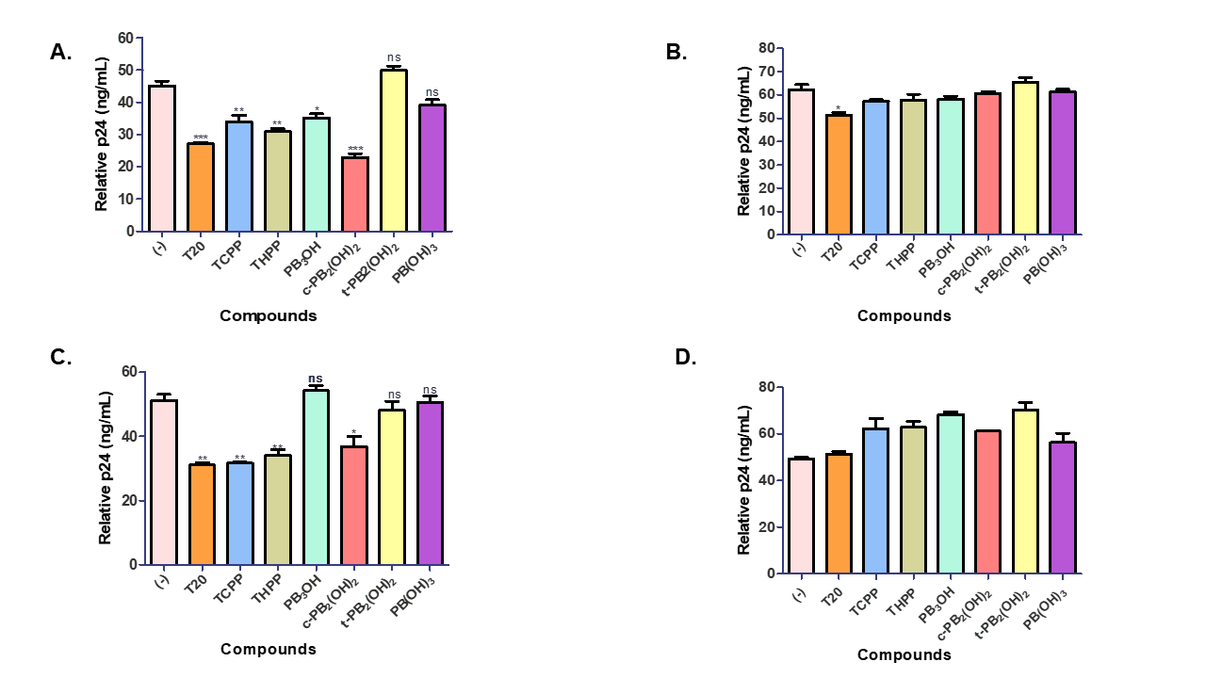
Figure S23: Carboxyphenyl porphyrins prevented HIV-1 NL4-3 or K3016 virus entry in T cells—5 µM concentration of (a). Compounds were added during virus infection of HuTR5 cells with NL4-3 virus (n=3). (b). Compounds were added post-infection with NL4-3 virus (n=3). (c). Compounds were added during virus infection of HuTR5 cells with the K3016 virus (n=3). (d). Compounds were added post-infection with the K3016 virus (n=3). Relative p24 levels were quantified by ELISA on day 4 for NL4-3 and day 7 for K3016 and compared to 5% DMSO in water (-) control sample as shown (n=3). Enfuvirtide (T20) is an FDA-approved HIV-1 fusion inhibitor. Error bars indicate standard deviations. *p-value < 0.05, **p-value < 0.01, ***p value < 0.001: student’s t-test.

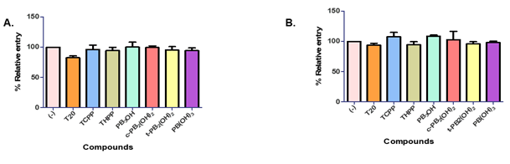
Figure S24: TZM-bl cells were pre-treated with 5 µM of carboxyphenyl porphyrins, 0.5µM T20, or 5% DMSO in water (-) for 2 h at 37 °C. Then, cells were washed and infected with 10 ng of HIV-1 p24 normalized. (a). NL4-3 virus or (b). K3016 virus for 2 h at 37 °C in the presence or absence of compounds. The effect of compounds on virus entry was estimated by measuring luciferase activity after 48h. Error bars indicate standard deviations from three independent experiments. *p-value <0.05**p-value <0.01***p value <0.001: student’s t-test.
References:
1 Platt, E. J., Wehrly, K., Kuhmann, S. E., Chesebro, B. & Kabat, D. Effects of CCR5 and CD4 cell surface concentrations on infections by macrophagetropic isolates of human immunodeficiency virus type 1. J. Virol. 72, 2855-2864 (1998).
2 Checkley, M. A. et al. Reevaluation of the requirement for TIP47 in human immunodeficiency virus type 1 envelope glycoprotein incorporation. J. Virol. 87, 3561-3570 (2013).
3 Myśliwa-Kurdziel, B., Solymosi, K., Kruk, J., Böddi, B. & Strzałka, K. Solvent effects on fluorescence properties of protochlorophyll and its derivatives with various porphyrin side chains. Eur. Biophys. J. 37, 1185-1193 (2008).
4 de Jong, M., Seijo, L., Meijerink, A. & Rabouw, F. T. Resolving the ambiguity in the relation between Stokes shift and Huang-Rhys parameter. Phys. Chem. Chem. Phys. 17, 16959-16969 (2015).

