SUPPLEMENTARY DATA 1: Study design, inclusion and exclusion criteria.

AvonCAP study criteria for final clinical diagnosis of LRTI | - Clinical records contain a diagnosis or treatment consistent with LRTI, OR  - Positive laboratory test for pneumococcus, RSV, SARS-CoV-2, or any other infectious respiratory pathogen, OR  - Evidence of both:  - Active infection, i.e. at least 1 of the following conditions: reported fever, reported chills, measured temperature of >38.0°C or <35°C, or an abnormal white blood cell count or differential) AND  - Lower respiratory tract disease (at least 1 of the following conditions: abnormal breath sounds, documented tachypnea, cough, sputum production, or dyspnoea).
AvonCAP study exclusion criteria | - Age <18 years  - Signs and symptoms of LRTD manifest after being hospitalized for ≥48 hours (either at current hospital, another transferring hospital, or a combination of these), unless admitted with current, previously proven, or suspected COVID-19 infection.  - Previous enrolment in the study and within 7 days of discharge, unless admitted with current, previously proven, or suspected COVID-19 infection.  - LRTD-related diagnosis excluded at the time of enrolment, or alternative diagnosis confirmed.

SUPPLEMENTARY DATA 2: Diagnostic symptoms for Lower Respiratory Tract Infection.

 | NHS public site | BMJ Best Practice ,
Fever
Cough
Breathlessness
Wheeze
Pleuritic chest pain
Abnormal sputum
Myalgia
Headache
Tiredness/ fatigue
Malaise
Altered sense of taste/ smell
NHS = UK National Health Service; BMJ = British Medical Journal.
Black dots indicate general features of LRTI. Grey dots indicate common features of SARS-CoV-2 infection.

SUPPLEMENTARY DATA 3: Study flow diagram.

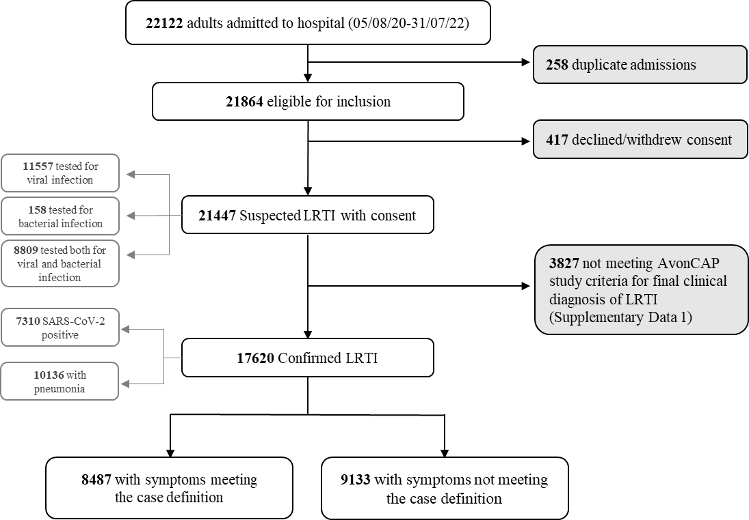

SUPPLEMENTARY DATA 4: Directed Acyclic Graph (DAG).
This DAG illustrates pathways between the exposure of interest (EOI: age ≥65y), outcome (symptoms meeting case definition) and associated factors. Patient sex and presence of comorbidities and dementia were included as covariates in the logistic regression model (indicated with boxes).
For the SARS-CoV-2 subgroup analysis vaccination status was included in the regression model to control for collider bias, since by conditioning on SARS-CoV-2 positivity we induce a causal relationship between vaccination status and age ≥65y.

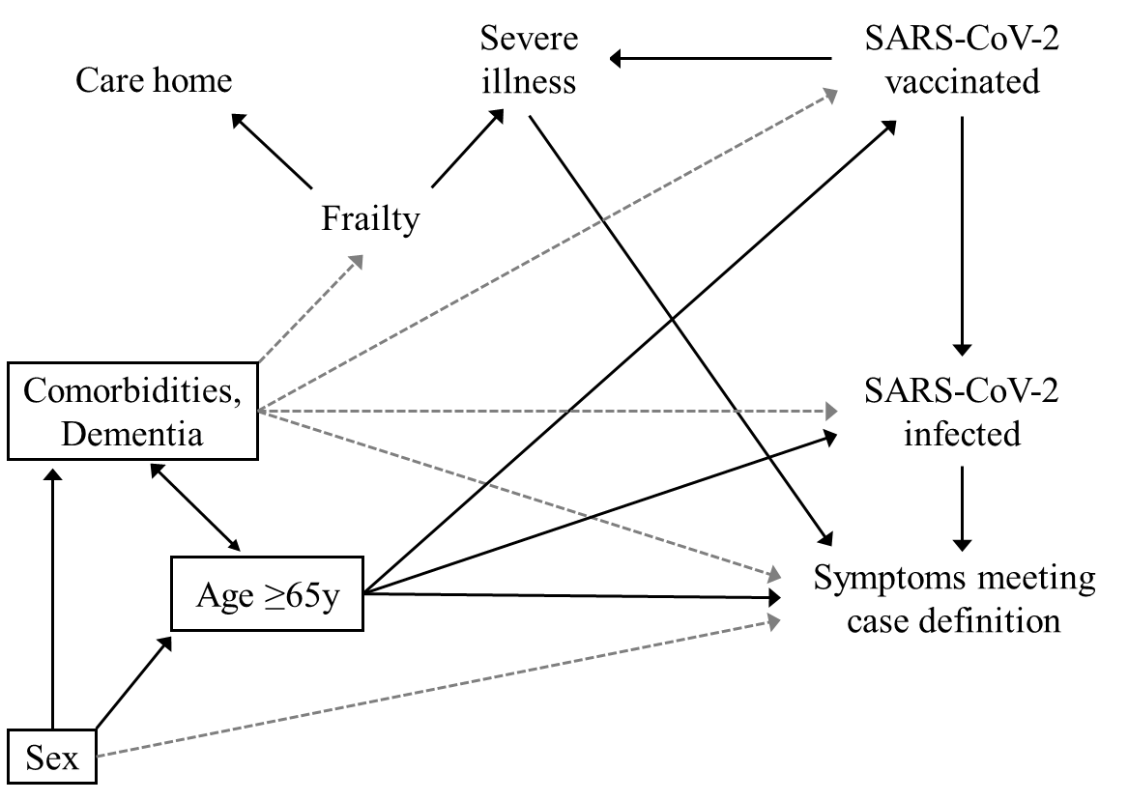

SUPPLEMENTARY DATA 5: Correlation matrix.
Pairwise correlations between factors that might affect the outcome (symptoms meeting case definition).

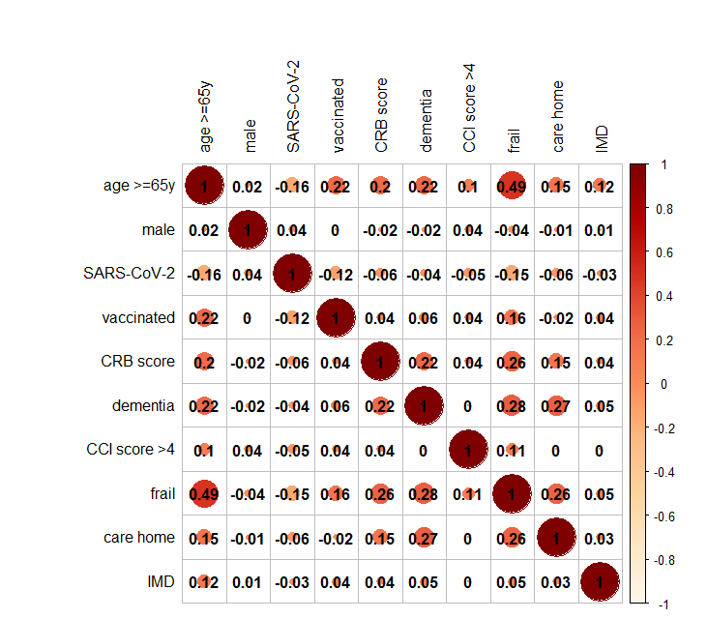

SUPPLEMENTARY DATA 6: Characteristics of LRTI cases by age category.
Characteristic | Aged <65 years*  N = 6,698 | Aged >=65 years*  N = 10,922 | p-value**
Symptoms meeting case definition | 3,722 (56%) | 4,765 (44%) | <0.001
Age group |  |  | <0.001
18-24 | 443 (6.6%) | 0 (0%)
25-34 | 998 (15%) | 0 (0%)
35-44 | 1,240 (19%) | 0 (0%)
45-54 | 1,639 (24%) | 0 (0%)
55-64 | 2,378 (36%) | 0 (0%)
65-74 | 0 (0%) | 3,127 (29%)
75-84 | 0 (0%) | 4,152 (38%)
>84 | 0 (0%) | 3,643 (33%)
SARS-CoV-2 test positive | 3,519 (53%) | 3,791 (35%) | <0.001
Vaccinated against SARS-CoV-2 | 3,157 (52%) | 7,232 (70%) | <0.001
Unknown | 571 | 620
CRB scoreª |  |  | <0.001
0 | 5,268 (79%) | 6,442 (59%)
1 | 1,307 (20%) | 3,693 (34%)
2 | 114 (1.7%) | 719 (6.6%)
3 | 7 (0.1%) | 59 (0.5%)
Unknown | 2 | 9
Male sex | 3,239 (48%) | 5,715 (52%) | <0.001
Care home resident | 177 (2.6%) | 1,215 (11%) | <0.001
Dementia/ cognitive impairment | 136 (2.0%) | 1,817 (17%) | <0.001
Clinically frail^{b} | 700 (14%) | 5,945 (65%) | <0.001
Unknown | 1,698 | 1,776
Comorbidity level^{c} |  |  | <0.001
None | 4,224 (63%) | 2,865 (26%)
Mild | 1,927 (29%) | 5,283 (48%)
Moderate | 392 (5.9%) | 1,990 (18%)
Severe | 153 (2.3%) | 775 (7.1%)
Unknown | 2 | 9
*n (%)
**Fisher's Exact Test for Count Data; Pearson's Chi-squared test; Wilcoxon rank sum test
ª Pneumonia severity score, 1 point assigned for each of:
acute confusion, raised respiratory rate, low blood pressure.
^{b} Rockwood frailty score >4
^{c} Charlson Comorbidity Index minus age and dementia scores.
mild: 1-2, moderate: 3-4, severe: >4

SUPPLEMENTARY DATA 7: Regression stratified by levels of comorbidity.

CCI score ≤4: Odds of symptoms meeting LRTI case definition
 | Unadjusted odds |  |  |  | Adjusted odds
Characteristic | N | OR* | 95% CI* | p-value | OR* | 95% CI* | p-value
Aged >=65y | 16,681 | 0.61 | 0.57, 0.65 | <0.001 | 0.66 | 0.62, 0.70 | <0.001
Male sex | 16,681 | 1.04 | 0.98, 1.10 | 0.20 | 1.05 | 0.99, 1.12 | 0.10
Dementia/ cognitive impairment | 16,681 | 0.51 | 0.46, 0.57 | <0.001 | 0.59 | 0.54, 0.66 | <0.001
* OR = Odds Ratio, CI = Confidence Interval
CCI score >4: Odds of symptoms meeting LRTI case definition
 | Unadjusted odds |  |  |  | Adjusted odds
Characteristic | N | OR* | 95% CI* | p-value | OR* | 95% CI* | p-value
Aged >=65y | 928 | 1.06 | 0.75, 1.52 | 0.70 | 1.09 | 0.77, 1.56 | 0.60
Male sex | 928 | 1.09 | 0.84, 1.43 | 0.50 | 1.08 | 0.83, 1.42 | 0.60
Dementia/ cognitive impairment | 928 | 0.75 | 0.49, 1.13 | 0.20 | 0.74 | 0.49, 1.12 | 0.20
* OR = Odds Ratio, CI = Confidence Interval

SUPPLEMENTARY DATA 8: Regression stratified by SARS-CoV-2 positivity.
SARS-CoV-2 negative LRTI: Odds of symptoms meeting LRTI case definition
 | Unadjusted odds |  |  |  | Adjusted odds
Characteristic | N | OR* | 95% CI* | p-value | OR* | 95% CI* | p-value
Aged >=65y | 10,310 | 0.55 | 0.50, 0.60 | <0.001 | 0.57 | 0.52, 0.62 | <0.001
Male sex | 10,310 | 0.95 | 0.88, 1.02 | 0.20 | 0.99 | 0.91, 1.07 | 0.80
Dementia/ cognitive impairment | 10,310 | 0.51 | 0.45, 0.57 | <0.001 | 0.59 | 0.52, 0.66 | <0.001
CCI score >4 (severe)ª | 10,306 | 0.74 | 0.63, 0.86 | <0.001 | 0.82 | 0.70, 0.97 | 0.022
Vaccinated against SARS-CoV-2 | 9,787 | 1.29 | 1.19, 1.41 | <0.001 | 1.41 | 1.29, 1.53 | <0.001
* OR = Odds Ratio, CI = Confidence Interval.
ª Charlson Comorbidity Index minus age and dementia scores.
SARS-CoV-2 positive LRTI: Odds of symptoms meeting LRTI case definition
 | Unadjusted odds |  |  |  | Adjusted odds
Characteristic | N | OR* | 95% CI* | p-value | OR* | 95% CI* | p-value
Aged >=65y | 7,310 | 0.56 | 0.51, 0.62 | <0.001 | 0.68 | 0.61, 0.75 | <0.001
Male sex | 7,310 | 1.22 | 1.11, 1.34 | <0.001 | 1.29 | 1.17, 1.43 | <0.001
Dementia/ cognitive impairment | 7,310 | 0.49 | 0.41, 0.58 | <0.001 | 0.58 | 0.48, 0.71 | <0.001
CCI score >4 (severe)ª | 7,303 | 0.74 | 0.57, 0.95 | 0.019 | 0.90 | 0.68, 1.17 | 0.40
Vaccinated against SARS-CoV-2 | 6,642 | 0.41 | 0.37, 0.45 | <0.001 | 0.45 | 0.41, 0.50 | <0.001
* OR = Odds Ratio, CI = Confidence Interval
ª Charlson Comorbidity Index minus age and dementia scores.

SUPPLEMENTARY DATA 9: Sensitivity analysis – alternative case definition.

Probability of cases reporting any one of the symptoms in the syndromic case definition (cough, fever, breathlessness, wheeze, pleurisy (chest pain on breathing), abnormal sputum production, myalgia, headache, or general deterioration (weakness/fatigue/anorexia).
 | Unadjusted odds |  |  |  | Adjusted odds
Characteristic | N | OR* | 95% CI* | p-value | OR* | 95% CI* | p-value
Aged >=65y | 17,620 | 0.86 | 0.78, 0.95 | 0.002 | 0.94 | 0.85, 1.04 | 0.20
Male sex | 17,620 | 1.08 | 0.98, 1.18 | 0.12 | 1.07 | 0.98, 1.17 | 0.14
Dementia/ cognitive impairment | 17,620 | 0.57 | 0.50, 0.65 | <0.001 | 0.58 | 0.51, 0.67 | <0.001
CCI score >4 (severe)ª | 17,609 | 1.10 | 0.90, 1.37 | 0.40 | 1.12 | 0.91, 1.39 | 0.30
*OR = Odds Ratio, CI = Confidence Interval
ª Charlson Comorbidity Index minus age and dementia scores.

SUPPLEMENTARY DATA 10: Relative proportions of male and female cases by age at admission.
For SARS-CoV-2 positive LRTI (bottom panel) there is a peak among young females, possibly representing pregnant women who may have had a lower threshold for admission (i.e milder cases). This may have attenuated the effect of age on meeting the LRTI case definition.

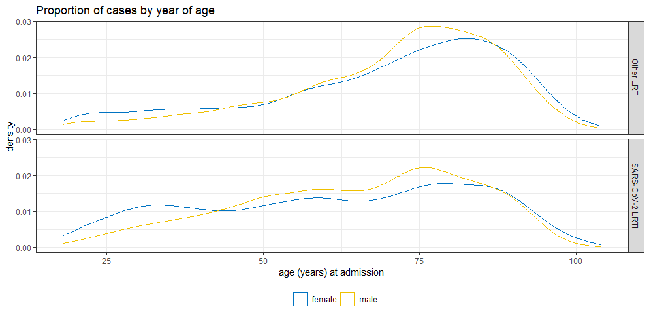

SUPPLEMENTARY DATA 11: Log odds ratios of symptom expression comparing older with younger adults, by SARS-CoV-2 infection status.
Comparison of LRTI symptom expression in older (≥65y) vs younger (<65y) adults is shown as a probability of each symptom occurring, with weighted log-odds ratios (empirical Bayes) expressed as z-scores.

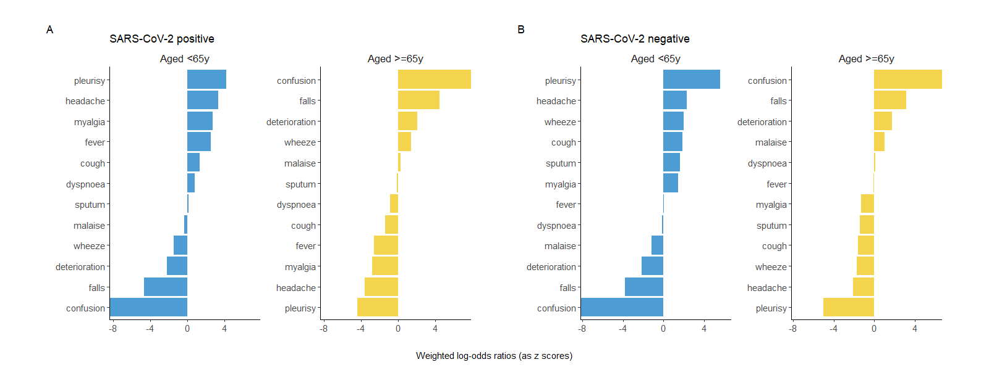

National Health Service. Chest infection - NHS. https://www.nhs.uk/conditions/chest-infection/ (2020).
British Medical Journal. Community-acquired pneumonia (non COVID-19) - Symptoms, diagnosis and treatment - Summary | BMJ Best Practice. https://bestpractice.bmj.com/topics/en-gb/3000108 (2023)
Coronavirus disease 2019 (COVID-19) - History and exam | BMJ Best Practice (2023). Available at: https://bestpractice.bmj.com/topics/en-gb/3000201/history-exam#keyFactors (Accessed: 13 June 2023).

