Annexes:

Supplemental figure 1. CAPE-V scale. It is composed by three distinct phonatory tasks: sustainable vowels, reading of sentences, and one spontaneous speech.

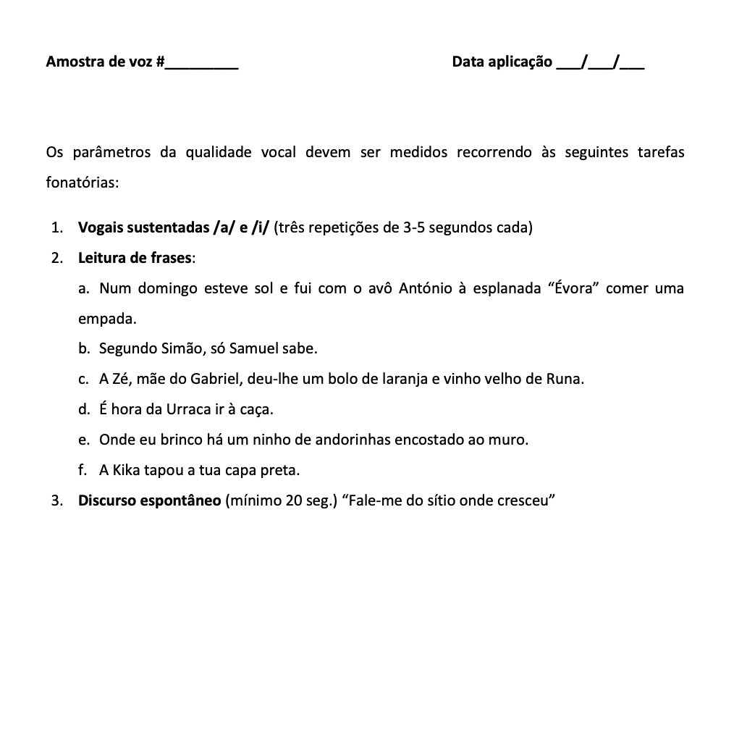

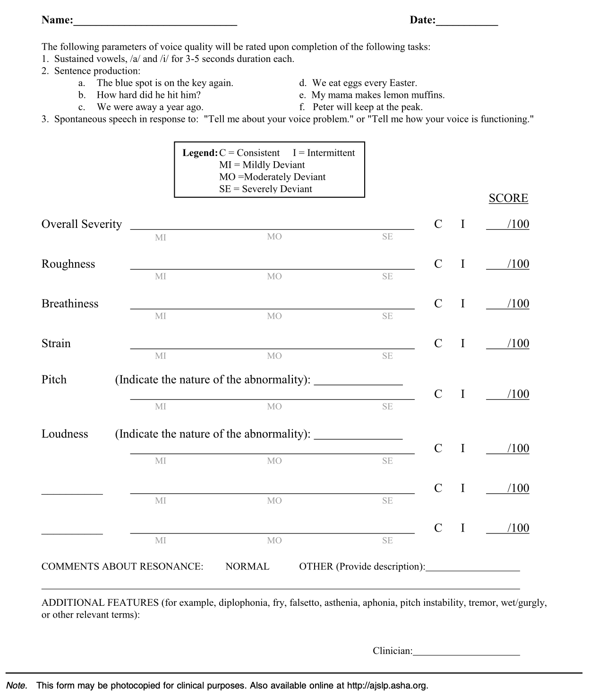
Supplemental figure 2. Evaluation protocol of CAPE-V.

