Supplementary figures:
Figure1: FAK and STAT3 have a positive correlation in breast cancer and may promote NNMT transcription. A: According to the BioGRID 4.4 database analysis, STAT3 is one of the proteins which may have interaction with FAK. B-C: According to the GEPIA 2 database analysis, FAK and STAT3 have a positive correlation between breast cancer and pan-cancer. D: According to the JASPAR database analysis, the promoters of the NNMT gene can comprise three P-STAT3 binding sites (P1, P2, P3)

Figure2: The presentative results of NNMT protein levels by WB (A) and QPCR (B) in four cell models used in anoikis assay.
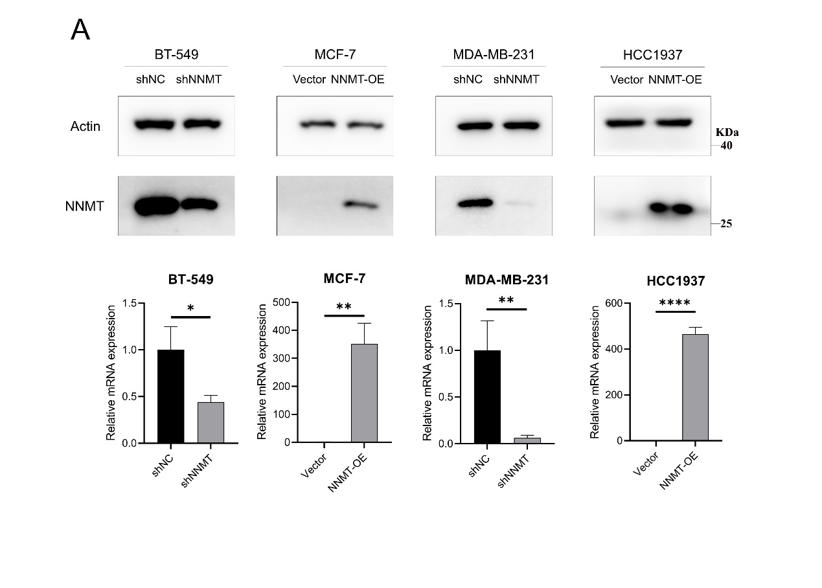

Figure3: The presentative results of NNMT protein levels by Western blotting in four breast cancer cell lines used in anoikis assay.

Figure4: Relationship between the mRNA expression of FAO pathway and NNMT in breast cancer patients from combined cohorts. (GSE4922,GSE24450)

Figure5: NNMT promote MDA-MB-231 cells FAO both under attachment and detachment. A: WB analysis showed CPT1A was downregulated in NNMT knock-down MDA-MB-231 cells compared to control. B: Measurements of FAO rate in attached and detached MDA-MB-231 cells using the seahorse XF96e extracellular flux analyzer.

Figure6: Representative results of membrane CD36 expression of BT-549 and MCF-7 cell lines by Annexin V/7-AAD staining after cultured on 1% agar plates for 48h
Figure 7: A: The weight growth curve of mice model with etomoxir treatment compared to control. B: Representative result of staining NNMT in normal breast tissue (negative control) and liver tissue (positive control) by IHC. And the representative result of replacing NNMT antibody by PBS to stain the same section. Scale bar, 200μm. C: Representative result of staining NNMT in MDA-MB-231 shNC and shNNMT primary tumor tissue from CTCs model. Scale bar, 200μm.
Figure 8: Representative images of HE staining showed that NNMT inhibitor, JBNSF000088, Vanillin, and Curcumin-treated SCID mice. Scale bar (20×), 1250μm. Scale bar (200×), 100μm.
Figure 9: 1-MNA didn’t affect the CPT1A and CD36 expression in BT-549 and MCF-7 cells.

