Supplementary Figures
Supplementary Figure S1. Knockdown of circXPO6 has no effect on XPO6 mRNA level
b
a
b
a
Supplementary Figure S2. The knockdown efficiency of c-Myc.
a. Effect of si-1 and si-2 on mRNA levels of c-Myc
b. Effect of si-1 and si-2 on protein expression of c-Myc
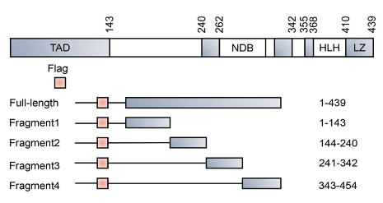
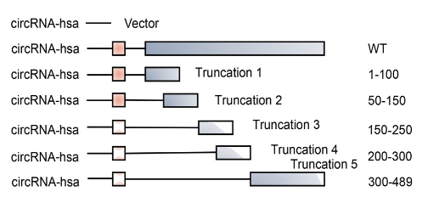
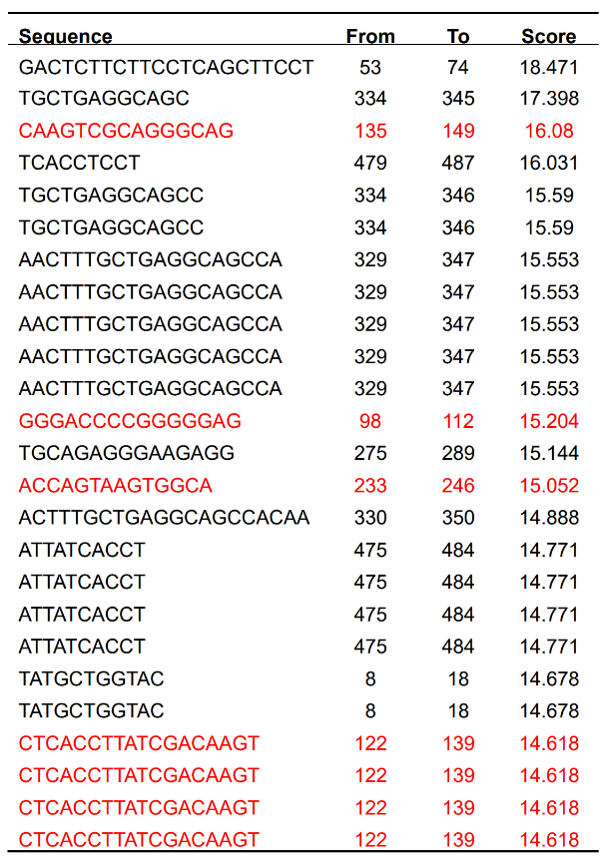
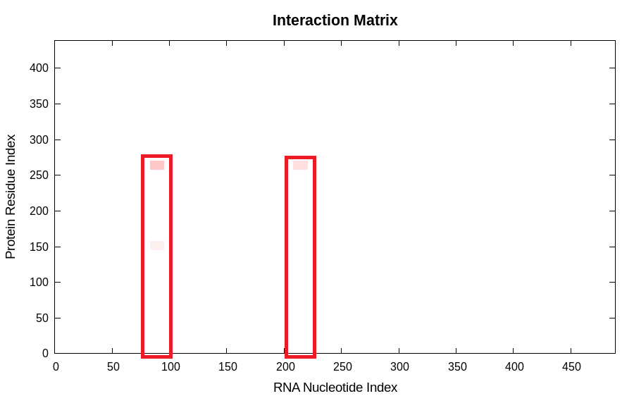
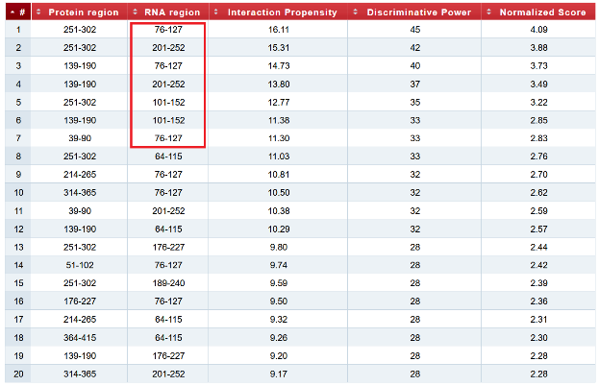
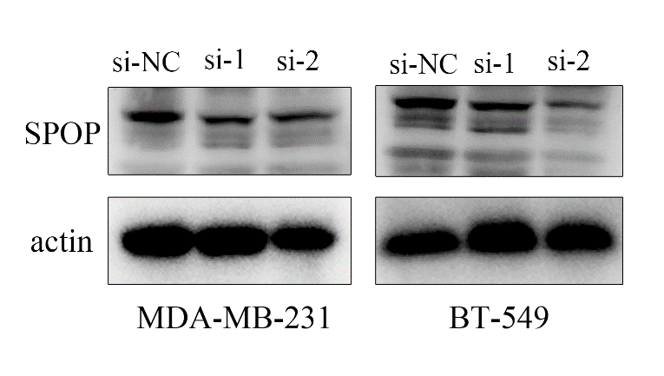
Supplementary Figure S3. The combination of CircXPO6 and c-Myc.
a. Prediction of the binding position of CircXPO6 to the c-Myc protein (catRAPID).
b. Prediction of the binding sequence of CircXPO6 to the c-Myc protein (CISBP-RNA).
c-d. Schematic diagram of c-Myc full-length and fragment(c); CircXPO6 full-length and truncated fragments(d).
d
c
b
a
Supplementary Figure S4. The knockdown efficiency of SPOP.
a. Effect of si-1 and si-2 on mRNA levels of SPOP
b. Effect of si-1 and si-2 on protein expression of SPOP
b
a

