Supplementary material
Investigation of cholinesterase and α-glucosidase enzyme activities, and molecular docking and dft studies for 1,2-disubstituted cyclopentane derivatives with phenyl and benzyl units
Tekin Artunçª, Yasin Çetinkaya^{a,*}, Parham Taslimi^{b,*}, Abdullah Menzek^{a,c,*}
ªDepartment of Chemistry, Faculty of Science, Atatürk University, 25240 Erzurum, Türkiye
^{b}Department of Biotechnology, Faculty of Science, Bartin University, 74100 Bartin, Türkiye
^{c}Department of Emergency Aid and Disaster Management, Faculty of Health Sciences,
Ardahan University, 75002 Ardahan, Türkiye

Contents Page
Table S1 Selected structural parameters of 10-13 S2
Table S2 Natural and Mulliken charges on the atoms for 10 and 11 S2
Table S3 Natural and Mulliken charges on the atoms for 12 and 13 S3
Table S4. Cartesian coordinates for the optimized structures of 10-13 S4-S9
¹H and ¹³C NMR spectra of 10 S10
¹H and ¹³C NMR spectra of 11 S11
¹H and ¹³C NMR spectra of 12 S12
HMQC spectrum of 12 S13
¹H and ¹³C NMR spectra of 13 S14
HRMS spectra of 10-13 S15

Table S1. Selected structural parameters of 10-13 using the B3LYP/6-31+G(d,p) basis set.
 | 10 | 11 |  | 12 | 13
Bond lengths (Å)
C3-C9 | 1.494 | 1.514 | C3-C7 | 1.513 | 1.514
C9-C10 | 1.485 | 1.540 | C7-C8 | 1.543 | 1.541
C10-C12 | 1.355 | 1.551 | C8-C10 | 1.556 | 1.550
C12-C18 | 1.481 | 1.516 | C10-C16 | 1.520 | 1.514
Bond angles (º)
C3-C9-C10 | 120.1 | 114.7 | C3-C7-C8 | 113.0 | 114.0
C9-C10-C12 | 128.4 | 113.7 | C7-C8-C10 | 112.7 | 113.1
C10-C12-C18 | 126.6 | 116.1 | C8-C10-C16 | 114.8 | 115.1
C12-C18-C20 | 121.2 | 121.3 | C10-C16-C18 | 118.1 | 121.3
Dihedral angles (º)
C4-C3-C9-O10 | -41.6 | -76.0 | C4-C3-C7-C8 | -173.5 | -76.9
C3-C9-C10-C12 | 135.6 | -179.6 | C3-C7-C8-C10 | 163.6 | 174.0
C9-C10-C12-C18 | -7.3 | -66.9 | C7-C8-C10-C16 | -68.1 | -64.8
C10-C12-C18-C20 | 126.9 | 124.7 | C8-C10-C16-C18 | 115.2 | 125.0
C4-C3-C9-C10 | -41.6 | -76.0
C19-C18-C12-C10 | -52.2 | -55.5

Table S2. Natural and Mulliken charges on the atoms for compounds 10 and 11.
Atoms | 10 |  | 11
Atoms | Natural charges | Mulliken  charges | Natural charges | Mulliken  charges
C1 | -0.33368 | 0.052041 | -0.33085 | 0.127033
C2 | -0.18836 | -0.430534 | -0.22173 | -0.326295
C3 | -0.13142 | 0.605670 | -0.08105 | 0.769081
C4 | 0.31276 | -0.303549 | 0.29705 | -0.564757
C5 | 0.20966 | -0.557262 | 0.21736 | -0.494808
C6 | 0.29515 | 0.230106 | 0.27927 | 0.263333
C9 | 0.21554 | -0.171475 | -0.46681 | -0.036436
C10 | -0.06715 | 0.620369 | -0.25612 | -0.141436
C11 | -0.47479 | -0.659298 | -0.46747 | -0.264840
C12 | -0.00085 | -0.235293 | -0.28308 | 0.012034
C13 | -0.46890 | -0.634620 | -0.48081 | -0.501799
C16 | -0.47822 | 0.247367 | -0.45544 | -0.331789
C18 | -0.12713 | 0.693696 | -0.07663 | 0.107743
C19 | -0.19519 | -1.038177 | -0.21712 | -0.211300
C20 | 0.29934 | 0.070550 | 0.29011 | -0.052992
C21 | -0.32953 | -0.276808 | -0.32495 | 0.152558
C23 | 0.23148 | -0.312841 | 0.22913 | -0.401805
C24 | 0.29557 | 0.405090 | 0.28159 | 0.348224
O26 | -0.55843 | -0.228935 | -0.56109 | -0.296764
O27 | -0.56617 | -0.404694 | -0.56631 | -0.403235
O28 | -0.54225 | -0.384840 | -0.54691 | -0.389452
O29 | -0.57107 | -0.281012 | -0.57325 | -0.284388
O30 | -0.57408 | -0.339239 | -0.57180 | -0.341660
O31 | -0.53293 | -0.354730 | -0.53961 | -0.378913
C32 | -0.32190 | -0.090254 | -0.32204 | -0.141963
C36 | -0.32598 | -0.162743 | -0.32636 | -0.165237
C40 | -0.33251 | -0.123358 | -0.33106 | -0.129417
C44 | -0.32683 | -0.096257 | -0.32526 | -0.087825
C48 | -0.33215 | -0.172219 | -0.32236 | -0.134984
C52 | -0.33294 | -0.144774 | -0.33167 | -0.140011
N59 | -0.25729 | 0.152556
N60 | -0.46622 | -0.093110
C62 | 0.51095 | 0.350646
O63 | -0.62177 | -0.424395

Table S3. Natural and Mulliken charges on the atoms for compounds 12 and 13.
Atoms | 12 |  | 13
Atoms | Natural charges | Mulliken  charges | Natural charges | Mulliken  charges
C1 | -0.19510 | -0.084063 | -0.18604 | -0.096752
C2 | -0.11735 | -0.065559 | -0.13030 | -0.269237
C3 | -0.07798 | 0.332913 | -0.06829 | 0.431620
C4 | 0.30962 | 0.127604 | 0.29867 | 0.045050
C5 | 0.22644 | 0.187761 | 0.24963 | -0.014447
C6 | 0.26447 | -0.423464 | 0.25638 | -0.341252
C7 | -0.47621 | -0.443676 | -0.47808 | -0.141985
C8 | -0.25555 | -0.165950 | -0.24667 | -0.320923
C9 | -0.46727 | -0.107837 | -0.47202 | -0.181031
C10 | -0.28080 | -0.532427 | -0.27826 | 0.079551
C11 | -0.47809 | -0.595497 | -0.48077 | -0.522540
C14 | -0.46464 | -0.311939 | -0.46013 | -0.344127
C16 | -0.04973 | 0.745431 | -0.03736 | -0.022663
C17 | -0.12684 | -0.393000 | -0.24269 | 0.392952
C18 | 0.28666 | -0.075047 | 0.27705 | -0.111424
C19 | -0.18396 | 0.120182 | -0.15572 | 0.162884
C20 | 0.24655 | 0.301329 | 0.24679 | 0.021354
C21 | 0.26696 | -0.723617 | 0.25170 | -0.741383
O22 | 0.55014 | -0.266350 | -0.55932 | -0.288013
O23 | -0.57143 | -0.418008 | -0.56943 | -0.402623
O24 | -0.57139 | -0.325764 | -0.57147 | -0.333066
O25 | -0.57390 | -0.255276 | -0.57248 | -0.296990
O26 | -0.57744 | -0.368832 | -0.57900 | -0.359274
O27 | -0.56302 | -0.266382 | -0.56734 | -0.299425
C28 | -0.32089 | -0.097386 | -0.32524 | -0.138871
C32 | -0.32851 | -0.119557 | -0.33041 | -0.124158
C36 | -0.32884 | -0.143962 | -0.32874 | -0.145225
C40 | -0.32649 | -0.082134 | -0.32595 | -0.091076
C44 | -0.32606 | -0.115020 | -0.32592 | -0.100285
C48 | -0.32741 | -0.126353 | -0.32633 | -0.119320
Br59 | 0.09464 | 0.134699 | 0.09364 | 0.133642
Br60 | 0.10556 | 0.120719 | 0.10790 | 0.127908
Br61 | 0.10653 | 0.104228 | 0.06750 | 0.120949
Br62 | 0.10714 | 0.174129

Table S4. Cartesian coordinates for the optimized structures of 10-13

Compound 10

----------------------------------------------------
Center Coordinates (Angstroms)
Number X Y Z
----------------------------------------------------
1 -4.361625 0.328270 -1.941393
2 -3.013845 0.669998 -1.855105
3 -2.266484 0.472710 -0.688835
4 -2.919241 -0.107476 0.427704
5 -4.284898 -0.443898 0.363979
6 -5.008469 -0.212345 -0.827530
7 -4.900830 0.514816 -2.861615
8 -2.516234 1.105085 -2.714045
9 -0.824954 0.866500 -0.675218
10 -0.246610 1.535615 0.518150
11 -0.970575 2.709164 1.163789
12 0.934220 1.285776 1.133233
13 -0.213318 2.910925 2.495082
14 -2.036911 2.512294 1.311062
15 -0.900531 3.594576 0.513877
16 1.178305 2.281897 2.259119
17 -0.732988 2.363876 3.289314
18 1.865044 0.171873 0.839211
19 1.414890 -1.153197 0.810069
20 3.229734 0.412333 0.561494
21 2.273724 -2.218278 0.532485
22 0.369593 -1.351375 1.019606
23 4.096191 -0.639273 0.230235
24 3.619341 -1.968074 0.242690
25 1.886567 -3.229867 0.538379
26 -2.174622 -0.260046 1.564368
27 -4.917015 -0.878003 1.506079
28 -6.340342 -0.514392 -0.782704
29 3.639820 1.721794 0.483951
30 5.403132 -0.370657 -0.091708
31 4.540142 -2.926701 -0.065536
32 -2.309635 -1.425547 2.384505
33 -3.148282 -1.332345 3.076212
34 -2.436035 -2.323930 1.769009
35 -1.372438 -1.499216 2.941241
36 -5.510745 -2.183890 1.478700
37 -6.339085 -2.228817 0.768687
38 -4.762061 -2.944669 1.222312
39 -5.879787 -2.363527 2.490512
40 -7.134271 -0.253193 -1.935615
41 -8.149065 -0.550264 -1.668197
42 -7.122388 0.812645 -2.192907
43 -6.795563 -0.842788 -2.796234
44 4.726114 2.131657 1.330463
45 4.461367 1.983341 2.384833
46 5.639498 1.582658 1.094453
47 4.864890 3.196802 1.136123
48 5.686893 -0.395265 -1.506012
49 5.578534 -1.411108 -1.899548
50 5.025681 0.291506 -2.044723
51 6.725200 -0.073422 -1.606768
52 4.120057 -4.285420 -0.084803
53 5.006694 -4.865140 -0.344475
54 3.752971 -4.603734 0.898936
55 3.340305 -4.453105 -0.838376
56 -0.159448 3.960946 2.798566
57 1.583211 1.796325 3.154776
58 1.916646 3.029528 1.942825
59 -0.217303 0.697370 -1.810864
60 1.053163 1.152970 -1.983136
61 1.551123 1.655421 -1.249160
62 1.696958 0.893773 -3.161486
63 2.846097 1.237823 -3.399399
64 1.059841 0.334762 -3.866552
----------------------------------------------------

Compound 11

--------------------------------------------------
Center Coordinates (Angstroms)
Number X Y Z
--------------------------------------------------
1 4.496108 1.112672 1.244730
2 3.130424 1.416033 1.244454
3 2.189761 0.611666 0.603337
4 2.654532 -0.554517 -0.045844
5 4.022739 -0.878706 -0.066757
6 4.948675 -0.024829 0.575728
7 5.190069 1.771842 1.751484
8 2.791564 2.306545 1.766755
9 0.718204 0.967338 0.600238
10 0.199924 1.546630 -0.729291
11 0.852896 2.873796 -1.161410
12 -1.307706 1.911978 -0.704040
13 -0.129055 3.504806 -2.184702
14 1.858680 2.734647 -1.569050
15 0.953459 3.526072 -0.283052
16 -1.480181 2.760249 -1.991389
17 0.236209 3.380873 -3.209836
18 -2.274129 0.751260 -0.577559
19 -2.257880 -0.318636 -1.478848
20 -3.233539 0.706912 0.455217
21 -3.149119 -1.390611 -1.387209
22 -1.526662 -0.323084 -2.281915
23 -4.131066 -0.366912 0.575650
24 -4.097208 -1.419704 -0.359542
25 -3.098491 -2.189232 -2.117708
26 1.706824 -1.296354 -0.705158
27 4.442077 -1.954694 -0.815437
28 6.267430 -0.383216 0.464513
29 -3.255902 1.705867 1.406059
30 -5.077060 -0.345834 1.574471
31 -5.017197 -2.415486 -0.171357
32 1.699789 -2.721194 -0.580283
33 2.407814 -3.185508 -1.269915
34 1.932556 -3.024052 0.447966
35 0.681132 -3.032992 -0.822767
36 5.108979 -3.017130 -0.120476
37 6.061386 -2.682635 0.296389
38 4.473047 -3.414048 0.681627
39 5.283549 -3.796732 -0.865072
40 7.248496 0.480766 1.023372
41 8.212106 0.024504 0.791997
42 7.201731 1.480393 0.573905
43 7.137272 0.564339 2.111884
44 -4.371645 2.603684 1.332201
45 -4.374506 3.135037 0.371638
46 -5.316217 2.068203 1.464479
47 -4.235915 3.321874 2.143671
48 -4.810799 -1.216774 2.681607
49 -4.783091 -2.262500 2.358196
50 -3.864016 -0.946506 3.164655
51 -5.633727 -1.073409 3.384895
52 -5.057816 -3.479065 -1.113264
53 -5.867571 -4.133426 -0.787335
54 -5.273163 -3.109933 -2.123860
55 -4.116248 -4.043085 -1.124474
56 -0.232650 4.582394 -2.019380
57 -1.678049 2.098284 -2.842345
58 -2.335271 3.440946 -1.918145
59 0.126792 0.076829 0.841793
60 0.533813 1.700114 1.396636
61 0.367485 0.798410 -1.515391
62 -1.464782 2.565288 0.162034
--------------------------------------------------

Compound 12

---------------------------------------------------
Center Coordinates (Angstroms)
Number X Y Z
---------------------------------------------------
1 4.266699 0.275547 -0.432775
2 3.248350 -0.685159 -0.370082
3 1.897382 -0.319066 -0.379663
4 1.573803 1.057886 -0.473472
5 2.587054 2.031140 -0.521448
6 3.934877 1.631612 -0.491422
7 0.755941 -1.307606 -0.281812
8 0.142463 -1.382103 1.132250
9 0.911373 -2.197044 2.186074
10 -1.254666 -2.066174 1.146313
11 -0.111635 -2.365733 3.326674
12 1.837867 -1.711170 2.508856
13 1.186698 -3.176241 1.771869
14 -1.489810 -2.515621 2.624761
15 -0.111552 -1.467983 3.955725
16 -2.358786 -1.277897 0.461220
17 -2.787963 0.009862 0.840243
18 -2.948323 -1.827572 -0.697997
19 -3.730853 0.720051 0.086436
20 -3.904619 -1.130097 -1.450999
21 -4.298403 0.155466 -1.064018
22 0.240584 1.341104 -0.429262
23 2.267464 3.368369 -0.501155
24 4.915228 2.589783 -0.542208
25 -2.537655 -3.058351 -1.159936
26 -4.484341 -1.715201 -2.550110
27 -5.163806 0.872813 -1.841688
28 -0.323039 2.469665 -1.111105
29 -0.143110 3.395601 -0.564142
30 0.080850 2.549705 -2.126592
31 -1.393767 2.268033 -1.160949
32 2.608847 4.125296 -1.676225
33 3.681761 4.079104 -1.875107
34 2.052396 3.753872 -2.545621
35 2.309631 5.153574 -1.465032
36 5.269419 3.154553 0.733152
37 6.055177 3.883882 0.529851
38 4.406053 3.650836 1.188674
39 5.655243 2.379127 1.404017
40 -3.442053 -4.142565 -0.894083
41 -3.567793 -4.281650 0.186763
42 -4.414217 -3.962236 -1.362922
43 -2.980952 -5.032650 -1.326044
44 -3.759276 -1.528650 -3.778927
45 -3.690197 -0.463214 -4.024426
46 -2.758417 -1.966732 -3.703978
47 -4.332515 -2.046801 -4.549695
48 -6.551182 0.515335 -1.713389
49 -7.091108 1.168532 -2.400606
50 -6.707682 -0.531046 -1.991913
51 -6.899423 0.693833 -0.689598
52 0.121336 -3.214058 3.978310
53 -2.258552 -1.922008 3.124360
54 -1.833929 -3.555742 2.640122
55 -0.023976 -0.982043 -0.976882
56 1.084182 -2.299871 -0.599566
57 0.042080 -0.361226 1.506926
58 -1.140346 -2.975723 0.551626
59 3.721501 -2.530595 -0.293136
60 6.105258 -0.186863 -0.414065
61 -2.130814 0.822066 2.438207
62 -4.338207 2.449088 0.583640
---------------------------------------------------

Compound 13

---------------------------------------------------
Center Coordinates (Angstroms)
Number X Y Z
---------------------------------------------------
1 4.116401 0.122947 -0.367530
2 2.974547 -0.686800 -0.305629
3 1.694991 -0.132856 -0.159411
4 1.582927 1.274905 -0.086895
5 2.720314 2.097923 -0.146615
6 3.991829 1.512610 -0.269720
7 0.428727 -0.957860 -0.071276
8 -0.133770 -1.091540 1.357143
9 0.695414 -1.913147 2.360417
10 -1.505730 -1.811649 1.404647
11 -0.283697 -2.202246 3.525611
12 1.603606 -1.396913 2.687213
13 1.011925 -2.851334 1.889051
14 -1.714100 -2.078693 2.920725
15 -0.149624 -1.473800 4.332673
16 -2.639293 -1.078205 0.718831
17 -2.931835 0.252213 1.048161
18 -3.407141 -1.693768 -0.286357
19 -3.941556 0.951214 0.397457
20 -4.428121 -0.984825 -0.946403
21 -4.709513 0.348243 -0.604766
22 0.323518 1.767215 0.115096
23 2.588180 3.454259 0.021724
24 5.099152 2.320601 -0.321619
25 -3.109010 -2.976208 -0.689185
26 -5.182274 -1.611950 -1.910925
27 -5.660216 1.050068 -1.297259
28 -0.151020 2.874665 -0.665172
29 0.207751 3.823158 -0.261850
30 0.160828 2.770128 -1.711078
31 -1.239693 2.830969 -0.605515
32 2.973788 4.281797 -1.091429
33 4.021751 4.124021 -1.354574
34 2.336402 4.075016 -1.959624
35 2.818592 5.310967 -0.762806
36 5.646214 2.674311 0.961347
37 4.915024 3.238254 1.550253
38 5.959237 1.777577 1.507206
39 6.518179 3.296615 0.753806
40 -4.059675 -3.982612 -0.309138
41 -4.128023 -4.052618 0.783808
42 -5.045587 -3.769400 -0.732208
43 -3.679013 -4.923631 -0.710823
44 -4.735762 -1.379394 -3.258120
45 -4.785438 -0.312771 -3.501104
46 -3.713688 -1.751275 -3.391551
47 -5.417031 -1.936703 -3.903737
48 -7.015501 0.811552 -0.882961
49 -7.640875 1.425700 -1.533041
50 -7.276736 -0.244642 -1.003713
51 -7.157878 1.120582 0.159098
52 -0.105507 -3.189782 3.962853
53 -2.255187 -1.242122 3.376473
54 -2.322493 -2.973807 3.087694
55 -0.333806 -0.473126 -0.689114
56 0.603154 -1.952267 -0.487652
57 -0.259272 -0.079518 1.763645
58 -1.384443 -2.774410 0.896088
59 3.176383 -2.576752 -0.459288
60 5.859635 -0.593749 -0.568800
61 -4.304443 2.757996 0.892266
62 -2.352752 0.758229 1.812126
---------------------------------------------------
¹H NMR and ¹³C NMR spectra of compounds 10-13.

Compound 10
Compound 11
Compound 12
HMQC spectrum of compound 12

Compound 13
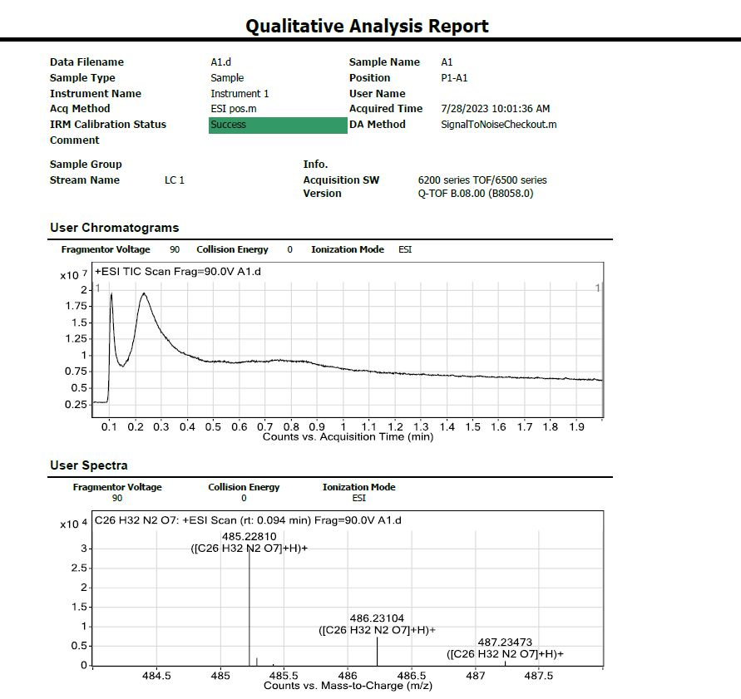
HRMS spectra of 10-13
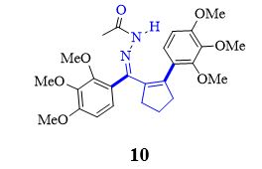
HRMS spectrum of 10

HRMS spectrum of 11
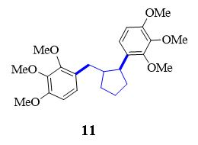
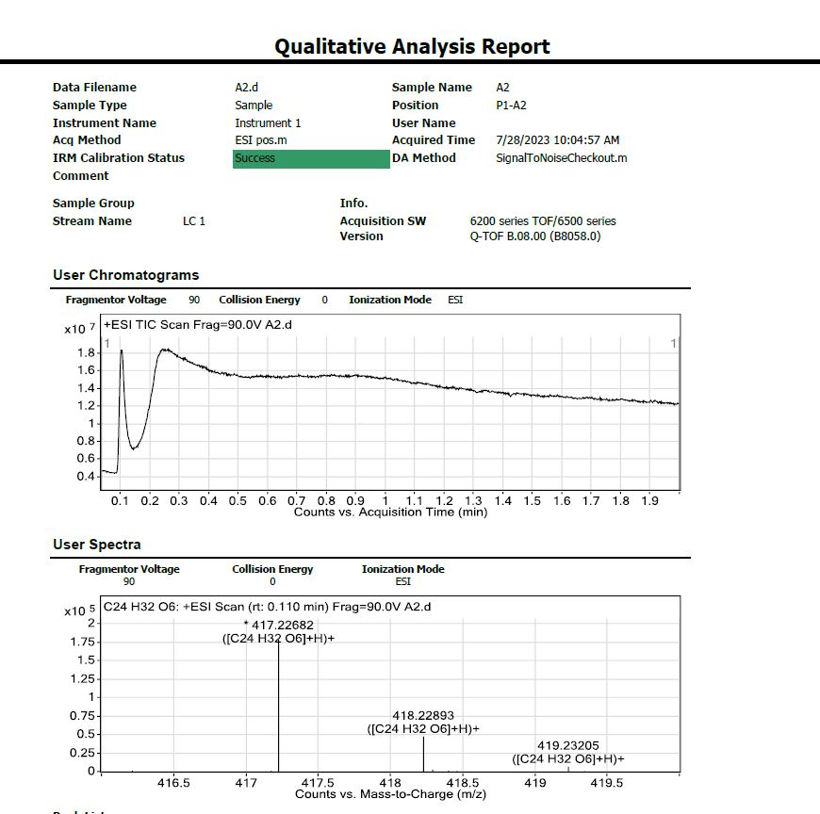

HRMS spectrum of 12
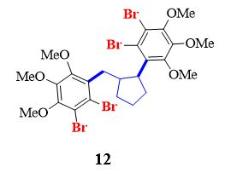
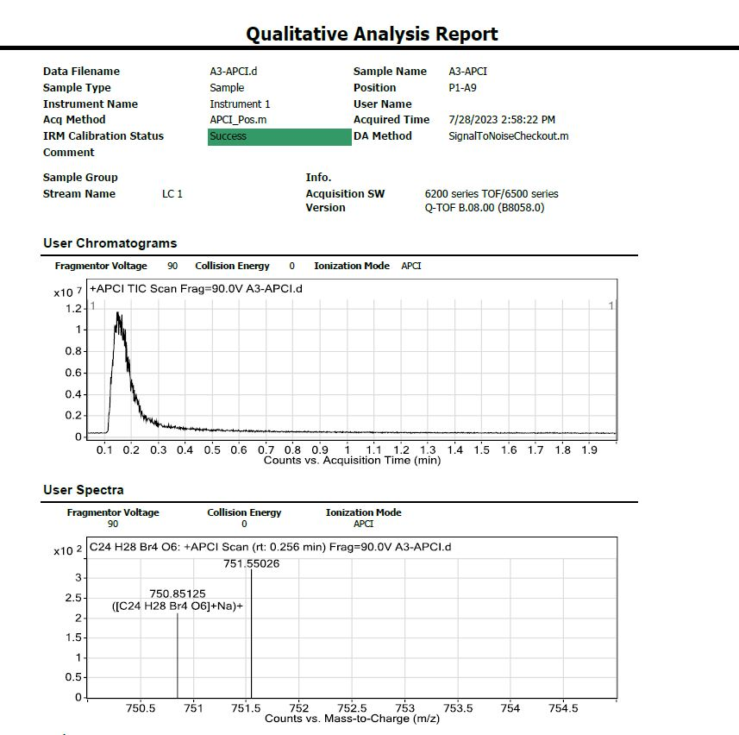

HRMS spectrum of 13
