Tables

Patients – Total | 362
Type of Diagnosis
True Undescended testis | 236 (53,4%)
Retractile Testis | 219 (46,6%)
Operations
Inguinal Orchidopexy | 227 (48,3%)
Applied on true UDT | 176 (37,4%)
Applied on retractile testis | 51 (10,9%)
Scrotal Orchidopexy | 216 (46%)
Applied on true UDT | 48 (10,2%)
Applied on retractile testis | 168 (35,7%)
Orchiectomy | 1 (0,2%)
Laparoscopic orchidopexy | 24 (5,1%)
Inguinal exploration | 2 (0,4%)

Table 1. Characteristics of the reviewed patients.

Orchidopexy/  Diagnosis | True UDT | Retractile testis | Total
Inguinal | 176 | 51 | 227(51.2%)
Scrotal | 48 | 168 | 216(48.8%)
Total | 224 | 219 | 443

Table 2. Inguinal/Scrotal orchidopexy and initial diagnosis.

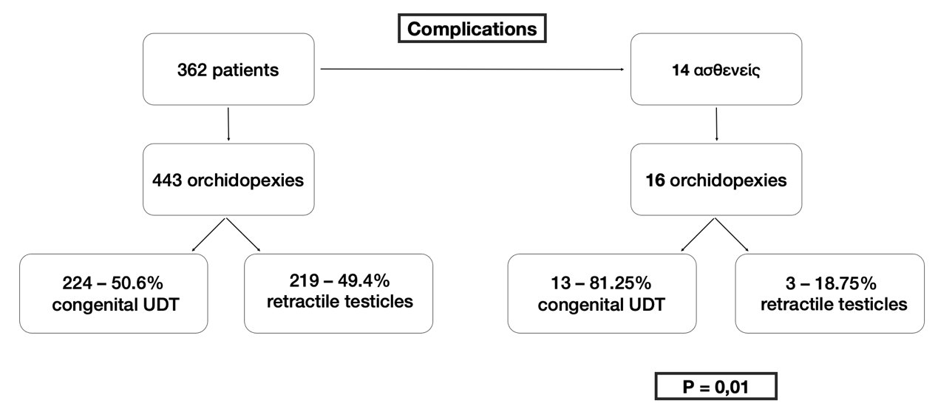
Table 3. Comparison between the type of cryptorchidism diagnosis and the orchidopexy complications.

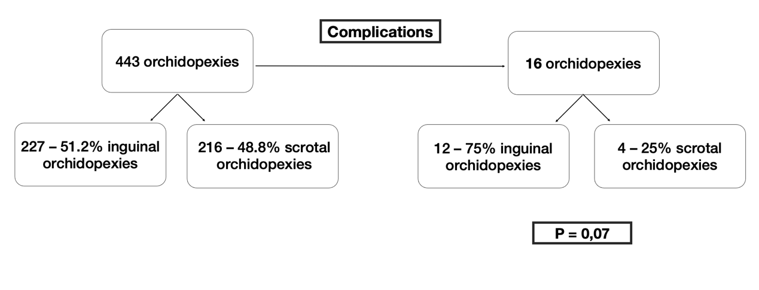
Table 4. Comparison between the type of the applied orchidopexy and the complications.

