Table 1. Observer Assessment of Alertness/Sedation (OAA/S) scale.
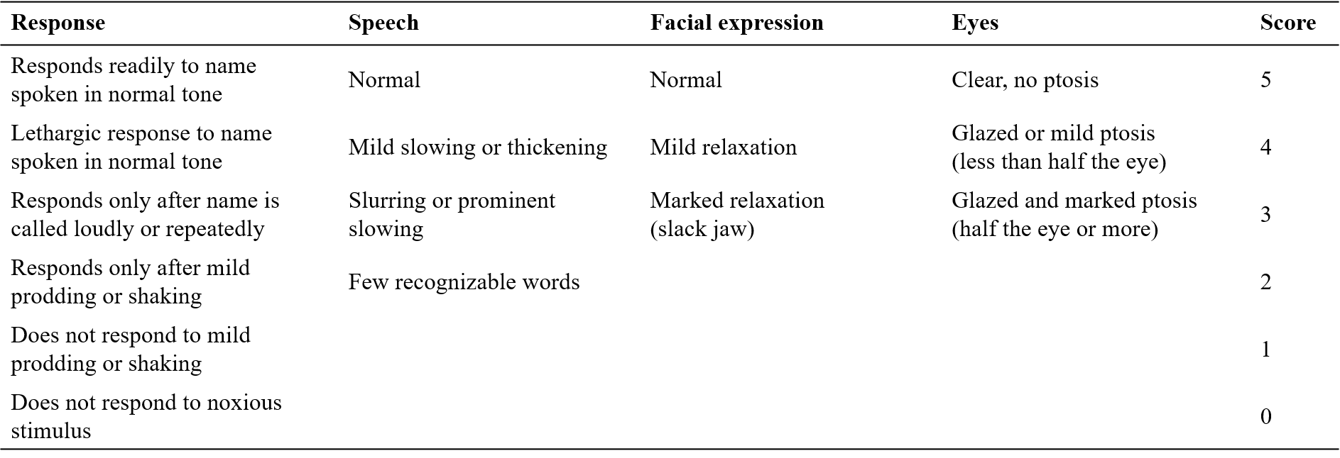
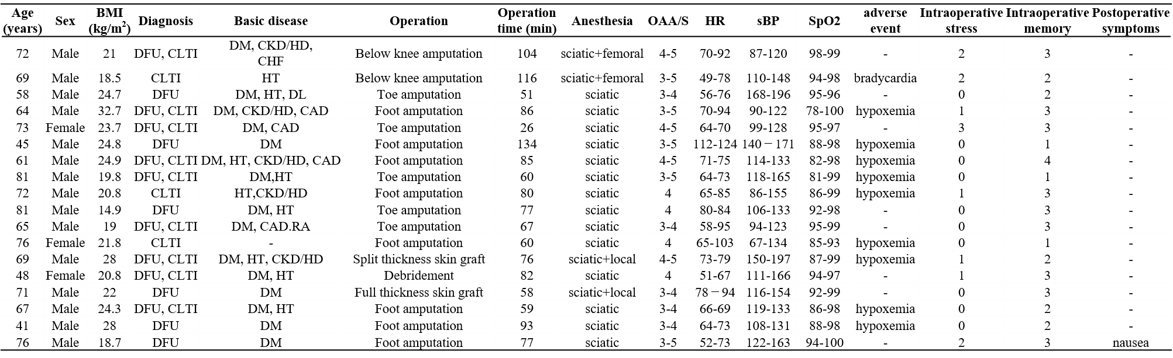
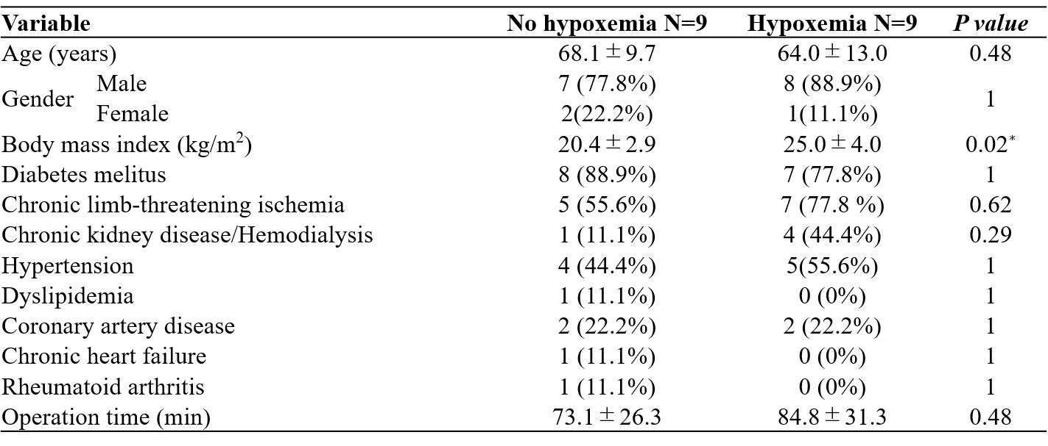
DFU: diabetic foot ulcer, CLTI: chronic limb-threatening ischemia, DM: diabetes mellitus, CKD/HD: chronic kidney disease/hemodialysis, CHF: chronic heart failure, HT: hypertension, DL: dyslipidemia, CAD: Coronary Artery Disease, RA: rheumatoid arthritis, OAA/S: Observer Assessment of Alertness/Sedation scale
Table 2. Data and outcome of patients
Data are shown as mean ± standard deviations or number of patients (percentage).
∗P < 0.05 for no hypoxemia vs. hypoxemia in univariate analysis.
Table 3. Comparison of characteristics of patients with and without hypoxemia in univariate analysis.

