Natural medicines from Cymbopogon for Methicillin-resistant Staphylococcus aureus
Vinutha Mª, Manikandan A^{b,}*, Lakshmikanth R Nª, Shravani Sª, Divyashree Bª, Aishwarya Kª and Nagaraj M Mª
ªDepartment of Biotechnology, M.S Ramaiah College of Arts, Science and Commerce, Bangalore-54, India.
^{b*}Department of Microbiology, M.S Ramaiah College of Arts, Science and Commerce, Bangalore-54, India.
*Corressponding author email: mailtomicromani@gmail.com; ORCID: 0000-0002-7065-5884
Table of contents
S. No. Content Page No.
1. Table S1. GC-MS analysis NIST library compounds from C. winterianus 2-3
2. Table S2. GC-MS analysis NIST library compounds from C. winterianus 4
3. Table S3. GC-MS analysis NIST library compounds from C. flexuosus 4-5
4. Table S4. GC-MS analysis NIST library compounds from C. martinii 6
5. Table S5. GC-MS analysis NIST library compounds from C. martinii 6-7
6. Table S6: Antibacterial activity of C. winterianus 8
7. Table S7: Antibacterial activity of C. flexuosus 8
8. Table S8: Antibacterial activity of C martinii 8
9. Table S9: Antibacterial activity of C winterianus 9
10. Table S10: Antibacterial activity of C flexuosus 9
11. Table S11: Antibacterial activity of C martinii 9
12. Table S12: Antibacterial activity of C. winterianus 10
13. Table S13: Antibacterial activity of C. flexuosus 10
14. Table S14: Antibacterial activity of C martinii 10
15. Table 15: Primer details 11
16. Figure S1: CHROMATOGRAM OF C. winterianus 11
17. Figure S2: CHROMATOGRAM OF C. flexuosus 11
18. Figure S3: CHROMATOGRAM OF C. martinii 11
Table S1: List of compounds from C. winterianus essential oil from GC-MS analysis.

Peak NO. | Compound Name | Percentage
1 | Methylcyclopentanol | 0.06
2 | Ethanone,1-[2-(1-hydroxy-1-thylethyl)cyclopropyl]- | 0.08
3 | 3-Hydroxy-3-methylvaleric acid | 0.06
4 | Hydroperoxide, 1-ethylbutyl | 0.03
5 | Hydroperoxide, 1-methylpentyl | 0.05
6 | 3-Hexen-2-one(1-Butenyl methyl ketone) | 0.30
7 | trans-2-[2'-(2"-Methyl-1"-propenyl)cyclopropyl] propan-2-ol | 0.09
8 | 5-Hepten-2-one, 6-methyl- | 0.16
9 | 5-Hepten-2-ol, 6-methyl- | 0.33
10 | D-Limonene | 4.67
11 | Cyclohexane, 1,1,3,5-tetramethyl-, cis- | 0.61
12 | beta Linalool | 1.10
13 | 2H-Pyran, tetrahydro-4-methyl-2- (2-methyl-1-propenyl)- | 0.26
14 | β-citronella | 0.99
15 | cis-p-Mentha-2,8-dien-1-ol | 0.04
16 | Citronellal | 12.13
17 | Isopulegol | 0.25
18 | Naphthalene, decahydro-1,6-dimethyl- | 0.17
19 | Terpineol acetate | 0.10
20 | Citronellol | 14.9
21 | Neral | 0.27
22 | Geraniol | 22.45
23 | Geranial | 0.85
24 | 2-Octen-1-ol,7-[(tetrahydro-2H-pyran-2-yl)oxy]-, (E)- | 0.05
25 | Linalool | 0.51
26 | Cyclohexane,(1-methylethylidene)- Isopropylidenecyclohexane | 0.09
27 | Citriodiol | 0.16
28 | 2,6-Octadiene, 2,6-dimethyl- | 1.55
29 | Eugenol | 1.59
30 | Geranyl Acetate | 1.27
31 | Cyclohexane, 1-ethenyl-1-methyl- 2,4-bis(1-methylethenyl)-,  [1S-(1.alpha.,2.beta.,4.beta.) | 2.21
32 | β - Caryophyllene | 0.10
33 | 1,4,7,-Cycloundecatriene, 1,5,9,9-  tetramethyl-, Z,Z,Z- | 0.14
34 | Naphthalene, 1,2,3,4,4a,5,6,8a-octahydro-7-methyl-4-methylene-1-(1-methylethyl)-, (1.al | 0.13
35 | 1,6-Cyclodecadiene, 1-methyl-5-methylene-8-(1-methylethyl)-, [s-(E,E)]- | 1.46
36 | Germacrene-D | 0.60
37 | Naphthalene,1,2,3,4,4a,5,6,8a-octahydro- 7-methyl-4-methylene-1-(1-methylethyl)-, (1.al | 0.65
38 | Naphthalene,1,2,4a,5,8,8a-hexahydro-4,7-dimethyl-1-(1-methylethyl)-, [1S-(1.alpha.,4a.b | 1.65
39 | Cubenol | 0.04
40 | Naphthalene, 1, 2,4a,5,6,8a-hexahydro-4,7-dimethyl-1-(1-methylethyl)-,[1S-(1.alpha., 4a.(0-Menth-8-ene-4-methanol) | 0.05
41 | Cyclohexanemethanol,4-ethenyl-.alpha.,.alpha.,4-trimethyl-  3-(1-methylethenyl)-, [1R-(1 | 10.95
42 | 1-Hydroxy-1,7-dimethyl-4-isopropyl-2,7-cyclodecadiene | 5.19
43 | Caryophyllene oxide | 0.11
44 | 2 cis- Geranylgeraniol | 0.14
45 | Androstan-17-one,3-ethyl-3-hydroxy-, (5.alpha.)- | 0.20
46 | γ-Eudesmol | 0.71
47 | Cadinol | 1.59
48 | Cubenol | 5.82
49 | Aromadendrene | 0.26
50 | 6-Isopropenyl-4,8a-dimethyl-1,2,3,5,6,7,8,8a-octahydro-naphthalen-2-ol | 0.11
51 | 4,8,13-Cyclotetradecatriene-1,3-diol,1, 5,9-trimethyl-12-(1-methylethyl)- ( 4,8,13-Duvatriene-1,3-diol) | 0.04
52 | 2-cis-Geronylgereniol | 0.95
53 | 9,10-Dimethyltricyclo[4.2.1.1(2,5)]  decane-9,10-diol | 0.26
54 | 7R,8R-8-Hydroxy-4-isopropylidene-7-methylbicyclo  [5.3.1]undec-1-ene | 0.05
55 | 1-Heptatriacotanol | 0.10
56 | 3a,7-Methano-3aH-cyclopentacyclooctene,1,4,5,6,7,8,9,9a-octahydro-1,1,7-trimethyl-, [3 | 0.05
57 | Oxirane, 2,2-dimethyl-3- (3,7,12,16,20-pentamethyl-3,7,11,15,19-heneicosapentaenyl)-, (a | 0.06
58 | 2,6,10,14,18-Pentamethyl-2,6,10,14,18-eicosapentaene | 0.04
59 | Cyclopropane methanol, 2-methyl-2- (4-methyl-3-pentenyl)- | 0.06
60 | 4,4,8-Trimethyl-non-5-enal | 0.04
61 | Ledol | 0.37
62 | 1,6,10,14,18,22-Tetracosahexaen-3-ol, 2,6,10,15,19,23-hexamethyl-, (all-E)- | 0.03
63 | 1,6,10,14,18,22-Tetracosahexaen-3-ol, 2,6,10,15,19,23-hexamethyl-, (all-E)- | 0.11
64 | Silane,diphenyl-bis-[2-(1,3,5,5,7,7-heptamethyl-2,4,6,8-  tetraoxy-1,3,5,7-tetrasilacyclooc | 0.03
65 | Nimbiol | 0.11
66 | 3-Ethoxy-1,1,1,5,5,5-hexamethyl-3-(trimethylsiloxy)  trisiloxane (Ethyltris(trimethyl silyl) Silicate) | 0.04

Table S2: Important chemical constituents from GC-MS analysis of C. winterianus
Peak  NO. | Percentage | Compound name | Biological activity and uses
1 | 4.67 | D-Limonene | Safety and clinical applications.
2 | 1.10 | β Linalool | Antimicrobial and antifungal properties.  And used in toiletry products
3 | 12.13 | Citronellal | It has a role as a metabolite and as  An antifungal agent.
4 | 14.9 | Citronellol | Antifungal, antibacterial, anti-barnacle and  Antinflammatory activity.
5 | 1.59 | Eugenol | Antibacterial activity, used in food industry
6 | 22.45 | Geraniol | Antimicrobial property
7 | 1.27 | Geranyl Acetate | Antinociceptive activity, Insecticidal and  repellent properties, anticancerous property.

Table S3: List of compounds of C. flexuosus essential oil from GC-MS analysis
Peak NO. | Compound name | Percentage
1 | 3-Hexenal, (Z)- $$ cis-3-Hexenal $$ 3-(Z)-Hexenal  $$ cis-.beta.,.gamma.-Hexylenic aldeh | 0.05
2 | Pentane, 3-ethyl-2,4-dimethyl- | 0.06
3 | 3-Hydroxy-3-methylvaleric acid | 0.06
4 | 1R-.alpha.-Pinene | 0.12
5 | Bicyclo[2.2.1]heptane, 2,2-dimethyl-3-methylene-, (1S)- | 0.70
6 | 3-Hexen-2-one | 0.37
7 | 5-Hepten-2-one, 6-methyl- | 1.06
8 | Octanal | 0.12
9 | D-Limonene | 1.32
10 | 1,3,6-Octatriene, 3,7-dimethyl-, (Z)- | 0.04
11 | Cyclopropane, 2-(1,1-dimethyl-2-propenyl)-1,1-dimethyl- | 0.08
12 | 4-Nonanone | 1.54
13 | 1,6-Octadien-3-ol, 3,7-dimethyl- | 1.88
14 | Bicyclo[3.1.1]heptane-2-carboxaldehyde, 6,6-dimethyl- | 0.12
15 | 6-Octen-1-ol, 7-methyl-3-methylene- | 0.53
16 | 6-Octenal, 3,7-dimethyl-, (R)- | 1.56
17 | Carane, 4,5-epoxy-, trans | 2.05
18 | Cyclopentene, 1,4-dimethyl-5-(1-methylethyl)- | 1.35
19 | Carane, 4,5-epoxy-, trans | 3.03
20 | Cyclopentanol, 1,2-dimethyl-3-(1-methylethenyl)-,  [1R-(1.alpha.,2.alpha.,3.alpha.)]- | 0.54
21 | Decanal | 0.11
22 | 6-Octen-1-ol, 3,7-dimethyl-, (R)- | 0.88
23 | Oxiranecarboxaldehyde, 3-methyl-3-(4-methyl-3-pentenyl)- | 0.18
24 | 2,6-Octadienal, 3,7-dimethyl-, (Z)- | 27.55
25 | 2,6-Octadien-1-ol, 3,7-dimethyl-, (E)- | 9.04
26 | 2-Cyclohexen-1-one, 3-methyl-6-(1-methylethyl)- | 0.05
27 | 2,6-Octadienal, 3,7-dimethyl, (E)- | 34.64
28 | 7-Oxabicyclo[4.1.0]heptane, 1-methyl-4-(1-methylethenyl)- | 0.09
29 | Bornyl acetate | 0.14
30 | 1,6-Octadien-3-ol, 3,7-dimethyl-, formate | 0.12
31 | Neric acid | 0.05
32 | 2-Butenoic acid, 3,7-dimethyl-6-octenyl ester | 0.42
33 | Eugenol | 0.13
34 | 2,6-Octadien-1-ol, 3,7dimethyl-, acetate, (E)- | 3.52
35 | Bicyclo[5.3.0]decane, 2-methylene-5-(1-methylvinyl)-8-methyl- | 0.04
36 | 3,5-Heptadienal, 2-ethylidene-6-methyl- | 0.04
37 | Caryophyllene | 0.40
38 | Phenol, 2-methoxy-4-(1-propenyl)-, (E)- | 0.07
39 | 1,4,7,-Cycloundecatriene, 1,5,9,9-tetramethyl-, Z,Z,Z- | 0.04
40 | 1,6-Cyclodecadiene, 1-methyl-5-methylene-8-(1-methylethyl)-, [s-(E,E)]- | 0.06
41 | 3-Buten-2-ol, 4-(2,6,6-trimethyl-1-cyclohexen-1-yl)- | 0.31
42 | Naphthalene, 1,2,3,4,4a,5,6,8a-octahydro-7-methyl-4-methylene-1-(1-methylethyl)-, (1.al | 1.29
43 | Cubenol
44 | Cyclohexanemethanol, 4-ethenyl-.alpha.,.alpha.,4-trimethyl-3-(1-methylethenyl)-, [1R-(1. | 0.48
45 | 1-Hydroxy-1,7-dimethyl-4-isopropyl-2,7 -cyclodecadiene | 0.05
46 | Caryophyllene oxide | 2.52
47 | Caryophyllene oxide | 0.29
48 | Di-epi-.alpha.-cedrene-(I) | 0.12
59 | 1-Naphthalenol, 1,2,3,4,4a,7,8,8a-octahydro-  1,6-dimethyl-4-(1-methylethyl)-, [1R-(1.alph | 0.14
50 | Cubenol | 0.30
51 | Androstan-17-one, 3-ethyl-3-hydroxy-, (5.alpha.)- | 0.14
52 | Cyclopropanemethanol, .alpha.,2-dimethyl-2-  (4-methyl-3-pentenyl)-, [1.alpha.(R*),2.alph | 0.04
53 | Silicic acid, diethyl bis(trimethylsilyl) ester | 0.04
54 | 0.05 Silicic acid, diethyl bis(trimethylsilyl) ester | 0.05
55 | 3-Ethoxy-1,1,1,5,5,5-hexamethyl-3-(trimethylsiloxy)trisiloxane | 0.07

Table S4: Important chemical constituents from GC-MS analysis of C. flexuosus
Peak  Number | Percentage | Compound name | Biological activity and uses
1 | 34.64 | 2,6-Octadienal, 3,7-dimethyl, (E)-  (Geranial) | Antinflammation, Antimicrobial, Anticancer
2 | 27.55 | 2,6-Octadienal, 3,7-dimethyl-,(Z)-  (neral) | Antimicrobial property
3 | 4.79 | 2,6-Octadien-1-ol,3,7dimethyl-,  acetate, (E)-(Geranyl acetate) | Antimicrobial property
4 | 9.04 | 2,6-Octadien-1-ol, 3,7-dimethyl-,  (E)-( Geraniol) | Antimicrobial property
5 | 1.32% | D-Limonene | Antitumor, Antiviral, Anti-inflammatory, Antibacterial
6 | 2.81% | Caryophyllene oxide | Anti‐inflammatory, Anti-carcinogenic, Antimicrobial, Antioxidant,

Table S5: List of compounds of C. martinii essential oil from GC-MS analysis
Sl.No. | Name of the compound | Percentage
1 | Cyclopentanol, 3-methyl- | 0.16
2 | 2-Pentanethiol, 2-methyl- | 0.43
3 | Butanal, 2-ethyl-3-methyl- | 0.49
4 | Hexane, 2-nitro- | 0.36
5 | Pentane, 3-ethyl-2,4-dimethyl- | 0.40
6 | 3-Hexen-2-one | 2.51
7 | 5-Hepten-2-one, 6-methyl- | 0.68
8 | 6-Hepten-1-ol, 3-methyl- $$ 3-Methyl-6-hepten | 1.06
9 | 3-Dodecyne | 0.15
10 | D-Limonene | 2.82
11 | 1,3,6-Octatriene, 3,7-dimethyl-, (Z)- (beta – ocimene) | 2.60
12 | 2-Octene, 2-methyl-6-methylene- | 0.03
13 | 1-Octanol | 0.09
14 | 5-Methyl-4,5-dihydroisoxazole-5-carboxylic acid, methyl ester | 0.12
15 | Cyclohexene, 1-methyl-4-(1-methylethylidene)- (Terpinolene) | 0.32
16 | 1,6-Octadien-3-ol, 3,7-dimethyl- (beta linalool) | 4.75
17 | Ethanone, 1-(2-methyl-1-cyclopenten-1-yl)- | 0.05
18 | 6-Octen-1-ol, 7-methyl-3-methylene- | 0.09
19 | 3-Cyclohexene-1-carboxaldehyde, 2,4,6-trimethyl- | 0.03
20 | 4-(1,2-Dimethyl-cyclopent-2-enyl)-butan-2-one | 0.07
21 | 3-Cyclohexene-1-carboxaldehyde, 2,4,6-trimethyl | 0.23
22 | Cyclopentanol, 1,2-dimethyl-3-(1-methylethenyl)-, [1R-(1.alpha.,2.alpha.,3.alpha.)]- | 0.40
23 | 3-Cyclohexene-1-carboxaldehyde, 1,3,4-trimethyl- | 0.05
24 | 2,6-Octadien-1-ol, 3,7-dimethyl-, (Z)-(Nerol) | 5.37
25 | 2,6-Octadienal, 3,7-dimethyl-, (Z)- (Neral) | 1.40
26 | 2,6-Octadien-1-ol, 3,7-dimethyl-, (E)-Geraniol | 15.15
27 | 2,6-Octadien-1-ol, 3,7-dimethyl-, (Z)- Nerol | 5.74
28 | 2-Isopropenyl-5-methylhex-4-enal (Lavandulal) | 1.70
29 | 1,6-Octadien-3-ol, 3,7-dimethyl-, formate Linalyl formate | 0.87
30 | 2,6-Octadienal, 3,7-dimethyl-(Geranial) | 0.15
31 | 2-Methoxy-4-vinylphenol | 0.02
32 | Oxiranemethanol, 3-methyl-3-(4-methyl-3-pentenyl)- | 0.04
33 | Oxiranemethanol, 3-methyl-3-(4-methyl-3-pentenyl)- | 0.32
34 | 7-Oxabicyclo[4.1.0]heptane, 1-methyl-4-(1-methylethenyl)- | 0.05
35 | 2,6-Octadien-1-ol, 3,7-dimethyl-, acetate, (Z)- (Neryl acetate) | 0.10
36 | 2-Octen-1-ol, 3,7-dimethyl-, isobutyrate, (Z)- | 0.38
37 | 2,6-Octadien-1-ol, 3,7-dimethyl-, acetate, (E)- (Geranyl acetate) | 17.47
38 | Bicyclo[3.1.0]hexane-6-methanol, 2-hydroxy-1,4,4-trimethyl- | 0.04
39 | Bicyclo[5.3.0]decane, 2-methylene-5-(1-methylvinyl)-8-methyl- | 0.05
40 | 7-Oxabicyclo[4.1.0]heptane, 1-methyl-4-(1-methylethenyl)- | 0.23
41 | Caryophyllene | 2.10
42 | 2,6,10,14-Hexadecatetraen-1-ol, 3,7,11,15-tetramethyl-, acetate, (E,E,E)- | 0.39
43 | 1,4,7,-Cycloundecatriene, 1,5,9,9-tetramethyl-, Z,Z,Z- | 0.28
44 | 2-Octen-1-ol, 3,7-dimethyl-, isobutyrate, (Z)- | 0.32
45 | 3-Buten-2-one, 4-(2,6,6-trimethyl-1-cyclohexen-1-yl)- | 0.19
46 | 1H-Cycloprop[e]azulene, decahydro-1,1,7-trimethyl-4-methylene- | 0.03
47 | Androst-4-en-3-one, 17-[(cyclohexylcarbonyl)oxy]-, (17.beta.)- | 0.03
48 | 2,6,10-Dodecatrienal, 3,7,11-trimethyl-, (E,E)- | 0.42
49 | Butanoic acid, 3,7-dimethyl-2,6-octadienyl ester, (E)-(Geranyl butyrate) | 1.88
50 | 1,6,10-Dodecatrien-3-ol, 3,7,11-trimethyl-, (E)-(Nerolidol) | 0.62
51 | 2,6,10,14-Hexadecatetraen-1-ol, 3,7,11,15-tetramethyl-, acetate, (E,E,E)- | 0.09
52 | Caryophyllene oxide | 1.05
53 | 3,5-Dimethylcyclohex-1-ene-4-carboxaldehyde | 0.05
54 | Tetracyclo[6.3.2.0(2,5).0(1,8)]tridecan-9-ol, 4,4-dimethyl- | 0.13
55 | Hexadeca-2,6,10,14-tetraen-1-ol, 3,7,11,16-tetramethyl-, (E,E,E)- | 0.15
56 | Andrographolide | 0.05
57 | 2,6,10-Dodecatrien-1-ol, 3,7,11-trimethyl-, (Z,E)- | 0.03
58 | Cyclopropanemethanol, 2-methyl-2-(4-methyl-3-pentenyl)- | 0.03
59 | 2,6,10-Dodecatrien-1-ol, 3,7,11-trimethyl-, (E,E)- (Farnesyl alcohol/Farnesol) | 10.31
60 | Hexanoic acid, 3,7-dimethyl-2,6-octadienyl ester, (E)- Neryl hexanoate | 8.36
61 | Pentacyclo[9.1.0.0(2,4).0(5,7).0(8,10)]dodecane, 3,3,6,6,9,9,12,12-octamethyl-, anti,anti, | 0.03
62 | 3,7,11,15-Tetramethyl-2-hexadecen-1-ol (Phytol) | 0.70
63 | Nerolidol 2 | 1.12
64 | 2-Cyclohexen-1-ol, 1-methyl-4-(1-methylethenyl)-, trans- | 0.06
65 | 4-Bromobutanoic acid, undec-2-enyl ester | 0.08
66 | 2,6,10-Dodecatrien-1-ol, 3,7,11-trimethyl-, acetate, (E,E)- | 0.08
67 | 2,6-Octadien-1-ol, 3,7-dimethyl-, propanoate, (E)- (Neryl propionate) | 3.17
68 | Hexadeca-2,6,10,14-tetraen-1-ol, 3,7,11,16-tetramethyl-, (E,E,E)- | 0.02
69 | cis-1-Chloro-9-octadecene | 0.17
70 | 6,11-Dimethyl-2,6,10-dodecatrien-1-ol | 0.80
71 | beta.-D-Mannofuranoside, farnesyl- | 0.02
72 | 2,6,10-Dodecatrien-1-ol, 3,7,11-trimethyl-, acetate, (E,E)- | 0.02
73 | Tetracontane | 0.03
74 | Tetracosamethyl-cyclododecasiloxane | 0.08
75 | Tetracosamethyl-cyclododecasiloxane | 0.05
76 | 2,4,6-Cycloheptatrien-1-one, 3,5-bis-trimethylsilyl- | 0.10

Table S6: Antibacterial activity of C. winterianus essential oil by measuring zones of Inhibition (mm) using Agar well diffusion method
SL NO | Concentrations  (%) | Zone of inhibition (mm)
SL NO | Concentrations  (%) | Isolate 1 | Isolate 2 | Isolate 3 | Isolate 4 | Isolate 5
1 | 35% | 11.1mm | 12mm | 11mm | 11mm | 13mm
2 | 40% | 13mm | 13mm | 11mm | 12mm | 13mm
3 | 45% | 13.5mm | 13mm | 11mm | 13mm | 13mm
4 | 50% | 15mm | 14mm | 16mm | 20mmm | 14mm
5 | 55% | 15mm | 15mm | 17mm | 20mm | 14mm

Table S7: Antibacterial activity of C. flexuosus essential oil by measuring zones of inhibition (mm) using Agar well diffusion method.

SL  NO | Concentrations  (%) | Zone of inhibition (mm) C. flexuosus
SL  NO | Concentrations  (%) | Isolate 1 | Isolate 2 | Isolate 3 |  | Isolate 4 | Isolate 5
1 | 6% | 12.5mm | 15.5mm |  | 22% | 20mm | 11mm
  13mm
2 | 8% | 21mm | 17.5mm | 13.5mm | 24% | 21mm | 13mm
3 | 10% | 26.5mm | 20.6mm | 14.5mm | 26% | 22mm | 13mm
4 | 12% | 27.5mm | 22mm | 15mm | 28% | 24mmm | 15mm
5 | 14% | 28.5mm | 24.5mm | 24mm | 30% | 29mm | 16mm

Table S8: Antibacterial activity of C martinii essential oil by measuring zones of inhibition (mm) using Agar well diffusion method.
SL NO | Concentrations  (%) | Zone of inhibition (mm) C martinii
SL NO | Concentrations  (%) | Isolate 1 | Isolate 2 | Isolate 3 | Isolate 4 | Isolate 5
1 | 24% | 10.25mm | 11.12mm | 10.6mm | 10.95.mm | 11.75.mm
2 | 26% | 11.1mm | 11.75mm | 11mm | 11.2mm | 12.25mm
3 | 28% | 11.25mm | 11.75mm | 11.25mm | 11.27mm | 13.25mm
4 | 30% | 11.75mm | 11.95mm | 14.75mm | 15.25mm | 13.45mm
5 | 32% | 16.7mm | 12.7mm | 16.25mm | 17mm | 13.5mm

Table S9: Antibacterial activity of C winterianus essential oil by measuring zones of inhibition (mm) using Disc diffusion method.

SL NO | Concentrations  (%) | Zone of inhibition (mm) C. winterianus
SL NO | Concentrations  (%) | Isolate 1 | Isolate 2 | Isolate 3 | Isolate 4 | Isolate 5
1 | 35% | 19.25mm | 12mm | 11mm | 11mm | 13mm
2 | 40% | 19.75mm | 13mm | 11mm | 12mm | 13mm
3 | 45% | 19.5mm | 13mm | 11mm | 13mm | 13mm
4 | 50% | 21.25mm | 14mm | 16mm | 20mmm | 14mm
5 | 55% | 21.7mm | 15mm | 17mm | 20mm | 14mm

Table S10: Antibacterial activity of C flexuosus essential oil by measuring zones of inhibition (mm) using Disc diffusion method.

SL  NO | Concentrations  (%) | Zone of inhibition (mm) C flexuosus
SL  NO | Concentrations  (%) | Isolate 1 | Isolate 2 | Isolate 3 | Isolate 4 | Isolate 5
1 | 15% | 11mm | 16mm | 35mm | 21mm | 12mm
2 | 20% | 15mm | 34mm | 37mm | 26mm | 15mm
3 | 25% | 24mm | 35mm | 55mm | 31mm | 21mm
4 | 30% | 25mm | 50mm | 60mm | 32mm | 40mm
5 | 35% | 30mm | 60mm | 61mm | 70mm | 57mm

Table S11: Antibacterial activity of C martinii essential oil by measuring zones of growth inhibition (mm) using Disc diffusion method.

SL  NO | Concentrations  (%) | Zone of inhibition (mm) C martinii
SL  NO | Concentrations  (%) | Isolate 1 | Isolate 2 | Isolate 3 | Isolate 4 | Isolate 5
1 | 25% | 11mm | 11mm | 15mm | 11mm | 12mm
2 | 30% | 17mm | 14mm | 17mm | 14mm | 20mm
3 | 35% | 34mm | 20mm | 25mm | 16mm | 30mm
4 | 40% | 45mm | 22mm | 35mm | 30mm | 40mm
5 | 45% | 55mm | 35mm | 45mm | 45mm | 50mm

Table S12: Antibacterial activity of C. winterianus essential oil by visualizing turbidity using Broth dilution method
SL  NO | Concentrations  in µg/ml | Isolate 1 | Isolate 2 | Isolate 3 | Isolate 4 | Isolate 5
1 | 2 | + | + | + | + | +
2 | 4 | + | + | + | + | -
3 | 6 | + | + | + | + | -
4 | 8 | + | + | + | - | -
5 | 16 | - | - | - | - | -
6 | 32 | - | - | - | - | -
7 | 64 | - | - | - | - | -
8 | 128 | - | - | - | - | -
9 | 256 | - | - | - | - | -
Resistant: +, Sensitive; -

Table S13: Antibacterial activity of C. flexuosus essential oil by measuring zones of inhibition (mm) using Broth dilution method
SL  NO | Concentrations  in µg/ml | Isolate 1 | Isolate 2 | Isolate 3 | Isolate 4 | Isolate 5
1 | 2 | + | + | + | + | +
2 | 4 | + | + | - | - | -
3 | 6 | + | + | - | - | -
4 | 8 | + | + | - | - | -
5 | 16 | - | - | - | - | -
6 | 32 | - | - | - | - | -
7 | 64 | - | - | - | - | -
8 | 128 | - | - | - | - | -
9 | 256 | - | - | - | - | -
Resistant: +, Sensitive; -
Table S14: Antibacterial activity of C martinii essential oil by measuring zones of inhibition (mm) using Broth dilution method

Concentrations in  µg/ml | Isolate 1 | Isolate 2 | Isolate 3 | Isolate 4 | Isolate 5
2 | + | + | + | + | +
4 | + | + | + | + | +
6 | + | + | + | + | -
8 | - | + | - | - | -
16 | - | - | - | - | -
32 | - | - | - | - | -
64 | - | - | - | - | -
128 | - | - | - | - | -
256 | - | - | - | - | -
Resistant: +, Sensitive; -

Table 15: Primer details:
Sl.No. | Primer | Forward sequence | Tm
1 | OPA16 | AGCCAGCGAA | 25°C
2 | OPB11 | GTAGACCCGT | 25°C
3 | OPC16 | CACACTCCAG | 25°C
4 | OPD13 | GGGGTGACGA | 25°C

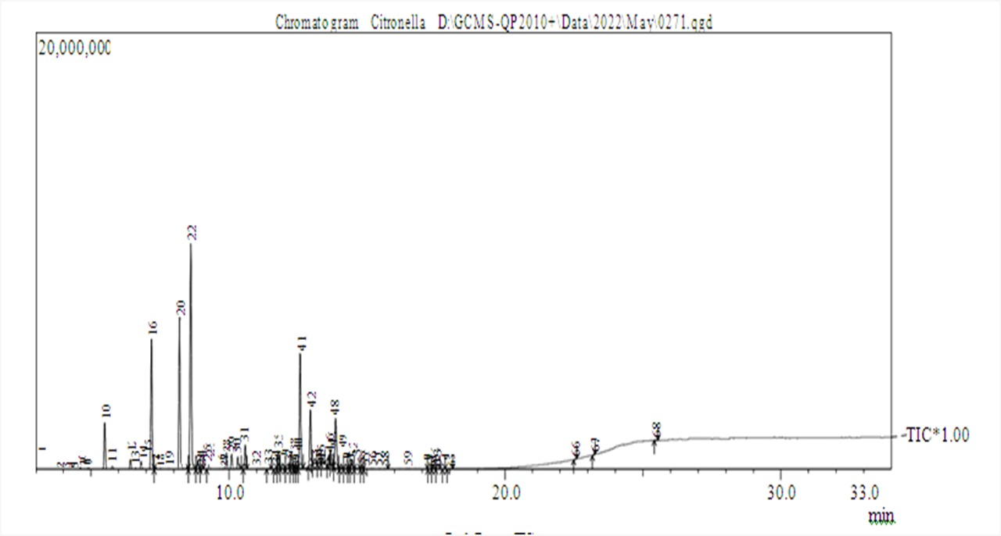

Figure S1: CHROMATOGRAM OF C. winterianus
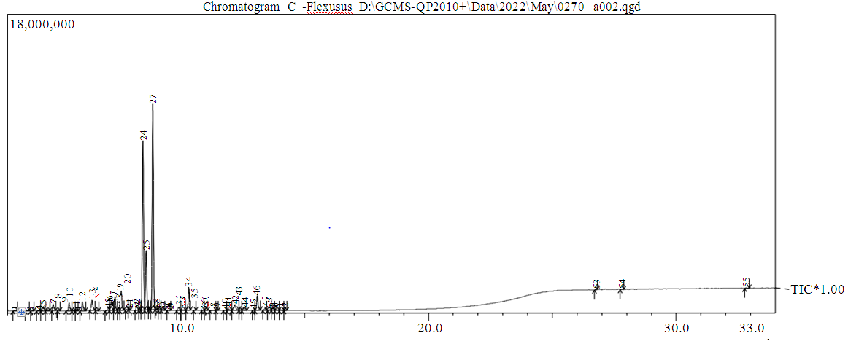

Figure S2: CHROMATOGRAM OF C. flexuosus
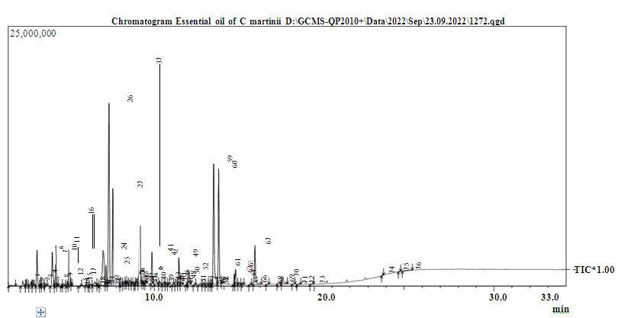

Figure S3: CHROMATOGRAM OF C. martinii

