Supporting Information

Phthalocyanine Aggregates as “Semiconductor-like” Photocatalysts for Hypoxic-Tumor Photodynamic Immunotherapy

Hao Liu¹, Ziqing Li¹, Xiaojun Zhang¹, Yihui Xu¹, Guoyan Tang¹, Zhaoxin Wang², Yuan-Yuan Zhao¹. Mei-Rong Ke¹, Bi-Yuan Zheng¹, Shuping Huang², Jian-Dong Huang¹* and Xingshu Li¹*

¹Provincial Key Laboratory of Cancer Metastasis Chemoprevention and Chemotherapy, College of Chemistry, Fuzhou University, Fuzhou, China
²Fujian Provincial Key Laboratory of Electrochemical Energy Storage Materials, College of Chemistry, Fuzhou University, Fuzhou, China

Corresponding authors. E-mail: jdhuang@fzu.edu.cn (J. -D. H.); xingshuli@fzu.edu.cn (X. L.)

Section 1. Synthesis and characterization
Materials
Before use, dimethyl sulfoxide (DMSO), dimethylformamide (DMF) and n-pentanol were distilled under reduced pressure and stored in molecular sieves. DMSO, DMF, methanol (MeOH), ethyl acetate (EA), dichloromethane (DCM), tetrahydrofuran (THF) and n-hexane were purchased from TCI, Shanghai, China. All other solvents and reagents were analytical grade and employed as received. Chromatographic purification was performed on silica gel columns (300-400 mesh, Qingdao Haiyang Chemical Co., Ltd, China) and alkaline alumina column chromatography (300-400 mesh, Shanghai Haohong Biomedical Technology Co., Ltd, China) with the indicated eluents. Size exclusion chromatography was performed with BioRad BioBeads S-X3 and BioRad BioBeads S-X1 by designated solvent. Dimethylaminomethyl phenol, triphenylchloromethane tyramine, 4-butylphenol and phenol were brought from Innochem, Beijing, China. 3-nitrophthalonitrile, 1,8-diazabicyclo[5.4.0]undec-7-ene (DBU), 4-methoxyphenol, 4-chlorophenol, 4-hydroxybenzonitrile and 4-nitrophenol were brought from TCI.
Synthesis of tetrasubstituted zinc(Ⅱ) phthalocyanines
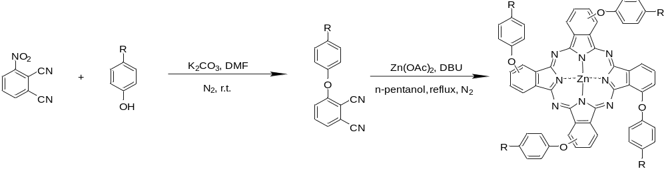
Scheme S1 Synthesis of tetrasubstituted phthalocyanines.
All tetrasubstituted zinc(Ⅱ) phthalocyanines were synthesized according to our previous work^{1, 2}.
Synthesis of NMe. A mixture of 3-nitrophthalonitrile (3.46 g, 20 mmol), dimethylaminomethyl phenol (3.02 g, 20 mmol), and K₂CO₃ (5.52 g, 40 mmol) in 70 mL DMF were stirred at room temperature for 20 h under the protection of N₂. After evaporating the solvent in vacuo, the obtained solid was dissolved with EA and extracted by water and saturated NaHCO₃ solution for 3-5 times. The product was then purified by a silica gel column chromatography using DCM and EA (1:1, v/v) as eluent to afford a yellow solid (1.24 g, 44.75%) called Ligand NMe (LgNMe). Then, a mixture of LgNMe (0.28 g, 1.00 mmol) and Zn(OAc)₂ (0.09 g, 0.50 mmol) in 40 mL anhydrous n-amyl alcohol was stirred at 90 ℃ for 15 min. And 1 mL DBU (4.70 mmol) was added and stirred at 135 ℃ for 12 h under the protection of N₂. After evaporating the solvent in vacuo, the product was then purified by a silica gel column chromatography using DMF as eluent. The crude product was then purified by size exclusion chromatography on a Bio-Beads S-X3 column and a Bio-Beads S-X1 column using DMF as eluent to collect a blue-green band. The solvent was evaporated under reduced pressure to give a crude product. The crude product was dissolved in DMF (5 mL) and poured into ice water (50 mL), which was collected by filtration and dried in vacuo to afford a blue solid NMe (31.0 mg, 10.56%). ¹H NMR (500 MHz, DMSO-d₆): δ 8.24 – 8.21 (m, 4H, 1-H), 8.13 – 8.05 (m, 4H, 2-H), 7.95 – 7.90 (m, 4H, 3-H), 7.60 – 7.58 (m, 4H, 4-H), 7.32 – 7.26 (m, 12H, 4-H, 5-H), 4.09 – 4.00 (m, 8H, 6-H), 2.38 – 2.36 (m, 24H, 7-H). HRMS(ESI): m/z calcd for C₆₈H₆₂N₁₂O₄Zn [M+2H]²⁺ 587.7156, found 587.7188. Relative error: 5.44 ppm.
Synthesis of NH. A mixture of 3-nitrophthalonitrile (3.46 g, 20 mmol), triphenylchloromethane tyramine (7.59 g, 20 mmol), and K₂CO₃ (5.52g, 40 mmol) in 70 mL DMF were stirred at room temperature for 20 h under the protection of N₂. After evaporating the solvent in vacuo, the obtained solid was dissolved with EA and extracted by water and saturated NaHCO₃ solution for 3-5 times to afford a yellow solid (1.10 g, 41.31%) called Ligand NH (LgNH). Then, a mixture of LgNH (0.50 g, 1.00 mmol) and Zn(OAc)₂ (0.09 g, 0.50 mmol) in 40 mL anhydrous n-amyl alcohol was stirred at 90 ℃ for 15 min. And 1 mL DBU (4.70 mmol) was added and stirred at 135 ℃ for 12 h under the protection of N₂. After evaporating the solvent in vacuo, the product was then purified by a silica gel column chromatography using EA as eluent. The product was then purified by size exclusion chromatography on a Bio-Beads S-X3 column and a Bio-Beads S-X1 column using DMF as eluent to collect a blue-green band. The solvent was evaporated under reduced pressure to give a blue product. The blue product was dissolved in DCM (5 mL) and poured into n-hexane (25 mL), which was collected by filtration and dried in vacuo to afford a crude blue solid. Then the crude blue solid (0.50 g, 1 mmol) in 35 mL DMF were stirred at room temperature for 15 min under the protection of N₂. And added trifluoroacetic acid (10.00 mL) to stir at 45 ℃ for 8 h. After evaporating the solvent in vacuo, the product was dissolved in DMF (5 mL) and poured into ice water (25 mL), which was collected by filtration and dried in vacuo to afford a blue solid. The blue product was then purified by size exclusion chromatography on a Bio-Beads S-X3 column and a Bio-Beads S-X1 column using DMF as eluent to collect a blue-green band. The product was dissolved in DCM (5 mL) and poured into n-hexane (25 mL), which was collected by filtration and dried in vacuo to afford a blue solid NH (51.1 mg, 19.32%). ¹H NMR (500 MHz, DMSO-d6): δ 9.40 – 9.32 (m, 2H, 1-H), 8.75 – 8.38 (m, 2H, 1-H), 8.37 – 7.72 (m, 8H, 2-H, 3-H), 7.48 – 7.15 (m, 16H, 4-H, 5-H), 2.94 (t, J = 8.2 Hz, 8H, 6-H), 2.62 (t, J = 8.1 Hz, 8H, 7-H). HRMS (ESI): m/z calcd for C₆₄H₅₂N₁₂O₄Zn [M+H]⁺ 1117.3599, found 1117.3615. Relative error: 1.43 ppm.
Synthesis of OMe. A mixture of 3-nitrophthalonitrile (3.46 g, 20 mmol), 4-methoxyphenol (2.48 g, 20 mmol), and K₂CO₃ (5.52 g, 40 mmol) in 70 mL DMF were stirred at room temperature for 20 h under the protection of N₂. After evaporating the solvent in vacuo, the obtained solid was dissolved with EA and extracted by water and saturated NaHCO₃ solution for 3-5 times. The product was then purified by a silica gel column chromatography using EA as eluent to afford a yellow solid (2.16 g, 43.16%) called Ligand OMe (LgOMe). Then, a mixture of LgOMe (0.25 g, 1.00 mmol) and Zn(OAc)₂ (0.09 g, 0.50 mmol) in 40 mL anhydrous n-amyl alcohol was stirred at 90 ℃ for 15 min. And 1 mL DBU (4.70 mmol) was added and stirred at 135 ℃ for 12 h under the protection of N₂. After evaporating the solvent in vacuo, the product was then purified by a silica gel column chromatography using DMF as eluent. The crude product was then purified by size exclusion chromatography on a Bio-Beads S-X3 column and a Bio-Beads S-X1 column using DMF as eluent to collect a blue-green band. The solvent was evaporated under reduced pressure to give a crude product. The crude product was dissolved in DCM (5 mL) and poured into n-hexane (25 mL), which was collected by filtration and dried in vacuo to afford a blue solid OMe (43.0 mg, 16.13%). ¹H NMR (500 MHz, DMSO-d6, ppm): δ 7.56 – 7.50 (m, 12H, 1-H, 4-H), 7.50 – 7.45 (m, 4H, 2-H), 7.10 – 7.07 (m, 8H, 5-H), 6.85 – 6.67 (m, 4H, 3-H), 3.79 (s, 12H, 6-H). HRMS (ESI): m/z calcd for C₆₀H₄₀N₈O₈Zn [M+H]⁺, 1065.2333, found 1065.2324. Relative error: 0.84 ppm.
Synthesis of Bu. A mixture of 3-nitrophthalonitrile (3.46 g, 20 mmol), 4-butylphenol (3.00 g, 20 mmol), and K₂CO₃ (5.52g, 40 mmol) in 70 mL DMF were stirred at room temperature for 20 h under the protection of N₂. After evaporating the solvent in vacuo, the obtained solid was dissolved with EA and extracted by water and saturated NaHCO₃ solution for 3-5 times. The product was then purified by a silica gel column chromatography using DCM and n-hexane (2:1, v/v) as eluent to afford a yellow solid (3.17 g, 57.36%) called Ligand Bu (LgBu). Then, a mixture of LgBu (0.28 g, 1.00 mmol) and Zn(OAc)₂ (0.09 g, 0.50 mmol) in 40 mL anhydrous n-amyl alcohol was stirred at 90 ℃ for 15 min. And 1 mL DBU (4.70 mmol) was added and stirred at 135 ℃ for 12 h under the protection of N₂. After evaporating the solvent in vacuo, the product was then purified by a silica gel column chromatography using EA as eluent. The crude product was then purified by size exclusion chromatography on a Bio-Beads S-X3 column and a Bio-Beads S-X1 column using THF as eluent to collect a blue-green band. The solvent was evaporated under reduced pressure to give a crude product. The crude product was dissolved in DCM (5 mL) and poured into n-hexane (25 mL), which was collected by filtration and dried in vacuo to afford a blue solid Bu (46.5 mg, 15.89%). ¹H NMR (500 MHz, Chloroform-d, ppm): δ 8.69 – 7.46 (m, 8H, 1-H, 2-H), 7.25 – 6.62 (m, 20H, 3-H, 4-H, 5-H), 2.71 – 2.52 (m, 8H, 6-H), 1.73 – 1.57 (m, 8H, 7-H), 1.52 – 1.17 (m, 12H, 9-H), 1.10 – 1.00 (m, 8H, 8-H). HRMS(ESI): m/z calcd for C₇₅H₇₆N₈O₄Zn [M+H]⁺ 1169.4400, found 1169.4395. Relative error: 0.43 ppm.
Synthesis of H. A mixture of 3-nitrophthalonitrile (3.46 g, 20 mmol), phenol (1.88 g, 20 mmol), and K₂CO₃ (5.52 g, 40 mmol) in 70 mL DMF were stirred at room temperature for 20 h under the protection of N₂. After evaporating the solvent in vacuo, the obtained solid was dissolved with EA and extracted by water and saturated NaHCO₃ solution for 3-5 times. The product was then purified by a silica gel column chromatography using DCM and n-hexane (1:1, v/v) as eluent to afford a yellow solid (1.92 g, 43.59%) called Ligand H (LgH). Then, a mixture of LgH (0.22 g, 1.00 mmol) and Zn(OAc)₂ (0.09 g, 0.50 mmol) in 40 mL anhydrous n-amyl alcohol was stirred at 90 ℃ for 15 min. And 1 mL DBU (4.70 mmol) was added and stirred at 135 ℃ for 12 h under the protection of N₂. After evaporating the solvent in vacuo, the product was then purified by a silica gel column chromatography using EA as eluent. The crude product was then purified by size exclusion chromatography on a Bio-Beads S-X3 column and a Bio-Beads S-X1 column using THF as eluent to collect a blue-green band. The solvent was evaporated under reduced pressure to give a crude product. The crude product was dissolved in DCM (5 mL) and poured into n-hexane (25 mL), which was collected by filtration and dried in vacuo to afford a blue solid H (37.4 mg, 15.81%). ¹H NMR (500 MHz, DMSO-d6, ppm): δ 9.35 – 9.28 (m, 2H, 1-H), 8.64 – 8.63 (m, 2H, 1-H), 8.30 – 8.22 (m, 2H, 2-H), 8.00 – 7.92 (m, 2H, 2-H), 7.87 – 7.77 (m, 2H, 3-H), 7.49 – 7.31 (m, 16H, 4-H, 5-H), 7.24 – 7.10 (m, 4H, 6-H), 7.14 – 7.09 (m, 2H, 3-H). HRMS(ESI): m/z calcd for C₅₆H₄₃N₈O₄Zn [M+H]⁺ 945.1911, found 945.1882. Relative error: 3.07 ppm.
Synthesis of Cl. A mixture of 3-nitrophthalonitrile (3.46 g, 20 mmol), 4-chlorophenol (2.57 g, 20 mmol), and K₂CO₃ (5.52 g, 40 mmol) in 70 mL DMF were stirred at room temperature for 20 h under the protection of N₂. After evaporating the solvent in vacuo, the obtained solid was dissolved with EA and extracted by water and saturated NaHCO₃ solution for 3-5 times to afford a yellow solid (2.42 g, 47.51%) called Ligand Cl (LgCl). Then, a mixture of LgCl (0.25 g, 1.00 mmol) and Zn(OAc)₂ (0.09 g, 0.50 mmol) in 40 mL anhydrous n-amyl alcohol was stirred at 90 ℃ for 15 min. And 1 mL DBU (4.70 mmol) was added and stirred at 135 ℃ for 12 h under the protection of N₂. After evaporating the solvent in vacuo, the product was then purified by a silica gel column chromatography using EA as eluent. The crude product was then purified by size exclusion chromatography on a Bio-Beads S-X3 column and a Bio-Beads S-X1 column using THF as eluent to collect a blue-green band. The solvent was evaporated under reduced pressure to give a crude product. The crude product was dissolved in DMF (5 mL) and poured into ice water (50 mL), which was collected by filtration and dried in vacuo to afford a blue solid Cl (47.9 mg, 17.67%). ¹H NMR (500 MHz, Chloroform-d, ppm): δ 8.69 – 7.60 (m, 4H, 1-H), 7.50 – 7.27 (m, 6H, 2-H, 3-H), 6.99 – 6.92 (m, 12H, 3-H, 4-H, 5-H), 6.72 – 6.50 (m, 6H, 5-H). HRMS(ESI): m/z calcd for C₅₆H₂₈Cl₄N₈O₄Zn [M+H]⁺ 1081.0352, found 1081.0340. Relative error: 1.11 ppm.
Synthesis of OCF. A mixture of 3-nitrophthalonitrile (3.46 g, 20 mmol), 4-trifluoromethoxyphenol (3.56 g, 20 mmol), and K₂CO₃ (5.52 g, 40 mmol) in 70 mL DMF were stirred at room temperature for 20 h under the protection of N₂. After evaporating the solvent in vacuo, the obtained solid was dissolved with EA and extracted by water and saturated NaHCO₃ solution for 3-5 times. The product was then purified by a silica gel column chromatography using DCM and n-hexane (3:1, v/v) as eluent to afford a yellow solid (2.97 g, 48.81%) called Ligand OCF (LgOCF). Then, a mixture of LgOCF (0.30 g, 1.00 mmol) and Zn(OAc)₂ (0.09 g, 0.50 mmol) in 40 mL anhydrous n-amyl alcohol was stirred at 90 ℃ for 15 min. And 1 mL DBU (4.70 mmol) was added and stirred at 135 ℃ for 12 h under the protection of N₂. After evaporating the solvent in vacuo, the product was then purified by a silica gel column chromatography using EA as eluent. The crude product was then purified by size exclusion chromatography on a Bio-Beads S-X3 column and a Bio-Beads S-X1 column using THF as eluent to collect a blue-green band. The solvent was evaporated under reduced pressure to give a crude product. The crude product was dissolved in DCM (5 mL) and poured into n-hexane (25 mL), which was collected by filtration and dried in vacuo to afford a blue solid OMe (51.1 mg, 15.94%). ¹H NMR (500 MHz, DMSO-d6, ppm): δ 9.20 – 9.10 (m, 1H, 1-H), 8.65 – 8.60 (m, 1H, 1-H), 8.20 – 8.14 (m, 2H, 1-H), 8.05 – 7.95 (m, 2H, 2-H), 7.80 – 7.72 (m, 2H, 2-H), 7.50 – 7.45 (m, 4H, 3-H), 7.35 – 7.24 (m, 12H, 4-H, 5-H), 7.18 – 7.13 (m, 4H, 4-H). HRMS(ESI): m/z calcd for C₆₀H₂₈F₁₂N₈O₈Zn [M+H]⁺ 1281.1203, found 1281.1178. Relative error: 1.95 ppm.
Synthesis of COP. A mixture of 3-nitrophthalonitrile (3.46 g, 20 mmol), p-hydroxybenzophenone (3.96 g, 20 mmol), and K₂CO₃ (5.52 g, 40 mmol) in 70 mL DMF were stirred at room temperature for 20 h under the protection of N₂. After evaporating the solvent in vacuo, the obtained solid was dissolved with EA and extracted by water and saturated NaHCO₃ solution for 3-5 times. The product was then purified by a silica gel column chromatography using DCM and n-hexane (6:1, v/v) as eluent to afford a white solid (3.42 g, 52.72%) called Ligand COP (LgCOP). Then, a mixture of LgCOP (0.32 g, 1.00 mmol) and Zn(OAc)₂ (0.09 g, 0.50 mmol) in 40 mL anhydrous n-amyl alcohol was stirred at 90 ℃ for 15 min. And 1 mL DBU (4.70 mmol) was added and stirred at 135 ℃ for 12 h under the protection of N₂. After evaporating the solvent in vacuo, the product was then purified by a silica gel column chromatography using EA and n-hexane (2:1, v/v) as eluent. The crude product was then purified by size exclusion chromatography on a Bio-Beads S-X3 column and a Bio-Beads S-X1 column using DMF as eluent to collect a blue-green band. The solvent was evaporated under reduced pressure to give a crude product. The crude product was dissolved in DMF (5 mL) and poured into ice water (50 mL), which was collected by filtration and dried in vacuo to afford a blue solid COP (47.3 mg, 13.88%). ¹H NMR (500 MHz, DMSO-d6): δ 8.78 – 8.41 (m, 2H, 1-H), 8.25 – 8.09 (m, 2H, 1-H), 8.05 – 7.96 (m, 2H, 2-H), 7.93 – 7.83 (m, 6H, 2-H, 3-H), 7.77 – 7.71 (m, 8H, 4-H), 7.70 – 7.66 (m, 2H, 6-H), 7.66 – 7.53 (m, 14H, 6-H, 7-H), 7.52 – 7.46 (m, 8H, 5-H), 7.45 – 7.33 (m, 4H, 8-H). HRMS(ESI): m/z calcd for C₈₇H₆₀N₈O₈Zn [M] 1408.3820, found 1408.3900. Relative error: 5.68 ppm.
Synthesis of CN. A mixture of 3-nitrophthalonitrile (3.46 g, 20 mmol), 4-hydroxybenzonitrile (2.38 g, 20 mmol), and K₂CO₃ (5.52 g, 40 mmol) in 70 mL DMF were stirred at room temperature for 20 h under the protection of N₂. After evaporating the solvent in vacuo, the obtained solid was dissolved with EA and extracted by water and saturated NaHCO₃ solution for 3-5 times. The product was then purified by a silica gel column chromatography using DCM and n-hexane (1:1, v/v) as eluent to afford a white solid (2.92 g, 59.65%) called Ligand CN (LgCN). Then, a mixture of LgCN (0.25 g, 1.00 mmol) and Zn(OAc)₂ (0.09 g, 0.50 mmol) in 40 mL anhydrous n-amyl alcohol was stirred at 90 ℃ for 15 min. And 1 mL DBU (4.70 mmol) was added and stirred at 135 ℃ for 12 h under the protection of N₂. After evaporating the solvent in vacuo, the product was then purified by a silica gel column chromatography using DCM and EA (25:1, v/v) as eluent. The crude product was then purified by size exclusion chromatography on a Bio-Beads S-X3 column and a Bio-Beads S-X1 column using THF as eluent to collect a blue-green band. The solvent was evaporated under reduced pressure to give a crude product. The crude product was dissolved in THF (5 mL) and poured into ice water (50 mL), which was collected by filtration and dried in vacuo to afford a blue solid CN (42.7 mg, 16.32%). ¹H NMR (500 MHz, DMSO-d6, ppm): δ 8.48 (d, J = 7.5 Hz, 4H, 1-H), 8.12 (t, J = 7.5 Hz, 4H, 2-H), 7.90 (d, J = 7.6 Hz, 4H, 3-H), 7.83 (d, J = 9.5 Hz, 8H, 5-H), 7.43 (d, J = 9.5 Hz, 8H, 4-H). HRMS(ESI): m/z calcd for C₆₀H₂₈N₁₂O₄Zn [M+H]⁺ 1045.1721, found 1045.1704. Relative error: 1.63 ppm.
Synthesis of NO. A mixture of 3-nitrophthalonitrile (3.46 g, 20 mmol), 4-nitrophenol (2.78 g, 20 mmol), and K₂CO₃ (5.52 g, 40 mmol) in 70 mL DMF were stirred at room temperature for 20 h under the protection of N₂. After evaporating the solvent in vacuo, the obtained solid was dissolved with EA and extracted by water and saturated NaHCO₃ solution for 3-5 times. The product was then purified by a silica gel column chromatography using DCM and n-hexane (1:4, v/v) as eluent to afford a white solid (3.13 g, 59.08%) called Ligand NO (LgNO). Then, a mixture of LgNO (0.27 g, 1.00 mmol) and Zn(OAc)₂ (0.09 g, 0.50 mmol) in 40 mL anhydrous n-amyl alcohol was stirred at 90 ℃ for 15 min. And 1 mL DBU (4.70 mmol) was added and stirred at 135 ℃ for 12 h under the protection of N₂. After evaporating the solvent in vacuo, the product was then purified by a silica gel column chromatography using EA and n-hexane (1:5, v/v) as eluent. The crude product was then purified by size exclusion chromatography on a Bio-Beads S-X3 column and a Bio-Beads S-X1 column using THF as eluent to collect a blue-green band. The solvent was evaporated under reduced pressure to give a crude product. The crude product was dissolved in THF (5 mL) and poured into ice water (50 mL), which was collected by filtration and dried in vacuo to afford a blue solid NO (47.2 mg, 33.52%). ¹H NMR (500 MHz, DMSO-d6, ppm): δ 8.87 – 8.69 (m, 2H, 1-H), 8.26 – 8.10 (m, 6H, 1-H, 2-H), 8.07 – 7.94 (m, 6H, 3-H, 5-H), 7.85– 7.65 (m, 4H, 5-H), 7.41 – 7.16 (m, 10H, 5-H, 4-H). HRMS(ESI): m/z calcd for C₅₆H₂₈N₁₂O₁₂Zn [M+H]⁺ 1125.1314, found 1125.1296. Relative error: 1.60 ppm.
Synthesis of NMO. A mixture of 3-nitrophthalonitrile (1.73 g, 10 mmol), octaethylene glycol monomethyl ether (3.84 g, 10 mmol), and K₂CO₃ (2.76 g, 20 mmol) in 50 mL DMF were stirred at room temperature for 20 h under the protection of N₂. After evaporating the solvent in vacuo, the product was purified by a silica gel column chromatography using DCM and MeOH (1:1, v/v) as eluent to afford a yellow liquid (2.16 g, 42.30%) called Ligand O (LgO). Then, a mixture of LgNMe (1.39 g, 5.00 mmol), LgO (0.51 g, 1.00 mmol) and Zn(OAc)₂ (0.18 g, 1.00 mmol) in 50 mL anhydrous n-amyl alcohol was stirred at 90 ℃ for 15 min. And 1 mL DBU (4.70 mmol) was added and stirred at 135 ℃ for 12 h under the protection of N₂. After evaporating the solvent in vacuo, the product was then purified by an alkaline alumina column chromatography using EA as eluent. The crude product was then purified by size exclusion chromatography on a Bio-Beads S-X3 column and a Bio-Beads S-X1 column using DMF as eluent to collect a blue-green band. The solvent was evaporated under reduced pressure to give a crude product. The crude product was dissolved into ice water (50 mL) and lyophilization to afford a blue solid NMO (34.0 mg, 2.41%). ¹H NMR (500 MHz, Methanol-d4, ppm): δ 7.78 – 7.68 (m, 2H, 1-H), 7.65 – 7.60 (m, 3H, 1-H, 2-H), 7.54 – 7.50 (m, 3H, 2-H), 7.39 – 7.31 (m, 6H, 4-H), 7.27 – 7.23 (m, 4H, 3-H), 7.02 – 6.92 (m, 6H, 5-H), 3.78 (t, J = 1.2 Hz, 2H, 6-H), 3.67 (t, J = 1.1 Hz, 2H, 7-H), 3.64 (s, 6H, 8-H), 3.63 – 3.62 (m, 28H, 9-H - 22-H), 3.35 (s, 3H, 23-H), 2.26 (s, 18H, 24-H). HRMS(ESI): m/z calcd for C₇₆H₈₃N₁₁O₁₂Zn [M+2H]²⁺ 703.7830, found 703.7810. Relative error: 2.84 ppm.

Section 2. Supplementary Figures and Tables
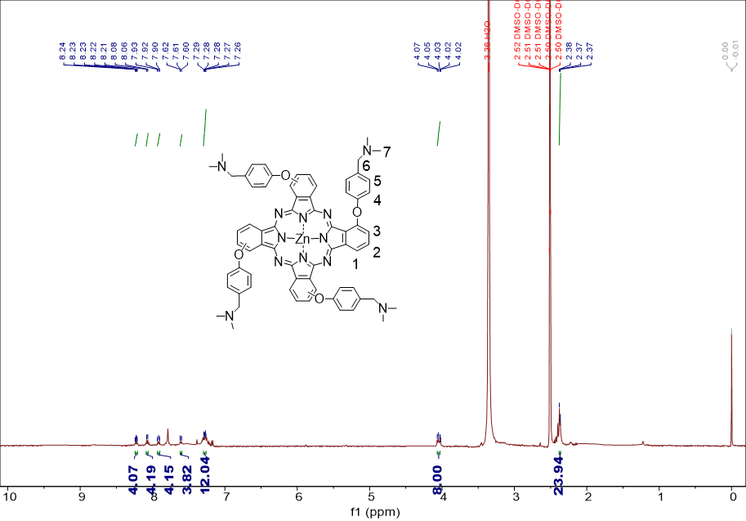
Fig. S1. ¹H NMR spectrum of NMe in DMSO-d6.
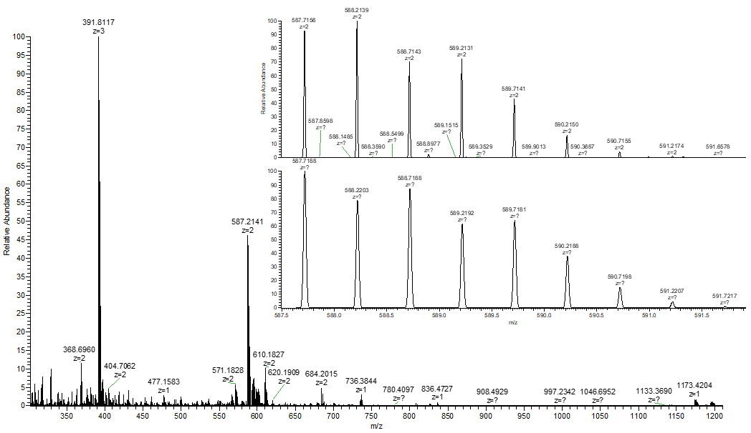
Fig. S2. HRMS spectrum of NMe. The inset shows the enlarged isotopic envelop for the [M+2H]²⁺ species.
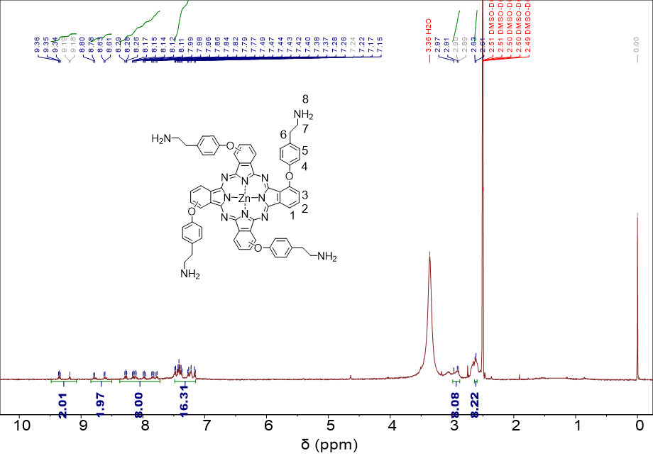
Fig. S3. ¹H NMR spectrum of NH in DMSO-d6.
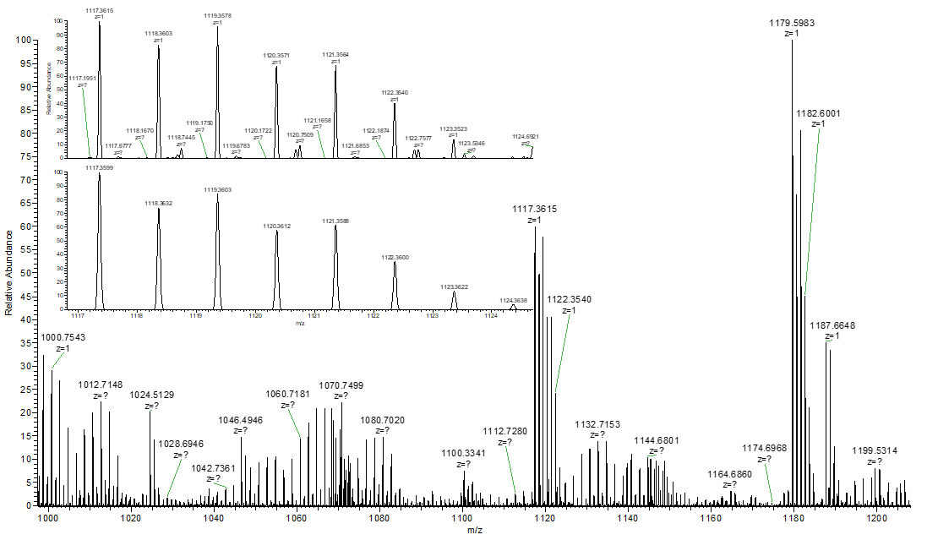
Fig. S4. HRMS spectrum of NH. The inset shows the enlarged isotopic envelop for the [M+H]⁺ species.
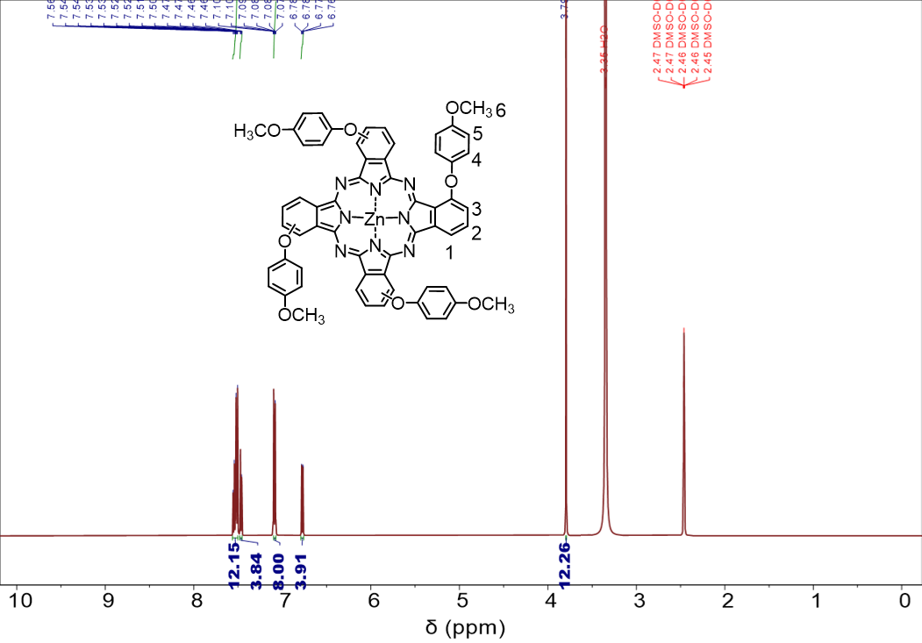
Fig. S5. ¹H NMR spectrum of OMe in DMSO-d6.
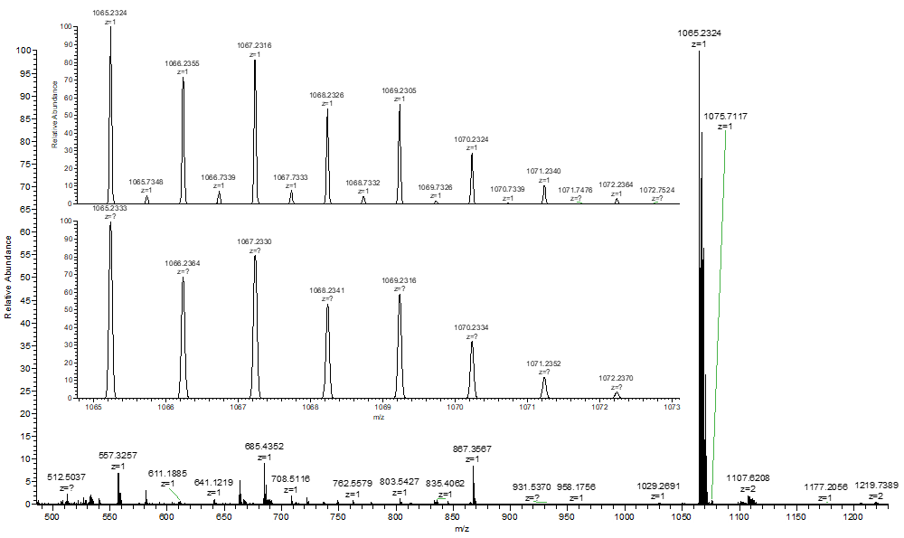
Fig. S6. HRMS spectrum of OMe. The inset shows the enlarged isotopic envelop for the [M+H]⁺ species.
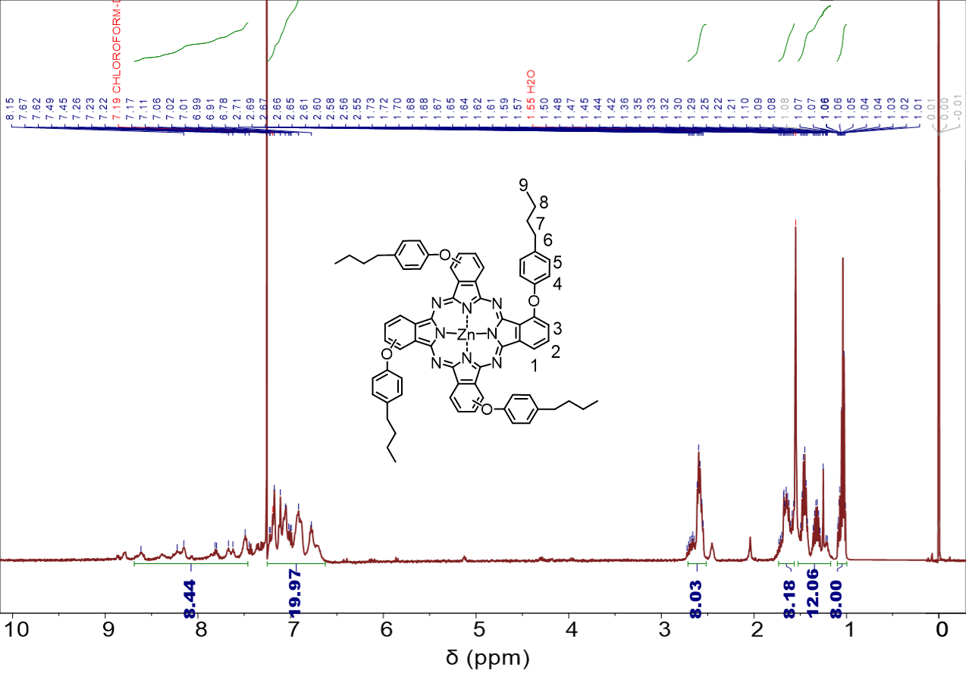
Fig. S7. ¹H NMR spectrum of Bu in Chloroform-d.
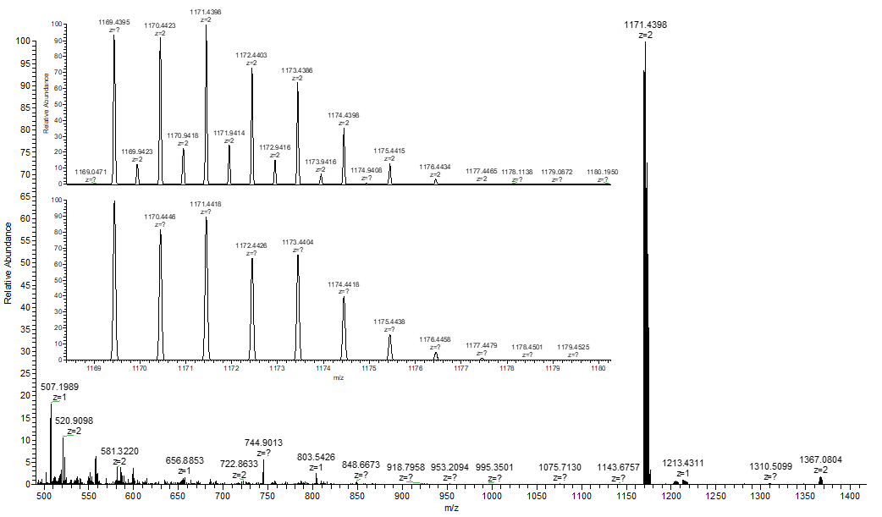
Fig. S8. HRMS spectrum of Bu. The inset shows the enlarged isotopic envelop for the [M+H]⁺ species.
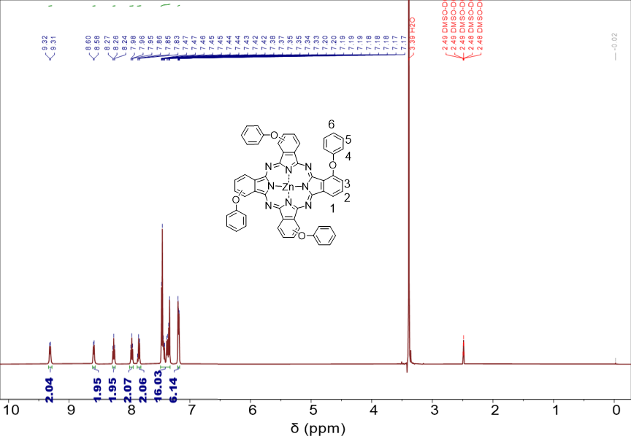
Fig. S9. ¹H NMR spectrum of H in DMSO-d6.
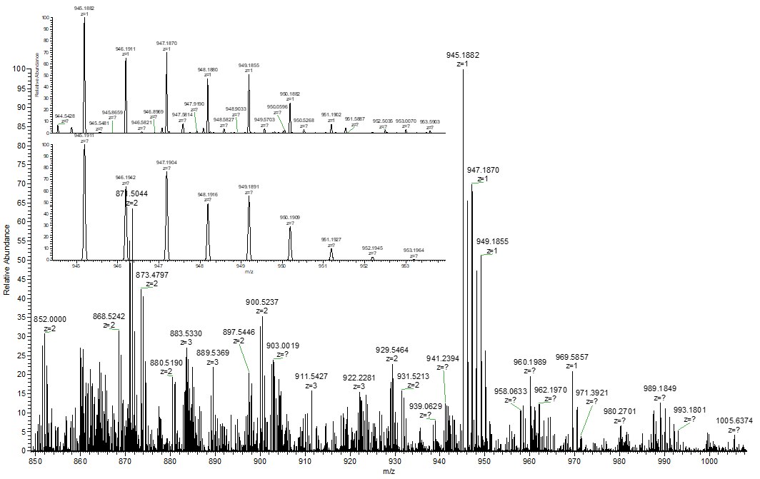
Fig. S10. HRMS spectrum of H. The inset shows the enlarged isotopic envelop for the [M+H]⁺ species.
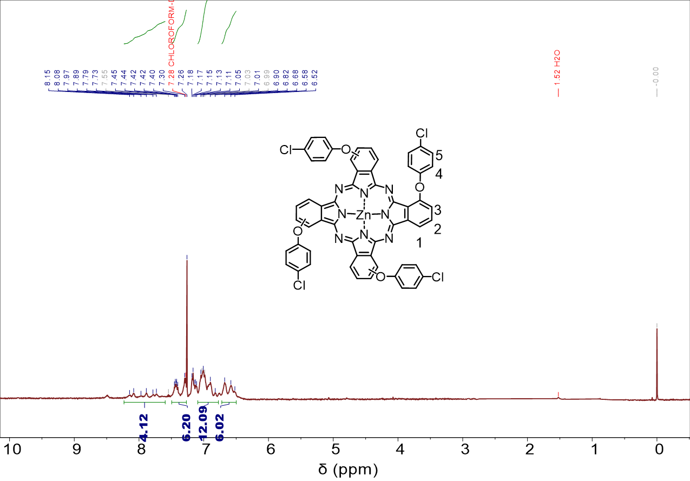
Fig. S11. ¹H NMR spectrum of Cl in Chloroform-d.
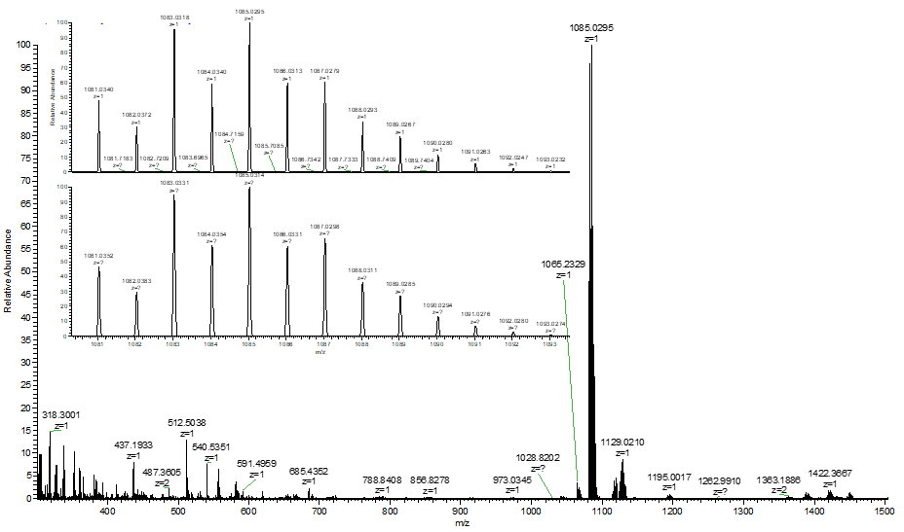
Fig. S12. HRMS spectrum of Cl. The inset shows the enlarged isotopic envelop for the [M+H]⁺ species.
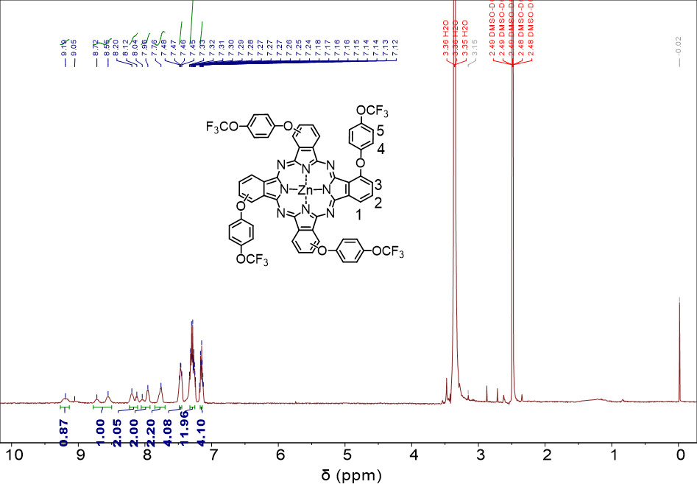
Fig. S13. ¹H NMR spectrum of OCF in DMSO-d6.
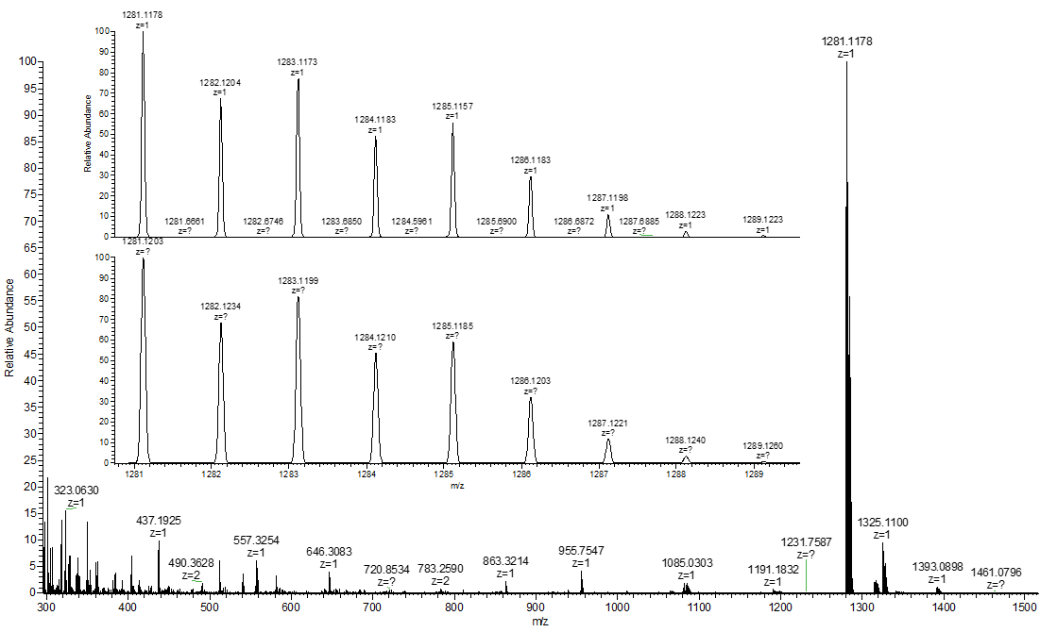
Fig. S14. HRMS spectrum of OCF. The inset shows the enlarged isotopic envelop for the [M+H]⁺ species.
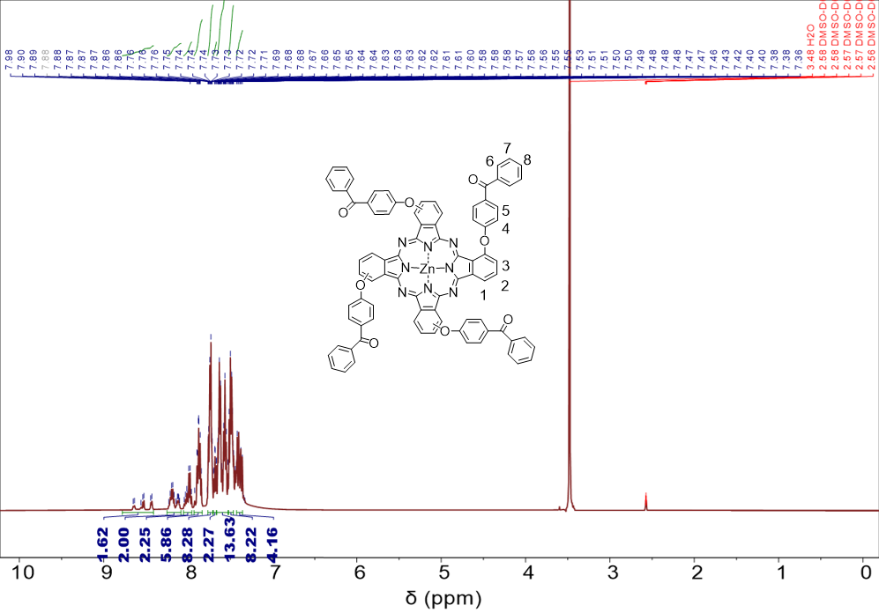
Fig. S15. ¹H NMR spectrum of COP in DMSO-d6.
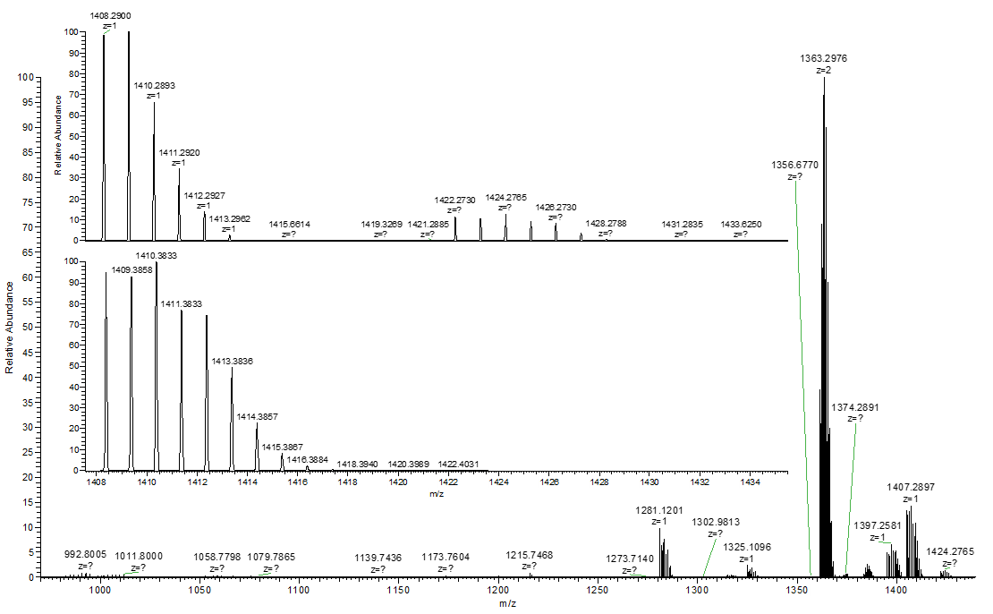
Fig. S16. HRMS spectrum of COP. The inset shows the enlarged isotopic envelop for the [M+H]⁺ species.
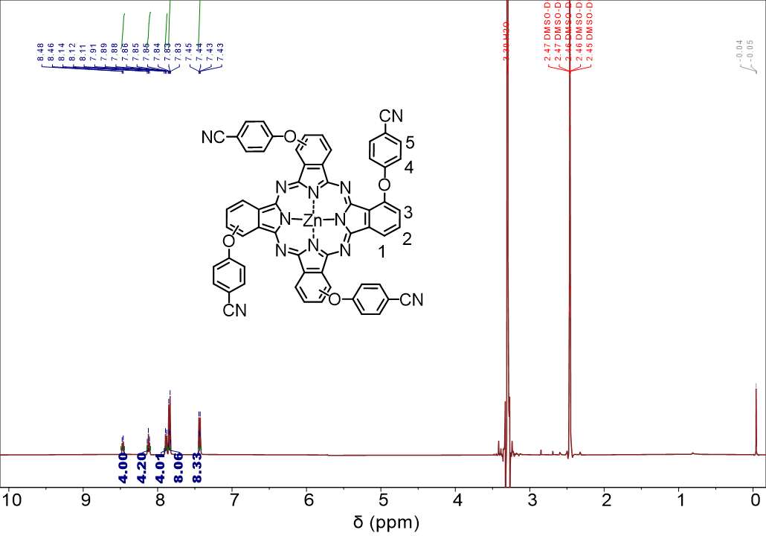
Fig. S17. ¹H NMR spectrum of CN in DMSO-d6.
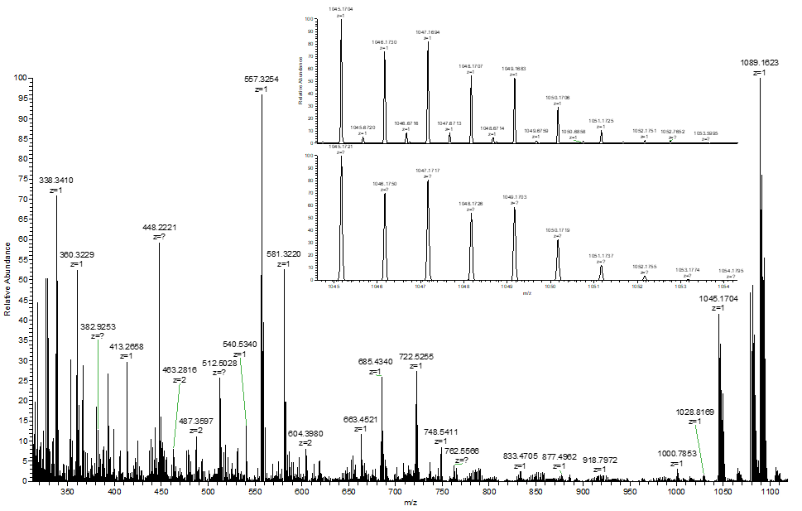
Fig. S18. HRMS spectrum of CN. The inset shows the enlarged isotopic envelop for the [M+H]⁺ species.
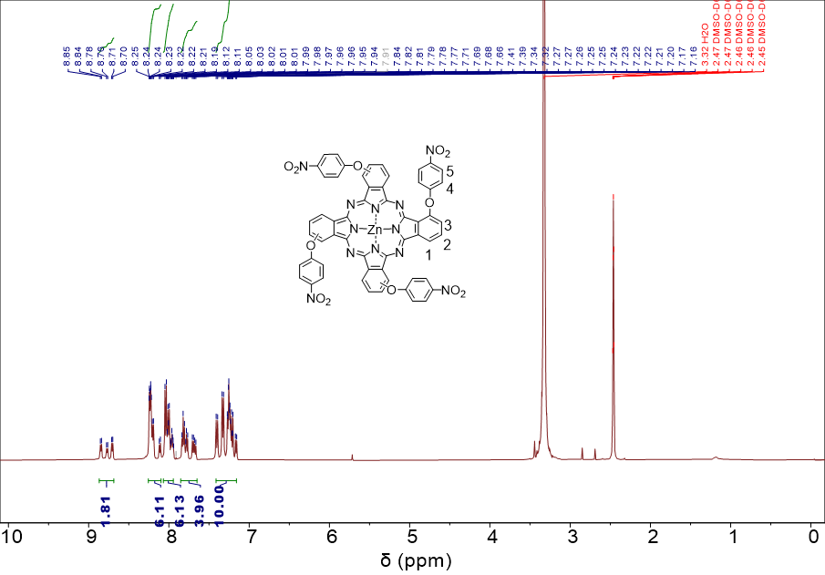
Fig. S19. ¹H NMR spectrum of NO in DMSO-d6.
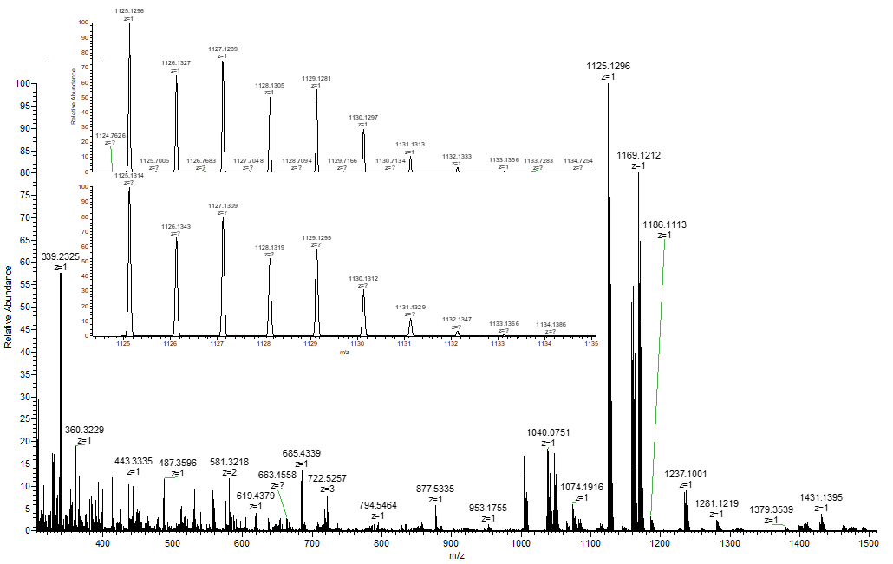
Fig. S20. HRMS spectrum of NO. The inset shows the enlarged isotopic envelop for the [M+H]⁺ species.

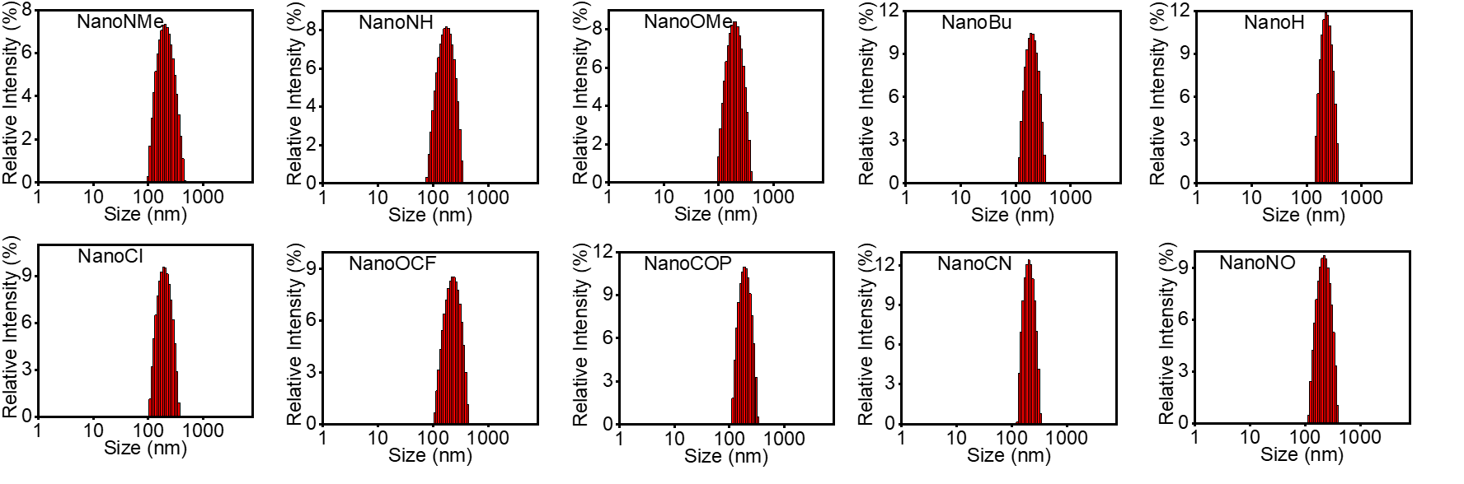
Fig. S21. Size distribution of NanoPcs (5 μM) in water detected using DLS.

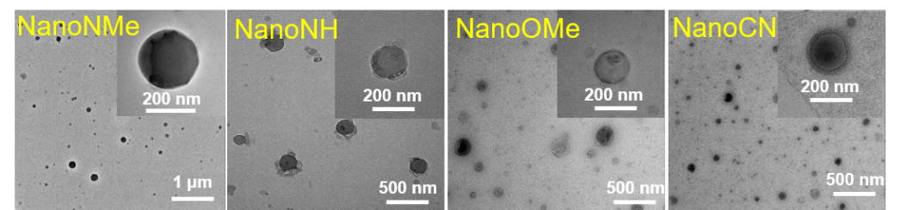
Fig. S22. Morphology of NanoPcs determined using TEM.

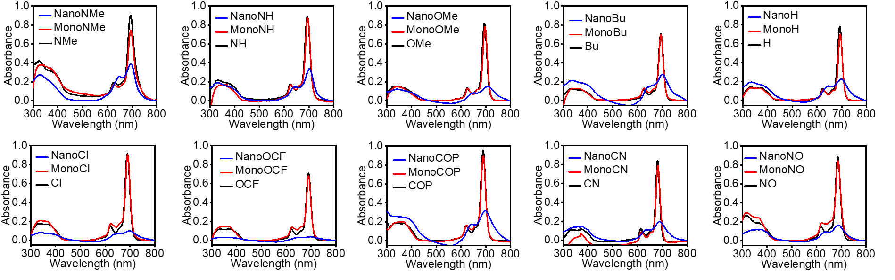
Fig. S23. Absorption spectra of NanoPcs (5 μM), MonoPcs (5 μM) and Pcs (5 μM) in DMF.
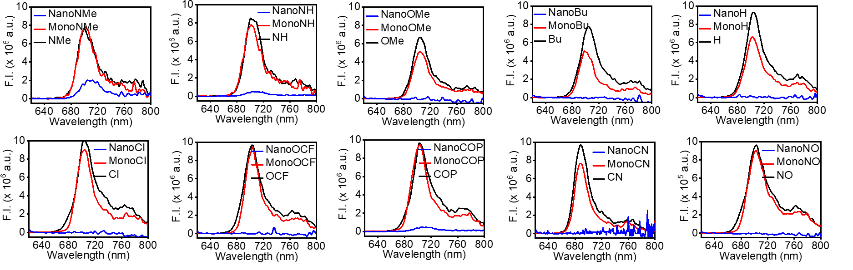
Fig. S24 Fluorescence spectra (excited at 610 nm) of NanoPcs (5 μM) and MonoPcs (5 μM) and Pcs (5 μM) in DMF. F.I., fluorescence intensity.
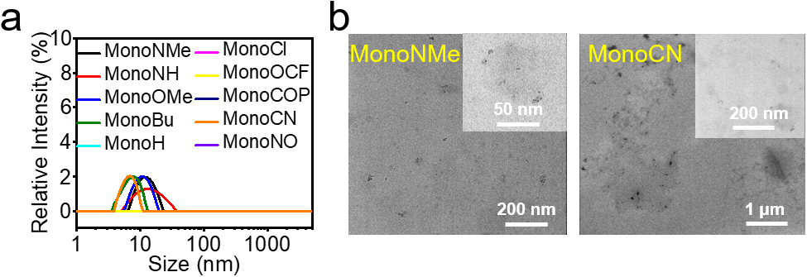
Fig. S25. (a) Size distribution of MonoPcs determined using DLS and (b) morphology of MonoNMe and MonoCN determined using TEM.

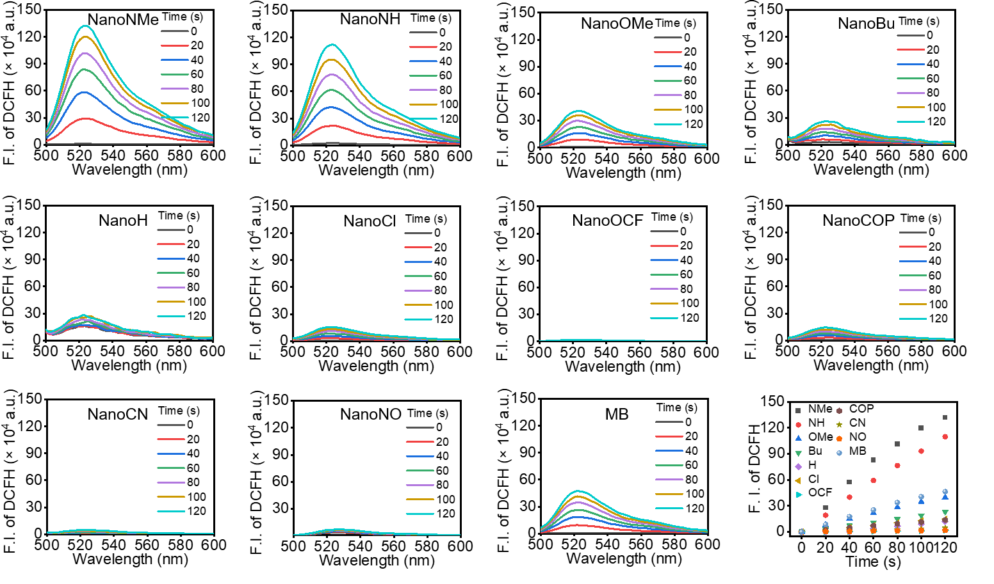
Fig. S26. Detection of ROS generation by NanoPcs using DCFH probe under irradiation (λ > 610 nm; 5 mW·cm⁻²) and the changes in fluorescence intensity of DCFH at 525 nm. F.I., fluorescence intensity.

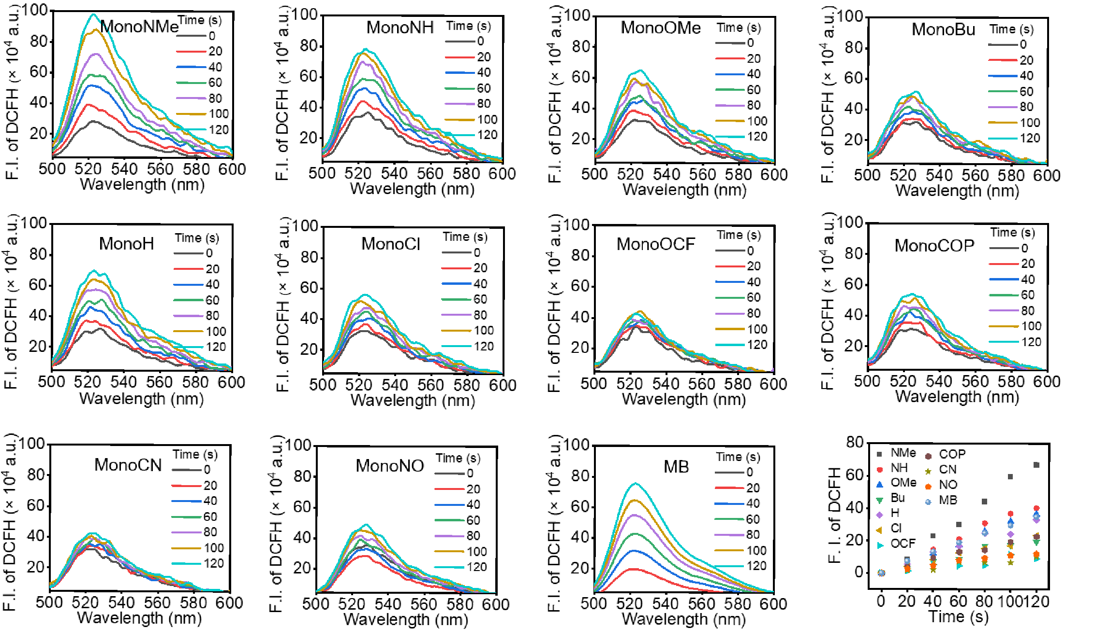
Fig. S27. Detection of ROS generation by MonoPcs using DCFH probe under irradiation (λ > 610 nm; 5 mW·cm⁻²) and the changes in fluorescence intensity of DCFH at 525 nm. F.I., fluorescence intensity.

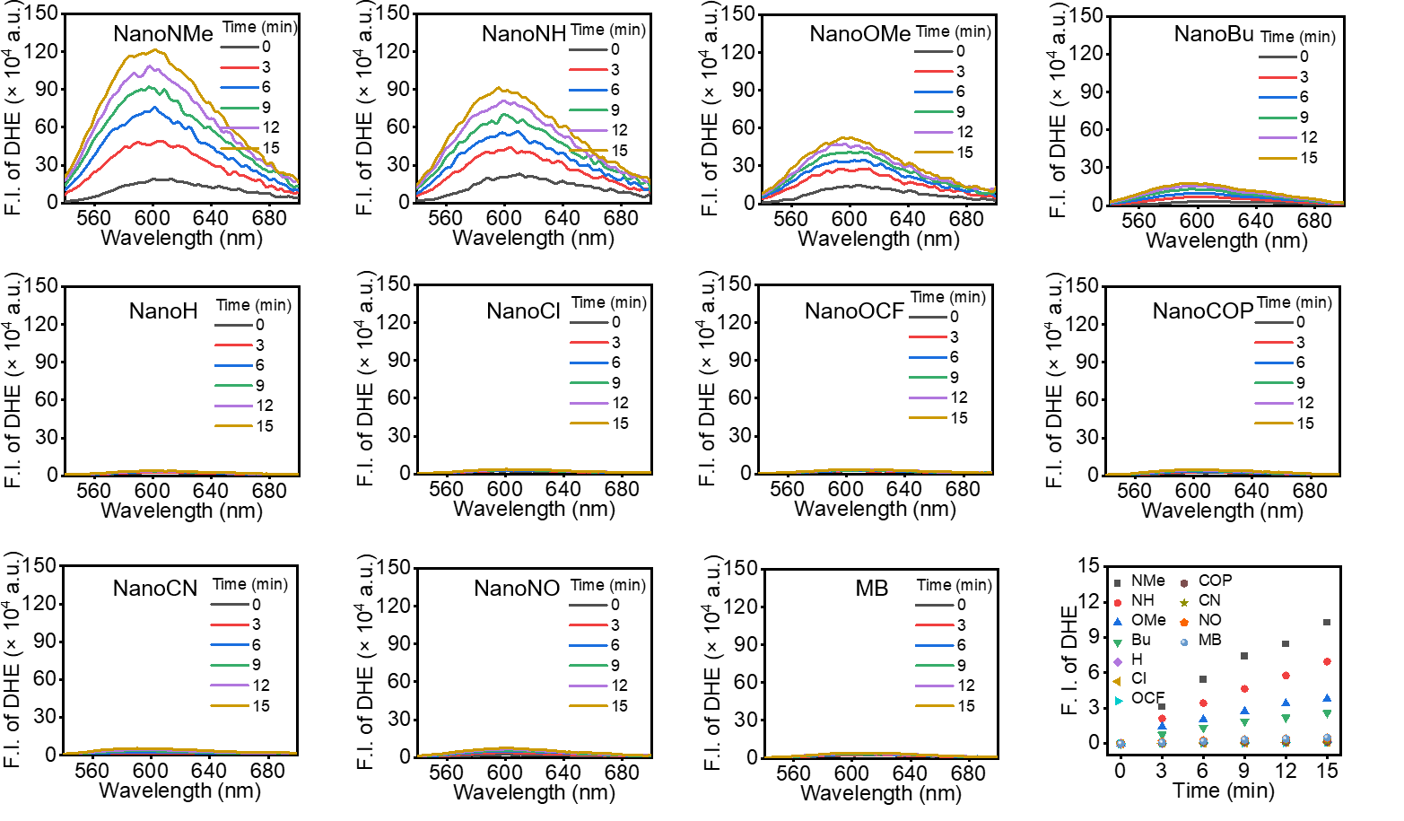
Fig. S28. Detection of O₂^{•-} generation by NanoPcs using DHE probe under irradiation (λ > 610 nm; 5 mW·cm⁻²) and the changes in fluorescence intensity of DHE at 599 nm. F.I., fluorescence intensity.

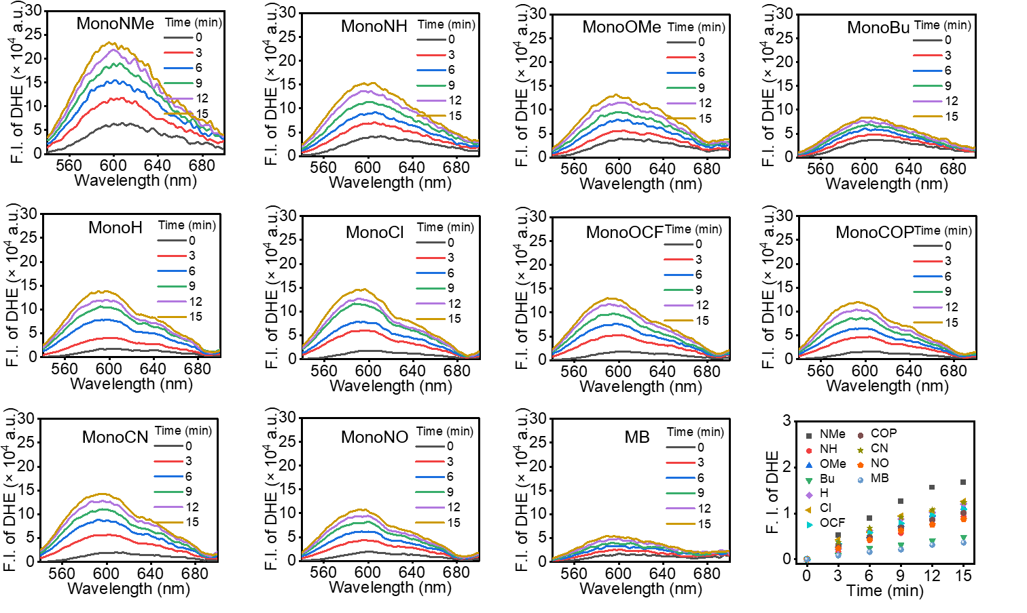
Fig. S29. Detection of O₂^{•-} generation by MonoPcs using DHE probe under irradiation (λ > 610 nm; 5 mW·cm⁻²) and the changes in fluorescence intensity of DHE at 599 nm. F.I., fluorescence intensity.

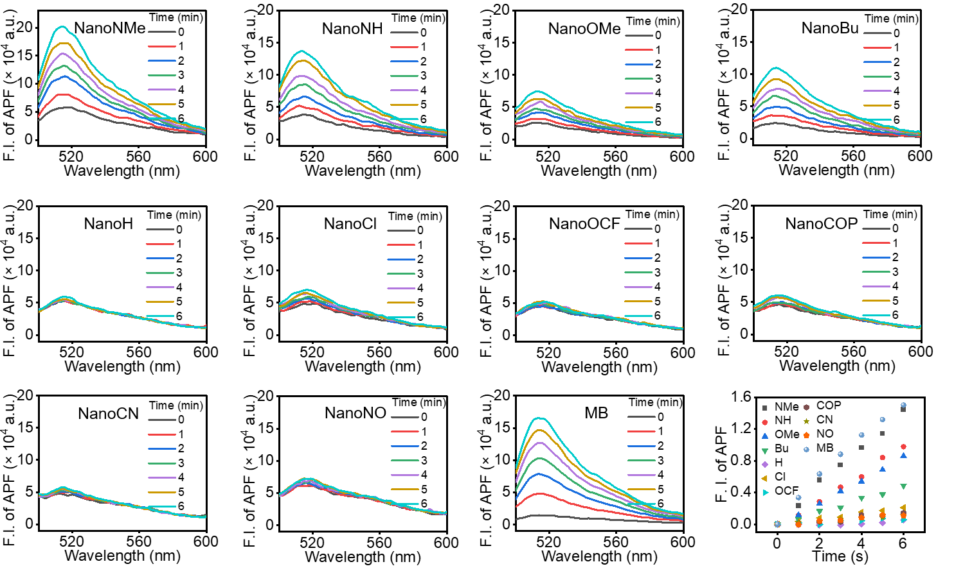
Fig. S30. Detection of •OH generation by NanoPcs using APF probe under irradiation (λ > 610 nm; 5 mW·cm⁻²) and the changes in fluorescence intensity of APF at 515 nm. F.I., fluorescence intensity.

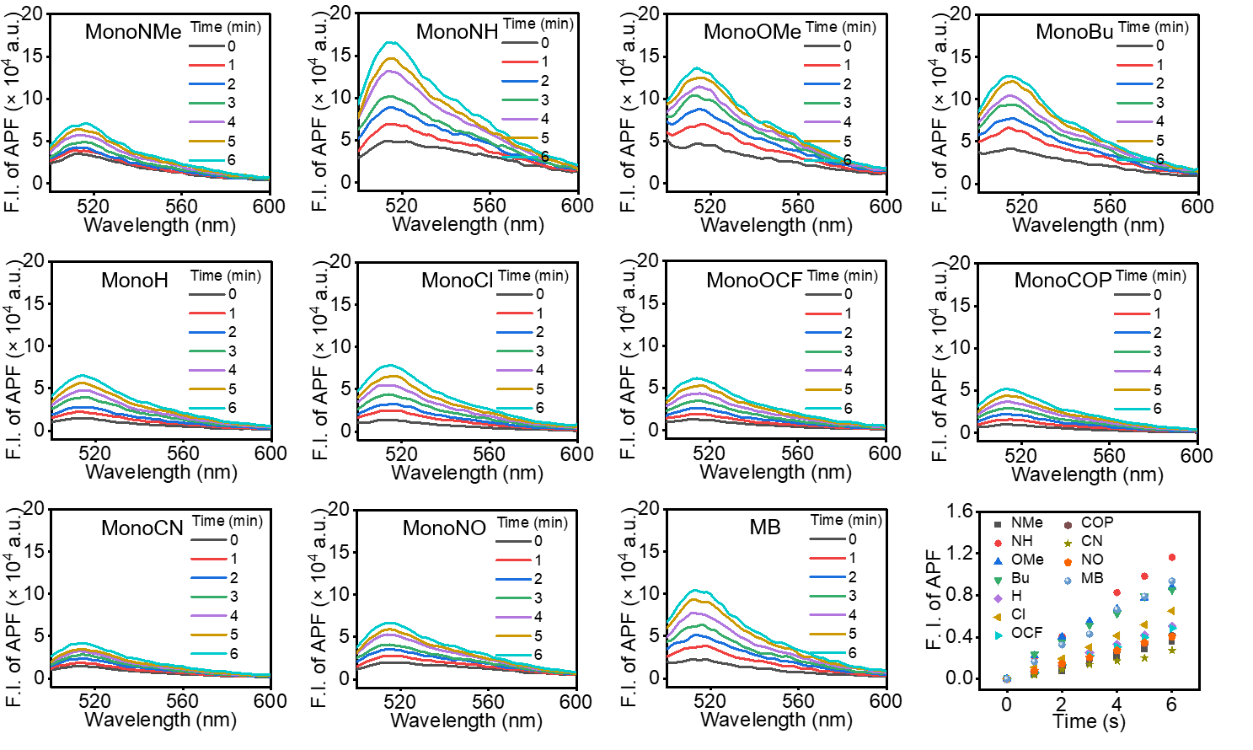
Fig. S31. Detection of •OH generation by MonoPcs using APF probe under irradiation (λ > 610 nm; 5 mW·cm⁻²) and the changes in fluorescence intensity of APF at 515 nm. F.I., fluorescence intensity.

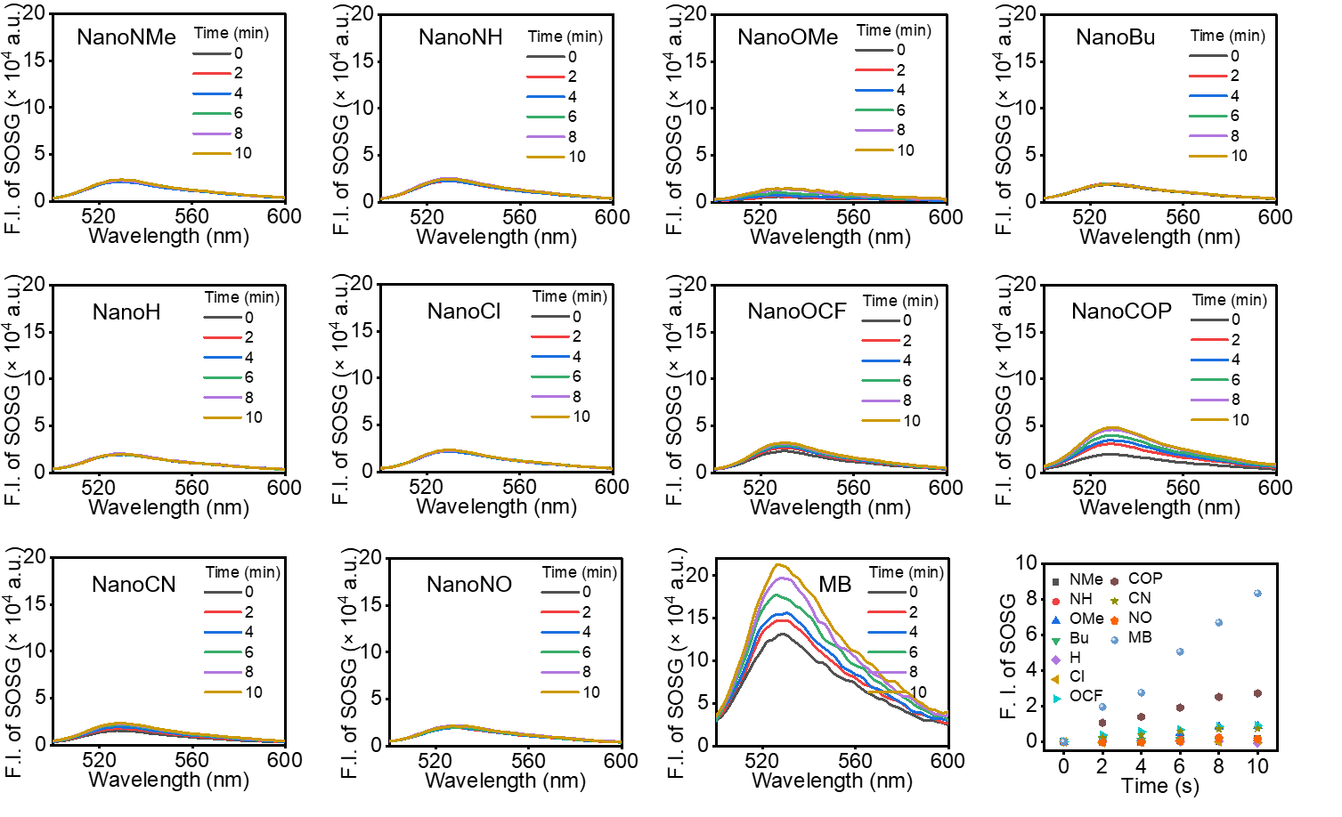
Fig. S32. Detection of ¹O₂ generation by NanoPcs using SOSG probe under irradiation (λ > 610 nm; 5 mW·cm⁻²) and the changes in fluorescence intensity of SOSG at 520 nm. F.I., fluorescence intensity.

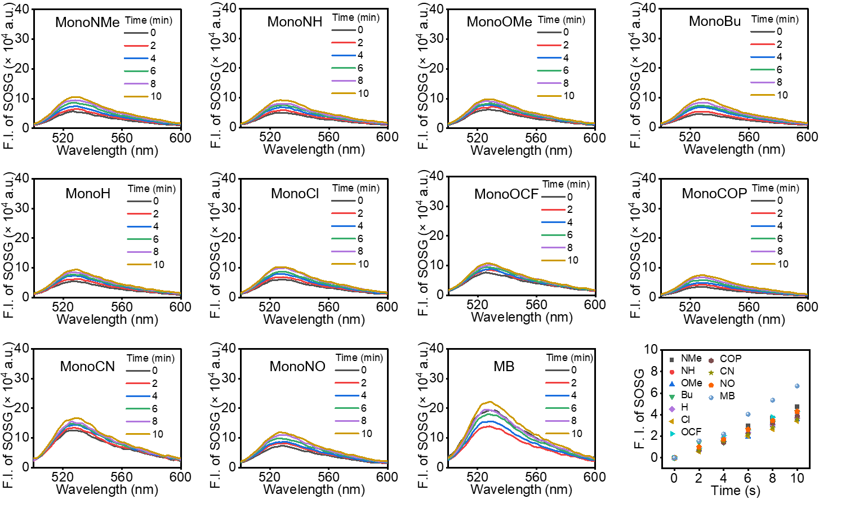
Fig. S33. Detection of ¹O₂ generation by MonoPcs using SOSG probe under irradiation (λ > 610 nm; 5 mW·cm⁻²) and the changes in fluorescence intensity of SOSG at 520 nm. F.I., fluorescence intensity.

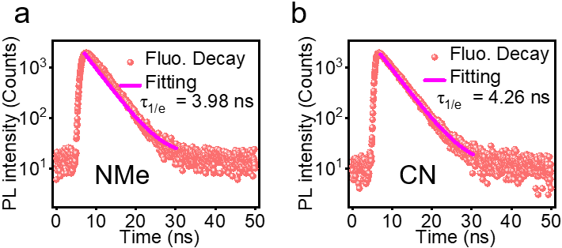
Fig. S34. Fluorescence lifetime of (a) NMe and (b) CN in THF at 298 K (EPL-670, 50 ps, 10 MHz).

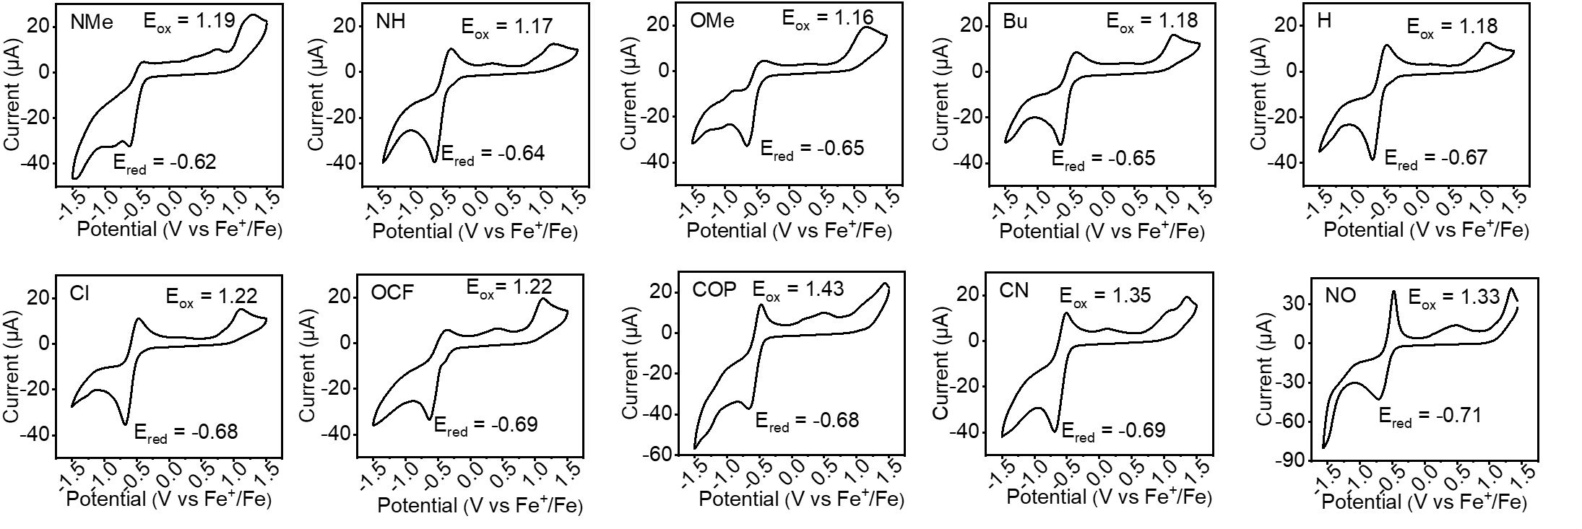
Fig. S35. Cyclic voltammogram of Pcs in DMF with 0.1 M (n-Bu)₄N⁺PF^{6–} as a supporting electrolyte, glassy carbon as a working electrode, Ag/AgCl as a reference electrode, Pt wire as counter electrode, and a scanning rate of 100 mV·s⁻¹, Ferrocene was used as an external reference.

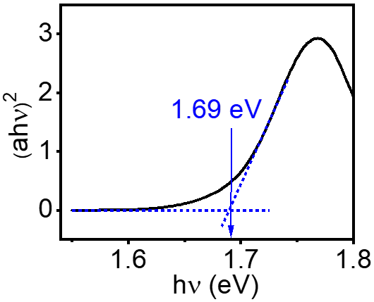
Fig. S36. Absorption spectra of NanoNMe. hν can be converted according to hν = 1240 / λ.

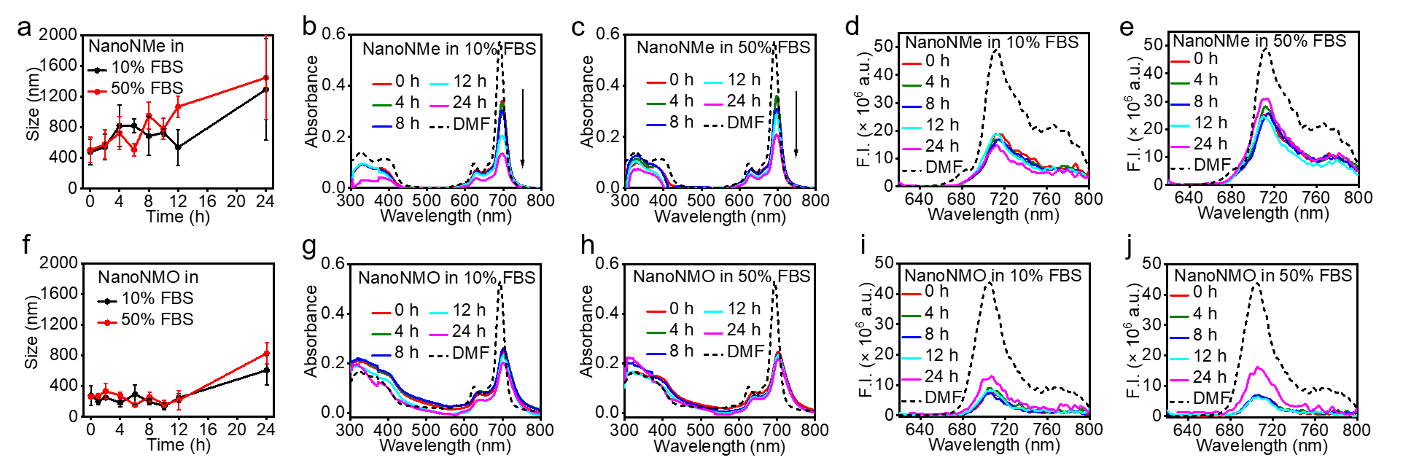
Fig. S37. (a) Mean size of NanoNMe (5 μM) in water after aging for different times detected using DLS. Absorption spectra of NanoNMe (5 μM) in PBS contain (b) 10% FBS or (c) 50%FBS after aging for different times. Fluorescence spectra (λ_{ex} = 610 nm) of NanoNMe (10 μM) in PBS contain (d) 10% FBS or (e) 50% FBS after aging for different times. (f) Mean size of NanoNMO (5 μM) in water after aging for different times detected using DLS. Absorption spectra of NanoNMO (5 μM) in PBS contain (g) 10% FBS or (h) 50% FBS after aging for different times. Fluorescence spectra of NanoNMO (5 μM) in PBS contain (i) 10% FBS or (j) 50%FBS after aging for different times. F.I., fluorescence intensity.

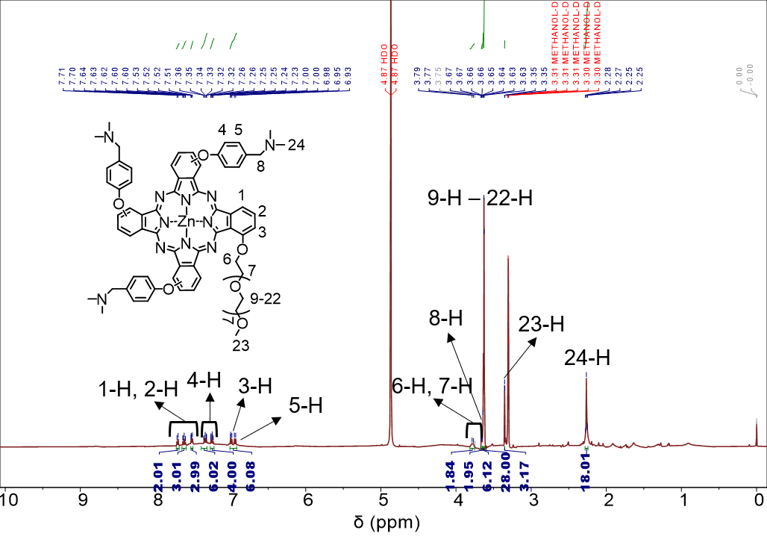
Fig. S38. ¹H NMR spectrum of NMO in methanol-d4.

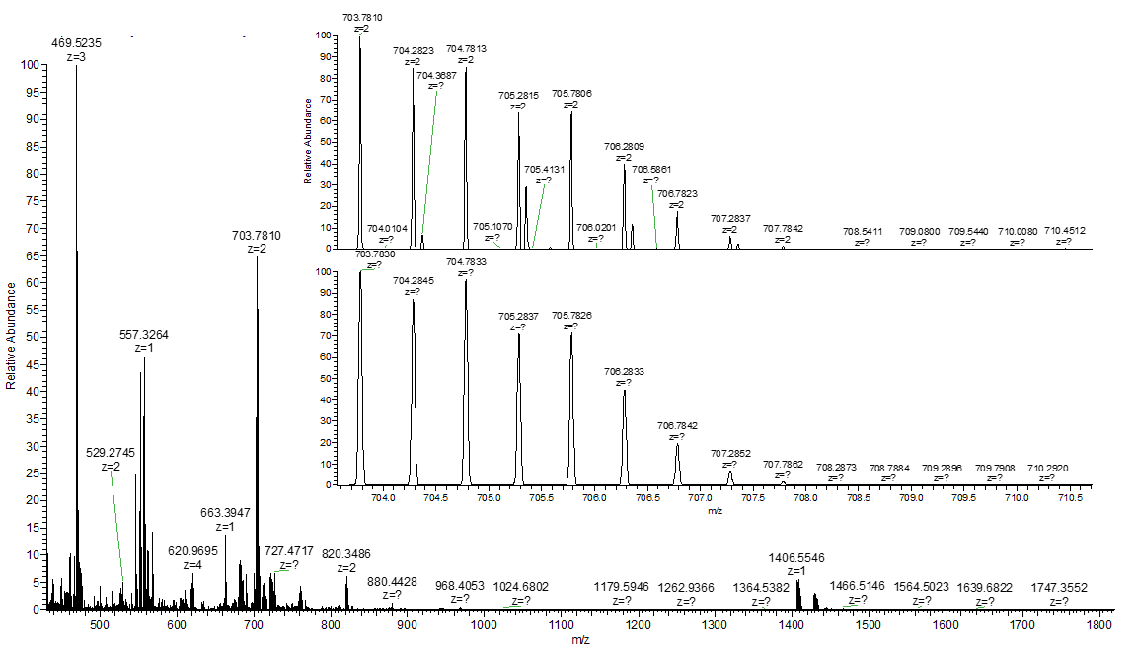
Fig. S39. HRMS spectrum of NMO. The inset shows the enlarged isotopic envelop for the [M+2H]²⁺ species.

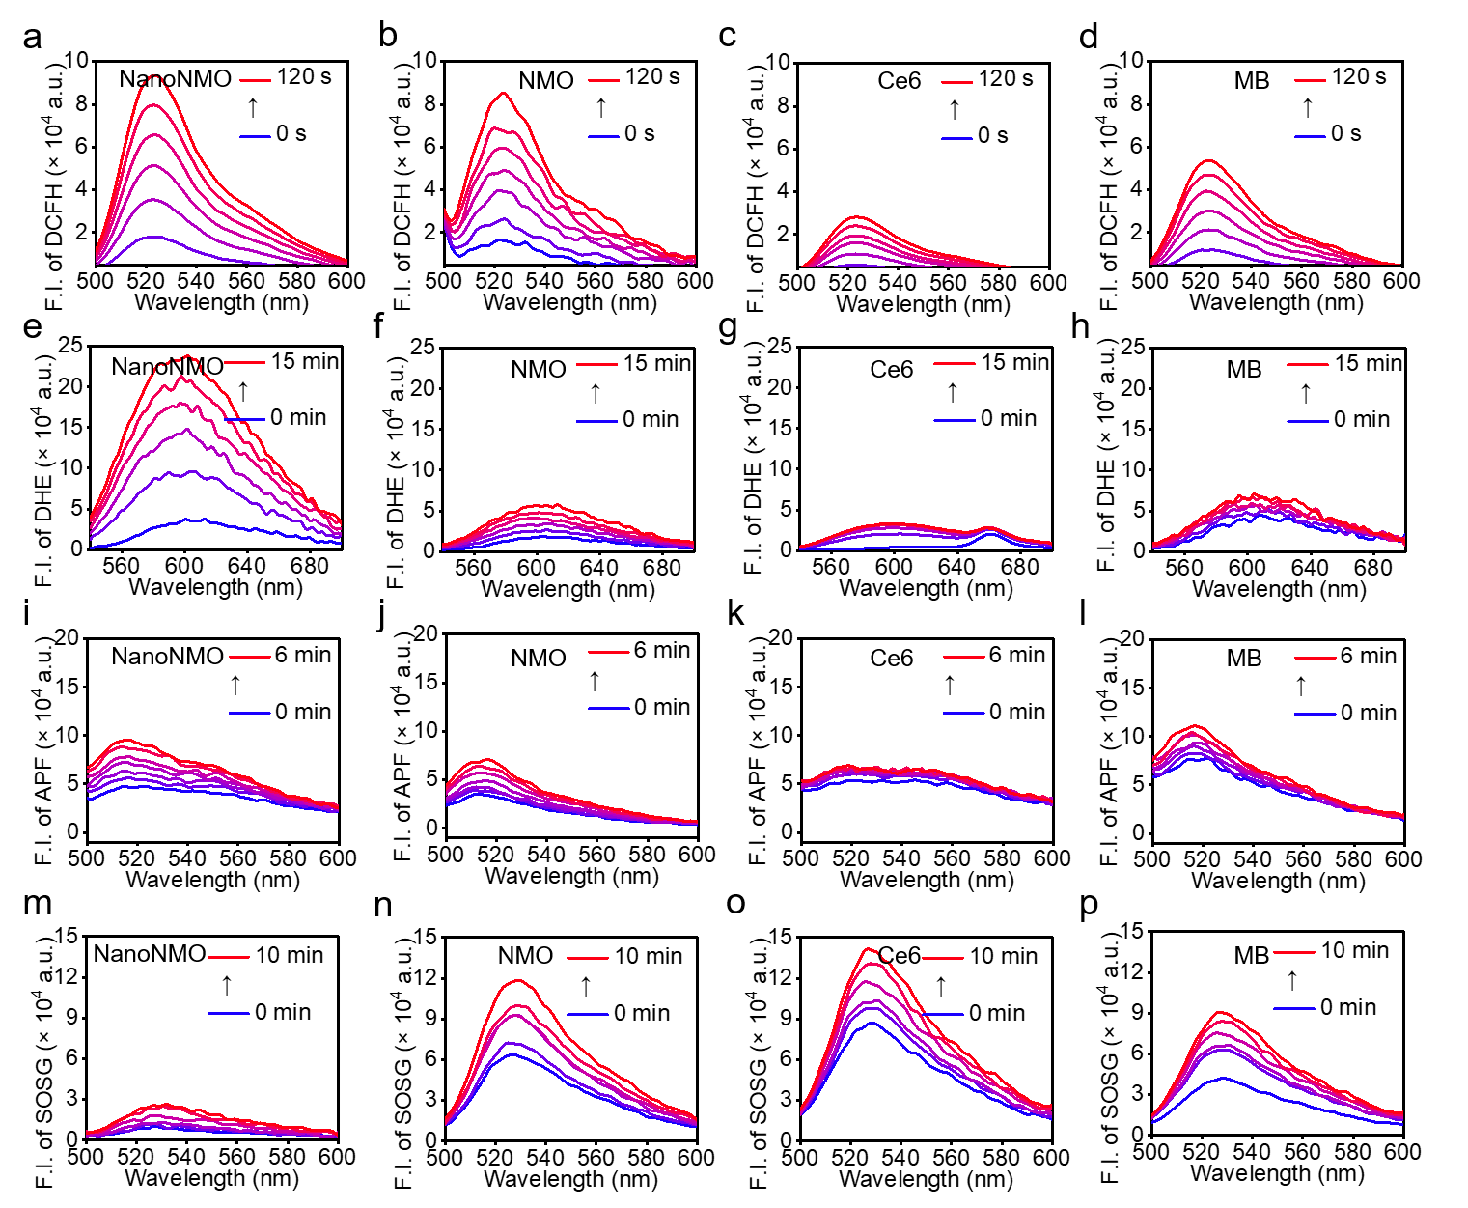
Fig. S40. Detection of ROS generation by (a) NanoNMO, (b) NMO, (c) Ce6 and (d) MB using DCFH probe. Detection of O₂^{•-} generation by (e) NanoNMO, (f) NMO, (g) Ce6 and (h) MB using DHE probe. Detection of •OH generation by (i) NanoNMO, (j) NMO, (k) Ce6 and (l) MB using APF probe. Detection of ¹O₂ generation by (m) NanoNMO, (n) NMO, (o) Ce6 and (p) MB using SOSG probe. The samples were exposed under light (λ > 610 nm, 5 mW·cm⁻²) for different times. F.I., fluorescence intensity.

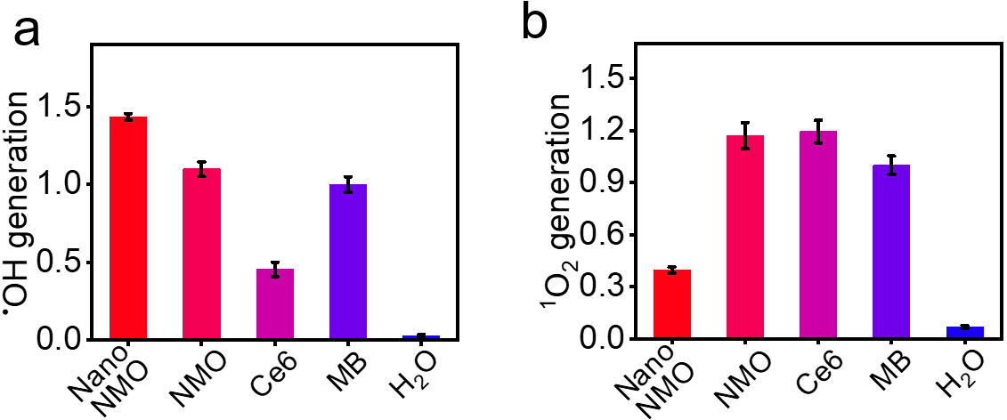
Fig. S41. (a) Relative •OH generation of NanoNMO, NMO, Ce6 and MB using APF probe. (b) Relative ¹O₂ generation of NanoNMO, NMO, Ce6 and MB using SOSG probe. The relative •OH and ¹O₂ generations of NanoNMO, NMO and Ce6 were determined comparing them with the reference samples (MB). The probe slope of MB was considered as 1, and the slope ratios were served as the ordinate.

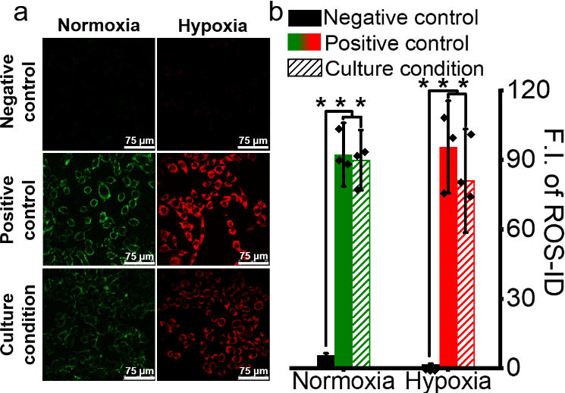
Fig. S42. (a) Intracellular normoxia and hypoxia imaging and (b) quantitative data performed by ROS-ID, with a negative control and a positive control (ROS inducer and hypoxia inducer) included³. For normoxia condition, the negative control group was treated with the hypoxia inducer to induce hypoxia within the cells. The positive control group, on the other hand, was treated with a ROS inducer to induce the production of ROS within the cells. For hypoxia condition, the negative control group was treated with a ROS inducer to induce ROS production within the cells. The positive control group was treated with the hypoxia inducer to induce a hypoxic condition within the cells. The average intracellular fluorescence intensities were quantified. Data were expressed as mean ± SD. ***p < 0.001, determined by Student’s t test.

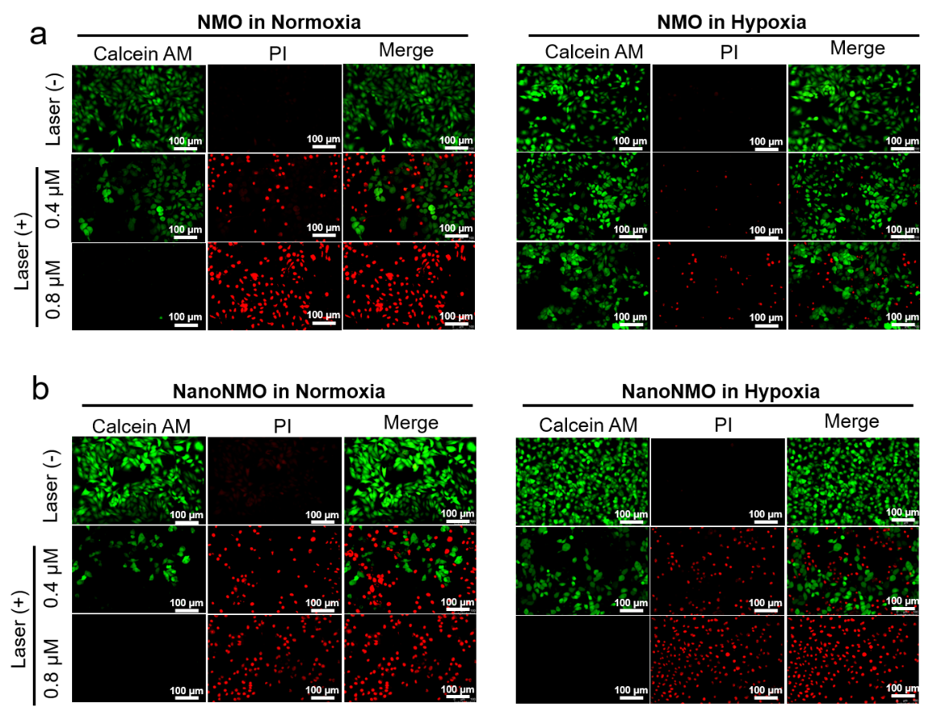
Fig. S43. Calcein-AM/PI costaining detected by fluorescence microscopy (scale bar = 100 μm). Calcein-AM staining was shown in the green channel, PI staining was shown in the red channel. (a) Cells were treated with dark, 0.4 μM or 0.8 μM NMO with 685 nm laser (15 mW·cm⁻², 30 min) under normoxia (left) or hypoxia (left), respectively. (b) Cells were treated with dark, 0.4 μM or 0.8 μM NanoNMO with 685 nm laser (15 mW·cm⁻², 30 min) under normoxia (left) or hypoxia (left), respectively.

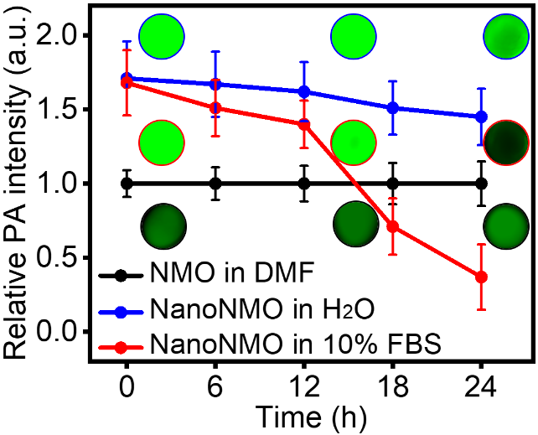
Fig. S44. Relative photoacoustic intensities of NMO and NanoNMO under different conditions.

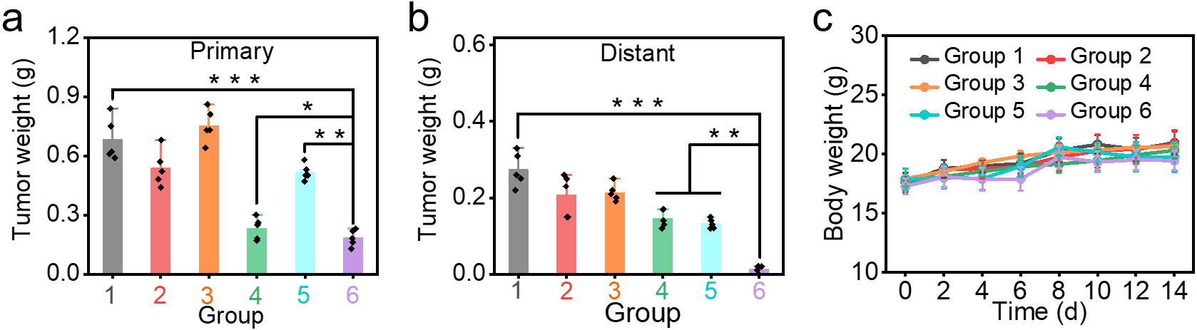
Fig. S45. Average weights of (a) primary tumors and (b) distant tumors following different treatments (n = 5). (c) Average body weight changes of mice after different treatments. Group 1: treated with saline; Group 2: treated with saline followed by laser irradiation (685 nm, 100 mW·cm⁻²) 8 h after injection; Group 3: treated with NanoNMO (200 μM, 100 μL); Group 4: treated with NanoNMO (200 μM, 100 μL) followed by laser irradiation (685 nm, 100 mW·cm⁻²) on the primary tumor 8 h after injection; Group 5: treated with αPD-1 twice (2.5 mg·kg⁻¹) on day 1 and day 3, respectively; Group 6: treated with NanoNMO (200 μM, 100 μL) followed by laser irradiation (685 nm, 100 mW·cm⁻²) on the primary tumor 8 h after injection, and then treated with αPD-1 twice (2.5 mg·kg⁻¹) on day 1 and day 3, respectively.

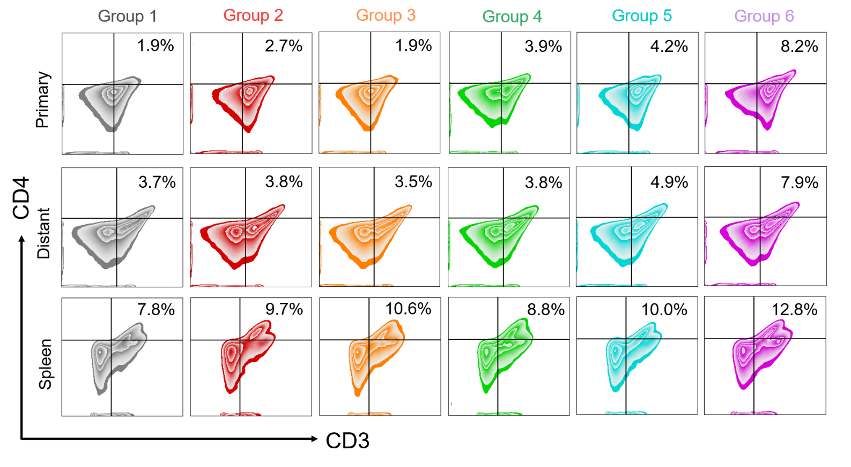
Fig. S46. Flow cytometry examination of tumor and spleen-infiltrating CD4⁺ T lymphocytes after different treatments.

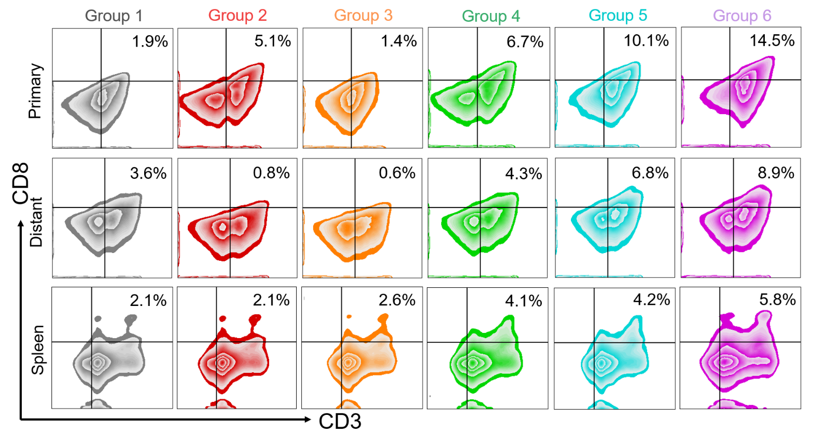
Fig. S47. Flow cytometry examination of tumor and spleen-infiltrating CD8⁺ T lymphocytes after different treatments.

Table S1. TD-B3LYP⁴/PCM calculated vertical excitation energies E(eV) and leading transition composition (the H and L refer to the HOMO and LUMO, respectively) for the singlet excitation states.
Structure | State | E(eV) | Leading transition configurations (%)
NMe | S1 | 1.890 | H -> L 97.1%
NMe | S2 | 1.890 | H -> L+1 97.1%
NMe | S3 | 2.073 | H-1 -> L+1 51.1%, H-1 -> L 48.0%
NH | S1 | 1.897 | H -> L 82.3%, H -> L+1 14.9%
NH | S2 | 1.898 | H -> L+1 82.3%, H -> L 14.9%
NH | S3 | 2.961 | H-1 -> L+1 60.8%, H-1 -> L 27.5%, H-3 -> L 5.4%
OMe | S1 | 1.898 | H -> L 88.9%, H -> L+1 8.3%
OMe | S2 | 1.898 | H -> L+1 88.9%, H -> L 8.3%
OMe | S3 | 2.842 | H-1 -> L 57.8%, H-1 -> L+1 23.6%, H-3 -> L+1 10.4%
Bu | S1 | 1.899 | H -> L 97.1%
Bu | S2 | 1.899 | H -> L+1 97.1%
Bu | S3 | 3.022 | H-3 -> L 48.7%, H-2 -> L+1 48.2%
H | S1 | 1.907 | H -> L 97.0%
H | S2 | 1.907 | H -> L+1 97.0%
H | S3 | 3.048 | H-2 -> L 48.6%, H-3 -> L+1 48.4%
Cl | S1 | 1.905 | H -> L 86.3%, H -> L+1 10.8%
Cl | S2 | 1.909 | H -> L+1 86.3%, H -> L 10.8%
Cl | S3 | 2.884 | H-1 -> L 55.8%, H-1 -> L+1 34.1%, H-3 -> L 5.7%
OCF | S1 | 1.908 | H -> L 94.2%
OCF | S2 | 1.909 | H -> L+1 94.2%
OCF | S3 | 2.954 | H-1 -> L 35.3%, H-2 -> L+1 27.8%, H-3 -> L 15.0%, H-2 -> L 12.9%
COP | S1 | 1.948 | H -> L 95.6%
COP | S2 | 1.960 | H -> L+1 95.5%
COP | S3 | 2.911 | H-1 -> L 95.3%
CN | S1 | 1.989 | H -> L 86.8%, H -> L+1 9.4%
CN | S2 | 1.989 | H -> L+1 86.8%, H -> L 9.4%
CN | S3 | 3.048 | H-1 -> L+1 40.6%, H-5 -> L+1 38.6%
NO | S1 | 1.991 | H -> L 95.4%
NO | S2 | 1.991 | H -> L+1 95.4%
NO | S3 | 2.457 | H -> L+2 94.0%, H -> L+3 5.1%

Table S2. The redox potential, excitation energy and Gibbs-free energy of Pcs⁵.
Compound | E_{ox} (V) | E_{red}(V) | ªE*(V) | ^{b}∆G(eV)
NMe | 1.19 | -0.62 | 1.893 | -0.08
NH | 1.17 | -0.64 | 1.897 | -0.09
OMe | 1.16 | -0.65 | 1.898 | -0.09
Bu | 1.18 | -0.65 | 1.899 | -0.07
H | 1.18 | -0.67 | 1.907 | -0.06
Cl | 1.22 | -0.68 | 1.905 | -0.01
OCF | 1.22 | -0.69 | 1.908 | 0.00
COP | 1.43 | -0.68 | 1.948 | 0.16
CN | 1.35 | -0.69 | 1.989 | 0.05
NO | 1.33 | -0.71 | 1.991 | 0.05
ª The singlet excitation energy were carried out at B3LYP/6-31G* optimized TD-DFT, where the excitation energy were the adiabatic excitation energy between S1 and S0. ^{b}∆G were calculated according to ∆G = e(E_{ox} - E_{red}) - E*.

References
1. Li, X., Lee, D., Huang, J.D. & Yoon, J. Phthalocyanine-assembled nanodots as photosensitizers for highly efficient type I photoreactions in photodynamic therapy. Angew. Chem. Int. Ed. 57, 9885-9890 (2018).
2. Li, X., et al. Nanostructured phthalocyanine assemblies with protein-driven switchable photoactivities for biophotonic imaging and therapy. J. Am. Chem. Soc. 139, 10880-10886 (2017).
3. Zhao, Y.Y., et al. Nanostructured phthalocyanine assemblies with efficient synergistic effect of type I photoreaction and photothermal action to overcome tumor hypoxia in photodynamic therapy. J. Am. Chem. Soc. 143, 13980-13989 (2021).
4. Teng, K.X., et al. BODIPY-based photodynamic agents for exclusively generating superoxide radical over singlet oxygen. Angew. Chem. Int. Ed. 60, 19912-19920 (2021).
5. Vauthey, E. Photoinduced symmetry-breaking charge separation. ChemPhysChem 13, 2001-2011 (2012).

