Supplementary Information
Exciton-Harvesting Enabled Efficient Charged Particle Detection in Zero-Dimensional Halides
Qian Wang^{1†}, Chenger Wang^{2,3†}, Hongliang Shi^{4†}, Jie Chen^{2,5}, Junye Yang^{2,5}, Alena Beitlerova⁶, Romana Kucerkova⁶, Zhengyang Zhou¹, Yunyun Li¹, Martin Nikl⁶, Xilei Sun^{2,}*, Xiaoping OuYang^{7,}*, and Yuntao Wu^{1,}*
¹Shanghai Institute of Ceramics, Chinese Academy of Sciences, Shanghai, 201899, China.
²Institute of High Energy Physics, Chinese Academy of Sciences, Beijing, 100049, China.
³National Engineering Research Center for Rare Earth, Grirem Advanced Materials Co., Ltd. and General Research Institute for Nonferrous Metals; Beijing, 100088, China.
⁴Department of Physics, Beihang University; Beijing, 100191, China.
⁵Spallation Neutron Source Science Center, Dongguan 523803, China
⁶Department of Optical Materials, Institute of Physics of the Czech Academy of Sciences; Prague, 16200, Czech Republic.
⁷Northwest Institute of Nuclear Technology; Xi’an, 710024, China.

†These authors contributed equally to this work.
*Correspondence author. Email: sunxl@ihep.ac.cn (X. Sun), oyxp2003@aliyun.com (X. OuYang), ytwu@mail.sic.ac.cn (Y. Wu)

Difference between theoretical and measured light yield
The light yields and photoluminescence quantum yields (PLQYs) of low-dimensional copper-based halide scintillators are listed by statistics. The theoretical light yields are estimated according the reported band gap values by Bartram–Lempicki model¹:
$$\begin{aligned}LR=\frac{S*Q}{β*E_{g}}\#1\end{aligned}$$
where S and Q are the transport/transfer efficiency of the e–h pair energy to the emission centers and the internal quantum efficiency in emission centers, respectively. Here, the values are set as 1. β is 1.5–1.8 for ionic halide compounds and the approximate mean is used as 1.65.
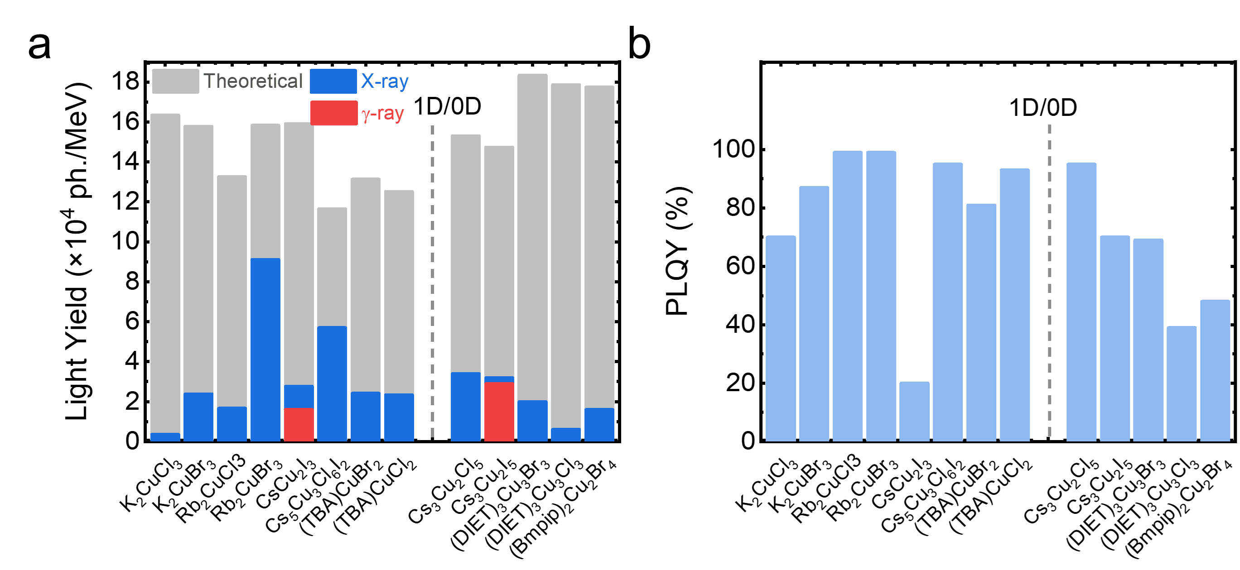
Figure S1. Light yields (a) and PLQYs (b) of low-dimensional copper-based halide scintillators.2, 3, 4, 5, 6, 7, 8, 9, 10, 11, 12, 13, 14

Crystallographic property
The differential scanning calorimetry (DSC) measurement was conducted by using a Netzsch STA449F3 instrument. About 50 mg single crystal was loaded in an Al₂O₃ crucible, and heated to 450 °C at a rate of 5 °C/min under ultra-high purity argon atmosphere.
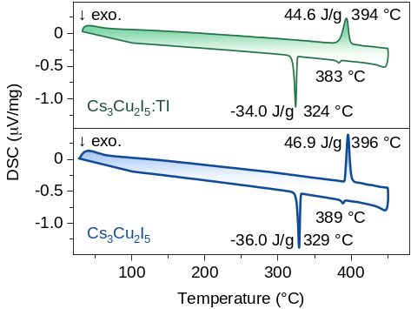
Figure S2. DSC profiles of Cs₃Cu₂I₅ and Cs₃Cu₂I₅:Tl in Ar atmosphere.

There is no additional thermal effect induced by Tl doping. The Cs₃Cu₂I₅ shows a pair of exothermic and endothermic peaks at 396 °C and 329 °C corresponding to the melting point (T_{m}) and crystallization point (T_{c}). Compared with undoped Cs₃Cu₂I₅, the T_{m} and T_{c} decrease slightly in Cs₃Cu₂I₅:Tl. It is worthwhile to note that for both the undoped and Tl-doped Cs₃Cu₂I₅, the thermal supercooling, which causes spontaneous nucleation in the melt into multiple grains, is severe due to a large temperature difference between T_{m} and T_{c}, e.g. 67 °C for Cs₃Cu₂I₅ and 70 °C for Cs₃Cu₂I₅:Tl. Moreover, there is an additional exothermic peak at the lower temperature side of the main melting peak. It can be interpreted as the second phase precipitated due to the incongruent melting of Cs₃Cu₂I₅.¹⁵ The CsI phase precipitated first (389°C, L_{0.60CsI+0.40CuI}→CsI+L) during the temperature decrease. When the ratio of CsI in the melt is reduced to 0.59, the crystallization process is transformed and the Cs₃Cu₂I₅ main phase is precipitated (329°C, L_{0.59CsI+0.41CuI}→Cs₃Cu₂I₅).
Temperature-dependent in-situ synchrotron powder X-ray diffraction (PXRD) measurements were conducted by using a PANalytical X'Pert diffractometer using Cu Kα radiation. The crystal lattice parameters at different temperatures were calculated by Le bail fitting of PXRD patterns through Jana2006.
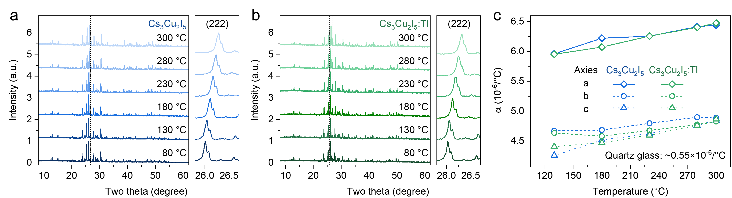
Figure S3. a, b, Temperature-dependent in-situ PXRD patterns of Cs₃Cu₂I₅ (a) and Cs₃Cu₂I₅:Tl (b) . c, Crystallographic evolution of thermal expansion coefficients as a function of temperature.

The in-situ PXRD measurements from room temperature to 300 °C were conducted. The XRD patterns as a function of temperature are shown in Fig. S3a and Fig. S3b. The XRD peaks shift to a lower angle due to the thermal expansion effect, for example for (222) crystallographic plane, the angle shifts from 26.283° to 26.008° for Cs₃Cu₂I₅, and 26.317° to 26.028° for Cs₃Cu₂I₅:Tl. The lattice parameters were calculated at different temperatures via the Le bail fitting, and listed in Table S3-4.
The evolution of thermal lattice expansion coefficients along crystallographic axes as a function of temperature is plotted in Fig. S3c. The thermal expansion behavior in Cs₃Cu₂I₅ and Cs₃Cu₂I₅:Tl is similar. The thermal expansion coefficient along b and c axis is of 4.3×10⁻⁶ and 4.8×10⁻⁶ /°C, respectively, which is about 25% smaller than that along a axis ranging from 6.0×10⁻⁶ /°C to 6.5×10⁻⁶ /°C. It indicates rather weak thermal expansion anisotropy in both Cs₃Cu₂I₅ and Cs₃Cu₂I₅:Tl, comparing with the LaBr₃:Ce that is apt to crack due to a large difference in thermal expansion coefficient along crystallographic axis (28.1×10⁻⁶ /°C along a axis and 7.5×10⁻⁶ /°C along c axis).¹⁶

Table S1. Lattice parameters of Cs₃Cu₂I₅ at different temperatures.

Temperature (°C) | a (Å) | b (Å) | c (Å) | Pnma  α = β= γ= 90°
25 | 10.17475 | 11.65392 | 14.36231 | Pnma  α = β= γ= 90°
80 | 10.20575 | 11.68294 | 14.39435 | Pnma  α = β= γ= 90°
130 | 10.23617 | 11.71024 | 14.42502 | Pnma  α = β= γ= 90°
180 | 10.26926 | 11.73768 | 14.45934 | Pnma  α = β= γ= 90°
230 | 10.30154 | 11.76704 | 14.49425 | Pnma  α = β= γ= 90°
280 | 10.33668 | 11.79741 | 14.53136 | Pnma  α = β= γ= 90°
300 | 10.35036 | 11.80856 | 14.54783 | Pnma  α = β= γ= 90°

Table S2. Lattice parameters of Cs₃Cu₂I₅:Tl at different temperatures.

Temperature (°C) | a (Å) | b (Å) | c (Å) | Pnma  α = β= γ= 90°
80 | 10.19706 | 11.67873 | 14.38901 | Pnma  α = β= γ= 90°
130 | 10.22742 | 11.7058 | 14.42072 | Pnma  α = β= γ= 90°
180 | 10.259 | 11.73227 | 14.45337 | Pnma  α = β= γ= 90°
230 | 10.29278 | 11.76069 | 14.48828 | Pnma  α = β= γ= 90°
280 | 10.32767 | 11.79028 | 14.52614 | Pnma  α = β= γ= 90°
300 | 10.34233 | 11.80279 | 14.54313 | Pnma  α = β= γ= 90°

Based on the above analysis results, we stress the importance of ampoule design and crystal growth process. The quartz ampoule with a straight capillary was used to prevent the thermal supercooling effect. A large temperature gradient of 30-40 °C and a slow growth rate of 0.3-0.5 mm/h were adopted to avoid the constitutional supercooling effect.
The raw materials were weighed according to the formula, and loaded into a quartz ampoule with 7 mm inner diameter in an Argon-filled glovebox. The loaded raw materials were heated to 120 °C under vacuum of 10⁻⁴ Pa to remove any trace moisture prior to sealing with an oxy-hydrogen torch. The crystals were grown from a randomly oriented seed formed in a quartz ampoule with a capillary at the front. Moreover, to avoid the adverse reactions between the crystal and the surface of quartz ampoule, the ampoule was coated with a durable pyrolytic carbon before use.
The crystal growth was conducted in a home-made multi-ampoule vertical Bridgman furnace. The loaded ampoules were first heated to above the melting point of Cs₃Cu₂I₅ for several hours to fully mix and homogenize the melt. After optimization, the translation rate and temperature gradient are found to be 0.4 mm/h and 20∼25 °C/cm, respectively. After growth completion, the furnace was cooled to room temperature at 5 °C/h.

Evaluation of crystal quality
The optical transmission spectra from 200 to 800 nm were recorded by the PerkinElmer-Lambda 950 ultraviolet-visible spectrophotometer. Refractive index and extinction coefficient spectra were obtained using a sopra GES-SE ellipsometer.
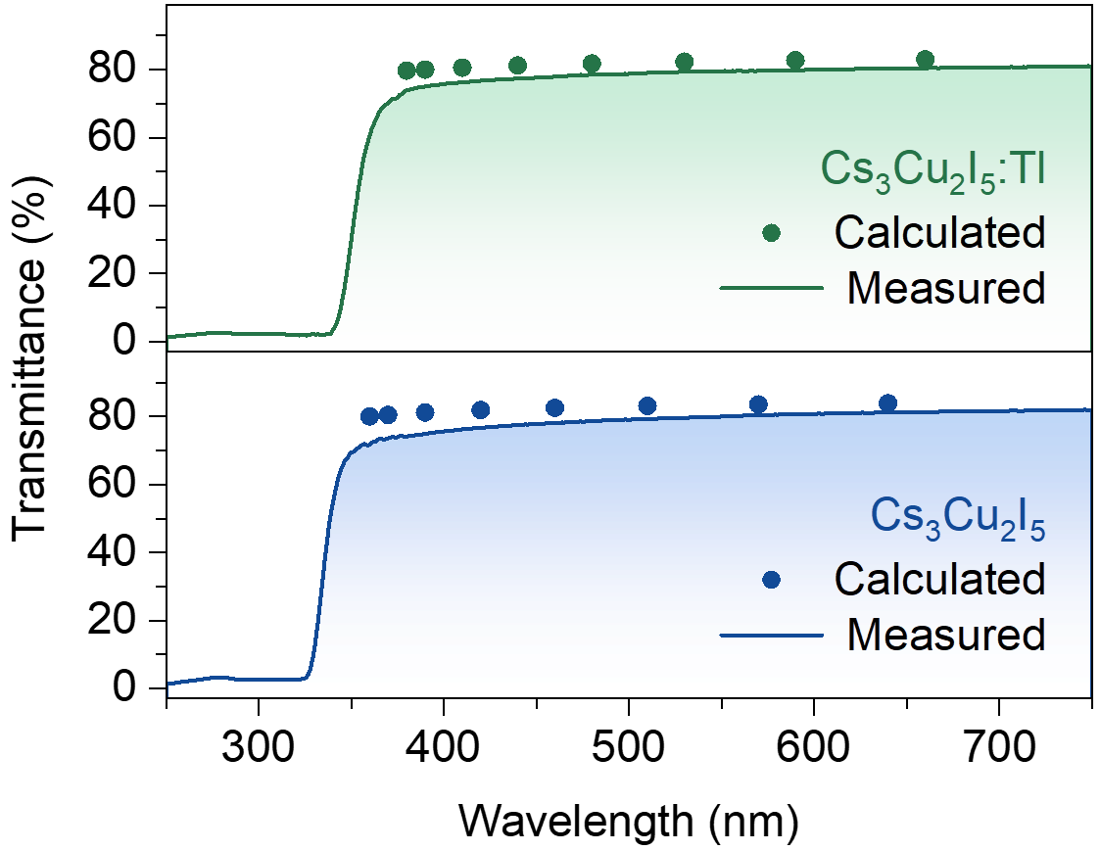
Figure S4. Optical transmission spectra and the theoretical values of crystal slabs.
The theoretical transmittance (T_{s}) at different wavelengths was calculated by using the following equation¹⁷:
$$\begin{aligned}T_{s}=\frac{2n_{crystal}n_{air}}{n_{crystal}^{2}+n_{air}^{2}}\#2\end{aligned}$$
where n_{crystal} and n_{air} are the refractive index of crystal and air as a function of temperature, respectively. The value of n_{air} is 1.0027. The refractive index at the maximum emission wavelength is 1.90 (445 nm) of Cs₃Cu₂I₅ and 1.92 (505 nm) of Cs₃Cu₂I₅:Tl.
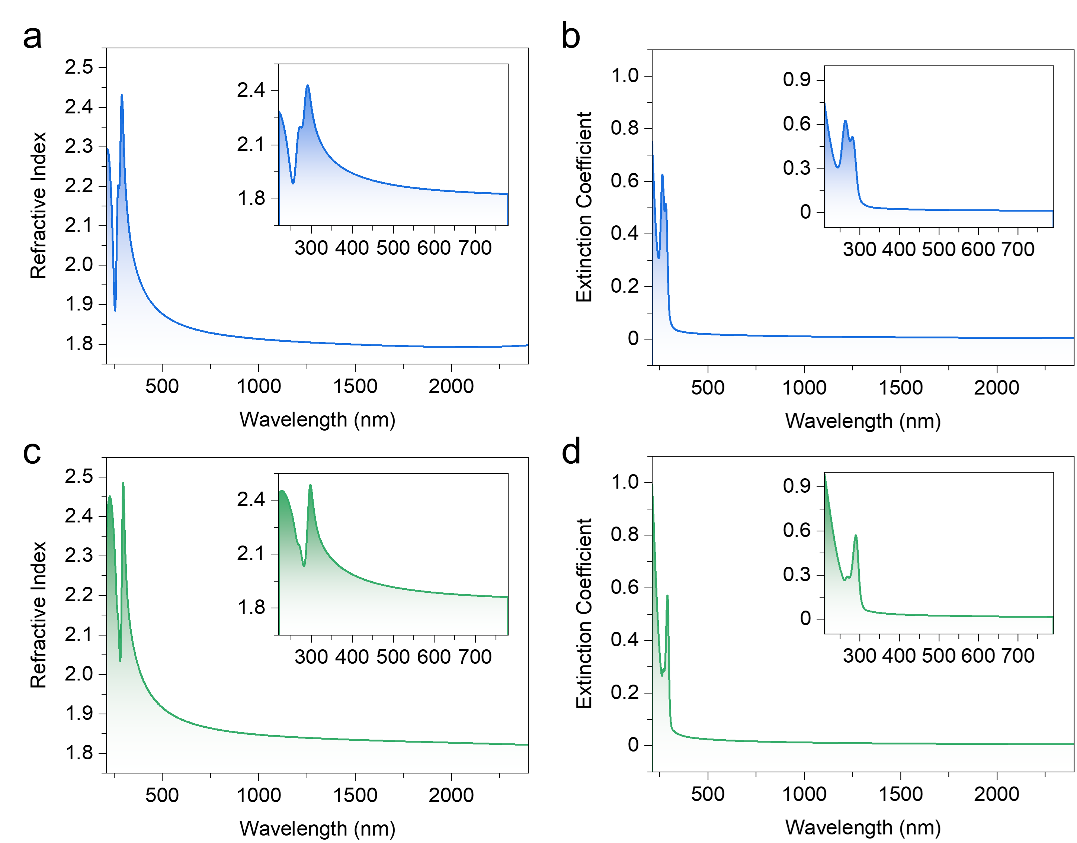
Figure S5. a, b, Refractive indexes (a) and extinction coefficients (b) of Cs₃Cu₂I₅ single crystal. c, d, Refractive indexes (c) and extinction coefficients (d) of Cs₃Cu₂I₅:Tl single crystal.

Rietveld refinement by NPD
Table S3. Crystallographic parameters of Cs₃Cu₂I₅:Tl obtained by NPD data at room temperature.
Sample | Cs₃Cu₂I₅:Tl
Temperature | 298 K
Crystal system | Orthorhombic
Space group | Pnma (No. 62)
Unit cell parameters | a= 10.1693(3) Å, α=90°  b= 11.6495(3) Å, β=90°  c= 14.3572(5) Å, γ=90°
R_{wp} | 11.5%
R_{p} | 8.69%
χ² | 1.30

Table S4. Atomic positions of Cs₃Cu₂I₅:Tl from NRD Rietveld refinement.
Atoms | Sites | x | y | z | occ
Cs1 | 4c | 0.59156 | 0.25000 | 0.55287 | 1.00
Cs2 | 8d | 0.05377 | 0.98806 | 0.67951 | 0.98(1)
Tl | 8d | 0.05377 | 0.98806 | 0.67951 | 0.02(1)
Cu1 | 4c | 0.24017 | 0.25000 | 0.37443 | 1.00
Cu2 | 4c | 0.21845 | 0.25000 | 0.55227 | 1.00
I1 | 8d | 0.69170 | 0.55827 | 0.55047 | 1.00
I2 | 4c | 0.15729 | 0.25000 | 0.20011 | 1.00
I3 | 4c | 0.97013 | 0.25000 | 0.50940 | 1.00
I4 | 4c | 0.29978 | 0.25000 | 0.71805 | 1.00

Photoluminescence
The PL emission and excitation contour mappings were measured with a Horiba Jobin Yvon Fluorolog-3 spectrofluorometer. With the increase of Tl concentration, the relative intensity of Tl-related emission to STE emission increases clearly. For the Cs₃Cu₂I₅:1%Tl sample, it is almost entirely dominated by Tl-related emission. The variations in luminescent center spectral shapes observed during contour mapping are attributed to the overlapping of spectra and coloring deviation.
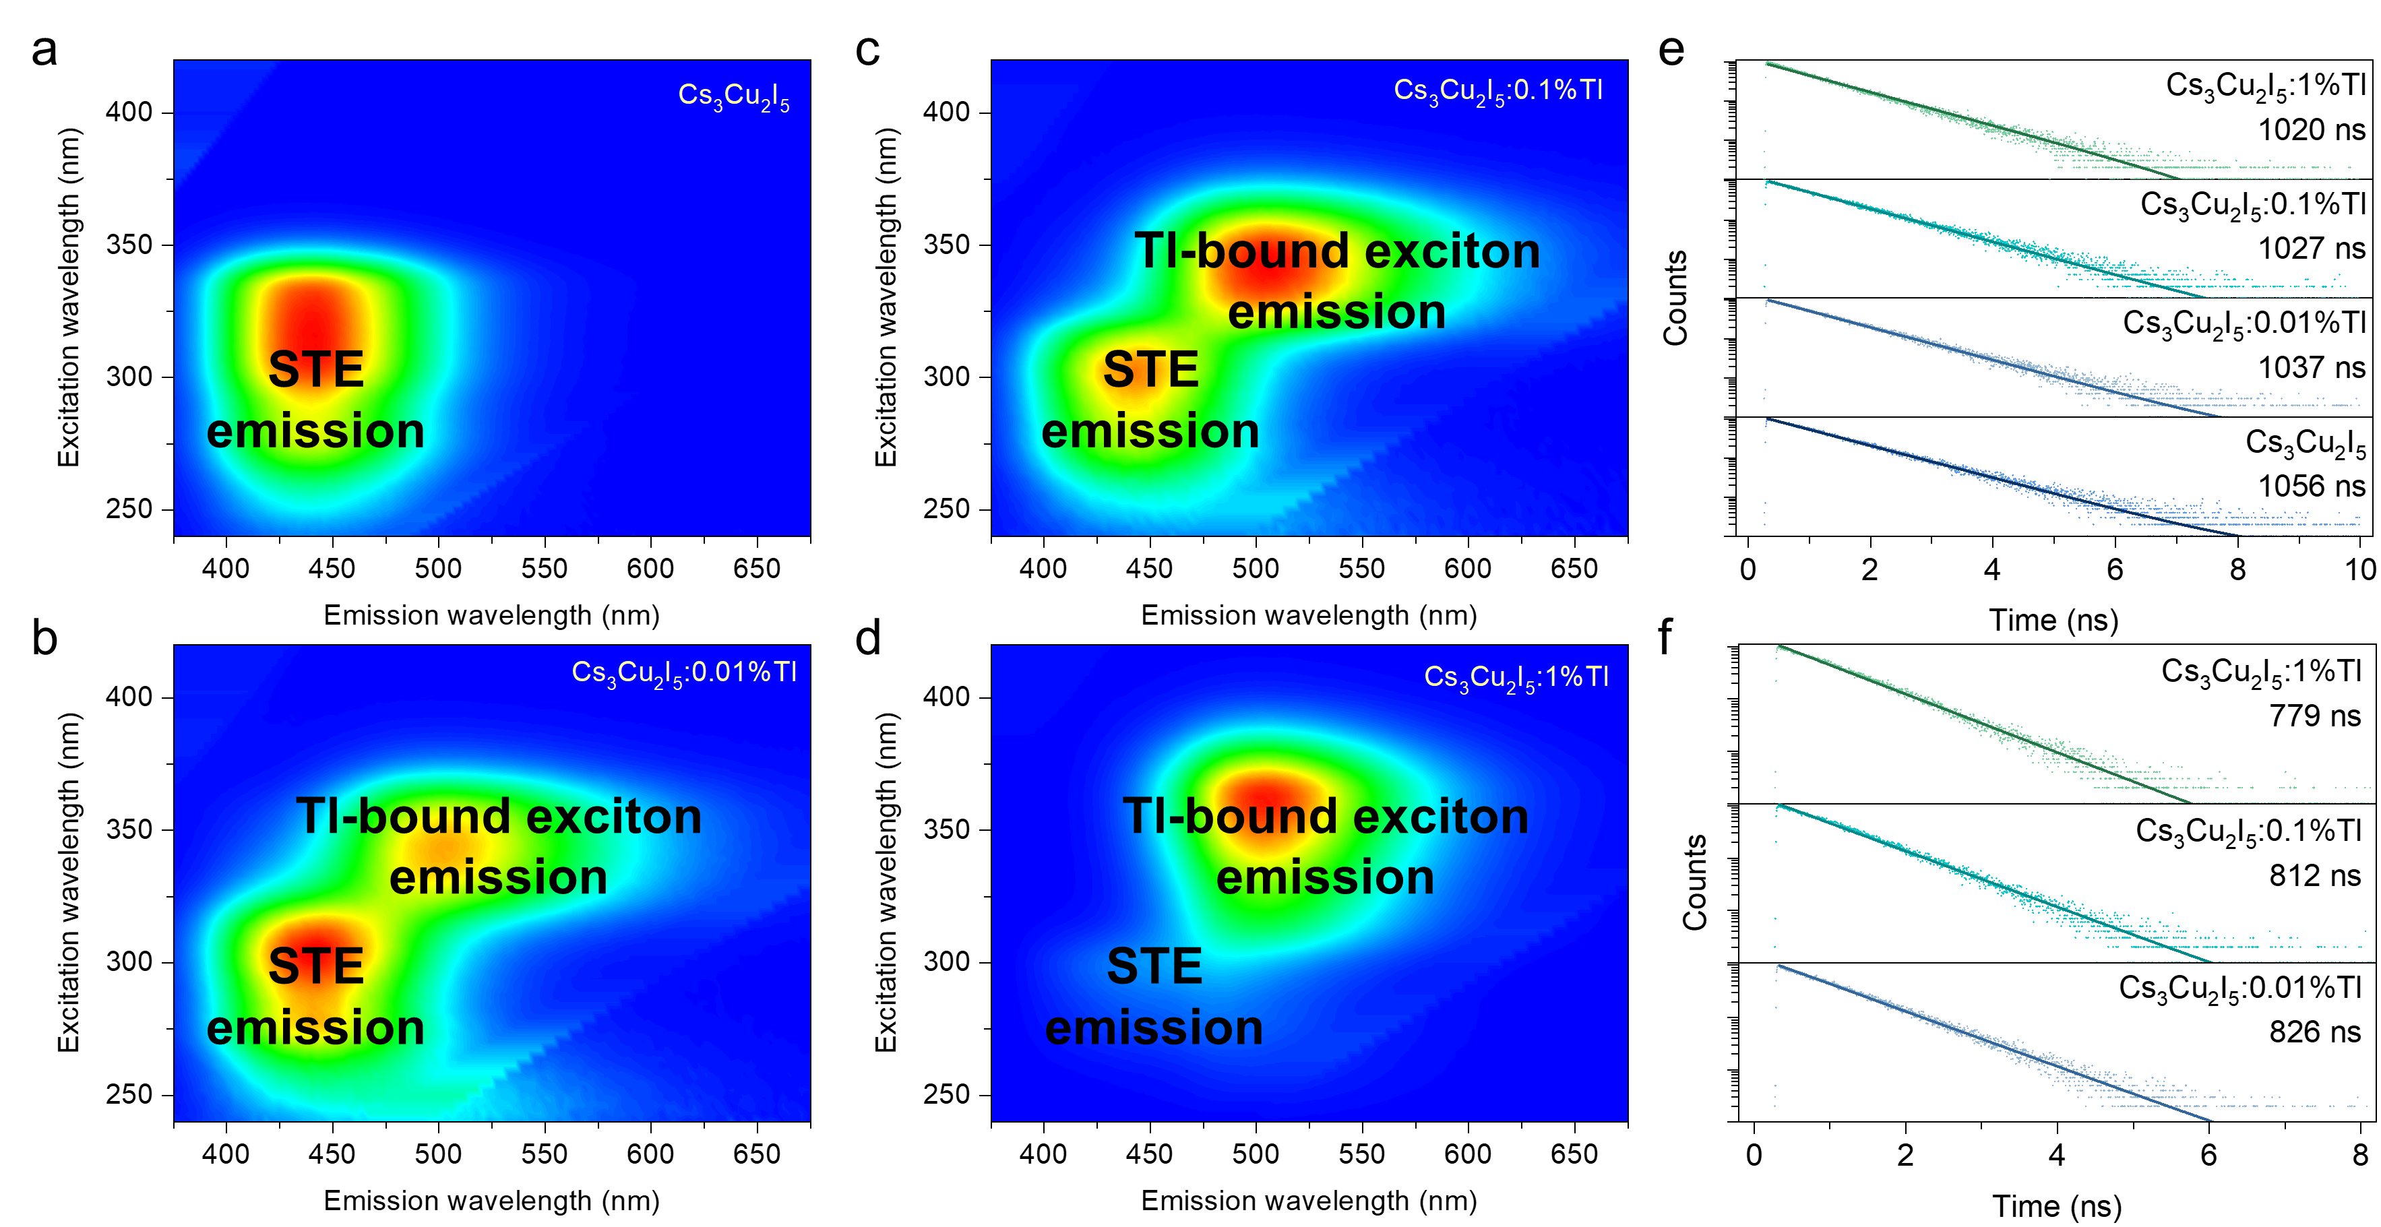
Figure S6. a, b, c, d, PL and PLE spectra mapping of Cs₃Cu₂I₅ (a), Cs₃Cu₂I₅: 0.01%Tl (b), Cs₃Cu₂I₅: 0.1%Tl (c), and Cs₃Cu₂I₅:1%Tl (d). e, f, Doping concentration dependent PL decay profiles of STE emission (e, λ_{ex} = 280 nm, λ_{em} = 440 nm) and Tl-related emission (f, λ_{ex} = 330 nm, λ_{em} = 530 nm) at room temperature.

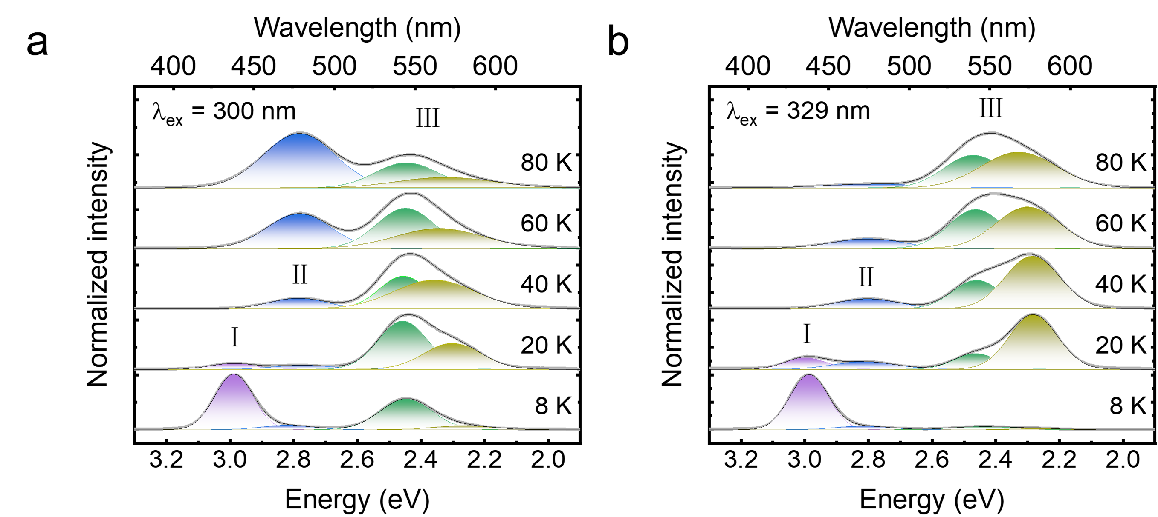
Figure S7. Temperature-dependent PL spectra of Cs₃Cu₂I₅:Tl single crystal under 300 nm (a) and 329 nm (b) excitation below 80 K.
Figure S8. PL decay profile of 410 nm (2.99 eV) emission in Cs₃Cu₂I₅:Tl single crystal at 8 K.

Figure S9. Full width at half maximum (FWHM) of STE emission (445 nm) as a function of temperature. The fitted Huang-Rhys factor (S) and phonon frequency (ℏω_{phonons}) are listed in the figure.

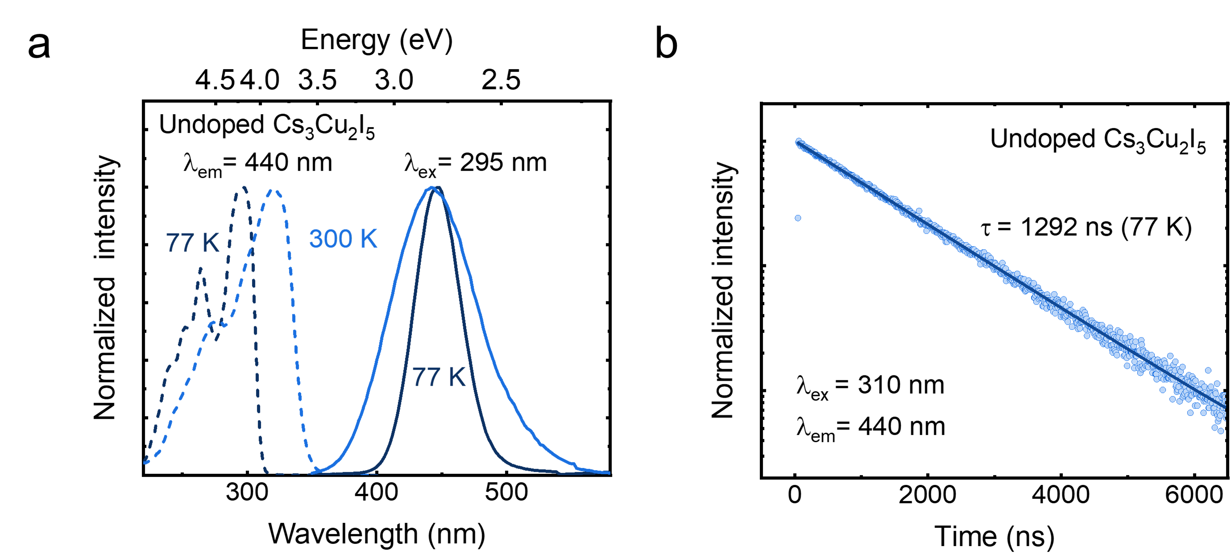
Figure S10. a, PL and PLE spectra of Cs₃Cu₂I₅ at 77 and 300 K. b, PL decay time profile of Cs₃Cu₂I₅ at 77 K
Figure S11. PL decay profile of 445 nm (2.79 eV) emission in Cs₃Cu₂I₅:Tl single crystal at 8 K.

Figure S12. PL-PLE mapping of Cs₃Cu₂I₅:Tl single crystal at 77 K.

Figure S13. Two-peak gaussian fitting of Tl-bound exciton emission spectra from 77 to 220 K.

Figure S14. FWHM of Tl-bound exciton emission (510 nm) as a function of temperature. The fitted Huang-Rhys factor and phonon frequency are listed in the figure.

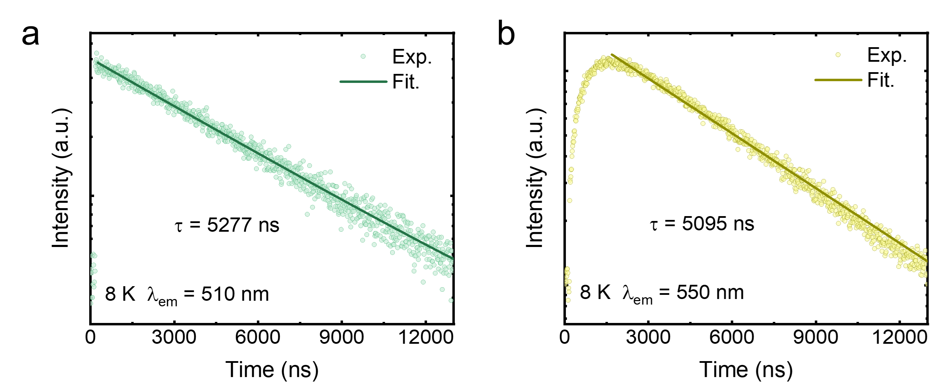
Figure S15. PL decay profile of emission at 510 nm (a) and emission at 550 nm (b) in Cs₃Cu₂I₅:Tl single crystal at 8 K.

Figure S16. PL decay profile of emission from 490 to 570 nm under 330 nm excitation at 77 K. The upper figure shows the feature of single-exponential fitting. The derived results are shown in the right figure.

Thermoluminescence
Thermoluminescence (TL) glove curve measurement was performed with the custom-made thermoluminescence spectrometer. The samples with 4 mm × 4 mm × 3 mm were irradiated under X-ray (Au target, 50 kV, 75 μA) for 15 min at 77 K. Then the samples were heated from 77 K to 480 K with a heating rate of 0.1 K/s.
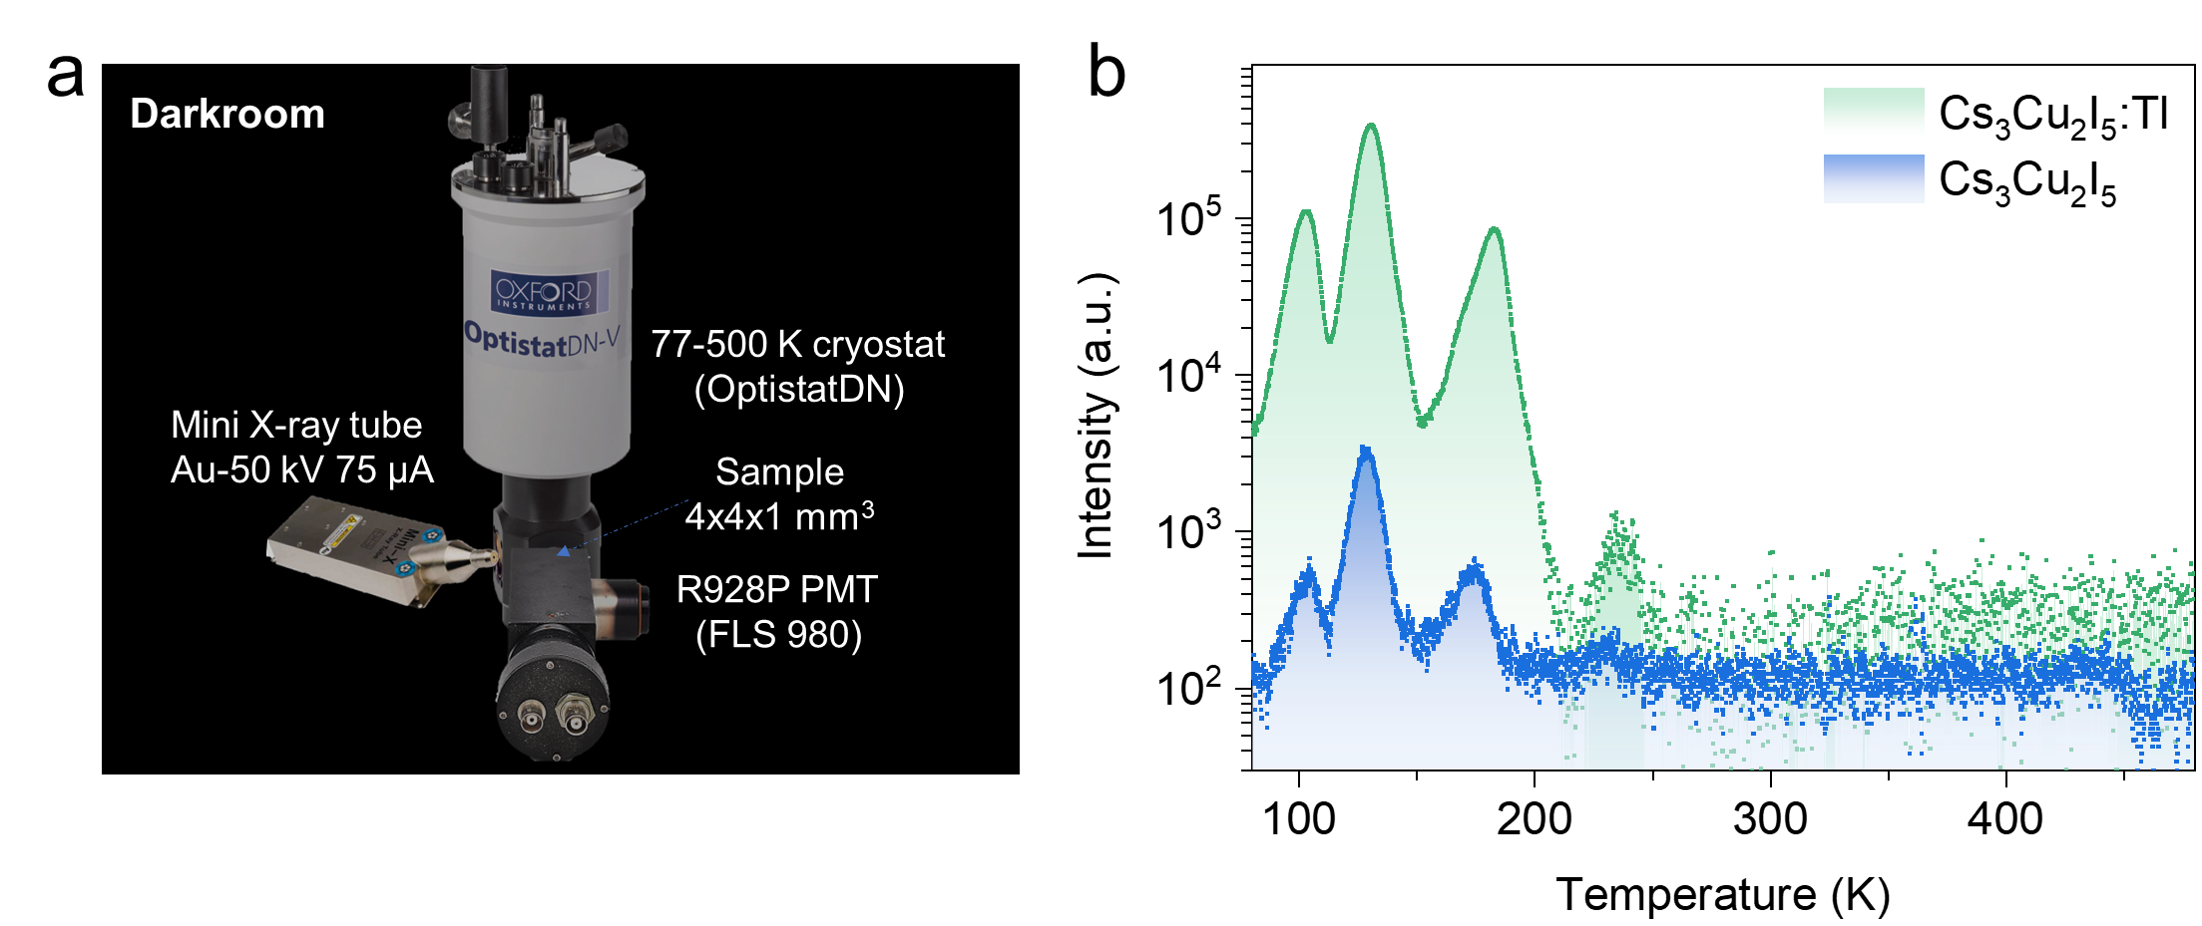
Figure S17. a, Schematic diagram of the custom-made TL spectrometer. b, TL glow curves of Cs₃Cu₂I₅ and Cs₃Cu₂I₅:Tl single crystals.

Particle detection and discrimination

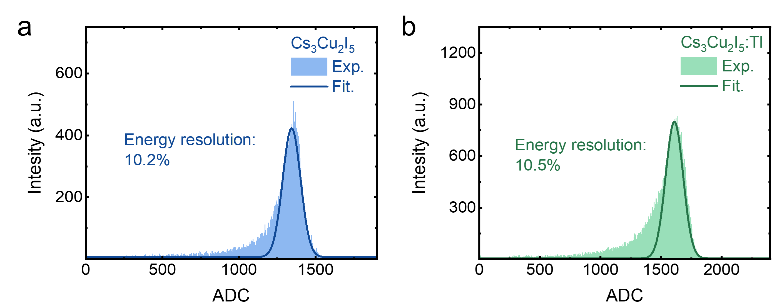
Figure S18. Pulse height spectra of Cs₃Cu₂I₅ (a) and Cs₃Cu₂I₅:Tl (b) under ²⁴¹Am excitation acquired using Hamamatsu a R6233-100 PMT.

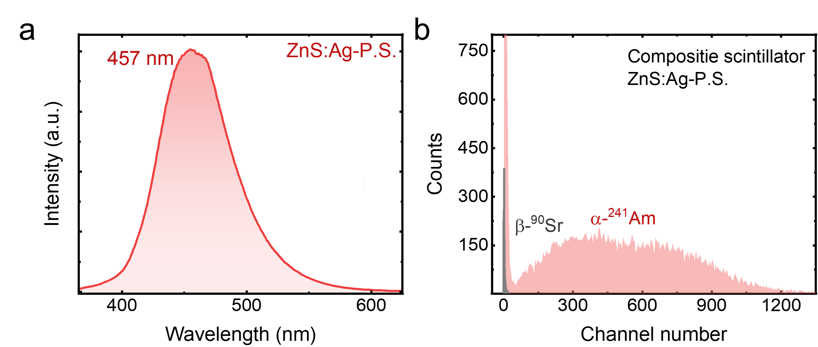
Figure S19. Emission spectra under X-ray excitation (a), and pulse height spectra under ²⁴¹Am and ⁹⁰Sr excitation (b) of composite detector based on ZnS:Ag and plastic scintillator.

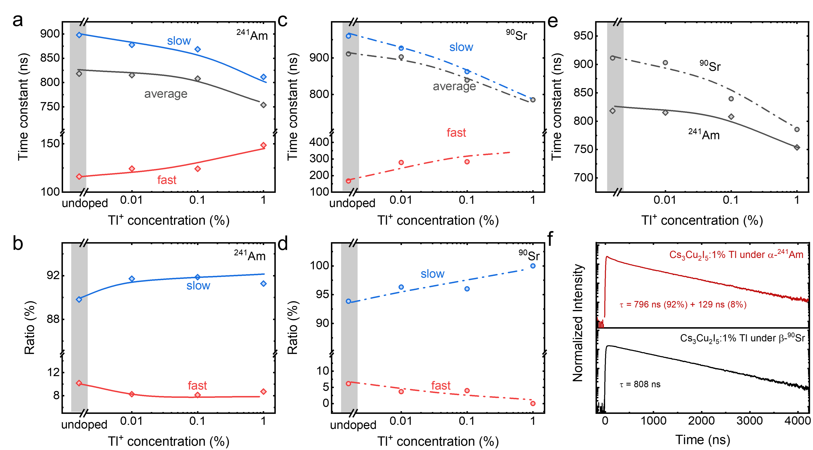
Figure S20. Scintillation decay evolution as a function of Tl concentration. (a, b) Time constants and ratios of the fast and slow components under ²⁴¹Am excitation. (c, d) Time constants and ratios of the fast and slow components under ⁹⁰Sr excitation. (e) Averaged scintillation decay constants of Cs₃Cu₂I₅:Tl. (f) Scintillation decay profiles of Cs₃Cu₂I₅:1%Tl under ²⁴¹Am and ⁹⁰Sr sources excitation.
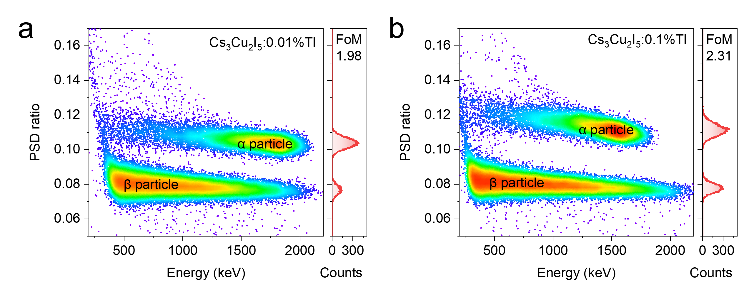
Figure S21. PSD scatter plots and spectra of Cs₃Cu₂I₅:0.01%Tl and Cs₃Cu₂I₅:0.1%Tl under the excitation of ²⁴¹Am and ⁹⁰Sr sources.

²²⁰Rn loading and measurement:
A ²³²Th diffusion source (1.2×10³ Bq) was used to produce ²²⁰Rn, which was then loaded into a 70 ml gas-wash bottle using a pump. The bottle loaded with ²²⁰Rn was placed upside-down on a Cs₃Cu₂I₅:1%Tl crystal and coupled with a PMT (HZC PHOTONICS XP3240) for testing. The PMT was operated at -700V and the signal was recorded directly with a CAEN DT5751 digitizer for 3 hours. To serve as environmental background testing, an air-filled gas-wash bottle was used when measuring radon. This control setup served to establish a comparative context for evaluating the measured radon values.
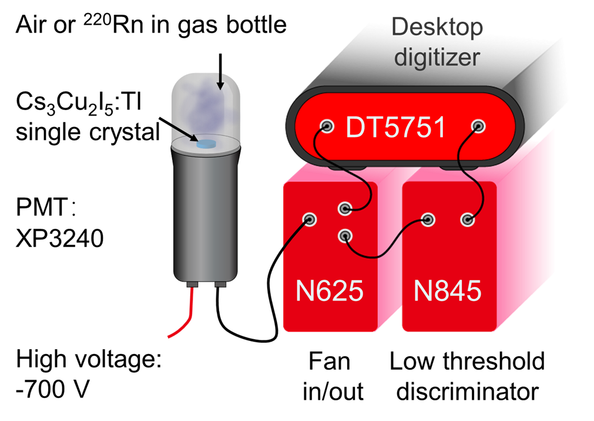
Figure S22. Schematic diagram of the preliminary ²²⁰Rn measurement system.

As compared to widely used scintillation cells (flask coated by scintillator, such as ZnS:Ag, et al.) and liquid scintillation devices (mixture of an organic solvent and flour, such as PPO-loaded DIN, et al.), the device offers a compact structure and lower usage cost.^{18, 19, 20} The time gate parameters used for the PSD were the same as the tests conducted under the excitation of ²⁴¹Am and ⁹⁰Sr sources.
The environmental test result of a gas wash bottle filled with natural air wherein 23 α events were detected during a sampling time of 3 hours, indicating the presence of α emitters in the air, building, or bottle material. The extra α events detected clearly originated from the ²²⁰Rn samples loaded into the bottle.
Comparation of α/β discrimination scintillators
Table S5. The physical and scintillation properties of 0D Cs₃Cu₂I₅:Tl single crystal, conventional, and some newly developed solid scintillators for α/β discrimination application.

Scintillators | Cs₃Cu₂I₅:Tl single crystal | ZnS:Ag composition | CsI:Na single crystal | Plastic scintillator
Density (g/cm³) | 4.5 | 4.1, ~1 | 4.5 | ~1
Z_{eff} | 52.2 | N/A | 54 | ＜10
Light yield at 662 keV (ph./MeV) | 83 000 | N/A | 41 000 | ~10 000
Energy resolution at 662 keV (%) | 3.3 | N/A | 6.7 | N/A
PSD FoM | 2.64 | 1.92 | 3.0 (α/γ) | ~1
Stability | Stable | Sensitive to temperature | Sensitive to humidity | Sensitive to temperature
Compact | √ | × | √ | √
 | This work | Ref.21²¹ | Ref.22²² | Ref.23²³

Supplementary Reference
1. Ronda, C.R., Srivastava, A.M. Scintillators. In: Ronda, CR (ed). Luminescence: From Theory to Applications, 2007, pp 105-132.
2. Zhang, F., et al. Blue–violet emitting K₂CuCl₃ compound: facile synthesis, photoluminescence and radioluminescence properties. J Mater Sci, 57: 10260-10270 (2022).
3. Gao, W., et al. One-dimensional all-inorganic K₂CuBr₃ with violet emission as efficient X-ray scintillators. ACS Applied Electronic Materials, 2: 2242-2249 (2020).
4. Zhao, X., et al. All-inorganic copper halide as a stable and self-absorption-free X-ray scintillator. J Phys Chem Lett, 11: 1873-1880 (2020).
5. Cheng, S., et al. Non-hygroscopic, self-Absorption free, and efficient 1D CsCu₂I₃ perovskite single crystal for radiation detection. ACS Appl Mater Interfaces, 13: 12198-12202 (2021).
6. Ma, Z., et al. Stable yellow light-emitting devices based on ternary copper halides with broadband emissive self-trapped excitons. ACS Nano, 14: 4475-4486 (2020).
7. Niu, X., et al. Highly efficient blue emissive copper halide Cs₅Cu₃Cl₆I₂ scintillators for X-ray detection and imaging. Ceram Int, 48: 30788-30796 (2022).
8. Li, J., et al. A highly efficient and stable blue-emitting Cs₅Cu₃Cl₆I₂ with a 1D chain structure. Adv Mater, 32: e2002945 (2020).
9. Lian, L., et al. Highly luminescent zero-dimensional organic copper halides for X-ray scintillation. J Phys Chem Lett, 12: 6919-6926 (2021).
10. Zhou, Q., et al. Highly efficient copper halide scintillators for high-performance and dynamic X-ray imaging. Nanoscale, 13: 19894-19902 (2021).
11. Cheng, S., et al. Zero-dimensional Cs₃Cu₂I₅ perovskite single crystal as sensitive X-ray and γ-ray scintillator. Phys Status Solidi Rapid Res Lett, 14: 2000374 (2020).
12. Cheng, S., et al. Ultrabright and highly efficient all‐inorganic zero‐dimensional perovskite scintillators. Adv Opt Mater, 9: 2100460 (2021).
13. Han, K., Jin, J., Su, B., Qiao, J., Xia, Z. Promoting single channel photon emission in copper(I) halide clusters for X-Ray detection. Adv Opt Mater, 10: 2200865 (2022).
14. Xu, T., et al. Lead-free zero-dimensional organic-copper(I) halides as stable and sensitive X-ray scintillators. ACS Appl Mater Interfaces, 14: 14157-14164 (2022).
15. Wojakowska, A., Górniak, A., Kuznetsov, A.Y., Wojakowski, A., Josiak, J. Phase Diagram of the System Copper(I) Iodide + Cesium Iodide. Journal of Chemical & Engineering Data, 48: 468-471 (2003).
16. Doty, F.P., et al. Structure and properties of lanthanide halides. Penetrating Radiation Systems and Applications VIII; 2007.
17. Mao, R., Zhang, L., Zhu, R.-Y. Optical and scintillation properties of inorganic scintillators in high energy physics. IEEE Trans Nucl Sci, 55: 2425-2431 (2008).
18. Li, J., et al. Novel liquid scintillator radon detector. Radiation Detection Technology and Methods, 6: 294-301 (2022).
19. Feng, X.-g., He, Q.-g., Wang, J.-c., Chen, J. A general method for optimizing the parameter of α/β discrimination in liquid scintillation counting. Anal Methods, 6: 115-119 (2014).
20. Abdalla, A.M., et al. Radon detection using alpha scintillation KACST cell. Nucl Instrum Methods Phys Res A, 922: 84-90 (2019).
21. Ifergan, Y., et al. Development of a thin, double-sided alpha/beta detector for surface-contamination measurement. IEEE Trans Nucl Sci, 63: 634-638 (2016).
22. Winyard, R.A., Lutkin, J.E., McBeth, G.W. Pulse shape discrimination in inorganic and organic scintillators. I. Nucl Instrum Methods, 95: 141-153 (1971).
23. Morishita, Y., Di Fulvio, A., Clarke, S.D., Kearfott, K.J., Pozzi, S.A. Organic scintillator-based alpha/beta detector for radiological decontamination. Nucl Instrum Methods Phys Res A, 935: 207-213 (2019).

