Supporting Information

Biomimetic-Magnetic Dual-Targeted Metal-Organic Framework to Improve the Anti-Hepatocellular Carcinoma Efficacy of PD-1 Inhibitor

Hong Guo ‡, Xia Li ‡, Dengxuan Mao, Hong Wang, Liangyin Wei, Ding Qu, Xiaoying Qin, Xiaoqi Li, Yuping Liu*, and Yan Chen*.

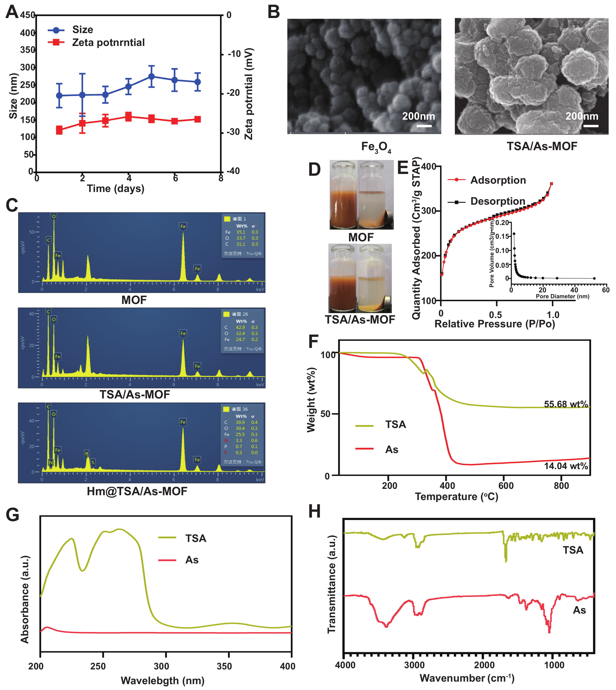
Figure S1. Changes in Hm@TSA/As-MOF size and zeta potential were monitored over the course of a week using DLS (A). Image demonstrating morphologies of Fe₃O₄ nanoparticles and TSA/As-MOF taken by SEM (scale bar = 200 nm) (B). Elemental composition analysis of MOF, TSA/As-MOF, and Hm@TSA/As-MOF were conducted using SEM coupled with energy-dispersive X-ray spectroscopy (SEM-EDS) (C). The responsiveness of MOF and TSA/As-MOF to magnetic fields were evaluated using NdFeB permanent magnets, respectively (D). The pore characteristics of MOF was observed by the curves of nitrogen adsorption and desorption (E). The TGA (F), UV (G), and FTIR (H) results of TSA and As are shown.

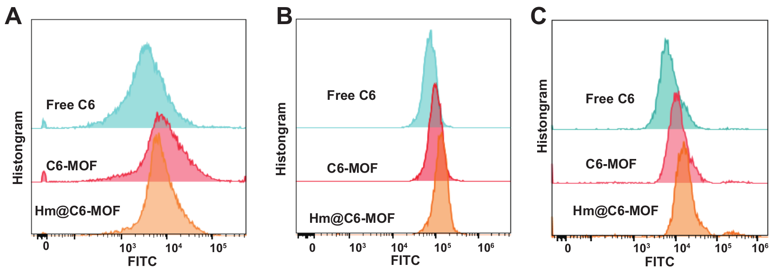
Figure S2. Uptake analysis of free Free C6, C6-MOF, and Hm@C6-MOF by bEnd.3 cells (A), TILs (B), and HCC cells (C) in vitro (n=3). Data represent the means ± SD. (**, p < 0.01; ***, p < 0.001; two-tailed Student’s t-test).
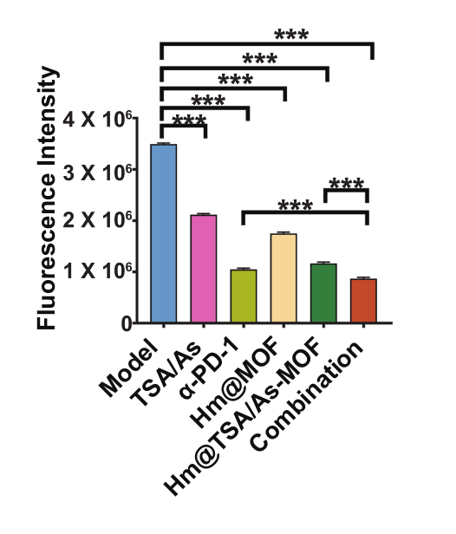
Figure S3. The extent of tumor bioluminescence in mice was measured and analyzed (n=6). Data represent the means ± SD. (***, p < 0.001; two-tailed Student’s t-test).
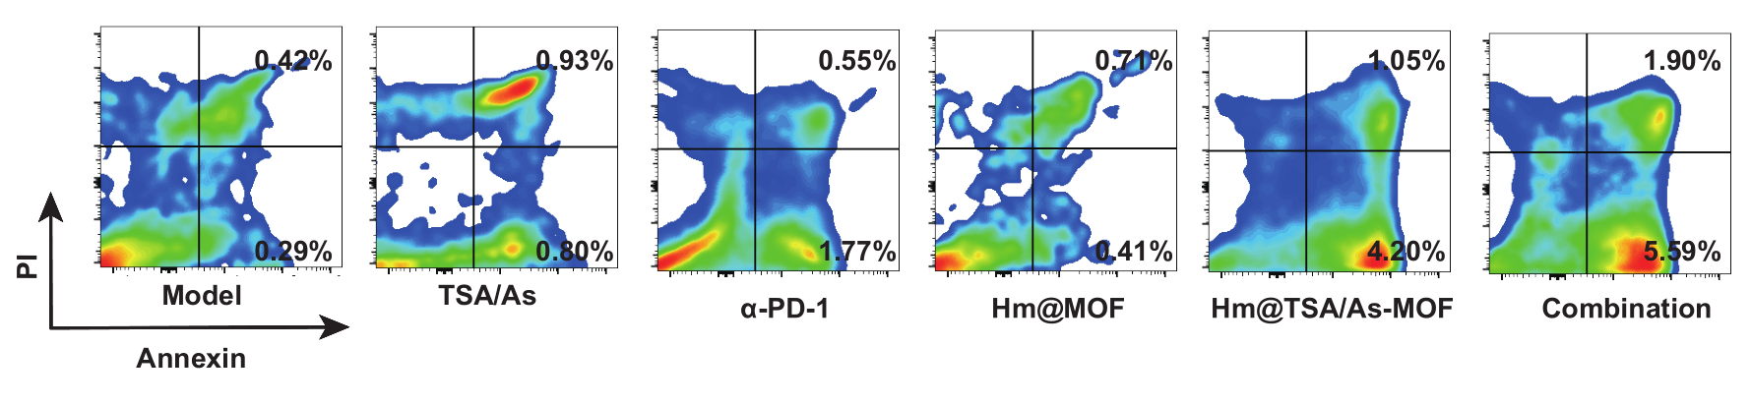
Figure S4. Tumor cell apoptosis was assessed by flow cytometry.
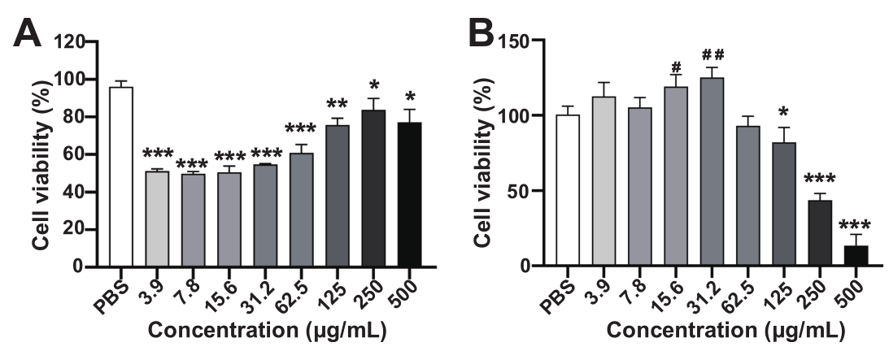
Figure S5. In vitro assessment of the effects of Hm@TSA/As-MOF on the activity of bEnd.3 (A) and TILs (B) using CCK-8 assay (n=6). Data were presented as means ± SD. (inhibition of viability: *, p < 0.05; **, p < 0.01; ***, p < 0.001; enhancement of viability: #p < 0.05, ##p < 0.01; vs. PBS two-tailed Student’s t-test).
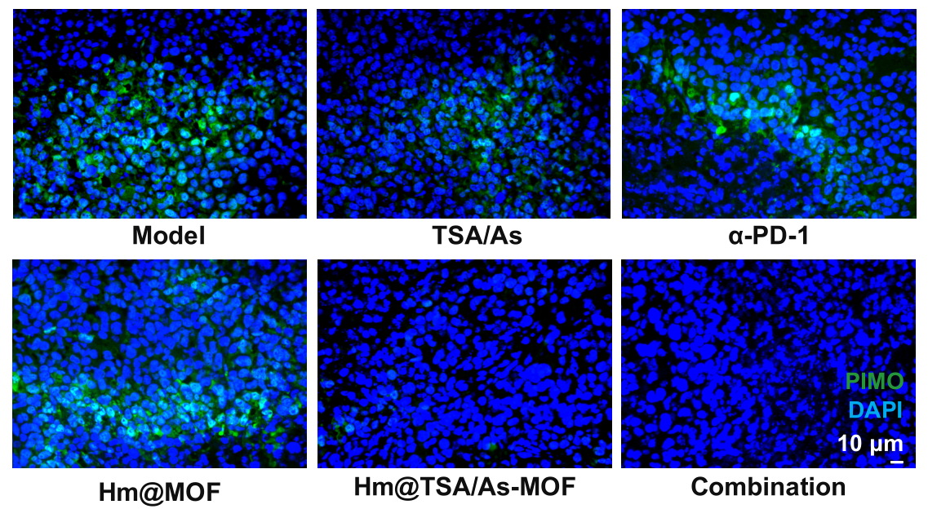
Figure S6. Tumour hypoxia was assessed using PIMO (scale bar = 10 μm).

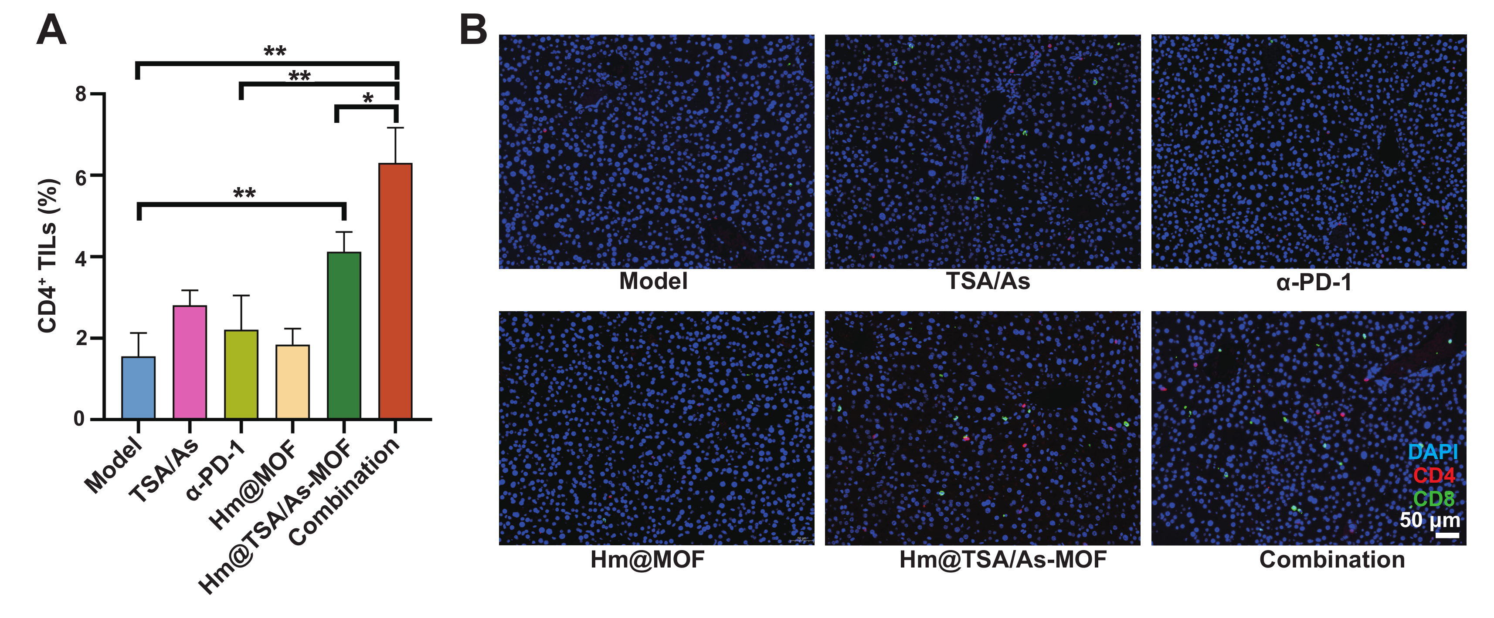
Figure S7. Levels of CD4⁺ (A) were demonstrated by flow cytometry (n=3). CD4⁺ and CD8⁺ TILs (B) were labeled on tumor tissue sections by fluorescent staining (scale bar = 50 μm). Data represent the means ± SD. (*, p < 0.05; **, p < 0.01; two-tailed Student’s t-test).

