Figure S1
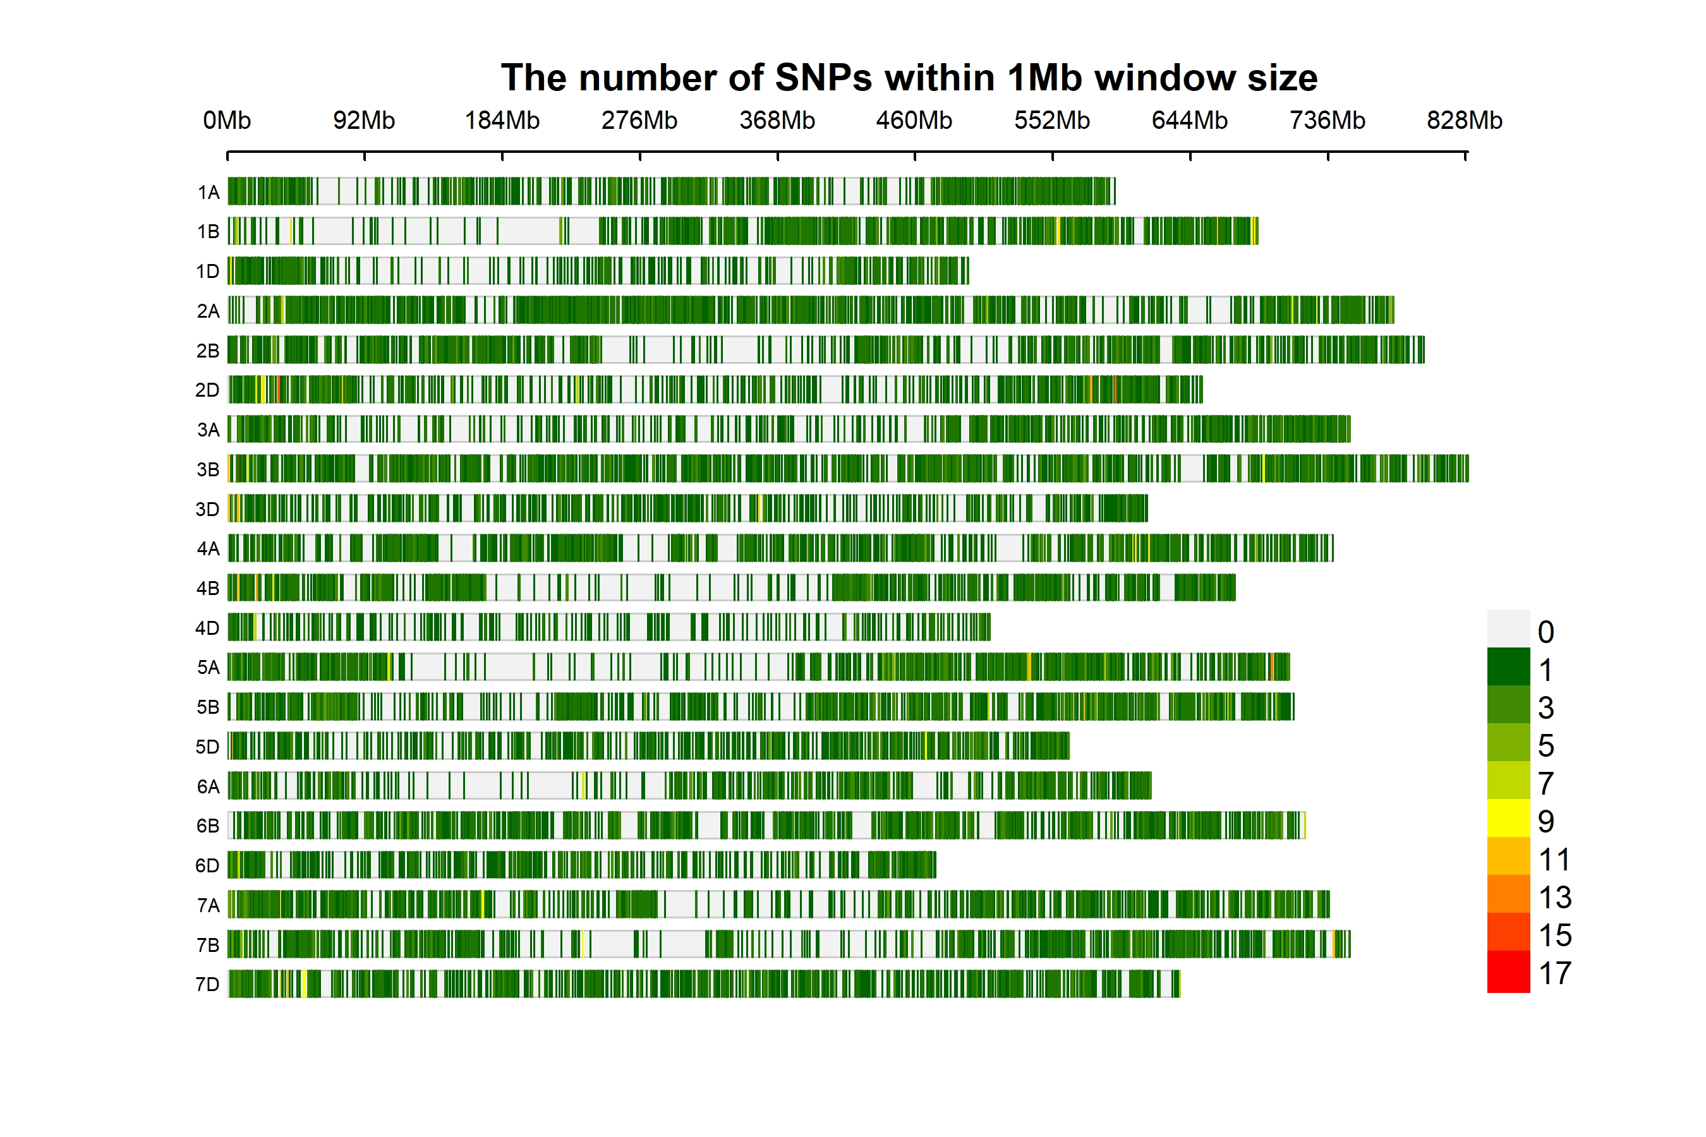
Figure S2
a
b

