Physics and Chemistry of Minerals
Supporting Information for
Electrical conductivity of siderite and the effect of the spin transition of iron
Izumi Mashino^{1*}, Takashi Yoshino¹, Takaya Mitsui², Kosuke Fujiwara², Máté Garai³, and Shigeru Yamashita¹
¹Institute for Planetary Materials, Okayama University, 827 Yamada, Misasa, Tottori, Japan
²Synchrotron Radiation Research Center, Kansai Photon Science Institute, Quantum Beam Science Research Directorate, National Institutes for Quantum Science and Technology, Sayo, Hyogo, Japan
³The University of the South, 735 University Avenue Sewanee, TN, USA

*Corresponding author: Izumi Mashino (izumi.mashino@okayama-u.ac.jp), ORCID: 0000-0001-9719-593X,

Contents of this file

Text S1
Figures S1 to S4
Tables S1

Text S1. Estimation of sample thickness.
Considering the current paths in the samples of our cell assembly, the thickness of the sample volume for which the electrical conductivity was measured should be the same as the sample thickness. To estimate the thickness of the sample, we adopted the thickness estimation methods proposed by Li et al. (2007). In the thickness estimation methods, the effects of the gasket plastic deformation and the diamond elastic deformation have been considered. We measured the distance between the back facets of the two diamond anvils mechanically using a micrometer along with both increasing (compression: T_{C}) and decreasing (decompression: T_{D}) pressures. The anvil deformation at each pressure (D_{P}) can be obtained by
$$D_{P}=H_{0}-\left[T_{D}\left(P\right)-L_{M}\right]$$
where H₀ is the initial thickness of the two anvils and L_{M} is the sample thickness at the maximum pressure.
The sample thickness (t) can be expressed as
$$t=T_{C}\left(P\right)-(H_{0}-D_{P})$$
L_{M} can be obtained by
$$L_{M}=T_{D}\left(0\right)-H_{0}$$
In this study, H₀ is 4.062 (mm) and T_{D}(0) is 4.076 (mm). Thus, L_{M} is 0.014 (mm).
Fig. S2 shows the pressure dependence of the distance between the back facets of the two diamond anvils along with both increasing (compression: T_{C}) and decreasing (decompression: T_{D}) pressures.
Fig. S3 shows the pressure dependence of diamond deformation (D_{P}). We can obtain a parabola of fit as follows:
$$D_{P}=-2.8967×{10}^{-6}P^{2}+7.2245×{10}^{-4}P$$
Thus, the sample thickness at each pressure (T(P)) can be obtained by
$$t=T\left(P\right)-\left(4.062-D_{P}\right)$$
Fig. S4 show the pressure evolution of the sample thickness.

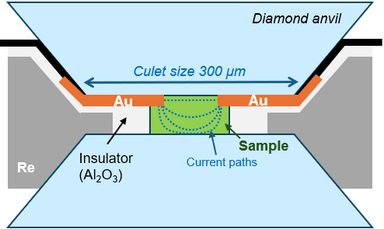

Figure S1. Schematic cross section of the experimental setup in a DAC for electrical conductivity measurements. The dotted curves in the sample show the current paths.

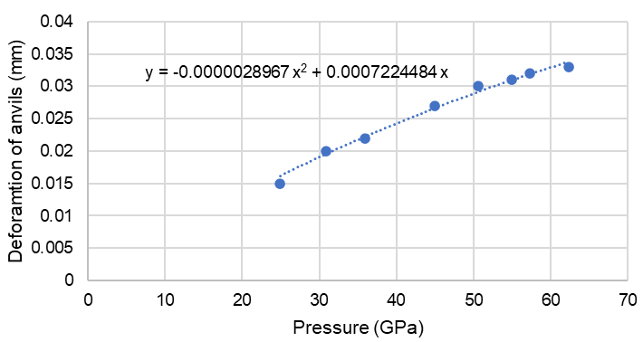

Figure S2. The deformation of anvils as a function of pressure.

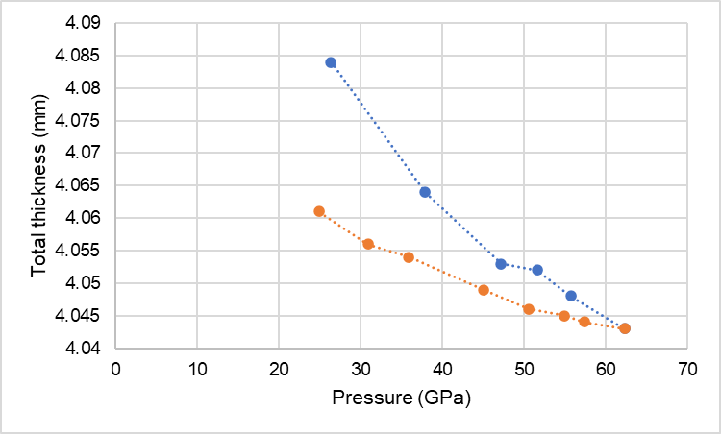

Figure S3. The total thickness, including the thicknesses of the two anvils and the sample as a function of pressure. Blue circles, T_{C}; orange circles, T_{D}.

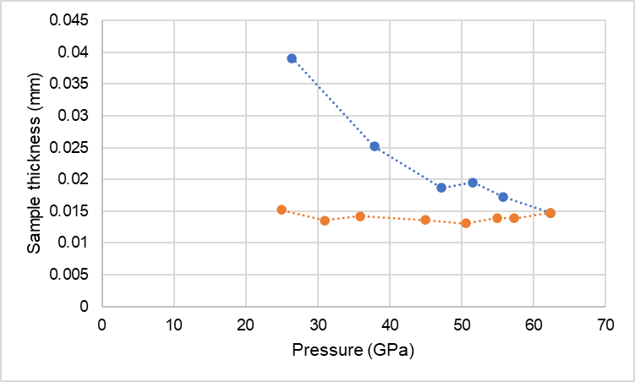

Figure S4. The estimated sample thickness as a function of pressure. Blue circles, T_{C}; orange circles, T_{D}.

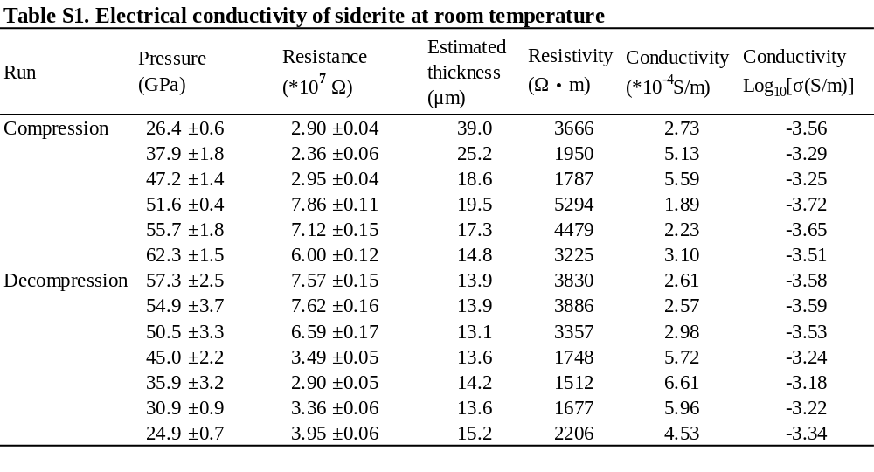

Table S1. Electrical conductivity of siderite at room temperature.

