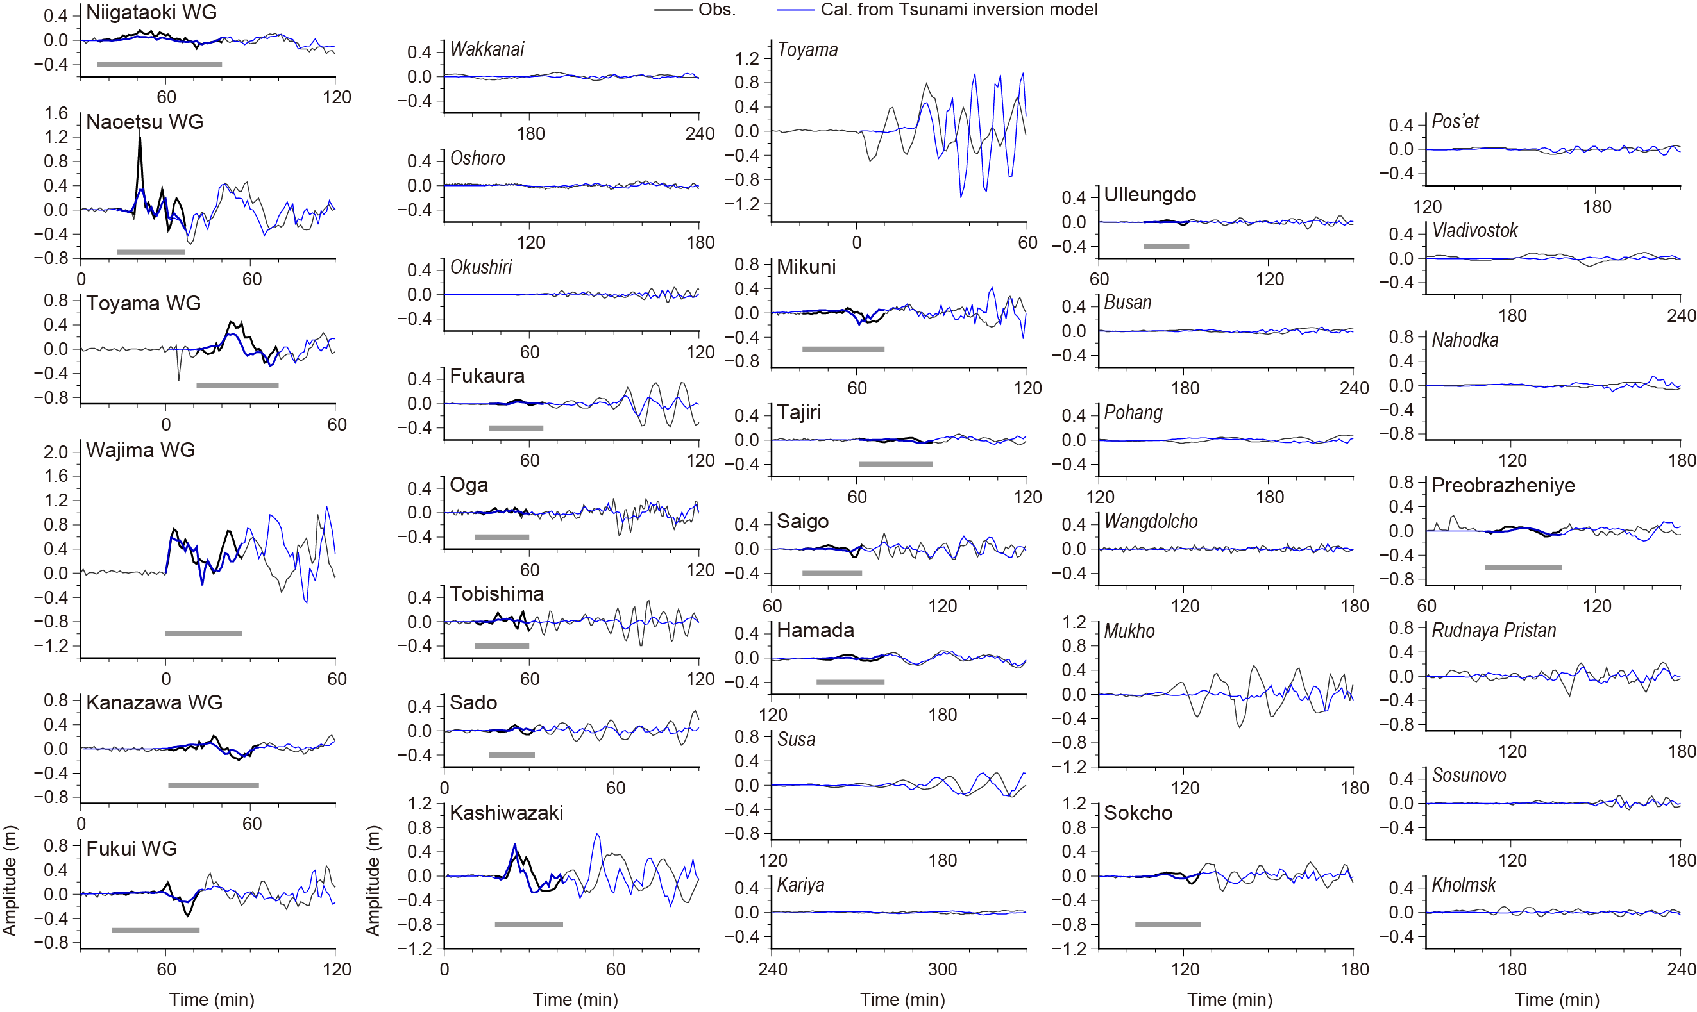
Fig. S1 Comparison of the observed and calculated tsunami waveforms from the inversion using only tsunami waveform data for the JSPJ fault models. The thick black and gray lines are the observed waveforms used and not used in the inversion, respectively. The blue lines show the synthetic tsunami waveforms from the tsunami waveform inversion, with the thick parts used in the inversion. The gray bars below the waveforms indicate the time windows used in the inversion.

Table S1 Fault parameters of the MLIT models and the inversion results.
#_Seg.# | Lat. (deg) | Lon. (deg) | Length (km) | Width (km) | Depth (km) | Strike (deg) | Dip (deg) | Rake (deg) | Slip (m)
 |  |  |  |  |  |  |  |  | Joint | Tsunami | GNSS
F42_1* | 38.009533 | 137.893863 | 37.7 | 17.7 | 2.5 | 201 | 45 | 78 | 0.11 | 0.14 | 0.00
F42_2* | 37.698281 | 137.743602 | 18.1 | 17.7 | 2.5 | 241 | 45 | 112 | 0.00 | 0.00 | 0.00
F43_2 | 37.51792 | 137.17528 | 45.9 | 19.7 | 1.1 | 55 | 45 | 105 | 3.69 | 3.57 | 6.54
F43_1 | 37.327401 | 136.681138 | 48.3 | 19.7 | 1.1 | 64 | 45 | 113 | 2.23 | 1.87 | 2.57
#_Seg.#: Subfault and segment number. Lat., Lon., and Depth: Location and the top depth of the eastmost corners (with *), and the westmost corners for the others. Rigidity of 34.3GP is assumed. |  |  |  |  |  |  |  | Mo (Nm) | 1.90 × 10²⁰ | 1.75 × 10²⁰ | 2.87 × 10²⁰
 |  |  |  |  |  |  |  | Mw | 7.5 | 7.4 | 7.6

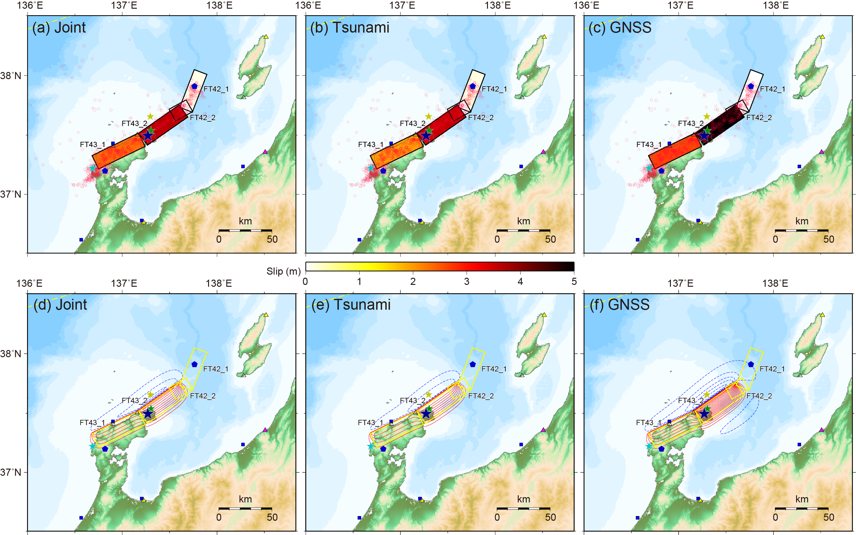
Fig. S2 Same as Fig. 4, but for a case adopting the MLIT fault models.

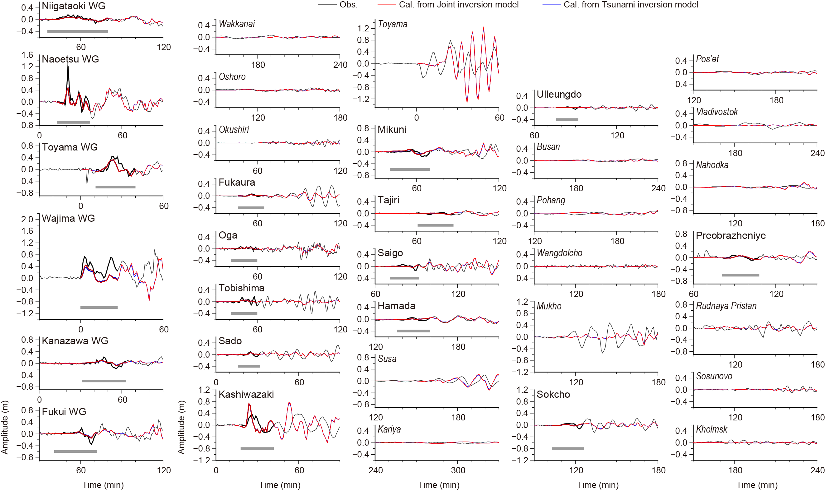
Fig. S3 Same as Fig. 2, but for a case adopting the MLIT fault models.

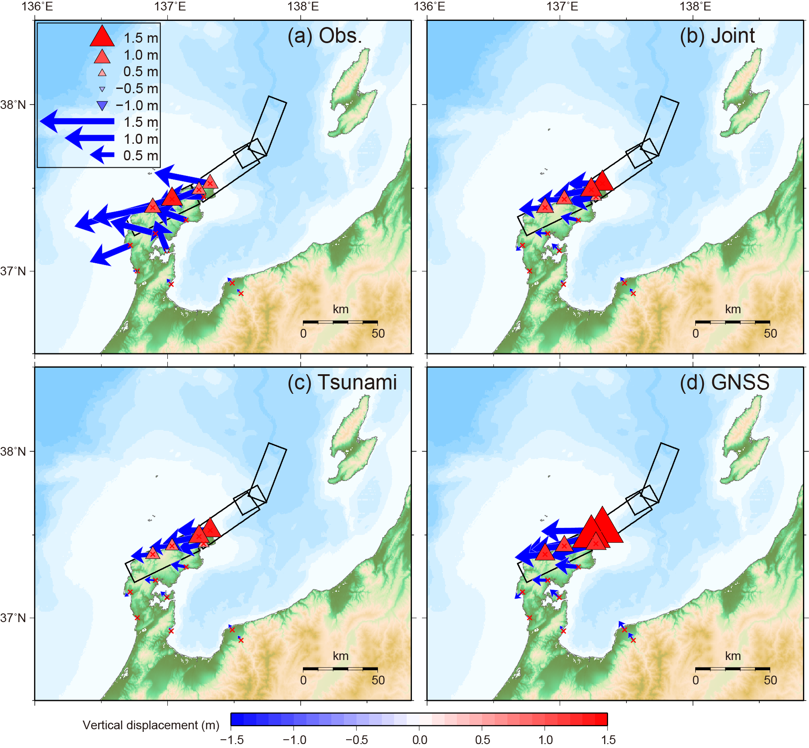
Fig. S4 Same as Fig. 3, but for a case adopting the MLIT fault models.

