Extended Data Fig.1: Efficient labeling of cortical astrocytes using AAV. AAV.PhP.eB expressing Lck-GFP, under the control of an astrocyte-specific promoter (GfaABC₁D), which were retro-orbitally injected into neonates at P1 with titers of 1e11. Astrocytes were labeled from P8 to P21 in the visual cortex, and tissues were subsequently stained with GFP antibodies.

Extended Data Fig.2: Ultrafast tissue clearing of whole-mount brain tissues with FOCM. Mouse coronal brain sections, fixed with 4% PFA and having thicknesses of 300 μm, 400 μm, and 500 μm, were treated with either FOCM or PBS (control). Tissues achieved optical clearance within 10 minutes of FOCM treatment.

Extended Data Fig.3: Evaluating Astrocyte Morphology using multiple morphological metrics. a. In order to assess the morphological characteristics of astrocytes in a 2D format, we retroorbitally injected WT or γC3 KO mice with AAV.PhP.eb carrying Lck-GFP under the control of the astrocyte-specific GfaABC1D promoter. The mice were harvested at P21 and subsequently subjected to immunostaining using an anti-GFP antibody. Included in the presentation are representative images of single astrocytes, flattened in a confocal volume, from both WT and γC3 KO in layer 5/6 V1 mice. b. The results are summarized in plots representing various morphological parameters, including Feret max, Feret min, aspect ratio, territory size, roundness, and circularity.WT, N=24 astrocytes from six mice; γC3 KO, N=21 astrocytes from four mice. Error bars, s.e.m. Scale bars 10 µm. ***p<0.001.
Extended Data Fig.4: Expression of AAVs expressing γC3FL in vivo. To assess the cell-autonomous effects of γC3 in astrocytes, we used AAV.PhP.eB to express Lck-smMyc and γC3 full-length under an astrocyte-specific GfaABC₁D promoter in γC3 KO mice. These constructs were retro-orbitally delivered into P1 mice. Expression of γC3FL was detected using anti-V5 (red). Astrocyte morphology was labeled with anti-Myc antibody (green). Scale bars, 10 µm.

Extended Data Fig.5: Expression of AAVs expressing γC3 homophilic binding mutants in vivo. AAV.PhP.eB was used to express Lck-smMyc, γC3-L87E, and γC3-L342E mutants under an astrocyte-specific GfaABC₁D promoter in γC3 KO mice. AAV.PhP.eB expressing γC3-L87E and γC3-L342E, both tagged with C-terminal 3xV5, were retro-orbitally delivered into P1 mice. Astrocyte morphology was labeled by co-injecting AAV.GfaABC1D expressing Lck-smMyc (green). a. Expression of γC3-L87E (red). b. Expression of γC3-L342E at P21 (red). Astrocyte morphology was visualized with an anti-Myc antibody. Scale Bars 10 µm.

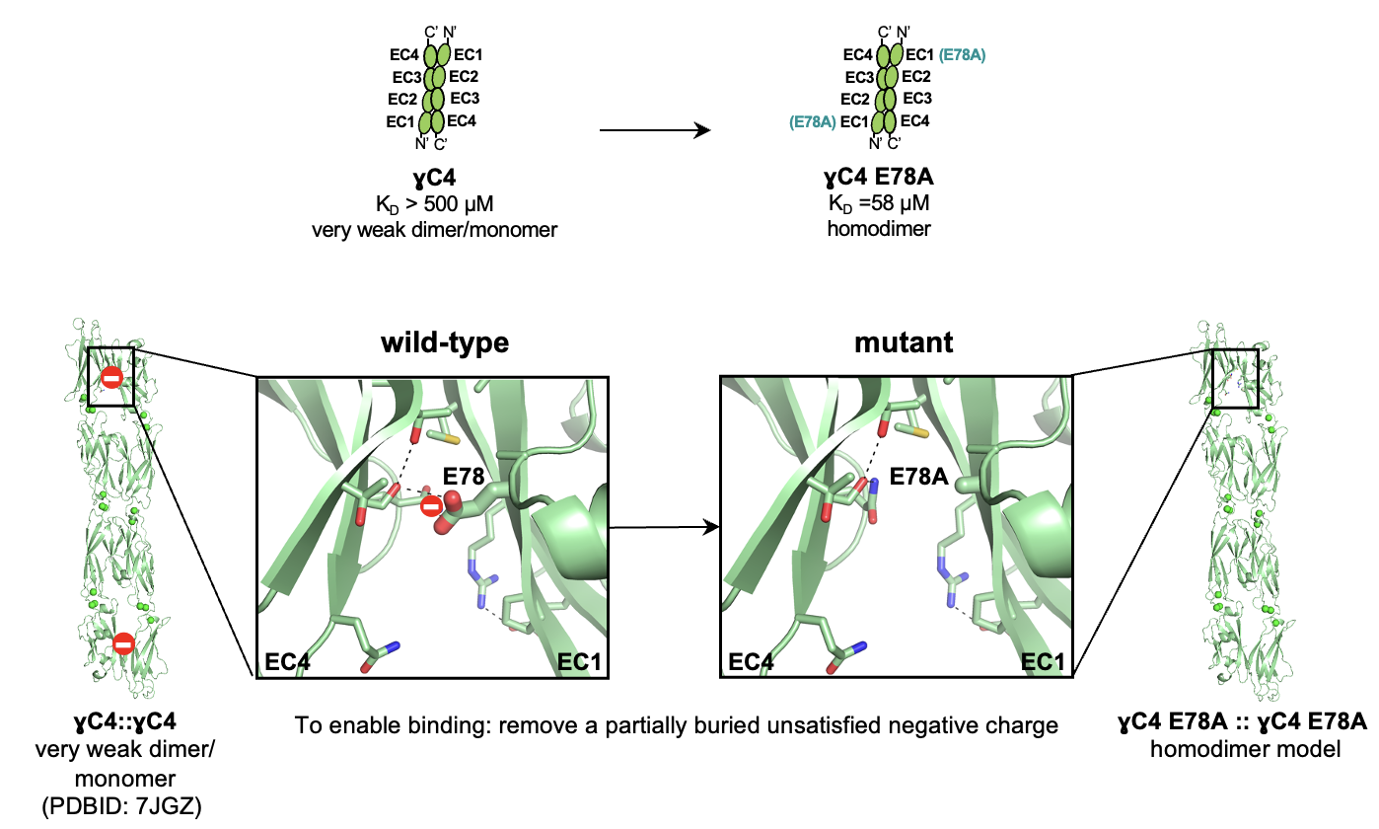
Extended Data Fig.6: Enhancing wild-type PcdhγC4 homophilic binding with E78A mutation. Summary of the AUC experiments (top). Comparison of trans-dimer interfaces before (WT, left) and after mutation (mutant, right) (bottom). Trans-dimers shown in ribbon representation. Interfacial residues shown as sticks. Mutated residue is labelled and shown in thick sticks. Unsatisfied buried charges as red spheres.

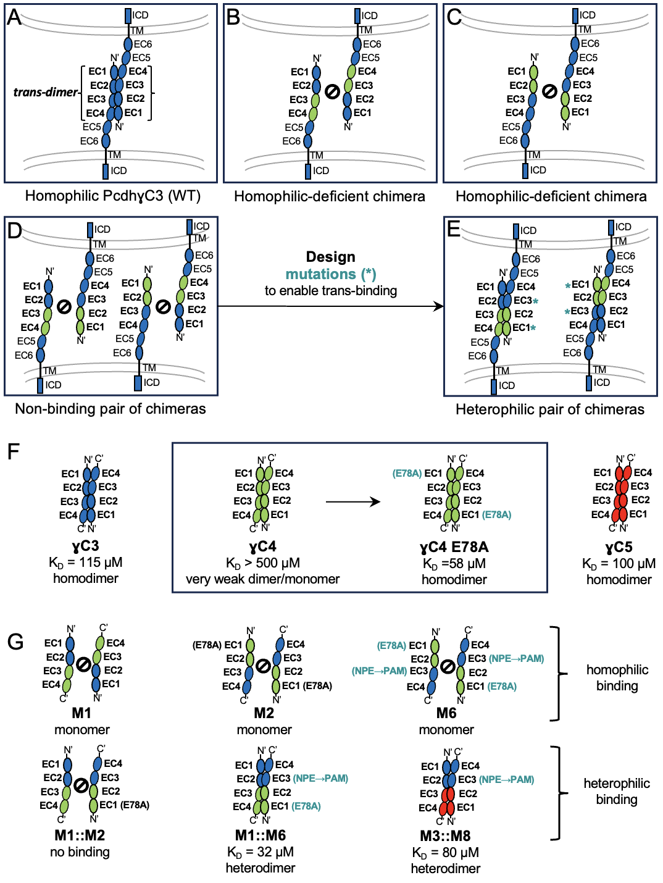
Extended Data Fig.7: Design of heterophilic protocadherin chimera pairs that lost homophilic binding. a. Contact between cell membranes (grey) of astrocyte sister branches (WT). γC3 molecules (blue) forming a trans-dimer (in curly brackets) are shown schematically with extracellular cadherin (EC) domains as ellipses. b,c. Homophilic-deficient Pcdh chimeras. d. A pair of chimeras (one from b and another from c) co-expressed in the same astrocyte. e. A pair of chimeras in D modified with mutations (asterisk, cyan) that enable heterophilic binding. f. Summary of AUC experiments of WT γC3, γC4, and γC5, parts of which were used for chimera design. Of note, AUC on γC5 was done in the context of the EC1-EC5 fragment, but only the EC1-EC4 trans-dimer is shown in the schematic. g. Summary of AUC experiments on the designed chimeras. See Methods for details on mutation (cyan) design. A sign with a circle and a line through it depicts inability to form dimers.
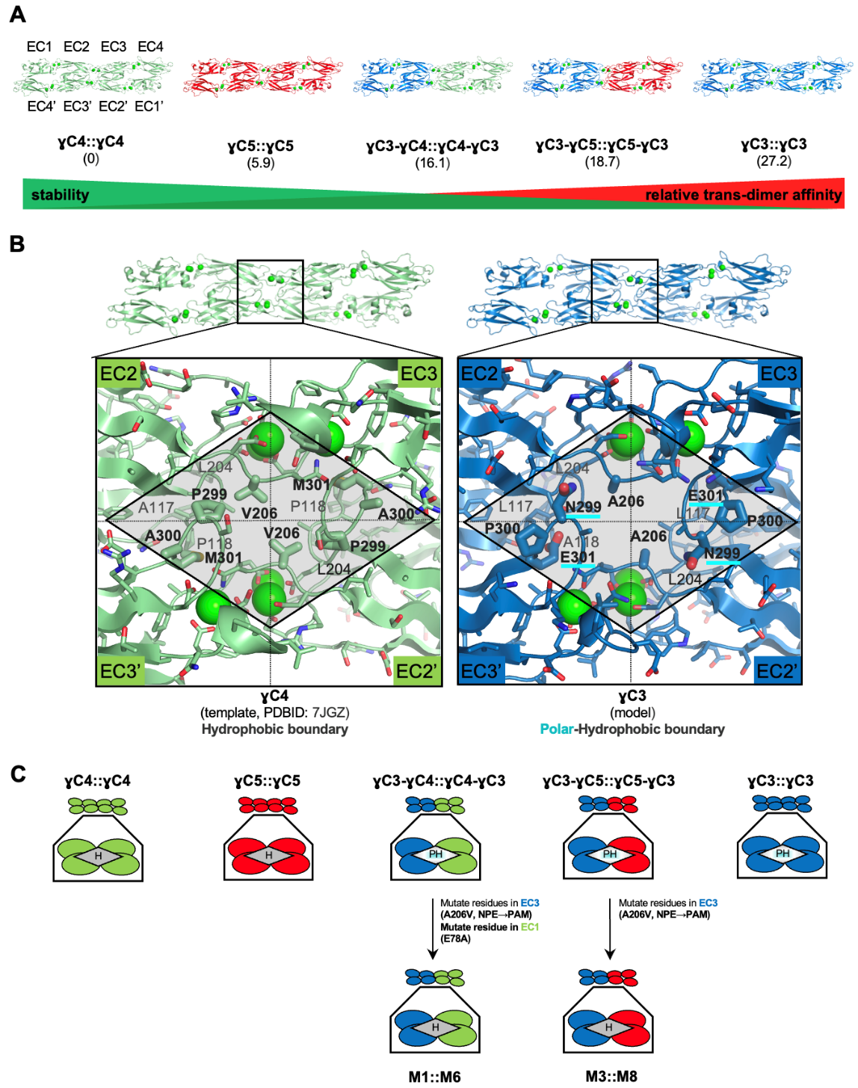
Extended Data Fig.8: Trans-dimer models and their properties at the EC2-EC3 boundary. a. Relative FoldX energies (in parenthesis in kcal/mol) of the EC1-EC4::EC4’-EC1’ trans-homodimers assuming all complexes form dimers identical in C𝛼 backbone to γC4::γC4. The chimeras are color-coded based on the sequence composition: γC3 (blue), γC4 (green) or γC5 (red). All structures shown in ribbon representation with calcium atoms as green balls. b. Comparison of the amino acid properties at the EC2EC3 boundary of γC4 trans-dimer and γC3. Protein backbone is in ribbon representation. Residues are shown as sticks in the expanded view of the EC2EC3::EC3’EC2’ interface. Residues that differ in properties between γC4 and γC3 in a diamond-shaped area correspond to thicker sticks. Polar residues predicted to destabilize γC3 trans-dimer in the γC4-like orientation are underlined in cyan. c. Schematic representation of the expanded views shown in b for all WT and chimera proteins. H – hydrophobic boundary, PH – polar/hydrophobic non-complementary boundary.
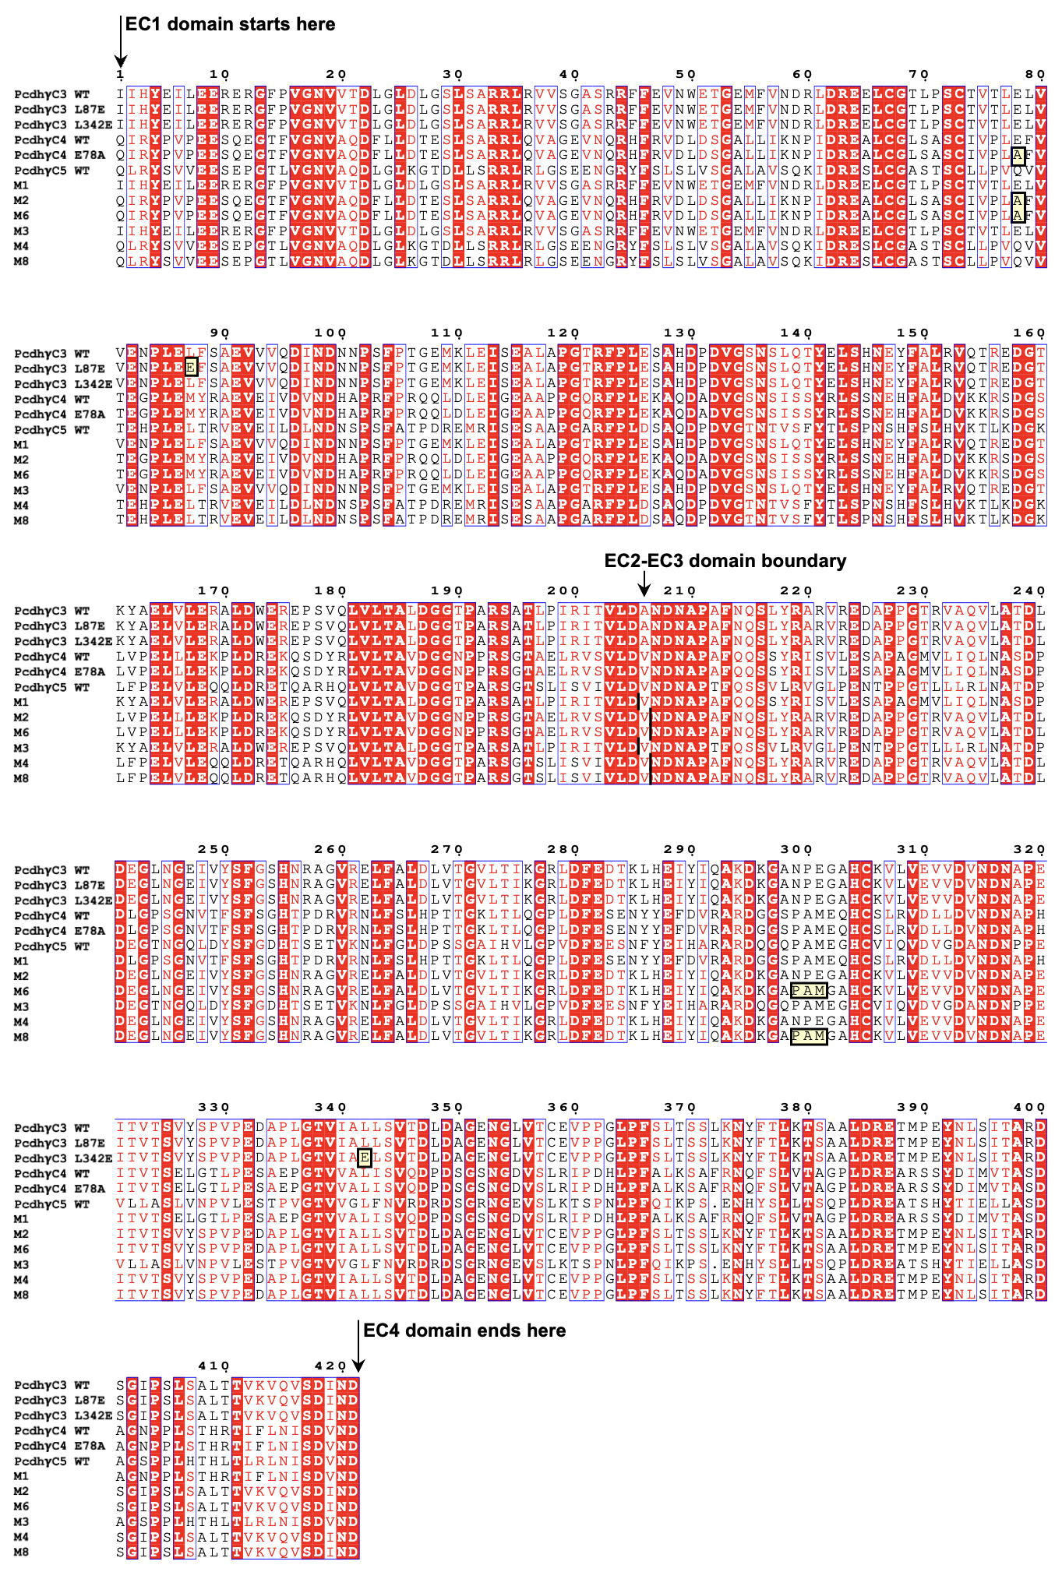
Extended Data Fig.9: Multiple sequence alignment of protocadherin EC1-EC4 fragments modeled using FoldX and experimentally probed in AUC. Red denotes regions conserved in sequence. Yellow boxes highlight mutated regions compared to WT proteins. Vertical black bars show the EC2-EC3 domain boundaries (near residue 206) used in the chimeras. Residue numbering as in template, γC4 WT (PDBID: 7JGZ).
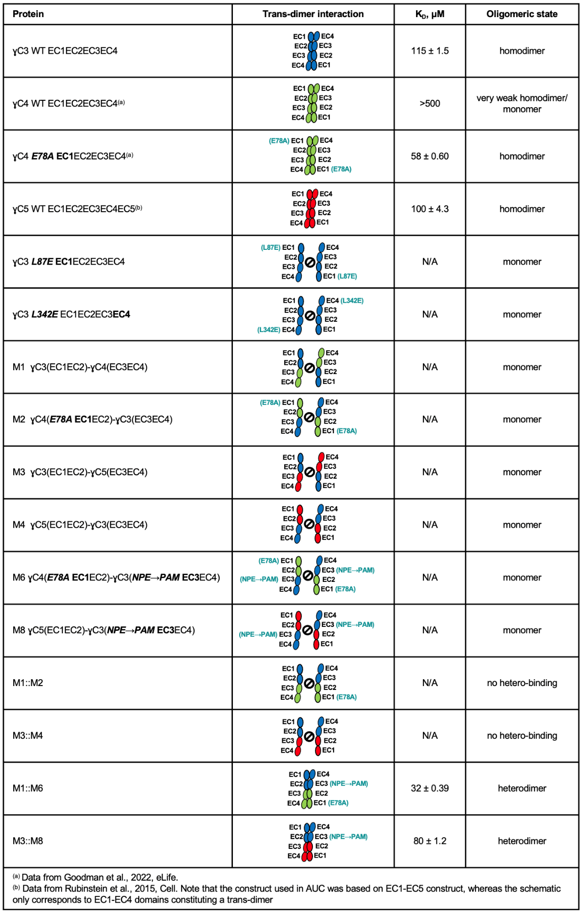
Supplementary Table 1: Analytical ultracentrifugation (AUC) analysis of protocadherin trans-dimers.

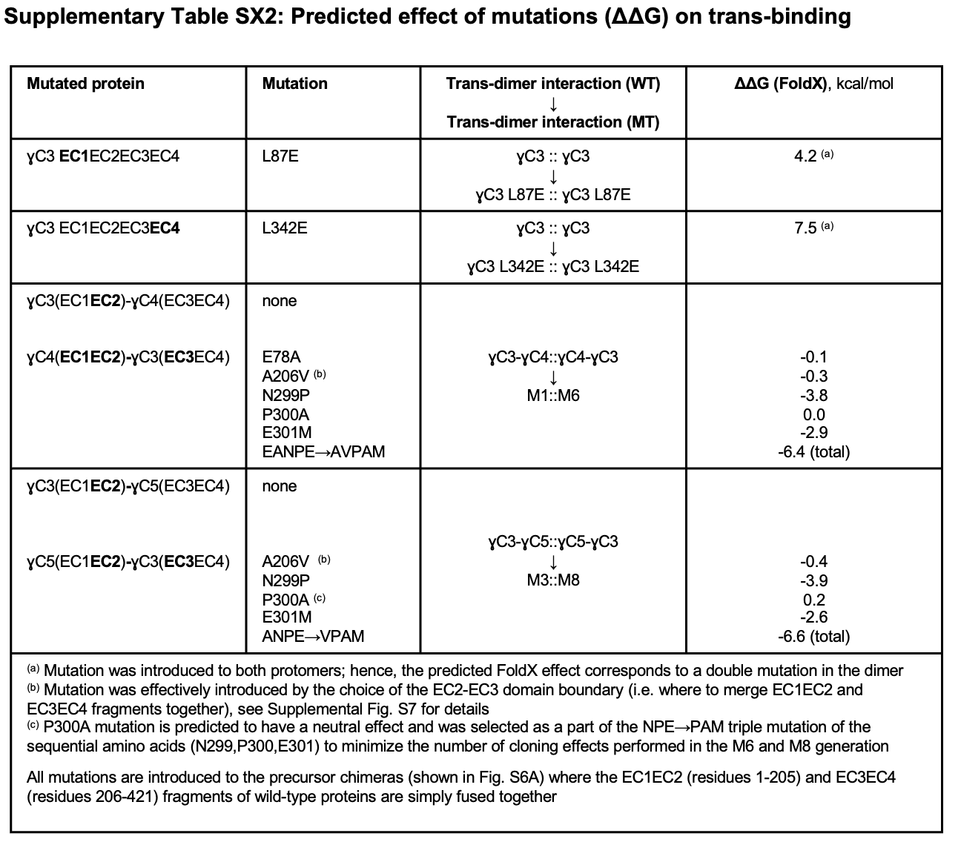
Supplementary Table 2: Predicted effect of mutations (ΔΔG) on trans-binding interaction.

