Supplementary Information

Ion migration as a tool to enhance the performance of perovskite CsPbBr₃ γ-ray detectors

Lei Pan^{1†}, Khasim Saheb Bayikadi^{1†}, Indra Raj Pandey^{1,2}, Sujita Karki¹, Zhifu Liu³, John A. Peters^{3,4}, Michael De Siena¹, Duck Young Chung², Bruce W. Wessels³, and Mercouri G. Kanatzidis^{1,2,3}*
¹Department of Chemistry, Northwestern University, Evanston, IL 60208, USA
²Materials Science Division, Argonne National Laboratory, Lemont, IL 60439, USA
³Department of Materials Science and Engineering, Northwestern University, Evanston, IL 60208, USA
⁴Department of Chemistry, Physics, & Engineering Studies, Chicago State University, Chicago, IL 60608
†These authors contributed equally to this work
*Correspondence to: m-kanatzidis@northwestern.edu

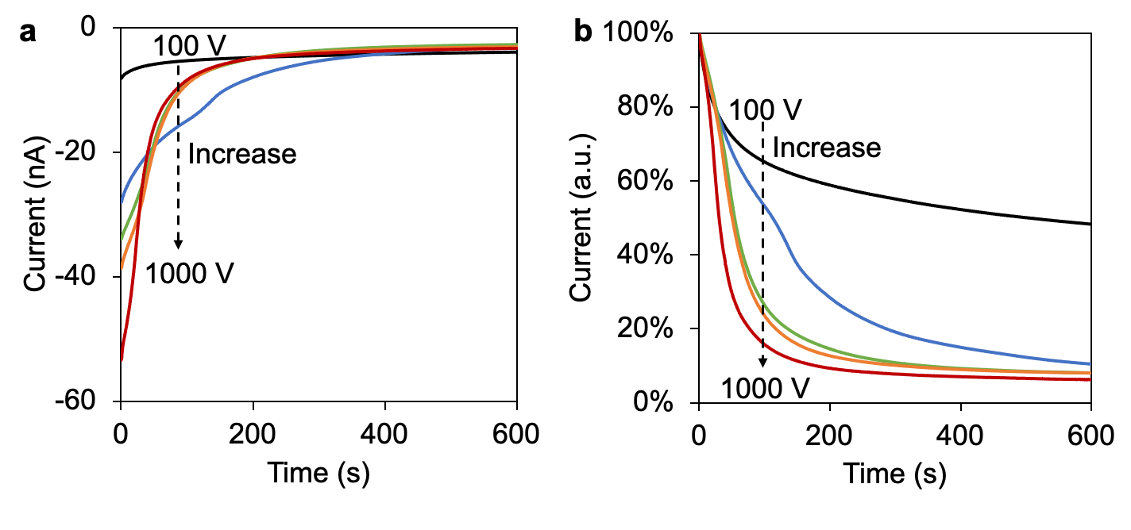
Supplementary Figure 1.a, reverse current decreasing at different bias voltage. all measurements were performed at room temperature. b, reverse currents normalized to their respective initial values to better observe the decreasing speed. Itis noted that each time after testing at a reverse bias voltage, we applied forward bias to the detector until the small forward current increased to similar large values. Then reverse current decreasing testing at another bias voltage was performed.

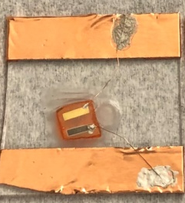
Supplementary Figure 2. A CsPbBr₃ device with Bi and Au electrode deposited on the same side of the crystal for contact potential difference measurement. The width of the electrodes is ~ 1 mm and the separation of the two electrodes is 2.6 mm.

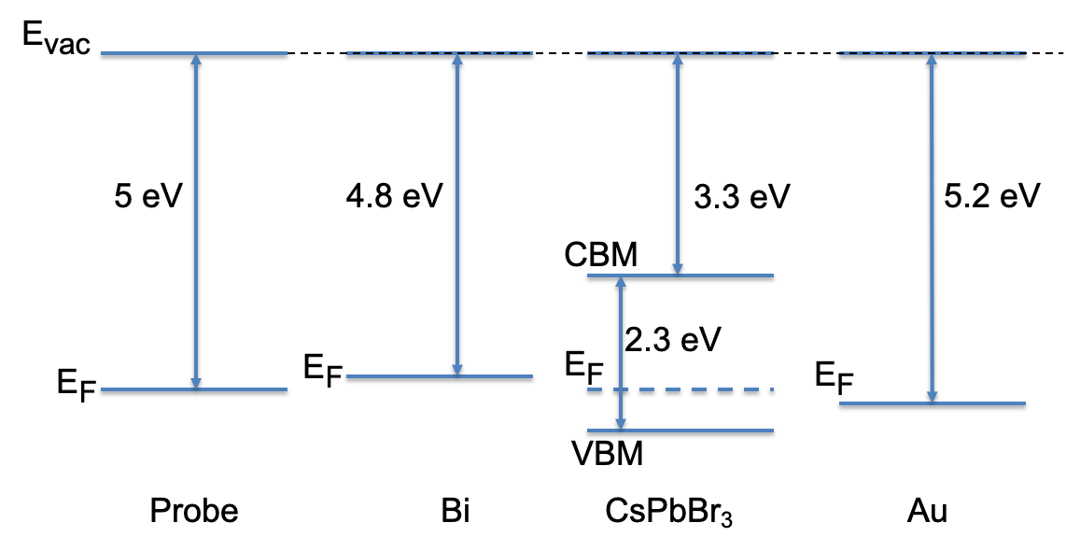
Supplementary Figure 3. Work function of Kelvin Probe is calibrated to be 5 eV. Without any deliberate biasing, the work function of Bi and Au electrode deposited on CsPbBr₃ surface is measured to be 4.8 eV and 5.2 eV, respectively, by the Kelvin Probe. Bandgap and electron affinity of CsPbBr₃ is 2.3 eV and 3.3 eV respectively, which is measured in our previous work¹. CBM and VBM stand for conduction band minimum and valance band maximum, respectively.

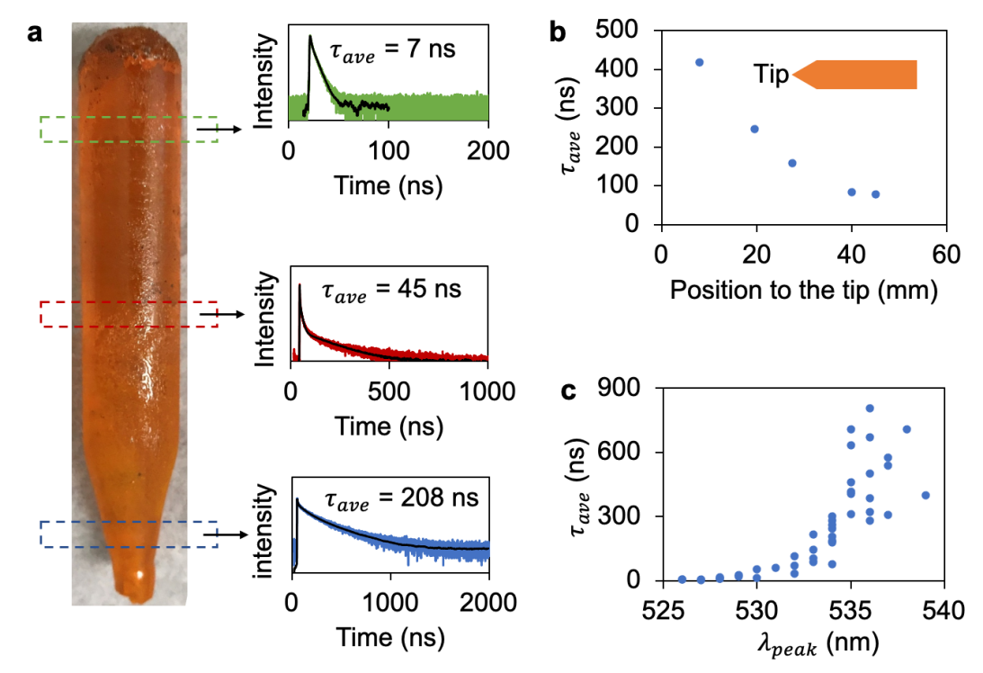
Supplementary Figure 4. As grown CsPbBr₃ ingot show quality gradient affected by impurity concentration (adopted from our previous work²). a, PL decay lifetime τ_{ave} of crystals from different part of the ingot.PL decay time decreases from the bottom part to the top part. The ingot has a color gradient with top part darker than the bottom tip part, which means more impurities in the top part. Shorter PL decay time of the top part of as-grown CsPbBr₃ ingot is due to excessive extrinsic impurities. Longer PL decay time means less impurities. b, A typical correlation ofτ_{ave} of crystal from the same ingot but different location in the ingot. c, Statistical correlation of τ_{ave} and λ_{peak} of CsPbBr₃ crystals from many ingots. Longer PL decay time is usually accompanied by longer PL emission wavelength.
To elucidate the impact of biasing-induced ion migration on CsPbBr₃ crystal defect characteristics, a meticulous experimental design was implemented. Two discrete sets of detectors were fashioned from two crystal discs denoted as set-I and set-II, each possessing a uniform thickness of 2 mm. Within each set, four detectors were systematically engineered, with one maintained in an unbiased state and the remaining three subjected to a reverse bias voltage of 300 V for distinct durations. After the crystals were treated with different biasing time, employing a 375 nm pulsed laser diode as the excitation source at ambient temperature, steady-state, and time-resolved photoluminescence (PL) spectra of these crystals were diligently recorded utilizing an Edinburgh Instruments FS5 spectrofluorometer equipped with a 395 nm grating filter. Notably, to obviate any potential confounding effects from surface preparation procedures, PL measurements were exclusively conducted on freshly cleaved crystal surfaces.
Detailed outcomes pertaining to the PL emission characteristics and time-resolved PL decay times have been documented within Table S1 for the set-I and Table S2 for the set-II, respectively. These tables show the nuanced variations in PL emission wavelengths as well as the elongation of the PL decay times after biasing-induced ion migration.

Table S1. PL measurement results of the four CsPbBr₃ crystals from the set-I subject to reverse biasing.
Biasing time | Emission peak λ_{peak} (nm) | τ_{ave} (ns) at 529 nm | Fitted decay time components
None-biased | 529 | 43.1 | $τ_{1}$: 15.2 ns (B₁: 32.53%)  $τ_{2}$: 56.6 ns (B₂: 67.47%)
8 hours | 529 | 70.2 | $τ_{1}$: 19.6 ns (B₁: 30.52%)  $τ_{2}$:92.5 ns (B₂: 69.48%)
12 hours | 533 | 65.97 | $τ_{1}$:17.7 ns (B₁: 25%)  $τ_{2}$:82.1 ns (B₂: 74.95%)
15 hours | 533 | 62.38 | $τ_{1}$:17.66 ns (B₁: 31.42%)  $τ_{2}$:82.84 ns (B₂: 68.58%)
The PL decay was fitted to a multi-exponential decay equation $R\left(t\right)=B_{1}e^{-t/τ_{1}}+B_{2}e^{-t/τ_{2}}+B_{3}e^{-t/τ_{3}}$, where $R\left(t\right)$ is measured PL intensity, $B_{1}$, $B_{2}$, $B_{3}$ are proportionality coefficients. $τ_{ave}$ is intensity averaged lifetime calculated as $τ_{ave}=\frac{\sum{B_{i}τ_{i}^{2}}}{\sum{B_{i}τ_{i}}}$.

Table S2. PL measurement results of the four CsPbBr₃ crystals from the set-II subject to reverse biasing.
Biasing time | Emission peak λ_{peak} (nm) | τ_{ave} (ns) at 529 nm | Fitted decay time components
None-biased | 530 | 62.2 | $τ_{1}$: 22.92 ns (B₁: 32.05 %)  $τ_{2}$: 80.75 ns (B₂: 67.95%)
5 hours | 532 | 73.77 | $τ_{1}$: 25 ns (B₁: 30.17%)  $τ_{2}$: 95 ns (B₂: 69.83%)
10 hours | 535 | 75.38 | $τ_{1}$: 25.1 ns (B₁: 33.79%)  $τ_{2}$: 101.04 ns (B₂: 66.21%)
22 hours | 535 | 77.96 | $τ_{1}$: 22.98 ns (B₁: 30.1%)  $τ_{2}$: 101.6 ns (B₂: 69.92%)

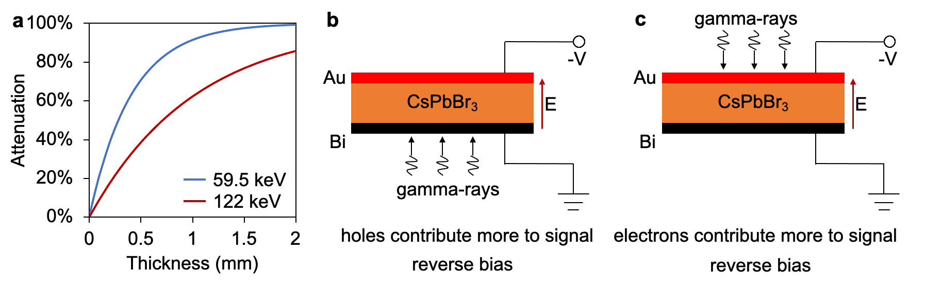
Supplementary Figure 5. a, attenuation of 59.5 keV and 122 keV gamma ray by CsPbBr₃. 1 mm thick CsPbBr₃ can attenuate 91% 59.5 keV and 63% 122 keV gamma ray.b, gamma rays irradiating anode so that holes contribute more to the total induced signal. c, gamma rays irradiating cathode so that electrons contribute more to the total induced signal.

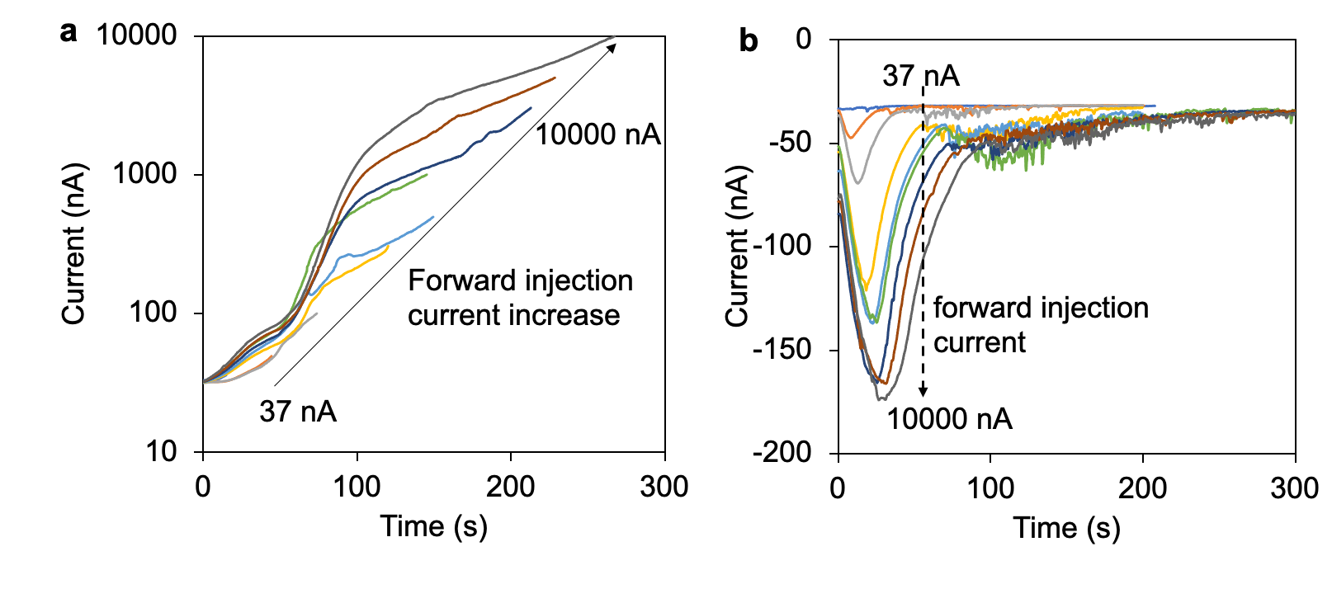
Supplementary Figure 6. Reverse current testing after different forward injection current. Each reverse current shown in b was measured after forward biasing where the forward current increased to certain value as shown in a. The reverse current and forward current were measured alternatively. A larger forward current associated with a longer forward biasing time leads to more charge injection and charge trapping, which results in a larger reverse current peak due to charge de-trapping.

Table S3. PL measurement results of the four CsPbBr₃ crystals subject to forward biasing.
Biasing time | Emission peak λ_{peak} (nm) | τ_{ave} (ns) at 532 nm | Fitted decay time components
None-biased | 532 | 54.0 | $τ_{1}$: 5.46 ns (B₁: 5.29 %)  $τ_{2}$: 28.6 ns (B₂: 40.49%)  $τ_{3}$: 77.5 ns (B₂: 54.22%)
4 hours | 531 | 58.5 | $τ_{1}$: 3.9 ns (B₁: 3.59%)  $τ_{2}$: 26.8 ns (B₂: 37.9%)  $τ_{3}$: 82.2 ns (B₂: 58.51%)
8 hours | 533 | 86.7 | $τ_{1}$: 6.83 ns (B₁: 4.75%)  $τ_{2}$: 35.5 ns (B₂: 30.86%)  $τ_{3}$: 117.1 ns (B₂: 64.4%)
12 hours | 533 | 78.2 | $τ_{1}$: 5.5 ns (B₁: 4.4%)  $τ_{2}$: 31.3 ns (B₂: 31.64%)  $τ_{3}$: 106.2 ns (B₂: 63.97%)
A large CsPbBr₃ crystal with average PL decay time of ~ 54 ns was broken into four pieces with one served as the non-biased control sample and the remaining three were subjected to forward biasing at 300 V.

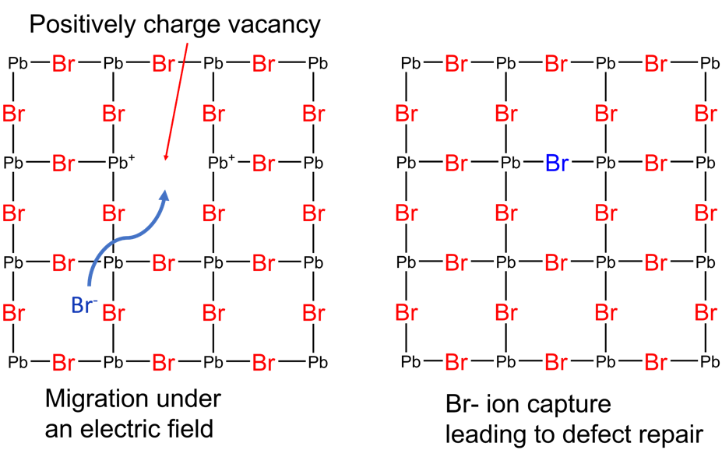
Supplementary Figure 7. Schematic structural model of CsPbBr₃ showing the presence of an interstitial Br- ion and the positively charged vacancy where the Pb²⁺ are undercoordinated. In principle, the number of interstitial Br- ions and vacant positively charged sites are equal. On the left, the figure indicates the possible ion migration path under the application of an electric field. The right model represents defect repair through recapturing of the Br- ion by the undercoordinated Pb²⁺ atom.
Thermal stimulated current (TSC) spectroscopy
For electronic traps using a quasi-equilibrium approach of Bube³, the energy level of the trap $E_{T_{i}}$ is given by the equation (1)
 | $$E_{T_{i}}={kT}_{m}ln⁡(\frac{NSv_{th}kT_{m}^{2}}{βE_{T_{i}}})$$ | (1)
where k is the Boltzmann constant, T_{m} is the TSC peak temperature, N is the effective density of states,$S$ is the capture cross section, $v_{th}$ is the thermal velocity of the carriers, βis the heating rate. The trap energy $E_{T_{i}}$ can be calculated using equation (2) below⁴, noting that N, the effective density of states, is proportional to T^{3/2},and v_{th}, the thermal velocity, is proportional to T^{½}
 | $$E_{T_{i}}={kT}_{m}ln⁡(\frac{T_{m}^{4}}{β})$$ | (2)
The trap concentration N_{Ti} can be approximately determined from the collected charge for trap i (Q_{Ti}) using equation (3) and (4).
 | $$Q_{T_{i}}=\int{I_{TSC}^{i}dt}$$ | (3)
 | $$N_{T_{i}}=\frac{Q_{T_{i}}}{2μτeAE}$$ | (4)
Here, $I_{TSC}^{i}$is the collected current for trap i and $Q_{T_{i}}$is the temporal integration of each TSC peak. $μ$ is the carrier mobility, $τ$ the carrier lifetime, e the electron charge, $A$ is the electrode area, and $E$ is the applied electric field. Using equations (2) and (3), the trap depths and capture cross sections for the observed traps were calculated using SIMPA fitting. Potential defects were identified according to reported theoretical calculation results⁵.
Table S3 shows the SIMPA fitting results for the non-biased and biased CsPbBr₃ samples up to 300 K. The total number of traps in the temperature range of 79 K to 300 K is ~ 2×10¹⁴ cm⁻³ and ~5×10¹² cm⁻³ for the non-biased and biased samples, respectively.

Table S3. Individual trap energy and density determined for the CsPbBr₃ samples
 | T_{m} (K) | $E_{T_{i}}$ (eV) | $N_{T_{i}}$ (10¹¹ cm⁻³) | Possible defects
Non-biased CsPbBr₃ | 79.68 | 0.14 | 98 | [Cs_{Pb}]⁻, [V_{Pb}]²⁻
Non-biased CsPbBr₃ | 93.01 − 102.10 | 0.16 − 0.19 | 113 | [V_{Cs}]⁻
Non-biased CsPbBr₃ | 111.32 − 143.51 | 0.21 − 0.28 | 316 | [Pb_{i}]⁺
Non-biased CsPbBr₃ | 154.74 − 181.5 | 0.31 − 0.37 | 250 | [Pb_{i}]²⁺
Non-biased CsPbBr₃ | 190.37 − 243.94 | 0.39 − 0.52 | 385 | [Pb_{Br}]²⁺
Non-biased CsPbBr₃ | 253.86 | 0.55 | 230 | [Pb_{Br}]³⁺
Non-biased CsPbBr₃ | 270.30 − 286.00 | 0.59 − 0.63 | 218 | [Pb_{Br}]³⁺
Non-biased CsPbBr₃ | 288.51 − 299.11 | 0.63 − 0.66 | 485 | [Pb_{Br}]³⁺
CsPbBr₃ biased for 36 hours | 82.19 − 83.93 | 0.14 − 0.15 | 1.51 | [Cs_{Pb}]⁻, [V_{Pb}]²⁻
CsPbBr₃ biased for 36 hours | 89.28 − 105.05 | 0.16 − 0.19 | 5.54 | [V_{Cs}]⁻
CsPbBr₃ biased for 36 hours | 111.69 − 176.25 | 0.21 − 0.36 | 19.10 | [Pb_{i}]⁺
CsPbBr₃ biased for 36 hours | 182.76 − 184.07 | 0.37 | 2.72 | [Pb_{i}]²⁺
CsPbBr₃ biased for 36 hours | 191.09 − 238.21 | 0.39 − 0.51 | 13.90 | [Pb_{Br}]²⁺
CsPbBr₃ biased for 36 hours | 248.06 − 262.94 | 0.53 − 0.57 | 4.60 | [Pb_{Br}]³⁺
CsPbBr₃ biased for 36 hours | 269.27 − 282.02 | 0.59 − 0.62 | 3.49 | [Pb_{Br}]³⁺
CsPbBr₃ biased for 36 hours | 290.83 − 302.46 | 0.64 − 0.67 | 3.35 | [Pb_{Br}]³⁺

References
1 He, Y. et al. High spectral resolution of gamma-rays at room temperature by perovskite CsPbBr3 single crystals. Nat Commun9, 1609 (2018).
2 Pan, L. et al. Perovskite CsPbBr3 single-crystal detector operating at 1010 photons/s/mm2 for ultra-high flux X-ray detection. (2022).
3 Bube, R. H. Photoconductivity of solids. (RE Krieger Pub. Co., 1978).
4 Fang, Z., Shan, L., Schlesinger, T. & Milnes, A. Study of defects in LEC-grown undoped SI-GaAs by thermally stimulated current spectroscopy. Materials Science and Engineering: B5, 397-408 (1990).
5 Zhang, M. et al. Determination of defect levels in melt-grown all-inorganic perovskite CsPbBr3 crystals by thermally stimulated current spectra. The Journal of Physical Chemistry C122, 10309-10315 (2018).

