Graph 1. Scatter Plot of HIEF and Population Growth
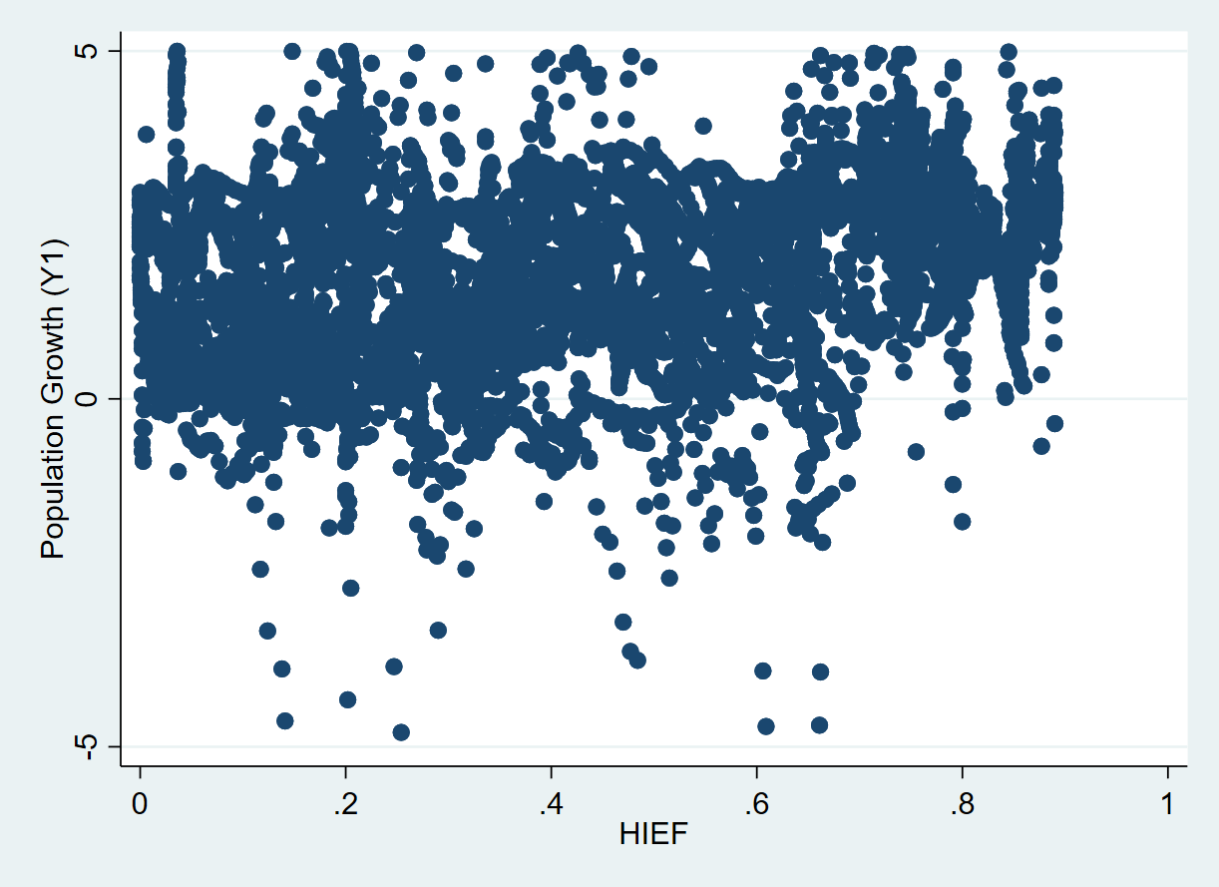

Graph 2. Scatter Plot of HIEF and Income Growth
