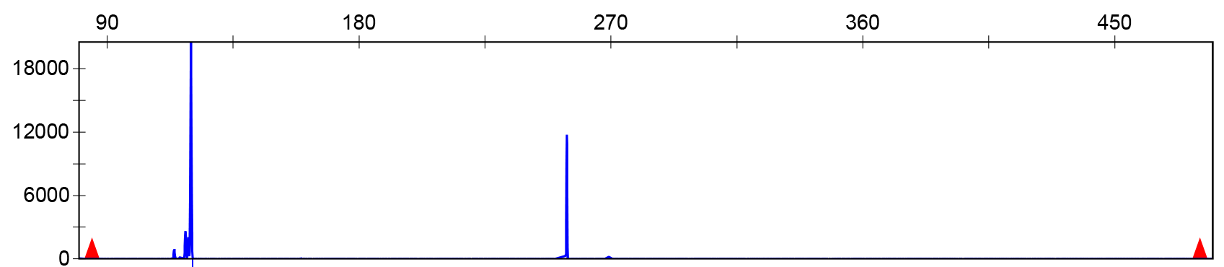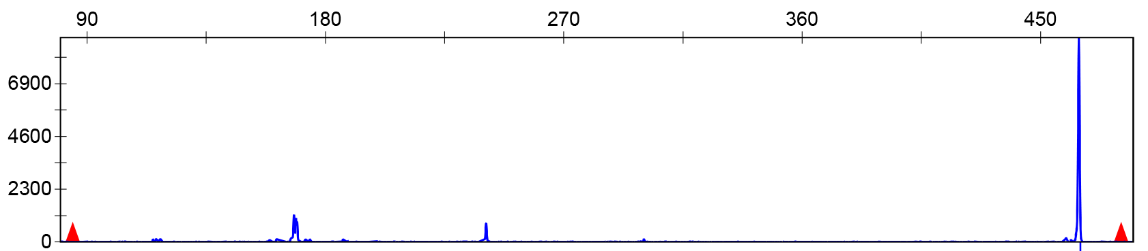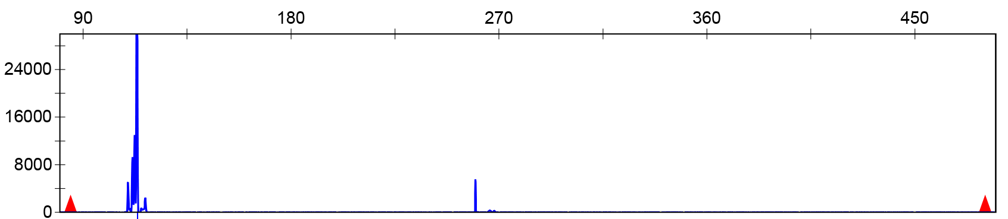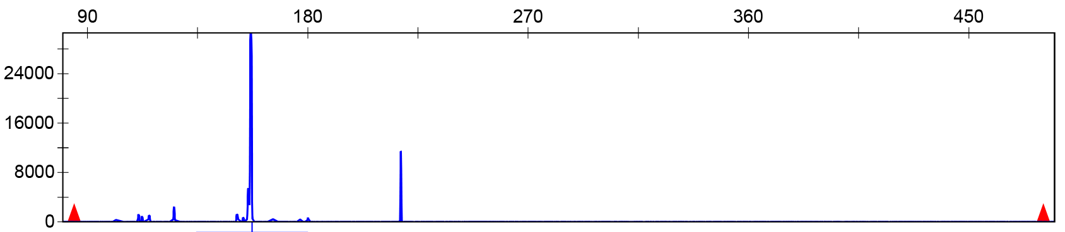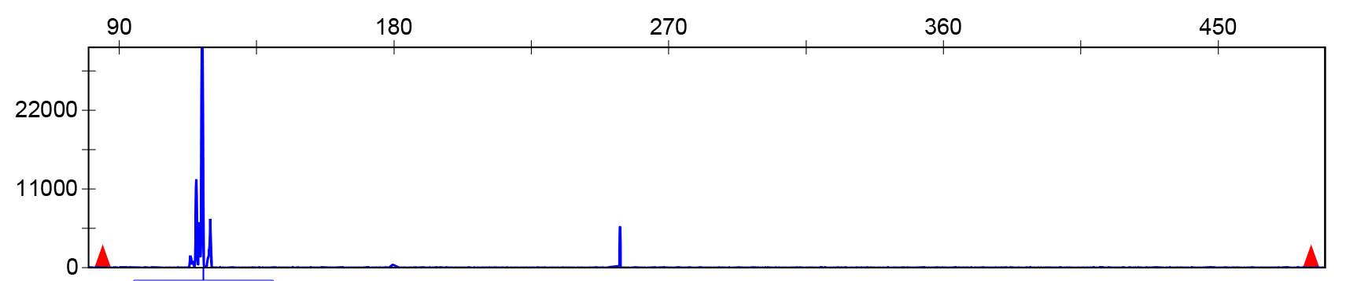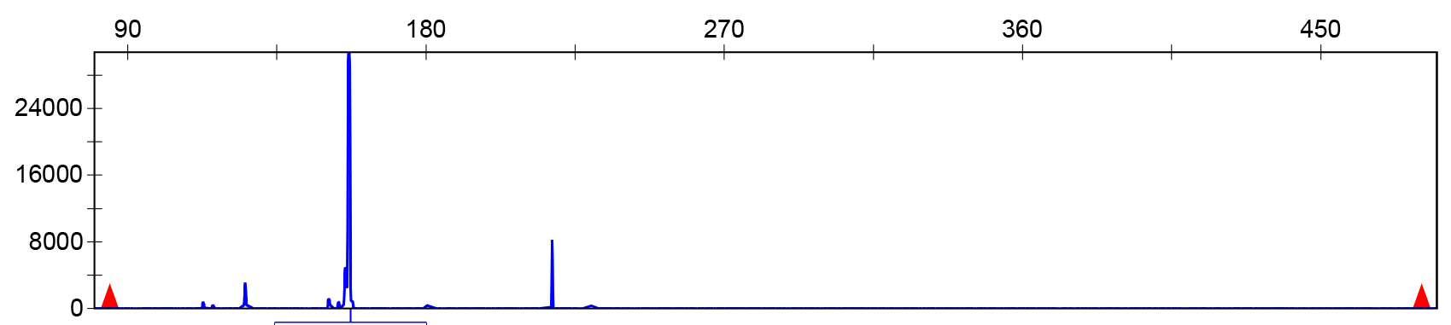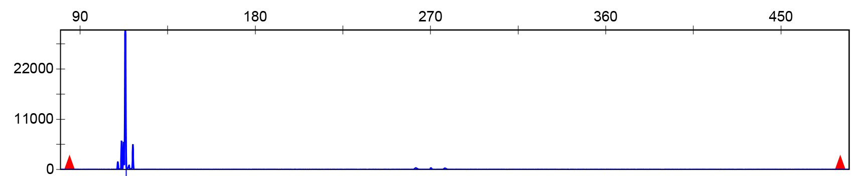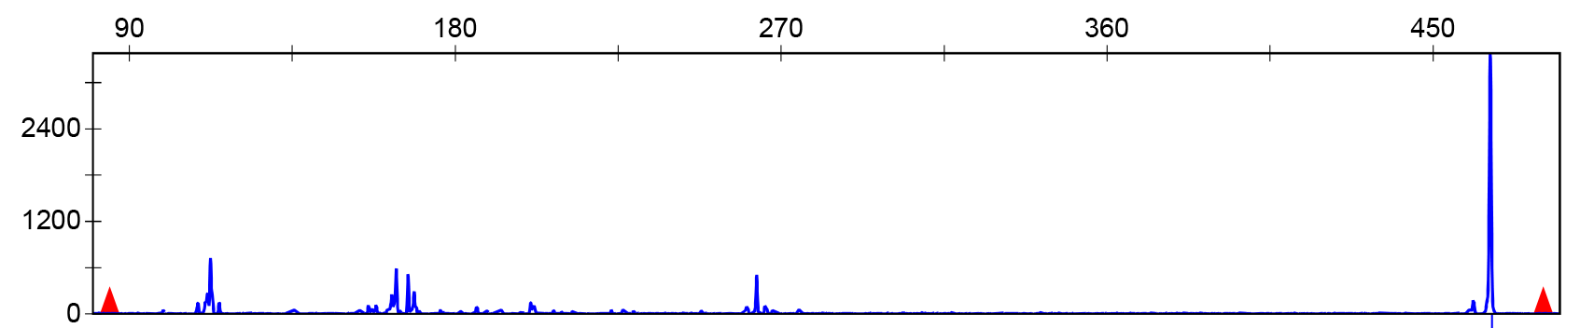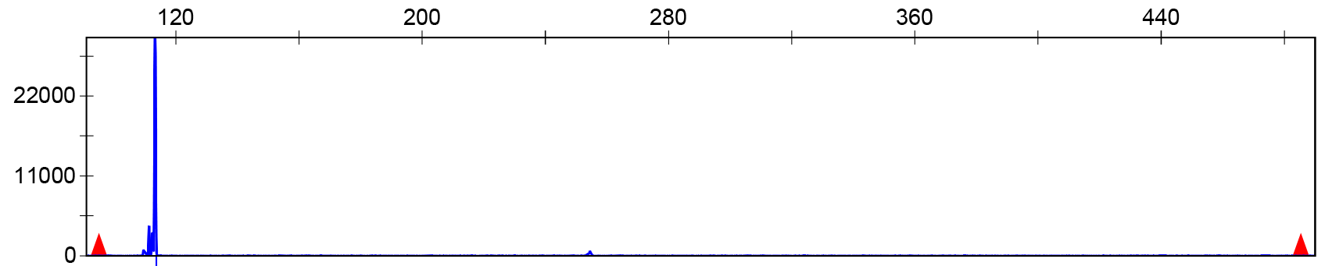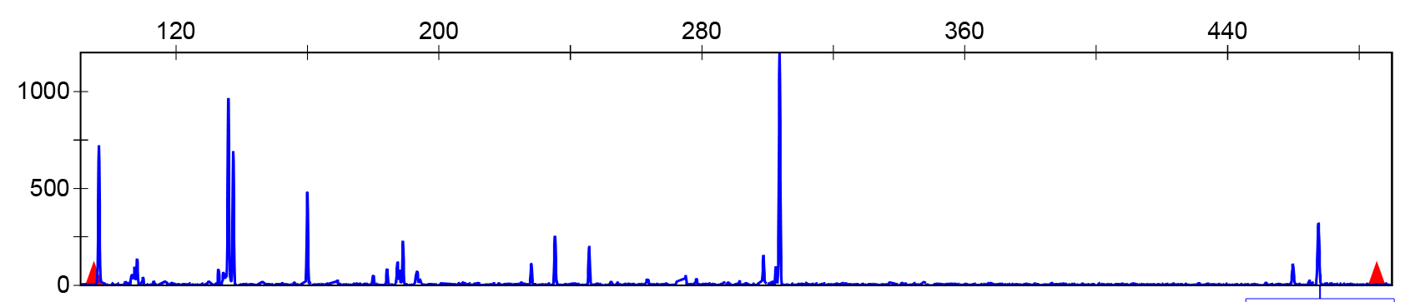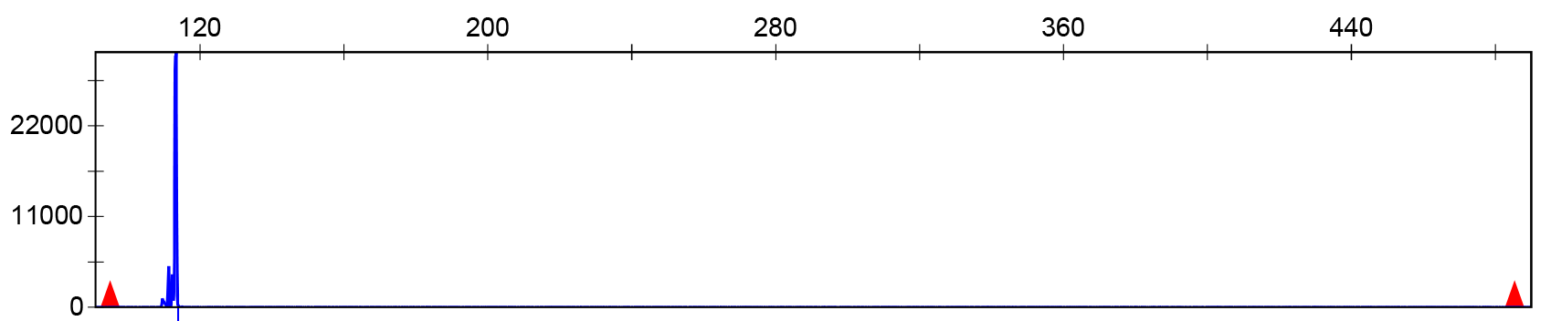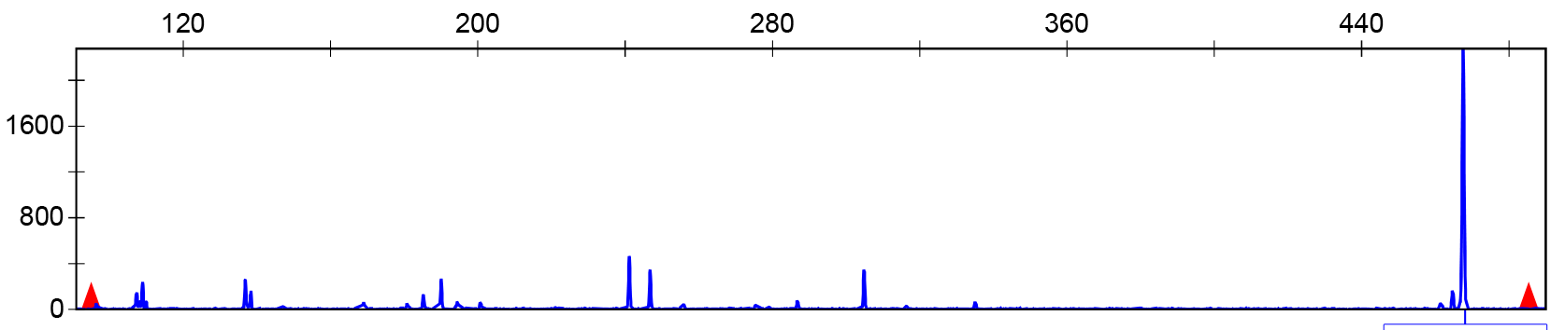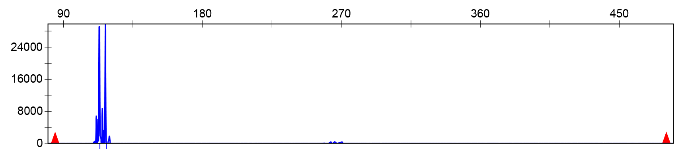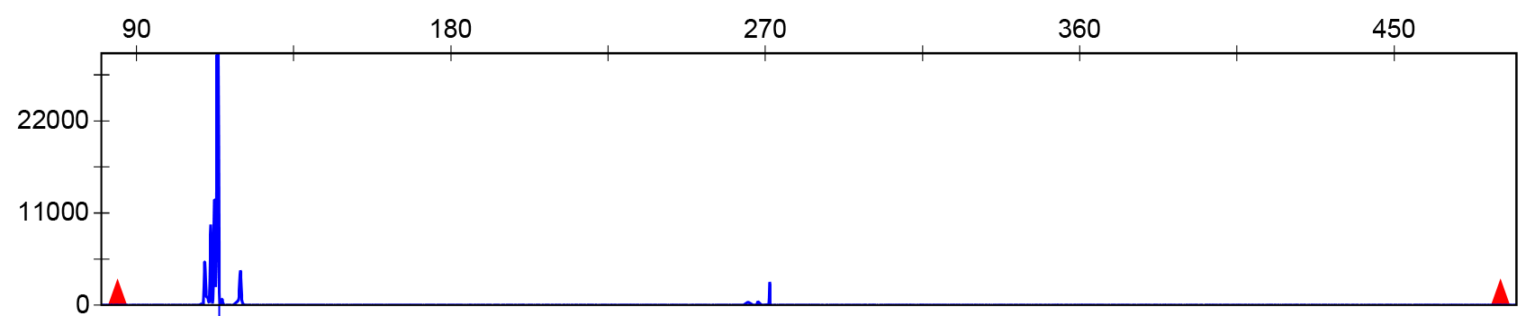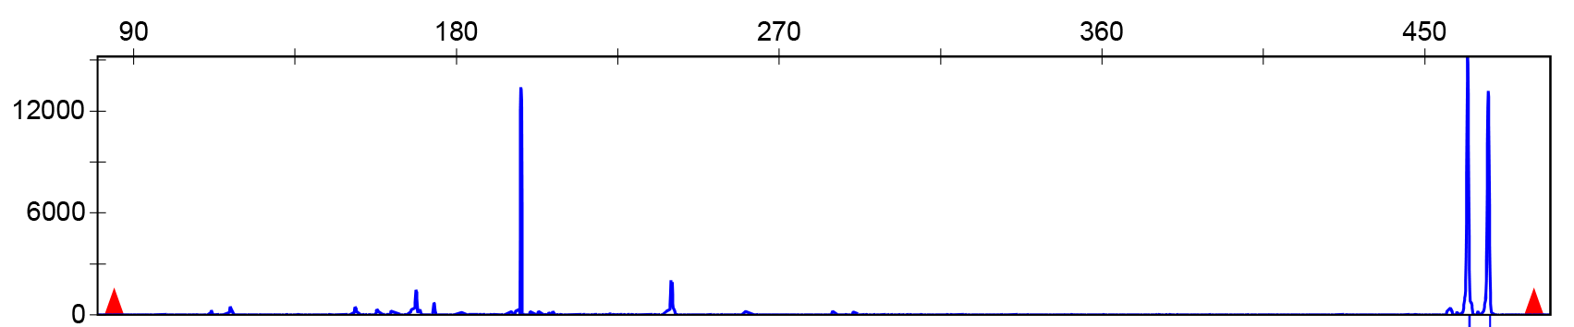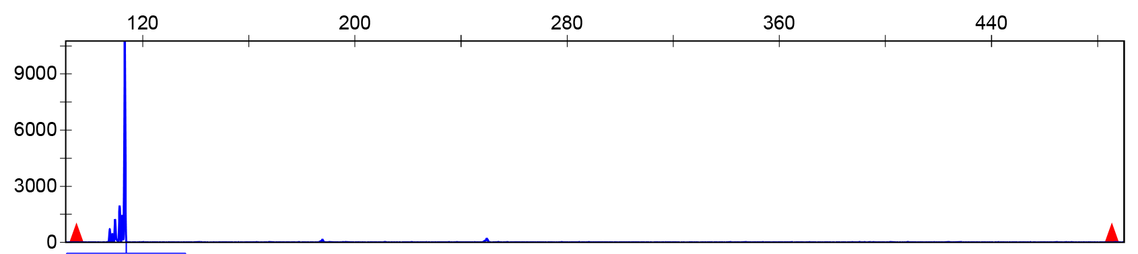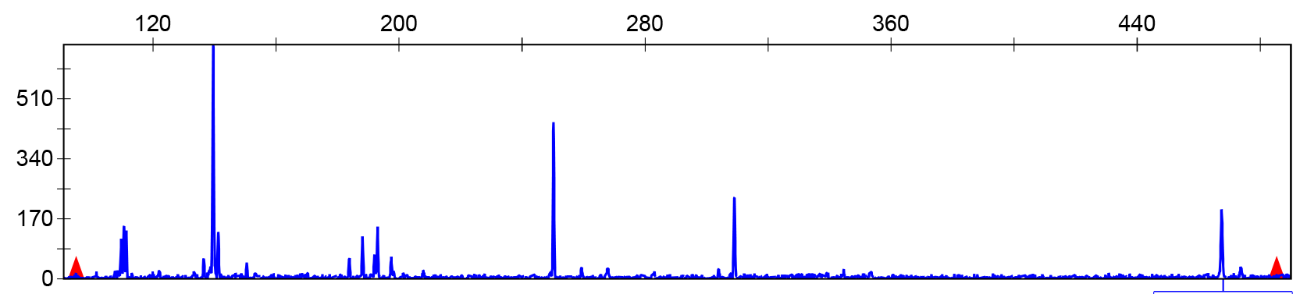
MY1
MYXZ
GP
RB
ZPCA
ZPLP
ZPLY
XZSS
XZ
ZPXC
ORTHOMCL4541
ORTHOMCL4735

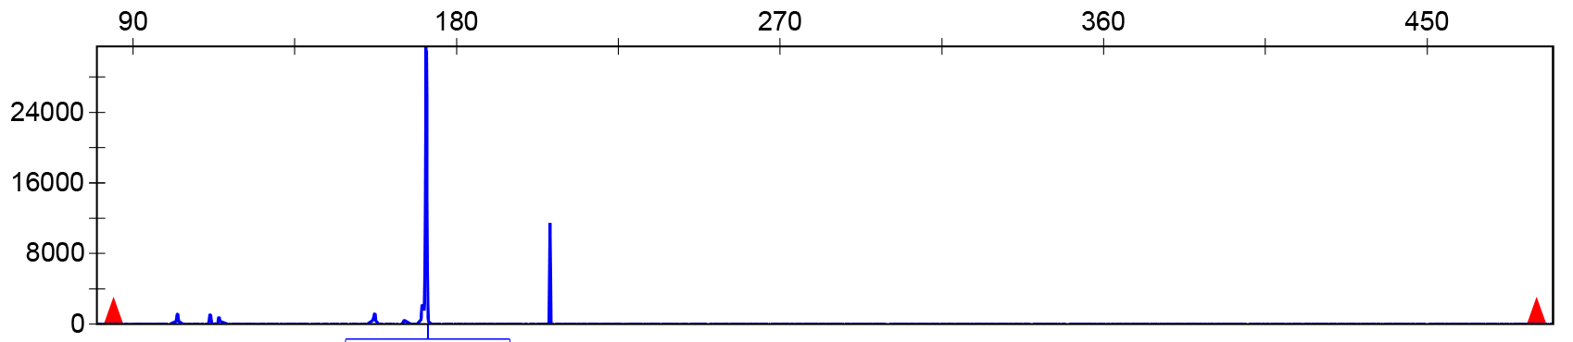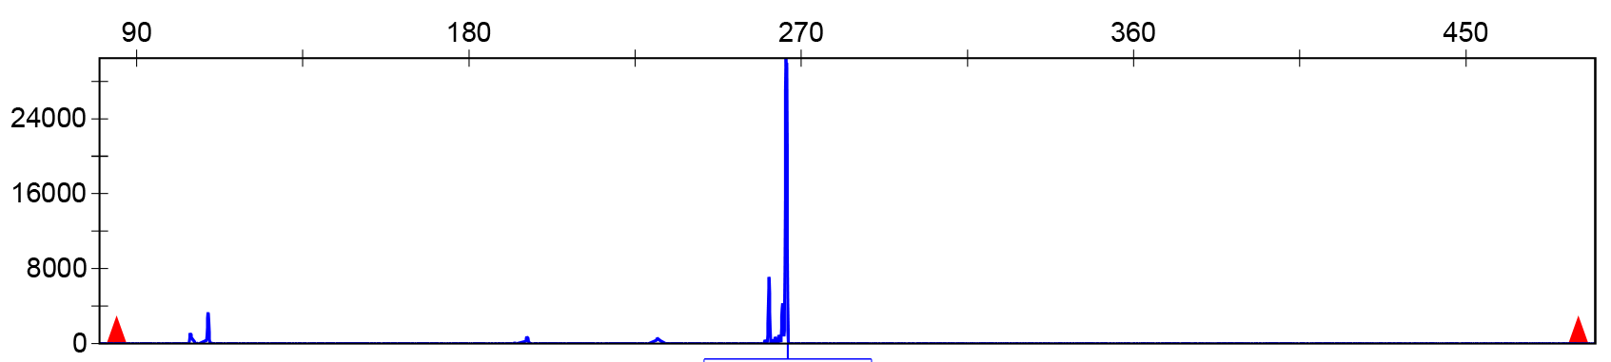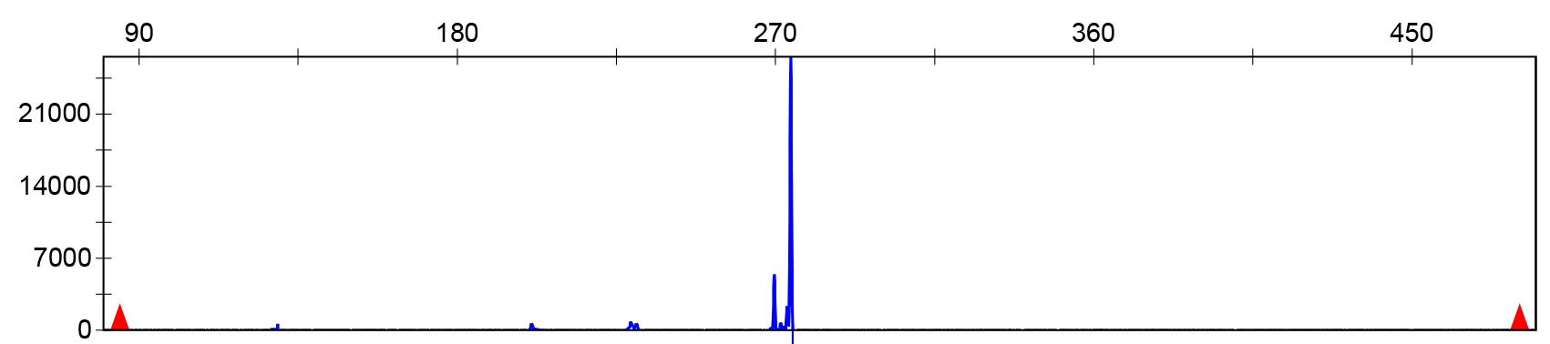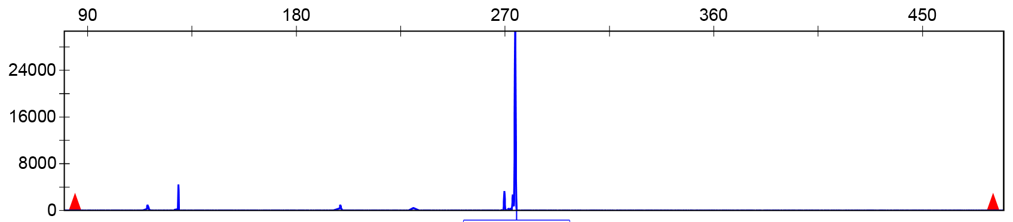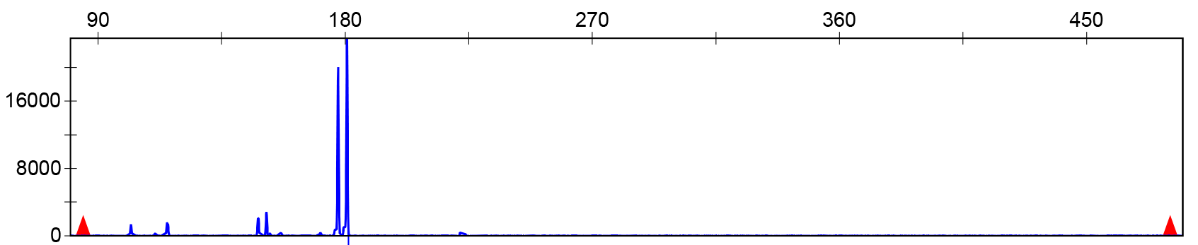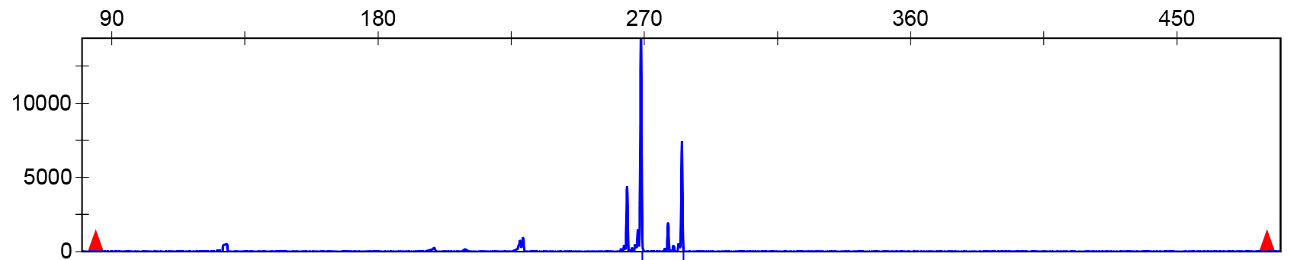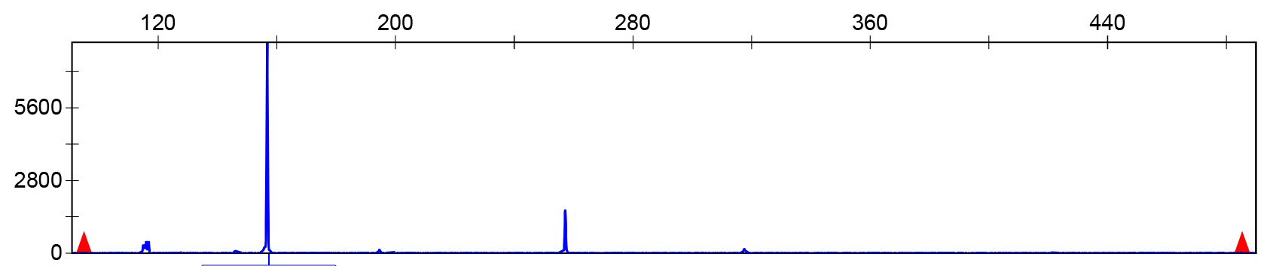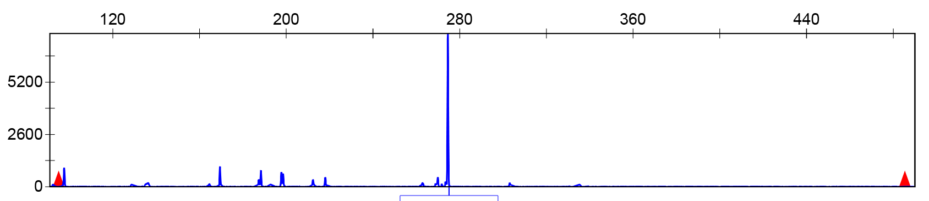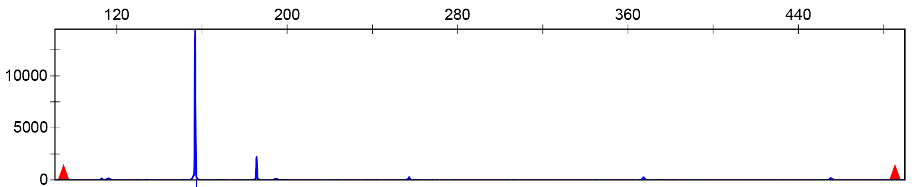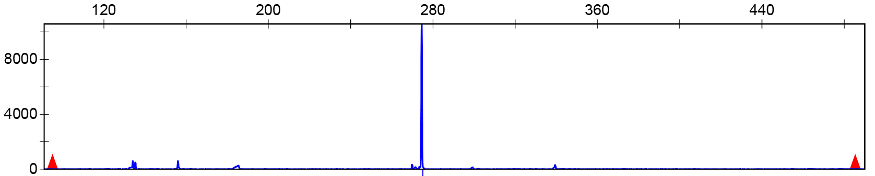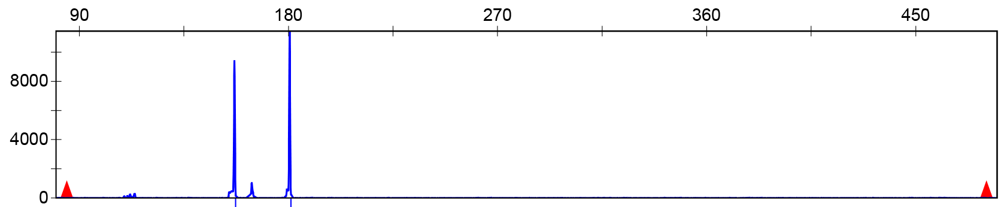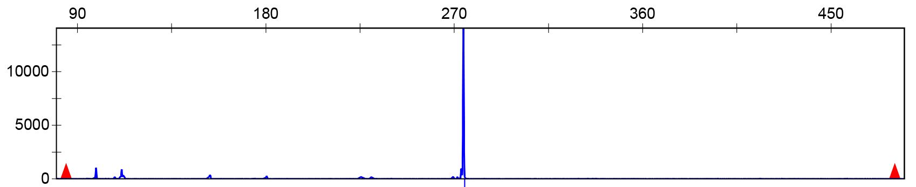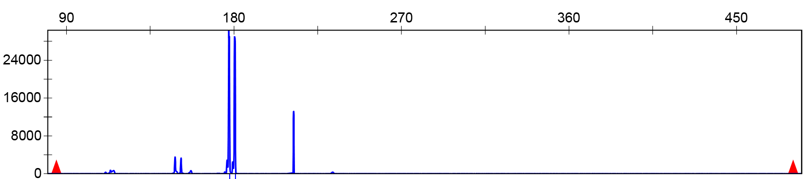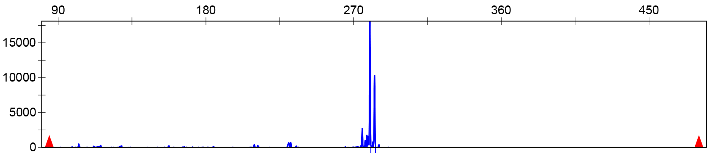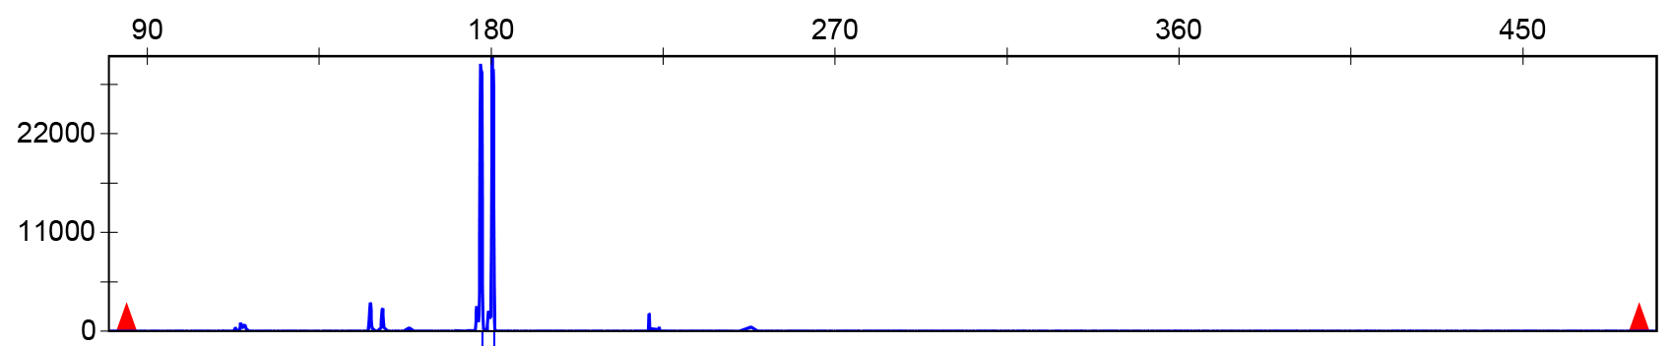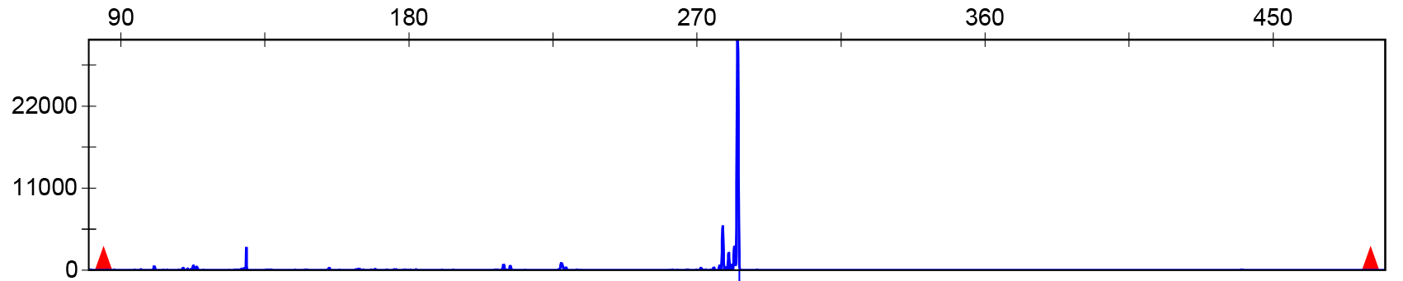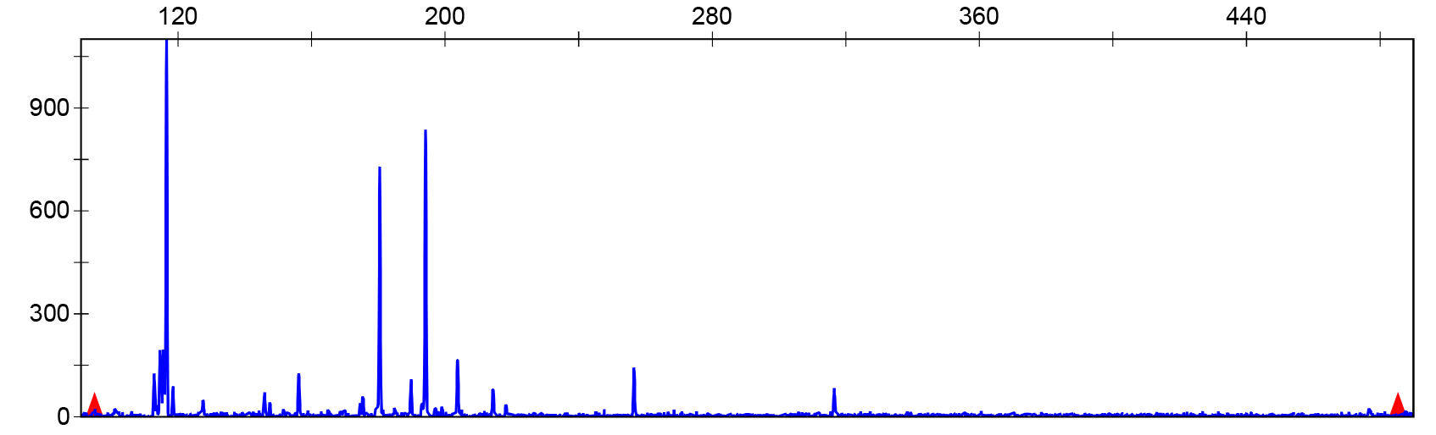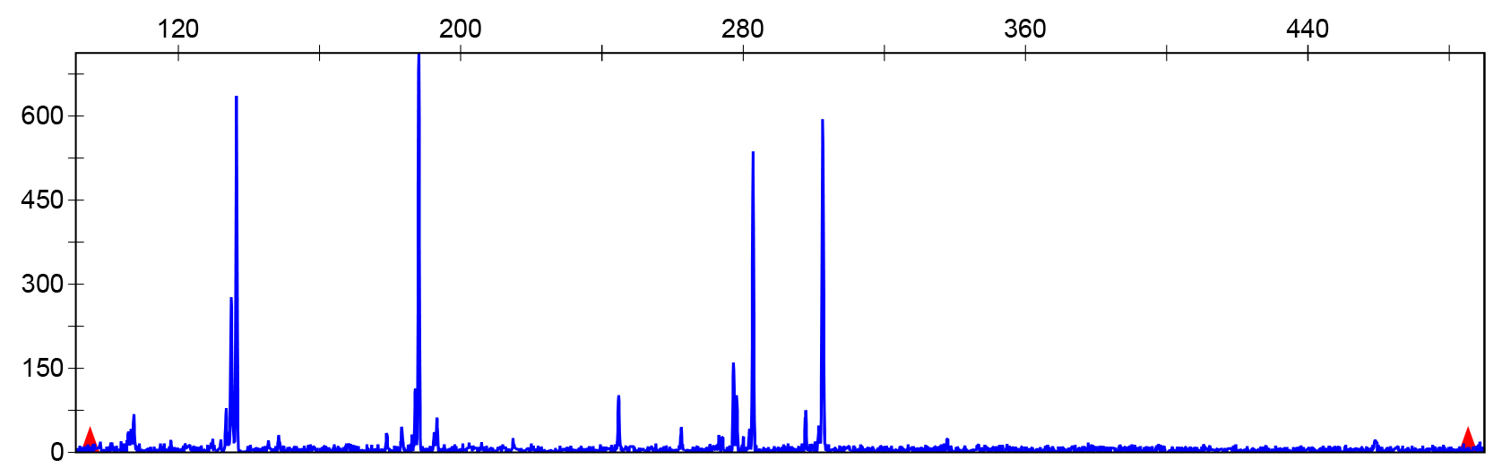
MY1
MYXZ
GP
RB
ZPCA
ZPLP
ZPLY
XZSS
XZ
ZPXC
ORTHOMCL9476
ORTHOMCL6247

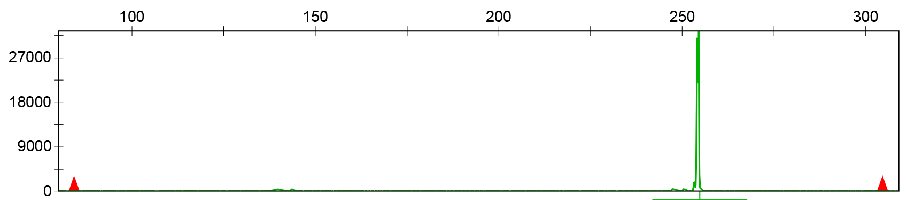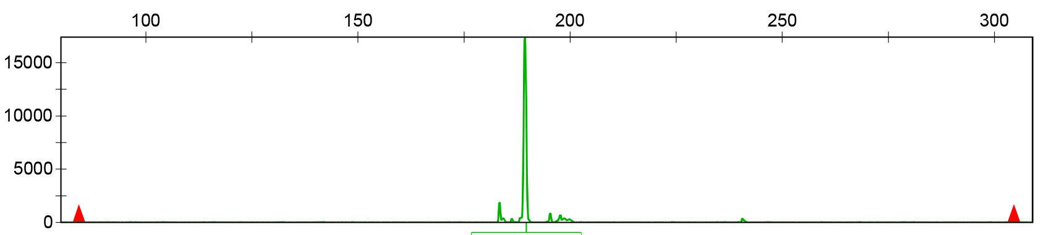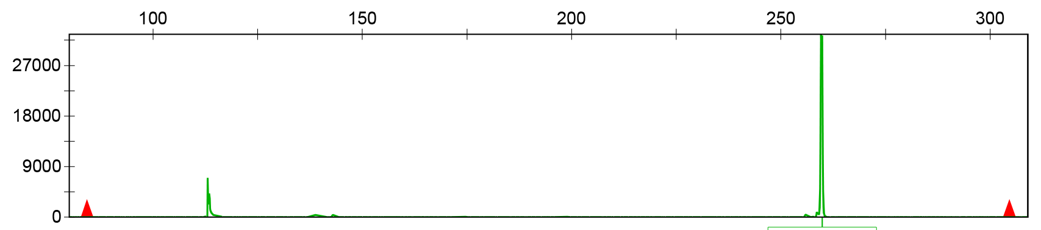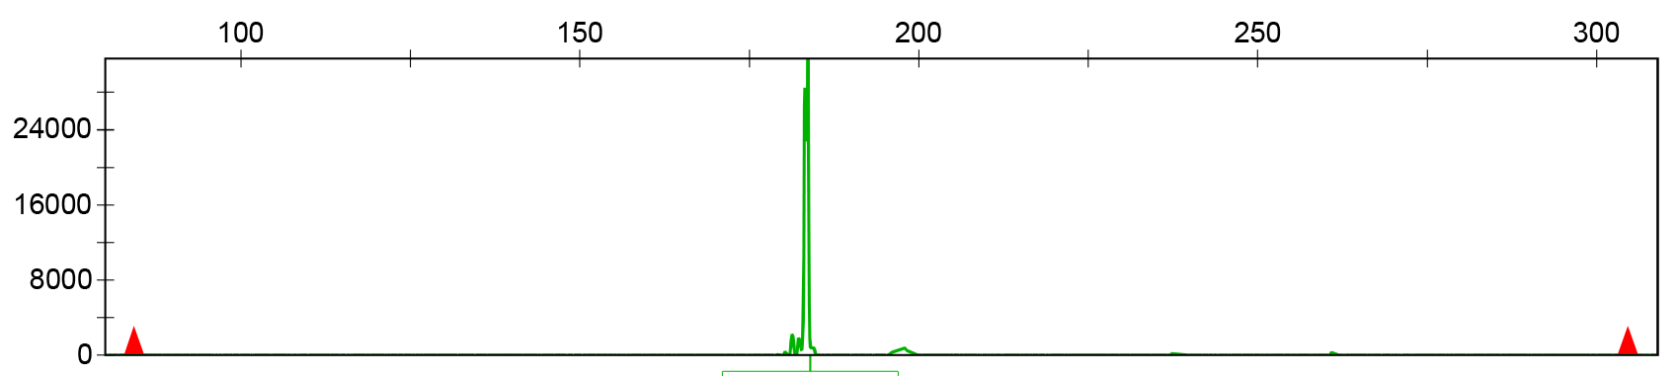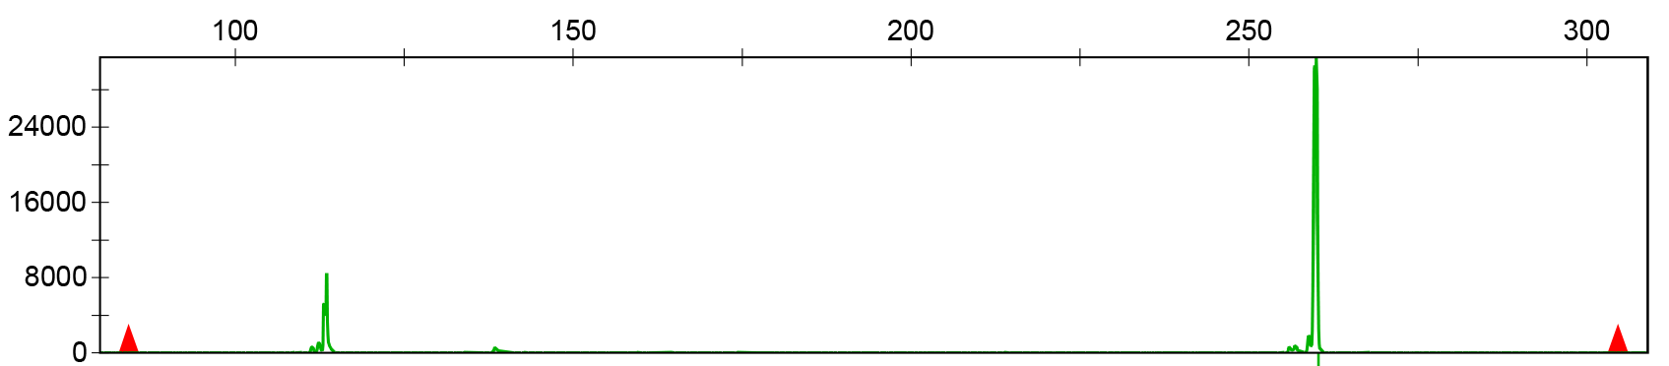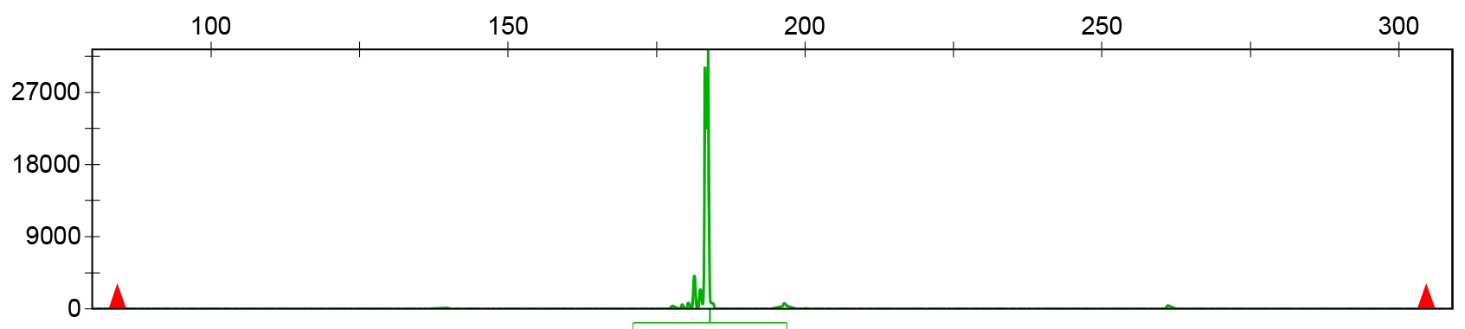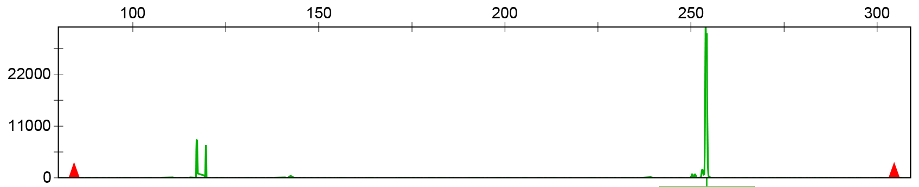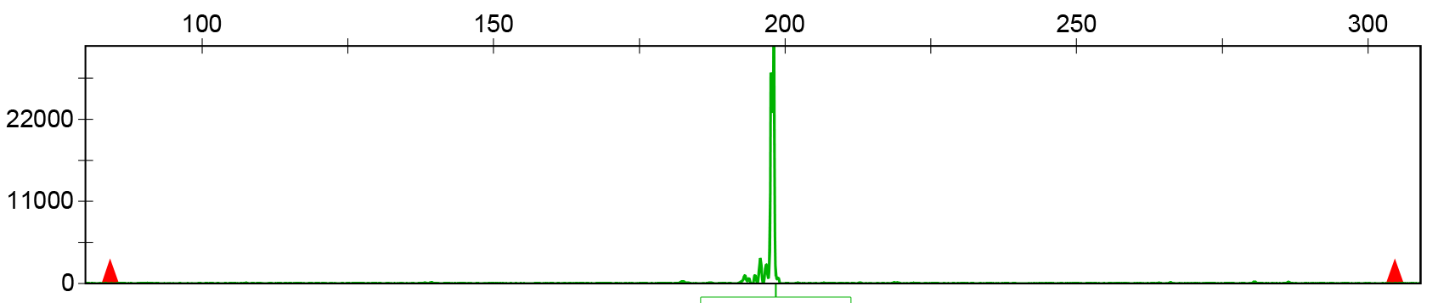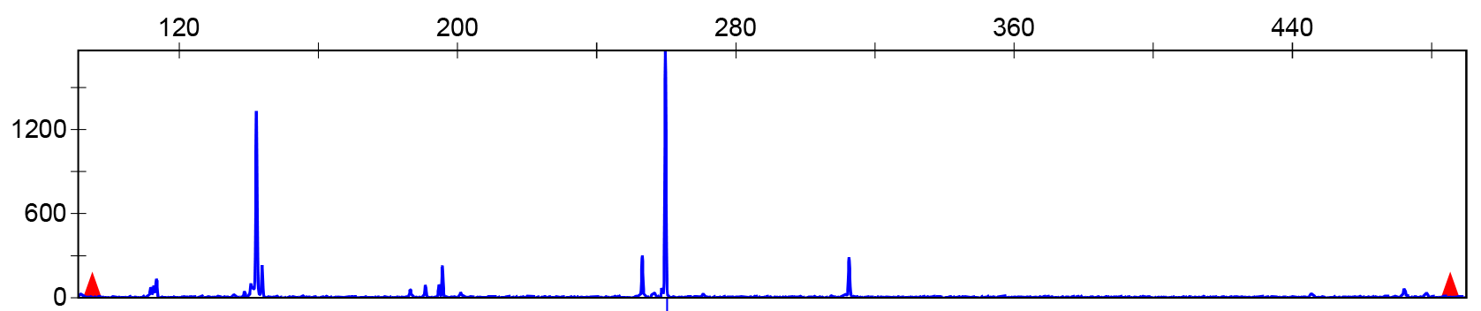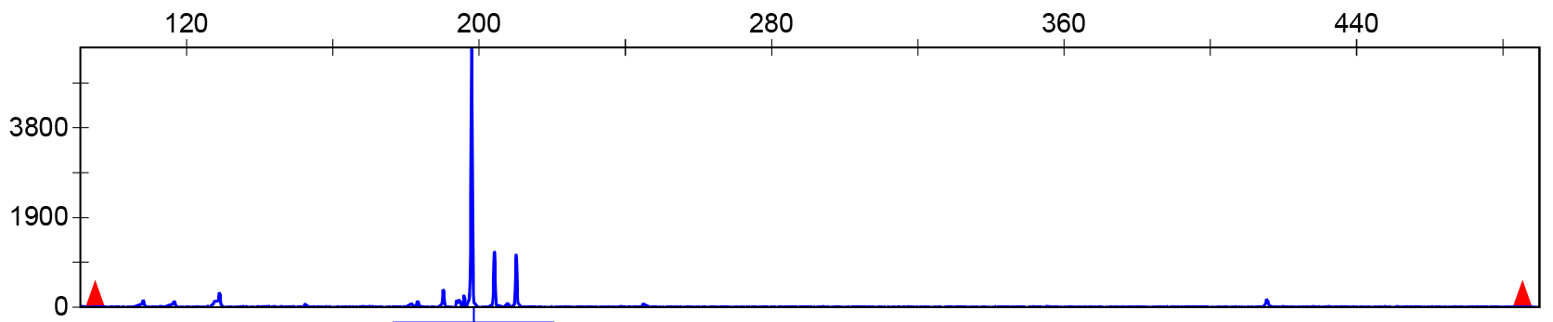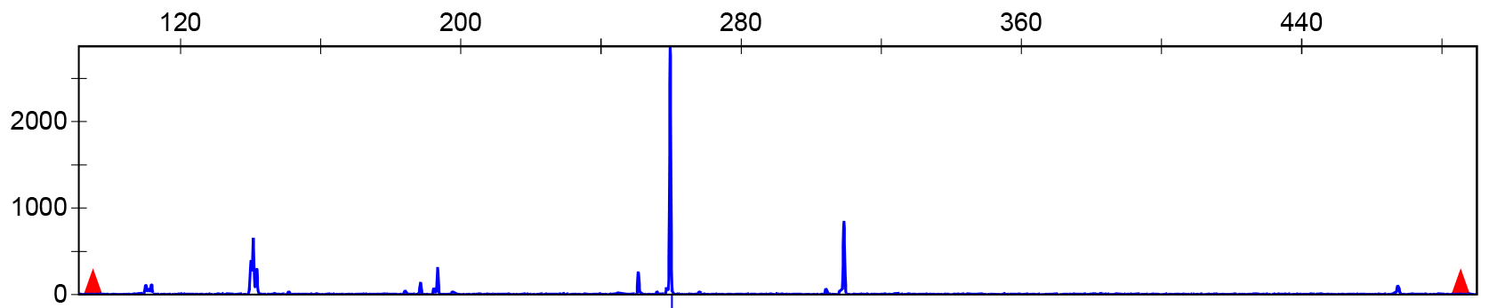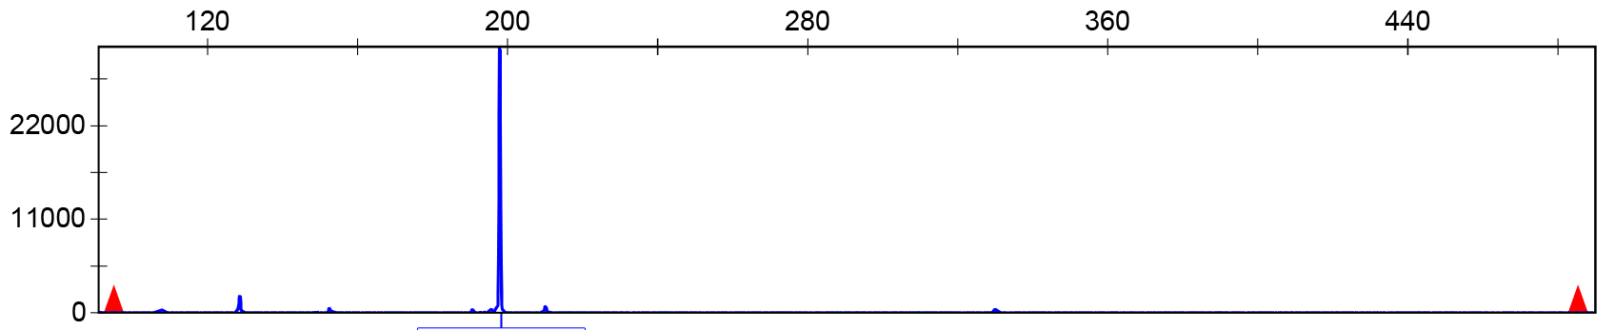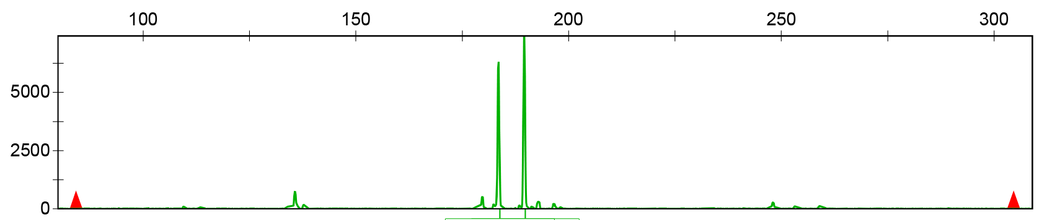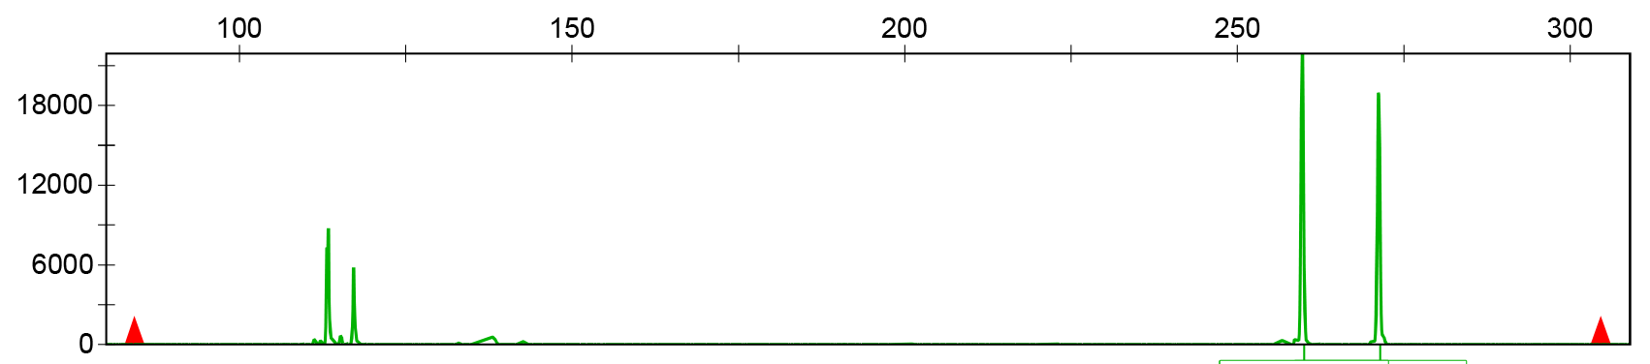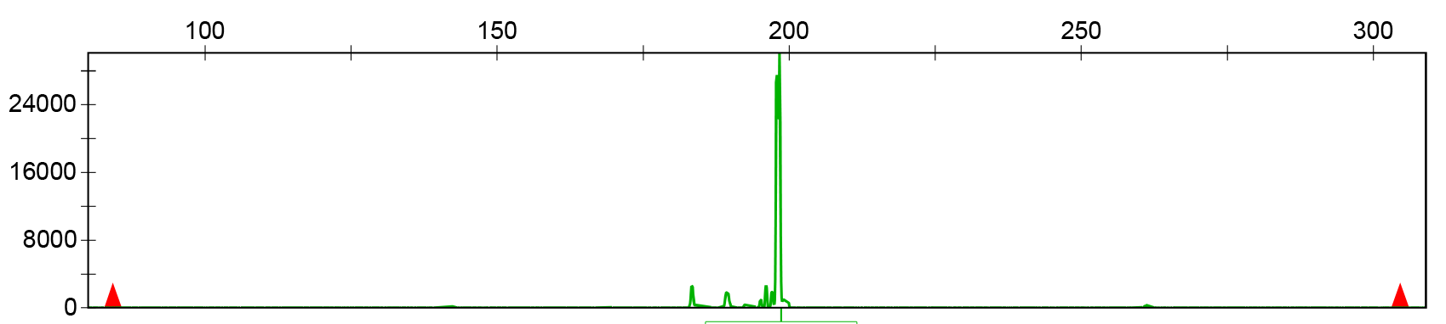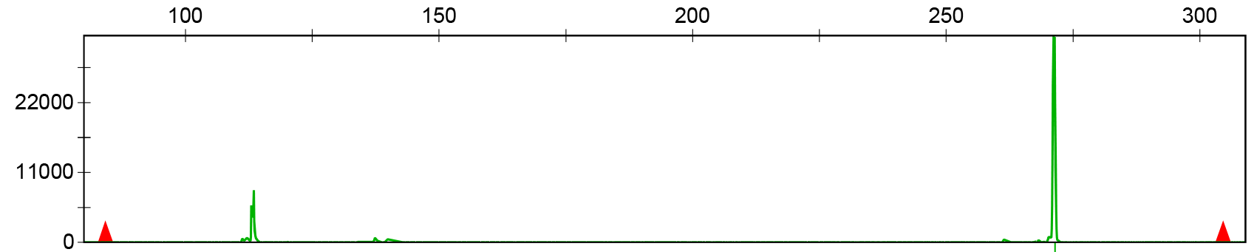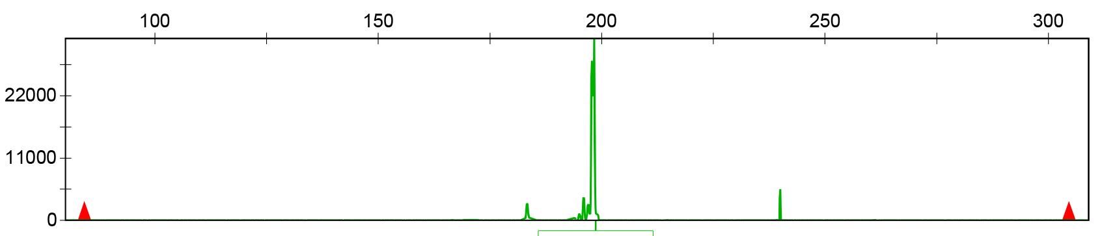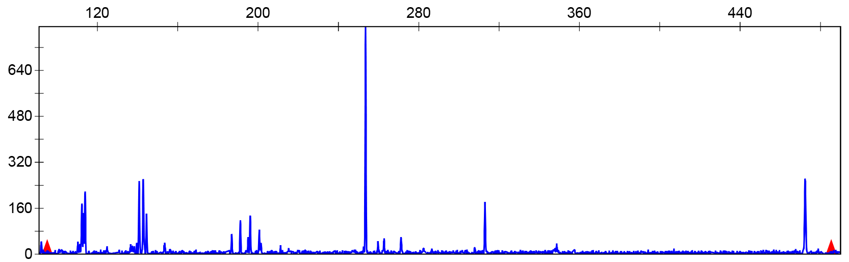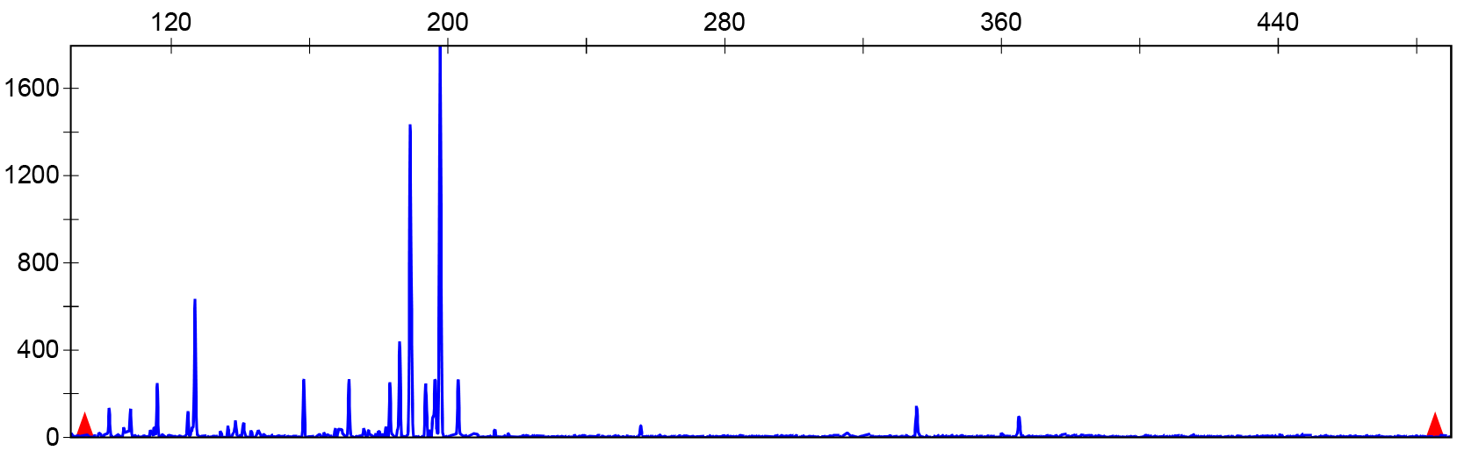
MY1
MYXZ
GP
RB
ZPCA
ZPLP
ZPLY
XZSS
XZ
ZPXC
ORTHOMCL9834
ORTHOMCL8700

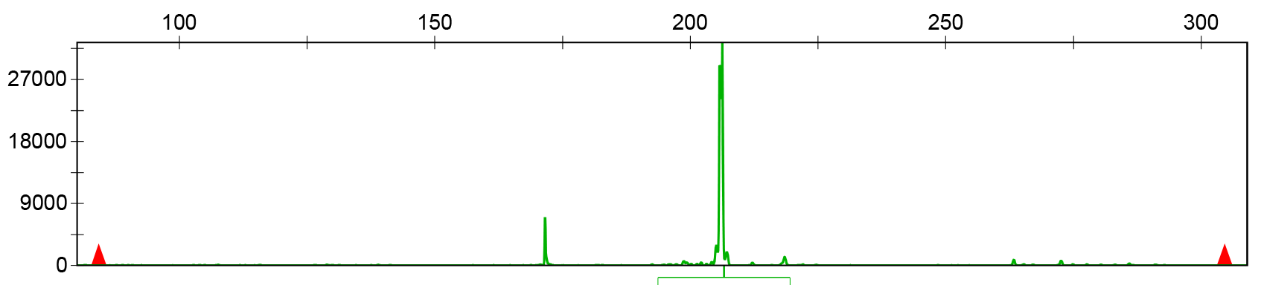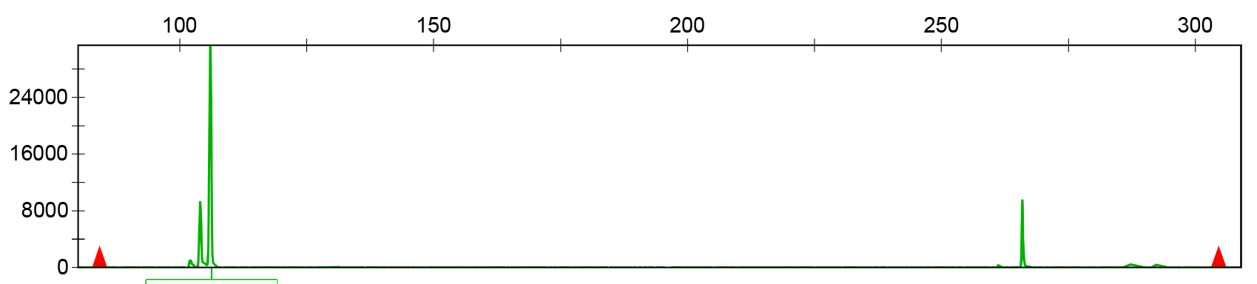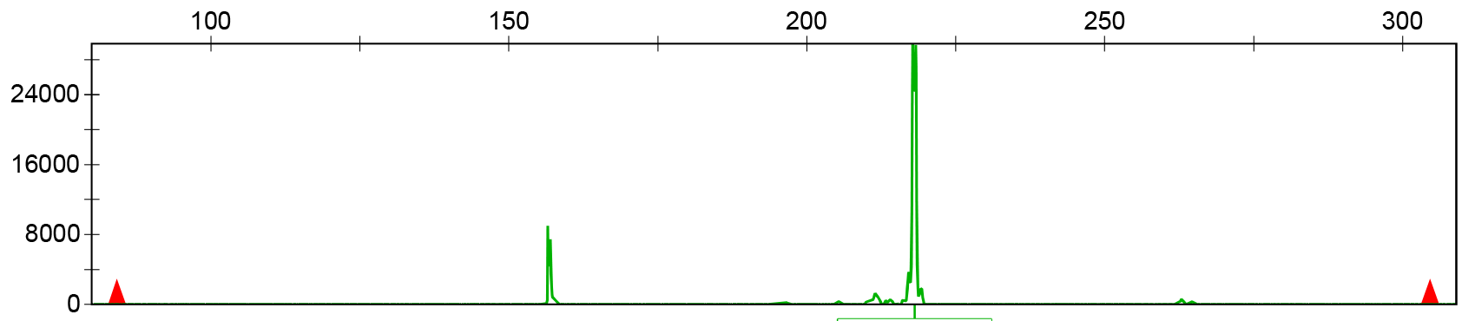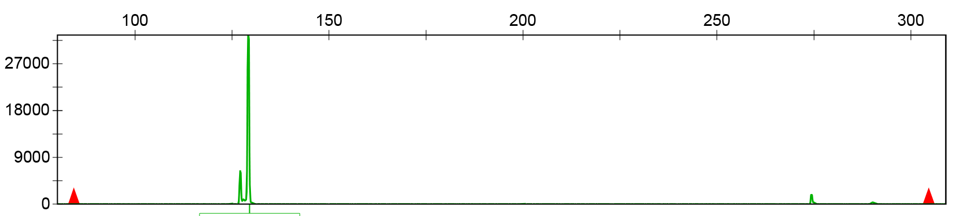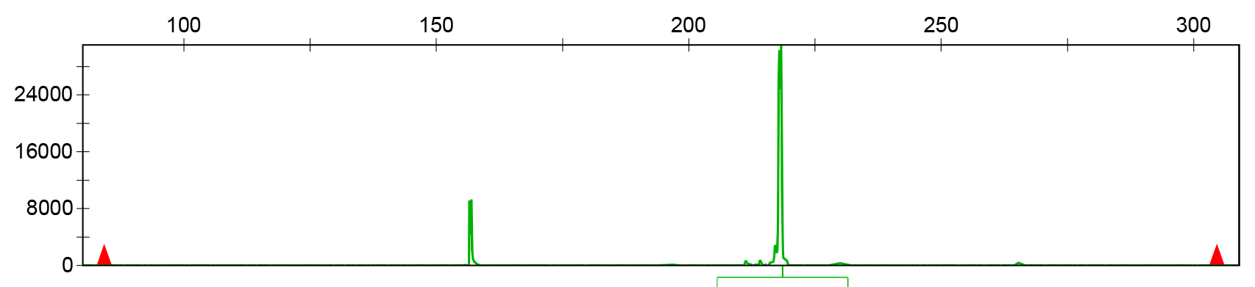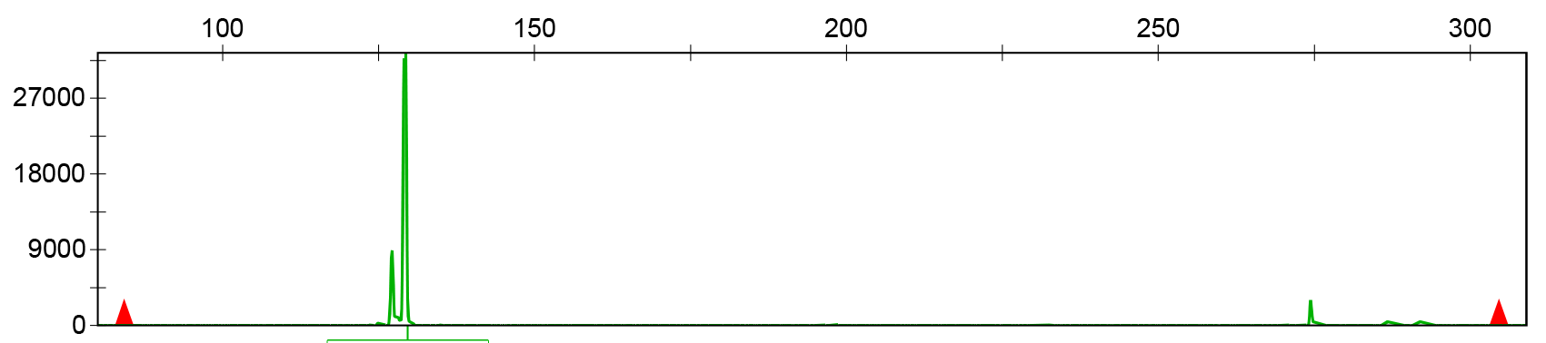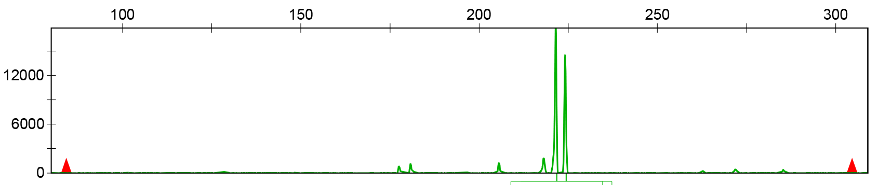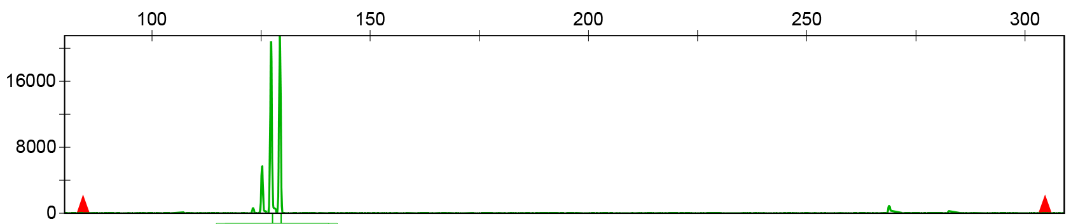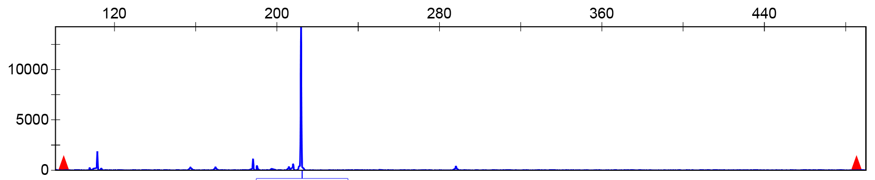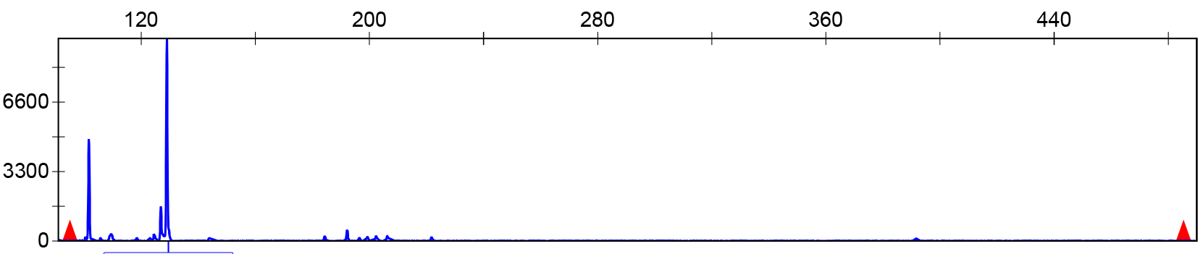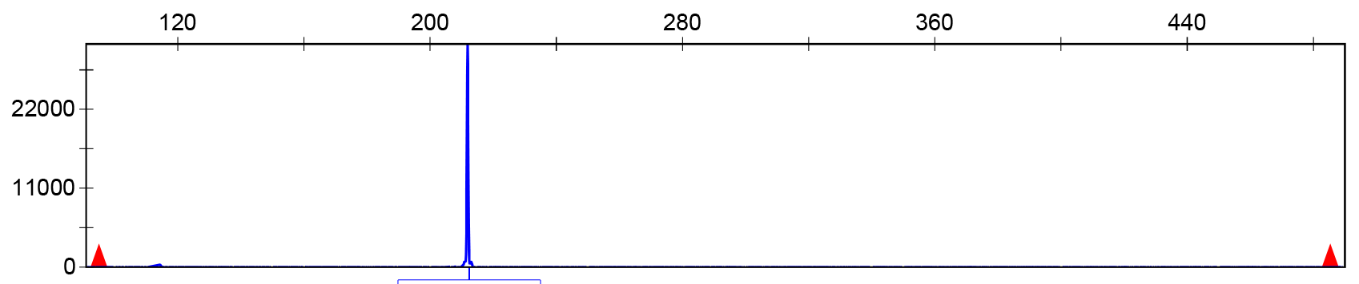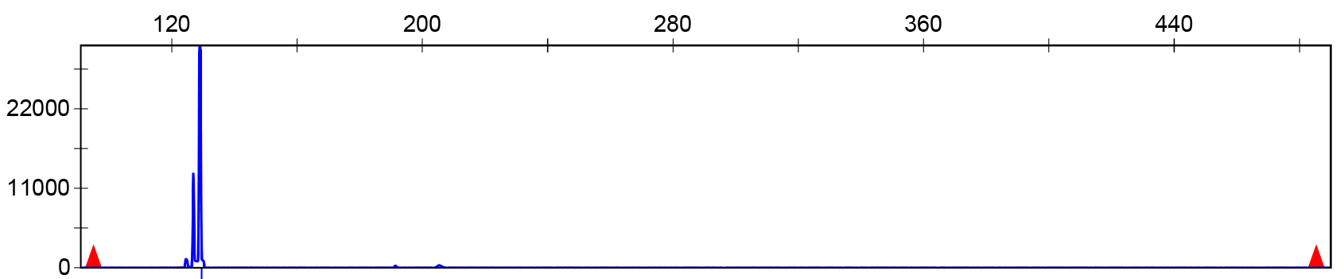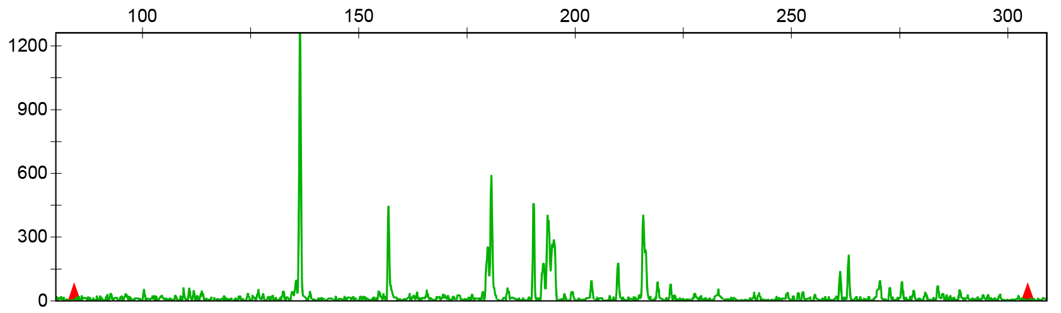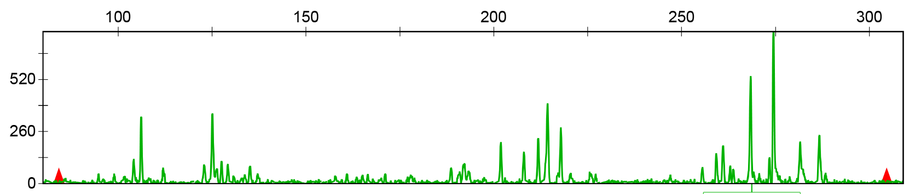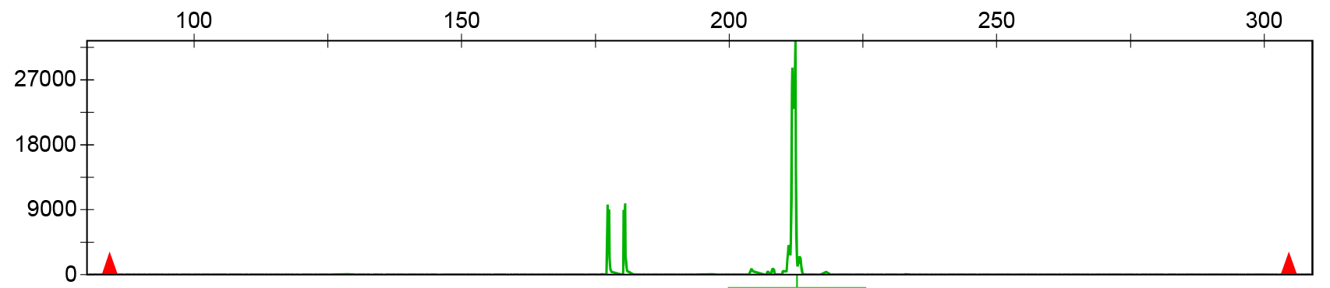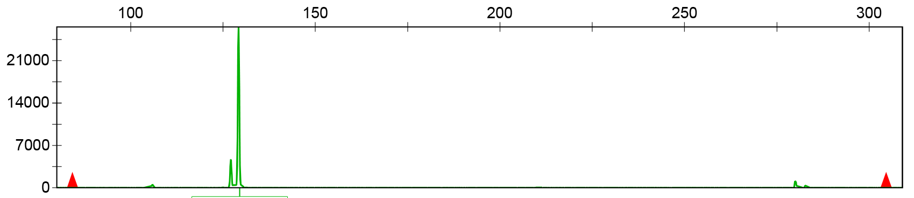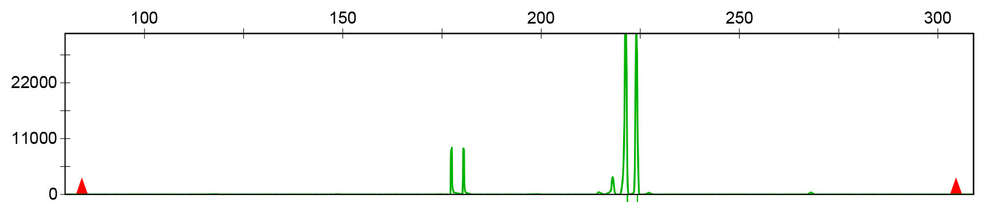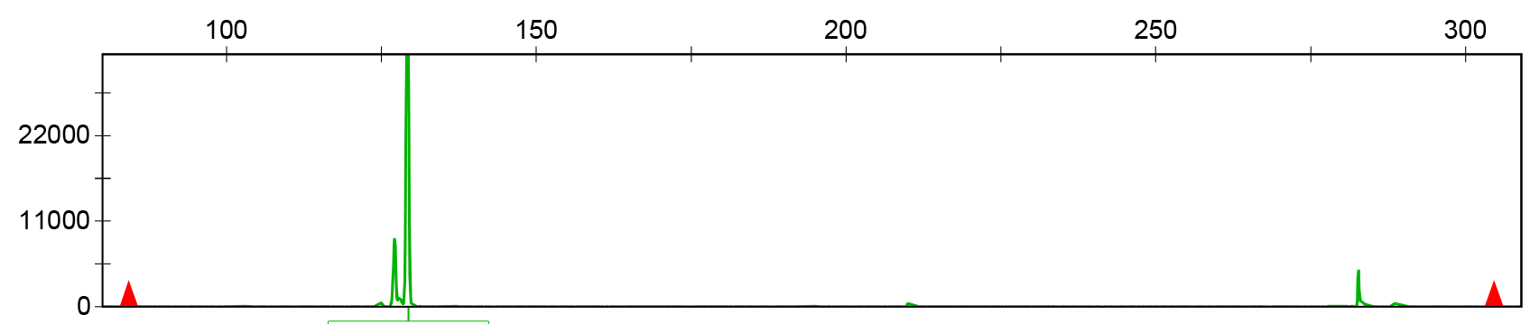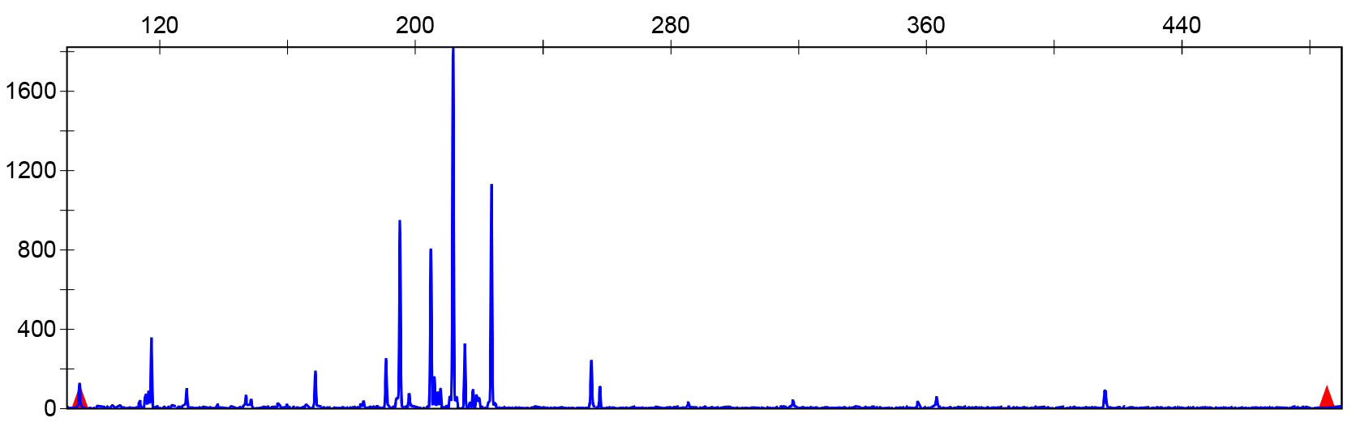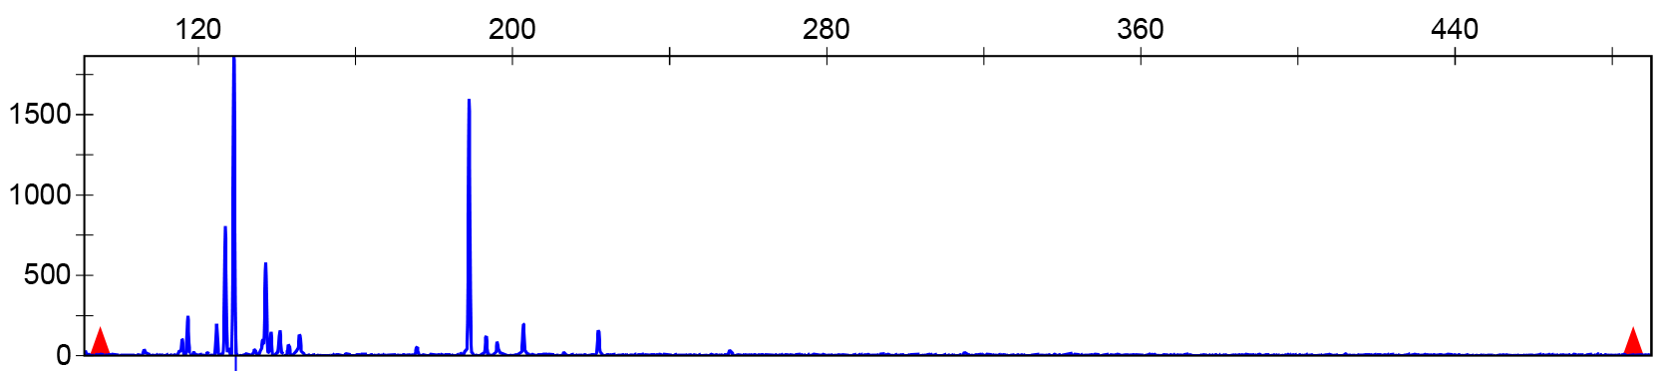
MY1
MYXZ
GP
RB
ZPCA
ZPLP
ZPLY
XZSS
ZPXC
XZ
ORTHOMCL8947
ORTHOMCL6535

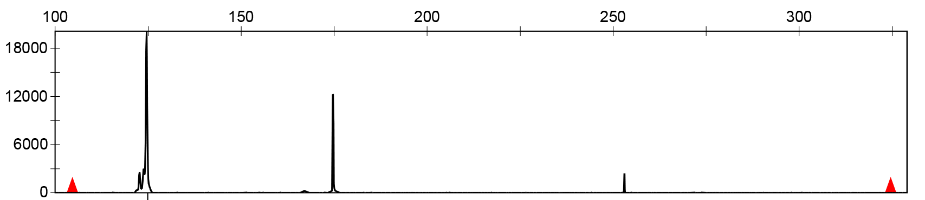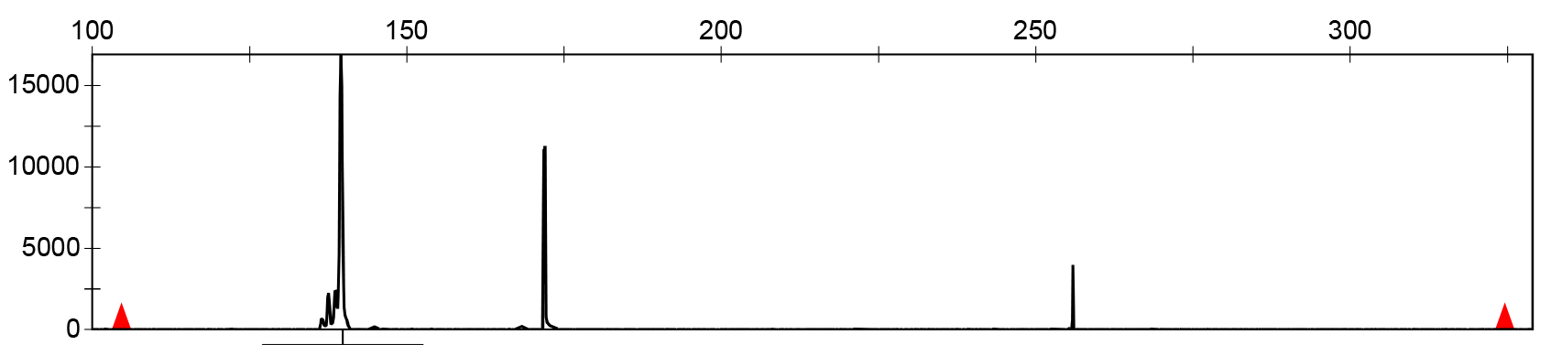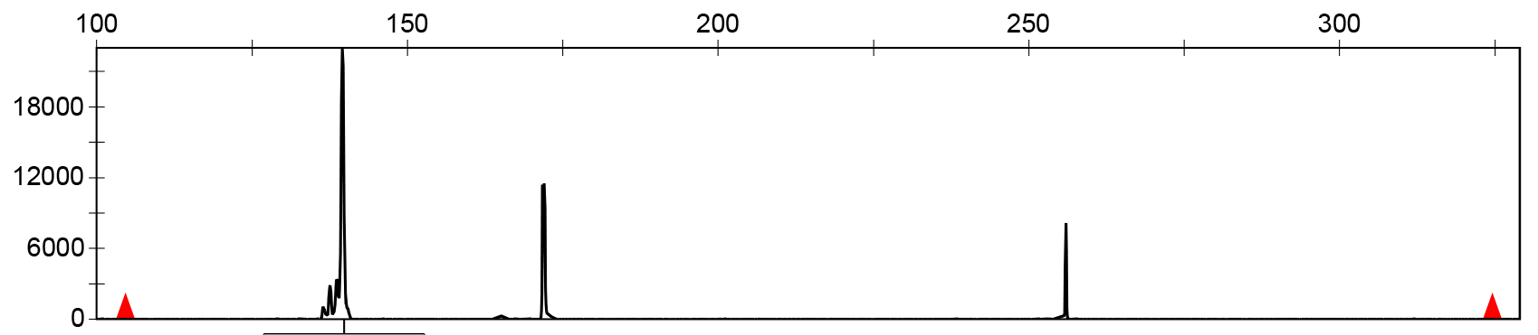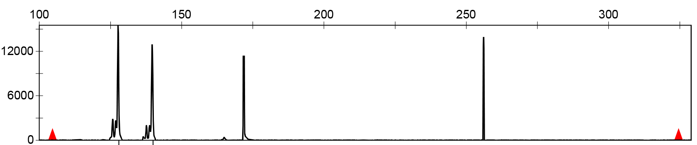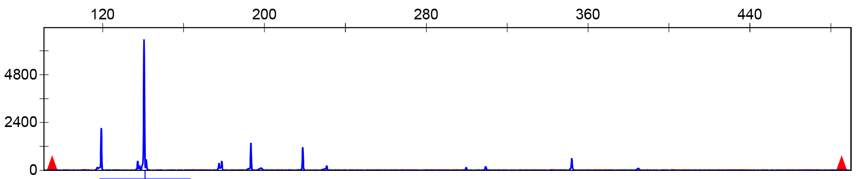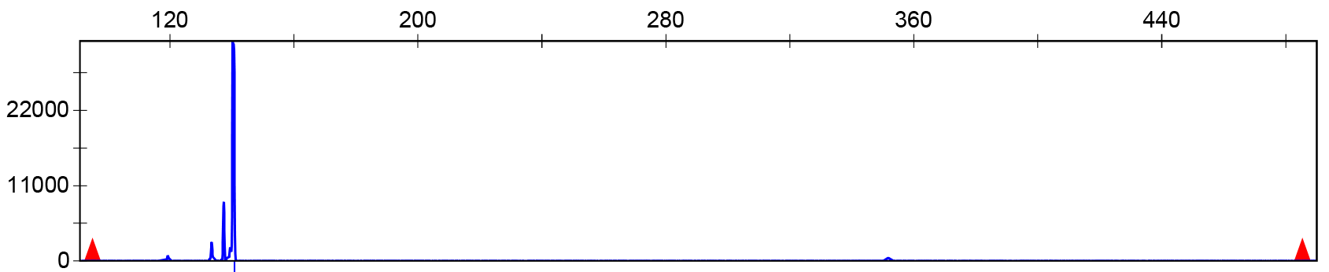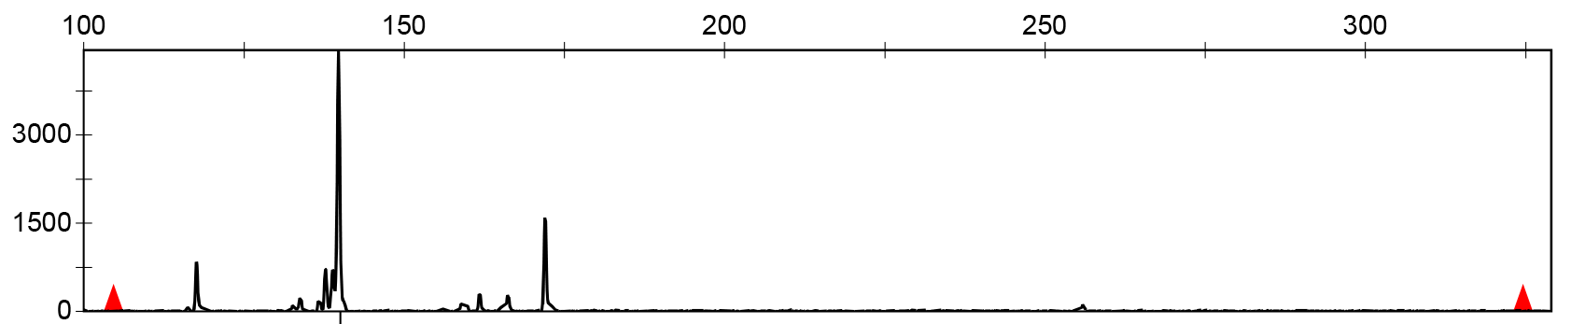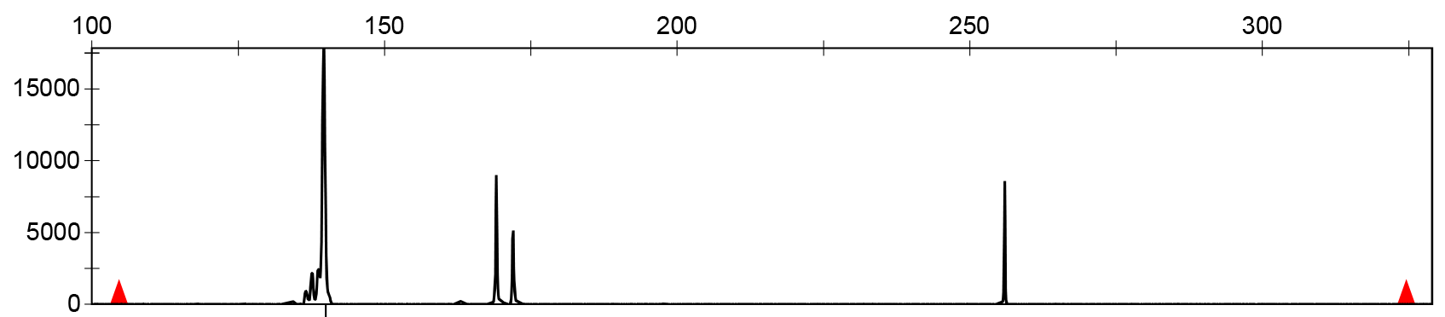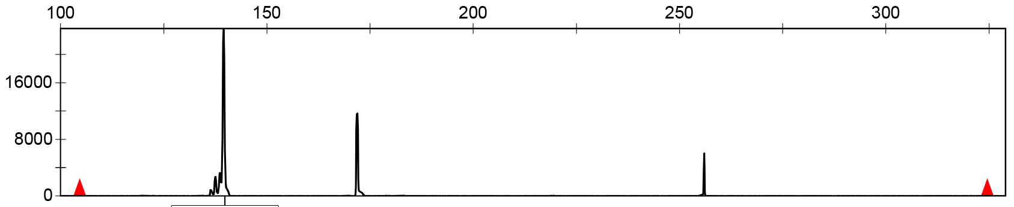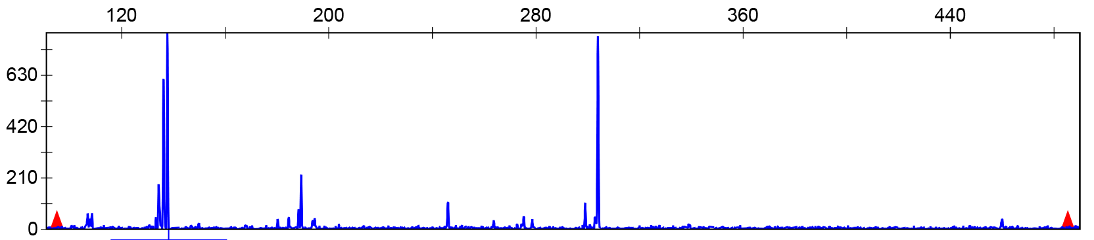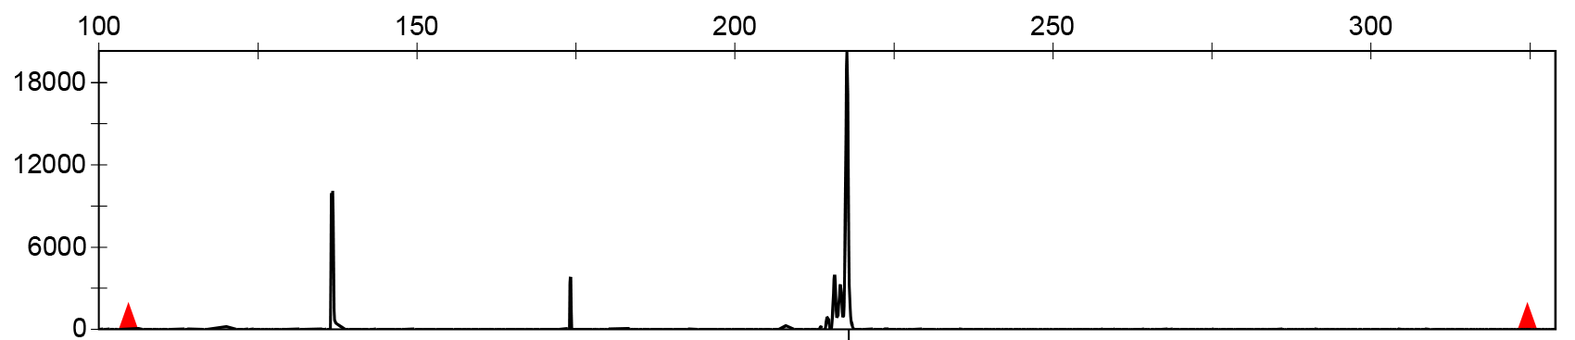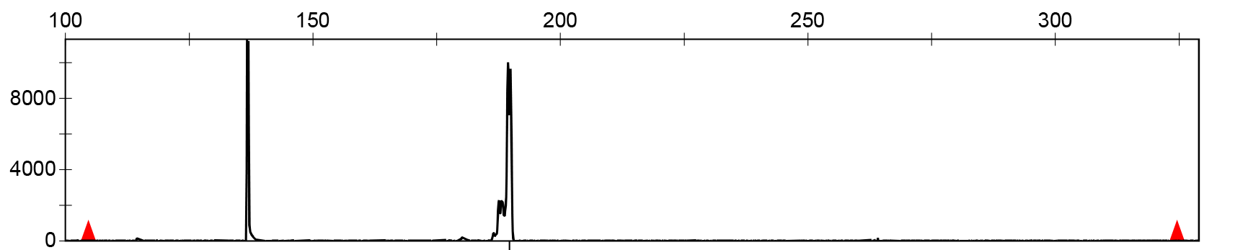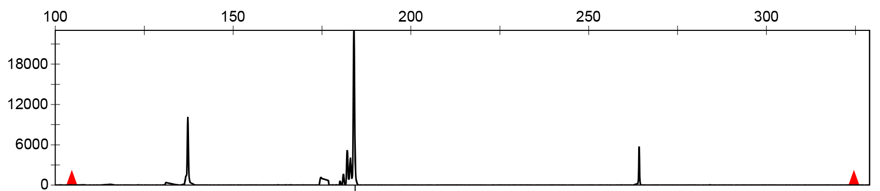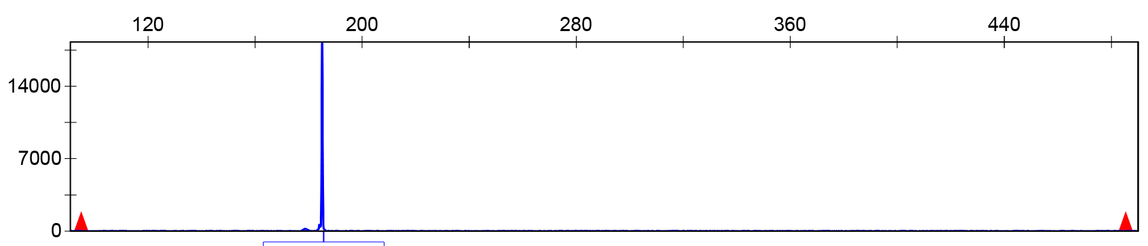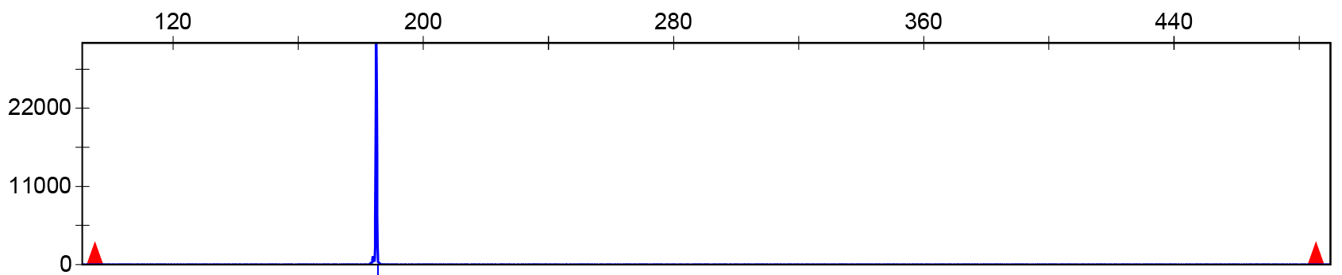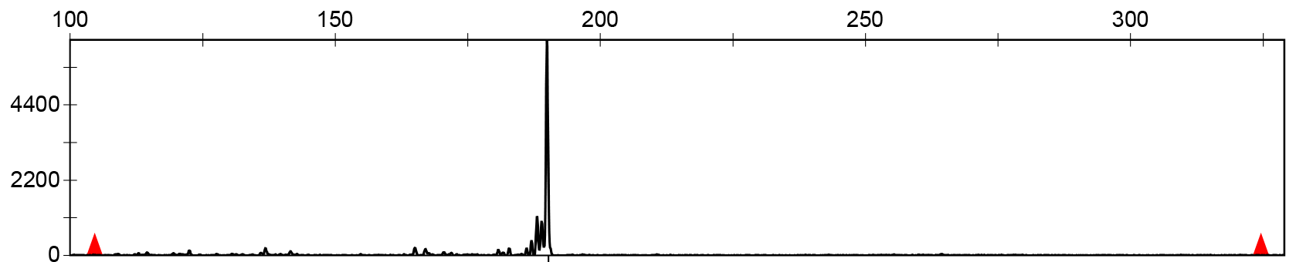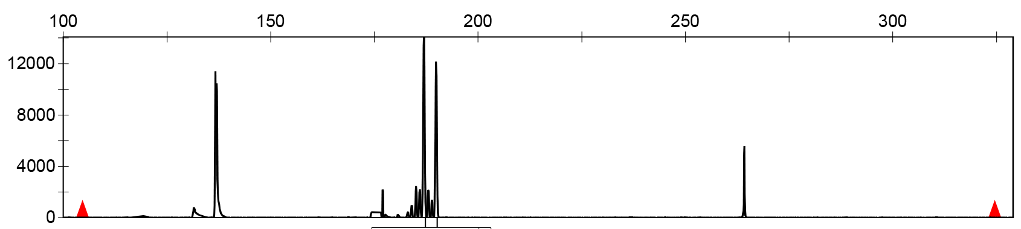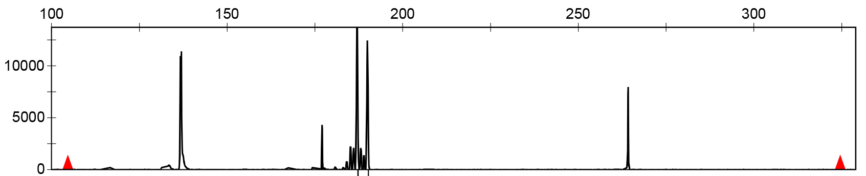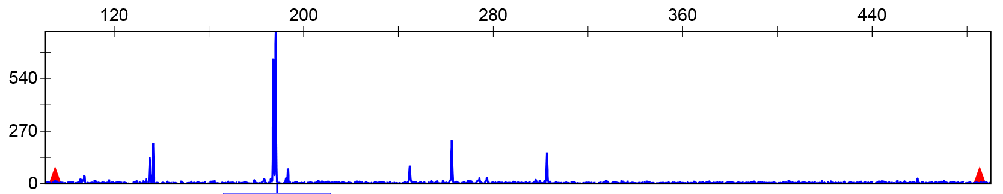
ORTHOMCL8473
MY1
MYXZ
GP
RB
ZPCA
ZPLP
ZPLY
XZSS
XZ
ZPXC
ORTHOMCL7263

Supplemental Figure1. Capillary electrophoresis result of 11 SSR primers. In this graph, x-axis represents size of fragment, y-axis represent expression of corresponding fragments.

