Supporting Information for
Hydroxy-terminated polybutadiene polyurethane demonstrates exceptional mechanical performance at low temperatures through cross-linking reaction with hyperbranched polysiloxane
Junshan Yuan,† Xiaoying Huang,† Rui Wang, Wei Tian, Weixu Feng and Hongxia Yan*
Key Laboratory of Special Functional and Smart Polymer Materials of Ministry of Industry and Information Technology, Shaanxi Key Laboratory of Macromolecular Science and Technology, School of Chemistry and Chemical Engineering, Northwestern Polytechnical University, Xi'an, Shaanxi, 710129, PR China

Content Page

Fig. S1. The reaction mechanism of HBPSi-NH₂/HTPB composites. S2

Fig. S2. FTIR spectra of distillate of HBPSi-NH2 and standard ethanol S2

Fig. S3. GPC curve of HBPSi-NH₂ S2

Table S1. GPC data of HBPSi-NH₂ S2

Table S2. Titrimetric results of -OH content in HBPSi-NH₂ S3

Table S3. Thermal decomposition data of HTPB-0 and HTPB-4 S4

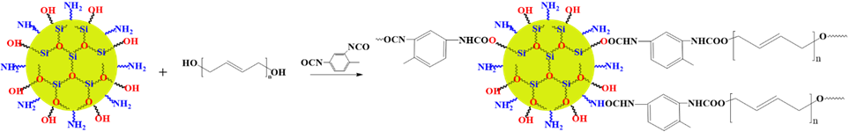

Fig. S1. The reaction mechanism of HBPSi-NH₂/HTPB composites.
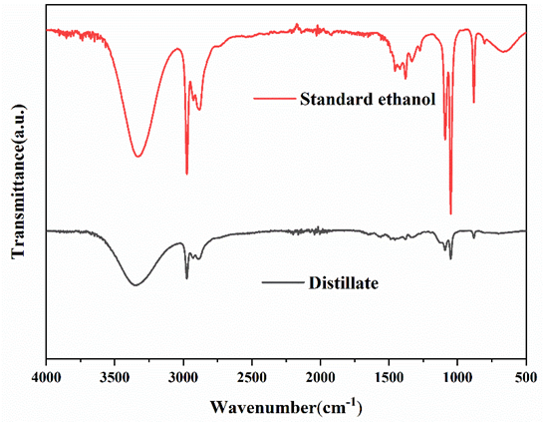

Fig. S2. FTIR spectra of distillate of HBPSi-NH₂ and standard ethanol.

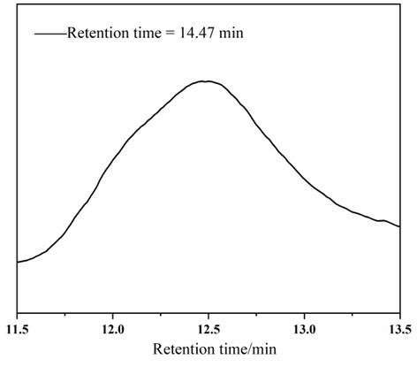

Fig. S3. GPC curve of HBPSi-NH₂.

Table S1 GPC data of HBPSi-NH₂.
Polymer | Mn | Mw | Mz | Mz+1 | PDI (Mw/Mn)
HBPSi-NH₂ | 16300 | 16700 | 17100 | 17500 | 1.02

The content of -OH group was determined by titrimetric methods referring to GB/T 7383-2007 (Chinese standard). Firstly, weighed 140 g phthalic anhydride in a beaker, adding 1L pyridine and stirring the mixture until completely dissolved to obtain phthalic anhydride pyridine solution, recorded as acylation reagent. Transferred 25.0 mL acylation reagent into a 250 mL conical flask with a pipette. Then, the sample to be tested was accurately weighed (accurate to 0.001g), mixed with 25.0 mL acylation reagent, and then condensed for reflux for 1 h at 115℃±2℃. Added 4~5 drops phenolphthalein indicator, dropped with sodium hydroxide standard liquid, and recorded the amount of NaOH solution consumed (repeat 3 times). The controlled trial without HBPSi-NH₂ was performed 3 times. The I_{(OH)} was calculated by using Eqn (1).
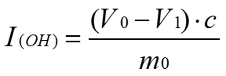 (1)
Where I_{(OH)} is the -OH value of HBPSi-NH₂; V₀ and V₁ are the amount of NaOH solution consumed by controlled trial and HBPSi-NH₂ samples, respectively; c is the concentration of NaOH solution; m₀ is the mass of the HBPSi-NH₂ sample. The result of the titration are listed in Table S2.

Table S2 Titrimetric results of -OH content in HBPSi-NH₂.
Test number | c (mol·L⁻¹) | V₀ (mL) | V₁ (mL) | m (g) | I(OH) (mol·g⁻¹)
Controlled 1 | 0.5 | 83.5 | — | —
Controlled 2 | 0.5 | 84.2 | — | —
Controlled 3 | 0.5 | 84.3 | — | —
Average | 0.5 | 84 | — | —
1 | 0.5 | 84 | 67.7 | 0.4059 | 20.08×10⁻³
2 | 0.5 | 84 | 70.8 | 0.3003 | 21.98×10⁻³
3 | 0.5 | 84 | 70.9 | 0.3053 | 21.45×10⁻³
Average | — | — | — | — | 21.17×10⁻³

Table S3 Thermal decomposition data of HTPB-0 and HTPB-4.
 | 5wt% loss(℃) | 50wt% loss(℃) | DTG(℃)
HTPB-0 | 321.1 | 444.01 | 472.16
HTPB-4 | 323.98 | 479.04 | 485.71

