ONLINE SUPPLEMENTARY
FIGURES & TABLES

“Neutrophil Elastase Inhibitor (Sivelestat) in the Treatment of Acute Respiratory Distress Syndrome Induced by COVID-19: A Multicenter Retrospective Cohort Study”

This supplementary material is provided by the authors to give readers additional information about their work.

Content
Supplemental figure 3
Supplemental Figure 1. Propensity score matching jitter plot (A) and the balance of the covariates after propensity score matching (B). 3
Supplemental tables 4
Supplementary Table 1. The components and individual values of the Murray lung injury score. 4
Supplementary Table S2. The Murry lung injury scores in two groups. 5
Supplementary Table 3. The decrease in Murry lung injury score compared with baseline. 6
Supplementary Table 4. Comparison of adverse events between two groups. 7

Supplemental figure

Supplemental Figure 1. Propensity score matching jitter plot (A) and the balance of the covariates after propensity score matching (B).
PSM denotes propensity score matching. ICU denotes intensive care unit. WBC denotes white blood cells.
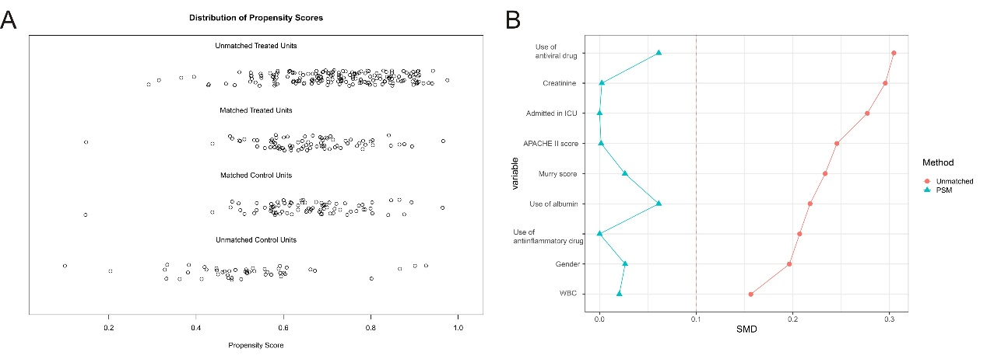

Supplemental tables

Supplementary Table 1. The components and individual values of the Murray lung injury score.
Score  Components | 0 | 1 | 2 | 3 | 4
PEEP (when ventilated)  （cmH₂O） | ≤5 | 6-8 | 9-11 | 12-14 | ≥15
Hypoxemia  （PaO₂/FiO₂） | ≥300 | 225-299 | 175-224 | 100-174 | <100
Chest roentgenogram score | No alveolar consolidation | Alveolar consolidation confined to 1 quadrant | Alveolar consolidation confined to 2 quadrants | Alveolar consolidation confined to 3 quadrants | Alveolar consolidation in all 4 quadrants
Respiratory system compliance (when ventilated)  （ml/cmH₂O） | ≥80 | 60-79 | 40-59 | 20-39 | ≤19

The final value is obtained by dividing the aggregate sum by the number of components that were used.
Score
No lung injury 0
Mild-to moderate lung injury 0.1-2.5
Severe lung injury (ARDS) >2.5

Supplementary Table S2. The Murry lung injury scores in two groups.
Variables | Sivevastat (n=79) | Control (n=79) | P value
Day 1, median (IQR) | 2 (0, 2) | 2 (0, 2) | 1.00
Day 3, median (IQR) | 2 (2, 2) | 2 (2, 3) | 0.016
Day 5, median (IQR) | 2 (2, 2) | 2 (2, 3) | 0.157
Day 7, median (IQR) | 2 (2, 2) | 2 (2, 2.8) | 0.317
Abbreviations: IQR: interquartile range.

Supplementary Table 3. The decrease in Murry lung injury score compared with baseline.
Variables | Sivevastat (n=79) | Control (n=79) | P value
Day 1, median (IQR) | 0 (0, 1) | 0 (0, 1) | 0.637
Day 3, median (IQR) | 0 (0, 1) | 0 (0, 0) | 0.120
Day 5, median (IQR) | 0 (0, 1) | 0 (0, 0.5) | 0.439
Day 7, median (IQR) | 0 (0, 1) | 0 (0, 1) | 0.564
Abbreviations: IQR: interquartile range.

Supplementary Table 4. Comparison of adverse events between two groups.
Sivevastat |  |  |  |  | Control
Variables | Frequency(n) | Patients(n) | Percentage (%) | Frequency(n) |  | Patients(n) | Percentage (%) | P value
Adverse events | 3 | 3 | 1.16 | 1 |  | 1 | 0.78 | 1.0
Adverse events related to the study drug | 1 | 1 | 0.39 | 0 |  | 0 | 0 | 1.0
Severe adverse events | 0 | 0 | 0 | 0 |  | 0 | 0 | -
Severe adverse event related to the study drug | 0 | 0 | 0 | 0 |  | 0 | 0 | -
Adverse events leading to withdrawal from the trial | 0 | 0 | 0 | 0 |  | 0 | 0 | -

