Supplementary Table 1. The standardized uptake value ratio from each reference region.

 |  | WM | CG | WC | WC+B | PERSI
15 Controls | Mean | 0.91 | 0.91 | 0.87 | 0.87 | 0.95
15 Controls | SD | 0.047 | 0.062 | 0.044 | 0.037 | 0.076
15 Controls | COV | 5.16% | 6.81% | 5.06% | 4.25% | 8.06%
15 Alzheimer’s disease | Mean | 1.28 | 1.56 | 1.52 | 1.54 | 1.67
15 Alzheimer’s disease | SD | 0.082 | 0.369 | 0.332 | 0.311 | 0.203
15 Alzheimer’s disease | COV | 6.41% | 23.65% | 21.84% | 20.19% | 12.19%
15 Alzheimer’s disease | Effect size | 0.941 | 0.775 | 0.808 | 0.834 | 0.920

PERSI: parametric Estimate of Reference Signal Intensity in the white matter; WM: white matter mean value; CG: cerebellar gray; WC+B: whole cerebellum plus brainstem; SD: standard deviation; COV: coefficient of variance.
Effect sizes were calculated using Cohen’s d with pooled standard deviation.

Supplementary Table 2. Multiple linear regression analysis for the total CASI score

 | Unstandardized coefficients |  | Standardized coefficients
Variables | B | SE | B | 95% CI of B | T | P
LOAD
Constant | 32.914 | 39.492 | - | -46.29-112.126 | 0.833 | 0.408
Amyloid Centiloid | 0.050 | 0.053 | 0.097 | -.0056-0.156 | 0.944 | 0.350
gTS | -0.197 | 0.058 | -0.396 | -0.313- -080 | -3.375 | 0.001*
Age at image | 0.158 | 0.427 | 0.040 | -0.699- 1.1015 | 0.370 | 0.713
Education | 1.519 | 0.378 | 0.414 | 0.761-2.277 | 4.019 | <0.001*
Sex | 3.533 | 3.479 | 0.098 | -3.445-10.511 | 1.016 | 0.314
Hippocampal volume | 12067.968 | 4290.054 | 0.327 | 3463.2-20672.7 | 2.813 | 0.007*
YOAD
Constant | -26.333 | 50.333 | - | -127.203-74.573 | -0.523 | 0.603
Amyloid Centiloid | 0.009 | 0.074 | 0.012 | -0.141-0.158 | 0.115 | 0.909
gTS | -0.195 | 0.070 | -0.323 | -0.335- -0.056 | -2.807 | 0.007*
Age at image | 0.878 | 0.617 | 0.170 | -0.358-2.114 | 1.423 | 0.160
Education | 1.142 | 0.529 | 0.233 | 0.082-2.202 | 2.160 | 0.035*
Sex | 2.985 | 4.059 | 0.073 | -5.150-11.120 | 0.735 | 0.465
Hippocampal volume | 21375.544 | 5645.929 | 0.416 | 10060.85-32690.23 | 3.786 | <0.001*

*P value <0.05, T: T value of the model,
Model of YOAD or LOAD were both significant (p<0.001)
Hippocampal volume adjusted to estimated total intracranial volume.
CASI, Cognitive Abilities Screening Instrument; LOAD, Late-onset Alzheimer's disease; gTS, global tau severity scale; YOAD, Young-onset Alzheimer disease; CI: Confidence Intervals; SE: standard error

Supplementary Table 3. Multiple linear regression analysis for the Executive domains

 | Unstandardized coefficients |  | Standardized coefficients
Variables | B | SE | B | 95% CI of B | T | P
LOAD
Constant | 39.060 | 16.665 | - | 5.634-72.486 | 2.344 | 0.023*
Amyloid Centiloid | 0.026 | 0.022 | 0.116 | -0.019-0.070 | 1.144 | 0.258
gTS | -0.084 | 0.025 | -0.394 | -0.133- -0.034 | -3.403 | 0.001*
Age at image | -0.242 | 0.180 | -0.144 | -0.603-0.120 | -1.343 | 0.185
Education | 0.809 | 0.159 | 0.515 | 0.489-1.129 | 5.074 | <0.001*
Sex | 0.763 | 1.468 | 0.049 | -2.181-3.708 | 0.520 | 0.605
Hippocampal volume | 1936.795 | 1810.330 | 0.123 | -1694.268-5567.858 | 1.070 | 0.290
YOAD
Constant | -2.243 | 22.381 | - | -47.095-42.608 | -0.100 | 0.921
Amyloid Centiloid | -0.005 | 0.033 | -0.016 | -0.071-0.062 | -0.137 | 0.891
gTS | -0.083 | 0.031 | -0.333 | -0.145- -0.021 | -2.681 | 0.010*
Age at image | 0.286 | 0.274 | 0.134 | -0.264-0.836 | 1.042 | 0.302
Education | 0.542 | 0.235 | 0.268 | 0.071-1.014 | 2.307 | 0.025*
Sex | 2.056 | 1.805 | 0.121 | -1.561-5.673 | 1.139 | 0.260
Hippocampal volume | 6370.494 | 2510.448 | 0.301 | 1339.443-11401.544 | 2.538 | 0.014*

*P value <0.05, T: T value of the model,
Model of YOAD or LOAD were both significant (p<0.001)
Hippocampal volume adjusted to estimated total intracranial volume;
CASI, Cognitive Abilities Screening Instrument; LOAD, Late-onset Alzheimer's disease; gTS, global tau severity scale; YOAD, Young-onset Alzheimer disease; CI: Confidence Intervals; SE: standard error

Supplementary Table 4. Multiple linear regression analysis for the Non-Executive domains

 | Unstandardized coefficients |  | Standardized coefficients
Variables | B | SE | B | 95% CI of B | T | P
LOAD
Constant | -6.146 | 26.702 | - | -59.703-47.411 | -0.230 | 0.819
Amyloid Centiloid | 0.024 | 0.036 | 0.073 | -0.047-0.096 | 0.681 | 0.499
gTS | -0.113 | 0.039 | -0.351 | -0.192- -0.034 | -2.868 | 0.006*
Age at image | 0.400 | 0.289 | 0.157 | -0.179-0.979 | 1.385 | 0.172
Education | 0.710 | 0.256 | 0.298 | 0.197-1.222 | 2.777 | 0.008*
Sex | 2.770 | 2.352 | 0.119 | -1.948-7.488 | 1.177 | 0.244
Hippocampal volume | 10131.173 | 2900.608 | 0.424 | 4313.291-15949.055 | 3.493 | 0.001*
YOAD
Constant | -24.090 | 31.776 | - | -87.769-39.590 | -0.758 | 0.452
Amyloid Centiloid | 0.013 | 0.047 | 0.030 | -0.081-0.107 | 0.279 | 0.781
gTS | -0.112 | 0.044 | -0.295 | -0.200- -0.024 | -2.559 | 0.013*
Age at image | 0.592 | 0.389 | 0.182 | -0.188-1.373 | 1.520 | 0.134
Education | 0.600 | 0.334 | 0.193 | -0.069-1.268 | 1.796 | 0.078
Sex | 0.929 | 2.563 | 0.036 | -4.207-6.064 | 0.362 | 0.718
Hippocampal volume | 15005.050 | 3564.307 | 0.463 | 7862.019-22148.081 | 4.210 | <0.001*

*P value <0.05, T: T value of the model,
Model of YOAD or LOAD were both significant (p<0.001)
Hippocampal volume adjusted to estimated total intracranial volume;
CASI, Cognitive Abilities Screening Instrument; LOAD, Late-onset Alzheimer's disease; gTS, global tau severity scale; YOAD, Young-onset Alzheimer disease; CI: Confidence Intervals; SE: standard error
Supplementary Table 5. Multiple linear regression analysis for the Mental Manipulation score

 | Unstandardized coefficients |  | Standardized coefficients
Variables | B | SE | B | 95% CI of B | T | P
LOAD
Constant | 8.240 | 7.789 | - | -7.382-23.863 | 1.058 | 0.295
Amyloid Centiloid | 0.005 | 0.010 | 0.058 | -0.016-0.026 | 0.497 | 0.622
gTS | -0.029 | 0.011 | -0.339 | -0.052- -0.006 | -2.531 | 0.014*
Age at image | -0.037 | 0.084 | -0.054 | -0.205-0.132 | -0.434 | 0.666
Education | 0.328 | 0.075 | 0.517 | 0.179-0.478 | 4.401 | <0.001*
Sex | -0.179 | 0.686 | -0.029 | -1.556-1.197 | -0.261 | 0.795
Hippocampal volume | 323.838 | 846.109 | 0.051 | -1373.242-2020.917 | 0.383 | 0.703
YOAD
Constant | -15.661 | 7.542 | - | -30.775- -0.546 | -2.076 | 0.043*
Amyloid Centiloid | 0.009 | 0.011 | 0.096 | -0.013-0.032 | 0.848 | 0.400
gTS | -0.015 | 0.010 | -0.173 | -0.036-0.006 | -1.416 | 0.162
Age at image | 0.252 | 0.092 | 0.346 | 0.066-0.437 | 2.723 | 0.009*
Education | 0.263 | 0.079 | 0.380 | 0.104-0.422 | 3.319 | 0.002*
Sex | 0.762 | 0.608 | 0.131 | -0.457-1.981 | 1.252 | 0.216
Hippocampal volume | 2092.425 | 846.005 | 0.289 | 396.993-3787.857 | 2.473 | 0.017*

*P value <0.05, T: T value of the model,
Model of YOAD or LOAD were both significant (p<0.001)
Hippocampal volume adjusted to estimated total intracranial volume;
CASI, Cognitive Abilities Screening Instrument; LOAD, Late-onset Alzheimer's disease; gTS, global tau severity scale; YOAD, Young-onset Alzheimer disease; CI: Confidence Intervals; SE: standard error

Supplementary Table 6. Multiple linear regression analysis for the Attention score

 | Unstandardized coefficients |  | Standardized coefficients
Variables | B | SE | B | 95% CI of B | T | P
LOAD
Constant | 5.405 | 4.086 | - | -2.791-13.601 | 1.323 | 0.192
Amyloid Centiloid | -0.003 | 0.005 | -0.078 | -0.014-0.008 | -0.598 | 0.553
gTS | -0.010 | 0.006 | -0.244 | -0.022-0.002 | -1.645 | 0.106
Age at image | 0.008 | 0.044 | 0.025 | -0.081-0.097 | 0.180 | 0.858
Education | 0.133 | 0.039 | 0.443 | 0.055-0.212 | 3.412 | 0.001*
Sex | -0.006 | 0.360 | -0.002 | -0.728-0.716 | -0.015 | 0.988
Hippocampal volume | 138.986 | 443.873 | 0.046 | -751.310-1029.282 | 0.313 | 0.755
YOAD
Constant | -4.914 | 3.968 | - | -12.866-3.037 | -1.239 | 0.221
Amyloid Centiloid | 0.002 | 0.006 | 0.033 | -0.010-0.013 | 0.275 | 0.785
gTS | -0.005 | 0.005 | -0.117 | -0.016-0.006 | -0.888 | 0.379
Age at image | 0.130 | 0.049 | 0.363 | 0.032-0.227 | 2.663 | 0.010*
Education | 0.104 | 0.042 | 0.306 | 0.020-0.187 | 2.491 | 0.016*
Sex | 0.207 | 0.320 | 0.073 | -0.434-0.848 | 0.647 | 0.520
Hippocampal volume | 988.955 | 445.080 | 0.279 | 96.995-1880.916 | 2.222 | 0.030*

*P value <0.05, T: T value of the model,
Model of YOAD or LOAD were both significant (p<0.001)
Hippocampal volume adjusted to estimated total intracranial volume;
CASI, Cognitive Abilities Screening Instrument; LOAD, Late-onset Alzheimer's disease; gTS, global tau severity scale; YOAD, Young-onset Alzheimer disease; CI: Confidence Intervals; SE: standard error

Supplementary Table 7. Multiple linear regression analysis for the Abstract Thinking score

 | Unstandardized coefficients |  | Standardized coefficients
Variables | B | SE | B | 95% CI of B | T | P
LOAD
Constant | 19.653 | 6.312 | - | 6.993-32.313 | 3.114 | 0.003*
Amyloid Centiloid | 0.012 | 0.008 | 0.150 | -0.004-0.029 | 1.474 | 0.146
gTS | -0.027 | 0.009 | -0.340 | -0.046- -0.009 | -2.930 | 0.005*
Age at image | -0.183 | 0.068 | -0.288 | -0.320- -0.046 | -2.681 | 0.010*
Education | 0.284 | 0.060 | 0.479 | 0.163- 0.405 | 4.702 | <0.001*
Sex | -0.304 | 0.556 | -0.052 | -1.419-0.811 | -0.546 | 0.587
Hippocampal volume | 608.755 | 685.656 | 0.102 | -766.497-1984.006 | 0.888 | 0.379
YOAD
Constant | 8.499 | 8.125 | - | -7.784-24.782 | 1.046 | 0.300
Amyloid Centiloid | -0.011 | 0.012 | -0.113 | -0.035-0.013 | -0.917 | 0.363
gTS | -0.033 | 0.011 | 0-.396 | -0.056- -0.011 | -2.957 | 0.005*
Age at image | -0.014 | 0.100 | -0.020 | -0.213-0.186 | -0.140 | 0.889
Education | 0.132 | 0.085 | 0.194 | -0.039-0.303 | 1.547 | 0.128
Sex | 0.417 | 0.655 | 0.073 | -0.896-1.730 | 0.636 | 0.527
Hippocampal volume | 1315.511 | 911.379 | 0.185 | -510.933-3141.956 | 1.443 | 0.155

*P value <0.05, T: T value of the model,
Model of YOAD or LOAD were both significant (p<0.001)
Hippocampal volume adjusted to estimated total intracranial volume;
CASI, Cognitive Abilities Screening Instrument; LOAD, Late-onset Alzheimer's disease; gTS, global tau severity scale; YOAD, Young-onset Alzheimer disease; CI: Confidence Intervals; SE: standard error

Supplementary Table 8. Multiple linear regression analysis for the Verbal fluency score

 | Unstandardized coefficients |  | Standardized coefficients
Variables | B | SE | B | 95% CI of B | T | P
LOAD
Constant | 5.762 | 7.370 | - | -9.020-20.545 | 0.782 | 0.438
Amyloid Centiloid | 0.011 | 0.010 | 0.151 | -0.009-0.031 | 1.131 | 0.263
gTS | -0.017 | 0.011 | -0.243 | -0.039-0.004 | -1.597 | 0.116
Age at image | -0.030 | 0.080 | -0.054 | -0.190-0.129 | -0.381 | 0.705
Education | 0.064 | 0.071 | 0.121 | -0.078-0.205 | 0.904 | 0.370
Sex | 1.252 | 0.649 | 0.241 | -0.050-2.554 | 1.929 | 0.059
Hippocampal volume | 865.217 | 800.589 | 0.163 | -740.561-2470.995 | 1.081 | 0.285
YOAD
Constant | 9.833 | 8.237 | - | -6.675-26.341 | 1.194 | 0.238
Amyloid Centiloid | -0.005 | 0.012 | -0.048 | -0.029-0.020 | -0.378 | 0.707
gTS | -0.030 | 0.011 | -0.361 | -0.053- -0.007 | -2.643 | 0.011*
Age at image | -0.081 | 0.101 | -0.115 | -0.284-0.121 | -0.807 | 0.423
Education | 0.044 | 0.087 | 0.064 | -0.130-0.217 | 0.504 | 0.616
Sex | 0.671 | 0.664 | 0.118 | -0.661-2.002 | 1.009 | 0.317
Hippocampal volume | 1973.602 | 923.995 | 0.279 | 121.874-3825.330 | 2.136 | 0.037*

*P value <0.05, T: T value of the model,
Model of YOAD or LOAD were both significant (p<0.001)
Hippocampal volume adjusted to estimated total intracranial volume;
CASI, Cognitive Abilities Screening Instrument; LOAD, Late-onset Alzheimer's disease; gTS, global tau severity scale; YOAD, Young-onset Alzheimer disease; CI: Confidence Intervals; SE: standard error
Supplementary Table 9. Multiple linear regression analysis for the Orientation score

 | Unstandardized coefficients |  | Standardized coefficients
Variables | B | SE | B | 95% CI of B | T | P
LOAD
Constant | -19.061 | 13.670 | - | -46.480-8.358 | -1.394 | 0.169
Amyloid Centiloid | 0.005 | 0.018 | 0.032 | -0.032-0.042 | 0.285 | 0.777
gTS | -0.034 | 0.020 | -0.218 | -0.075-0.006 | -1.696 | 0.096
Age at image | 0.256 | 0.148 | 0.206 | -0.040-0.553 | 1.733 | 0.089
Education | 0.116 | 0.131 | 0.100 | -0.146-0.379 | 0.889 | 0.378
Sex | 1.416 | 1.204 | 0.124 | -0.999-3.832 | 1.176 | 0.245
Hippocampal volume | 6375.176 | 1484.990 | 0.548 | 3396.663-9353.690 | 4.293 | <0.001*
YOAD
Constant | -1.819 | 13.197 | - | -28.266-24.627 | -0.138 | 0.891
Amyloid Centiloid | 0.006 | 0.020 | 0.032 | -0.034-0.045 | 0.288 | 0.775
gTS | -0.043 | 0.018 | -0.284 | -0.079- -0.006 | -2.338 | 0.023*
Age at image | 0.053 | 0.162 | 0.041 | -0.271-0.377 | 0.326 | 0.745
Education | 0.071 | 0.139 | 0.058 | -0.207-0.349 | 0.513 | 0.610
Sex | 0.389 | 1.064 | 0.038 | -1.744-2.522 | 0.365 | 0.716
Hippocampal volume | 6413.278 | 1480.285 | 0.504 | 3446.720-9379.836 | 4.332 | <0.001*

*P value <0.05, T: T value of the model,
Model of YOAD or LOAD were both significant (p<0.001)
Hippocampal volume adjusted to estimated total intracranial volume;
CASI, Cognitive Abilities Screening Instrument; LOAD, Late-onset Alzheimer's disease; gTS, global tau severity scale; YOAD, Young-onset Alzheimer disease; CI: Confidence Intervals; SE: standard error

Supplementary Table 10. Multiple linear regression analysis for the Long-Term Memory score

 | Unstandardized coefficients |  | Standardized coefficients
Variables | B | SE | B | 95% CI of B | T | P
LOAD
Constant | 6.280 | 6.075 | - | -5.905-18.465 | 1.034 | 0.306
Amyloid Centiloid | 0.005 | 0.008 | 0.074 | -0.012-0.021 | 0.562 | 0.577
gTS | -0.016 | 0.009 | -0.267 | -0.034-0.002 | -1.765 | 0.083
Age at image | 0.019 | 0.066 | 0.040 | -0.113-0.151 | 0.285 | 0.777
Education | 0.128 | 0.058 | 0.293 | 0.012-0.245 | 2.206 | 0.032*
Sex | 0.623 | 0.535 | 0.145 | -0.451-1.696 | 1.164 | 0.250
Hippocampal volume | 673.432 | 659.944 | 0.153 | -650.247-1997.111 | 1.020 | 0.312
YOAD
Constant | -2.935 | 7.273 | - | -17.510-11.641 | -0.403 | 0.688
Amyloid Centiloid | -0.005 | 0.011 | -0.054 | -0.026-0.017 | -0.435 | 0.665
gTS | -0.017 | 0.010 | -0.228 | -0.037-0.003 | -1.693 | 0.096
Age at image | 0.132 | 0.089 | 0.207 | -0.047-0.311 | 1.481 | 0.144
Education | 0.107 | 0.076 | 0.176 | -0.046-0.260 | 1.397 | 0.168
Sex | 0.682 | 0.587 | 0.134 | -0.493-1.858 | 1.163 | 0.250
Hippocampal volume | 1711.975 | 815.809 | 0.270 | 77.057-3346.894 | 2.098 | 0.040*

*P value <0.05, T: T value of the model,
Model of YOAD or LOAD were both significant (p<0.001)
Hippocampal volume adjusted to estimated total intracranial volume;
CASI, Cognitive Abilities Screening Instrument; LOAD, Late-onset Alzheimer's disease; gTS, global tau severity scale; YOAD, Young-onset Alzheimer disease; CI: Confidence Intervals; SE: standard error

Supplementary Table 11. Multiple linear regression analysis for the Short Term Memory score

 | Unstandardized coefficients |  | Standardized coefficients
Variables | B | SE | B | 95% CI of B | T | P
LOAD
Constant | -2.108 | 8.170 | - | -18.495-14.279 | -0.258 | 0.797
Amyloid Centiloid | 0.014 | 0.011 | 0.156 | -0.008-0.036 | 1.283 | 0.205
gTS | -0.037 | 0.012 | -0.424 | -0.061- -0.013 | -3.056 | 0.004*
Age at image | 0.055 | 0.088 | 0.080 | -0.122-0.232 | 0.620 | 0.538
Education | 0.072 | 0.078 | 0.112 | -0.085-0.229 | 0.923 | 0.360
Sex | 0.530 | 0.720 | 0.084 | -0.913-1.974 | 0.737 | 0.465
Hippocampal volume | 1709.516 | 887.519 | 0.265 | -70.621-3489.653 | 1.926 | 0.059
YOAD
Constant | 0.223 | 8.124 | - | -16.058-16.504 | 0.027 | 0.978
Amyloid Centiloid | -0.003 | 0.012 | -0.026 | -0.027-0.021 | -0.240 | 0.811
gTS | -0.038 | 0.011 | -0.392 | -0.060- -0.015 | -3.375 | 0.001*
Age at image | 0.015 | 0.100 | 0.018 | -0.185-0.214 | 0.147 | 0.883
Education | -0.007 | 0.085 | -0.009 | -0.178-0.164 | -0.086 | 0.932
Sex | -0.686 | 0.655 | -0.104 | -1.999-0.627 | -1.048 | 0.299
Hippocampal volume | 3705.436 | 911.272 | 0.451 | 1879.206-5531.666 | 4.066 | <0.001*

*P value <0.05, T: T value of the model,
Model of YOAD or LOAD were both significant (p<0.001)
Hippocampal volume adjusted to estimated total intracranial volume;
CASI, Cognitive Abilities Screening Instrument; LOAD, Late-onset Alzheimer's disease; gTS, global tau severity scale; YOAD, Young-onset Alzheimer disease; CI: Confidence Intervals; SE: standard error

Supplementary Table 12. Multiple linear regression analysis for the Visual Construction score

 | Unstandardized coefficients |  | Standardized coefficients
Variables | B | SE | B | 95% CI of B | T | P
LOAD
Constant | 1.345 | 5.940 | - | -10.570-13.260 | 0.226 | 0.822
Amyloid Centiloid | -0.005 | 0.008 | -0.076 | -0.021-0.011 | -0.646 | 0.521
gTS | -0.016 | 0.009 | -0.236 | -0.033-0.002 | -1.773 | 0.082
Age at image | 0.071 | 0.064 | 0.137 | -0.058-0.200 | 1.110 | 0.272
Education | 0.284 | 0.057 | 0.584 | 0.170-0.398 | 4.996 | <0.001*
Sex | -0.007 | 0.523 | -0.001 | -1.057-1.043 | -0.013 | 0.989
Hippocampal volume | 644.791 | 645.296 | 0.132 | -649.508-1939.090 | 0.999 | 0.322
YOAD
Constant | -12.615 | 7.484 | - | -27.614-2.384 | -1.686 | 0.098
Amyloid Centiloid | 0.006 | 0.011 | 0.065 | -0.016-0.028 | 0.528 | 0.600
gTS | -0.004 | 0.010 | -0.051 | -0.025-0.017 | -0.386 | 0.701
Age at image | 0.229 | 0.092 | 0.344 | 0.045-0.413 | 2.496 | 0.016*
Education | 0.241 | 0.079 | 0.381 | 0.084-0.399 | 3.066 | 0.003*
Sex | 0.284 | 0.604 | 0.053 | -0.926-1.493 | 0.470 | 0.640
Hippocampal volume | 1734.226 | 839.536 | 0.262 | 51.758-3416.694 | 2.066 | 0.044*

*P value <0.05, T: T value of the model,
Model of YOAD or LOAD were both significant (p<0.001)
Hippocampal volume adjusted to estimated total intracranial volume;
CASI, Cognitive Abilities Screening Instrument; LOAD, Late-onset Alzheimer's disease; gTS, global tau severity scale; YOAD, Young-onset Alzheimer disease; CI: Confidence Intervals; SE: standard error

Supplementary Table 13. Multiple linear regression analysis for the Language score

 | Unstandardized coefficients |  | Standardized coefficients
Variables | B | SE | B | 95% CI of B | T | P
LOAD
Constant | 7.398 | 4.437 | - | -1.502-16.298 | 1.667 | 0.101
Amyloid Centiloid | 0.006 | 0.006 | 0.124 | -0.006-0.018 | 0.957 | 0.343
gTS | -0.011 | 0.007 | -0.239 | -0.024-0.003 | -1.614 | 0.112
Age at image | -0.001 | 0.048 | -0.003 | -0.097-0.095 | -0.019 | 0.985
Education | 0.109 | 0.042 | 0.332 | 0.024-0.194 | 2.563 | 0.013*
Sex | 0.207 | 0.391 | 0.064 | -0.577-0.991 | 0.530 | 0.598
Hippocampal volume | 728.258 | 482.021 | 0.221 | -238.553-1695.069 | 1.511 | 0.137
YOAD
Constant | -6.943 | 6.579 | - | -20.127-6.241 | -1.055 | 0.296
Amyloid Centiloid | 0.009 | 0.010 | 0.117 | -0.010-0.029 | 0.949 | 0.347
gTS | -0.011 | 0.009 | -0.159 | -0.029-0.007 | -1.191 | 0.239
Age at image | 0.164 | 0.081 | 0.282 | 0.002-0.325 | 2.030 | 0.047*
Education | 0.188 | 0.069 | 0.340 | 0.049-.0326 | 2.719 | 0.009*
Sex | 0.260 | 0.531 | 0.056 | -0.803-1.324 | 0.491 | 0.626
Hippocampal volume | 1440.134 | 737.944 | 0.249 | -38.739-2919.007 | 1.952 | 0.056

*P value <0.05, T: T value of the model,
Model of YOAD or LOAD were both significant (p<0.001)
Hippocampal volume adjusted to estimated total intracranial volume;
CASI, Cognitive Abilities Screening Instrument; LOAD, Late-onset Alzheimer's disease; gTS, global tau severity scale; YOAD, Young-onset Alzheimer disease; CI: Confidence Intervals; SE: standard error

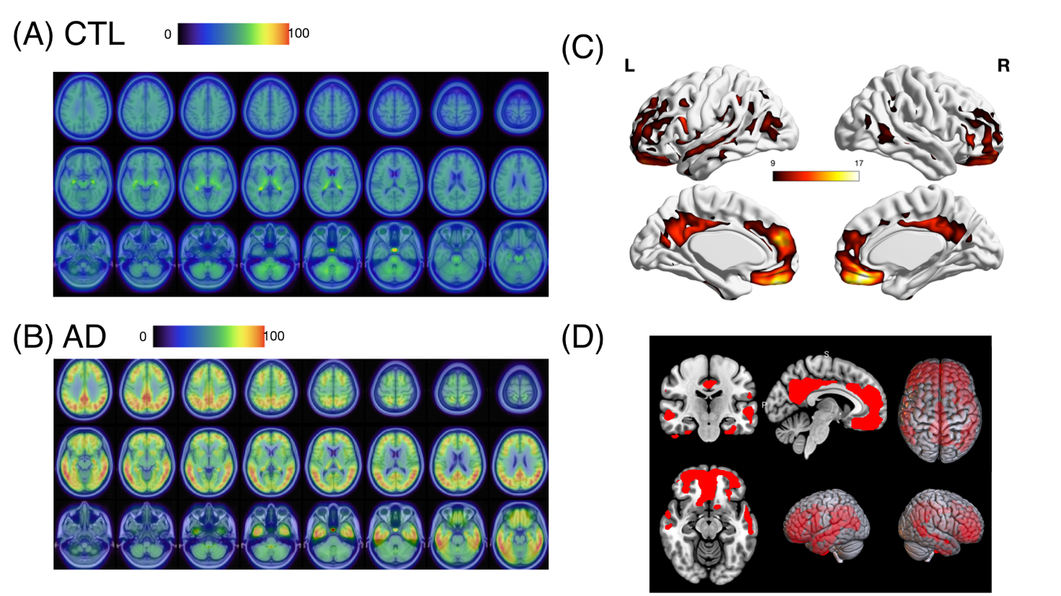Supplementary Figure 1. Average Florzolotau (18F) PET maps for 15 cognitive unimpaired controls (CTL; A) and 15 patients with Alzheimer disease (AD; B). Significant clusters indicating elevated Florzolotau (18F) burden in AD, including the precuneus, medial temporal, and bilateral frontal regions (C). These areas were binarized and converted to an AD-specific neocortical mask (D). Color bars in A and B are based on global tau severity score Centiloid units. Color bar in C represents T-value. Height threshold was set at p < 0.0001 with family-wise error corrections and an extent threshold of 200 voxels.

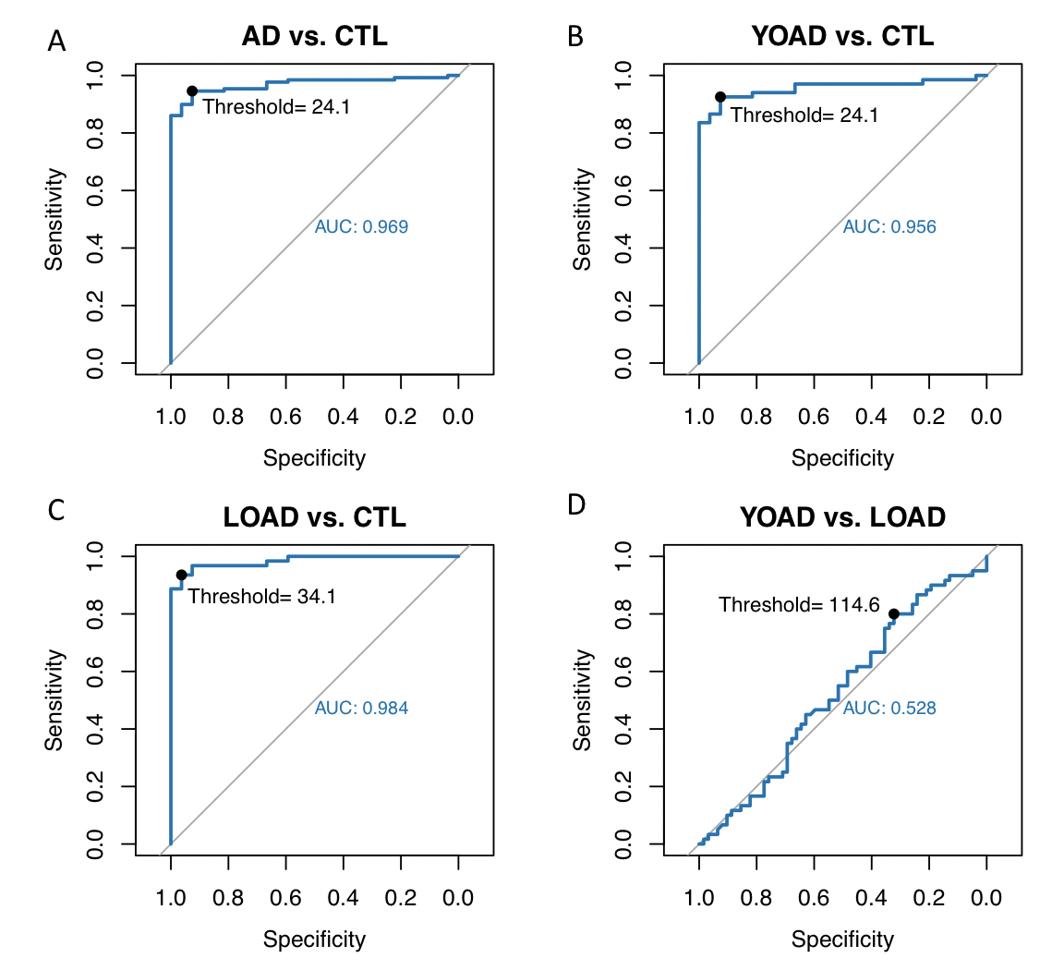Supplementary Figure 2. Receiver operation curves for the diagnosis of (A) AD (B) YOAD (C) LOAD with Cognitive unimpaired controls (CTL) as reference or (D) YOAD from LOAD. Key terms: Alzheimer's disease (AD), young-onset Alzheimer's disease (YOAD), late-onset Alzheimer's disease (LOAD), cognitive unimpaired controls (CTL).

