Material & Methods

Study area
To delineate the Arctic-boreal biomes we used the World Wildlife Fund terrestrial ecoregions¹ shapefile. We selected all ecoregions corresponding to the ‘Boreal Forests/Taiga’ and ‘Tundra’ biomes, and applied a 0.5 degree buffer to this region so that fires at the border of our study area would not be cut off abruptly when spreading over the biome boundaries. During postprocessing, only fires that intersected or fell completely within the study domain were retained.

Fire atlas data
We used the active fire location products (VNP14IMGML, Collection 1 Version 5) from the Visible Infrared Imaging Radiometer Suite (VIIRS) aboard the Suomi National Polar-orbiting Partnership (Suomi-NPP) satellites for tracking all individual fires in the study area between 2012 and 2021. VIIRS has a minimum of two daily overpasses with local overpass times at 1:30 am and 1:30 pm for each location on Earth with an increasing overpass frequency at high latitudes due to overlapping scan tracks. Due to its higher spatial resolution, VIIRS has shown to increase burned area detections in boreal regions by more than 40 % compared to its predecessor, the Moderate Resolution Imaging Spectroradiometer (MODIS)². The science-quality VNP14IMGML active fire locations were downloaded from the University of Maryland VIIRS Active Fire website (https://viirsfire.geog.umd.edu/). We used only active fire detections with nominal or high confidence, and those flagged as vegetation or offshore fires. Offshore fires were included since vegetation fire detections in lake-rich areas such as Northern Canada or northeastern Siberia were frequently erroneously flagged as offshore fires in the active fire product. To eliminate the numerous gas flaring fires that were erroneously flagged as vegetation fires in the VIIRS active fire product we filtered out fire locations that overlapped with known gas flare locations according to the NOAA gas flare dataset³.
To assemble active fire detections into fire clusters, we determined spatial and temporal thresholds according to land cover and peat presence underlying the fire locations of each new time step. To determine the dominant land cover, we used the annual European Space Agency (ESA) Climate Change Initiative (CCI) land cover dataset at 300m resolution from the EC C3S Land cover project. We used version 2.0.7 for the years 2012 – 2015, and version 2.1.1 for years 2016 – 2020. Since land cover data was not yet available for the year 2021, we used 2020 data in replacement. The land cover data was aggregated into six classes (forest, shrubland/mosaic/open, grassland, cropland, urban and other) using a conversion table (Supplementary Table 1). In addition, we used the maps of northern peatland extent version 2 from the Bolin Centre for Climate research⁴ to assess peat presence. We flagged a 10km pixel (and each overlapping fire location) as potential peatland if combined fraction of Histel (perennially frozen organic soil) and Histosol was larger than 10 %.
To minimize commission errors we corrected all fire perimeters using high-resolution lake perimeters derived during postprocessing. We used the annual Global Surface Water dataset version 5 from 2012 to 2021⁵ to create an annual inventory of permanent surface water features. The original 0.00025 degree (approximately 30m) resolution data was gridded to a projected polar coordinate system (EPSG 3571) at 90m resolution using nearest neighbor interpolation to reduce the processing time for feature extraction. Individual lakes were extracted from this grid using the same alpha hull algorithm that was used for the fire tracking (see section ‘Fire tracking algorithm’), using an alpha of 100m to account for the higher spatial resolution of the lake data.

Fire tracking algorithm
We adapted the fire object tracking system deployed in the Californian Fire Events Database⁶ for Arctic-boreal fires. In a first step, the fire locations of each day were clustered into 12-hour time steps using the local solar time, with local solar times between 6am and 6pm being classified as day time overpasses, and those between 6pm and 6am as night time. It is important to note that in the case of high latitudes the day/night flag of VIIRS active fires cannot be accurately used for differentiating between morning and afternoon overpasses since it relies on solar zenith angles. The fire locations were transformed to a projected polar coordinate system (North Pole Lambert Azimuthal Equal Area, EPSG 3571) so that distance calculations and buffering operations are accurately performed throughout the fire tracking procedure.
The locations of each time step were clustered using a ball tree algorithm and a query radius of 1000 m. To assess whether a cluster belonged to an existing fire, each cluster was compared with all existing active fires using an rtree⁷ (Python ctypes wrapper (http://toblerity.org/rtree/) of libspatialindex (https://libspatialindex.github.io/) neighbor search. The search radius was adjusted to the dominant land cover of the last active fire detections of each fire according to Supplementary Table 2. Likewise the maximum time of inactivity was set based on the land cover and peat presence of the last active fire detections. Boreal fires can smolder for extended periods of time⁸. To account for this, we implemented a ‘sleeper’ procedure, which allowed fires to stay active for up to 30 days at locations along an active fire line located in forests or areas with peat. These ‘sleeper’ fires were allowed to reactivate when new fire pixels were detected within 1000 m of the previous active fire line. As a final step, the algorithm merges fire complexes that have grown together with the inclusion of new fire clusters using the same thresholds in Supplementary Table 2.

Computing fire attributes
To create the fire geometries at each time step, we used the alpha shape algorithm which has been successfully applied in previous work to represent fire perimeters^{6,9}. In the alpha shape, a concave hull of a set of points, or fire pixels, is computed using a disk with a fixed radius that it fitted piecewise to form the edges of the polygon. The alpha parameter defines the radius of the disk and thereby how tightly the hull is fitted around the points. Following Chen et al.⁶, we used an alpha of 1000 m, which represented a good compromise between capturing fine-scale fire features and retaining the coherence of the contiguous fire perimeters. An example of all half-daily perimeters created for a large fire in Siberia with multiple ignitions is presented in Fig. 1B.
Apart from the geometries for each time step, the fire tracking algorithm records a variety of fire properties over time, such as daily size, the current fuel type, fire spread, fire line length and fire intensity. In this study, we used only a part of the complete suite of statistics, including the ignition timing and locations, final fire perimeters and fire sizes, total duration of fires and fire radiative power. Sub-daily estimates of fire radiative power (FRP) were derived by averaging the pixel-normalized FRP values per fire and time step. As a metric of intensity over the lifetime of a fire, we computed the 95th percentile of fire intensity per fire based on these sub-daily fire radiative power statistics.
At the end of their lifetime, wildfires may smolder for extended periods of time without transitioning to flaming again. These smoldering hotspots can be picked up by VIIRS, leading to elongated fire durations during which no fire spread is occurring. To account for this residual smoldering, we used the time series of sub-daily fire size estimates for each fire to compute a corrected duration. As a corrected extinction time we thereby used the first detection when 95 percent of the final fire size was reached.
We generated annual vector layers of all final fire perimeters and ignition locations. The final fire type was derived using the dominant land cover type over the whole fire scar based on a combination of ESA CCI land cover data and the circumpolar Arctic vegetation map¹⁰. For each fire, the class with the largest overlap was chosen as dominant land cover. Fire perimeters that fell within tundra vegetation according to the circumpolar Arctic vegetation map were classified as tundra fires. For all other fires, we used the classes delineated in Supplementary Table 1.

Validation of the fire atlas
We validated the final perimeters from our fire atlas using governmental fire perimeter data from the Alaskan and Canadian fire databases. For Alaska, we used the Alaska Wildland Fire Maps (AWFM, https://fire.ak.blm.gov/predsvcs/maps.php), and for Canada the National Burned Area Composite (NBAC) developed by the Canada Centre for Mapping and Earth Observation and the Canadian Forest Service¹¹. Official fire perimeter databases often rely on higher-resolution imagery (i.e. from Landsat) than the VIIRS active fire locations we used, and may therefore contain more accurate spatial information. Nevertheless, the interannual burned area and number of fires from our fire atlas showed a close agreement with the governmental databases (Supplementary Fig. 1). The largest disparities were seen for the total number of fires in Canada, mainly due to small agricultural burns in southern Manitoba, Saskatchewan and Alberta, which were not mapped in NBAC since they did not exceed the minimum mapping unit. The official perimeter data slightly differed between Alaska and Canada, with NBAC accounting for unburned islands within perimeters, whereas AWFM only contain outer perimeters. The VIIRS-generated perimeters developed here contain unburned islands, but exclude lakes, which may explain the slightly lower burned area compared to, and larger burned area compared to NBAC resulting for example in the lake-rich Northwest Territories (Supplementary Fig. 2, Supplementary Table 3). For the fires detected by both products, fire sizes were generally similar, with largest deviations for fires that were erroneously merged or split up in too many parts due to missing fire detections (Supplementary Fig. 2).

Selection of fires for the analysis
Arctic-boreal regions comprise a variety of fire types, many of them being small in size and short in duration. The VIIRS instrument was able to pick up fires as small as larger campfires and many of the recorded small and short-lived fires were anthropogenically caused fires such as agricultural fires. Furthermore, many unmapped refineries and other gas flaring areas, for example in western Siberia, were falsely identified as vegetation fires in the VIIRS product. While all of these were retained in the fire atlas product, we applied a stricter filtering routine to the database used for the characterization of Arctic-boreal pyroregions here, since the large number of very small fires added very little burned area but had a large effect on the statistics of for example fire number and size.
In total, we recorded 104973 Arctic-boreal fires, which burned an area of 120 Mha between 2012 and 2021. While 63% of the recorded fires were smaller than 1 km², the 10% largest fires accounted for 91% of the total burned area. As a first step, we therefore filtered out small agricultural fires for fires whose final fire type was classified as Cropland, Grassland, Urban or Other. We also excluded fires that started in January, February, November or December. These two filters were tailored to filter out agricultural burns and other small fires caused by people such as camp fires, trash burning or bonfires. As a next step, we applied a series of filters aimed at filtering out gas flares. Due to spatial lumping of production areas and refineries, fire detections associated with gas flaring were not always constricted to single VIIRS pixels. However, true wildfires can also burn close to areas of known gas flaring. To find suitable fire size thresholds, we therefore used a database of known gas flaring sites ³. We selected all fires smaller than 20 km² that overlapped with at least one known gas flare and build a model predicting the fire size from the number of gas flare sites overlapping with each fire. We then used the upper prediction interval as a cut-off for the fire size. The cut-offs ranged from 2.5 km² for one gas flare overlap to 21 km² for fires with 25 overlapping gas flare sites. We then only removed fires which were smaller than the computed cut-off value based on the number of gas flare overlaps. Since the known gas flaring record was not exhaustive, we further applied two additional filters on the fires smaller than 20 km². The first of these filters included a search for very long-lasting fires (> 100 days) with little daily fire spread (< 1 km²/day). Further, we searched for overlapping fires (< 20 km²) between 2012 and 2021 and removed fires from the record if they overlapped in more than two years. This procedure also removed repeated agricultural burns that were not previously detected. Lastly, we filtered out all fires with a final size of less than 1 km² as these also most likely represented agricultural or other human-caused fires, and added little to the total burned area. Using the fire identification numbers of the final set of filtered fires, we also only kept the ignitions associated with these fires in a filtered ignition database. Our final selection comprised 26504 fires that burned an area of 112 Mha.

Mapping of fire regime properties and clustering into pyroregions
To derive fire regime properties, we aggregated data from the filtered fires into a 100 km grid in a polar projected coordinate system (EPSG 3571). To aggregate the total burned area, we summarized the area of each fire that fell within a grid cell. For all other grid cell statistics (fire density, fire size, fire duration, fire radiative power and fire start date), we computed two versions: one based on all fires whose centroid was located within a 250 km radius from the grid cell centroid, and a second based on all fires that had a minimum overlap of 30% of their area with a grid cell. We used the first (radius-based) estimate for the maps and clustering into pyroregions, and the second estimate for the modelling part, to have an exact overlap between the fire data and environmental and climatic drivers. To compute the fire number and fire density we aggregated the number of initial fire starts, irrespective of whether these would later merge together into fire complexes.
We used a model-based clustering approach to identify pyroregions with similar fire regime characteristics using the six predictor variables shown in Fig. 2. The analysis was performed using the R Mclust package¹², which is deploys a finite Gaussian mixture modelling framework and enables the optimization of cluster sizes and shapes based on the Bayesian Information Criterion (BIC). We first performed several modelling runs with different cluster shapes and cluster sizes ranging from one to nine, and selected a model allowing for a variable volume, shape, and orientation of clusters, based on the highest BIC (Supplementary Fig. 3). While the BIC continued to increase with cluster numbers up to nine clusters, we chose a cluster number of seven, because the increase became negligible beyond that, following the methodology applied in Archibald et al.¹³. Uncertainties were largely uniform across clusters, and rarely exceeded 0.2 (85th percentile) (Supplementary Table 4). Furthermore, clusters were mostly spatially contiguous and cluster uncertainty was largest at the spatial borders between different clusters (Fig. 3), which speaks for the reliability of the cluster patterns.

Data for assessing drivers of spatial variability
Fuel availability, fuel moisture content and ignition sources are the three determining factors for fire occurrence in any ecosystem. In boreal regions, fire activity is mainly limited by an absence of ignition sources and a surplus of moisture, and fuel limitations can be particularly important in sparsely vegetated Arctic regions¹⁴. We chose a set of climatic and geographic variables to represent these three factors for assessing the drivers of spatial variability in fire activity (Extended Data Fig. 3). All data was reprojected to match the coordinate system of the fire maps and aggregated to their 100 km spatial resolution by computing the average of all overlapping pixels.
Climate. As a proxy for fire weather influences on fuel moisture we used the vapor pressure deficit (VPD), which has shown to be a suitable predictor of fuel flammability and thus fire ignitions and fire spread¹⁵. We computed VPD from ERA5-land temperature and dewpoint temperature at 2m as:
$$VPD=SVP-AVP$$
Where the saturation vapor pressure (SVP) and the actual vapor pressure (AVP) were computed according to Tetens equation:
$$AVP= 0.61078 ×e^{\frac{(17.27*T)}{(237.15+T)}}$$
Where T is the temperature in degrees Celsius. For the computation of SVP, the temperature is simply replaced by the dewpoint temperature in this equation. ERA5-land products are delivered at a native resolution of approximately 9km. As a proxy for the climatological fire danger, we identified the month with the maximum VPD for each pixel, and compute a multi-year average of the average VPD during this month for the years 2012-2021.
Lightning ignition. We extracted lightning density from the World Wide Lightning Location Network (WWLLN) for the years 2012-2021¹⁶. The WWLLN consists of a number of radio receivers in the very-low frequency range (3-30 kHz) distributed throughout the world, that enable very long-range (thousands of km) lightning detection with a spatial accuracy of about 5km^{17–19}. While detection efficiency is not uniform over the boreal regions due to gaps in the network in Siberia¹⁸, this dataset is, to our knowledge, the only currently openly available ground-based lightning detection network with global coverage. The data is distributed as a gridded, monthly-aggregated climatology product at 5 arc-minute resolution, which has been pre-processed to correct for the differences in the detection efficiency using gridded detection efficiency maps. We aggregated this data for the months March to October, the extended Arctic-boreal fire season, over all years to derive a climatological value that matches the temporal extent of the fire data.
Fuels. As a proxy for aboveground fuels we used the GlobBiomass product^{20,21}, a static aboveground biomass map of the year 2010. We further used the peatland map derived from the Northern Circumpolar Soil Carbon Database ⁴ which was used in the fire tracking algorithm to derive the fraction of land covered by peatlands within each map pixel. Lastly, we derived the tree species dominance for each pixel based on the ESA CCI land cover data. We extracted annual tree cover per forest type (deciduous broad-leaved, coniferous needle-leaved, and deciduous needle-leaved) following Forkel et al.²² and computed the average percentage of the three forest types for each pixel. For the tree species analysis, we used data from 2020 since large-scale tree species abundance changed little throughout 2012-2020.
Human impact. Humans shape fire regimes through their impact on ignitions and active fire suppression, but also through their influence on fuel continuity and fuel type. We included two datasets to account for different types of human impact. We used the Historic Database of the Global Environment (HYDE version 3.2.1)²³ for estimating the percentage of croplands and grazing lands in each pixel. HYDE is provided at a 5 arc-min resolution and contains data for the Common Era from 2012 to 2015. To estimate the percentage of each pixel that was completely untouched by humans, we used the Human Footprint Map of the year 2013^{24,25}. The Human Footprint Maps approximate the magnitude of human influence on a global map using data on build-up areas, population density, infrastructure elements and crop and pasture lands and are delivered at a spatial resolution of 1km². A value smaller than four in these maps has previously been used to identify wilderness areas with no human influence²⁴. To be conservative, we only classified pixels with a value of zero as wilderness. Thanks to the higher spatial resolution of the human footprint maps compared to the grid cell size in our analysis, we calculated the wilderness fraction of each grid cell by computing the percentage of all 1km² pixels containing wilderness within each 100 km by 100 km pixel.

Drivers of spatial variability and climate sensitivity
As a first step to assessing drivers of spatial variability in fire activity we investigated differences in the geographic and climatic drivers between the clusters using boxplots (Extended Data Fig. 4) and Tukey’s Honest Significant Difference (HSD) tests to assess significant differences between pyroregions (Extended Data Fig. 5). We further computed the partial Spearman correlation between all drivers and fire regime characteristics within pyroregions and across the Arctic-boreal biomes. Lastly, we built linear models predicting fire regime characteristics from the environmental and climatic driver to assess the overall predictability of fire activity within and across pyroregions.
The sensitivity of the pyroregions to climate (Extended Data Table 2) was assessed by computing grid cell based Spearman correlations between annual burned area, fire density and fire sizes, and the annual average of vapor pressure deficit in the month of maximum VPD. For each pyroregion we reported the average and standard deviation of the correlations of all grid cells that contained at least five fires, and at least three years of data.
The time series of burned area, fire number and fire size for the whole domain (Extended Data Fig. 1) and the seven pyroregions (Extended Data Fig. 6) include an extension of the fire atlas data for 2022 and 2023. These results only include data up to October 31, 2023. They rely on near real time data from VIIRS since science-quality archive data was not available yet. Because of these limitations data from 2022 and 2023 were only used for the time series, but not for the clustering or analysis of drivers.

Supplementary Table 1: Conversion table for simplifying the land cover classes of the European Space Agency Climate Change Initiative Land cover product
New land cover class | Original land cover classes
Other | 0 (no data), 200 (bare areas), 210 (water bodies), 220 (permanent snow & ice)
Cropland | 10 (rainfed cropland), 20 (irrigated cropland), 30 (mosaic cropland/natural vegetation), 40 (mosaic natural vegetation/cropland)
Forest/Tree cover | 50 (broadleaved >15%), 60 (deciduous > 15%), 70 (evergreen needleleaved > 15%), 80 (deciduous needleleaved > 15%), 90 (mixed leaf type), 160 (flooded, fresh water), 170 (flooded, saline)
Shrubland/  mosaic/  open | 100 (mosaic tree and shrub/herbaceous), 110 (mosaic herbaceous/tree and shrub), 120 (shrubland), 140 (lichen and moss), 150 (sparse vegetation), 180 (shrub/herbaceous, flooded)
Grassland | 130 (grassland)
Urban | 190 (urban areas)

Supplementary Table 2: Land cover dependent spatial and temporal thresholds for merging new fire clusters with existing active fires
 | Other | Cropland | Forest (>15% tree cover) |  | Shrubland/  mosaic/open |  | Grassland |  | Urban areas
Peat presence |  |  | Peat |  | Peat |  | Peat
Smouldering time (hours) | 4 | 5 | 10 (30) | 10 (30) | 10 (30) | 10 | 10 (30) | 3 | 5
Distance threshold (km) | 1 | 1 | 2.5 | 2.5 | 2.5 | 2.5 | 1 | 1 | 1

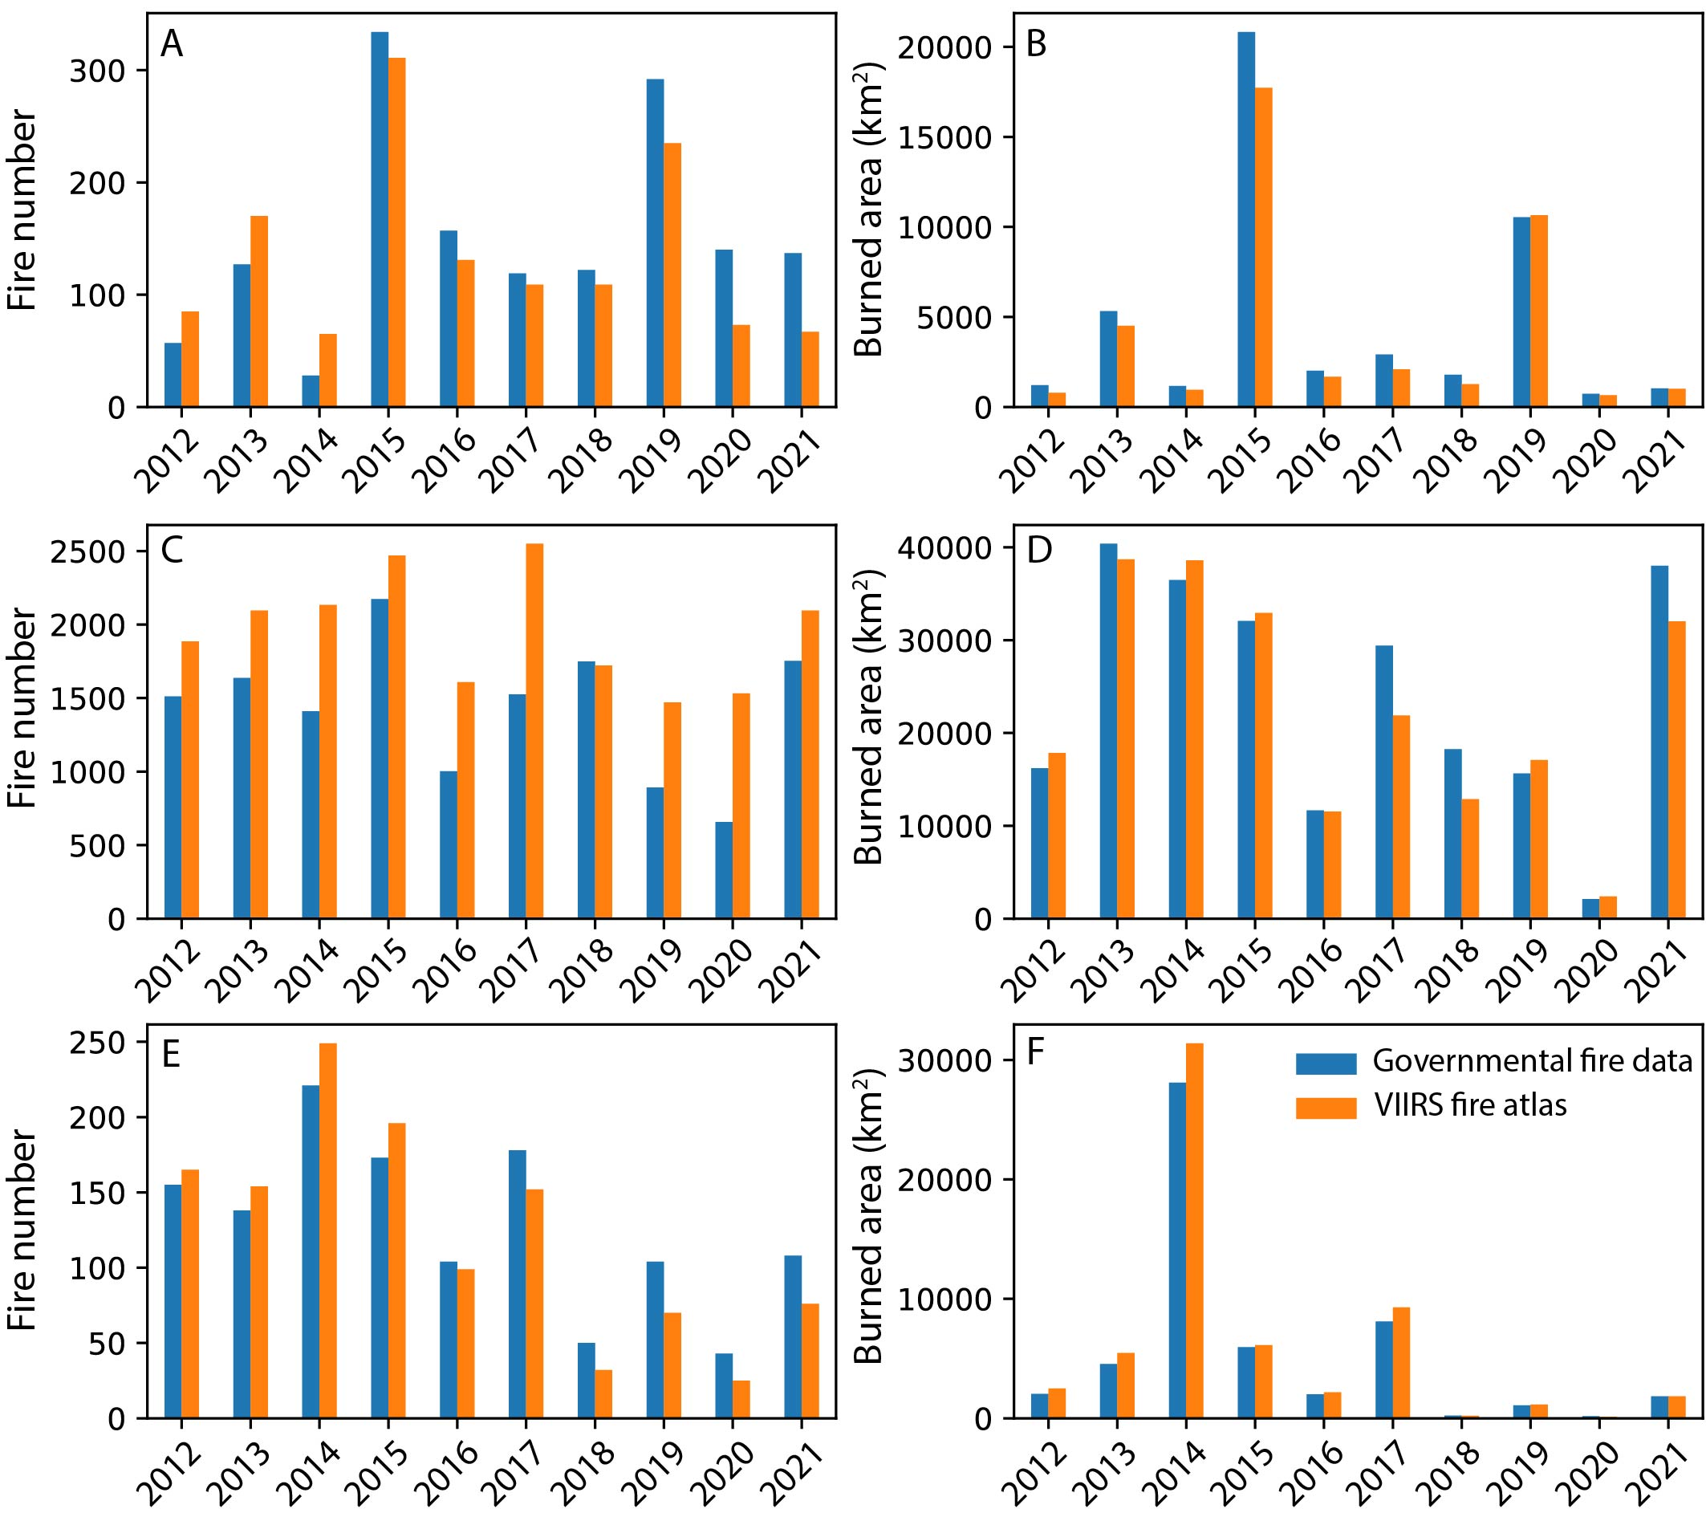
Supplementary Figure 1: Comparison of the number of fires (a,c,e) and the annual burned area (b,d,f) of reference fire perimeters (blue) and perimeters derived from the Visible Infrared Imaging Radiometer Suite (VIIRS, orange) for Alaska (a-b), Canada (c-d) and the Northwest Territories (e-f).

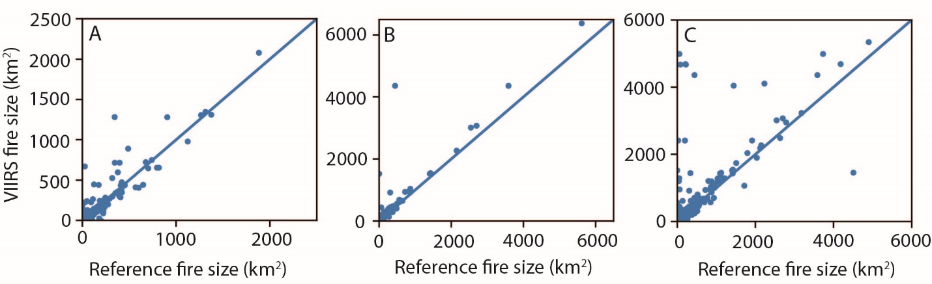
D | Omission (%) | Commission (%) | Dif_{Mean} (km²) | Dif_{Median} (km²) | Dif_{Median} (%)
Alaska | 22.4 | 10.7 | 0.96 | 0.45 | 8.1
Canada | 28.6 | 24.0 | 13.2 | 0.24 | 10.8
NWT, Canada | 10.4 | 19.5 | 13.9 | 0.54 | 13.3
Supplementary Figure 2: Comparison of the size of single fires for Alaska (a), the Northwest Territories (NWT, b) and Canada (c). D, Omission and commission errors of fire perimeters generated from the Visible Infrared Imaging Radiometer Suite compared to official fire databases, as well as the mean and median differences per fire.

Supplementary Table 3: Confusion matrices comparing annual burned area derived from Visible Infrared Imaging Radiometer Suite (VIIRS) imagery vs. reference fire databases. A, Alaska. B, Canada. C, Northwest Territories.
A |  | Reference (Alaska Wildland Fire Maps)
Alaska |  | Burned (km²) | Unburned (km²) | Total (km²) | Commission (%)
VIIRS | Burned (km²) | 36900.6 | 4419.9 | 41320.5 | 10.7
VIIRS | Unburned (km²) | 10651.7
 | Total (km²) | 47552.3
 | Omission (%) | 22.4
B |  | Reference (National Burned Area Composite)
Canada |  | Burned (km²) | Unburned (km²) | Total (km²) | Commission (%)
VIIRS | Burned (km²) | 171678.3 | 54155.1 | 225833.4 | 24.0
VIIRS | Unburned (km²) | 68755.2
 | Total (km²) | 240433.5
 | Omission (%) | 28.6

C |  | Reference (National Burned Area Composite)
NWT |  | Burned (km²) | Unburned (km²) | Total (km²) | Commission (%)
VIIRS | Burned (km²) | 48498.0 | 11751.5 | 60249.5 | 19.5
VIIRS | Unburned (km²) | 5618.1
 | Total (km²) | 54116.1
 | Omission (%) | 10.4

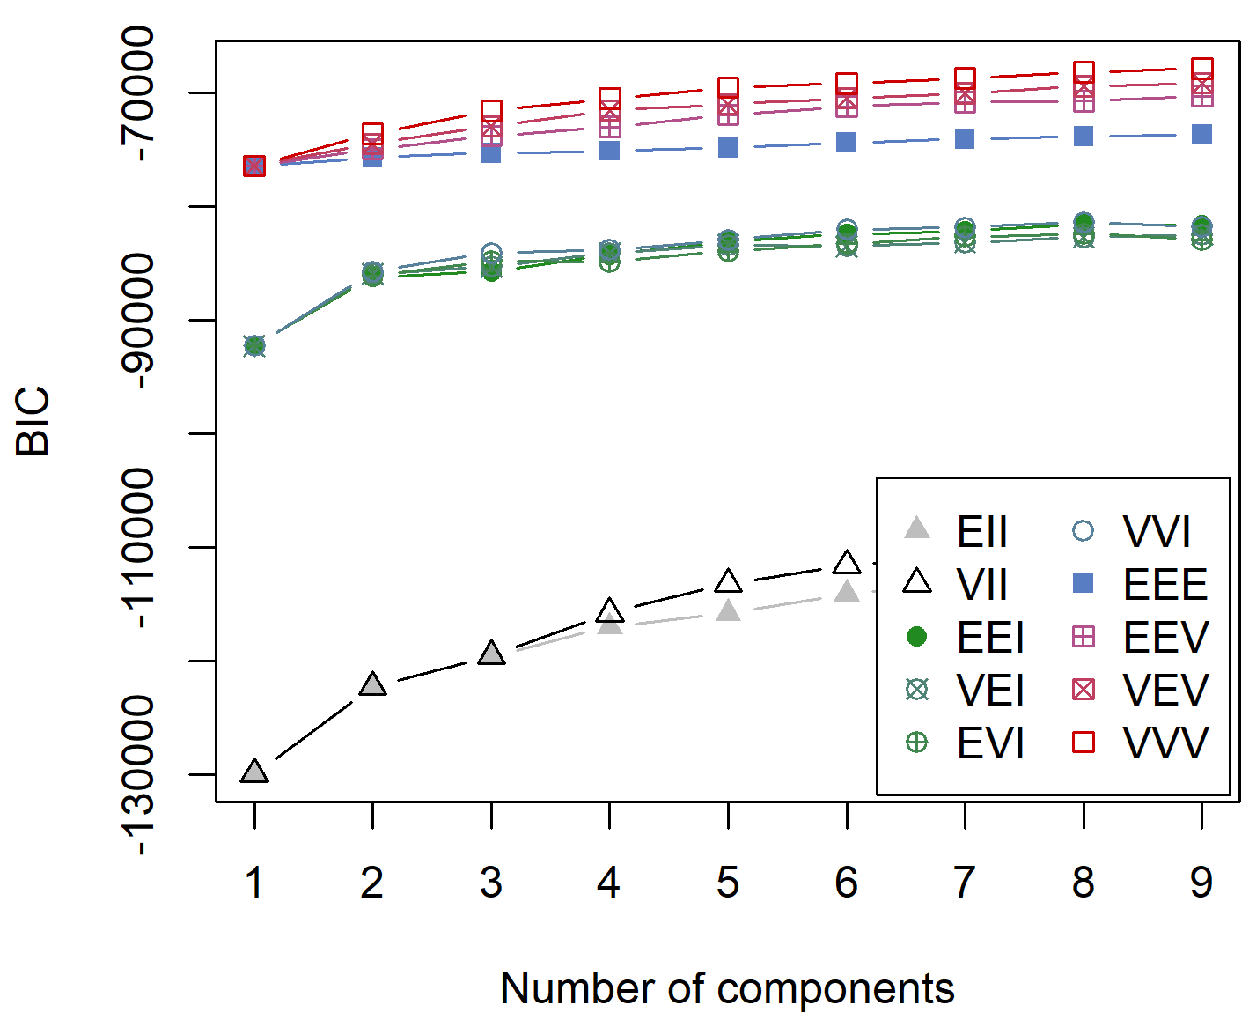
Supplementary Figure 3: Bayesian Information Criterion (BIC) plot for models fitted with different cluster shapes and cluster numbers. Cluster shapes are represented by different colours and shapes. Cluster shapes are defined by their volume, shape and orientation, all represented by one letter in the cluster shape name. E thereby stands for equal (all clusters can only have the same volume/shape/orientation), V for variable (values are allowed to vary per cluster), and I for invariant (in this case the shape can only represent a sphere and the orientation is along the coordinate axes).

Supplementary Table 4: Statistics of uncertainties for the cluster affiliation of each pyroregion. Summary statistics are based on the uncertainty assigned to each pixel by the model. N: total number of pixels, min: minimum cluster uncertainty, max: maximum cluster uncertainty, mean: average cluster uncertainty, perc90: 90th percentile of cluster uncertainty, perc95: 95th percentile of cluster uncertainties.
 | Rare  Small  Early | Rare  Small  Cool | Frequent Small  Early | Frequent Large  Cool | Frequent Large  Early | Frequent Large Intense | Rare  Small Intense
N | 328 | 456 | 185 | 394 | 320 | 568 | 297
min | 0.00 | 0.00 | 0.00 | 0.00 | 0.00 | 0.00 | 0.00
max | 0.50 | 0.64 | 0.46 | 0.58 | 0.63 | 0.63 | 0.58
mean | 0.04 | 0.12 | 0.03 | 0.08 | 0.13 | 0.08 | 0.07
perc90 | 0.15 | 0.38 | 0.08 | 0.30 | 0.36 | 0.28 | 0.25
perc95 | 0.25 | 0.46 | 0.18 | 0.39 | 0.45 | 0.38 | 0.37

References
1. Olson, D. M. et al. Terrestrial ecoregions of the world: a new map of life on Earth. Bioscience 51, 933–938 (2001).
2. Xu, W., Scholten, R. C., Hessilt, T. D., Liu, Y. & Veraverbeke, S. Overwintering fires rising in eastern Siberia. Environ. Res. Lett. 17, 045005 (2022).
3. Elvidge, C. D., Zhizhin, M., Baugh, K., Hsu, F. C. & Ghosh, T. Methods for global survey of natural gas flaring from visible infrared imaging radiometer suite data. Energies 9, (2016).
4. Hugelius, G. et al. Maps of northern peatland extent, depth, carbon storage and nitrogen storage. https://doi.org/10.17043/hugelius-2020-peatland-2 (2021) doi:10.17043/hugelius-2020-peatland-2.
5. Pekel, J. F., Cottam, A., Gorelick, N. & Belward, A. S. High-resolution mapping of global surface water and its long-term changes. Nature 540, 418–422 (2016).
6. Chen, Y. et al. California wildfire spread derived using VIIRS satellite observations and an object-based tracking system. Sci. Data 9, 249 (2022).
7. Guttman, A. R-trees. ACM SIGMOD Rec. 14, 47–57 (1984).
8. Scholten, R. C., Jandt, R., Miller, E. A., Rogers, B. M. & Veraverbeke, S. Overwintering fires in boreal forests. Nature 593, 399–404 (2021).
9. Hantson, S., Andela, N., Goulden, M. L. & Randerson, J. T. Human-ignited fires result in more extreme fire behavior and ecosystem impacts. Nat. Commun. 13, 1–8 (2022).
10. Walker, D. A. et al. The Circumpolar Arctic Vegetation Map. J. Veg. Sci. 16, 267–282 (2005).
11. Hall, R. J. et al. Generating annual estimates of forest fire disturbance in Canada: The National Burned Area Composite. Int. J. Wildl. Fire 29, 878–891 (2020).
12. Scrucca, L., Fop, M., Murphy, T. B. & Raftery, A. E. mclust 5 : Clustering , Classification and Density Estimation Using Gaussian Finite Mixture Models. 8, 289–317 (2016).
13. Archibald, S., Lehmann, C. E. R., Gómez-Dans, J. L. & Bradstock, R. A. Defining pyromes and global syndromes of fire regimes. Proc. Natl. Acad. Sci. U. S. A. 110, 6442–6447 (2013).
14. Kelley, D. I. et al. How contemporary bioclimatic and human controls change global fire regimes. Nat. Clim. Chang. 9, 690–696 (2019).
15. Sedano, F. & Randerson, J. T. Multi-scale influence of vapor pressure deficit on fire ignition and spread in boreal forest ecosystems. Biogeosciences 11, 3739–3755 (2014).
16. Kaplan, J. O. & Lau, K. H.-K. The WGLC global gridded lightning climatology and time series. Earth Syst. Sci. Data 13, 3219–3237 (2021).
17. Abarca, S. F., Corbosiero, K. L. & Galarneau, T. J. An evaluation of the Worldwide Lightning Location Network (WWLLN) using the National Lightning Detection Network (NLDN) as ground truth. J. Geophys. Res. 115, D18206 (2010).
18. Hutchins, M. L., Holzworth, R. H., Brundell, J. B. & Rodger, C. J. Relative detection efficiency of the World Wide Lightning Location Network. Radio Sci. 47, n/a-n/a (2012).
19. Rodger, C. J. et al. Detection efficiency of the VLF World-Wide Lightning Location Network (WWLLN): initial case study. Ann. Geophys. 24, 3197–3214 (2006).
20. Santoro, M. GlobBiomass - global datasets of forest biomass. PANGAEA (2018) doi:https://doi.org/10.1594/PANGAEA.894711.
21. Santoro, M. et al. The global forest above-ground biomass pool for 2010 estimated from high-resolution satellite observations. Earth Syst. Sci. Data 13, 3927–3950 (2021).
22. Forkel, M. et al. A data-driven approach to identify controls on global fire activity from satellite and climate observations (SOFIA V1). Geosci. Model Dev. 10, 4443–4476 (2017).
23. Klein Goldewijk, K., Beusen, A., Doelman, J. & Stehfest, E. Anthropogenic land use estimates for the Holocene – HYDE 3.2. Earth Syst. Sci. Data 9, 927–953 (2017).
24. Williams, B. A. et al. Change in Terrestrial Human Footprint Drives Continued Loss of Intact Ecosystems. One Earth 3, 371–382 (2020).
25. Venter, O. et al. Global terrestrial Human Footprint maps for 1993 and 2009. Sci. Data 3, 1–10 (2016).

