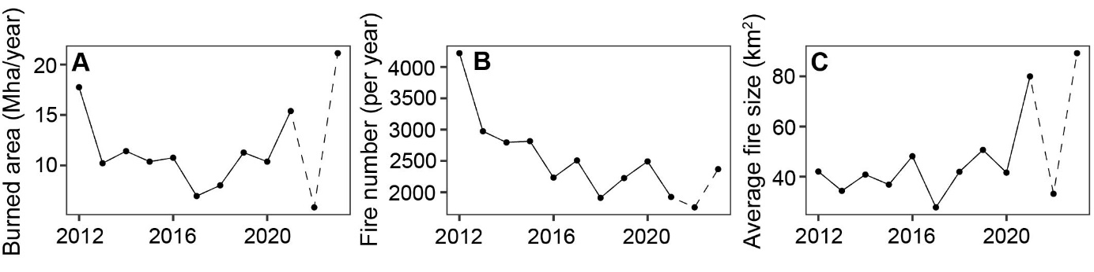
Extended Data Figure 1: Time series of total burned area and the number of fires in Arctic and boreal biomes between 2012 and 2021. Fire number refers to the number of fire starts in each year. Fire numbers show a decreasing trend (-138 fires/year, p =0.004), while average fire size has increased with 2.9 km² per year (p = 0.059). Dashed lines refer to data that is based on near real time active fire locations instead of the science quality archive active fire product.
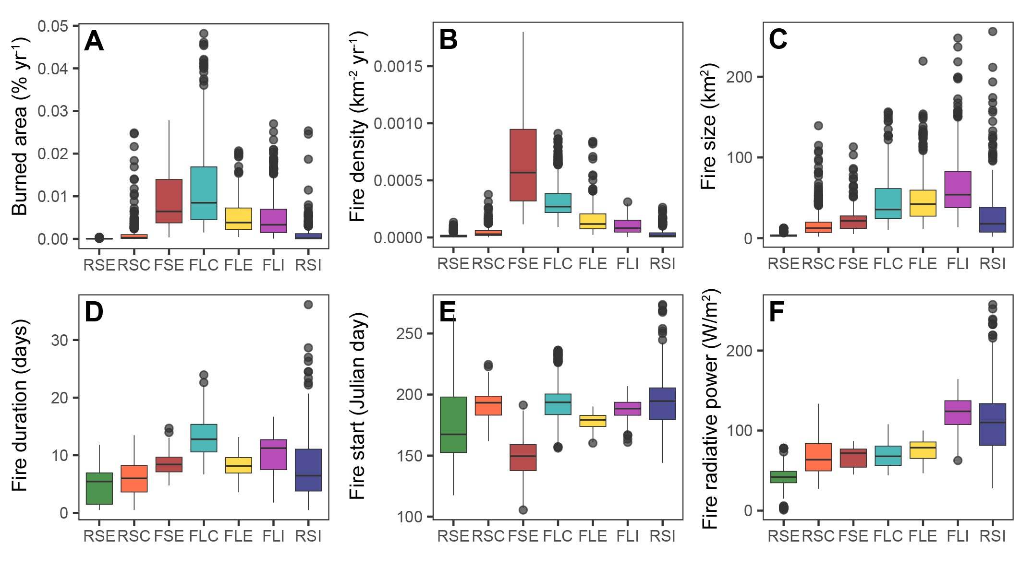
Extended Data Figure 2: Fire characteristics of Arctic-boreal pyroregions. A, annual percentage burned area, B, fire number density, C, average fire size, D, average fire duration in pixel, E, average fire start day in pixel, F, average of the 95th percentile of fire radiative power values per fire. RSE: rare-small-early, RSC: rare-small-cool, FSE: frequent-small-early, FLC: frequent-large-cool, FLE: frequent-large-early, FLI: frequent-large-intense, RSI: rare-small-intense. See Fig. 3 for the geographical extent of the pyroregions.

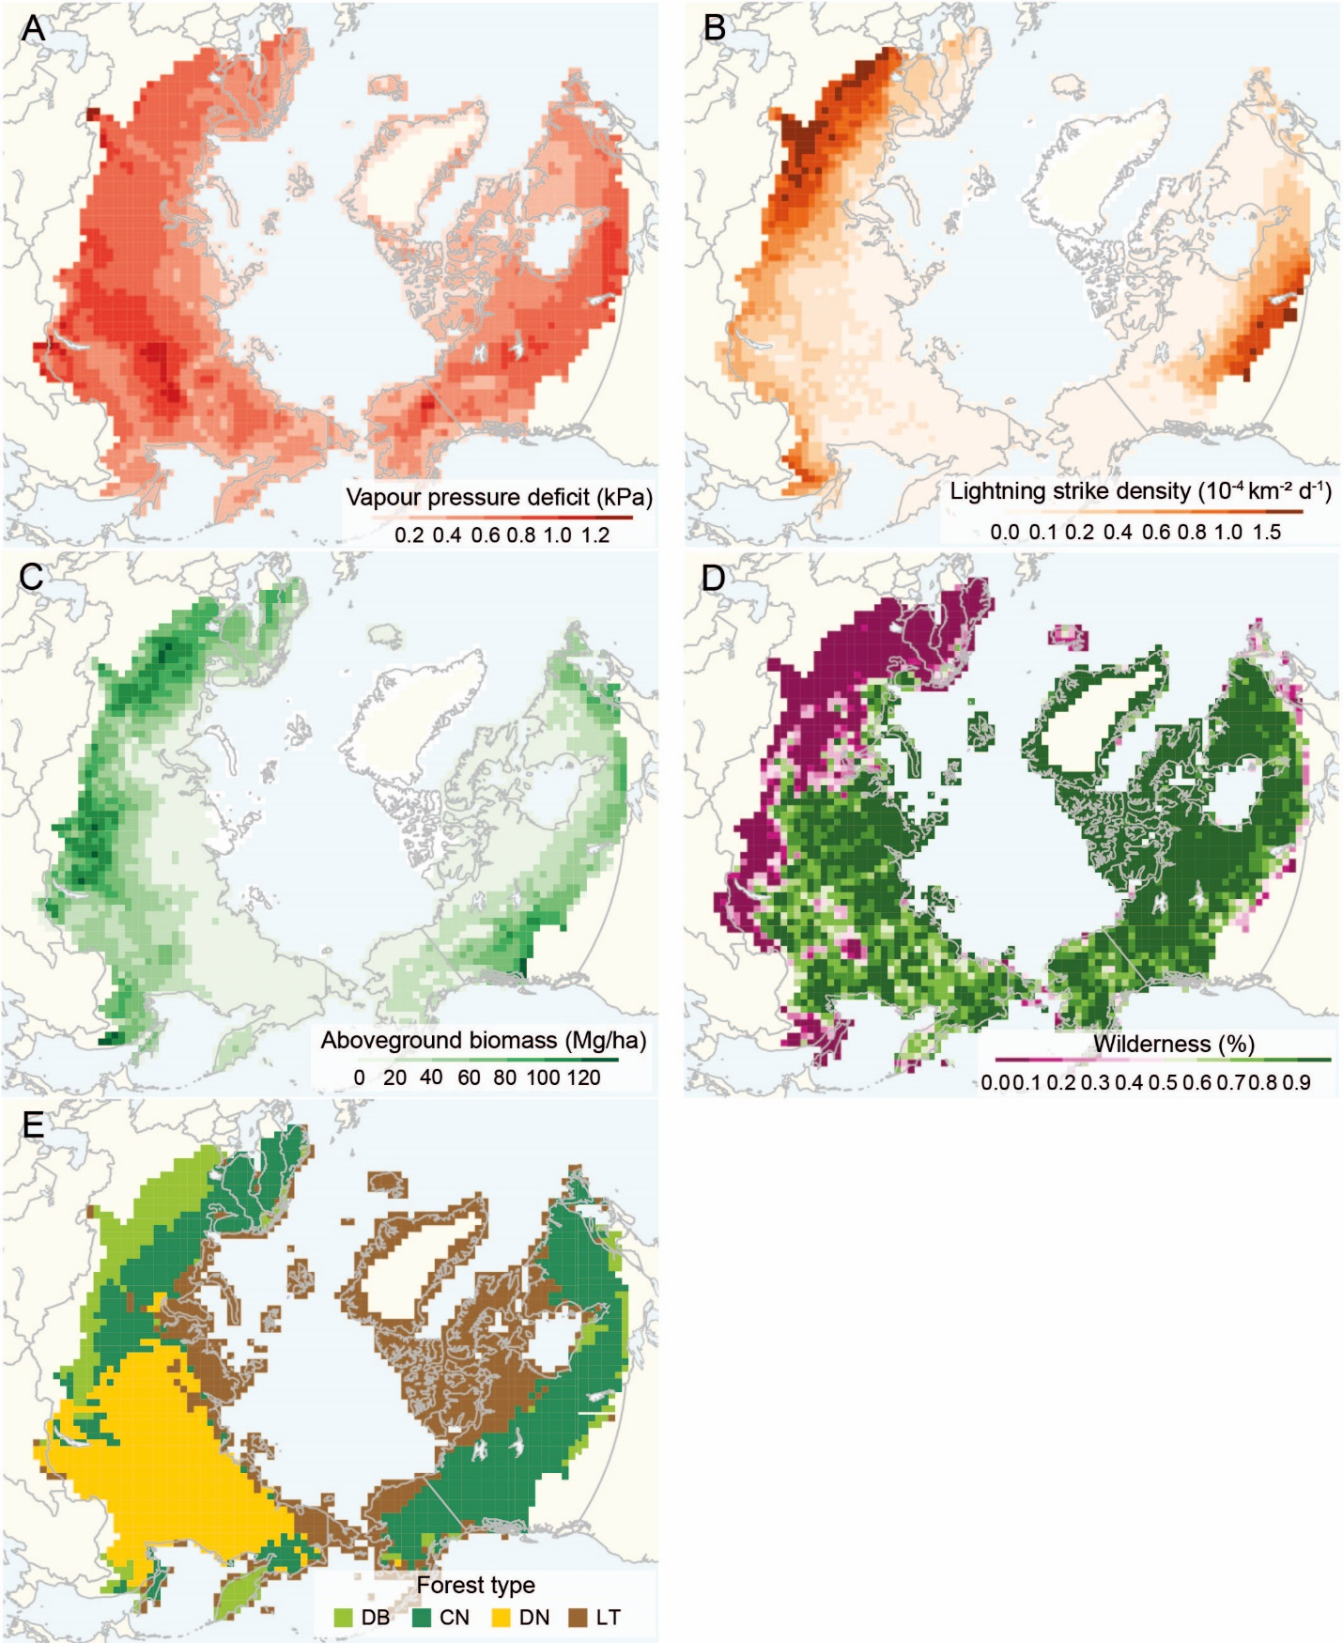
Extended Data Figure 3: Maps of environmental drivers of fire activity. A, average vapor pressure deficit (VPD) in the month of maximum VPD. B, average lightning density between March and October. C, average aboveground biomass. D, fraction of pixel covered by wilderness according to the Human Footprint Map of 2013. E, dominant forest type for each pixel; DB: deciduous broadleaf, CN: coniferous evergreen needleleaf, DN: coniferous deciduous needleleaf, LT: low tree cover (< 15%).

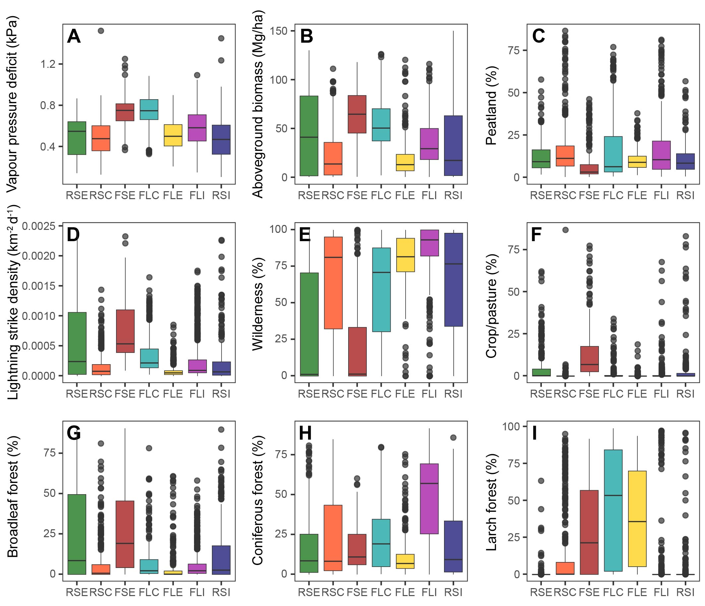
Extended Data Figure 4: Environmental and climatic characteristics of the seven pyroregions. RSE: rare-small-early, RSC: rare-small-cool, FSE: frequent-small-early, FLC: frequent-large-cool, FLE: frequent-large-early, FLI: frequent-large-intense, RSI: rare-small-intense. See Fig. 3 for the geographical extent of the pyroregions.
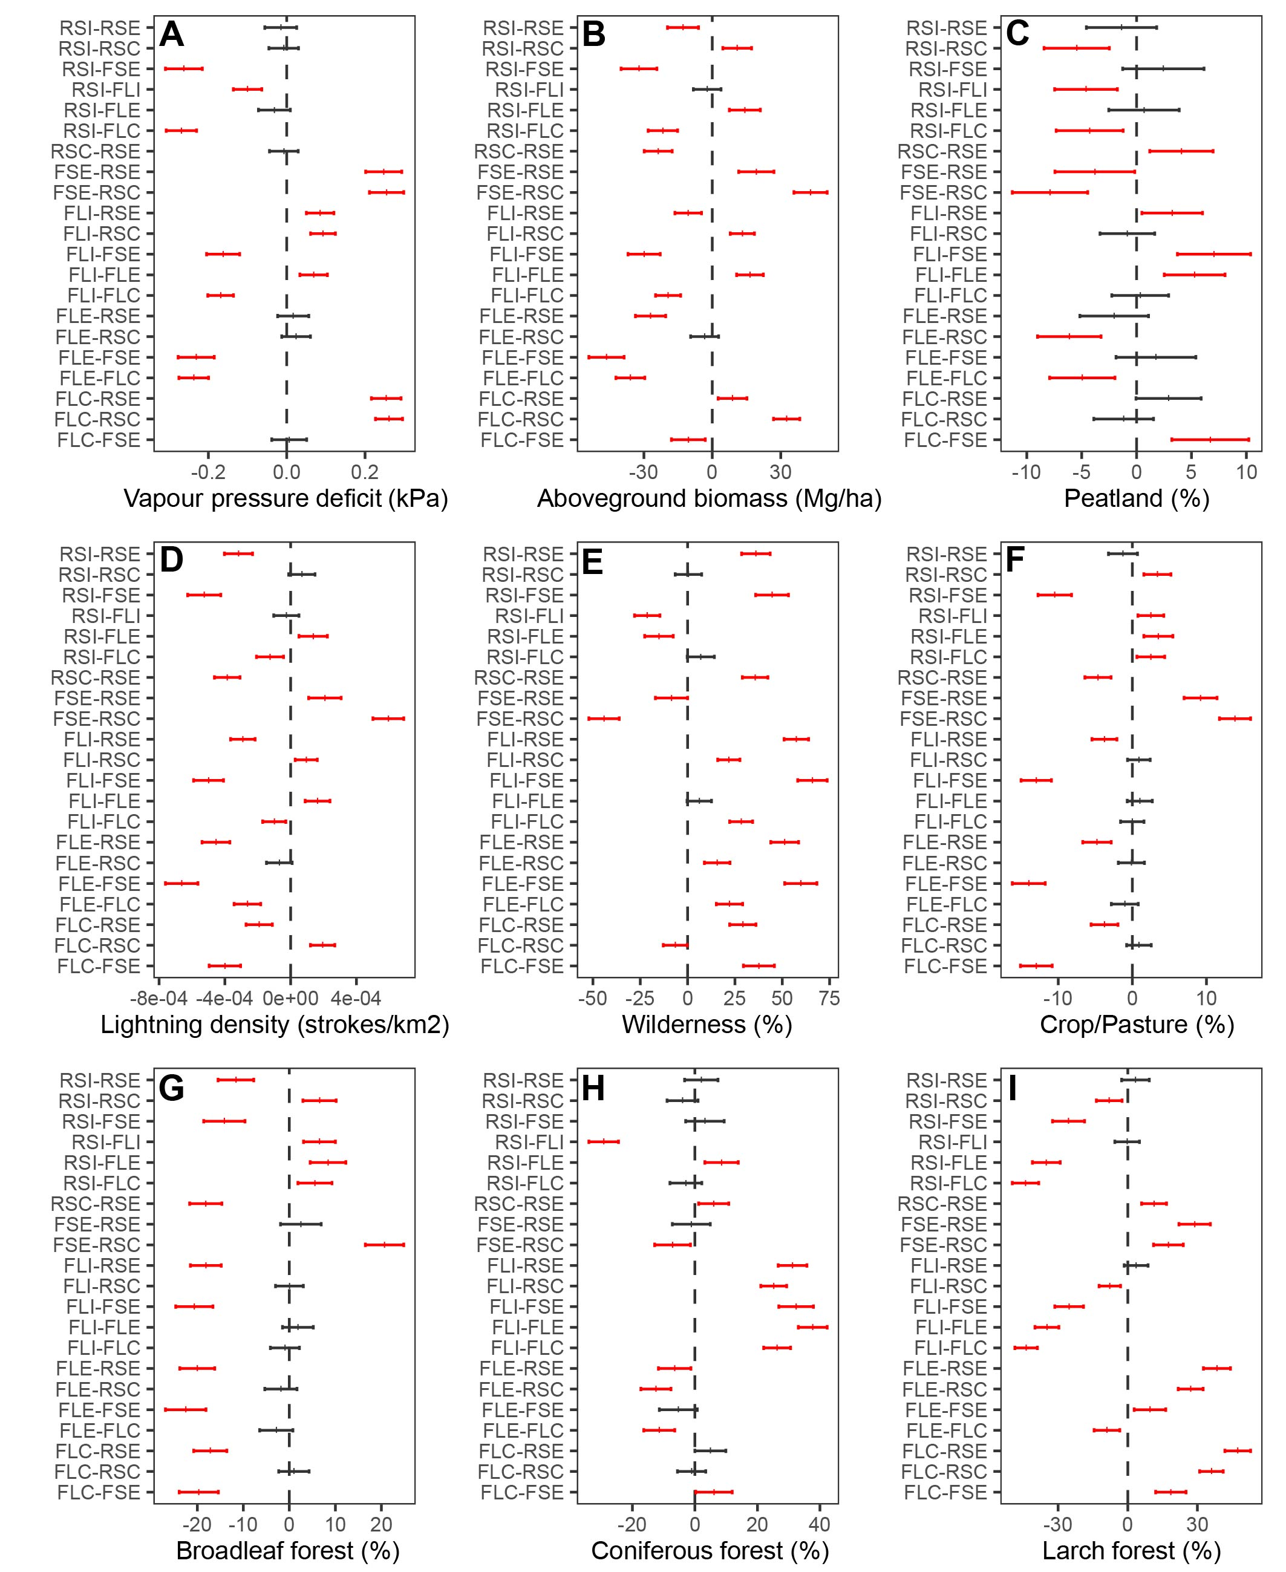
Extended Data Figure 5: Results of Tukey Honest Significant Difference test of differences between pyroregions. Shown are the mean difference (+) and 95% confidence interval (error bars). Red colors indicate significant differences between groups (alpha > 0.05). Black dashed line shows zero-difference. RSE: rare-small-early, RSC: rare-small-cool, FSE: frequent-small-early, FLC: frequent-large-cool, FLE: frequent-large-early, FLI: frequent-large-intense, RSI: rare-small-intense. See Fig. 3 for the geographical extent of the pyroregions.
Extended Data Table 1: Model coefficient of determination (R²) for linear models predicting fire characteristics from environmental variables (vapor pressure deficit, lightning density, wilderness fraction, aboveground biomass and the fraction of croplands and pastures). R²_{env}: models using only environmental variables. R²_{env+ft}: models including environmental variables and the fraction of forest type (deciduous-broadleaf, deciduous-needleleaf and coniferous). Only grid cells with at least five fires (n = 1120) were used for the models to assure representative values for average fire size, duration and fire radiative power.
 | R²_{env} | R²_{env+ft}
% Burned area | 0.30 | 0.33
Fire number | 0.29 | 0.30
Fire size | 0.13 | 0.13
Fire duration | 0.17 | 0.22
Fire Radiative Power | 0.14 | 0.30

Extended Data Table 2: Spearman correlation between annual fire activity and annual vapor pressure deficit for the seven pyroregions. Vapor pressure deficit values represent averages for the month of maximum vapor pressure deficit for each grid cell. Each annual observation for each grid cell serves as one observation. N refers to the total number of observations (grid cells x years). The number of grid cells in parentheses is the number of grid cells with at least one fire used for the fire size correlation estimation. Values printed in italics are not significant (p > 0.05).
 | Burned area | Fire number | Fire size | N
Rare-small-early (RSE) | 0.20 | 0.20 | -0.01 | 3280 (222)
Rare-small-cool (RSE) | 0.32 | 0.32 | 0.15 | 4560 (745)
Frequent-small-early (FSE) | 0.19 | 0.21 | 0.15 | 1850 (1100)
Frequent-large-cool (FLC) | 0.50 | 0.46 | 0.38 | 3940 (2377)
Frequent-large-early (FLE) | 0.47 | 0.47 | 0.31 | 3200 (1221)
Frequent-large-intense (FLI) | 0.43 | 0.42 | 0.30 | 5680 (1721)
Rare-small-intense (RSI) | 0.16 | 0.16 | -0.06 | 2970 (216)

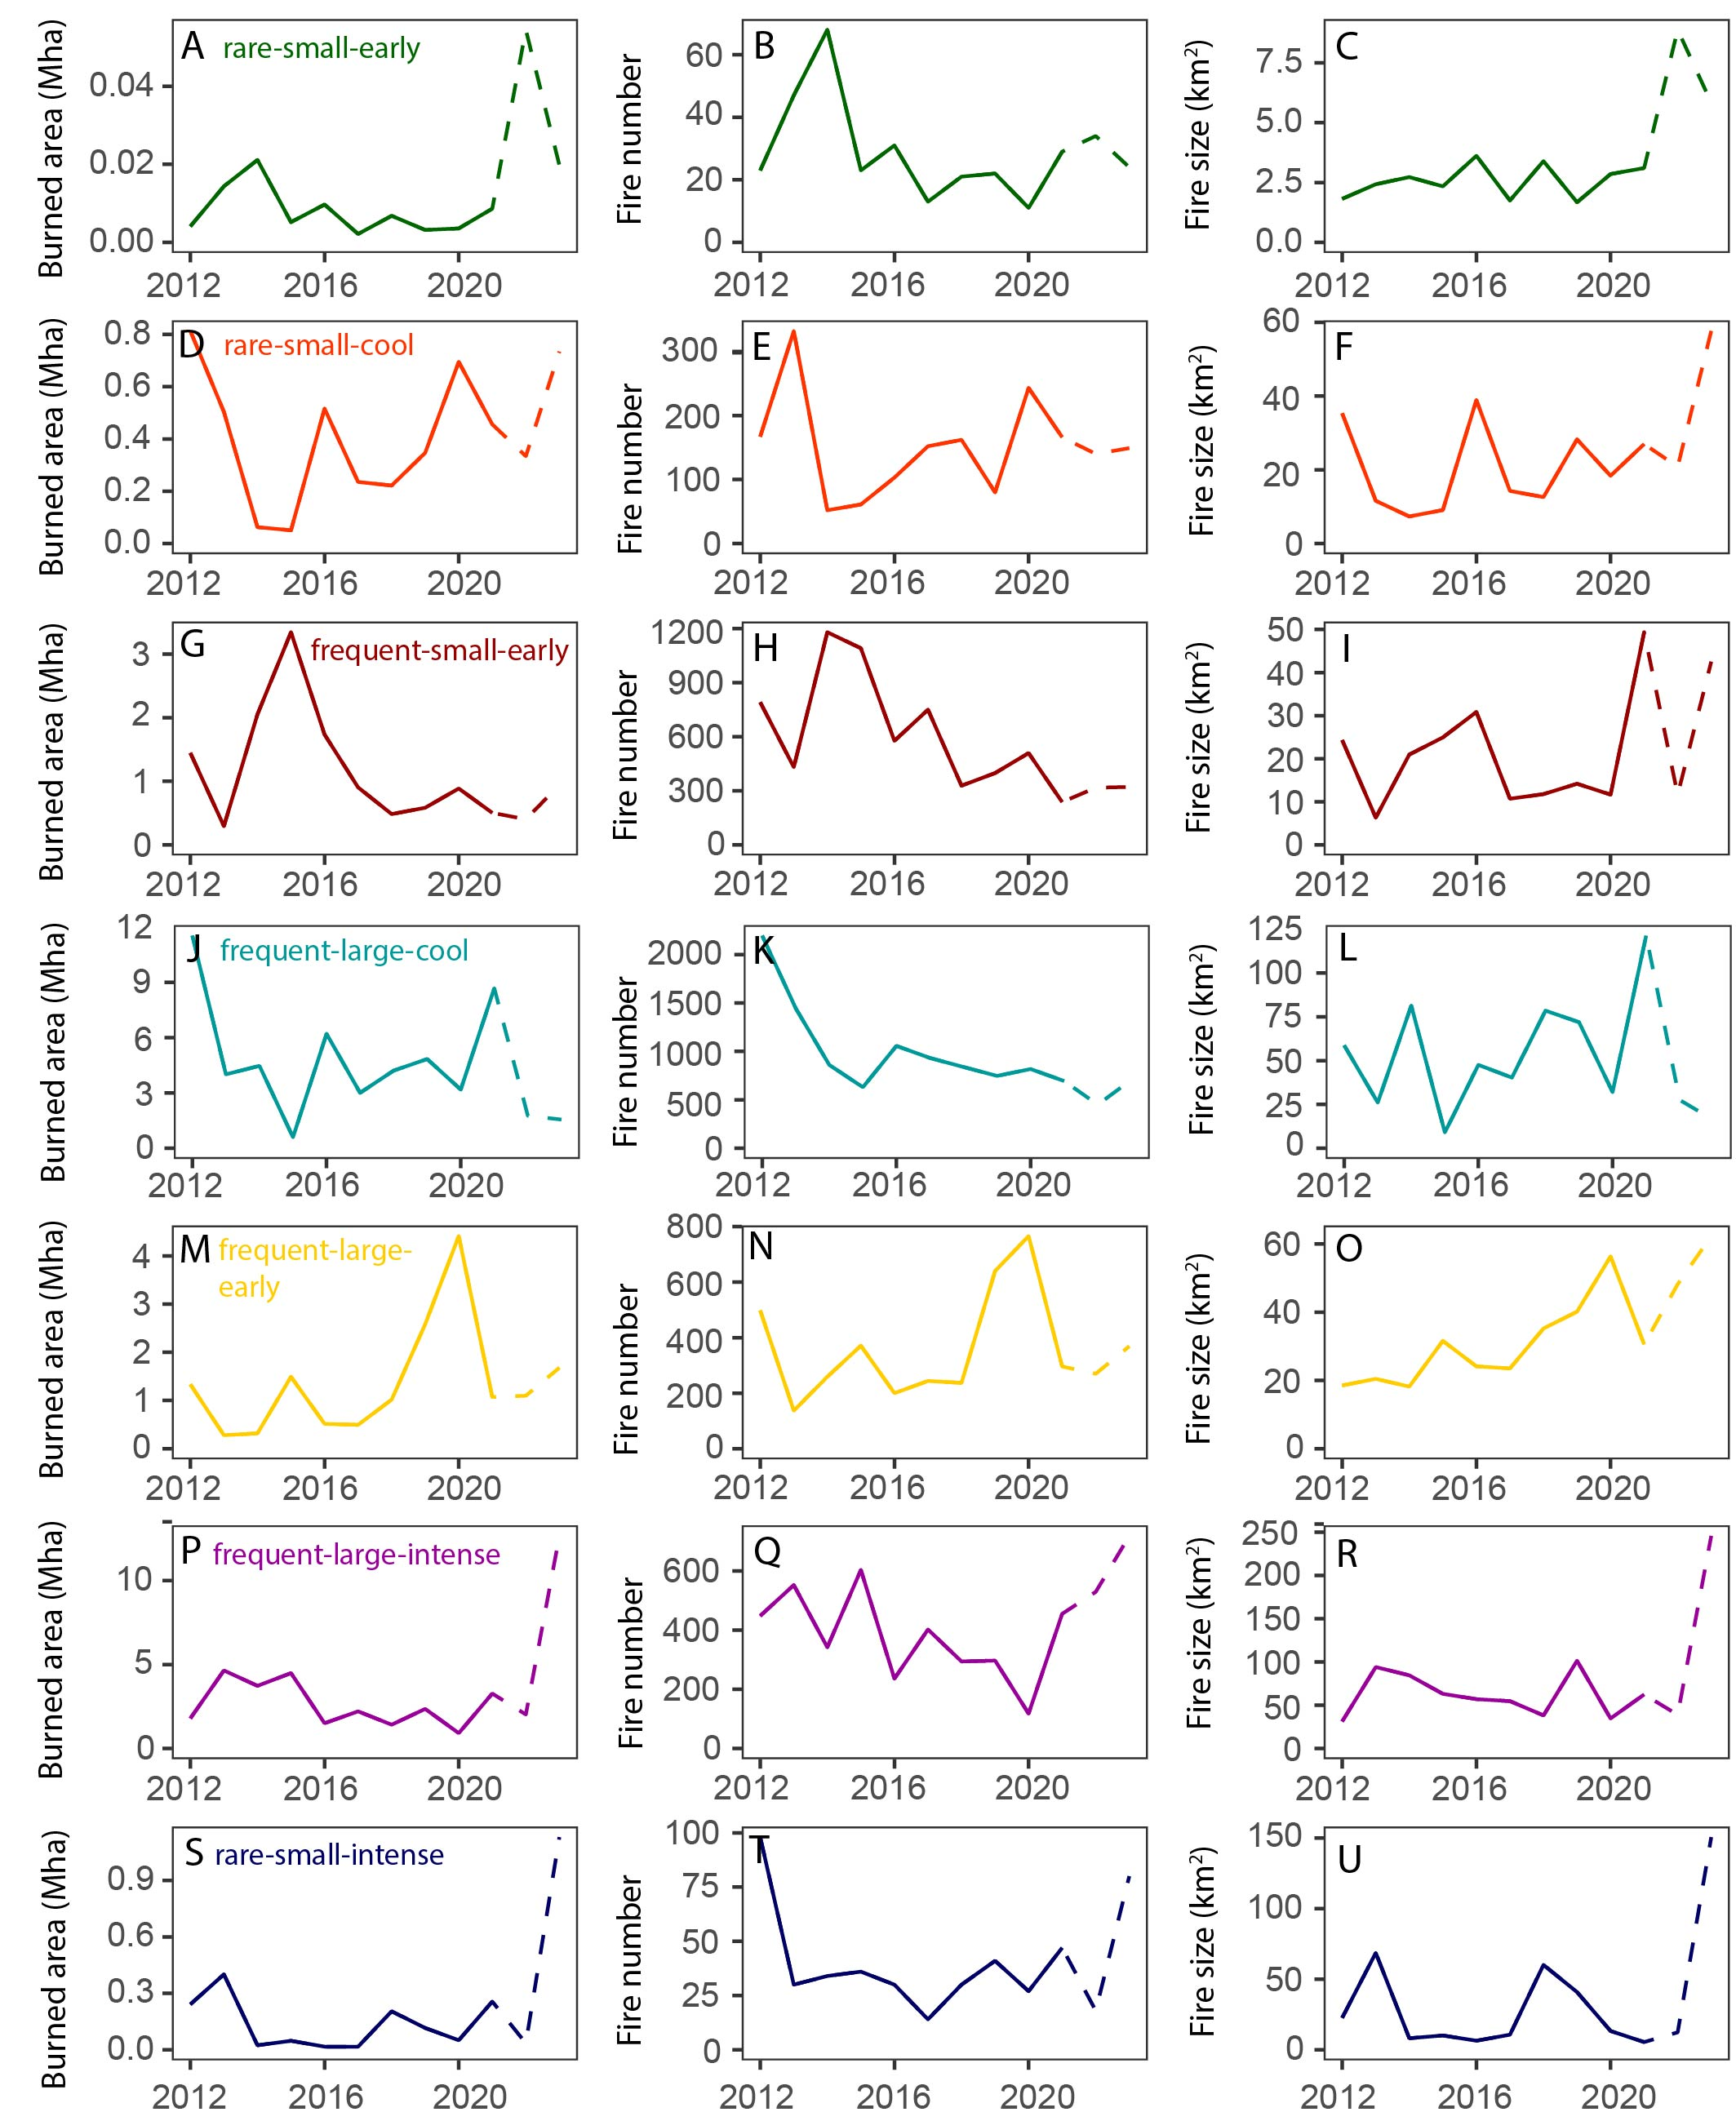
Extended Data Figure 6: Annual burned area, number of fires and average fire size between 2012 and 2023 in the seven pyroregions. Dashed lines refer to data that is based on Visible Infrared Imaging Radiometer Suite near real-time active fire locations instead of the science quality archive active fire product See Fig. 3 for the geographical extent of the pyroregions.

