Supplementary Materials

Electricity-producing Staphylococcus epidermidis Counteracts Cutibacterium acnes

Shinta Marito¹, Sunita Keshari², Supitchaya Traisaeng², Do Thi Tra My¹, Arun Balasubramaniam¹, Prakoso Adi¹, Ming-Fa Hsieh³, Deron Raymond Herr⁴, and Chun-Ming Huang¹*

¹Department of Biomedical Sciences and Engineering, National Central University, Taoyuan, Taiwan
²Department of Life Sciences, National Central University, Taoyuan, Taiwan
³Department of Biomedical Engineering, Chung Yuan Christian University, Taoyuan, Taiwan
⁴Department of Biology, San Diego State University, San Diego, USA

*Correspondence: Professor Chun-Ming Huang, Department of Biomedical Sciences and Engineering, National Central University, Taoyuan, Taiwan. E-mail:chunming@ncu.edu.tw; Tel.: +886-3-422-7151 ext. 36101; Fax: +886-3-425-3427

Supplementary methods
The influence of voltage difference created by C. acnes on the growth of S. epidermidis. The rich media containing S. epidermidis ATCC 12228 (10⁷ CFU) was added into a 10 cm diameter petri dish where anode, cathode and PEM (Fig. 1a and b) were placed. C. acnes (10⁷ CFU) in the presence of 2% PEG-8 Laurate or the same volume of water was pipetted on the surface of the anode. The voltage differences (mV) were measured by a digital multimeter for 360 min. After that, S. epidermidis was collected from the petri dish, serially diluted (1 : 10⁰ - 1 : 10⁵), and spotted onto a TSB agar plate to count CFU.

The effect of voltage generation on the growth of C. acnes. The voltage was generated by a power supply using ELITE (BioPro Scientific Co., LTd. Hsinchu, Taiwan) in constant current mode. The maximum and minimum voltages were set at 4.4 mV and -4.4 mV, respectively. The anode was connected to a lead current input (I_{in}) and the cathode was linked to voltage input (V_{in}) and output (V_{out}). C. acnes (10⁷CFU/mL) was pipetted onto to the anode for 1 h. Bacteria on the anode without providing voltage were used as a control. C. acnes was then collected from the anode, serially diluted, and spotted onto a TSB agar plate to count CFUs.

Figure Legends
Supplementary Fig. S1. There was no effect of PEG-10 Laurate on growth of S. epidermidis or C. acnes. (a) S. epidermidis ATCC 12228 (S. epi) or C. acnes ATCC 6919 (10⁷ CFU) was incubated with and without 2% PEG-10 Laurate for 24 h. CFUs of bacteria were enumerated by plating serial dilution (1:10⁰-1:10⁵) on TSB agar plates. (b) Data of CFU/mL are represented as mean ± SD, in triplicate, two-tailed t-tests. ns = non-significant.

Supplementary Fig. S2. Inhibition of cyclophilin A did not affect the PEG-8 Laurate fermentation of S. epidermidis. Rich media containing phenol red were used for culture of PEG-8 Laurate alone, S. epidermidis (S. epi) alone, S. epidermidis plus PEG-8 Laurate, TMN 355 alone, or TMN 355-pretreated S. epidermidis in the presence or absence of PEG-8 Laurate for 12 h. Fermentation was detected in the culture of S. epidermidis pretreated with/without TMN 355 in the presence of PEG-8 Laurate. The condition that phenol red in media of turned yellow (a) leading to significant reduction of OD₅₆₀ (b) indicated the occurrence of bacterial fermentation. Data are represented as mean ± SD from three independent experiments. *** P < 0.001, (two-tailed t-tests). ns = non-significant. Illustration (a) is from own resources.

Supplementary Fig. S3. Extremely low voltage difference detected by C. acnes plus PEG-8 Laurate did not influence the growth of S. epidermidis. (a) The voltage differences (mV) were measured for 360 min after pipetting C. acnes (10⁷ CFU) with PEG-8 Laurate or water (H₂O) on the surface of anode in the presence of S. epidermidis (10⁷ CFU) in a petri dish containing anode, cathode and PEM. (b) S. epidermidis was collected, serially diluted (1 : 10⁰ - 1 : 10⁵), and spotted on TSB agar plates for CFU counts. Data of CFU/mL are denoted as mean ± SD, in triplicate, two-tailed t-tests. ns = non-significant.

Supplementary Fig. S4. Addition of FMN enhanced electricity production of S. epidermidis. 10 µM FMN or the same volume of sterile water (H₂O) was added into rich media containing S. epidermidis (S. epi) ATCC 12228 (10⁷ CFU) plus 2% PEG-8 Laurate. The voltage difference (mV) was measured for 120 min after pipetting S. epidermidis plus PEG-8 Laurate with/without FMN on anodes.

Supplementary Fig. S5. Voltage difference exerts an inhibitory effect on the growth of C. acnes. (a) Voltage difference was created by a power supply in current constant model. (b) C. acnes (10⁷ CFU) on the surface of anode was provided without (0) or with 4.4 mV for 1 h. CFUs of C. acnes bacteria were enumerated by plating serial dilution (1:10⁰-1:10⁵) on TSB agar plates. Data of CFU/mL are displayed as mean ± SD, in triplicate, **P < 0.01 (two-tailed t-tests). Illustration (a) is from own resources.

Supplementary Fig. S1.

Supplementary Fig. S2.

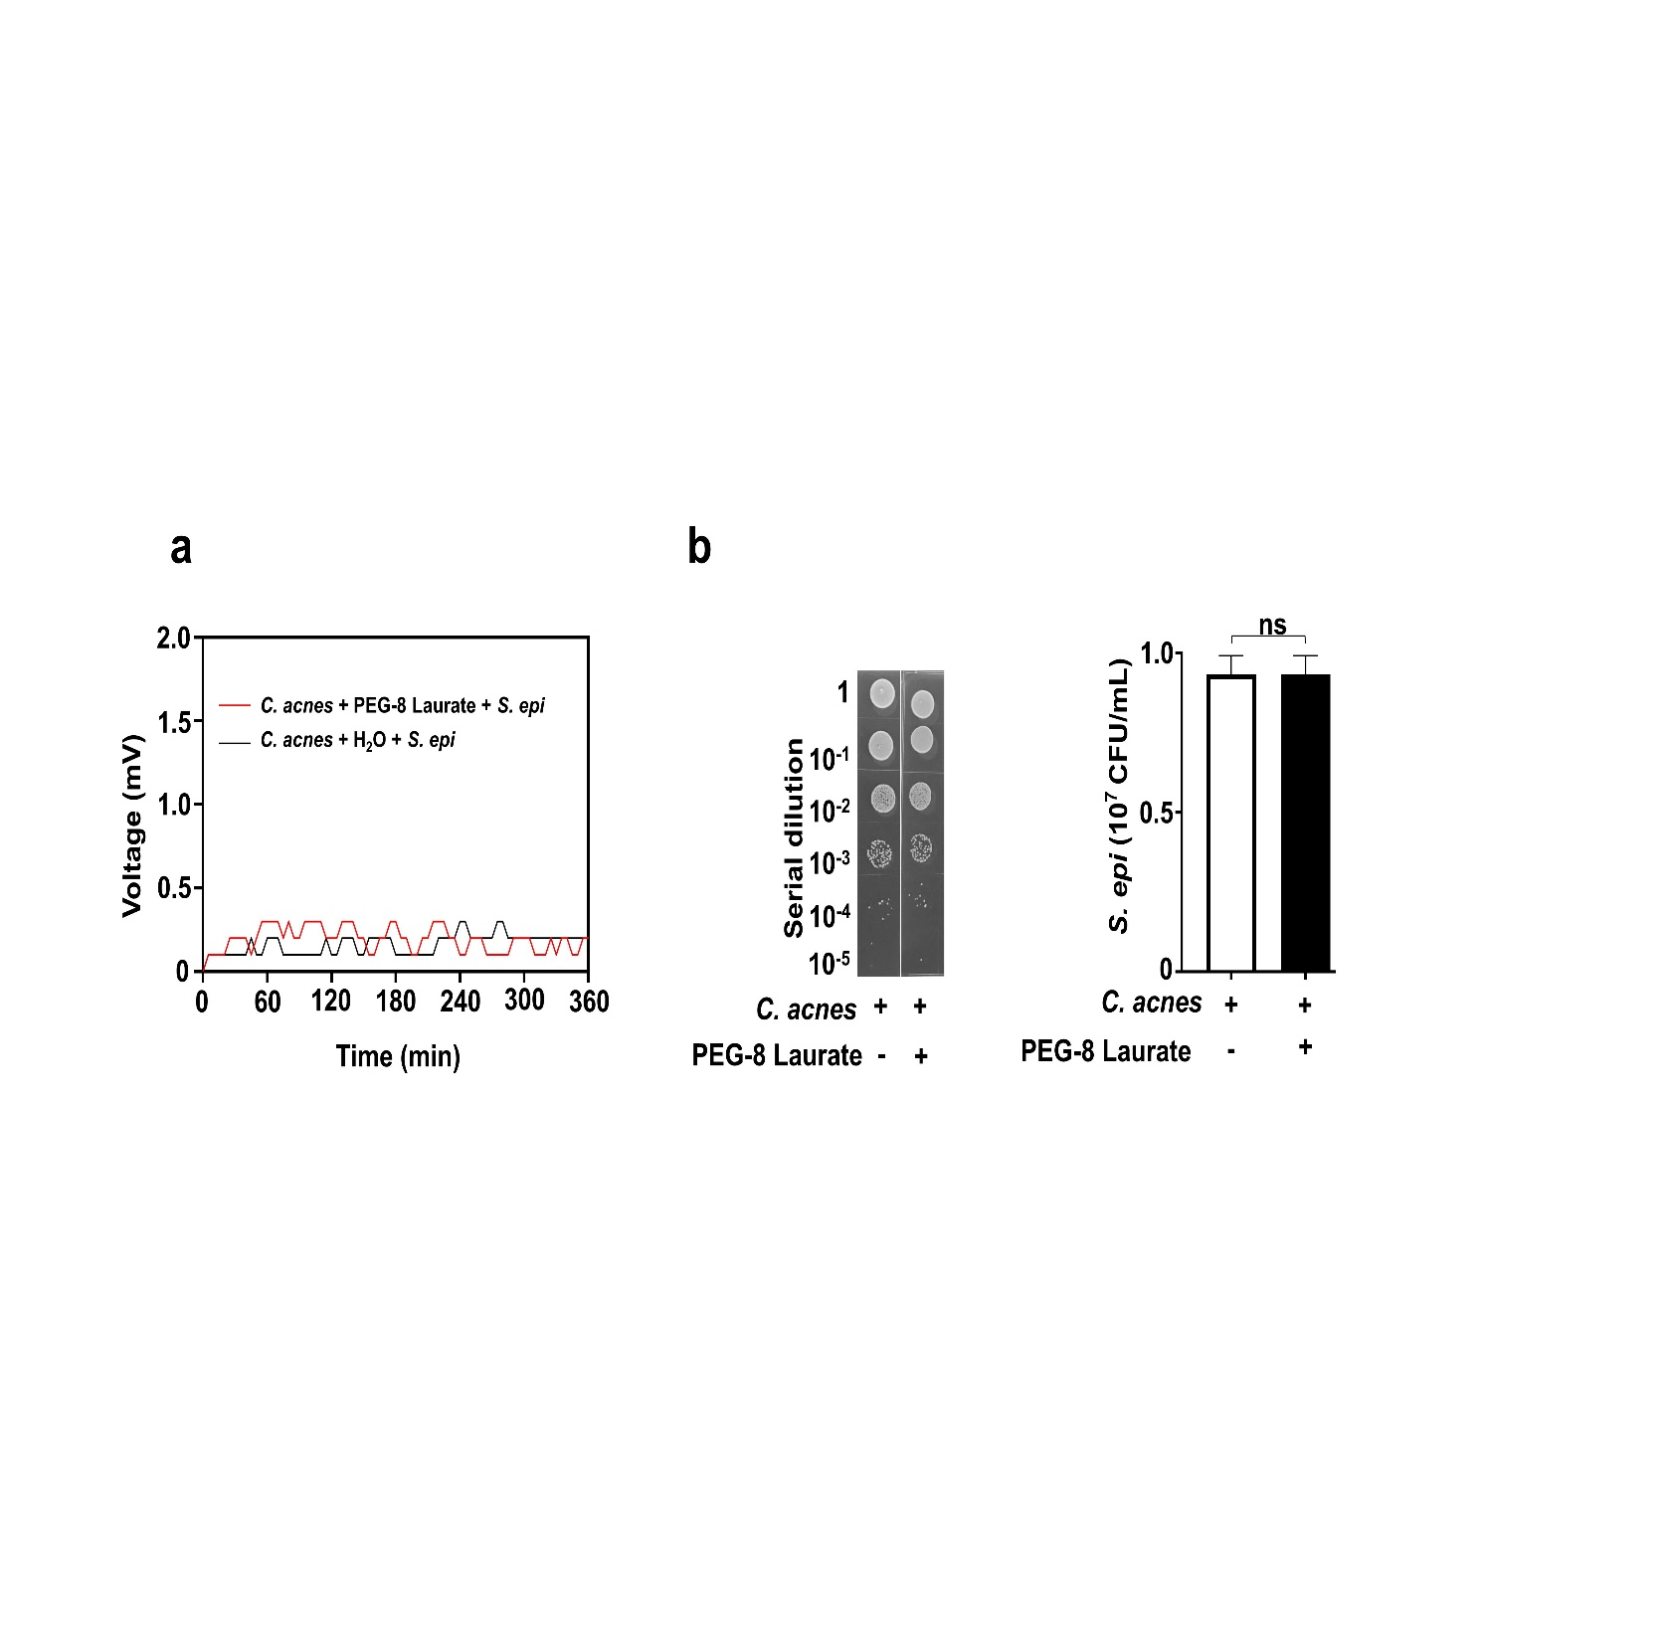
Supplementary Fig. S3.

Supplementary Fig. S4.

Supplementary Fig. S5.
