Supporting Information

Perylene-Based Columnar Liquid Crystal: Reveling Unipolar Resistive Switching for Nonvolatile Memory Devices

PerLC synthesis
The synthesis and mesomorphic characterization of 3,9(10)-bis-(2-methoxyethoxycarbonyl)-4,10(9)-bis(2-(2-methoxyethoxy)ethoxycarbonyl)perylene (PerLC), was published elsewhere [1]. The molecular structure, photophysical and electrical characteristics can be found in Ref. [2]. This molecule was also reported as efficient stabilizer in ZnO quantum dot synthesis [3].

Synthesis of $ZnO@SiO_{2}$ core/shell QDs
Precursor solutions of zinc acetate dihydrate and lithium hydroxide were prepared by dissolving 0.0274 g of [Zn(CH3CO2)2•2H2O] in 12.5 mL of ethanol with magnetic stirring at 65 °C and 0.0225 g of LiOH in 12.5 mL of ethanol with ultrasound at 65 °C. The LiOH solution was added dropwise to the [Zn(CH3CO2)2•2H2O] solution into a three-necked flask. The reaction time began to be followed when the first drop of LiOH fell on the zinc acetate solution. The final concentration reached in the reactor was 5.0×10-3 mol L-1 and 3.8×10-2 mol L-1 for zinc acetate and lithium hydroxide, respectively.
The reaction is kept under magnetic stirring at 65 °C for 2 h. Then, the three-neck flask is cooled to room temperature under constant stirring, and 30 μL of tetraethyl-orthosilicate [Si(OC2H5)4] and 100 μL of Mili-Q water were added. The reaction was continued for another 2 h at room temperature (~25 °C). The dispersion is then withdrawn from the three-neck flask and placed into two conical centrifuge tubes of 15 mL and was centrifuged for 10 minutes at 2100 rpm and the supernatant was removed. At this stage, nanoparticle sedimentation is perceived. Finally, 5 mL of ethanol were added followed by another 10-minute centrifugation, and then a further removal of the ethanolic supernatant.

X-ray diffraction
The X-ray diffraction (XRD) experiments were carried out with the X`Pert-PRO (PANalytical) diffractometer using the linear monochromatic Cu Kα beam (λ = 1.5405 Å), with an applied voltage of 40 kV and current of 30 mA. The pure and QD-doped samples were prepared by heating until isotropic and subsequent cooling to room temperature on glass plates, resulting in a film of approximately 1.0 mm thick. The scans were performed in continuous mode from 2º to 30º (2θ angle) at room temperature.

Resistive switching memory device preparation
Initially, the QD powder was dispersed in ethanol (solvent) and sonicated for 1 h. Then, different amounts of this solution were mixed with a PerLC solution to prepare the PerLC:QD mixtures at different weight percentages of QDs (10, 20 and 40 % wt.). The mixtures were sonicated in an ultrasonic bath for approximately 2 h with heating to obtain a homogeneous solution. The solvent was then removed by placing the mixtures in a heating chamber at 90°C.
Finally, PerLC:QD samples of different QD concentrations were introduced into the resistive switching memory device by capillary action at 155 ºC (i.e. with PerLC in isotropic liquid phase). The device is a cell fabricated with of two indium-tin-oxide (ITO) coated glass plates of ($1.5×1.5 cm^{2}$). The ITO electrodes were cleaned by sonication in ethanol, acetone and deionized water and dried with nitrogen gas. The plates were superimposed with the ITO stripes on the inner side, using 8 μm-thick mylar spacers to control the active layer thickness. Scheme S1 illustrates the device fabrication resulting in diode-like structures with the PerLC (undoped or doped) as active layer.

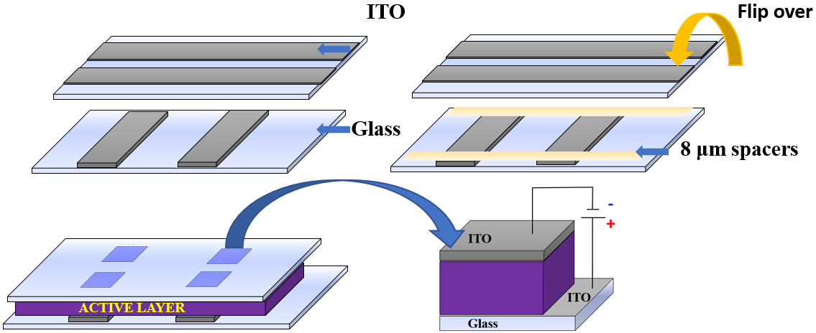

Scheme S1: Resistive switching memory device preparation.

Electrical measurements
Electrical impedance spectroscopy was measured with an AutoLab PGSTAT302N potentiostat/gavanostat/frequency response analyzer, controlled by NOVA 2.1 software, operating in the frequency range between $0.1 Hz$ and $100 kHz$. The applied potentials were AC $V_{RMS}$of 100mV, and fixed DC bias voltages of $1.5 V$. For the electrical characterization (current vs voltage (I-V)) a Keithley 2400 programmable electrometer was used.

Electric Impedance Spectroscopy (EIS)
The equivalent electrical circuit of Scheme S2 was used to fit the experimental data.
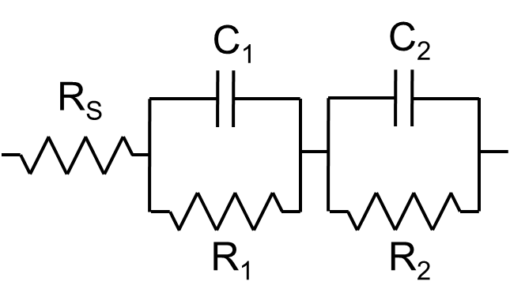
Scheme S2: Equivalent electrical circuit used to fit the experimental data.

Table 1. Fitted equivalent circuit parameters.
QD content | Electrical parameters
QD content | R_{s} / Ω | R₁ / Ω | R₂ / Ω | C₁ / F | C₂ / F
0% | 14500 | 2.49·10⁸ | 9.15·10⁷ | 1.98·10⁻¹¹ | 1.45·10⁻⁸
10% | 3320 | 1.45·10⁸ | 2.89·10⁷ | 4.21·10⁻¹¹ | 4.22·10⁻⁸
20% | 7260 | 7.81·10⁶ | 9.89·10⁶ | 5.75·10⁻¹¹ | 1.82·10⁻⁷
40% | 5380 | 6.42·10⁷ | 3.03·10⁷ | 2.56·10⁻¹¹ | 6.17·10⁻⁸

The system can be described by five parameters and only two time constants. The parallel connection of resistance (R₁, R₂) and capacitance (C₁, C₂) describes the charge transport along the active layer, associated to the resistance of the charge transfer between sites and the molecular charging capacity. The two connected circuit elements describe the total resistance and capacitance of the active layer, provided that all the considered sites have similar electrochemical properties. The fact that two couples of R-C are necessary to fit the experimental spectra indicates the existence of two different processes on the charge path. Presumably, one of them is charge transfer through the reduced states (electron transport from the cathode side), while the other one is the charge transfer through the oxidised states (hole transport).
The first couple of parameters, C₁ and R₁, are well justified, whereas the second couple, C₂ and R₂, can only be detected at very low frequencies, where data acquisition and fitting is less precise (Figure S1).

a) | b) | c) | d)
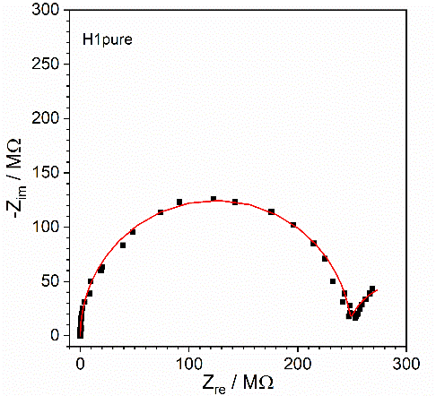 | 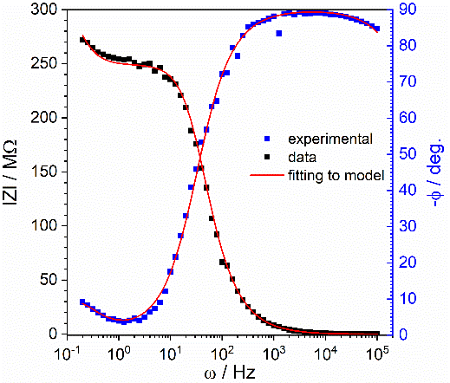 | 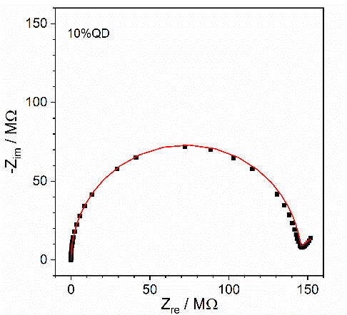 | 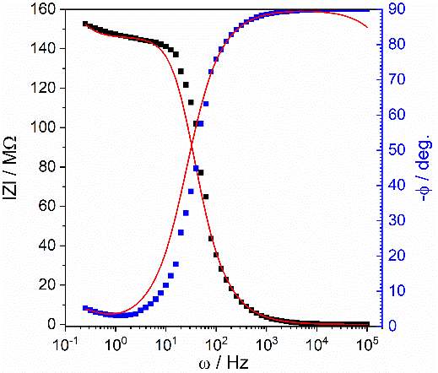
e) | f) | g) | h)
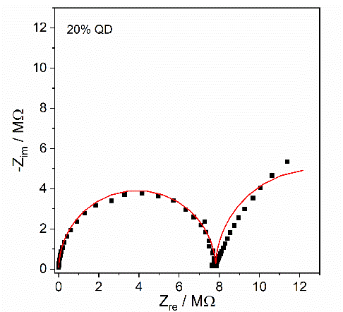 | 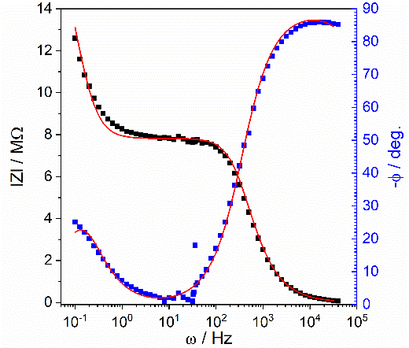 | 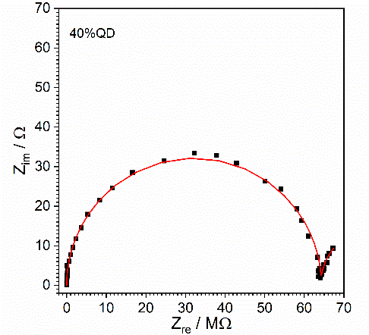 | 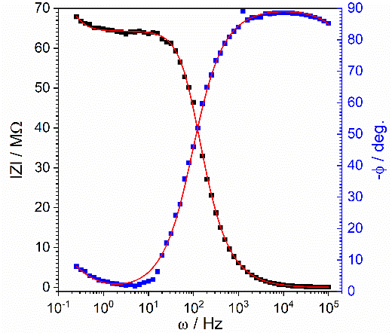

Figure S1: EIS of the pure PerLC (a,b), PerLC:QD10% (c,d), PerLC:QD20% (e,f), PerLC:QD40% (g,h). Nyquist diagram (a,c,e,g) and Bode diagram (b,d,f,h). The red lines are fits.

Due to the low quality of data fitting at low-frequencies, the R₂ and C₂ parameters have not been considered as a measure of the memory effect. As discussed in the main text, the spectrum analysis in a narrower frequency range, from 100 kHz to 100 Hz, is simpler and provides only three circuit parameters R_{s}, R₁ and C₁.
One of the characteristic parameters could be a time-constant which equals the product of corresponding resistance and capacitance, using equation (1). It can be regarded as the average time needed for a charge carrier to proceed through the conductive layer.
$τ_{i}=R_{i}∙C_{i}$ (1)
The corresponding equivalent circuit parameters obtained by fitting the curves of Figure S1 and the calculated time constants are shown in Figure S2 as function of the QD content.
a) | b)
c)
Figure S2: Equivalent circuit parameters obtained by fitting the curves of Figure S2 and calculated time constants: Internal resistance (a), capacitance (b) and time-constant of charge transport (c) for different QD contents.

Figure S2 shows that PerLC with 20% wt. QD doping transports charges best, due to the lowest resistance (Figure S2a). It also has the highest capacitance for both processes (Figure S2b). The time constants allow distinguishing between two charge transfer processes: those which are described by R₁-C₁ and R₂-C₂ circuits. The first process is faster than the second one (Figure S2c) by about three orders of magnitude. That is the reason why the electrical parameters R₂-C₂ can only be registered in the low frequency range. The first process, as the fastest, deserves special attention with respect to the memory effect.

Figure S3: The graphs show the J–V characteristics PerLC (a) and PerLC:QD 20% (b) in a log–log plot indicating the Ohmic and SCLC regimes. The solid lines are fits using the field-dependent mobility $μ=μ_{0}e^{γ\sqrt{E}}$. The obtained µ₀ and γ values are also presented.

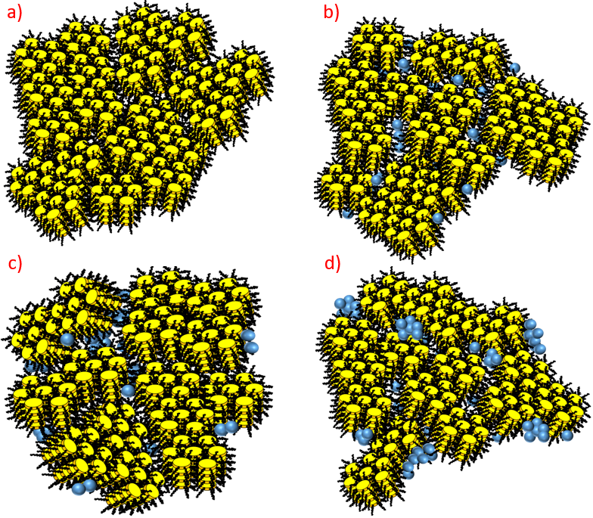
Scheme S3: Illustration of the macroscopic columnar hexagonal domains by QD doping, based on the XRD experiments. a) Pure PerLC, b) PerLC:QD10%, c) PerLC:QD20% and d) PerLC:QD40%.

Figure S4 shows the TEM image of ZnO@SiO2 quantum dots synthetized in the presence of PerLC. PerLC (2.0 × 10−5 mol L−1) and (QD = 2.0 × 10−3 mol L−1). The obtained particles diameter is 3.7 $±$ 0.4 nm, with a size dispersion of 20%.

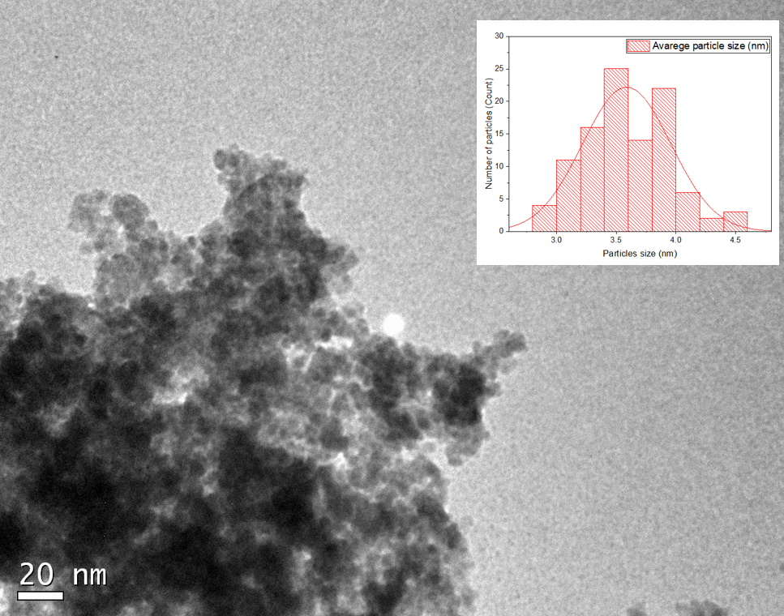
Figure S4: TEM images and size distribution histograms (insets) of PerLC:QD PerLC (2.0 × 10−5 mol L−1) and (QD = 2.0 × 10−3 mol L−1). The size of the nanoparticles was determined by transmission electron microscopy (TEM) using a JEOL JEM-2100 microscope operating at 100 kV.

Density functional theory (DFT) calculations
DFT calculations were conducted within the Gaussian computational package (version 09 revision E.01) [5] The ωB97x-D functional from Chai and Head-Gordon [6] was used together with 6-31+G(d,p) as basis set. Molecular geometries for the neutral, radical ionic and di-ionic molecules were optimized and vibrational frequencies were computed to verify the absence of imaginary frequencies and confirm the ground state nature of the involved species. Molecular orbital isosurfaces were plotted for an isovalue of 0.005 using Avogadro Version 1.2.0. [7]. Partial atomic charges and spin densities are calculated based on a partitioning scheme formulated within the quantum theory of atoms in molecules (QTAIM), using the software Multiwfn [8]. The color representation of the partial atomic charges on the molecular structure has been achieved using Vesta [9].

Charge density
The calculation of partial atomic charges allows to understand the organization of charge within the molecule. The conjugated core is largely neutral, while strong local dipoles exist on each side chain between the oxygen atoms and the carbon connecting them.

Figure S5: Partial atomic charges for neutral PerLC calculated using the quantum theory of atoms in molecules and projected onto the molecular structure. The carbon structure of the core is almost completely neutral (partial charge < 0.05e, shown in white); oxygens bear either -1.15 or -1.24 e (shown in red); the carbons connected to two oxygens +1.67 e (shown in deep blue); and the terminating carbon, +0.52 e (shown in pale blue).

References
[1] J. Kelber, M.-F. Achard, B. Garreau-de Bonneval, and H. Bock, “Columnar Benzoperylene-Hexa- and Tetracarboxylic Imides and Esters: Synthesis, Mesophase Stabilisation and Observation of Charge-Transfer Interactions between Electron-Donating Esters and Electron-Accepting Imides,” Chem. - A Eur. J., vol. 17, no. 29, pp. 8145–8155, Jul. 2011, doi: 10.1002/chem.201100939.
[2] J. Eccher, A. C. B. Almeida, T. Cazati, H. von Seggern, H. Bock, and I. H. Bechtold, “Triplet exciplex electroluminescence from two columnar liquid crystal perylene derivatives,” J. Lumin., vol. 180, pp. 31–37, Dec. 2016, doi: 10.1016/j.jlumin.2016.08.012.
[3] W. C. Costa et al., “Stabilization of ZnO quantum dots by preferred 1:2 interaction with a liquid crystal molecule,” J. Mol. Liq., vol. 310, p. 113273, Jul. 2020, doi: 10.1016/j.molliq.2020.113273.]
[4] H. Bassler, Phys Status Solidi B. 175 (1993) 15-56.
[5] M. J. Frisch et al., Gaussian, Inc., Wallingford, CT, USA, 2009.
[6] J. D. Chai, M. Head-Gordon, Phys. Chem. Chem. Phys. 2008, 10, 6615-6620.
[7] M. D. Hanwell, D. E. Curtis, D. C. Lonie, T. Vandermeersch, E. Zurek, G. R. Hutchison, J. Cheminform. 2012, 4, 17.
[8] Tian Lu and Feiwu Chen. “Multiwfn: A Multifunctional Wavefunction Analyzer”. In: Journal of Computational Chemistry 33.5 (Feb. 2012), pp. 580–592. issn: 01928651. doi: 10.1002/jcc.22885
[9] Koichi Momma and Fujio Izumi. “VESTA 3 for three-dimensional visualization of crystal, volumetric and morphology data”. In: Journal of Applied Crystallography 44.6 (Dec. 2011), pp. 1272–1276. doi: 10.1107/S0021889811038970. url: https://doi.org/10.1107/S0021889811038970.

